React: npm run dev
Node (backend-api): npm run start

React: A JavaScript library for building user interfaces.

What problem does React solve?
1. DOM (Document Object Model) Focused
https://codepen.io/learnwebcode/pen/qBEKBwx?editors=1010

2. Data / Declarative View
https://codepen.io/learnwebcode/pen/XWJYWwg?editors=1010

useState

useEffect(a,b)
a: the function you want to run
b: dependecies that changes then ur function runs, (usually [] to run once when page loads)

{settings.json}
“prettier.arrowParens”: “avoid”
allows you to write an arrow function and if you have exactly one parameter, can skip the parentheses without Prettier adding them for you (which can be annoying).

“prettier.trailingComma”: “none”
ensures that you don’t have unnecessary commas after the final property when defining an object literal.

{package.json}
npm init -y

npm install react react-dom

npm run dev (to keep the browser running)

PS C:\Users\commonuser\Documents\reactjs> npm install @babel/core @babel/preset-env @babel/preset-react babel-loader

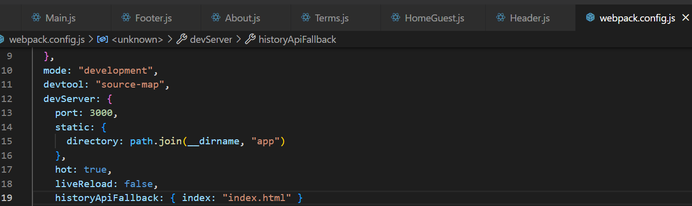
Inlcude historyApiFallback so that when it refreshes, this page runs again.

Download React Developer Tools Chrome

https://github.com/LearnWebCode/react-course
(Adding a snipper)
snippet-generator.app (to create own snipper)
rc tab (to load snippet)

MongoDB
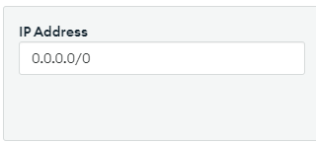

“Add any IP address”

MongoDB User
Username: mainUser
Password: zXDABfEEna1JZZRu

Create Environment:
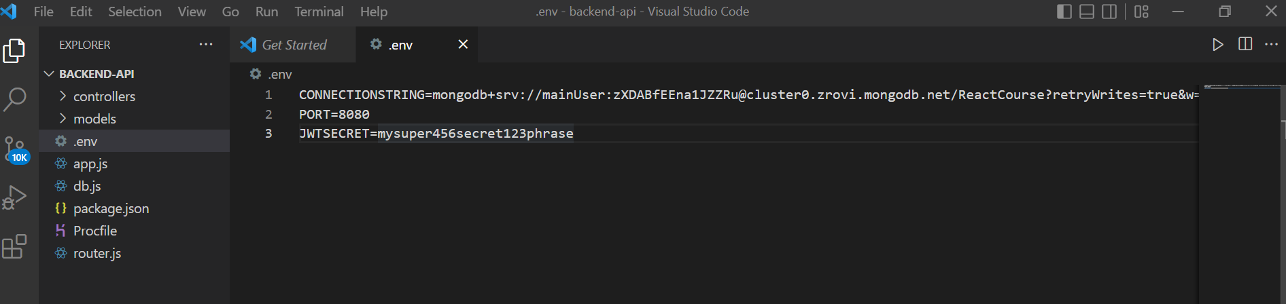
(Paste the MongoDB code inside)

“npm run start” to run the backend server in backend-api folder.

Docker
Run in Terminal:

“npm install axios” to install axios.

UseState
const [username, setUsername] = useState()

first parameter: to access value
second parameter: function that we can call to update its value.

Change attribute names (JSX)
- class to className
- href to “for”

HTML to JSX
a | Link
for | htmlFor
Autocomplete | autoComplete

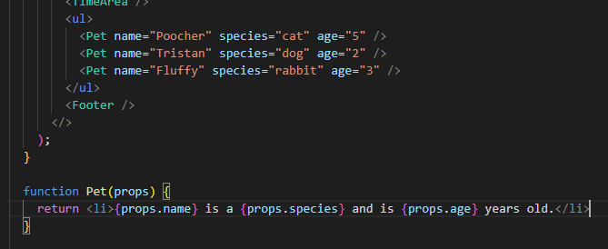
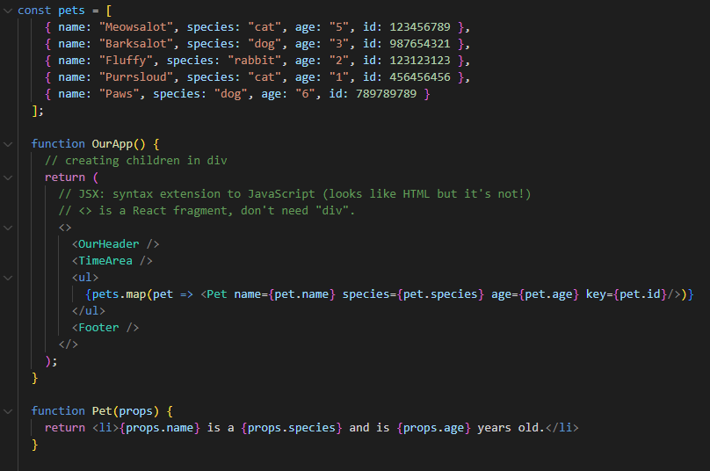

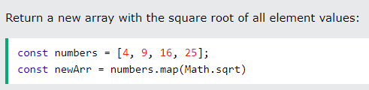

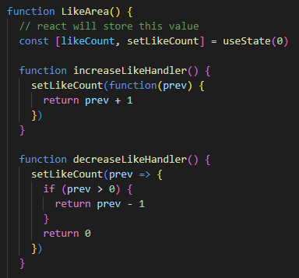

useState

- have to go to input field and include “onChange”
- useReducer is an alternative to useState. UseReducer is usually preferable to useState when you have complex state logic.

Immer
- Immer can be used in any context in which immutable data structures need to be used.
-npm install immer use-immer
-

