Leon Nguyen

**103139729**

**COS30020 Advanced web development**

Task 1: Creating a table and entering data

1. Query to create table:

CREATE TABLE cars(

car_id int NOT NULL AUTO_INCREMENT,

make varchar(30) NOT NULL,

model varchar(30) NOT NULL,

price double NOT NULL,

yom int NOT NULL,

PRIMARY KEY(car_id);

1. Entering data

INSERT INTO cars (make, model, price, yom)

VALUES ('Holden', 'Astra', 14000, 2005), ('BMW', 'X3', 35000, 2004), ('Ford', 'Falcon', 39000, 2011), ('Toyota', 'Corolla', 20000, 2012), ('Holden', 'Commodore', 13500, 2005), ('Holden', 'Astra', 8000, 2001), ('Holden', 'Commodore', 28000, 2009), ('Ford', 'Falcon', 14000, 2007), ('Ford', 'Falcon', 7000, 2003), ('Ford', 'Laser', 10000, 2010), ('Mazda', 'RX-7', 26000, 2000), ('Toyota', 'Corolla', 12000, 2001), ('Mazda', '3', 14500, 2009);

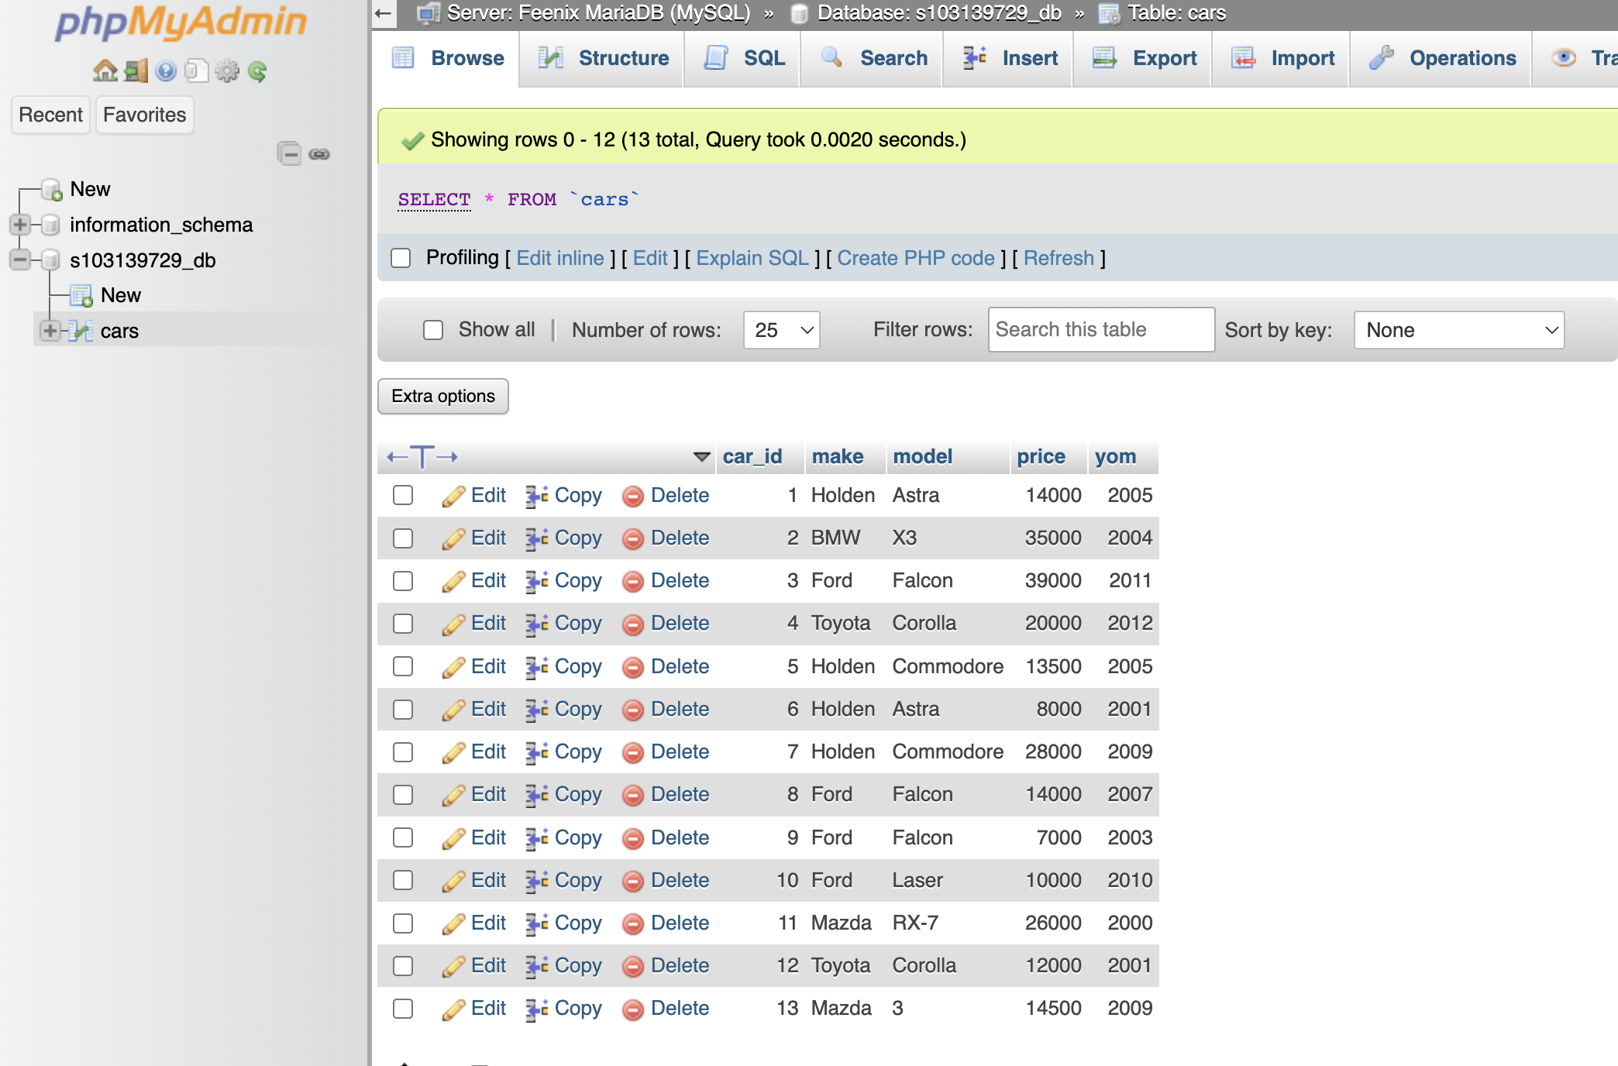

Task 2: Querying the table

1. All records query. 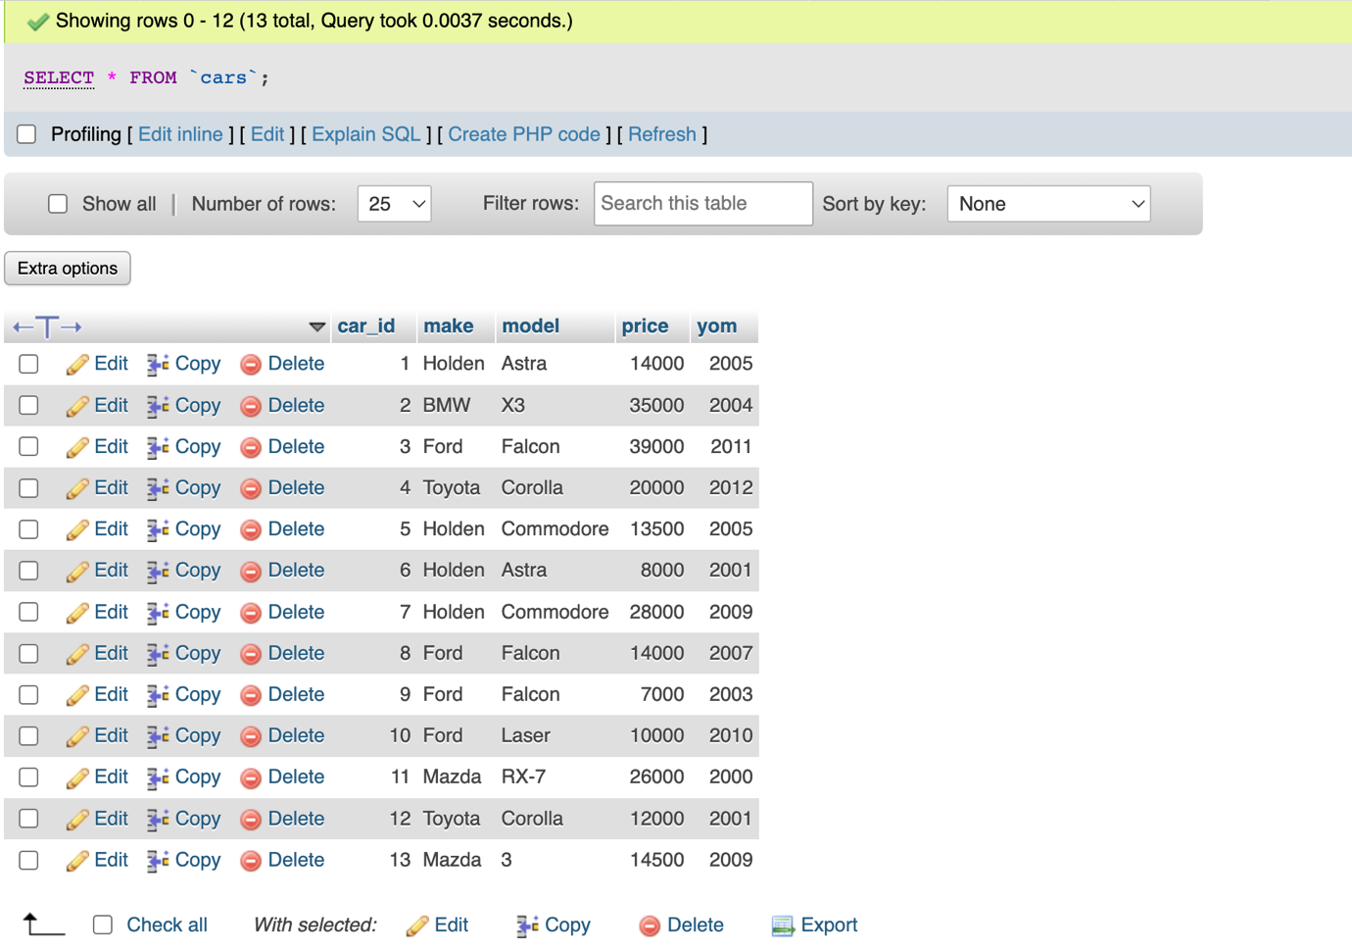
2. Make, model, price sorted by make and model. 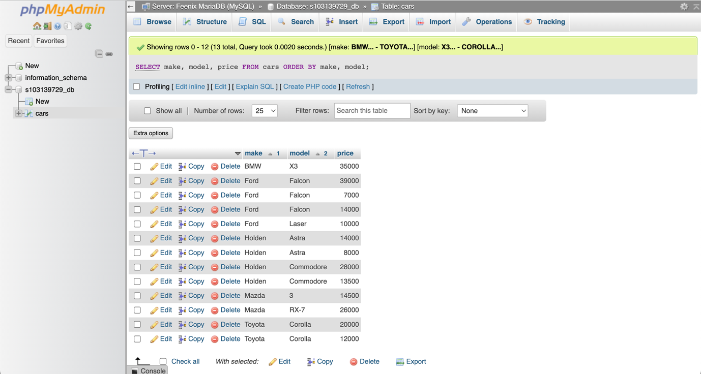
3. The make and model of the cars cost $20,000 more. 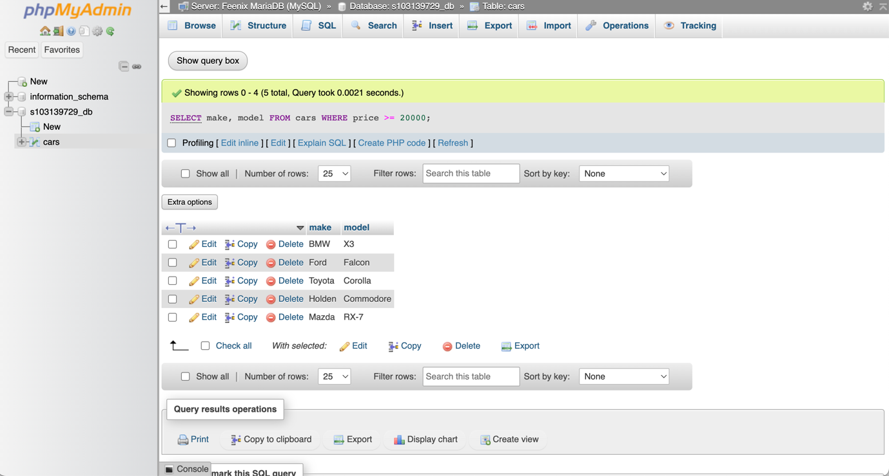
4. The make and model of the car cost below $15,000. 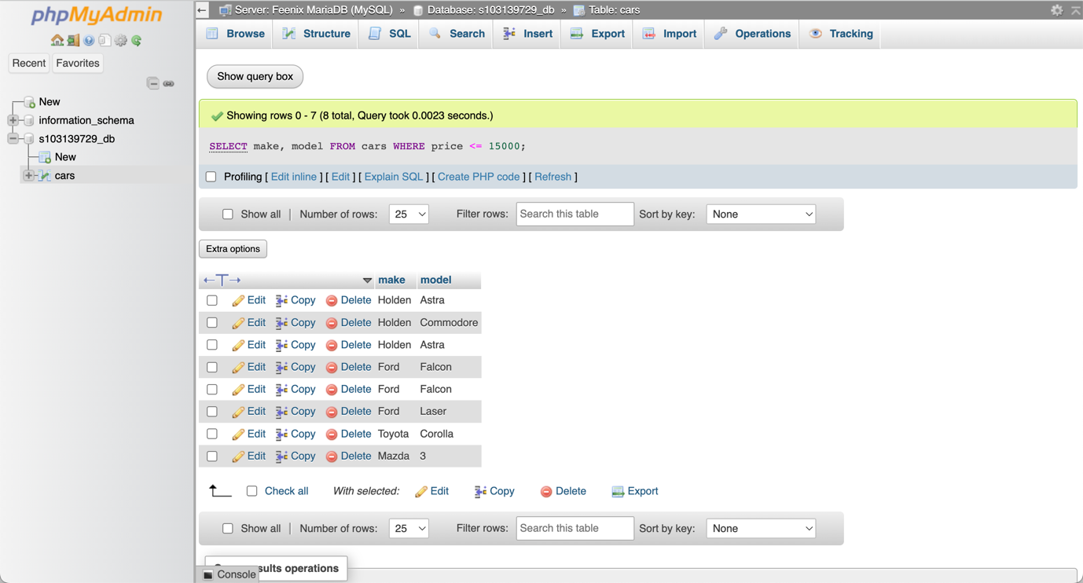
5. The average price of cars for similar make