Assignment

BSCS 409: Wireless and Mobile Computing

Otieno Leon

ICT-G-4-1007-19

Fixed Assignment Schemes.

definition of terms:

* Resource or resources - can be time slots, frequency channels, network addresses or code.
* Multiple Access – A single base station (B.S) is communicating with many devices.

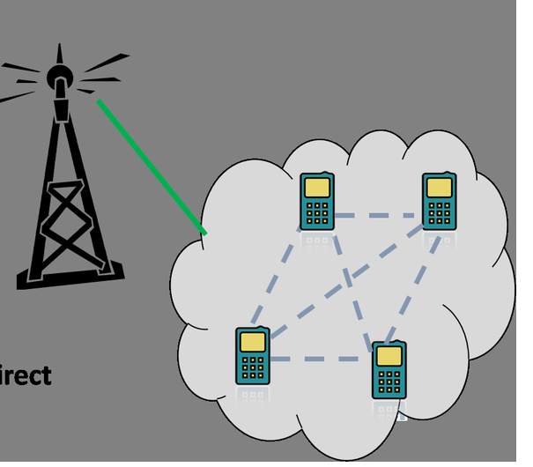Figure 1: A diagram showing a single base station communicating with multiple devices

* Bitrate – number of bits that are transmitted, processed or received per unit time.

Overview of Fixed Assignment Schemes

* It is also known as Circuit Switched Scheme.
* In fixed assignment scheme(using multiple access and the b.s is providing resources), the resources required by a cell are assigned for the entire duration of the cell. In other words each device is assigned a fixed resource for communication and must use that resource exclusively for all its transmissions.

There are three types of Fixed Assignment schemes available

* Frequency Division Multiple Access (FDMA)
* Time Division Multiple Access (TDMA)
* Code Division Multiple Access (CDMA)

Frequency Division Multiple Access (FDMA)

* Each user is assigned to a unique frequency or channel.
* These channels are are assigned on demand to users who request the service.
* During the period of the call, no other channel can share the same channel
* FDMA carries only one phone circuit at time.
* If an FDMA channel is not in use, then it sits idle and cannot be used by other users.
* FDMA requires light RF filtering to minimize adjacent channel interfacing
* For each channel a guard is provided to avoid adjacent channel interfacing.

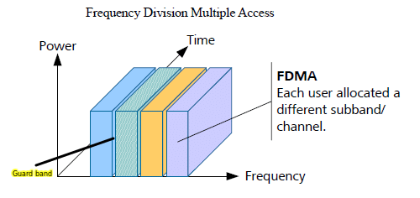Figure 2: FDMA description

Advantages of FDMA

* If channel is not in use it sits idle, making it easy for the user to access the resource.
* Channel bandwidth is relatively narrow which can help in improved signal quality and less susceptibility to interference
* Fairly efficient when the number of stations is small and the traffic is uniformly constant.
* No need of network timing(synchronizing network systems to a specific clock to keep track of data transmissions and scheduling events).
* There are no restrictions regarding the type of baseband or type of modulations(one can choose to either use analog or digital signals in terms of baseband or amplitude Modulation(AM) or Frequency Modulation(FM) in terms of Modulations).

Disadvantages of FDMA

* Presence of guard bands – The guard band’s space will not be used in communication which is a wastage.
* Maximum bit rate per channel is fixed, limiting communication
* Small, inhibiting flexibility in bit rate capability.
* Does not differ significantly from analog systems.