SI for
WaterMAP: A Scalable Machine Learning Framework for Emission-Factor-Derived Spatiotemporal GHG Prediction and Mitigation in Wastewater Treatment Plants
Jinqi Jiang†,††, Zhijing Wu†, Guosen Zhang†,††, Yuwei Zhang†, Yichao Lyu†, Shen Qu§*, Huabo Duan†, Hongxiao Guo‡, Xiang Xiang††, Zongping Wang†, Guanghao Chen‡, Gang Guo†*

† Hubei Key Laboratory of Multi-media Pollution Cooperative Control in Yangtze Basin, School of Environmental Science & Engineering, Huazhong University of Science and Technology (HUST), 1037 Luoyu Road, Wuhan, Hubei, 430074, China
†† Institute of Artificial Intelligence, Huazhong University of Science and Technology, Wuhan, Hubei, 430074, China
§ Center for Energy and Environmental Policy Research, Beijing Institute of Technology, Beijing, 100081, China;
‡ The Hong Kong University of Science and Technology, Hong Kong, 999077, China

*Corresponding Author: Dr. Gang Guo, E-mail: ceguogang@hust.edu.cn
Dr. Shen Qu, Email: squ@bit.edu.cn

Contents
Table S1. Hyper-parameters tuning of the Nat_total_model predicting EF-derived GHG emissions. 7
Table S2. Performances of the Nat_total_model predicting EF-derived GHG emissions. 7
Table S3. Hyper-parameters tuning of the Nat_type_model predicting EF-derived GHG emissions. 8
Table S4. Hyper-parameters tuning of Anhui-independent models predicting EF-derived GHG emissions. 9
Table S5. Hyper-parameters tuning of Beijing-independent models predicting EF-derived GHG emissions. 10
Table S6. Hyper-parameters tuning of Chongqing-independent models predicting EF-derived GHG emissions. 11
Table S7. Hyper-parameters tuning of Fujian-independent models predicting EF-derived GHG emissions. 12
Table S8. Hyper-parameters tuning of Gansu-independent models predicting EF-derived GHG emissions. 13
Table S9. Hyper-parameters tuning of Guangdong-independent models predicting EF-derived GHG emissions. 14
Table S10. Hyper-parameters tuning of Guangxi-independent models predicting EF-derived GHG emissions. 15
Table S11. Hyper-parameters tuning of Guizhou-independent models predicting EF-derived GHG emissions. 16
Table S12. Hyper-parameters tuning of Hainan-independent models predicting EF-derived GHG emissions. 17
Table S13. Hyper-parameters tuning of Hebei-independent models predicting EF-derived GHG emissions. 18
Table S14. Hyper-parameters tuning of Heilongjiang-independent models predicting EF-derived GHG emissions. 19
Table S15. Hyper-parameters tuning of Henan-independent models predicting EF-derived GHG emissions. 20
Table S16. Hyper-parameters tuning of Hubei-independent models predicting EF-derived GHG emissions. 21
Table S17. Hyper-parameters tuning of Hunan-independent models predicting EF-derived GHG emissions. 22
Table S18. Hyper-parameters tuning of Inner Mongolia-independent models predicting EF-derived GHG emissions. 23
Table S19. Hyper-parameters tuning of Jiangsu-independent models predicting EF-derived GHG emissions. 24
Table S20. Hyper-parameters tuning of Jiangxi-independent models predicting EF-derived GHG emissions. 25
Table S21. Hyper-parameters tuning of Jilin-independent models predicting EF-derived GHG emissions. 26
Table S22. Hyper-parameters tuning of Liaoning-independent models predicting EF-derived GHG emissions. 27
Table S23. Hyper-parameters tuning of Ningxia-independent models predicting EF-derived GHG emissions. 28
Table S24. Hyper-parameters tuning of Qinghai-independent models predicting EF-derived GHG emissions. 29
Table S25. Hyper-parameters tuning of Shaanxi-independent models predicting EF-derived GHG emissions. 30
Table S26. Hyper-parameters tuning of Shandong-independent models predicting EF-derived GHG emissions. 31
Table S27. Hyper-parameters tuning of Shanghai-independent models predicting EF-derived GHG emissions. 32
Table S28. Hyper-parameters tuning of Sichuan-independent models predicting EF-derived GHG emissions. 33
Table S29. Hyper-parameters tuning of Shanxi-independent models predicting EF-derived GHG emissions. 34
Table S30. Hyper-parameters tuning of Tianjin-independent models predicting EF-derived GHG emissions. 35
Table S31. Hyper-parameters tuning of Tibet-independent models predicting EF-derived GHG emissions. 36
Table S32. Hyper-parameters tuning of Xinjiang-independent models predicting EF-derived GHG emissions. 37
Table S33. Hyper-parameters tuning of Yunnan-independent models predicting EF-derived GHG emissions. 38
Table S34. Hyper-parameters tuning of Zhejiang-independent models predicting EF-derived GHG emissions. 39
Table S35. Datapoints and the number of wastewater treatment plants in China from 2009 to 2019. 40
Table S36. The datapoints of each province when predicting EF-derived GHG emissions. 40
Table S37. Cluster analysis of the mean values of the key predictors and EF-derived GHG intensity. 41
Table S38. Processes and their proportion of different clusters. 41
Table S39. Comparison of GHG Emissions from WWTPs Based on the Emission Factor Method and WaterMAP. 42
Table S40. Machine Learning-Assisted Prediction of GHG Emissions in Wastewater Treatment 43
Figure S1. The testing RMSE values of the best-performing ML models for each province, mapped for all EF-derived GHG emissions. 45
Figure S2. Model performances (R²) in predicting EF-derived N₂O emissions on testing datasets for each province. 46
Figure S3. Model performances (R²) in predicting EF-derived CH₄ emissions on testing datasets for each province. 47
Figure S4. Model performances (R²) in predicting EF-derived fossil CO₂ emissions on testing datasets for each province. 48
Figure S5. Model performances (R²) in predicting EF-derived EC emissions on testing datasets for each province. 49
Figure S6. Model performances (R²) in predicting EF-derived CC emissions on testing datasets for each province. 50
Figure S7. Learning curves of NAT_total_model and NAT_type_model predicting EF-derived total emissions (TE) and specific GHG intensity evaluated by RMSE and R². 51
Figure S8. Learning curves of PROV_type_model predicting provincial-specific EF-derived GHG intensity evaluated by RMSE: a) Beijing, b) Anhui, c) Chongqing, d) Fujian, e) Gansu, f) Guangdong, g) Guangxi, and h) Guizhou. 52
Figure S9. Learning curves of PROV_type_model predicting provincial-specific EF-derived GHG intensity evaluated by RMSE: a) Hainan, b) Hebei, c) Heilongjiang, d) Henan, e) Hubei, f) Hunan, g) Inner Mongolia, and h) Jiangsu. 53
Figure S10. Learning curves of PROV_type_model predicting provincial-specific EF-derived GHG intensity evaluated by RMSE: a) Jiangxi, b) Jilin, c) Liaoning, d) Ningxia, e) Qinghai, f) Shaanxi, g) Shandong, and h) Shanghai. 54
Figure S11. Learning curves of PROV_type_model predicting provincial-specific EF-derived GHG intensity evaluated by RMSE: a) Shanxi, b) Sichuan, c) Tianjin, d) Tibet, e) Xinjiang, f) Yunnan, and g) Zhejiang. 55
Text S1. Details of EF-based GHG emissions accounting. 56
Table S41. The emission factors of direct GHG emissions in WWTPs (Wang et al., 2022). 56
Table S42. Distribution table of regions in China. 57
Table S43. Annual variation of regional power grid EFs in China (kg CO₂e/ kWh). 57
Table S44. The Corrected coefficient of the emission factors of chemical consumption during 2009-2019 (Du et al., 2023). 58
Figure S12. The overall trend of EF-derived GHG emissions in China’s WWTPs during 2009-2019, including direct (scope 1) and indirect (scope 2 and 3) emissions. 59
Figure S13. Results of GHG emissions accounting using EF methods and ML model’s performance of the best-performing algorithms (NAT_type_model). The average GHG intensity of: (a) direct emissions from 2009-2019, (b) direct emissions in each province; (c) indirect emissions from 2009-2019, (d) indirect emissions in each province; (e-f) The scatter plots of true values and predictive values by the best-performing ML models predicting EF-derived GHG emissions; N₂O versus XGBoost, CH₄ versus CatBoost, CO₂ versus LightGBM, EC versus XGBoost, and CC versus TabNet. 60
Figure S14. Cumulative EF-derived GHG estimation using the WaterMAP (NAT_total_model) for 2009-2024. 61
Figure S15. Cumulative EF-derived GHG estimation using the WaterMAP (NAT_type_model) for 2009-2024. 62
Figure S16. Cumulative EF-derived GHG estimation using the WaterMAP (NAT_type_model) across provinces for 2009-2019. 63
Figure S17. Cumulative EF-derived GHG estimation using the WaterMAP (NAT_type_model) across provinces for 2020-2024. 63
Text S2. Using NAT_type_model to decipher key predictors influencing each EF-derived GHG at the firm-level. 64
Figure S18. Importance of the top 15 input features for combined models and the importance of variables in 5 groups of the influent parameters, effluent parameters, spatiotemporal factors, meteorological factors, and other factors: the best-performing models towards: (a) N₂O emissions; (b) CH₄ emissions; (c) CO₂ emissions; (d) EC emissions; (e) CC emissions. 65
Figure S19. Correlation Between the Key Features and EF-derived GHG emissions. Partial dependence plots of: (a-c) N₂O emissions with TN_{inf}, province, and year; (f-h) CH₄ emissions with temperature, province, and longitude; (j-l) CO₂ emissions with longitude, province, TP_{inf}; (m-o) EC emissions with treated volume, latitude, and sludge yield; (q-t) CC emissions with TN_{inf}, TN_{eff}, BOD_{inf}, and year. Two-dimensional PDPs showing: (d)longitude and latitude with N₂O emissions, (e) COD_{inf} and COD_{rem} with CH₄ emissions; (i) COD_{inf} and COD_{rem} with CO₂ emissions; (p) COD_{inf} and year with EC emissions. 66
Figure S20. SHAP importance of the best-performing EF-derived N₂O emissions predictive model. 68
Figure S21. SHAP importance of the best-performing EF-derived CH₄ emissions predictive model. 69
Figure S22. SHAP importance of the best-performing EF-derived CO₂ emissions predictive model. 70
Figure S23. SHAP importance of the best-performing EF-derived EC emissions predictive model. 71
Figure S24. SHAP importance of the best-performing EF-derived CC emissions predictive model. 72
Text S3. Details of Variance inflation factor (VIF) and partial correlation analysis for latitude. 73
Figure S25. Multicollinearity (VIF) and partial correlation analysis of latitude with predicted total EF-derived volumetric GHG intensity (TE_pred). 73
Text S4. Details of SEM. 74
Text S5. EF Uncertainty Analysis for the National-Scale Model 75
Table S45. EF uncertainties of Scope 1 emissions under varying process. 75
Figure S26. Coefficient of variation for NAT_total_model and NAT_type_model when predicting EF-derived total emissions (TE) and specific-GHG. 76
Figure S27. R² plots during 1000 Monte Carlo iterations for NAT_total_model. 78
Figure S28. R² plots during 1000 Monte Carlo iterations for NAT_type_model. 78
Table S46. Identifying provinces with high GHG intensity and CV through EF-derived GHG estimation and uncertainty assessment using NAT_total_model and NAT_type_model during 2009-2019. 78
Figure S29. Province-level four-quadrant plot of EF-derived total volumetric GHG intensity and the coefficient of variation during 2009–2019. 80
Figure S30. Province-level four-quadrant plot of EF-derived volumetric N₂O intensity and the coefficient of variation during 2009–2019. 81
Figure S31. Province-level four-quadrant plot of EF-derived volumetric CH₄ intensity and the coefficient of variation during 2009–2019. 82
Figure S32. Province-level four-quadrant plot of EF-derived volumetric CO₂ intensity and the coefficient of variation during 2009–2019. 83
Figure S33. Province-level four-quadrant plot of EF-derived volumetric EC intensity and the coefficient of variation during 2009–2019. 84
Figure S34. Province-level four-quadrant plot of EF-derived volumetric CC intensity and the coefficient of variation during 2009–2019. 85
Figure S35. Top feature frequency of NAT_total_model across 1000 MC iterations. 86
Figure S36. Top feature frequency of NAT_type_model across 1000 MC iterations. 87
Figure S37. GHG_SHI uncertainty analysis caused by sample sizes. 88
Text S6. Generalization Analysis 89
Figure S38. Temporal extrapolation performance of WaterMAP under leave-one-year-out (LOYO) validation. 91
Figure S39. External validation of WaterMAP using independent WWTP datasets. 92
Table S47. Comparison of external validation performance (MAPE) between national and provincial models across different GHG categories 92
Figure S40. Cross-provincial extrapolation performance of WaterMAP under leave-one-province-out (LOPO) validation 93
Text S7. Transfer learning reveals inter-province similarity and differences. 94
Figure S41. Inter-province similarity revealed by the best-performing province-independent transfer learning models. (a) The province transfer matrix (PTM) of N₂O emission among 31 provinces. Each entry denotes the testing R² score of N₂O emissions for each training–testing province pair. The bar plots showed the average training R² values on the specific testing province. Hierarchical clustering was utilized to analyze the similarity. (b-e) The PTM for CH₄, CO₂, EC, and CC emissions. (f) The average relative importance of top 10 features of GHGs emissions with high-transferability provinces. 94
Figure S42. Uncertainty analysis of the best-performing NAT_type_model. 95
Figure S43. Uncertainty analysis of the best-performing N₂O PROV_type_model with high transferability. 96
Figure S44. Uncertainty analysis of the best-performing CH₄ PROV_type_model with high transferability. 96
Figure S45. Uncertainty analysis of the best-performing CO₂ PROV_type_model with high transferability. 97
Figure S46. Uncertainty analysis of the best-performing EC PROV_type_model with high transferability. 98
Figure S47. Uncertainty analysis of the best-performing CC PROV_type_model with high transferability. 99
Table S48. Uncertainty analysis results about the percentage of the test samples that have their true values fall into the respective 95% confidence intervals of prediction for combined models. 99
Table S49. Uncertainty analysis results about the percentage of the test samples that have their true values fall into the respective 95% confidence intervals of prediction for province-independent models with high transferability. 100
Figure S48. Bar plots showing the average testing R² values on the specific training province towards EF-derived N₂O emissions. 102
Figure S49. Bar plots showing the average testing R² values on the specific training province towards EF-derived CH₄ emissions. 102
Figure S50. Bar plots showing the average testing R² values on the specific training province towards EF-derived fossil CO₂ emissions. 103
Figure S51. Bar plots showing the average testing R² values on the specific training province towards EF-derived EC emissions. 103
Figure S52. Bar plots showing the average testing R² values on the specific training province towards EF-derived CC emissions. 104
Figure S53. The correspondence of the top ten environmental factors in the high- transferability province prediction models, where a-e correspond to EF-derived N₂O, CH₄, fossil CO₂, EC, and CC emissions, respectively. 105
Figure S54. The ranking importance of EF-derived N₂O PROV_type_model with high transferability. 106
Figure S55. The ranking importance of EF-derived CH₄ PROV_type_model with high transferability. 107
Figure S56. The ranking importance of EF-derived fossil CO₂ PROV_type_model with high transferability. 108
Figure S57. The ranking importance of EF-derived EC PROV_type_model with high transferability. 109
Figure S58. The ranking importance of EF-derived CC PROV_type_model with high transferability. 110
Figure S59. The boxplots of C/N, C/P, and B/C ratios in top 10 correlating corresponding EF-derived GHG emissions: (a) N₂O;(b-c) CH₄; (d) CO₂; (e-g) EC; (h-i) CC. 112
Text S8. Details of process construction using ML classification models. 113
Table S50. The labels’ numbers of different processes when developing the classification model. 113
Table S51. Hyper-parameters tuning of different classification models. 114
Figure S60. Classification model performances of process construction: (a) F1-scores on training datasets; (b) Macro_AUC on training datasets; (c) F1-scores on testing datasets; (d) Macro_AUC on testing datasets. 115
Figure S61. AUC-ROC curves of the best-performing CatBoost classification model when constructing the process. 116
Figure S62. SHAP analysis of the best-performing CatBoost classification model when constructing the process: (a) SHAP summary plots; (b-f) SHAP plots towards SBR, OD, A²O, CAS, and other processes. 119
Text S9. Details of data encoding. 120
Table S52. Province data encoding for GHG emission prediction. 120
Text S10. Details of data normalization. 121
Table S53. Analysis of the raw data for the dataset of process data reconstruction. 122
Table S54. Analysis of the raw data for the EF-derived GHG emissions prediction dataset. 123
Text S11. Details of machine learning and deep learning methods. 124
Text S12. Details of model development and hyperparameters. 126
Figure S63. The data splitting formats and differences between (a) traditional and (b) province-stratified methods. 126
Text S13. Details of model evaluation. 128
Text S14. Details of model interpretation. 129
Text S15. Details of Ablation Analysis. 131
Table S55. Ablation study of EF-derived variables and non-formula feature contribution across GHG prediction tasks 131
References 133

Table S1. Hyper-parameters tuning of the Nat_total_model predicting EF-derived GHG emissions.
Methods | Hyper-parameters | Searching space | TE
XGBoost | n_estimators | (10,500,1) | 108
XGBoost | max_depth | (3,15,1) | 8
XGBoost | subsample | (0.5,1,0.001) | 0.922
XGBoost | learning_rate | (0.1,1,0.001) | 0.117
LightGBM | max_depth | (3,15,1) | 14
LightGBM | n_estimators | (10,500,1) | 437
LightGBM | learning_rate | (0.01,1,0.01) | 0.06
CatBoost | iterations | (10,300,1) | 285
CatBoost | depth | (3,15,1) | 10
CatBoost | learning_rate | (0.03,1,0.001) | 0.078
CatBoost | rsm | (0.6,0.8,0.001) | 0.774
RF | n_estimators | (10,300,1) | 274
RF | max_depth | (3,15,1) | 15
RF | max_features | (1,6,1) | 5
RF | min_samples_leaf | (1,10,1) | 2
SVR | C | (0.1,10,0.01) | 9
SVR | kernel | ['linear', 'rbf', 'poly'] | rbf
SVR | gamma | ['scale', 'auto', 0.001, 0.01, 0.1, 1] | 0.1
TabNet | n_d | (8,64,1) | 11
TabNet | n_a | (8,64,1) | 11
TabNet | gamma | (1,2,0.1) | 1.8
TabNet | n_steps | (3,10,1) | 6

Table S2. Performances of the Nat_total_model predicting EF-derived GHG emissions.

Model | R²_train | R²_test | RMSE_train | RMSE_test | MAE_train | MAE_test | MAPE_train | MAPE_test
Random Forest | 0.67 | 0.50 | 0.23 | 0.22 | 0.08 | 0.11 | 28.96 | 38.23
XGBoost | 0.99 | 0.60 | 0.03 | 0.19 | 0.02 | 0.10 | 7.39 | 33.44
LightGBM | 0.55 | 0.47 | 0.27 | 0.22 | 0.11 | 0.12 | 38.15 | 41.04
CatBoost | 0.94 | 0.54 | 0.10 | 0.21 | 0.06 | 0.11 | 20.71 | 33.91
TabNet | 0.18 | 0.34 | 0.36 | 0.25 | 0.13 | 0.13 | 37.18 | 38.13
SVR | 0.48 | 0.41 | 0.28 | 0.24 | 0.05 | 0.11 | 12.77 | 34.77

Table S3. Hyper-parameters tuning of the Nat_type_model predicting EF-derived GHG emissions.
Methods | Hyper-parameters | Searching space | N₂O | CO₂ | CH₄ | EC | CC
XGBoost | n_estimators | (10,500,1) | 108 | 480 | 339 | 318 | 379
XGBoost | max_depth | (3,15,1) | 8 | 6 | 8 | 12 | 7
XGBoost | subsample | (0.5,1,0.001) | 0.922 | 0.51 | 0.865 | 0.554 | 0.519
XGBoost | learning_rate | (0.1,1,0.001) | 0.117 | 0.108 | 0.112 | 0.131 | 0.102
LightGBM | max_depth | (3,15,1) | 14 | 11 | 10 | 13 | 4
LightGBM | n_estimators | (10,500,1) | 437 | 437 | 454 | 236 | 470
LightGBM | learning_rate | (0.01,1,0.01) | 0.06 | 0.14 | 0.11 | 0.03 | 0.12
CatBoost | iterations | (10,300,1) | 285 | default | 296 | 196 | 293
CatBoost | depth | (3,15,1) | 10 | default | 9 | 13 | 4
CatBoost | learning_rate | (0.03,1,0.001) | 0.078 | default | 0.149 | 0.159 | 0.352
CatBoost | rsm | (0.6,0.8,0.001) | 0.774 | default | 0.774 | 0.736 | 0.698
RF | n_estimators | (10,300,1) | 274 | default | default | 220 | 297
RF | max_depth | (3,15,1) | 15 | default | default | 15 | 15
RF | max_features | (1,6,1) | 5 | default | default | 6 | 5
RF | min_samples_leaf | (1,10,1) | 2 | default | default | 1 | 1
SVR | C | (0.1,10,0.01) | 9 | 8.14 | 2.83 | 7.62 | 7.94
SVR | kernel | ['linear', 'rbf', 'poly'] | rbf | rbf | rbf | rbf | rbf
SVR | gamma | ['scale', 'auto', 0.001, 0.01, 0.1, 1] | 0.1 | scale | 0.01 | 0.1 | scale
TabNet | n_d | (8,64,1) | 11 | 33 | 19 | 43 | 8
TabNet | n_a | (8,64,1) | 11 | 25 | 27 | 64 | 8
TabNet | gamma | (1,2,0.1) | 1.8 | 1.2 | 1.3 | 1.6 | 1.9
TabNet | n_steps | (3,10,1) | 6 | 3 | 3 | 3 | 5

Table S4. Hyper-parameters tuning of Anhui-independent models predicting EF-derived GHG emissions.
Methods | Hyper-parameters | Searching space | N₂O | CO₂ | CH₄ | EC | CC
XGBoost | n_estimators | (10,500,1) | 78 | 143 | 386 | 178 | 242
XGBoost | max_depth | (3,15,1) | 3 | 6 | 15 | 5 | 4
XGBoost | subsample | (0.5,1,0.001) | 0.93 | 0.694 | 0.522 | 0.776 | 0.727
XGBoost | learning_rate | (0.1,1,0.001) | 0.257 | 0.13 | 0.1 | 0.109 | 0.137
LightGBM | max_depth | (3,15,1) | 5 | 4 | 3 | 8 | 3
LightGBM | n_estimators | (10,500,1) | 141 | 208 | 170 | 364 | 437
LightGBM | learning_rate | (0.01,1,0.01) | 0.01 | 0.13 | 0.1 | 0.01 | 0.16
CatBoost | iterations | (10,300,1) | 190 | 259 | 258 | 203 | 294
CatBoost | depth | (3,15,1) | 12 | 4 | 4 | 10 | 3
CatBoost | learning_rate | (0.03,1,0.001) | 0.245 | 0.113 | 0.079 | 0.169 | 0.285
CatBoost | rsm | (0.6,0.8,0.001) | 0.638 | 0.63 | 0.664 | 0.718 | 0.738
RF | n_estimators | (10,300,1) | 132 | 66 | 189 | 247 | 128
RF | max_depth | (3,15,1) | 12 | 13 | 14 | 15 | 15
RF | max_features | (1,6,1) | 4 | 6 | 6 | 4 | 6
RF | min_samples_leaf | (1,10,1) | 7 | 2 | 2 | 2 | 1
SVR | C | (0.1,10,0.01) | 8.81 | 0.7 | 8.64 | 4.31 | 4.54
SVR | kernel | ['linear', 'rbf', 'poly'] | rbf | linear | rbf | rbf | rbf
SVR | gamma | ['scale', 'auto', 0.001, 0.01, 0.1, 1] | auto | 0.01 | 0.01 | 0.1 | 0.01
TabNet | n_d | (8,64,1) | 11 | 17 | 8 | 8 | 18
TabNet | n_a | (8,64,1) | 14 | 9 | 11 | 11 | 4
TabNet | gamma | (1,2,0.1) | 1.1 | 1.8 | 1.4 | 1.3 | 1.2
TabNet | n_steps | (3,10,1) | 3 | 3 | 3 | 3 | 4

Table S5. Hyper-parameters tuning of Beijing-independent models predicting EF-derived GHG emissions.
Methods | Hyper-parameters | Searching space | N₂O | CO₂ | CH₄ | EC | CC
XGBoost | n_estimators | (10,500,1) | 182 | 145 | 234 | 284 | 134
XGBoost | max_depth | (3,15,1) | 5 | 5 | 14 | 3 | 4
XGBoost | subsample | (0.5,1,0.001) | 0.733 | 0.662 | 0.974 | 0.594 | 0.668
XGBoost | learning_rate | (0.1,1,0.001) | 0.107 | 0.106 | 0.101 | 0.178 | 0.203
LightGBM | max_depth | (3,15,1) | 10 | 12 | 0 | 11 | 15
LightGBM | n_estimators | (10,500,1) | 186 | 392 | 241 | 131 | 396
LightGBM | learning_rate | (0.01,1,0.01) | 0.01 | 0.12 | 0.01 | 0.05 | 0.13
CatBoost | iterations | (10,300,1) | 256 | 250 | 112 | 169 | 155
CatBoost | depth | (3,15,1) | 11 | 4 | 8 | 6 | 4
CatBoost | learning_rate | (0.03,1,0.001) | 0.09 | 0.136 | 0.117 | 0.273 | 0.384
CatBoost | rsm | (0.6,0.8,0.001) | 0.721 | 0.711 | 0.695 | 0.749 | 0.688
RF | n_estimators | (10,300,1) | 130 | 190 | 93 | 186 | 215
RF | max_depth | (3,15,1) | 10 | 12 | 14 | 15 | 15
RF | max_features | (1,6,1) | 6 | 6 | 5 | 6 | 6
RF | min_samples_leaf | (1,10,1) | 6 | 1 | 2 | 2 | 1
SVR | C | (0.1,10,0.01) | 1.26 | 9 | 3.38 | 9.65 | 7.23
SVR | kernel | ['linear', 'rbf', 'poly'] | rbf | rbf | rbf | rbf | rbf
SVR | gamma | ['scale', 'auto', 0.001, 0.01, 0.1, 1] | auto | 0.01 | scale | 0.1 | 0.01
Note: TabNet failed to develop the models owing to small datasets.

Table S6. Hyper-parameters tuning of Chongqing-independent models predicting EF-derived GHG emissions.
Methods | Hyper-parameters | Searching space | N₂O | CO₂ | CH₄ | EC | CC
XGBoost | n_estimators | (10,500,1) | 10 | 107 | 54 | 116 | 303
XGBoost | max_depth | (3,15,1) | 3 | 3 | 15 | 4 | 3
XGBoost | subsample | (0.5,1,0.001) | 0.58 | 0.615 | 0.543 | 0.704 | 0.904
XGBoost | learning_rate | (0.1,1,0.001) | 0.101 | 0.125 | 0.159 | 0.105 | 0.124
LightGBM | max_depth | (3,15,1) | 11 | 5 | 3 | 10 | 3
LightGBM | n_estimators | (10,500,1) | 154 | 344 | 216 | 197 | 372
LightGBM | learning_rate | (0.01,1,0.01) | 0.01 | 0.13 | 0.2 | 0.23 | 0.15
CatBoost | iterations | (10,300,1) | 281 | 290 | 212 | 210 | 189
CatBoost | depth | (3,15,1) | 14 | 3 | 4 | 7 | 3
CatBoost | learning_rate | (0.03,1,0.001) | 0.254 | 0.143 | 0.184 | 0.309 | 0.339
CatBoost | rsm | (0.6,0.8,0.001) | 0.679 | 0.755 | 0.766 | 0.787 | 0.684
RF | n_estimators | (10,300,1) | 82 | 115 | 47 | 125 | 296
RF | max_depth | (3,15,1) | 8 | 12 | 14 | 11 | 15
RF | max_features | (1,6,1) | 1 | 6 | 6 | 6 | 6
RF | min_samples_leaf | (1,10,1) | 4 | 1 | 1 | 2 | 1
SVR | C | (0.1,10,0.01) | 5.11 | 7.42 | 4.44 | 8.22 | 9.97
SVR | kernel | ['linear', 'rbf', 'poly'] | rbf | rbf | rbf | rbf | rbf
SVR | gamma | ['scale', 'auto', 0.001, 0.01, 0.1, 1] | scale | 0.01 | 0.01 | 0.1 | 0.01
Note: TabNet failed to develop the models owing to small datasets.

Table S7. Hyper-parameters tuning of Fujian-independent models predicting EF-derived GHG emissions.
Methods | Hyper-parameters | Searching space | N₂O | CO₂ | CH₄ | EC | CC
XGBoost | n_estimators | (10,500,1) | 210 | 421 | 326 | 316 | 146
XGBoost | max_depth | (3,15,1) | 7 | 4 | 4 | 6 | 11
XGBoost | subsample | (0.5,1,0.001) | 0.862 | 0.607 | 0.999 | 0.551 | 0.636
XGBoost | learning_rate | (0.1,1,0.001) | 0.219 | 0.147 | 0.167 | 0.1 | 0.101
LightGBM | max_depth | (3,15,1) | 7 | 13 | 3 | 14 | 3
LightGBM | n_estimators | (10,500,1) | 100 | 139 | 246 | 152 | 467
LightGBM | learning_rate | (0.01,1,0.01) | 0.01 | 0.04 | 0.13 | 0.06 | 0.15
CatBoost | iterations | (10,300,1) | 192 | 210 | 249 | 150 | 97
CatBoost | depth | (3,15,1) | 15 | 3 | 3 | 8 | 5
CatBoost | learning_rate | (0.03,1,0.001) | 0.034 | 0.137 | 0.132 | 0.16 | 0.175
CatBoost | rsm | (0.6,0.8,0.001) | 0.714 | 0.676 | 0.638 | 0.742 | 0.734
RF | n_estimators | (10,300,1) | 58 | 286 | 98 | 82 | 110
RF | max_depth | (3,15,1) | 10 | 13 | 11 | 15 | 10
RF | max_features | (1,6,1) | 2 | 6 | 6 | 3 | 6
RF | min_samples_leaf | (1,10,1) | 10 | 1 | 1 | 1 | 1
SVR | C | (0.1,10,0.01) | 9.93 | 0.51 | 0.12 | 2.83 | 4.08
SVR | kernel | ['linear', 'rbf', 'poly'] | rbf | linear | linear | rbf | rbf
SVR | gamma | ['scale', 'auto', 0.001, 0.01, 0.1, 1] | scale | 0.1 | auto | 0.1 | 0.01
Note: TabNet failed to develop the models owing to small datasets.

Table S8. Hyper-parameters tuning of Gansu-independent models predicting EF-derived GHG emissions.
Methods | Hyper-parameters | Searching space | N₂O | CO₂ | CH₄ | EC | CC
XGBoost | n_estimators | (10,500,1) | 26 | 298 | 205 | 22 | 215
XGBoost | max_depth | (3,15,1) | 3 | 14 | 3 | 11 | 7
XGBoost | subsample | (0.5,1,0.001) | 0.966 | 0.517 | 0.685 | 0.576 | 0.533
XGBoost | learning_rate | (0.1,1,0.001) | 0.133 | 0.101 | 0.154 | 0.1 | 0.121
LightGBM | max_depth | (3,15,1) | 14 | 8 | 3 | 9 | 3
LightGBM | n_estimators | (10,500,1) | 118 | 269 | 312 | 133 | 473
LightGBM | learning_rate | (0.01,1,0.01) | 0.01 | 0.11 | 0.08 | 0.05 | 0.14
CatBoost | iterations | (10,300,1) | 95 | 87 | 273 | 174 | 254
CatBoost | depth | (3,15,1) | 13 | 5 | 6 | 8 | 3
CatBoost | learning_rate | (0.03,1,0.001) | 0.15 | 0.296 | 0.106 | 0.209 | 0.05
CatBoost | rsm | (0.6,0.8,0.001) | 0.629 | 0.673 | 0.696 | 0.727 | 0.6
RF | n_estimators | (10,300,1) | 201 | 186 | 171 | 93 | 177
RF | max_depth | (3,15,1) | 12 | 15 | 13 | 15 | 15
RF | max_features | (1,6,1) | 2 | 6 | 5 | 6 | 6
RF | min_samples_leaf | (1,10,1) | 5 | 1 | 1 | 3 | 1
SVR | C | (0.1,10,0.01) | 4.96 | 0.24 | 7.62 | 5.52 | 9.98
SVR | kernel | ['linear', 'rbf', 'poly'] | rbf | linear | rbf | rbf | rbf
SVR | gamma | ['scale', 'auto', 0.001, 0.01, 0.1, 1] | 0.1 | auto | 0.01 | scale | 0.01
Note: TabNet failed to develop the models owing to small datasets.

Table S9. Hyper-parameters tuning of Guangdong-independent models predicting EF-derived GHG emissions.
Methods | Hyper-parameters | Searching space | N₂O | CO₂ | CH₄ | EC | CC
XGBoost | n_estimators | (10,500,1) | 34 | 413 | 39 | 243 | 230
XGBoost | max_depth | (3,15,1) | 3 | 3 | 4 | 11 | 3
XGBoost | subsample | (0.5,1,0.001) | 0.698 | 0.595 | 0.869 | 0.881 | 0.836
XGBoost | learning_rate | (0.1,1,0.001) | 0.18 | 0.171 | 0.148 | 0.1 | 0.202
LightGBM | max_depth | (3,15,1) | 13 | 3 | 12 | 13 | 4
LightGBM | n_estimators | (10,500,1) | 253 | 432 | 158 | 476 | 367
LightGBM | learning_rate | (0.01,1,0.01) | 0.01 | 0.18 | 0.05 | 0.06 | 0.15
CatBoost | iterations | (10,300,1) | 179 | 186 | 106 | 171 | 234
CatBoost | depth | (3,15,1) | 5 | 3 | 4 | 6 | 4
CatBoost | learning_rate | (0.03,1,0.001) | 0.046 | 0.329 | 0.146 | 0.136 | 0.134
CatBoost | rsm | (0.6,0.8,0.001) | 0.648 | 0.748 | 0.727 | 0.705 | 0.613
RF | n_estimators | (10,300,1) | 86 | 50 | 157 | 98 | 246
RF | max_depth | (3,15,1) | 15 | 15 | 13 | 15 | 14
RF | max_features | (1,6,1) | 6 | 6 | 5 | 6 | 6
RF | min_samples_leaf | (1,10,1) | 4 | 1 | 1 | 1 | 1
SVR | C | (0.1,10,0.01) | 10 | 9.16 | 3.87 | 9.58 | 6.1
SVR | kernel | ['linear', 'rbf', 'poly'] | rbf | linear | rbf | rbf | rbf
SVR | gamma | ['scale', 'auto', 0.001, 0.01, 0.1, 1] | auto | scale | 0.001 | 0.01 | 0.01
TabNet | n_d | (8,64,1) | 23 | 64 | 12 | 26 | 24
TabNet | n_a | (8,64,1) | 21 | 34 | 51 | 51 | 13
TabNet | gamma | (1,2,0.1) | 1.2 | 1 | 1.2 | 1.3 | 1
TabNet | n_steps | (3,10,1) | 4 | 3 | 4 | 3 | 5

Table S10. Hyper-parameters tuning of Guangxi-independent models predicting EF-derived GHG emissions.
Methods | Hyper-parameters | Searching space | N₂O | CO₂ | CH₄ | EC | CC
XGBoost | n_estimators | (10,500,1) | 17 | 239 | 63 | 10 | 290
XGBoost | max_depth | (3,15,1) | 7 | 3 | 9 | 8 | 4
XGBoost | subsample | (0.5,1,0.001) | 0.592 | 0.954 | 0.57 | 0.527 | 0.567
XGBoost | learning_rate | (0.1,1,0.001) | 0.208 | 0.188 | 0.1 | 0.103 | 0.103
LightGBM | max_depth | (3,15,1) | 7 | 4 | 14 | 10 | 3
LightGBM | n_estimators | (10,500,1) | 184 | 177 | 365 | 107 | 418
LightGBM | learning_rate | (0.01,1,0.01) | 0.01 | 0.11 | 0.01 | 0.01 | 0.11
CatBoost | iterations | (10,300,1) | 192 | 288 | 192 | 278 | 118
CatBoost | depth | (3,15,1) | 14 | 3 | 5 | 8 | 3
CatBoost | learning_rate | (0.03,1,0.001) | 0.03 | 0.138 | 0.11 | 0.182 | 0.181
CatBoost | rsm | (0.6,0.8,0.001) | 0.601 | 0.775 | 0.776 | 0.654 | 0.725
RF | n_estimators | (10,300,1) | 107 | 141 | 135 | Fail* | 76
RF | max_depth | (3,15,1) | 14 | 14 | 13 | Fail* | 13
RF | max_features | (1,6,1) | 5 | 6 | 5 | Fail* | 6
RF | min_samples_leaf | (1,10,1) | 9 | 1 | 1 | Fail* | 1
SVR | C | (0.1,10,0.01) | 4.68 | 1.4 | 9.69 | 5.2 | 9.23
SVR | kernel | ['linear', 'rbf', 'poly'] | rbf | linear | rbf | rbf | rbf
SVR | gamma | ['scale', 'auto', 0.001, 0.01, 0.1, 1] | 0.1 | 0.001 | 0.001 | auto | 0.01
Note: TabNet failed to develop the models owing to small datasets.
'Fail*' means that the testing R² of the province-independent model before and after tuning is less than 0.

Table S11. Hyper-parameters tuning of Guizhou-independent models predicting EF-derived GHG emissions.
Methods | Hyper-parameters | Searching space | N₂O | CO₂ | CH₄ | EC | CC
XGBoost | n_estimators | (10,500,1) | 19 | 323 | 217 | 277 | 394
XGBoost | max_depth | (3,15,1) | 7 | 3 | 5 | 9 | 4
XGBoost | subsample | (0.5,1,0.001) | 0.712 | 0.802 | 0.757 | 0.96 | 0.584
XGBoost | learning_rate | (0.1,1,0.001) | 0.133 | 0.175 | 0.101 | 0.249 | 0.164
LightGBM | max_depth | (3,15,1) | 5 | 4 | 14 | 9 | 10
LightGBM | n_estimators | (10,500,1) | 169 | 297 | 355 | 153 | 375
LightGBM | learning_rate | (0.01,1,0.01) | 0.04 | 0.11 | 0.02 | 0.01 | 0.03
CatBoost | iterations | (10,300,1) | 142 | 211 | 273 | 220 | 248
CatBoost | depth | (3,15,1) | 12 | 5 | 7 | 9 | 5
CatBoost | learning_rate | (0.03,1,0.001) | 0.094 | 0.184 | 0.092 | 0.133 | 0.083
CatBoost | rsm | (0.6,0.8,0.001) | 0.785 | 0.726 | 0.787 | 0.709 | 0.674
RF | n_estimators | (10,300,1) | 226 | 207 | 182 | 291 | 144
RF | max_depth | (3,15,1) | 15 | 13 | 15 | 14 | 12
RF | max_features | (1,6,1) | 4 | 6 | 5 | 6 | 6
RF | min_samples_leaf | (1,10,1) | 1 | 1 | 1 | 9 | 2
SVR | C | (0.1,10,0.01) | 9.31 | 3.08 | 5.09 | 7.6 | 0.84
SVR | kernel | ['linear', 'rbf', 'poly'] | rbf | linear | rbf | rbf | linear
SVR | gamma | ['scale', 'auto', 0.001, 0.01, 0.1, 1] | 1 | scale | auto | scale | scale
TabNet | n_d | (8,64,1) | 11 | 26 | 8 | 8 | 20
TabNet | n_a | (8,64,1) | 8 | 37 | 23 | 24 | 18
TabNet | gamma | (1,2,0.1) | 1 | 1.7 | 1.8 | 1.4 | 1.1
TabNet | n_steps | (3,10,1) | 3 | 3 | 3 | 3 | 3

Table S12. Hyper-parameters tuning of Hainan-independent models predicting EF-derived GHG emissions.
Methods | Hyper-parameters | Searching space | N₂O | CO₂ | CH₄ | EC | CC
XGBoost | n_estimators | (10,500,1) | 242 | 19 | 208 | 212 | 462
XGBoost | max_depth | (3,15,1) | 13 | 8 | 5 | 3 | 3
XGBoost | subsample | (0.5,1,0.001) | 0.737 | 0.68 | 0.641 | 0.677 | 0.644
XGBoost | learning_rate | (0.1,1,0.001) | 0.187 | 0.266 | 0.357 | 0.296 | 0.153
LightGBM | max_depth | (3,15,1) | 4 | 4 | 12 | 14 | 3
LightGBM | n_estimators | (10,500,1) | 113 | 423 | 180 | 149 | 128
LightGBM | learning_rate | (0.01,1,0.01) | 0.01 | 0.01 | 1 | 6 | 0.26
CatBoost | iterations | (10,300,1) | 77 | 163 | 112 | 248 | 179
CatBoost | depth | (3,15,1) | 11 | 4 | 7 | 4 | 4
CatBoost | learning_rate | (0.03,1,0.001) | 0.542 | 0.107 | 0.26 | 0.495 | 0.162
CatBoost | rsm | (0.6,0.8,0.001) | 0.79 | 0.664 | 0.789 | 0.729 | 0.719
RF | n_estimators | (10,300,1) | 291 | 104 | 170 | 120 | 129
RF | max_depth | (3,15,1) | 11 | 14 | 9 | 15 | 15
RF | max_features | (1,6,1) | 5 | 6 | 6 | 5 | 6
RF | min_samples_leaf | (1,10,1) | 10 | 2 | 10 | 1 | 1
SVR | C | (0.1,10,0.01) | 8.77 | 0.44 | 8.84 | 7.34 | 8.31
SVR | kernel | ['linear', 'rbf', 'poly'] | linear | linear | rbf | rbf | rbf
SVR | gamma | ['scale', 'auto', 0.001, 0.01, 0.1, 1] | scale | auto | 0.001 | 0.1 | scale
Note: TabNet failed to develop the models owing to small datasets.

Table S13. Hyper-parameters tuning of Hebei-independent models predicting EF-derived GHG emissions.
Methods | Hyper-parameters | Searching space | N₂O | CO₂ | CH₄ | EC | CC
XGBoost | n_estimators | (10,500,1) | 13 | 395 | 68 | 197 | 393
XGBoost | max_depth | (3,15,1) | 12 | 4 | 4 | 7 | 3
XGBoost | subsample | (0.5,1,0.001) | 0.519 | 0.652 | 0.86 | 0.857 | 0.584
XGBoost | learning_rate | (0.1,1,0.001) | 0.129 | 0.101 | 0.111 | 0.133 | 0.196
LightGBM | max_depth | (3,15,1) | 3 | 11 | 11 | 13 | 4
LightGBM | n_estimators | (10,500,1) | 369 | 226 | 399 | 225 | 498
LightGBM | learning_rate | (0.01,1,0.01) | 0.01 | 0.11 | 0.01 | 0.04 | 0.15
CatBoost | iterations | (10,300,1) | 114 | 277 | 236 | 236 | 141
CatBoost | depth | (3,15,1) | 5 | 5 | 9 | 9 | 8
CatBoost | learning_rate | (0.03,1,0.001) | 0.043 | 0.123 | 0.071 | 0.13 | 0.106
CatBoost | rsm | (0.6,0.8,0.001) | 0.6 | 0.697 | 0.777 | 0.78 | 0.725
RF | n_estimators | (10,300,1) | 269 | 104 | 134 | 278 | 218
RF | max_depth | (3,15,1) | 13 | 12 | 13 | 15 | 15
RF | max_features | (1,6,1) | 5 | 6 | 5 | 6 | 6
RF | min_samples_leaf | (1,10,1) | 7 | 2 | 1 | 1 | 1
SVR | C | (0.1,10,0.01) | 9.38 | 8.53 | 1.24 | 3.6 | 9.25
SVR | kernel | ['linear', 'rbf', 'poly'] | rbf | rbf | rbf | rbf | rbf
SVR | gamma | ['scale', 'auto', 0.001, 0.01, 0.1, 1] | scale | 0.001 | auto | auto | 0.01
TabNet | n_d | (8,64,1) | 8 | 32 | 8 | 48 | 56
TabNet | n_a | (8,64,1) | 24 | 17 | 11 | 10 | 38
TabNet | gamma | (1,2,0.1) | 1.3 | 1.6 | 1.3 | 1.9 | 1.2
TabNet | n_steps | (3,10,1) | 4 | 3 | 3 | 4 | 4

Table S14. Hyper-parameters tuning of Heilongjiang-independent models predicting EF-derived GHG emissions.
Methods | Hyper-parameters | Searching space | N₂O | CO₂ | CH₄ | EC | CC
XGBoost | n_estimators | (10,500,1) | 373 | 185 | 300 | 412 | 137
XGBoost | max_depth | (3,15,1) | 3 | 5 | 3 | 6 | 4
XGBoost | subsample | (0.5,1,0.001) | 0.624 | 0.658 | 0.859 | 0.772 | 0.893
XGBoost | learning_rate | (0.1,1,0.001) | 0.133 | 0.125 | 0.129 | 0.155 | 0.159
LightGBM | max_depth | (3,15,1) | 6 | 12 | 9 | 15 | 8
LightGBM | n_estimators | (10,500,1) | 178 | 135 | 460 | 268 | 445
LightGBM | learning_rate | (0.01,1,0.01) | 0.12 | 0.04 | 0.08 | 0.01 | 0.09
CatBoost | iterations | (10,300,1) | 166 | 263 | 186 | 205 | 220
CatBoost | depth | (3,15,1) | 6 | 4 | 6 | 8 | 3
CatBoost | learning_rate | (0.03,1,0.001) | 0.09 | 0.084 | 0.098 | 0.127 | 0.108
CatBoost | rsm | (0.6,0.8,0.001) | 0.635 | 0.767 | 0.627 | 0.617 | 0.607
RF | n_estimators | (10,300,1) | 147 | 113 | 136 | 224 | 156
RF | max_depth | (3,15,1) | 11 | 15 | 13 | 14 | 13
RF | max_features | (1,6,1) | 6 | 6 | 4 | 5 | 5
RF | min_samples_leaf | (1,10,1) | 2 | 1 | 1 | 4 | 1
SVR | C | (0.1,10,0.01) | 1.74 | 6.96 | 6.53 | 4.64 | 3.87
SVR | kernel | ['linear', 'rbf', 'poly'] | rbf | linear | rbf | rbf | rbf
SVR | gamma | ['scale', 'auto', 0.001, 0.01, 0.1, 1] | auto | 0.1 | auto | auto | 0.01
Note: TabNet failed to develop the models owing to small datasets.

Table S15. Hyper-parameters tuning of Henan-independent models predicting EF-derived GHG emissions.
Methods | Hyper-parameters | Searching space | N₂O | CO₂ | CH₄ | EC | CC
XGBoost | n_estimators | (10,500,1) | 184 | 308 | 323 | 214 | 350
XGBoost | max_depth | (3,15,1) | 7 | 4 | 5 | 3 | 4
XGBoost | subsample | (0.5,1,0.001) | 0.712 | 0.824 | 0.86 | 0.831 | 0.679
XGBoost | learning_rate | (0.1,1,0.001) | 0.101 | 0.101 | 0.1 | 0.149 | 0.1
LightGBM | max_depth | (3,15,1) | 15 | 10 | 12 | 15 | 3
LightGBM | n_estimators | (10,500,1) | 138 | 380 | 445 | 153 | 270
LightGBM | learning_rate | (0.01,1,0.01) | 0.04 | 0.05 | 0.03 | 0.01 | 0.17
CatBoost | iterations | (10,300,1) | 155 | 258 | 218 | 269 | 65
CatBoost | depth | (3,15,1) | 7 | 4 | 5 | 7 | 6
CatBoost | learning_rate | (0.03,1,0.001) | 0.122 | 0.154 | 0.178 | 0.161 | 0.259
CatBoost | rsm | (0.6,0.8,0.001) | 0.642 | 0.779 | 0.639 | 0.782 | 0.76
RF | n_estimators | (10,300,1) | 119 | 210 | 117 | 244 | 165
RF | max_depth | (3,15,1) | 13 | 15 | 12 | 15 | 13
RF | max_features | (1,6,1) | 6 | 6 | 6 | 5 | 6
RF | min_samples_leaf | (1,10,1) | 2 | 1 | 1 | 1 | 2
SVR | C | (0.1,10,0.01) | 7.47 | 6.79 | 6.45 | 4.1 | 1.45
SVR | kernel | ['linear', 'rbf', 'poly'] | rbf | rbf | rbf | rbf | linear
SVR | gamma | ['scale', 'auto', 0.001, 0.01, 0.1, 1] | scale | 0.001 | scale | auto | auto
TabNet | n_d | (8,64,1) | 8 | 34 | 49 | 8 | 21
TabNet | n_a | (8,64,1) | 21 | 17 | 11 | 34 | 15
TabNet | gamma | (1,2,0.1) | 1.1 | 1.2 | 1.4 | 1.3 | 1.1
TabNet | n_steps | (3,10,1) | 3 | 3 | 3 | 3 | 6

Table S16. Hyper-parameters tuning of Hubei-independent models predicting EF-derived GHG emissions.
Methods | Hyper-parameters | Searching space | N₂O | CO₂ | CH₄ | EC | CC
XGBoost | n_estimators | (10,500,1) | 21 | 172 | 222 | 338 | 346
XGBoost | max_depth | (3,15,1) | 6 | 3 | 3 | 12 | 5
XGBoost | subsample | (0.5,1,0.001) | 0.552 | 0.845 | 0.549 | 0.691 | 0.657
XGBoost | learning_rate | (0.1,1,0.001) | 0.16 | 0.1 | 0.131 | 0.147 | 0.101
LightGBM | max_depth | (3,15,1) | 5 | 4 | 3 | 11 | 3
LightGBM | n_estimators | (10,500,1) | 299 | 338 | 291 | 305 | 312
LightGBM | learning_rate | (0.01,1,0.01) | 0.01 | 0.07 | 0.11 | 0.04 | 0.09
CatBoost | iterations | (10,300,1) | 211 | 299 | 188 | 296 | 62
CatBoost | depth | (3,15,1) | 10 | 4 | 5 | 8 | 5
CatBoost | learning_rate | (0.03,1,0.001) | 0.053 | 0.126 | 0.086 | 0.076 | 0.318
CatBoost | rsm | (0.6,0.8,0.001) | 0.763 | 0.665 | 0.684 | 0.622 | 0.734
RF | n_estimators | (10,300,1) | 62 | 238 | 236 | 145 | 30
RF | max_depth | (3,15,1) | 13 | 13 | 14 | 15 | 12
RF | max_features | (1,6,1) | 6 | 6 | 6 | 5 | 6
RF | min_samples_leaf | (1,10,1) | 5 | 1 | 1 | 1 | 1
SVR | C | (0.1,10,0.01) | 9.72 | 0.46 | 6.44 | 3.3 | 8.42
SVR | kernel | ['linear', 'rbf', 'poly'] | rbf | linear | rbf | rbf | rbf
SVR | gamma | ['scale', 'auto', 0.001, 0.01, 0.1, 1] | 0.01 | 0.001 | 0.01 | 0.1 | scale
TabNet | n_d | (8,64,1) | 16 | 8 | 12 | 13 | 9
TabNet | n_a | (8,64,1) | 12 | 8 | 9 | 11 | 62
TabNet | gamma | (1,2,0.1) | 1.7 | 1.9 | 1.5 | 1.1 | 1.9
TabNet | n_steps | (3,10,1) | 4 | 4 | 5 | 4 | 3

Table S17. Hyper-parameters tuning of Hunan-independent models predicting EF-derived GHG emissions.
Methods | Hyper-parameters | Searching space | N₂O | CO₂ | CH₄ | EC | CC
XGBoost | n_estimators | (10,500,1) | Fail* | 457 | 89 | 314 | 495
XGBoost | max_depth | (3,15,1) | Fail* | 6 | 7 | 10 | 6
XGBoost | subsample | (0.5,1,0.001) | Fail* | 0.893 | 0.805 | 0.667 | 0.698
XGBoost | learning_rate | (0.1,1,0.001) | Fail* | 0.325 | 0.102 | 0.336 | 0.109
LightGBM | max_depth | (3,15,1) | 9 | 3 | 3 | 9 | 15
LightGBM | n_estimators | (10,500,1) | 253 | 125 | 175 | 238 | 181
LightGBM | learning_rate | (0.01,1,0.01) | 0.01 | 0.23 | 0.05 | 0.01 | 0.04
CatBoost | iterations | (10,300,1) | 147 | 132 | 288 | 124 | 176
CatBoost | depth | (3,15,1) | Fail* | 3 | 5 | 11 | 4
CatBoost | learning_rate | (0.03,1,0.001) | Fail* | 0.163 | 0.059 | 0.254 | 0.238
CatBoost | rsm | (0.6,0.8,0.001) | Fail* | 0.713 | 0.627 | 0.658 | 0.612
RF | n_estimators | (10,300,1) | Fail* | 45 | 181 | 96 | 142
RF | max_depth | (3,15,1) | 9 | 15 | 12 | 13 | 12
RF | max_features | (1,6,1) | 6 | 6 | 6 | 5 | 6
RF | min_samples_leaf | (1,10,1) | 10 | 1 | 2 | 4 | 2
SVR | C | (0.1,10,0.01) | 4.79 | 2.04 | 6.72 | 5.39 | 4.02
SVR | kernel | ['linear', 'rbf', 'poly'] | rbf | linear | rbf | rbf | rbf
SVR | gamma | ['scale', 'auto', 0.001, 0.01, 0.1, 1] | 0.01 | 0.01 | 0.01 | 0.01 | scale
TabNet | n_d | (8,64,1) | 25 | 17 | 13 | 19 | 10
TabNet | n_a | (8,64,1) | 13 | 45 | 28 | 8 | 10
TabNet | gamma | (1,2,0.1) | 1.5 | 1.1 | 1.2 | 1.7 | 1
TabNet | n_steps | (3,10,1) | 3 | 5 | 4 | 3 | 5
'Fail*' means that the testing R² of the province-independent model before and after tuning is less than 0.

Table S18. Hyper-parameters tuning of Inner Mongolia-independent models predicting EF-derived GHG emissions.
Methods | Hyper-parameters | Searching space | N₂O | CO₂ | CH₄ | EC | CC
XGBoost | n_estimators | (10,500,1) | 24 | 247 | 186 | 111 | 294
XGBoost | max_depth | (3,15,1) | 11 | 3 | 6 | 7 | 5
XGBoost | subsample | (0.5,1,0.001) | 0.608 | 0.926 | 0.783 | 0.734 | 0.523
XGBoost | learning_rate | (0.1,1,0.001) | 0.143 | 0.304 | 0.16 | 0.108 | 0.112
LightGBM | max_depth | (3,15,1) | 6 | 13 | 8 | 13 | 4
LightGBM | n_estimators | (10,500,1) | 470 | 397 | 270 | 354 | 418
LightGBM | learning_rate | (0.01,1,0.01) | 0.01 | 0.09 | 0.07 | 0.01 | 0.14
CatBoost | iterations | (10,300,1) | 232 | 256 | 123 | 100 | 277
CatBoost | depth | (3,15,1) | 10 | 3 | 5 | 9 | 4
CatBoost | learning_rate | (0.03,1,0.001) | 0.165 | 0.185 | 0.14 | 0.214 | 0.195
CatBoost | rsm | (0.6,0.8,0.001) | 0.623 | 0.799 | 0.774 | 0.783 | 0.6
RF | n_estimators | (10,300,1) | 201 | 189 | 235 | 54 | 228
RF | max_depth | (3,15,1) | 11 | 9 | 13 | 11 | 12
RF | max_features | (1,6,1) | 6 | 6 | 6 | 6 | 5
RF | min_samples_leaf | (1,10,1) | 3 | 1 | 1 | 2 | 1
SVR | C | (0.1,10,0.01) | 6.33 | 7.03 | 8.84 | 6.5 | 4.43
SVR | kernel | ['linear', 'rbf', 'poly'] | rbf | linear | rbf | rbf | rbf
SVR | gamma | ['scale', 'auto', 0.001, 0.01, 0.1, 1] | scale | 1 | 0.01 | 0.1 | scale
Note: TabNet failed to develop the models owing to small datasets.

Table S19. Hyper-parameters tuning of Jiangsu-independent models predicting EF-derived GHG emissions.
Methods | Hyper-parameters | Searching space | N₂O | CO₂ | CH₄ | EC | CC
XGBoost | n_estimators | (10,500,1) | 29 | 487 | 297 | 155 | 191
XGBoost | max_depth | (3,15,1) | 7 | 5 | 11 | 6 | 6
XGBoost | subsample | (0.5,1,0.001) | 0.527 | 0.836 | 0.506 | 0.586 | 0.553
XGBoost | learning_rate | (0.1,1,0.001) | 0.147 | 0.163 | 0.101 | 0.242 | 0.1
LightGBM | max_depth | (3,15,1) | 11 | 4 | 3 | 13 | 5
LightGBM | n_estimators | (10,500,1) | 343 | 453 | 440 | 450 | 381
LightGBM | learning_rate | (0.01,1,0.01) | 0.01 | 0.13 | 0.05 | 0.05 | 0.3
CatBoost | iterations | (10,300,1) | 279 | 161 | 294 | 300 | 240
CatBoost | depth | (3,15,1) | 4 | 3 | 4 | 6 | 6
CatBoost | learning_rate | (0.03,1,0.001) | 0.051 | 0.36 | 0.065 | 0.21 | 0.151
CatBoost | rsm | (0.6,0.8,0.001) | 0.687 | 0.767 | 0.731 | 0.668 | 0.702
RF | n_estimators | (10,300,1) | 194 | 176 | 178 | 96 | 190
RF | max_depth | (3,15,1) | 10 | 14 | 15 | 15 | 14
RF | max_features | (1,6,1) | 6 | 6 | 6 | 5 | 6
RF | min_samples_leaf | (1,10,1) | 1 | 1 | 1 | 1 | 1
SVR | C | (0.1,10,0.01) | 9.5 | 8.8 | 1.46 | 4.37 | 4.76
SVR | kernel | ['linear', 'rbf', 'poly'] | rbf | rbf | linear | rbf | linear
SVR | gamma | ['scale', 'auto', 0.001, 0.01, 0.1, 1] | 0.01 | 0.001 | scale | 0.1 | scale
TabNet | n_d | (8,64,1) | 21 | 11 | 8 | 61 | 11
TabNet | n_a | (8,64,1) | 15 | 25 | 25 | 26 | 13
TabNet | gamma | (1,2,0.1) | 1.4 | 1.2 | 1.1 | 2 | 1.2
TabNet | n_steps | (3,10,1) | 3 | 6 | 3 | 3 | 3

Table S20. Hyper-parameters tuning of Jiangxi-independent models predicting EF-derived GHG emissions.
Methods | Hyper-parameters | Searching space | N₂O | CO₂ | CH₄ | EC | CC
XGBoost | n_estimators | (10,500,1) | 13 | 194 | 96 | 492 | 347
XGBoost | max_depth | (3,15,1) | 7 | 4 | 5 | 7 | 4
XGBoost | subsample | (0.5,1,0.001) | 0.604 | 0.643 | 0.827 | 0.741 | 0.684
XGBoost | learning_rate | (0.1,1,0.001) | 0.106 | 0.128 | 0.249 | 0.107 | 0.147
LightGBM | max_depth | (3,15,1) | 10 | 4 | 14 | 15 | 4
LightGBM | n_estimators | (10,500,1) | 152 | 253 | 154 | 336 | 360
LightGBM | learning_rate | (0.01,1,0.01) | 0.01 | 0.07 | 0.02 | 0.01 | 0.13
CatBoost | iterations | (10,300,1) | 83 | 243 | 300 | 208 | 201
CatBoost | depth | (3,15,1) | 9 | 3 | 6 | 12 | 3
CatBoost | learning_rate | (0.03,1,0.001) | 0.194 | 0.167 | 0.195 | 0.112 | 0.567
CatBoost | rsm | (0.6,0.8,0.001) | 0.656 | 0.729 | 0.631 | 0.745 | 0.645
RF | n_estimators | (10,300,1) | 145 | 106 | 217 | 286 | 131
RF | max_depth | (3,15,1) | 13 | 10 | 15 | 13 | 12
RF | max_features | (1,6,1) | 6 | 6 | 6 | 5 | 6
RF | min_samples_leaf | (1,10,1) | 9 | 1 | 2 | 1 | 1
SVR | C | (0.1,10,0.01) | 3.79 | 7.52 | 0.18 | 6.28 | 7.04
SVR | kernel | ['linear', 'rbf', 'poly'] | rbf | linear | linear | rbf | rbf
SVR | gamma | ['scale', 'auto', 0.001, 0.01, 0.1, 1] | auto | 0.001 | 0.1 | auto | 0.01
Note: TabNet failed to develop the models owing to small datasets.

Table S21. Hyper-parameters tuning of Jilin-independent models predicting EF-derived GHG emissions.
Methods | Hyper-parameters | Searching space | N₂O | CO₂ | CH₄ | EC | CC
XGBoost | n_estimators | (10,500,1) | 25 | 381 | 390 | 11 | 399
XGBoost | max_depth | (3,15,1) | 9 | 3 | 4 | 7 | 4
XGBoost | subsample | (0.5,1,0.001) | 0.615 | 0.898 | 0.552 | 0.973 | 0.647
XGBoost | learning_rate | (0.1,1,0.001) | 0.1 | 0.117 | 0.102 | 0.146 | 0.107
LightGBM | max_depth | (3,15,1) | 14 | 14 | 3 | 9 | 3
LightGBM | n_estimators | (10,500,1) | 259 | 255 | 147 | 114 | 337
LightGBM | learning_rate | (0.01,1,0.01) | 0.02 | 0.04 | 12 | 0.13 | 0.1
CatBoost | iterations | (10,300,1) | 279 | 294 | 275 | 292 | 102
CatBoost | depth | (3,15,1) | 8 | 3 | 6 | 9 | 3
CatBoost | learning_rate | (0.03,1,0.001) | 0.063 | 0.128 | 0.115 | 0.088 | 0.42
CatBoost | rsm | (0.6,0.8,0.001) | 0.71 | 0.645 | 0.641 | 0.79 | 0.714
RF | n_estimators | (10,300,1) | 298 | 62 | 213 | 204 | 279
RF | max_depth | (3,15,1) | 12 | 11 | 14 | 15 | 10
RF | max_features | (1,6,1) | 4 | 6 | 5 | 4 | 6
RF | min_samples_leaf | (1,10,1) | 3 | 1 | 2 | 1 | 1
SVR | C | (0.1,10,0.01) | 4.9 | 3.29 | 1.78 | 3.29 | 10
SVR | kernel | ['linear', 'rbf', 'poly'] | rbf | rbf | rbf | rbf | rbf
SVR | gamma | ['scale', 'auto', 0.001, 0.01, 0.1, 1] | auto | 0.01 | scale | 0.1 | 0.01
Note: TabNet failed to develop the models owing to small datasets.

Table S22. Hyper-parameters tuning of Liaoning-independent models predicting EF-derived GHG emissions.
Methods | Hyper-parameters | Searching space | N₂O | CO₂ | CH₄ | EC | CC
XGBoost | n_estimators | (10,500,1) | 10 | 406 | 253 | 127 | 444
XGBoost | max_depth | (3,15,1) | 9 | 3 | 7 | 3 | 3
XGBoost | subsample | (0.5,1,0.001) | 0.601 | 0.83 | 0.672 | 0.935 | 0.584
XGBoost | learning_rate | (0.1,1,0.001) | 0.179 | 0.217 | 0.264 | 0.212 | 0.208
LightGBM | max_depth | (3,15,1) | 4 | 8 | 10 | 11 | 15
LightGBM | n_estimators | (10,500,1) | 271 | 200 | 260 | 278 | 495
LightGBM | learning_rate | (0.01,1,0.01) | 0.09 | 0.06 | 0.01 | 0.02 | 0.01
CatBoost | iterations | (10,300,1) | 70 | 118 | 167 | 191 | 197
CatBoost | depth | (3,15,1) | 6 | 3 | 7 | 5 | 5
CatBoost | learning_rate | (0.03,1,0.001) | 0.286 | 0.164 | 0.1 | 0.359 | 0.226
CatBoost | rsm | (0.6,0.8,0.001) | 0.614 | 0.63 | 0.697 | 0.706 | 0.778
RF | n_estimators | (10,300,1) | 226 | 181 | 206 | 272 | 261
RF | max_depth | (3,15,1) | 15 | 15 | 14 | 14 | 14
RF | max_features | (1,6,1) | 6 | 5 | 6 | 6 | 6
RF | min_samples_leaf | (1,10,1) | 3 | 1 | 5 | 1 | 5
SVR | C | (0.1,10,0.01) | 7.97 | 8.47 | 3.37 | 9.85 | 9.64
SVR | kernel | ['linear', 'rbf', 'poly'] | rbf | linear | rbf | rbf | rbf
SVR | gamma | ['scale', 'auto', 0.001, 0.01, 0.1, 1] | scale | 0.01 | auto | auto | 0.01
Note: TabNet failed to develop the models owing to small datasets.

Table S23. Hyper-parameters tuning of Ningxia-independent models predicting EF-derived GHG emissions.
Methods | Hyper-parameters | Searching space | N₂O | CO₂ | CH₄ | EC | CC
XGBoost | n_estimators | (10,500,1) | 239 | 202 | 389 | 325 | 352
XGBoost | max_depth | (3,15,1) | 10 | 3 | 5 | 4 | 3
XGBoost | subsample | (0.5,1,0.001) | 1 | 0.846 | 0.574 | 0.838 | 0.547
XGBoost | learning_rate | (0.1,1,0.001) | 0.798 | 0.206 | 0.169 | 0.199 | 0.108
LightGBM | max_depth | (3,15,1) | 8 | 4 | 3 | 14 | 3
LightGBM | n_estimators | (10,500,1) | 253 | 398 | 220 | 124 | 345
LightGBM | learning_rate | (0.01,1,0.01) | 0.01 | 0.06 | 0.1 | 0.04 | 0.19
CatBoost | iterations | (10,300,1) | 22 | 203 | 205 | 262 | 250
CatBoost | depth | (3,15,1) | 3 | 3 | 4 | 9 | 4
CatBoost | learning_rate | (0.03,1,0.001) | 0.062 | 0.308 | 0.115 | 0.302 | 0.266
CatBoost | rsm | (0.6,0.8,0.001) | 0.659 | 0.612 | 0.607 | 0.76 | 0.793
RF | n_estimators | (10,300,1) | 294 | 153 | 260 | 300 | 242
RF | max_depth | (3,15,1) | 14 | 9 | 8 | 10 | 10
RF | max_features | (1,6,1) | 6 | 6 | 6 | 5 | 6
RF | min_samples_leaf | (1,10,1) | 3 | 1 | 1 | 3 | 1
SVR | C | (0.1,10,0.01) | 9.82 | 1.33 | 8.39 | 1.02 | 6.07
SVR | kernel | ['linear', 'rbf', 'poly'] | linear | linear | linear | rbf | linear
SVR | gamma | ['scale', 'auto', 0.001, 0.01, 0.1, 1] | 0.1 | 0.001 | 0.01 | 0.1 | 1
Note: TabNet failed to develop the models owing to small datasets.

Table S24. Hyper-parameters tuning of Qinghai-independent models predicting EF-derived GHG emissions.
Methods | Hyper-parameters | Searching space | N₂O | CO₂ | CH₄ | EC | CC
XGBoost | n_estimators | (10,500,1) | 115 | 489 | 109 | Fail* | 382
XGBoost | max_depth | (3,15,1) | 12 | 13 | 4 | Fail* | 3
XGBoost | subsample | (0.5,1,0.001) | 0.984 | 0.786 | 0.626 | Fail* | 0.709
XGBoost | learning_rate | (0.1,1,0.001) | 0.679 | 0.18 | 0.146 | Fail* | 0.177
LightGBM | max_depth | (3,15,1) | 10 | 6 | 6 | Fail* | 12
LightGBM | n_estimators | (10,500,1) | 157 | 460 | 221 | Fail* | 176
LightGBM | learning_rate | (0.01,1,0.01) | 0.01 | 0.26 | 0.02 | Fail* | 0.2
CatBoost | iterations | (10,300,1) | 57 | 186 | 54 | Fail* | 237
CatBoost | depth | (3,15,1) | 13 | 3 | 7 | Fail* | 5
CatBoost | learning_rate | (0.03,1,0.001) | 0.213 | 0.115 | 0.184 | Fail* | 0.174
CatBoost | rsm | (0.6,0.8,0.001) | 0.733 | 0.792 | 0.639 | Fail* | 0.628
RF | n_estimators | (10,300,1) | 59 | 73 | 179 | Fail* | 56
RF | max_depth | (3,15,1) | 10 | 8 | 11 | Fail* | 11
RF | max_features | (1,6,1) | 2 | 5 | 6 | Fail* | 6
RF | min_samples_leaf | (1,10,1) | 8 | 1 | 5 | Fail* | 1
SVR | C | (0.1,10,0.01) | 5.88 | 0.4 | 8.03 | 0.79 | 8.75
SVR | kernel | ['linear', 'rbf', 'poly'] | rbf | linear | rbf | rbf | rbf
SVR | gamma | ['scale', 'auto', 0.001, 0.01, 0.1, 1] | 0.1 | auto | 0.001 | auto | 0.01
Note: TabNet failed to develop the models owing to small datasets. 'Fail*' means that the testing R² of the province-independent model before and after tuning is less than 0.

Table S25. Hyper-parameters tuning of Shaanxi-independent models predicting EF-derived GHG emissions.
Methods | Hyper-parameters | Searching space | N₂O | CO₂ | CH₄ | EC | CC
XGBoost | n_estimators | (10,500,1) | 483 | 382 | 374 | 397 | 485
XGBoost | max_depth | (3,15,1) | 15 | 3 | 4 | 9 | 3
XGBoost | subsample | (0.5,1,0.001) | 0.826 | 0.811 | 0.722 | 0.712 | 0.626
XGBoost | learning_rate | (0.1,1,0.001) | 0.134 | 0.156 | 0.177 | 0.101 | 0.11
LightGBM | max_depth | (3,15,1) | 5 | 9 | 5 | 11 | 5
LightGBM | n_estimators | (10,500,1) | 485 | 171 | 351 | 438 | 455
LightGBM | learning_rate | (0.01,1,0.01) | 0.01 | 0.04 | 0.08 | 0.02 | 0.16
CatBoost | iterations | (10,300,1) | 207 | 202 | 286 | 272 | 137
CatBoost | depth | (3,15,1) | 7 | 3 | 6 | 6 | 5
CatBoost | learning_rate | (0.03,1,0.001) | 0.038 | 0.167 | 0.068 | 0.209 | 0.205
CatBoost | rsm | (0.6,0.8,0.001) | 0.674 | 0.664 | 0.627 | 0.788 | 0.8
RF | n_estimators | (10,300,1) | 238 | 105 | 176 | 295 | 253
RF | max_depth | (3,15,1) | 11 | 12 | 15 | 13 | 15
RF | max_features | (1,6,1) | 3 | 6 | 6 | 6 | 6
RF | min_samples_leaf | (1,10,1) | 4 | 1 | 1 | 2 | 2
SVR | C | (0.1,10,0.01) | 0.12 | 8.79 | 3.9 | 9 | 7.57
SVR | kernel | ['linear', 'rbf', 'poly'] | linear | rbf | rbf | rbf | rbf
SVR | gamma | ['scale', 'auto', 0.001, 0.01, 0.1, 1] | 1 | 0.01 | 0.01 | 0.1 | 0.01
Note: TabNet failed to develop the models owing to small datasets.

Table S26. Hyper-parameters tuning of Shandong-independent models predicting EF-derived GHG emissions.
Methods | Hyper-parameters | Searching space | N₂O | CO₂ | CH₄ | EC | CC
XGBoost | n_estimators | (10,500,1) | 14 | 474 | 405 | 356 | 319
XGBoost | max_depth | (3,15,1) | 4 | 3 | 6 | 5 | 5
XGBoost | subsample | (0.5,1,0.001) | 0.873 | 0.913 | 0.933 | 0.689 | 0.998
XGBoost | learning_rate | (0.1,1,0.001) | 0.173 | 0.105 | 0.36 | 0.264 | 0.157
LightGBM | max_depth | (3,15,1) | 4 | 4 | 3 | 10 | 3
LightGBM | n_estimators | (10,500,1) | 374 | 119 | 251 | 234 | 386
LightGBM | learning_rate | (0.01,1,0.01) | 0.01 | 0.13 | 0.08 | 0.05 | 0.26
CatBoost | iterations | (10,300,1) | 279 | 296 | 212 | 159 | 289
CatBoost | depth | (3,15,1) | 10 | 5 | 8 | 10 | 6
CatBoost | learning_rate | (0.03,1,0.001) | 0.034 | 0.159 | 0.109 | 0.175 | 0.126
CatBoost | rsm | (0.6,0.8,0.001) | 0.743 | 0.681 | 0.79 | 0.673 | 0.618
RF | n_estimators | (10,300,1) | 162 | 200 | 198 | 203 | 61
RF | max_depth | (3,15,1) | 13 | 12 | 13 | 15 | 12
RF | max_features | (1,6,1) | 6 | 6 | 6 | 5 | 6
RF | min_samples_leaf | (1,10,1) | 4 | 1 | 2 | 1 | 1
SVR | C | (0.1,10,0.01) | 9.61 | 6.6 | 6.05 | 7.48 | 7.73
SVR | kernel | ['linear', 'rbf', 'poly'] | rbf | rbf | rbf | rbf | rbf
SVR | gamma | ['scale', 'auto', 0.001, 0.01, 0.1, 1] | scale | 0.001 | scale | auto | 0.001
TabNet | n_d | (8,64,1) | 12 | 15 | 29 | 52 | 20
TabNet | n_a | (8,64,1) | 10 | 19 | 39 | 16 | 13
TabNet | gamma | (1,2,0.1) | 1.8 | 1.6 | 1.4 | 1.2 | 1
TabNet | n_steps | (3,10,1) | 3 | 3 | 3 | 3 | 6

Table S27. Hyper-parameters tuning of Shanghai-independent models predicting EF-derived GHG emissions.
Methods | Hyper-parameters | Searching space | N₂O | CO₂ | CH₄ | EC | CC
XGBoost | n_estimators | (10,500,1) | 305 | 296 | 227 | 498 | 495
XGBoost | max_depth | (3,15,1) | 3 | 4 | 5 | 3 | 4
XGBoost | subsample | (0.5,1,0.001) | 0.78 | 0.546 | 0.856 | 0.998 | 0.809
XGBoost | learning_rate | (0.1,1,0.001) | 0.362 | 0.133 | 0.399 | 0.124 | 0.113
LightGBM | max_depth | (3,15,1) | 13 | 3 | 10 | 5 | 6
LightGBM | n_estimators | (10,500,1) | 12 | 228 | 219 | 459 | 421
LightGBM | learning_rate | (0.01,1,0.01) | 0.01 | 0.03 | 0.03 | 0.09 | 0.18
CatBoost | iterations | (10,300,1) | 56 | 96 | 185 | 285 | 56
CatBoost | depth | (3,15,1) | 13 | 5 | 4 | 6 | 4
CatBoost | learning_rate | (0.03,1,0.001) | 0.065 | 0.095 | 0.122 | 0.098 | 0.567
CatBoost | rsm | (0.6,0.8,0.001) | 0.676 | 0.724 | 0.611 | 0.791 | 0.687
RF | n_estimators | (10,300,1) | 57 | 253 | 267 | 125 | 161
RF | max_depth | (3,15,1) | 11 | 15 | 11 | 12 | 10
RF | max_features | (1,6,1) | 2 | 6 | 6 | 6 | 6
RF | min_samples_leaf | (1,10,1) | 8 | 1 | 1 | 1 | 1
SVR | C | (0.1,10,0.01) | 0.24 | 1.74 | 1.07 | 8.02 | 7.83
SVR | kernel | ['linear', 'rbf', 'poly'] | linear | linear | linear | rbf | rbf
SVR | gamma | ['scale', 'auto', 0.001, 0.01, 0.1, 1] | 0.001 | 1 | 1 | 0.1 | scale
Note: TabNet failed to develop the models owing to small datasets.

Table S28. Hyper-parameters tuning of Sichuan-independent models predicting EF-derived GHG emissions.
Methods | Hyper-parameters | Searching space | N₂O | CO₂ | CH₄ | EC | CC
XGBoost | n_estimators | (10,500,1) | 37 | 344 | 137 | 283 | 221
XGBoost | max_depth | (3,15,1) | 4 | 5 | 6 | 9 | 5
XGBoost | subsample | (0.5,1,0.001) | 0.859 | 0.746 | 0.952 | 0.703 | 0.573
XGBoost | learning_rate | (0.1,1,0.001) | 0.161 | 0.102 | 0.1 | 0.101 | 0.165
LightGBM | max_depth | (3,15,1) | 5 | 10 | 11 | 13 | 3
LightGBM | n_estimators | (10,500,1) | 280 | 386 | 276 | 369 | 480
LightGBM | learning_rate | (0.01,1,0.01) | 0.01 | 0.08 | 0.06 | 0.17 | 0.17
CatBoost | iterations | (10,300,1) | 219 | 233 | 200 | 186 | 207
CatBoost | depth | (3,15,1) | 6 | 7 | 7 | 9 | 3
CatBoost | learning_rate | (0.03,1,0.001) | 0.051 | 0.144 | 0.106 | 0.114 | 0.254
CatBoost | rsm | (0.6,0.8,0.001) | 0.691 | 0.61 | 0.746 | 0.657 | 0.714
RF | n_estimators | (10,300,1) | 120 | 179 | 207 | 170 | 235
RF | max_depth | (3,15,1) | 14 | 13 | 14 | 15 | 14
RF | max_features | (1,6,1) | 2 | 6 | 6 | 6 | 6
RF | min_samples_leaf | (1,10,1) | 2 | 1 | 1 | 1 | 1
SVR | C | (0.1,10,0.01) | 7.41 | 3.55 | 1.49 | 6.05 | 5.59
SVR | kernel | ['linear', 'rbf', 'poly'] | rbf | rbf | rbf | rbf | rbf
SVR | gamma | ['scale', 'auto', 0.001, 0.01, 0.1, 1] | auto | 0.01 | auto | 0.1 | scale
Note: TabNet failed to develop the models owing to small datasets.

Table S29. Hyper-parameters tuning of Shanxi-independent models predicting EF-derived GHG emissions.
Methods | Hyper-parameters | Searching space | N₂O | CO₂ | CH₄ | EC | CC
XGBoost | n_estimators | (10,500,1) | 355 | 182 | 354 | 329 | 449
XGBoost | max_depth | (3,15,1) | 3 | 10 | 14 | 12 | 3
XGBoost | subsample | (0.5,1,0.001) | 0.846 | 0.564 | 0.621 | 0.707 | 0.915
XGBoost | learning_rate | (0.1,1,0.001) | 0.363 | 0.1 | 0.208 | 0.103 | 0.142
LightGBM | max_depth | (3,15,1) | 7 | 13 | 7 | 8 | 4
LightGBM | n_estimators | (10,500,1) | 223 | 298 | 120 | 437 | 354
LightGBM | learning_rate | (0.01,1,0.01) | 0.01 | 0.01 | 0.02 | 0.15 | 0.08
CatBoost | iterations | (10,300,1) | 22 | 283 | Fail* | 288 | 176
CatBoost | depth | (3,15,1) | 3 | 3 | Fail* | 7 | 5
CatBoost | learning_rate | (0.03,1,0.001) | 0.192 | 0.55 | Fail* | 0.153 | 0.271
CatBoost | rsm | (0.6,0.8,0.001) | 0.783 | 0.768 | Fail* | 0.681 | 0.674
RF | n_estimators | (10,300,1) | 174 | 108 | 174 | 200 | 290
RF | max_depth | (3,15,1) | 12 | 11 | 15 | 14 | 13
RF | max_features | (1,6,1) | 5 | 6 | 6 | 6 | 6
RF | min_samples_leaf | (1,10,1) | 7 | 2 | 2 | 1 | 1
SVR | C | (0.1,10,0.01) | 0.5 | 1.87 | 6.71 | 9.77 | 6.76
SVR | kernel | ['linear', 'rbf', 'poly'] | linear | linear | ploy | rbf | rbf
SVR | gamma | ['scale', 'auto', 0.001, 0.01, 0.1, 1] | 1 | scale | 1 | 0.1 | 0.01
TabNet | n_d | (8,64,1) | 12 | 12 | 11 | 8 | 21
TabNet | n_a | (8,64,1) | 14 | 14 | 32 | 9 | 44
TabNet | gamma | (1,2,0.1) | 1.2 | 2 | 1.8 | 1 | 1
TabNet | n_steps | (3,10,1) | 4 | 4 | 4 | 5 | 5
Note: TabNet failed to develop the models owing to small datasets. 'Fail*' means that the testing R² of the province-independent model before and after tuning is less than 0.

Table S30. Hyper-parameters tuning of Tianjin-independent models predicting EF-derived GHG emissions.
Methods | Hyper-parameters | Searching space | N₂O | CO₂ | CH₄ | EC | CC
XGBoost | n_estimators | (10,500,1) | 370 | 396 | 500 | 488 | 96
XGBoost | max_depth | (3,15,1) | 8 | 14 | 13 | 11 | 3
XGBoost | subsample | (0.5,1,0.001) | 0.946 | 0.646 | 0.736 | 0.562 | 0.68
XGBoost | learning_rate | (0.1,1,0.001) | 0.366 | 0.1 | 0.273 | 0.115 | 0.204
LightGBM | max_depth | (3,15,1) | 7 | 7 | 15 | 9 | 9
LightGBM | n_estimators | (10,500,1) | 219 | 411 | 417 | 216 | 233
LightGBM | learning_rate | (0.01,1,0.01) | 0.01 | 0.03 | 0.26 | 0.17 | 0.13
CatBoost | iterations | (10,300,1) | 261 | 153 | 204 | 235 | 269
CatBoost | depth | (3,15,1) | 7 | 4 | 7 | 8 | 3
CatBoost | learning_rate | (0.03,1,0.001) | 0.055 | 0.234 | 0.098 | 0.264 | 0.413
CatBoost | rsm | (0.6,0.8,0.001) | 0.65 | 0.795 | 0.771 | 0.697 | 0.627
RF | n_estimators | (10,300,1) | 272 | 131 | 50 | 91 | 125
RF | max_depth | (3,15,1) | 14 | 13 | 15 | 12 | 9
RF | max_features | (1,6,1) | 5 | 6 | 6 | 4 | 6
RF | min_samples_leaf | (1,10,1) | 1 | 1 | 1 | 1 | 1
SVR | C | (0.1,10,0.01) | 6.06 | 0.29 | 4.64 | 9.83 | 2.31
SVR | kernel | ['linear', 'rbf', 'poly'] | rbf | linear | rbf | rbf | linear
SVR | gamma | ['scale', 'auto', 0.001, 0.01, 0.1, 1] | 0.001 | 0.01 | 0.01 | 0.1 | 1
Note: TabNet failed to develop the models owing to small datasets.

Table S31. Hyper-parameters tuning of Tibet-independent models predicting EF-derived GHG emissions.
Methods | Hyper-parameters | Searching space | N₂O | CO₂ | CH₄ | EC | CC
XGBoost | n_estimators | (10,500,1) | 18 | 230 | 320 | 374 | 155
XGBoost | max_depth | (3,15,1) | 5 | 14 | 6 | 12 | 8
XGBoost | subsample | (0.5,1,0.001) | 0.765 | 0.532 | 0.991 | 0.83 | 0.659
XGBoost | learning_rate | (0.1,1,0.001) | 0.606 | 0.327 | 0.449 | 0.154 | 0.246
LightGBM | max_depth | (3,15,1) | Fail* | Fail* | Fail* | Fail* | Fail*
LightGBM | n_estimators | (10,500,1) | Fail* | Fail* | Fail* | Fail* | Fail*
LightGBM | learning_rate | (0.01,1,0.01) | Fail* | Fail* | Fail* | Fail* | Fail*
CatBoost | iterations | (10,300,1) | 242 | 215 | 288 | 179 | 57
CatBoost | depth | (3,15,1) | 11 | 4 | 3 | 10 | 12
CatBoost | learning_rate | (0.03,1,0.001) | 0.154 | 0.574 | 0.123 | 0.481 | 0.775
CatBoost | rsm | (0.6,0.8,0.001) | 0.707 | 0.633 | 0.675 | 0.706 | 0.634
RF | n_estimators | (10,300,1) | 177 | 186 | 183 | 55 | 41
RF | max_depth | (3,15,1) | 7 | 5 | 6 | 7 | 11
RF | max_features | (1,6,1) | 3 | 5 | 6 | 6 | 6
RF | min_samples_leaf | (1,10,1) | 9 | 1 | 1 | 3 | 2
SVR | C | (0.1,10,0.01) | 2.71 | 4.06 | 6.54 | 4.01 | 4.71
SVR | kernel | ['linear', 'rbf', 'poly'] | rbf | rbf | rbf | rbf | rbf
SVR | gamma | ['scale', 'auto', 0.001, 0.01, 0.1, 1] | 0.001 | 0.01 | scale | 0.1 | auto
Note: TabNet failed to develop the models owing to small datasets. 'Fail*' means that the testing R² of the province-independent model before and after tuning is less than 0.

Table S32. Hyper-parameters tuning of Xinjiang-independent models predicting EF-derived GHG emissions.
Methods | Hyper-parameters | Searching space | N₂O | CO₂ | CH₄ | EC | CC
XGBoost | n_estimators | (10,500,1) | 15 | 421 | 267 | 355 | 178
XGBoost | max_depth | (3,15,1) | 8 | 8 | 7 | 10 | 3
XGBoost | subsample | (0.5,1,0.001) | 0.972 | 0.761 | 0.599 | 0.663 | 0.599
XGBoost | learning_rate | (0.1,1,0.001) | 0.155 | 0.168 | 0.1 | 0.102 | 0.48
LightGBM | max_depth | (3,15,1) | 8 | 11 | 4 | 11 | 3
LightGBM | n_estimators | (10,500,1) | 315 | 374 | 172 | 500 | 467
LightGBM | learning_rate | (0.01,1,0.01) | 0.01 | 0.13 | 0.08 | 0.01 | 0.66
CatBoost | iterations | (10,300,1) | 101 | 137 | 267 | 239 | 240
CatBoost | depth | (3,15,1) | 9 | 3 | 6 | 10 | 6
CatBoost | learning_rate | (0.03,1,0.001) | 0.111 | 0.134 | 0.046 | 0.133 | 0.089
CatBoost | rsm | (0.6,0.8,0.001) | 0.602 | 0.708 | 0.64 | 0.741 | 0.64
RF | n_estimators | (10,300,1) | 194 | 109 | 149 | 123 | 176
RF | max_depth | (3,15,1) | 14 | 11 | 14 | 15 | 10
RF | max_features | (1,6,1) | 2 | 6 | 6 | 5 | 6
RF | min_samples_leaf | (1,10,1) | 1 | 1 | 2 | 2 | 2
SVR | C | (0.1,10,0.01) | 9.46 | 1.11 | 4.77 | 7 | 6.61
SVR | kernel | ['linear', 'rbf', 'poly'] | rbf | linear | rbf | rbf | rbf
SVR | gamma | ['scale', 'auto', 0.001, 0.01, 0.1, 1] | 0.1 | scale | auto | auto | 0.01
Note: TabNet failed to develop the models owing to small datasets.

Table S33. Hyper-parameters tuning of Yunnan-independent models predicting EF-derived GHG emissions.
Methods | Hyper-parameters | Searching space | N₂O | CO₂ | CH₄ | EC | CC
XGBoost | n_estimators | (10,500,1) | 295 | 499 | 351 | Fail* | 450
XGBoost | max_depth | (3,15,1) | 5 | 3 | 13 | Fail* | 3
XGBoost | subsample | (0.5,1,0.001) | 0.677 | 0.814 | 0.79 | Fail* | 0.93
XGBoost | learning_rate | (0.1,1,0.001) | 0.164 | 0.141 | 0.103 | Fail* | 0.161
LightGBM | max_depth | (3,15,1) | 4 | 11 | 13 | 8 | 3
LightGBM | n_estimators | (10,500,1) | 310 | 227 | 313 | 164 | 418
LightGBM | learning_rate | (0.01,1,0.01) | 0.03 | 0.02 | 0.02 | 0.06 | 0.29
CatBoost | iterations | (10,300,1) | 197 | 251 | 249 | 174 | 251
CatBoost | depth | (3,15,1) | 5 | 3 | 5 | 6 | 4
CatBoost | learning_rate | (0.03,1,0.001) | 0.073 | 0.083 | 0.114 | 0.095 | 0.066
CatBoost | rsm | (0.6,0.8,0.001) | 0.749 | 0.788 | 0.679 | 0.645 | 0.792
RF | n_estimators | (10,300,1) | 252 | 75 | 125 | 121 | 146
RF | max_depth | (3,15,1) | 13 | 13 | 13 | 13 | 15
RF | max_features | (1,6,1) | 5 | 6 | 5 | 6 | 6
RF | min_samples_leaf | (1,10,1) | 2 | 1 | 1 | 2 | 1
SVR | C | (0.1,10,0.01) | 7.58 | 1.52 | 4.79 | 5.78 | 9.75
SVR | kernel | ['linear', 'rbf', 'poly'] | rbf | linear | rbf | rbf | rbf
SVR | gamma | ['scale', 'auto', 0.001, 0.01, 0.1, 1] | 0.1 | scale | auto | auto | 0.01
TabNet | n_d | (8,64,1) | 10 | 12 | 8 | 8 | 37
TabNet | n_a | (8,64,1) | 9 | 21 | 12 | 12 | 40
TabNet | gamma | (1,2,0.1) | 1.1 | 1.6 | 2 | 1.8 | 1.2
TabNet | n_steps | (3,10,1) | 8 | 3 | 4 | 4 | 3
Note: TabNet failed to develop the models owing to small datasets. 'Fail*' means that the testing R² of the province-independent model before and after tuning is less than 0.

Table S34. Hyper-parameters tuning of Zhejiang-independent models predicting EF-derived GHG emissions.
Methods | Hyper-parameters | Searching space | N₂O | CO₂ | CH₄ | EC | CC
XGBoost | n_estimators | (10,500,1) | 185 | 75 | 137 | 344 | 469
XGBoost | max_depth | (3,15,1) | 11 | 6 | 14 | 12 | 3
XGBoost | subsample | (0.5,1,0.001) | 0.521 | 0.949 | 0.631 | 0.615 | 0.804
XGBoost | learning_rate | (0.1,1,0.001) | 0.101 | 0.127 | 0.13 | 0.106 | 0.185
LightGBM | max_depth | (3,15,1) | 6 | 6 | 13 | 8 | 12
LightGBM | n_estimators | (10,500,1) | 185 | 461 | 336 | 393 | 364
LightGBM | learning_rate | (0.01,1,0.01) | 0.08 | 0.09 | 0.13 | 0.09 | 0.04
CatBoost | iterations | (10,300,1) | 295 | 288 | 212 | 199 | 170
CatBoost | depth | (3,15,1) | 10 | 5 | 4 | 7 | 6
CatBoost | learning_rate | (0.03,1,0.001) | 0.092 | 0.2 | 0.093 | 0.165 | 0.111
CatBoost | rsm | (0.6,0.8,0.001) | 0.768 | 0.769 | 0.745 | 0.772 | 0.727
RF | n_estimators | (10,300,1) | 135 | 68 | 104 | 182 | 155
RF | max_depth | (3,15,1) | 13 | 12 | 14 | 15 | 15
RF | max_features | (1,6,1) | 5 | 6 | 5 | 5 | 6
RF | min_samples_leaf | (1,10,1) | 2 | 1 | 1 | 1 | 1
SVR | C | (0.1,10,0.01) | 9.45 | 0.15 | 9.32 | 6.74 |  | 9.72
SVR | kernel | ['linear', 'rbf', 'poly'] | rbf | linear | rbf | rbf | rbf
SVR | gamma | ['scale', 'auto', 0.001, 0.01, 0.1, 1] | 0.001 | 0.01 | 0.001 | auto | 0.01
TabNet | n_d | (8,64,1) | 17 | 42 | 31 | 8 | 12
TabNet | n_a | (8,64,1) | 8 | 44 | 21 | 60 | 25
TabNet | gamma | (1,2,0.1) | 1 | 1.1 | 1.2 | 1.9 | 1.1
TabNet | n_steps | (3,10,1) | 3 | 3 | 3 | 3 | 4

Table S35. Datapoints and the number of wastewater treatment plants in China from 2009 to 2019.
Year | 2009 | 2010 | 2011 | 2012 | 2013 | 2014 | 2015 | 2016 | 2017 | 2018 | 2019
Datapoints | 1876 | 2679 | 3018 | 3224 | 3403 | 3885 | 4052 | 4173 | 4469 | 4788 | 5155

Table S36. The datapoints of each province when predicting EF-derived GHG emissions.
Province | Anhui | Beijing | Chongqing | Fujian | Gansu | Guangdong
Datapoints | 1221 | 420 | 620 | 1089 | 624 | 4443
Province | Guangxi | Guizhou | Hainan | Hebei | Heilongjiang | Henan
Datapoints | 1135 | 2172 | 301 | 2088 | 866 | 1948
Province | Hubei | Hunan | Inner Mongolia | Jiangsu | Jiangxi | Jilin
Datapoints | 1411 | 1523 | 987 | 3751 | 1049 | 588
Province | Liaoning | Ningxia | Qinghai | Shaanxi | Shandong | Shanghai
Datapoints | 1265 | 258 | 258 | 1105 | 2774 | 530
Province | Shanxi | Sichuan | Tianjin | Tibet | Xinjiang | Yunnan
Datapoints | 1392 | 2877 | 333 | 39 | 577 | 1140
Province | Zhejiang
Datapoints | 1938

Table S37. Cluster analysis of the mean values of the key predictors and EF-derived GHG intensity.
Cluster | COD_{inf} | Treated volume | TN_{inf} | latitude | Sludge yield | GHG intensity
0 | 248.42 | 1431.55 | 36.26 | 36.78 | 9410.06 | 0.50
1 | 312.15 | 17178.34 | 37.54 | 33.44 | 125300.15 | 0.43
2 | 152.11 | 890.89 | 24.43 | 27.68 | 3619.26 | 0.39
3 | 407.87 | 818.66 | 60.88 | 35.93 | 8149.65 | 1.08

Table S38. Processes and their proportion of different clusters.
Cluster | SBR | OD | Others | CAS | A²O
0 | 146/8.5% | 337/19.6% | 180/10.5% | 343/20% | 712/41.4%
1 | 8/12.1% | 14/21.2% | 5/7.6% | 12/18.2% | 27/40.9%
2 | 331/11.8% | 769/27.4% | 291/10.4% | 477/17% | 940/33.5%
3 | 119/20.8% | 97/16.9% | 67/11.7% | 109/19% | 181/31.6%

Table S39. Comparison of GHG Emissions from WWTPs Based on the Emission Factor Method and WaterMAP.
Accounting scopes | GHG scopes | GHG intensity | Citations
China’s WWTPs during 2005-2014 | CH₄、N₂O | 1294.03 Gg CO₂-e in 2014 | (Yan et al., 2019)
China’s WWTPs during 2007-2020 | Direct and indirect emissions | 41.9 Mt CO₂-e in 2020 | (Qu et al., 2025)
China’s WWTPs during 2020 | CH₄、N₂O | CH₄ (150.6 Gg) and N₂O (22Gg) in 2020 | (Li et al., 2024)
China’s WWTPs during 2009-2019 | Direct and indirect emissions | 53.0 Mt CO₂-e in 2019 | (Du et al., 2023)
US WRRFs | N₂O | 11.6 MMT CO₂-e /year | (Song et al., 2024a)
96 US WRRFs | CH₄、N₂O、NH₃ | CH₄ (17.9 Mt CO₂-e /year), N₂O (31.5 Mt CO₂-e /year), NH₃(86kt/year) | (Moore et al., 2025)
US WRRFs | Direct emissions | 47 Mt CO₂-e/year | (El Abbadi et al., 2025)
Case study in China’s WWTPs during 2009-2024 | Direct and indirect emissions | 36.8 Mt CO₂-e in 2024 | This work

Table S40. Machine Learning-Assisted Prediction of GHG Emissions in Wastewater Treatment
Prediction Target | Model(s) | Performance | Key Advantages / Limitations & Application Scale | Citations
Indirect Emissions (Electricity) | Various data-driven algorithms (e.g., NN, Random Forest) | MSE=0.022–0.024, R²=0.65–0.68 | Limitation: Single-plant models may lack generalizability.  Scale: Individual/Partial WWTPs | (Harrou et al., 2021; Torregrossa et al., 2018; Xu et al., 2023)
Indirect Emissions (Electricity) | Tree-based models, Deep Learning (DL) | Outperformed mechanistic models | Adv: Accurately identifies key drivers (e.g., treatment capacity) for optimization.  Scale: Nationwide (multi-plant) | (Huang et al., 2023)
Indirect Emissions (Chemicals - P removal) | Input-output system (PAC dosage vs. TP removal) | Effective control of overdosing | Adv: Reduces chemical-related emissions.  Limitation: Large-scale smart application under-explored.  Scale: Individual WWTP | (Huang et al., 2025)
Indirect Emissions (Chemicals - sludge dewatering) | DL-based image sensor | R² > 0.9 | Adv: Enables feedback control of flocculant dosage.  Scale: Individual WWTP (pilot/validation) | (Yokoyama et al., 2024)
Direct Emissions (N₂O) | AdaBoost, LSTM, GNN, Hybrid (ASM+DL) | Best R²=0.94 (AdaBoost) | Adv: Hybrid model requires less data/calibration than pure mechanistic/data-driven models.  Scale: Individual WWTP (research/validation) | (Khalil et al., 2023; Li et al., 2022b; Yin et al., 2025a)
Direct Emissions (CH₄ & H₂S) | Microbiology-informed ML (Micro-ML) | Microbial features contributed >55% importance | Adv: Improves prediction by incorporating microbial information.  Limitation: Challenges in modeling dynamic microbial processes.  Scale: Sewer networks | (Yin et al., 2025b)
Direct Emissions (GHGs: CH₄, N₂O, CO₂) | Multilayer Perceptron Neural Network | High-accuracy predictions | Limitation: ML applications for fossil CO₂ are scarce; initial reliance on IPCC factors remains.  Scale: Individual WWTP | (Lancioni et al., 2024)
Direct and indirect emissions | Tree-based/SVM/TabNet models | RMSE of 0.19 kg CO₂-e/m³ towards total GHG emissions | Adv: Covering comprehensive scopes  Scale: National-Provincial-Individual WWTPs | This work

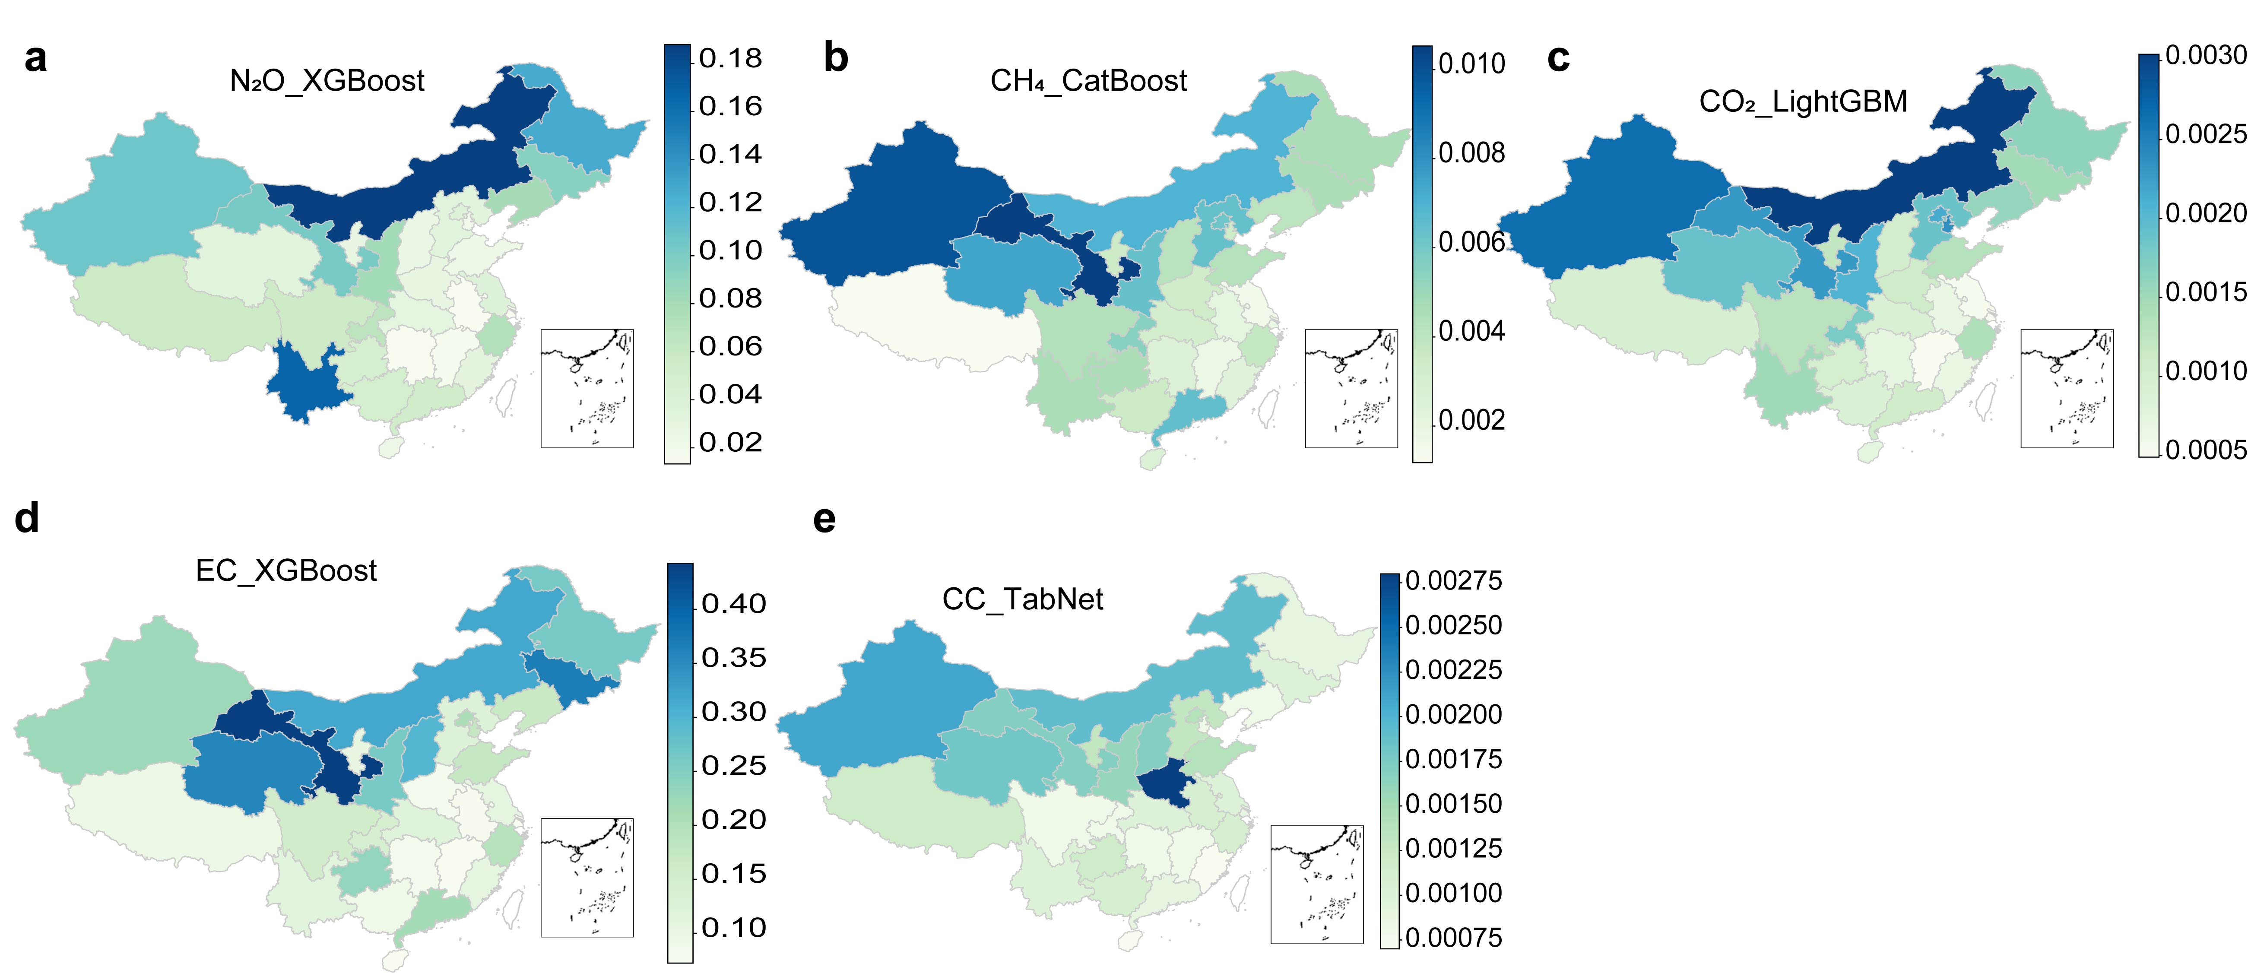

Figure S1. The testing RMSE values of the best-performing ML models for each province, mapped for all EF-derived GHG emissions.

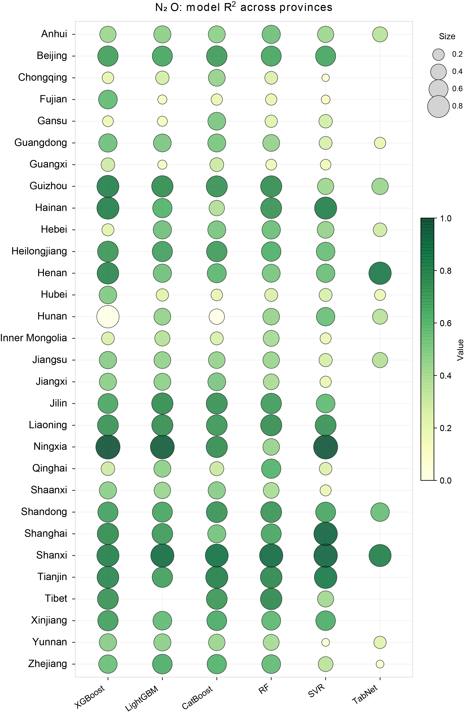

Figure S2. Model performances (R²) in predicting EF-derived N₂O emissions on testing datasets for each province.

Figure S3. Model performances (R²) in predicting EF-derived CH₄ emissions on testing datasets for each province.

Figure S4. Model performances (R²) in predicting EF-derived fossil CO₂ emissions on testing datasets for each province.

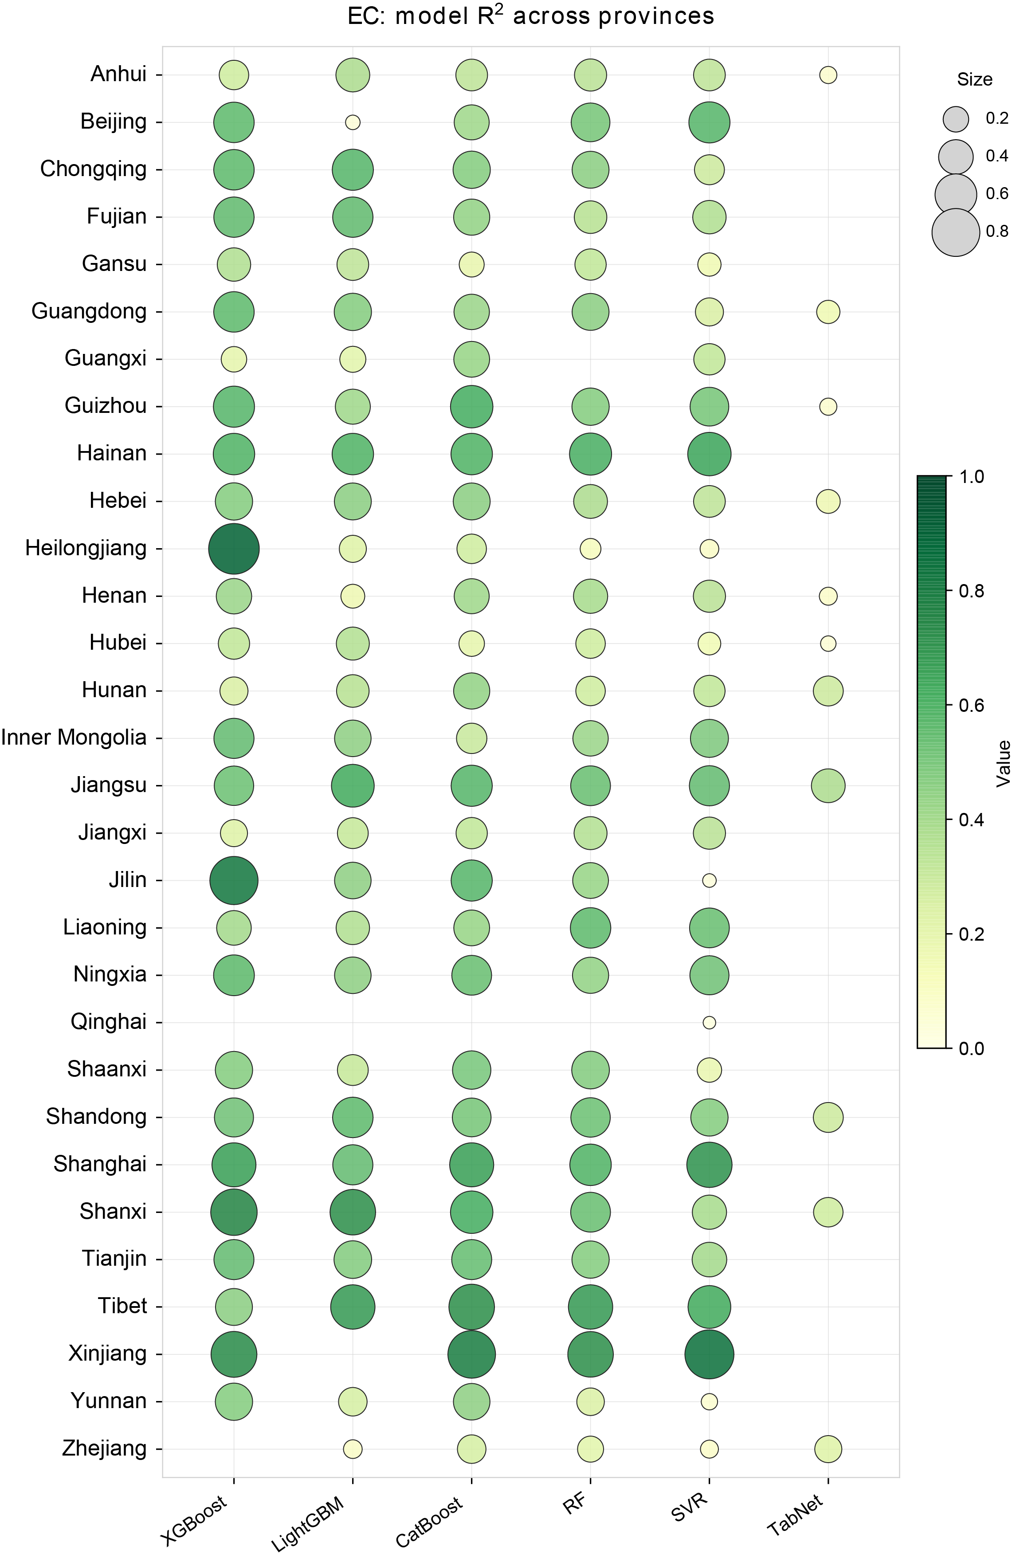

Figure S5. Model performances (R²) in predicting EF-derived EC emissions on testing datasets for each province.

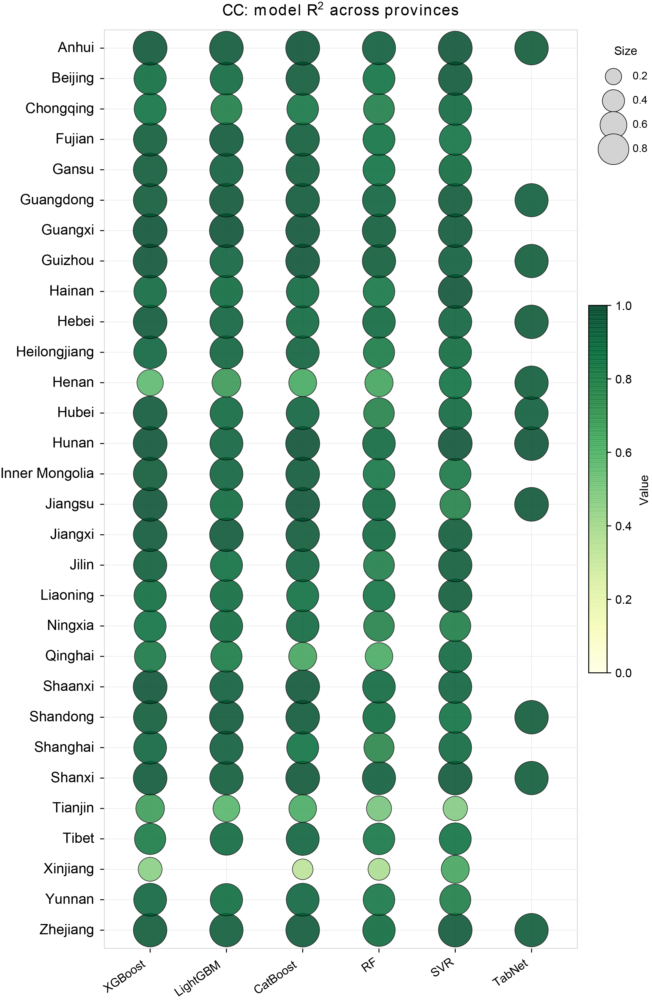

Figure S6. Model performances (R²) in predicting EF-derived CC emissions on testing datasets for each province.

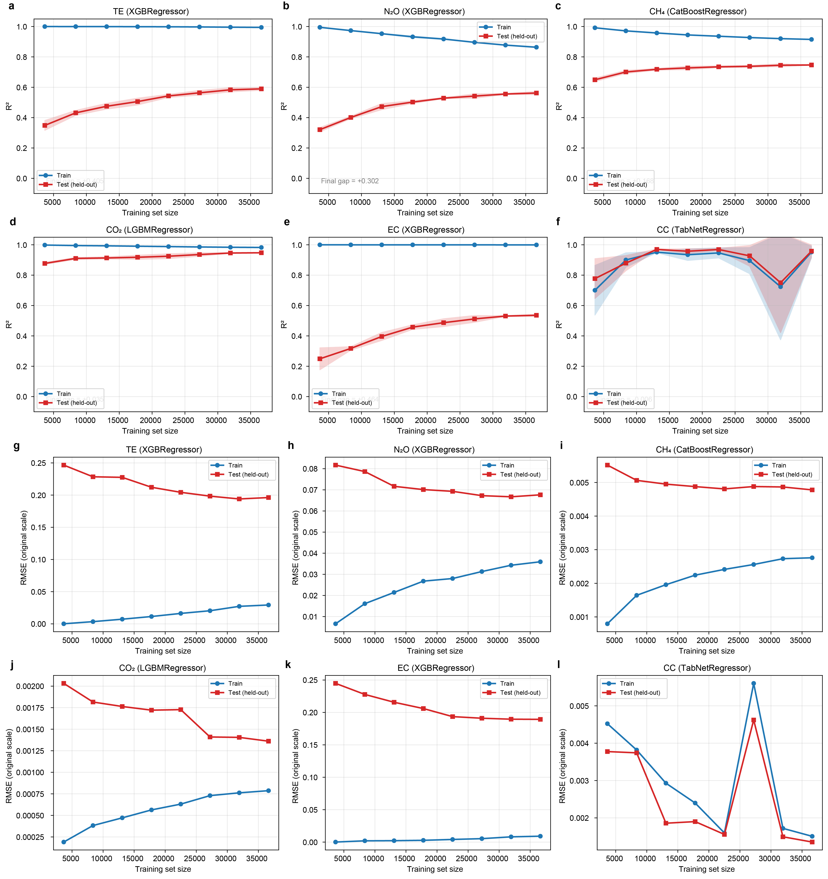

Figure S7. Learning curves of NAT_total_model and NAT_type_model predicting EF-derived total emissions (TE) and specific GHG intensity evaluated by RMSE and R².

Figure S8. Learning curves of PROV_type_model predicting provincial-specific EF-derived GHG intensity evaluated by RMSE: a) Beijing, b) Anhui, c) Chongqing, d) Fujian, e) Gansu, f) Guangdong, g) Guangxi, and h) Guizhou.

Figure S9. Learning curves of PROV_type_model predicting provincial-specific EF-derived GHG intensity evaluated by RMSE: a) Hainan, b) Hebei, c) Heilongjiang, d) Henan, e) Hubei, f) Hunan, g) Inner Mongolia, and h) Jiangsu.

Figure S10. Learning curves of PROV_type_model predicting provincial-specific EF-derived GHG intensity evaluated by RMSE: a) Jiangxi, b) Jilin, c) Liaoning, d) Ningxia, e) Qinghai, f) Shaanxi, g) Shandong, and h) Shanghai.

Figure S11. Learning curves of PROV_type_model predicting provincial-specific EF-derived GHG intensity evaluated by RMSE: a) Shanxi, b) Sichuan, c) Tianjin, d) Tibet, e) Xinjiang, f) Yunnan, and g) Zhejiang.

Text S1. Details of EF-based GHG emissions accounting.
(1) Direct Carbon Emissions
Activity Data: Since fugitive GHG emissions are primarily generated from the decomposition of organic and nitrogen pollutants, the removed COD was used as the activity data to estimate fugitive CH₄ and CO₂ emissions. Similarly, N₂O emissions were estimated using removed TN as the activity data. Additionally, fossil-based CO₂ emissions were considered, assuming that approximately 10% of the organic matter in municipal wastewater is of fossil origin (Du et al., 2023).
Emission Factors: The emission factor data were sourced from (Wang et al., 2022), where the emission factors were compiled from multiple authoritative studies (Table S41). These factors align with the GHG emission characteristics of different biological treatment technologies in China, providing a more comprehensive dataset compared to the values provided by the IPCC.

Table S41. The emission factors of direct GHG emissions in WWTPs (Wang et al., 2022).
 | Biological treatment technology | CH₄ | N₂O | CO₂
 | Biological treatment technology | g CH₄/kg COD _{rem} | g N₂O/kg TN _{inf} | g CO₂/kg COD _{rem}
1 | A²O | 2.66 | 6.19 | 375.53
2 | OD | 4.27 | 2.18 | 510.65
3 | SBR | 1.76 | 43.60 | 531.80
4 | CAS | 0.70 | 1.20 | 560.00
5 | Others | 3.1 | 14.5 | 466.18

(2) Indirect Carbon Emissions
Electricity Consumption: The activity data for electricity consumption were directly obtained from on-site plant data. The emission factors for electricity consumption are listed in Table S42-43.

Table S42. Distribution table of regions in China.
Grid Region | Provinces
North | Beijing, Tianjin, Hebei, Shanxi, Shandong, Inner Mongolia
Northeast | Liaoning, Jilin, Heilongjiang
East | Jiangsu, Zhejiang, Anhui, Fujian, Shanghai
Central | Henan, Hubei, Hunan, Jiangxi, Sichuan, Chongqing
Northwest | Shaanxi, Gansu, Qinghai, Ningxia, Xinjiang, Tibet
Southern | Guangdong, Guangxi, Yunnan, Guizhou, Hainan

Table S43. Annual variation of regional power grid EFs in China (kg CO₂e/ kWh).
Year | 2009 | 2010 | 2011 | 2012 | 2013 | 2014 | 2015 | 2016 | 2017 | 2018 | 2019
North | 1.0069 | 0.9914 | 0.9803 | 1.0021 | 1.0302 | 1.058 | 1.0416 | 1 | 0.968 | 0.946 | 0.942
Northeast | 1.1293 | 1.1109 | 1.0852 | 1.0935 | 1.112 | 1.1281 | 1.1291 | 1.1171 | 1.1082 | 1.093 | 1.083
East | 0.8825 | 0.8592 | 0.8367 | 0.8244 | 0.81 | 0.8095 | 0.8112 | 0.8086 | 0.8046 | 0.794 | 0.792
Central | 1.1255 | 1.0871 | 1.0297 | 0.9944 | 0.9779 | 0.9724 | 0.9515 | 0.9229 | 0.9014 | 0.877 | 0.859
Northwest | 1.0246 | 0.9947 | 1.0001 | 0.9913 | 0.972 | 0.9578 | 0.9457 | 0.9316 | 0.9155 | 0.898 | 0.892
South | 0.9987 | 0.9762 | 0.9489 | 0.9344 | 0.9223 | 0.9183 | 0.8959 | 0.8676 | 0.8367 | 0.809 | 0.804
Data are collected from National Development and Reform Commission of Climate Change (Jin et al., 2014).

Chemical Consumption: The activity data for chemical consumption were calculated using the following methods:
For the additional organic carbon (expressed in COD equivalent, Chem_{N}) used to enhance TN removal in wastewater treatment, the calculation formula is as follows:
Chem_{N} = ŋ (∆TN -0.175 ∆BOD)
where ΔTN and ΔBOD represent the removed TN and BOD in the wastewater treatment plant, respectively. Assuming that 1 kg of BOD removal can facilitate the denitrification of 0.175 kg of TN, and that the BOD in the wastewater is insufficient, the remaining TN removal must rely on additional organic carbon (with a COD equivalent of η).
For TP removal, which mainly exists in wastewater in the form of phosphates, biological phosphorus removal and chemical precipitation using iron or aluminum salts are commonly applied. A portion of TP can be removed biologically, a process that consumes organic carbon (removing 1 g of TP requires approximately 200 g of COD). The calculation formula is:
Chem_{P} = 𝛼 (∆TP – ∆COD/200).
The two most commonly used chemicals were selected:
- Acetic Acid, a widely used carbon source for denitrification, accounts for the highest proportion (46%) of usage in Chinese wastewater treatment plants, with a COD equivalent of 0.78 kg COD/kg TN removed.
- PAC (Polyaluminum Chloride), a common chemical used for phosphorus removal, accounts for 78.82% of usage in Chinese wastewater treatment plants, with a mass fraction of 15.35% Fe/Al.
Their emission factors are 1.184 kg CO₂e/kg and 1.828 kg CO₂e/kg, respectively. The correction table for the emission factors of chemical consumption is listed in Table S44, which fully considers advancements in water treatment technology (Du et al., 2023).

Table S44. The Corrected coefficient of the emission factors of chemical consumption during 2009-2019 (Du et al., 2023).
Year | 2009 | 2010 | 2011 | 2012 | 2013 | 2014 | 2015 | 2016 | 2017 | 2018 | 2019
Corrected coefficient | 1.223 | 1.179 | 1.138 | 1.106 | 1.149 | 1.157 | 1.188 | 1.171 | 1.117 | 1.045 | 1

According to the global warming potential (GWP) values of 25 CO₂-e for CH₄ and 298 CO₂-e for N₂O over a 100-year period, the fugitive emission intensity for a specific type of GHG was obtained by multiplying the case-specific emission factor by the corresponding plant-resolved activity data (Song et al., 2024b). Finally, the estimated GHG intensities for all types of GHGs were summed to derive the overall wastewater GHG intensity.
The accounting results were shown in Figure S12-17.
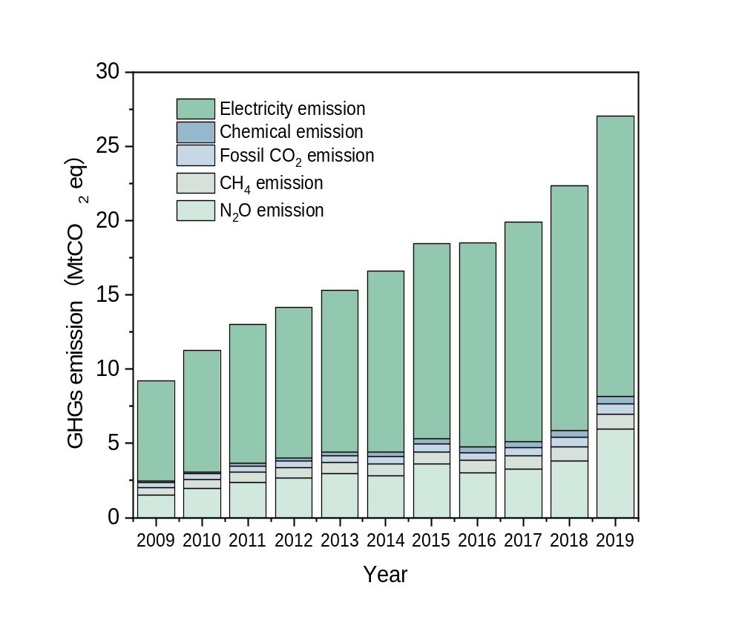

Figure S12. The overall trend of EF-derived GHG emissions in China’s WWTPs during 2009-2019, including direct (scope 1) and indirect (scope 2 and 3) emissions.

Figure S13. Results of GHG emissions accounting using EF methods and ML model’s performance of the best-performing algorithms (NAT_type_model). The average GHG intensity of: (a) direct emissions from 2009-2019, (b) direct emissions in each province; (c) indirect emissions from 2009-2019, (d) indirect emissions in each province; (e-f) The scatter plots of true values and predictive values by the best-performing ML models predicting EF-derived GHG emissions; N₂O versus XGBoost, CH₄ versus CatBoost, CO₂ versus LightGBM, EC versus XGBoost, and CC versus TabNet.

Figure S14. Cumulative EF-derived GHG estimation using the WaterMAP (NAT_total_model) for 2009-2024.

Figure S15. Cumulative EF-derived GHG estimation using the WaterMAP (NAT_type_model) for 2009-2024.

Figure S16. Cumulative EF-derived GHG estimation using the WaterMAP (NAT_type_model) across provinces for 2009-2019.

Figure S17. Cumulative EF-derived GHG estimation using the WaterMAP (NAT_type_model) across provinces for 2020-2024.

Text S2. Using NAT_type_model to decipher key predictors influencing each EF-derived GHG at the firm-level.
For EF-derived direct emissions (Figure S18, S20-22), N₂O emissions were predominantly associated with influent total nitrogen (TN_{inf}), which accounted for 25.9% of its importance. Additionally, spatial and temporal factors collectively contributed 26.6% to the variability in N₂O emissions. For CH₄ and CO₂ emissions, the top five predictors exhibited significant overlap, with notable differences observed only for temperature (8.97% for CH₄) and influent TP (2.73% for CO₂). Both emissions were strongly influenced by COD removal efficiency (6.65% for CO₂ and 7.16% for CH₄), influent chemical oxygen demand (COD_{inf}) (52.4% for CO₂ and 33.2% for CH₄), and spatial factors (10.81% for CO₂ and 15.53% for CH₄). Regarding EC emissions, the most influential predictor was treatment capacity (32.95%), year (15.10%), longitude (7.36%), sludge yield (6.39%), and COD_{inf} (3.44%). For CC emissions, nitrogen-related parameters, including TN_{inf}, effluent TN (TN_{eff}), and TN removal efficiency (TN_{rem}), dominated the rankings (59.51%), with influent biochemical oxygen demand (BOD_{inf}) ranking second (27.23%). However, understanding key predictors alone was insufficient to propose effective GHG emissions mitigation strategies. Thus, PDPs were utilized to further analyze the critical factors influencing GHG emissions and to identify specific ranges of influence (Jiang et al., 2025).

Figure S18. Importance of the top 15 input features for combined models and the importance of variables in 5 groups of the influent parameters, effluent parameters, spatiotemporal factors, meteorological factors, and other factors: the best-performing models towards: (a) N₂O emissions; (b) CH₄ emissions; (c) CO₂ emissions; (d) EC emissions; (e) CC emissions.
For EF-derived N₂O emissions (Figure S19a-d), the top five environmental factors were predominantly spatiotemporal, accounting for four out of five factors. Among the water quality parameters, TN_{inf} was identified as the most significant, exhibiting an almost linear increase-lower TN_{inf} levels were associated with reduced emissions(Song et al., 2024a). Consequently, minimizing peak TN_{inf} loads by equalizing wastewater flows might serve as an effective mitigation strategy to reduce N₂O emissions from WWTPs. Spatiotemporal factors demonstrated a greater overall influence than other water quality parameters. Spatially, the highest emissions were observed in Yunnan, also aligning with accounting findings. However, discrepancies were noted for regions with lower N₂O emissions. Jiangxi recorded the lowest emissions in carbon accounting, but ranked mid-level (#16) in the PDP analysis, while Anhui ranked last as the second-lowest in accounting. This divergence highlights the limited inter-provincial resolution of the NAT_type_model, further justifying the development of the PROV_type_model for province-specific analysis. Geographically, regions within mid-latitudes (26.89°N–31.87°N) and mid-longitudes (105.38°E–113.64°E) exhibited relatively low N₂O emissions.
Regarding EF-derived CH₄ emissions (Figure S19e-h), although the activity data were primarily based on COD_{rem} for accounting, COD_{inf} remained a more significant determinant. Lower COD_{inf} levels were preferable for mitigating CH₄ emissions, particularly when COD_{rem} efficiency exceeded 88%. Higher COD_{inf} signified a greater availability of organic substrates for methanogenic archaea, thereby resulting in increased CH₄ production (Kieft et al., 2023). Temperature also played a crucial role in regulating methanogenic activity. At lower air temperatures (9.7–13.0°C), methanogenic activity was suppressed, leading to reduced CH₄ emissions. In contrast, at moderate to high temperatures, methanogenic activity increased, contributing to elevated CH₄ emissions. Spatially, unlike N₂O emissions, CH₄ emissions were higher in mid-latitude and mid-longitude regions (105.38–113.64°E), including regions like Chongqing. Chongqing, which is characterized by relatively high temperatures, showed that elevated temperatures were associated with higher CH₄ emissions.

Figure S19. Correlation Between the Key Features and EF-derived GHG emissions. Partial dependence plots of: (a-c) N₂O emissions with TN_{inf}, province, and year; (f-h) CH₄ emissions with temperature, province, and longitude; (j-l) CO₂ emissions with longitude, province, TP_{inf}; (m-o) EC emissions with treated volume, latitude, and sludge yield; (q-t) CC emissions with TN_{inf}, TN_{eff}, BOD_{inf}, and year. Two-dimensional PDPs showing: (d)longitude and latitude with N₂O emissions, (e) COD_{inf} and COD_{rem} with CH₄ emissions; (i) COD_{inf} and COD_{rem} with CO₂ emissions; (p) COD_{inf} and year with EC emissions.
For fossil EF-derived CO₂ emissions (Figure S19i-l), COD_{inf} exhibited a similar pattern with CH₄ emissions. When COD_{rem} exceeded 88%, lower COD_{inf} was preferable for mitigating CO₂ emissions. Although the top influencing factors for CO₂ and CH₄ were similar, their rankings and influence patterns differed slightly. For instance, COD_{rem} had a stronger effect on CO₂ emissions compared to CH₄. The role of temperature was less significant for CO₂ than for CH₄, with optimal ranges for CO₂ emissions differing (e.g., 16–17°C and 21–22°C). The importance of influent total phosphorous (TP_{inf}) was notably enhanced for fossil CO₂ emissions, with the lowest emissions observed at TP concentrations between 1.8 and 3.8 mg/L. Higher TP_{inf} (>3.8 mg/L) increased sludge production, elevating the energy demand for both biological and chemical phosphorus removal. Conversely, at low TP concentrations (<1.8 mg/L), microbial metabolism, particularly the activity of polyphosphate-accumulating organisms (PAOs), might be limited(Guo et al., 2019; Guo et al., 2016). Spatially, fossil CO₂ emissions were lower in the mid-longitude range (105.38–113.64°E). Provinces such as Heilongjiang, despite experiencing lower average temperatures, exhibited higher CO₂ emissions, suggesting the influence of other regional factors such as wastewater characteristics, treatment technologies, and operational practices.
For EF-derived EC emissions (Figure S19m–p, S23), treatment capacity emerged as the most influential factor. Larger WWTP capacities corresponded to lower EC emissions, especially for capacities exceeding 5.98×10⁴m³. It indicated that larger-scale WWTPs utilized energy and equipment more efficiently, possessed a greater ability to buffer load fluctuations, and enhanced resource recovery measures that contributed to emission reductions(Huang et al., 2023). From a temporal perspective, EC emissions decreased during 2013-2017 but subsequently experienced an upward trend. Geographical differences significantly influenced EC emissions, with the highest values observed in Beijing and the lowest in Anhui. Increased sludge production was strongly correlated with higher emissions, with a critical threshold at 8304 tons. Below this threshold, emissions grew more rapidly compared to levels above it. Greater sludge yield implied increased sludge treatment requirements, such as dewatering, anaerobic digestion, and final disposal, which contributed to higher energy demand (Zhou et al., 2022; Zhou et al., 2023). Lower COD_{inf} values (<214.27 mg/L) were generally associated with lower EC emissions. This trend might result from reduced organic loading, which decreased the energy-intensive aeration required for biological treatment.
For EF-derived CC emissions (Figure S19q–t, S24), minimizing TN_{inf} (<117 mg/L) proved beneficial for reducing CC emissions. Conversely, higher TN_{eff} was associated with lower CC emissions, highlighting the close relationship between CC and TN_{rem}. Influent conditions can be optimized in equalization tanks, whereas effluent concentrations depended on factors such as carbon source addition. Insufficient TN_{rem}, often due to inadequate carbon dosing, may naturally reduce chemical usage, albeit at the cost of effluent quality. BOD_{inf} played a crucial role in both carbon source supplementation and phosphorus removal. Higher BOD_{inf} (>200 mg/L) generally results in lower carbon emissions, as elevated BOD facilitates N and P removal through activated sludge processes without the need for additional chemical dosing. This reduced dependency on external carbon sources and chemical agents, improving overall efficiency. Additionally, with the change in the CC-emission factor, its response magnitude was gradually declining. This reflected decreasing activity data and advancements in wastewater treatment technologies, which have improved efficiency and reduced the reliance on chemical inputs.

Figure S20. SHAP importance of the best-performing EF-derived N₂O emissions predictive model.

Figure S21. SHAP importance of the best-performing EF-derived CH₄ emissions predictive model.

Figure S22. SHAP importance of the best-performing EF-derived CO₂ emissions predictive model.

Figure S23. SHAP importance of the best-performing EF-derived EC emissions predictive model.

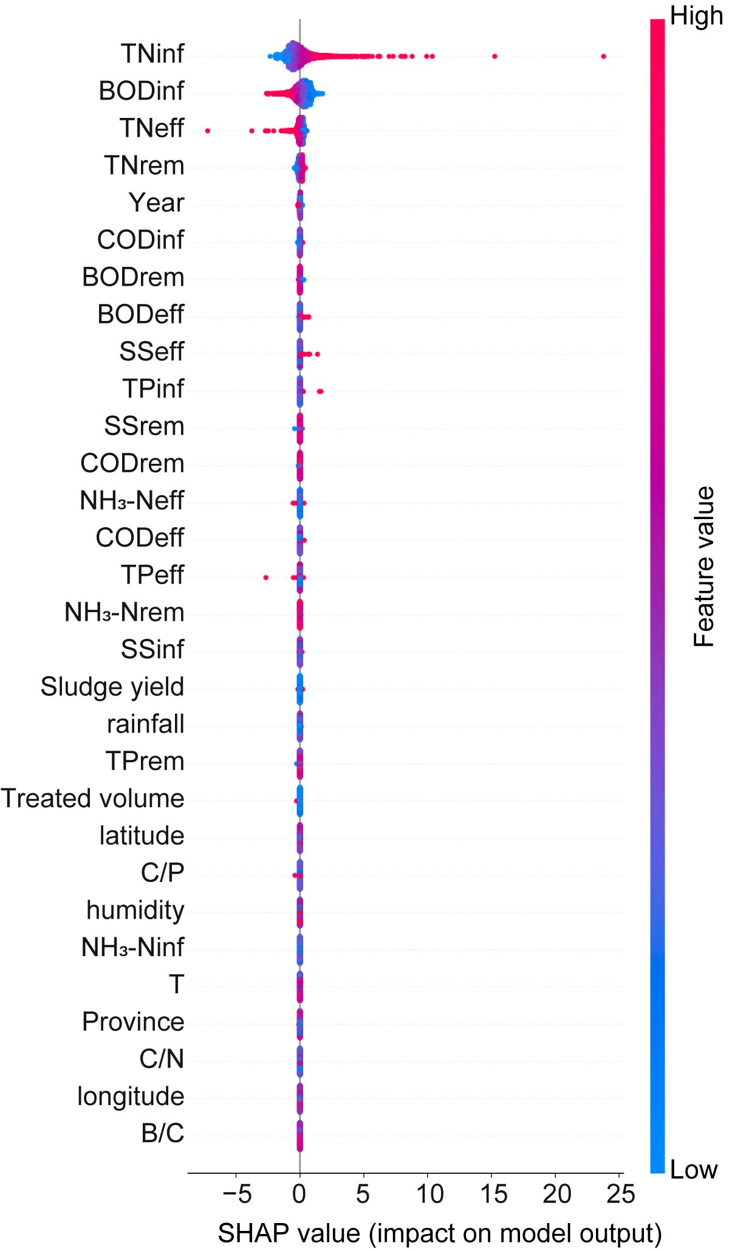

Figure S24. SHAP importance of the best-performing EF-derived CC emissions predictive model.

Text S3. Details of Variance inflation factor (VIF) and partial correlation analysis for latitude.
Latitude may act as a proxy for correlated environmental variables (e.g., climate conditions), potentially affecting the interpretability of model explanations. To evaluate whether the contribution of latitude reflected redundant information from other predictors, we assessed multicollinearity among latitude and variables that were both environmentally relevant and highly ranked in the model, including climatic variables (rainfall, humidity, and temperature), longitude, and operational characteristics.
The variance inflation factor (VIF) analysis showed that latitude had a VIF value of 3.97, which was below the commonly accepted threshold of 5, indicating no severe multicollinearity and suggesting that latitude retained substantial independent information rather than functioning as a redundant proxy variable (Figure S25).
To further distinguish direct and indirect associations, partial correlation analysis was performed. The raw correlation coefficient (r_{raw}) quantified the overall association between latitude and predicted total GHG emissions (TE_{pred}), whereas the partial correlation coefficient (r_{partial}) quantified the remaining association after controlling for climate variables, influent characteristics, and treatment scale. The correlation between latitude and TE_{pred} decreased from +0.216 to +0.041 after adjustment, indicating that part of the observed effect of latitude was mediated through climate and operational pathways, while an independent association remained. Together, the VIF and partial correlation results suggest that latitude influenced GHG emissions through both direct and indirect pathways, supporting its inclusion as an explanatory variable.
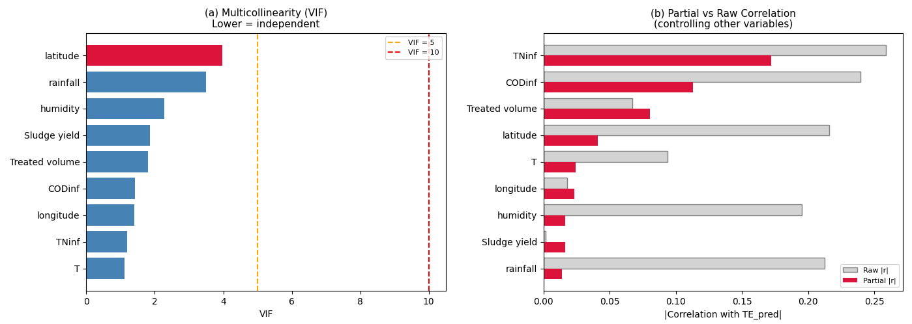

Figure S25. Multicollinearity (VIF) and partial correlation analysis of latitude with predicted total EF-derived volumetric GHG intensity (TE_pred).

Text S4. Details of SEM.
The specific SEM modeling procedure was as follows: Key predictors identified from the NAT_total_model, together with EF-derived volumetric GHG intensity, were selected to construct the SEM. Latitude was assumed to influence emission intensity both directly and indirectly through its effects on influent water quality. In addition, the covariance relationship between COD_{inf} and TN_{inf} was incorporated to improve model robustness. All continuous variables were standardized prior to modeling to eliminate scale effects and facilitate comparison of standardized path coefficients. Model parameters were estimated using the maximum likelihood method, and bootstrap resamples were performed to obtain robust standard errors and significance tests. Model fit was evaluated using the Comparative Fit Index (CFI), Goodness-of-Fit Index (GFI), and Root Mean Square Error of Approximation (RMSEA). Standardized path coefficients were further used to quantify the contributions of different driving pathways to the spatial heterogeneity of emissions. The specific structural paths were defined as follows (left: dependent variable; right: independent variable):
- GHG intensity ~ Treated volume + Sludge yield + Latitude + COD_{inf} + TN_{inf}
- Treated volume ~ Latitude
- Sludge yield ~ COD_{inf} + TN_{inf} + Treated volume
- COD_{inf} ~ Latitude
- TN_{inf} ~ Latitude
- COD_{inf} ~ TN_{inf}

Text S5. EF Uncertainty Analysis for the National-Scale Model
(1) EF-derived N₂O, CH₄, CO₂
(Wang et al., 2022) utilized EFs from Chinese municipal WWTP measurement and simulation studies tailored to domestic conditions. The mean values from the literature were adopted as default EFs, while minimum and maximum values were retained for uncertainty calculations. The resulting EFs and uncertainty ranges are summarized in Table S45, showing that the uncertainty intervals are very large.

Table S45. EF uncertainties of Scope 1 emissions under varying process.
 | CH₄ |  | N₂O |  | CO₂
CAS | -43% | 57% | -83% | 158% | -4% | 0%
A2O | -93% | 324% | -97% | 456% | -57% | 54%
OD | -33% | 22% | -50% | 228% | -71% | 49%
SBR | -86% | 28% | -40% | 50% | -82% | 82%
(2) EF-derived Energy Consumption
EFs for EC were sourced from IPCC. The EF for electricity use in different wastewater utilities was calculated based on regional Chinese power grid EFs from 2009 to 2019. Grid EFs are relatively mature with low uncertainty. Additional uncertainty data (±10%) were obtained from the LCA Ecoinvent Database Version 3, consistent with the approach of (Cullen et al., 2024).
(3) EF-derived Chemical Consumption
EFs for CC were also taken from (Du et al., 2023). This study selected reliable EFs and avoided fixed factors, instead reconstructing annual chemical emission factors for 2009–2018 based on 2019 baseline values plus adjustment coefficients. These coefficients account for decarbonization progress, technological advancement, energy mix, and production efficiency, providing a more realistic long-term inventory. Uncertainty is primarily derived from IPCC 2019 guidelines.
After defining representative EFs and their uncertainty ranges, the Monte Carlo method was used to quantify model uncertainty arising from EF-based training data. The procedure was as follows: a. Monte Carlo sample generation and label recalculation: Training and testing data were perturbed according to EF uncertainty, and GHG labels were recalculated based on the perturbed factors. Repeating this process over many iterations (1,000) generated a large sample of possible emission outcomes to quantify uncertainty (Table S46). b. Model prediction: For each perturbed dataset, the corresponding machine learning models (e.g., XGBoost, CatBoost, LightGBM, and TabNet) were applied to predict emissions. Model outputs included predictions for training and testing sets, and performance metrics (R², RMSE) were calculated.

Figure S26. Coefficient of variation for NAT_total_model and NAT_type_model when predicting EF-derived total emissions (TE) and specific-GHG.

Figure S27. R² plots during 1000 Monte Carlo iterations for NAT_total_model.

Figure S28. R² plots during 1000 Monte Carlo iterations for NAT_type_model.

Table S46. Identifying provinces with high GHG intensity and CV through EF-derived GHG estimation and uncertainty assessment using NAT_total_model and NAT_type_model during 2009-2019.
Province | Type | Intensity(kgCO₂-e/m³) | CV (%)
Shandong | Total | 0.4715 | 17.30
Liaoning | Total | 0.4900 | 14.23
Beijing | Total | 0.7091 | 15.51
Shanxi | Total | 0.6507 | 16.87
Inner Mongolia | Total | 0.7190 | 14.57
Tianjin | Total | 0.4960 | 15.93
Xinjiang | Total | 0.4544 | 17.32
Ningxia | Total | 0.4994 | 20.16
Zhejiang | N₂O | 0.0693 | 62.43
Jiangsu | N₂O | 0.0570 | 56.81
Heilongjiang | N₂O | 0.1483 | 153.06
Shanghai | N₂O | 0.0669 | 59.39
Beijing | N₂O | 0.0778 | 83.04
Inner Mongolia | N₂O | 0.1104 | 55.81
Shanxi | N₂O | 0.0798 | 60.65
Gansu | N₂O | 0.0645 | 60.11
Ningxia | N₂O | 0.0699 | 223.13
Shandong | CH₄ | 0.0179 | 52.04
Jiangsu | CH₄ | 0.0156 | 52.48
Shanghai | CH₄ | 0.0182 | 53.43
Beijing | CH₄ | 0.0204 | 48.33
Shanxi | CH₄ | 0.0197 | 52.81
Tianjin | CH₄ | 0.0159 | 52.08
Inner Mongolia | CH₄ | 0.0192 | 50.71
Gansu | CH₄ | 0.0165 | 43.94
Ningxia | CH₄ | 0.0206 | 52.15
Shandong | CO₂ | 0.0113 | 28.39
Shanghai | CO₂ | 0.0106 | 30.66
Chongqing | CO₂ | 0.0125 | 31.63
Shanxi | CO₂ | 0.0113 | 30.59
Ningxia | CO₂ | 0.0123 | 31.18
Shandong | EC | 0.3687 | 7.55
Heilongjiang | EC | 0.3779 | 7.08
Guizhou | EC | 0.3693 | 8.78
Ningxia | EC | 0.3813 | 13.03
Qinghai | EC | 0.5484 | 8.78
Hebei | CC | 0.0103 | 56.58
Shaanxi | CC | 0.0123 | 51.71
Inner Mongolia | CC | 0.0131 | 67.96
Heilongjiang | CC | 0.0098 | 53.04
Gansu | CC | 0.0156 | 59.55
Ningxia | CC | 0.0090 | 69.58
Qinghai | CC | 0.0092 | 58.14

Figure S29. Province-level four-quadrant plot of EF-derived total volumetric GHG intensity and the coefficient of variation during 2009–2019.
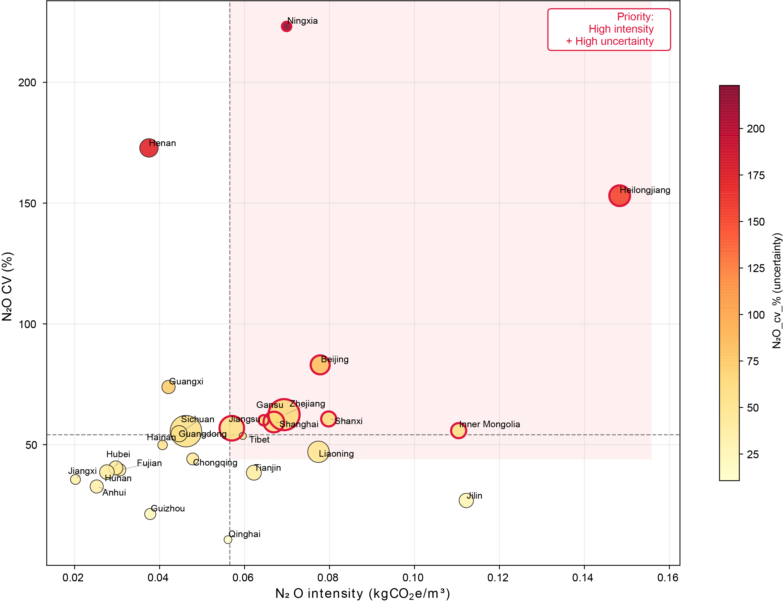

Figure S30. Province-level four-quadrant plot of EF-derived volumetric N₂O intensity and the coefficient of variation during 2009–2019.
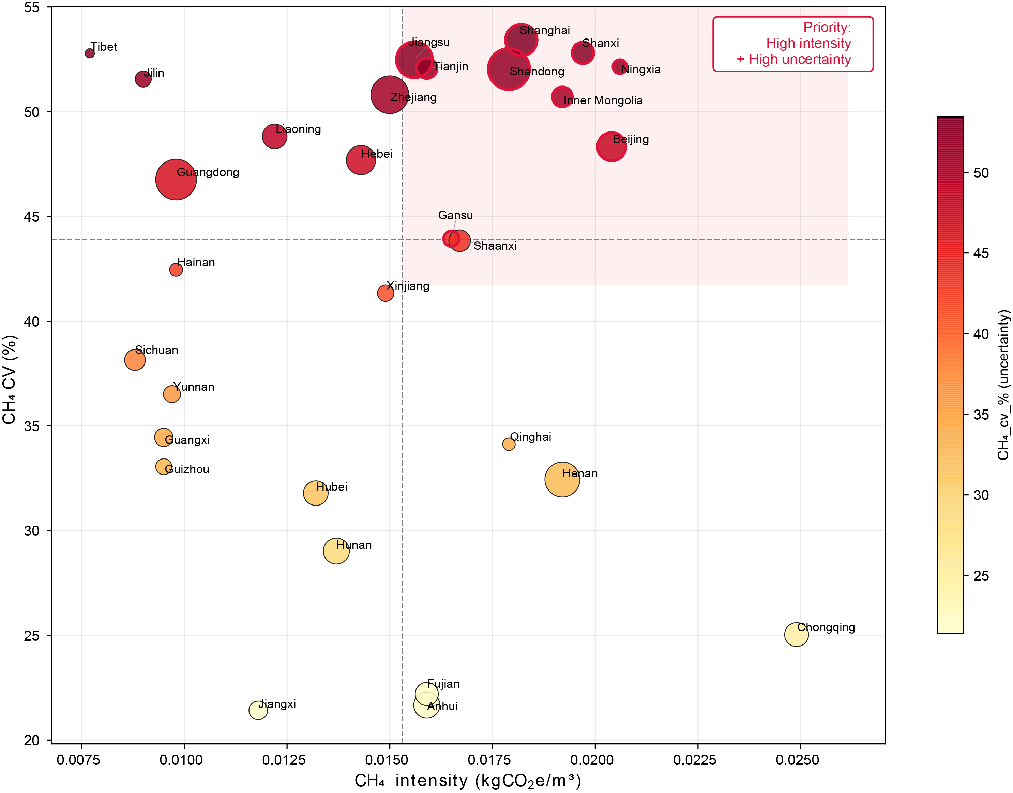

Figure S31. Province-level four-quadrant plot of EF-derived volumetric CH₄ intensity and the coefficient of variation during 2009–2019.

Figure S32. Province-level four-quadrant plot of EF-derived volumetric CO₂ intensity and the coefficient of variation during 2009–2019.
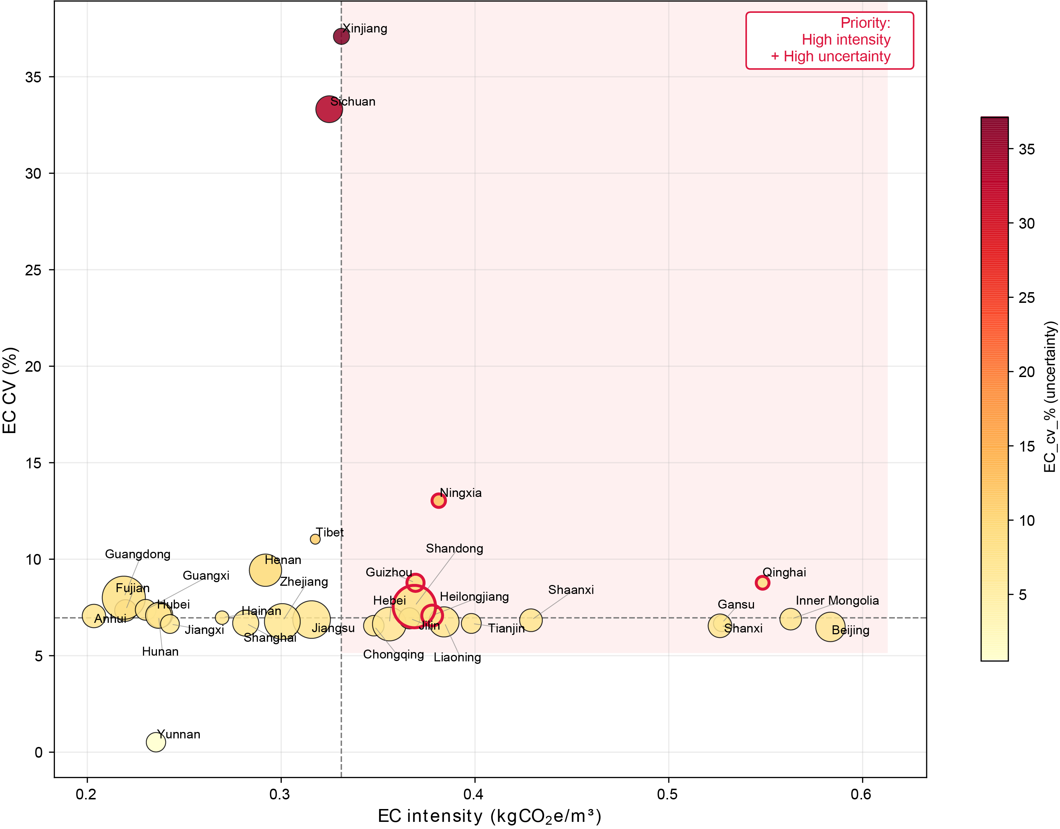

Figure S33. Province-level four-quadrant plot of EF-derived volumetric EC intensity and the coefficient of variation during 2009–2019.

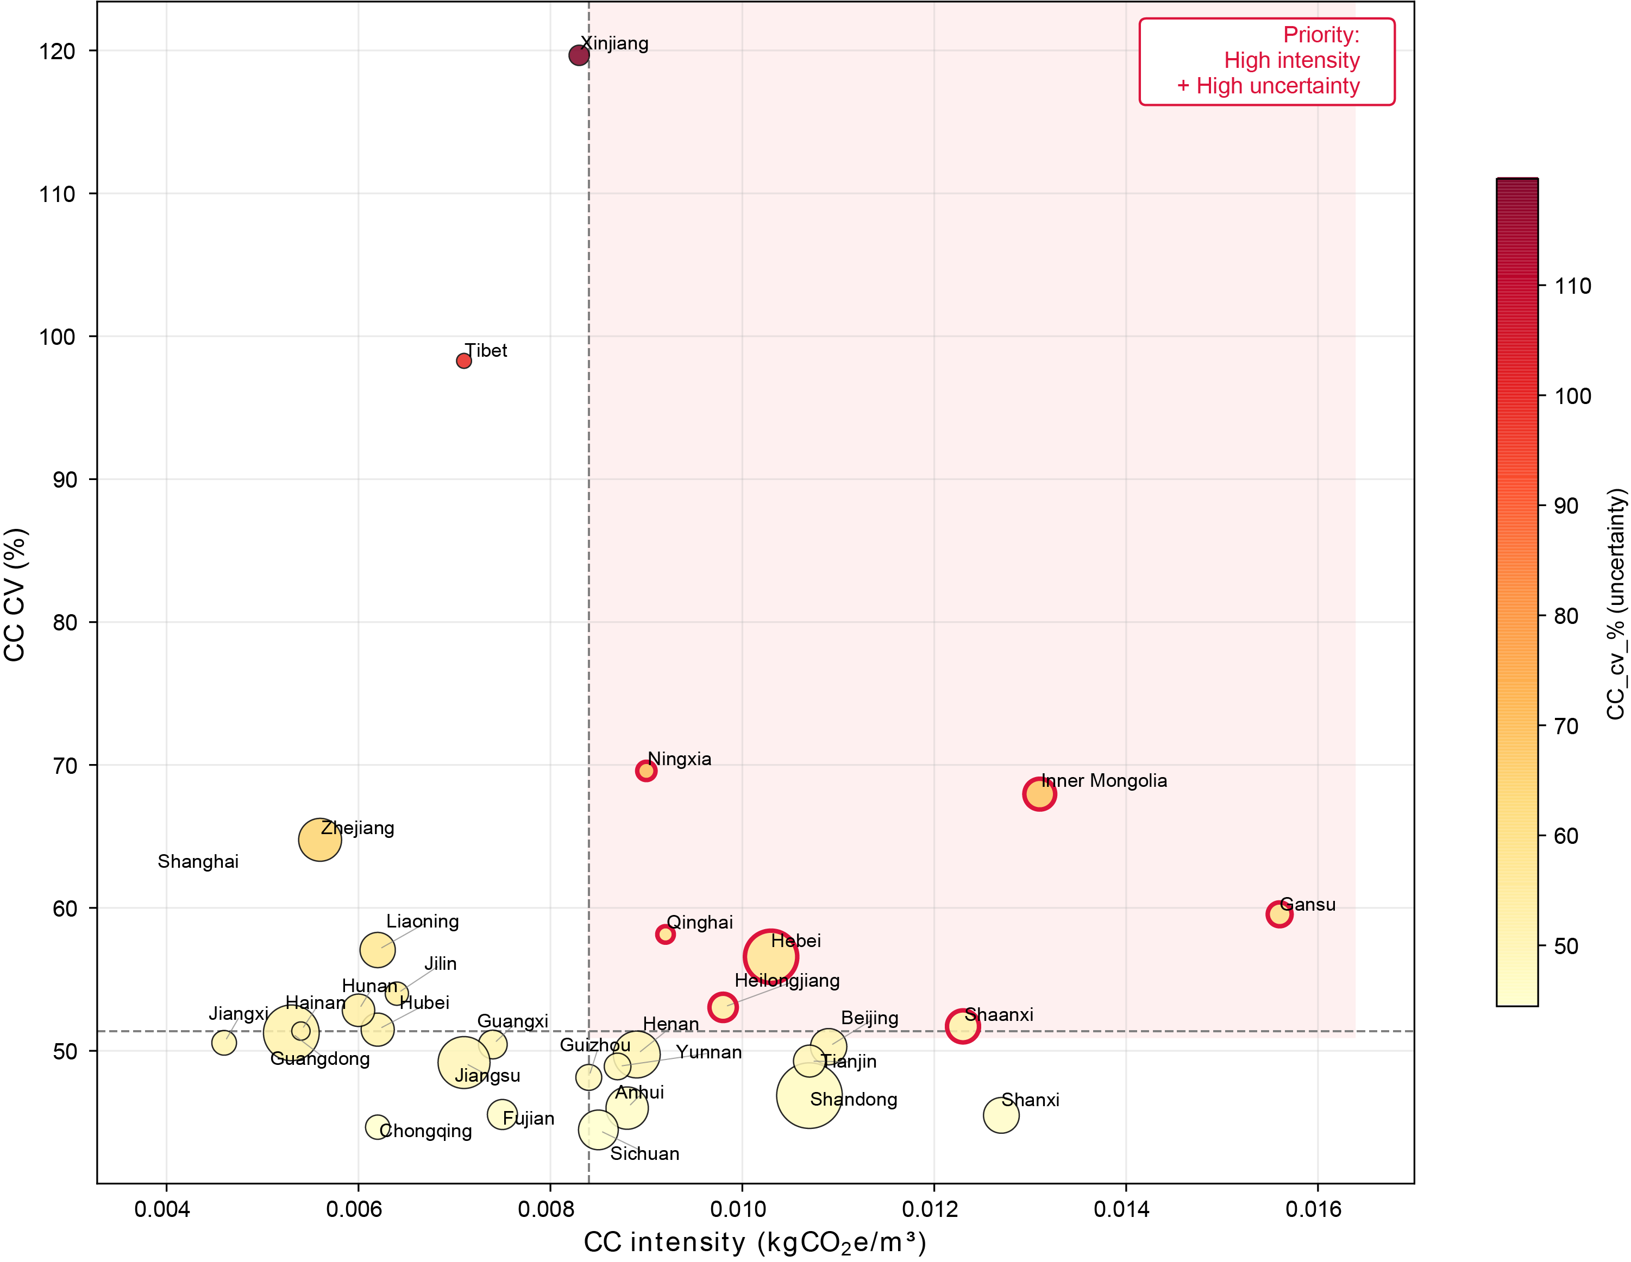

Figure S34. Province-level four-quadrant plot of EF-derived volumetric CC intensity and the coefficient of variation during 2009–2019.
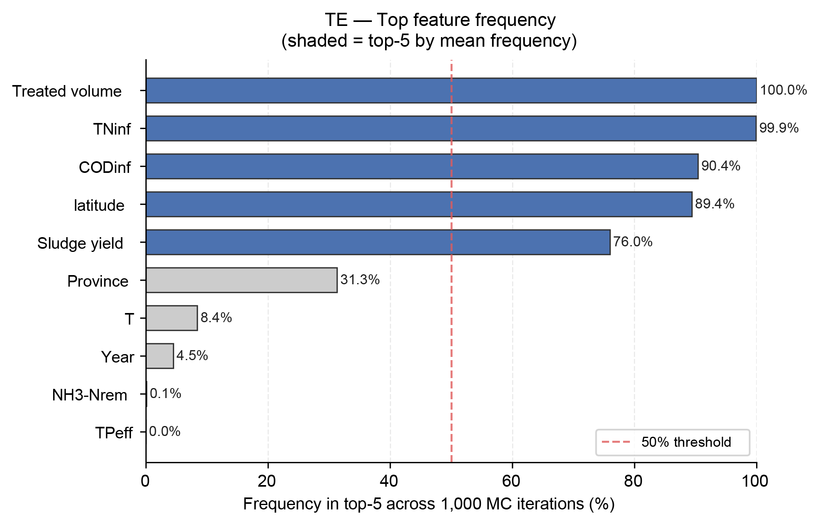

Figure S35. Top feature frequency of NAT_total_model across 1000 MC iterations.

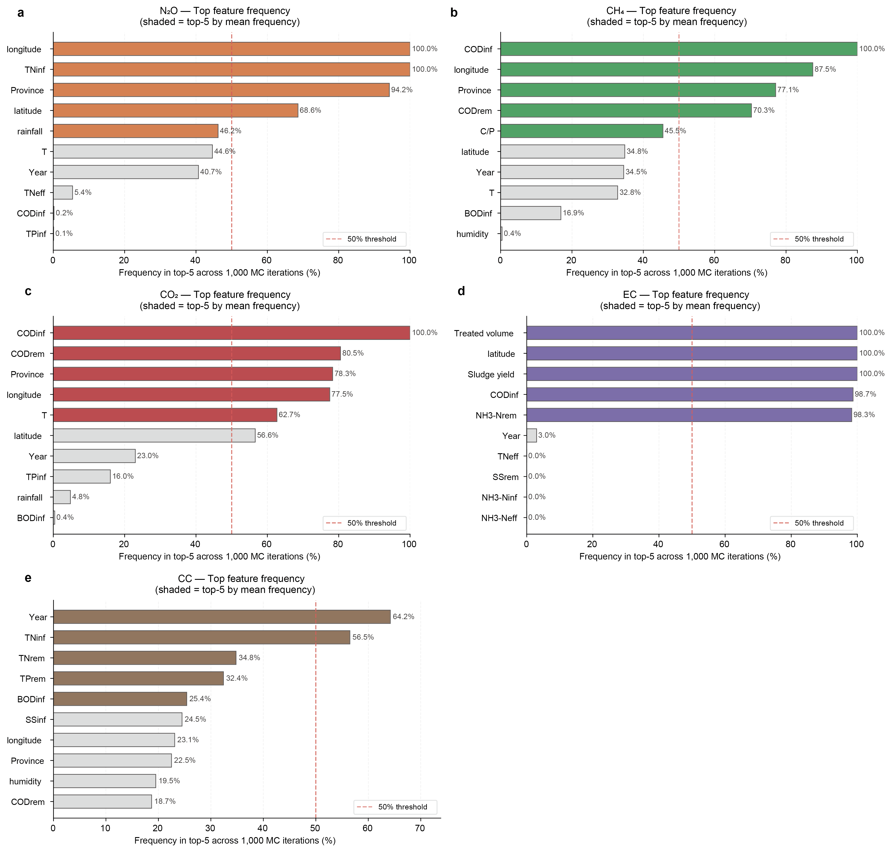

Figure S36. Top feature frequency of NAT_type_model across 1000 MC iterations.

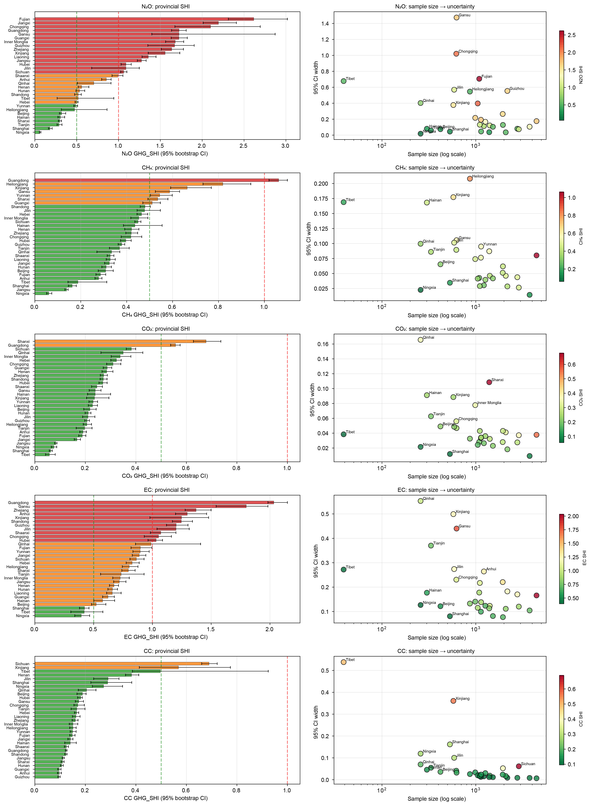

Figure S37. GHG_SHI uncertainty analysis caused by sample sizes.

Text S6. Generalization Analysis
A. Temporal extrapolation robustness (Leave-One-Year-Out, LOYO validation).
Using the best-performing model hyperparameters, we trained the models on data from 2009–2018 and tested them on 2019 data to evaluate temporal extrapolation capability. For NAT_Total_Model, the LOYO validation achieved an R²_{test} of 0.50 (Figure S38), representing only a 17.2% decrease compared with the original test performance (R² = 0.60), indicating that the model successfully captured stable relationships across years. At the NAT_Type_Model level (Figure S38), the temporal extrapolation performance varied across GHG categories: CH₄ decreased from 0.75 to 0.62, CO₂ from 0.95 to 0.90, EC from 0.54 to 0.51, CC from 0.99 to 0.97, but N₂O decreased from 0.58 to 0.15. The near-constant performance of CC, CO₂, and EC suggests strong temporal stability of these emission sources. By contrast, N₂O exhibited substantially weaker temporal generalization, which is consistent with our Monte Carlo EF uncertainty analysis showing that N₂O had the highest label uncertainty (CV ≈ 40%).
B. Independent out-of-sample external validation.
To evaluate performance under unseen conditions, we obtained operational and emission records from 10 WWTPs in Hubei Province in 2024, provided by the Hubei Planning Institute. Operational variables (e.g., influent/effluent quality, flow rate, energy consumption) were collected from provincial planning institute records. Emissions were calculated using the same EF-based accounting framework adopted in the training dataset, ensuring methodological consistency. The treatment process mainly included A²O and OD. This dataset was fully independent from the training data and represented more than five years of temporal extrapolation. The same preprocessing workflow used in WaterMAP was applied, and models (NAT_Total_Model, NAT_Type_Model, and Hubei PROV_Type_Model) were directly deployed without fine-tuning. Overall, the national model achieved a mean absolute percentage error (MAPE) of 12.6% for total emissions (TE) (Figure S39), indicating that WaterMAP retained predictive capability under previously unseen plant conditions. Interestingly, TE exhibited lower prediction error than most individual GHG components (except CO₂ and CH₄), suggesting partial statistical compensation among component-level uncertainties and supporting the use of TE as an integrated accounting indicator.
Comparison between NAT_Type_Model and Hubei PROV_Type_Model (Table S47) revealed differentiated advantages across GHG categories. Provincial models substantially improved prediction for N₂O and EC, likely because these emissions are strongly influenced by regional heterogeneity (e.g., temperature, influent C/N ratio, and process composition). In contrast, CO₂ and CH₄ showed similar performance between national and provincial models (<10% difference), indicating that national models were sufficient for these categories. Notably, the provincial model performed substantially worse for CC (MAPE: 90.3% vs. 46.6%), showing systematic underestimation. Combined with the strong temporal stability of CC observed in LOYO validation (R² = 0.97), this result suggests insufficient representativeness of chemical dosing practices in the provincial training subset (n ≈ 1,500). Therefore, CC was identified as a priority target for future fine-tuning calibration, supporting a potential pretraining–fine-tuning pathway.
C. Cross-provincial extrapolation robustness (Leave-One-Province-Out, LOPO validation).
To evaluate spatial generalizability, we conducted 31-fold leave-one-province-out validation, where models were trained using data from 30 provinces and tested on the remaining province. Results are summarized in Figure S40. The results showed that NAT_Total_Model and NAT_Type_Model could not generalize equally well to all provinces, highlighting the necessity of PROV_Type_Model and transfer learning to capture spatial heterogeneity. Some provinces exhibited clear outliers—for example, negative R² values for TE, N₂O, and EC in Xinjiang and Tibet. These deviations likely reflect region-specific environmental and operational characteristics: Xinjiang is characterized by a temperate continental climate and high-salinity influent with distinct process configurations, whereas Tibet operates under high-altitude and low-temperature conditions that alter biological treatment kinetics.
Overall, these validation results demonstrate not only the predictive robustness of WaterMAP under unseen conditions (external TE MAPE = 12.6%), but also support a differentiated deployment strategy: PROV_Type_Model should be prioritized for highly heterogeneous sources (e.g., N₂O and EC), whereas NAT_Type_Model is sufficient for sources governed by more general physicochemical patterns (e.g., CO₂, CH₄, and aggregated TE). This differentiated deployment principle reflects the practical value of WaterMAP as a parallel multi-model framework rather than a single unified predictor.
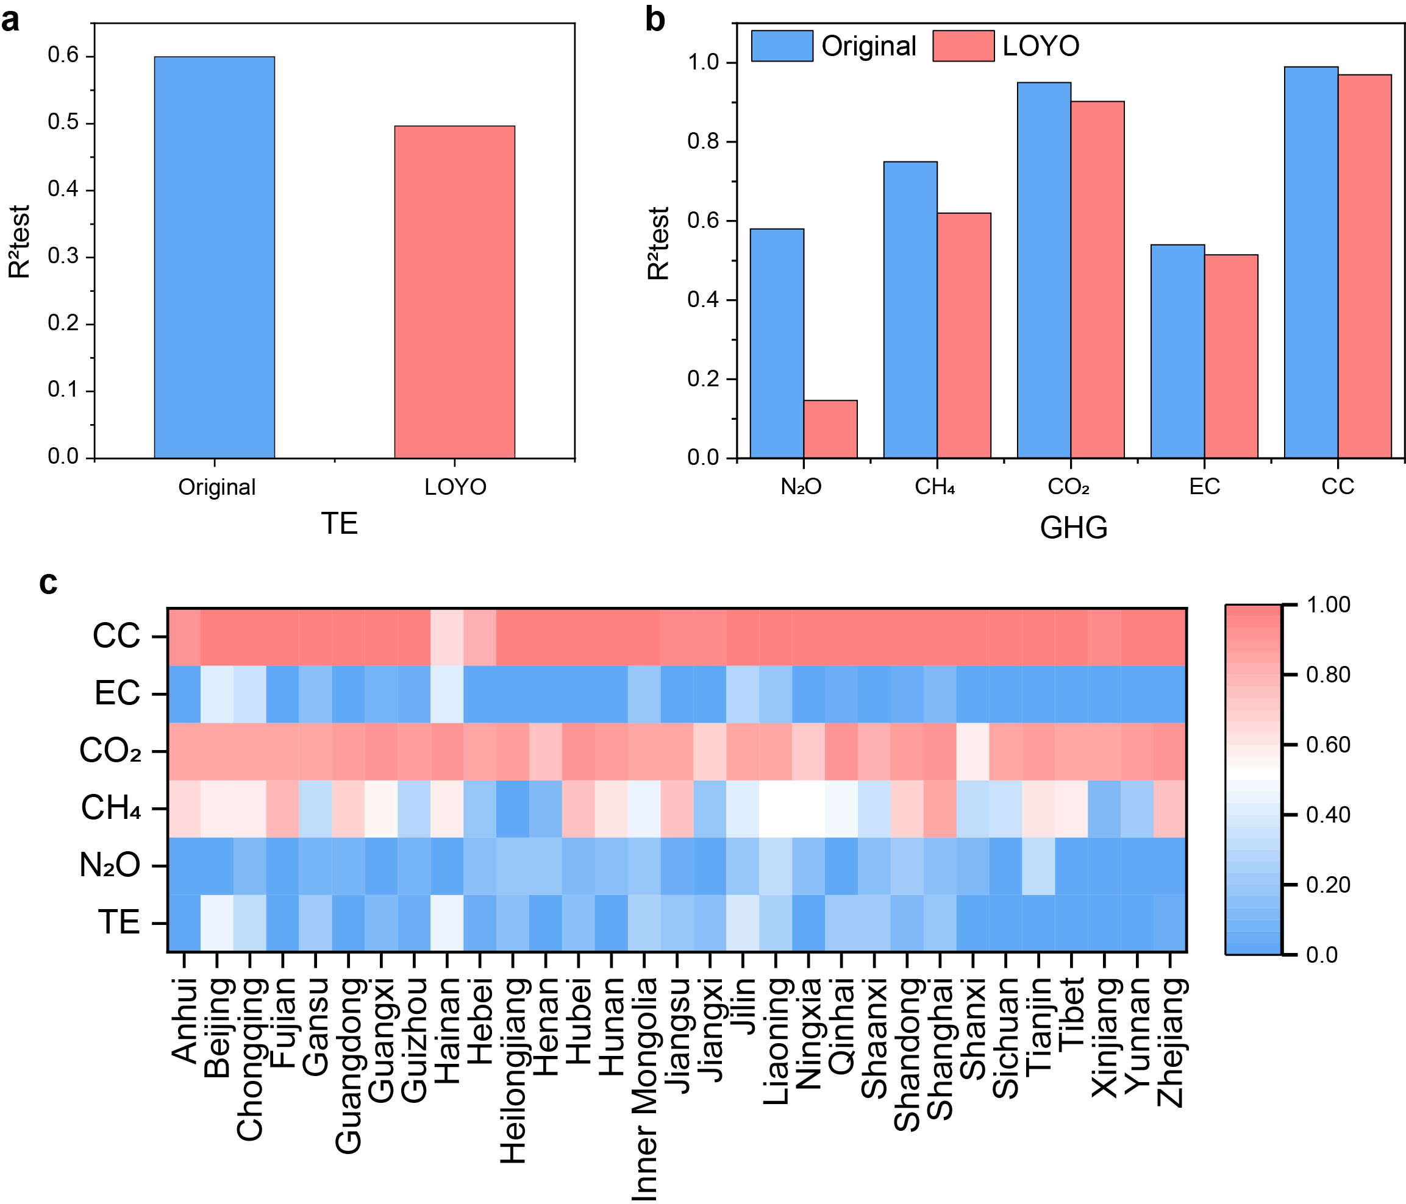

Figure S38. Temporal extrapolation performance of WaterMAP under leave-one-year-out (LOYO) validation.

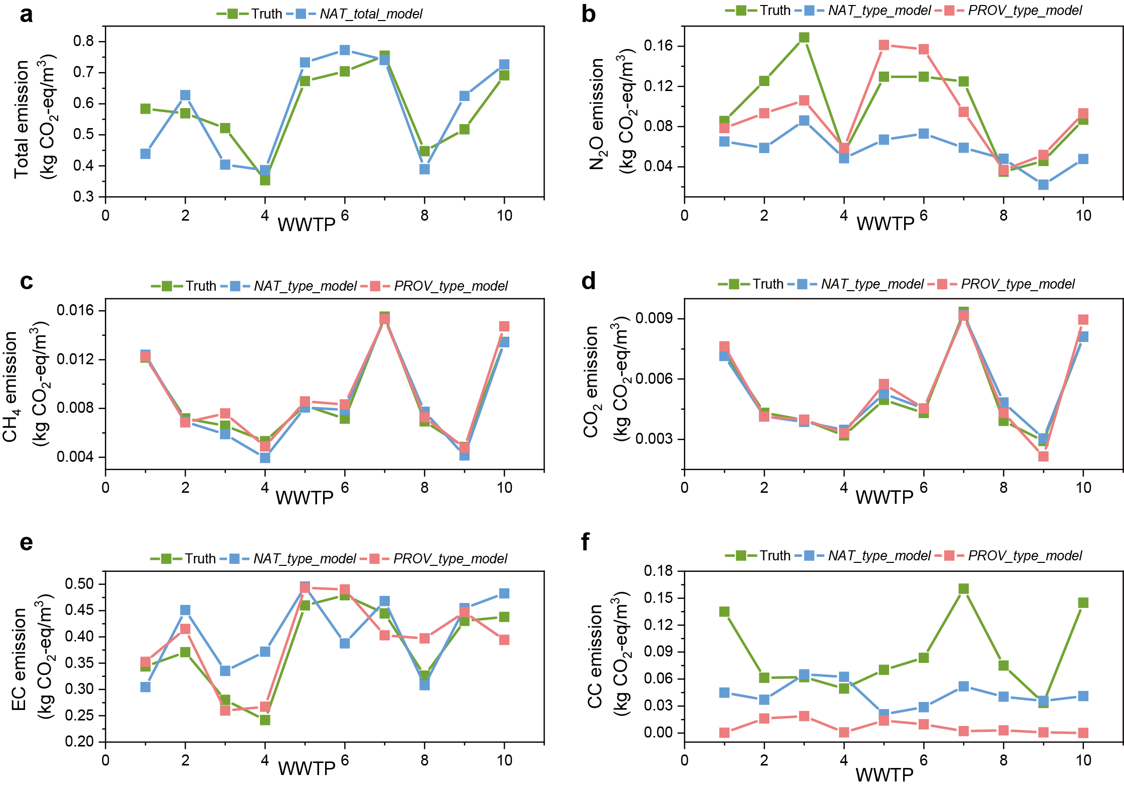

Figure S39. External validation of WaterMAP using independent WWTP datasets.

Table S47. Comparison of external validation performance (MAPE) between national and provincial models across different GHG categories
GHG | NAT_Type_Model | Hubei_Type_Model
N₂O | 41.4% | 17.5%
CH₄ | 8.1% | 6.5%
CO₂ | 5.9% | 8.3%
EC | 16.0% | 8.7%
CC | 46.6% | 90.3%

Figure S40. Cross-provincial extrapolation performance of WaterMAP under leave-one-province-out (LOPO) validation

Text S7. Transfer learning reveals inter-province similarity and differences.
To explore inter-province differences of EF-derived GHG emission patterns in China WTTPs, we conducted transfer learning by training the best provincial PROV_type_model on Province A, normalizing the data, and testing it on Province B (Xue et al., 2022). The mean testing R² values across all 31 provinces were used for hierarchical clustering. The transfer performance matrix (Figure S41) revealed that the PROV_type_model > NAT_type_model > transfer learning models. Although transfer learning underperformed compared to the other two strategies, it provided a data-driven approach to explore inter-province correlations and could inform GHG reduction transferred policies.
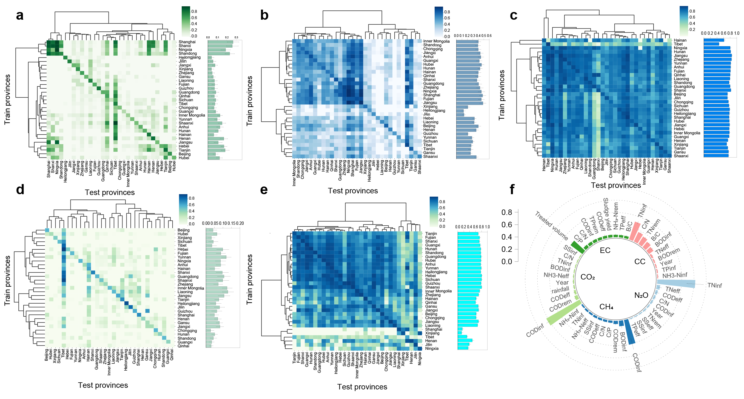

Figure S41. Inter-province similarity revealed by the best-performing province-independent transfer learning models. (a) The province transfer matrix (PTM) of N₂O emission among 31 provinces. Each entry denotes the testing R² score of N₂O emissions for each training–testing province pair. The bar plots showed the average training R² values on the specific testing province. Hierarchical clustering was utilized to analyze the similarity. (b-e) The PTM for CH₄, CO₂, EC, and CC emissions. (f) The average relative importance of top 10 features of GHGs emissions with high-transferability provinces.
The transfer performance matrix was asymmetrical, meaning the R² value for Province A training on Province B differs from the reverse scenario. For N₂O, provinces like Shanghai, Shanxi, Ningxia, and Shandong had the most generalizable patterns. For CH₄, clusters comprising Jiangsu, Fujian, Shanghai, Ningxia, Zhejiang, Guangdong, and Shanxi exhibited the best transfer performances. Similar clusters were identified for CO₂ (Fujian, Anhui, Yunnan, Zhejiang, Jiangsu, Hunan, Ningxia), EC (Tianjin, Jiangsu, Liaoning, Inner Mongolia), and CC (Sichuan, Hebei, Heilongjiang, Yunnan, Anhui), indicating key provinces whose GHG emission patterns were more transferable. Moreover, although the performances of the transfer learning models were not optimal, PROV_type_model with high transferability tended to show lower uncertainty than the NAT_type_model (Figure S42-47). Specifically, in EC prediction, the certainty ranges from 91.18% to 94.49%, which represented a significant improvement compared to the 56.04% certainty of the combined model (Table S48-49).

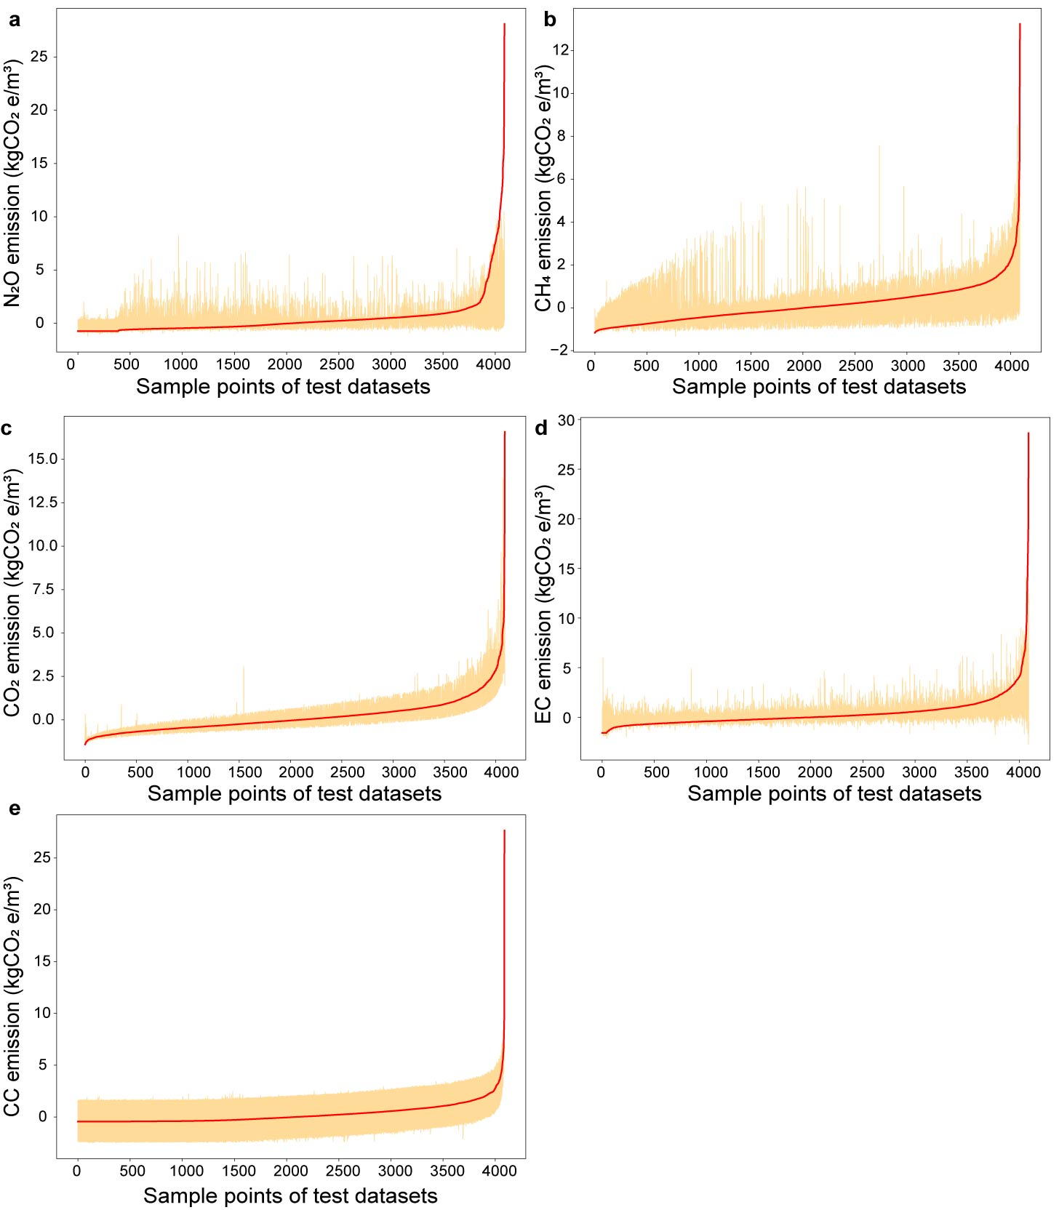

Figure S42. Uncertainty analysis of the best-performing NAT_type_model.
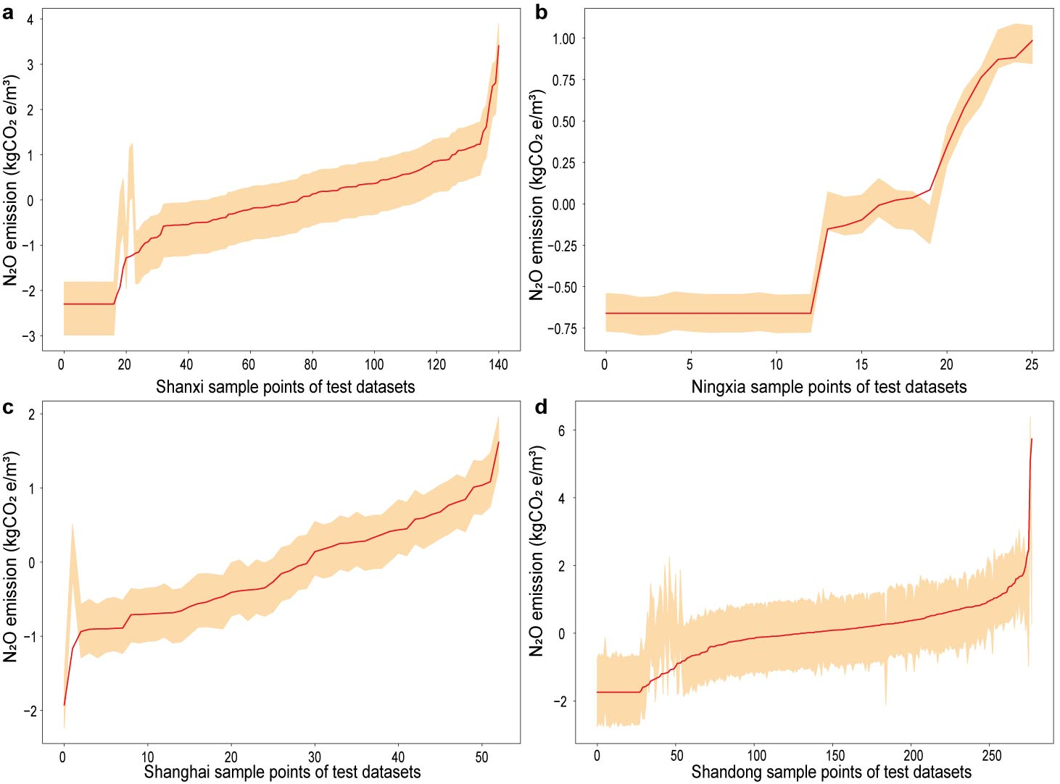

Figure S43. Uncertainty analysis of the best-performing N₂O PROV_type_model with high transferability.
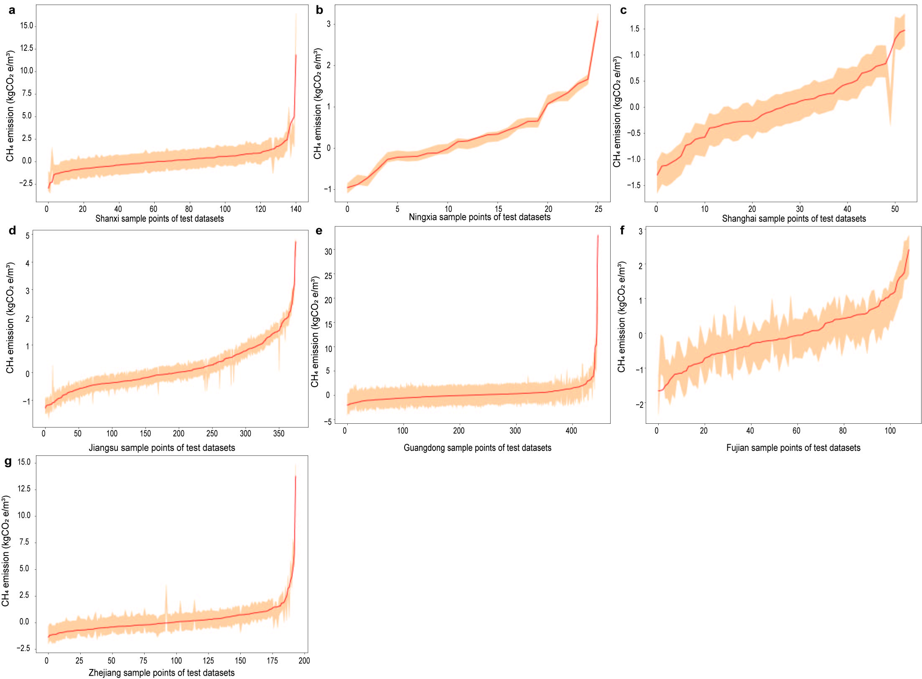

Figure S44. Uncertainty analysis of the best-performing CH₄ PROV_type_model with high transferability.
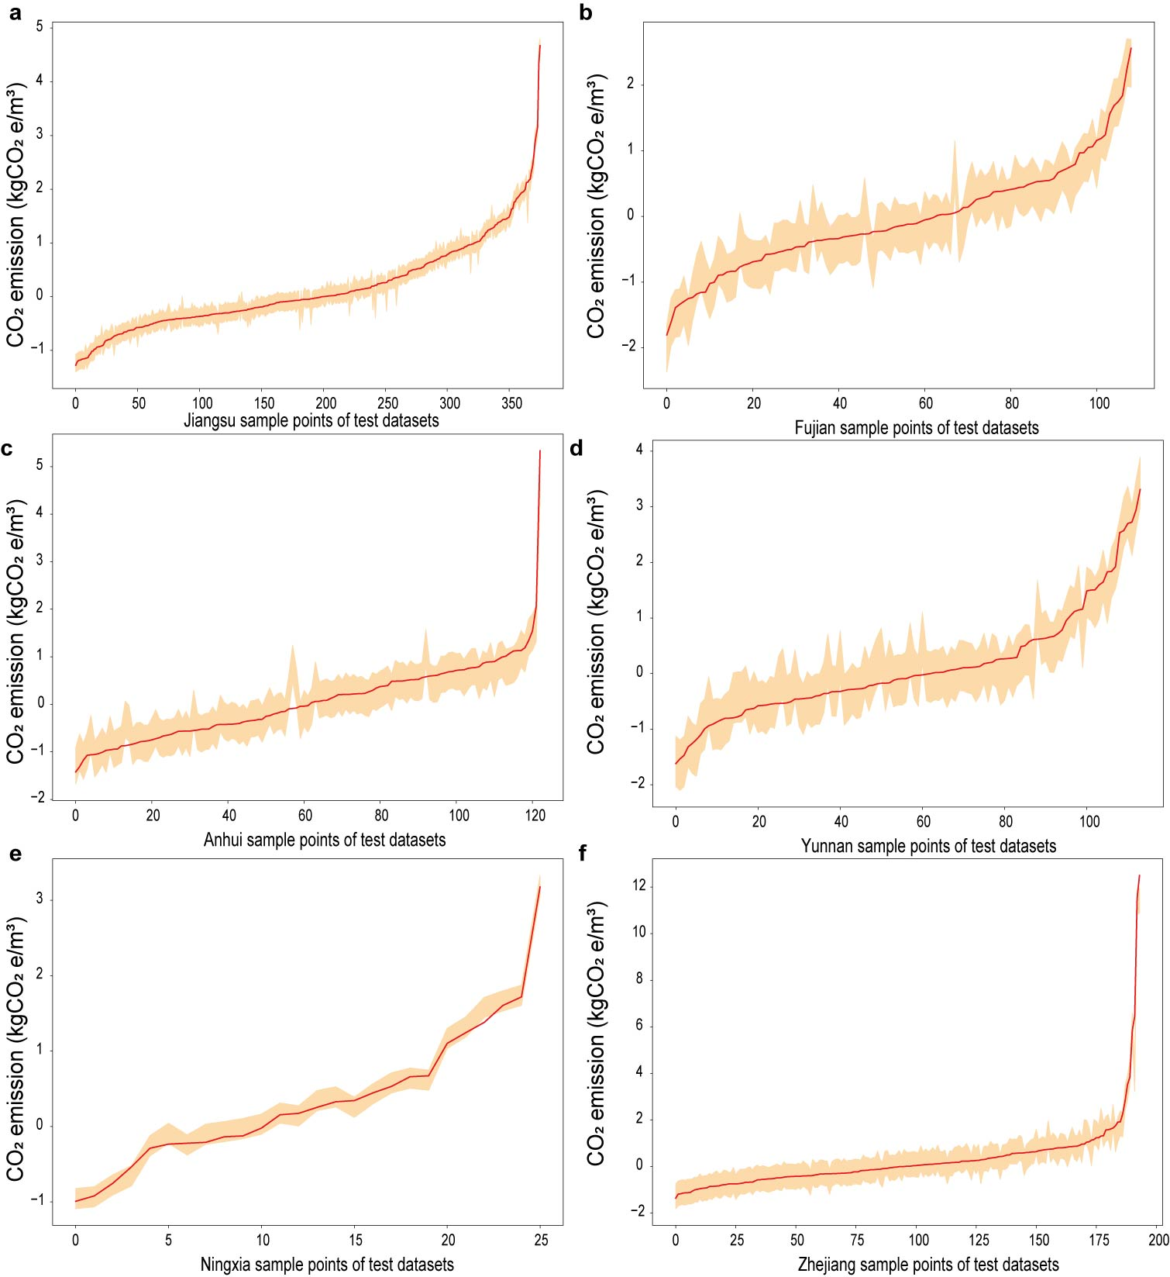

Figure S45. Uncertainty analysis of the best-performing CO₂ PROV_type_model with high transferability.
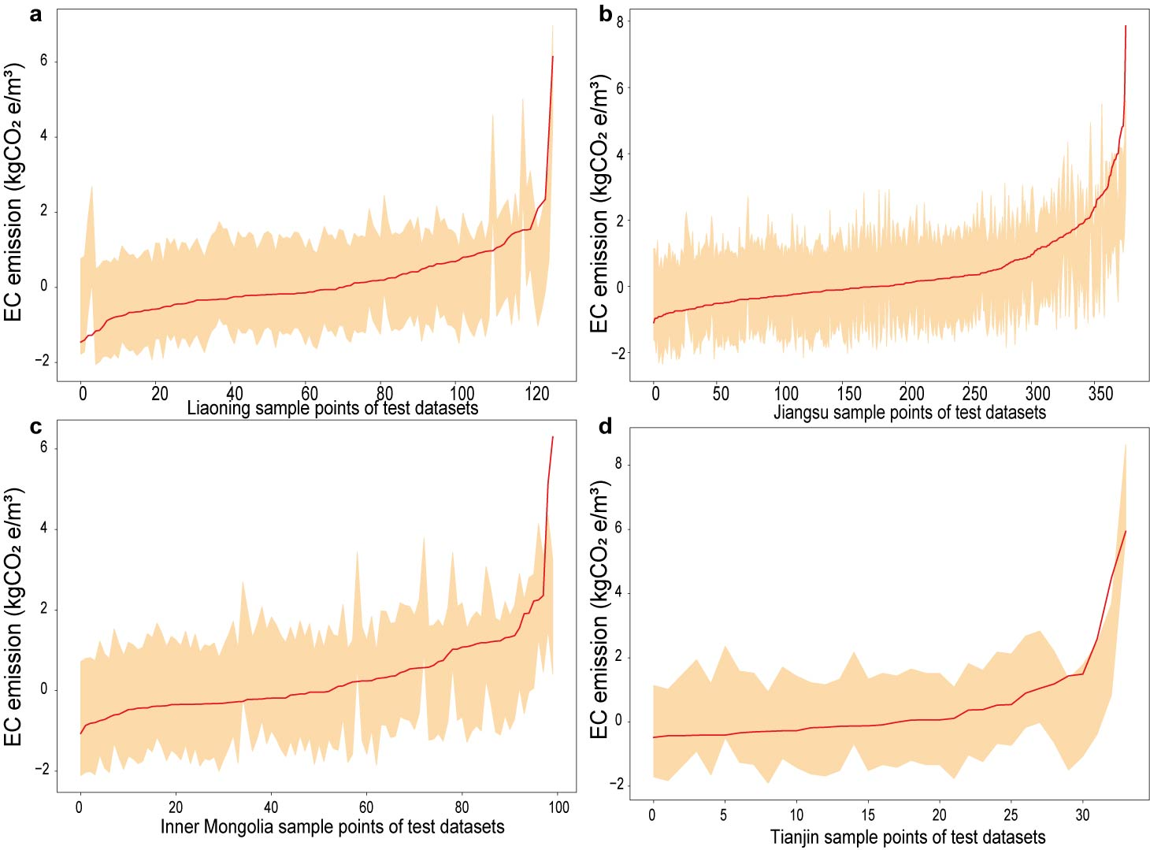

Figure S46. Uncertainty analysis of the best-performing EC PROV_type_model with high transferability.
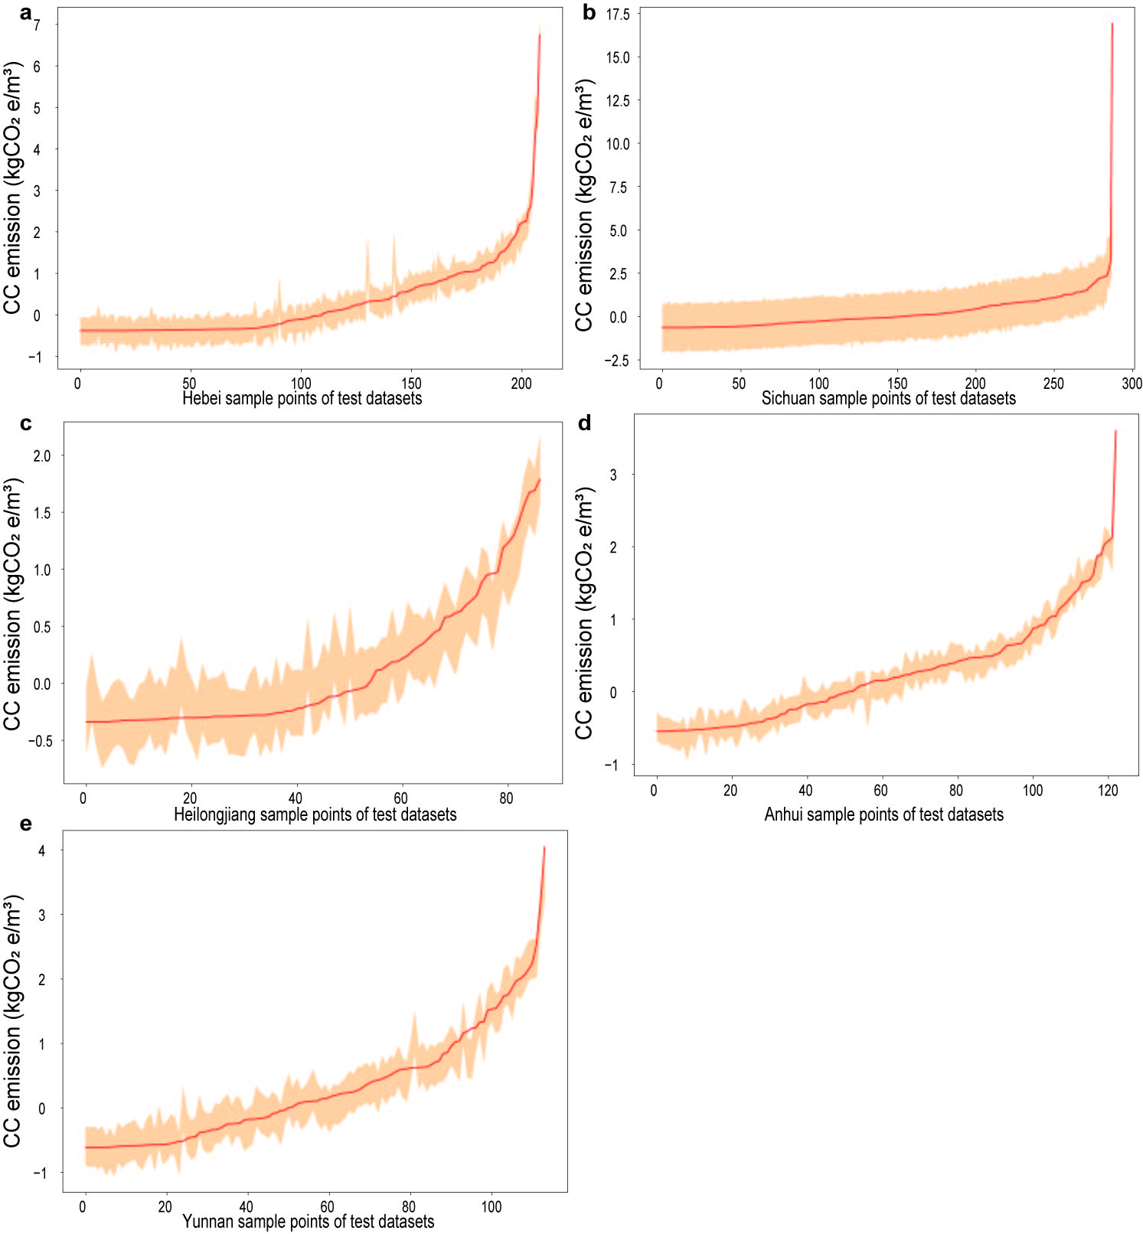

Figure S47. Uncertainty analysis of the best-performing CC PROV_type_model with high transferability.

Table S48. Uncertainty analysis results about the percentage of the test samples that have their true values fall into the respective 95% confidence intervals of prediction for combined models.
 | N_test | N_in interval | Proportion
N₂O | 4089 | 3397 | 83.08%
CH₄ | 4089 | 3563 | 87.14%
CO₂ | 4089 | 3481 | 85.13%
EC | 4089 | 2306 | 56.04%
CC | 4089 | 4088 | 99.98%
Note: N_test refers to the amount of data in the model test set; N_in interval refers to the amounts of samples that have their true values fall into the respective 95% confidence intervals of prediction.

Table S49. Uncertainty analysis results about the percentage of the test samples that have their true values fall into the respective 95% confidence intervals of prediction for province-independent models with high transferability.
EF-derived GHG | Province | N_test | N_in interval | Proportion
N₂O | Shanxi | 141 | 136 | 96.45%
N₂O | Ningxia | 26 | 25 | 96.15%
N₂O | Shanghai | 53 | 52 | 98.11%
N₂O | Shandong | 278 | 261 | 93.88%
CH₄ | Shanxi | 141 | 134 | 95.04%
CH₄ | Ningxia | 26 | 25 | 96.15%
CH₄ | Shanghai | 53 | 52 | 98.11%
CH₄ | Jiangsu | 376 | 363 | 96.54%
CH₄ | Guangdong | 446 | 437 | 97.98%
CH₄ | Fujian | 109 | 101 | 92.66%
CH₄ | Zhejiang | 194 | 183 | 94.33%
CO₂ | Jiangsu | 376 | 354 | 94.15%
CO₂ | Hunan | 153 | 145 | 94.77%
CO₂ | Fujian | 109 | 101 | 92.66%
CO₂ | Anhui | 123 | 114 | 92.68%
CO₂ | Yunnan | 114 | 104 | 91.23%
CO₂ | Ningxia | 26 | 24 | 92.31%
CO₂ | Zhejiang | 194 | 188 | 96.91%
EC | Liaoning | 127 | 120 | 94.49%
EC | Jiangsu | 376 | 350 | 93.09%
EC | Inner Mongolia | 100 | 95 | 95.00%
EC | Tianjin | 34 | 31 | 91.18%
CC | Hebei | 209 | 203 | 97.13%
CC | Sichuan | 288 | 287 | 99.65%
CC | Heilongjiang | 87 | 81 | 93.10%
CC | Anhui | 123 | 117 | 95.12%
CC | Yunnan | 114 | 108 | 94.74%

The distribution of high-transferability provinces exhibited significant technological convergence and regional ecological coupling mechanisms (Figure S48-52). N₂O high- transferability provinces (e.g., Shanghai, Shanxi), dominated by industrialization (such as coal chemical and steel industries), were primarily driven by stable nitrification/denitrification systems in treating partly industrial wastewater and complementary pathways with high sulfur-to-nitrogen ratios (Deng et al., 2022; Li et al., 2022a; Wang et al., 2025). CH₄-transferability clusters likely benefited from standardized upgrades in anaerobic zones of biological wastewater treatment processes and anaerobic digestion technologies, which enhanced organic hydrolysis and methane substrate flow stability (Xu et al., 2022).
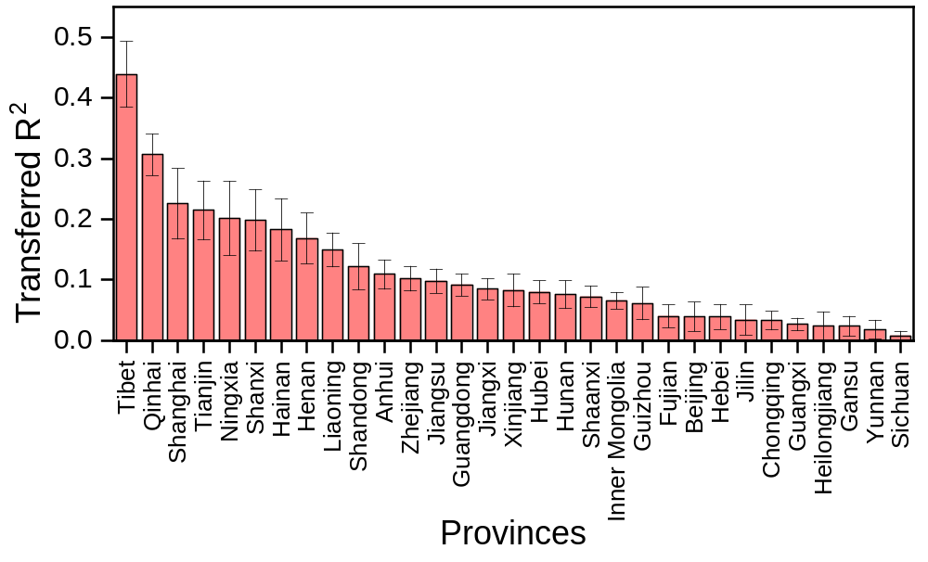

Figure S48. Bar plots showing the average testing R² values on the specific training province towards EF-derived N₂O emissions.
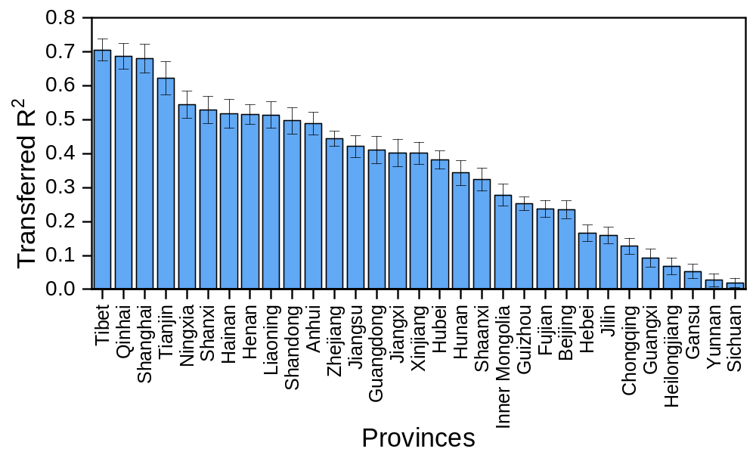

Figure S49. Bar plots showing the average testing R² values on the specific training province towards EF-derived CH₄ emissions.
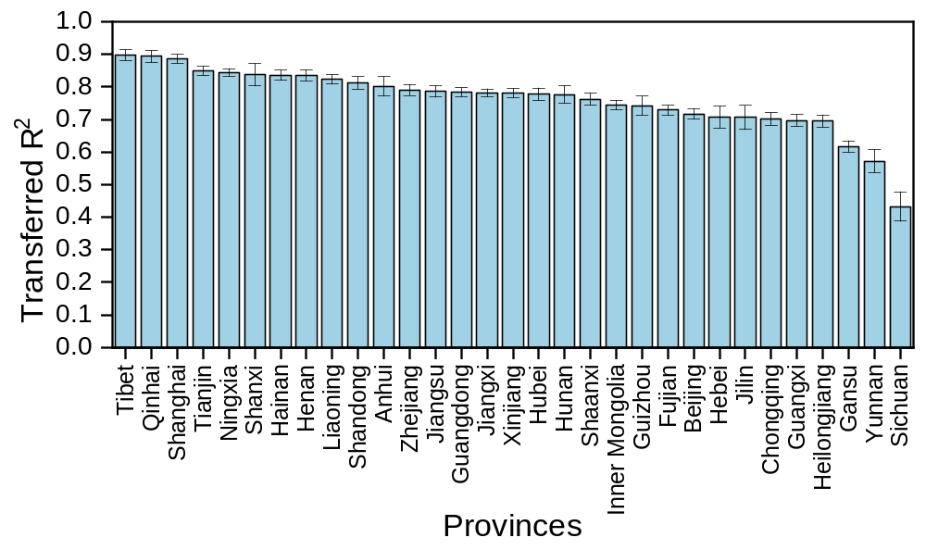

Figure S50. Bar plots showing the average testing R² values on the specific training province towards EF-derived fossil CO₂ emissions.

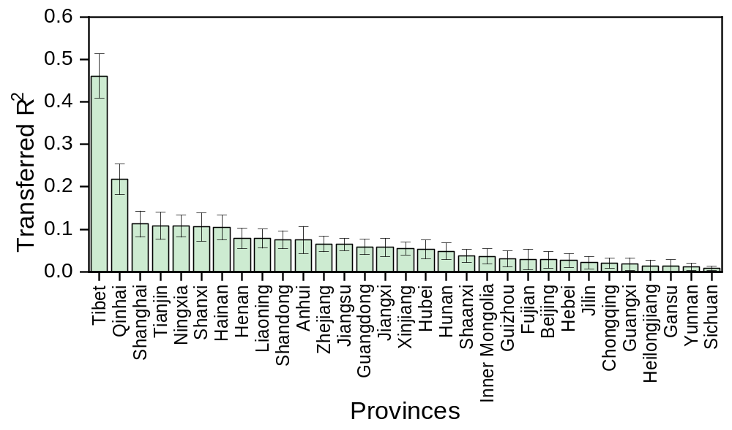

Figure S51. Bar plots showing the average testing R² values on the specific training province towards EF-derived EC emissions.

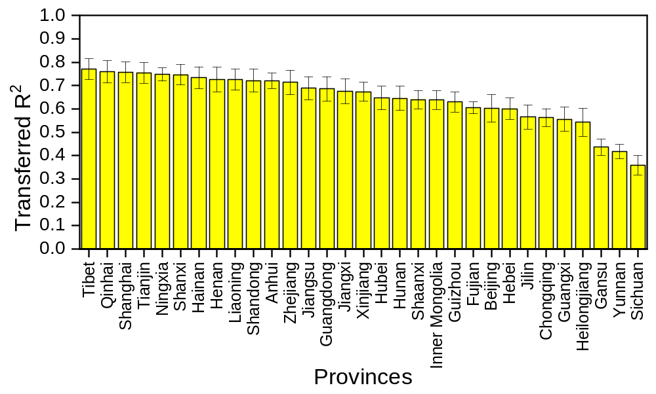

Figure S52. Bar plots showing the average testing R² values on the specific training province towards EF-derived CC emissions.

We analyzed the average feature importance for clusters with high transferability for each EF-derived GHG (Figure S53-58). Water quality parameters dominated, particularly TN_{inf} and COD_{inf}, which ranked first across scope 1 emissions (62.01%, 40.66%, and 62.34%). Temperature in the transfer learning models had lower influence than NAT_type_model due to reduced variance. For N₂O, the C/N ratio ranked fourth (3.11%) in importance, while CH₄ emissions also emphasized the C/P ratio (3.41%) and B/C ratio (3.33%). For CO₂, the key predictors included COD_{inf/eff/rem}, rainfall, and year. For indirect emissions, treatment capacity (24.09%) and TN_{inf} (30.43%) remained the top factors, with increased emphasis on C/N, C/P, and B/C ratios, highlighting their role in inter-province transferability.
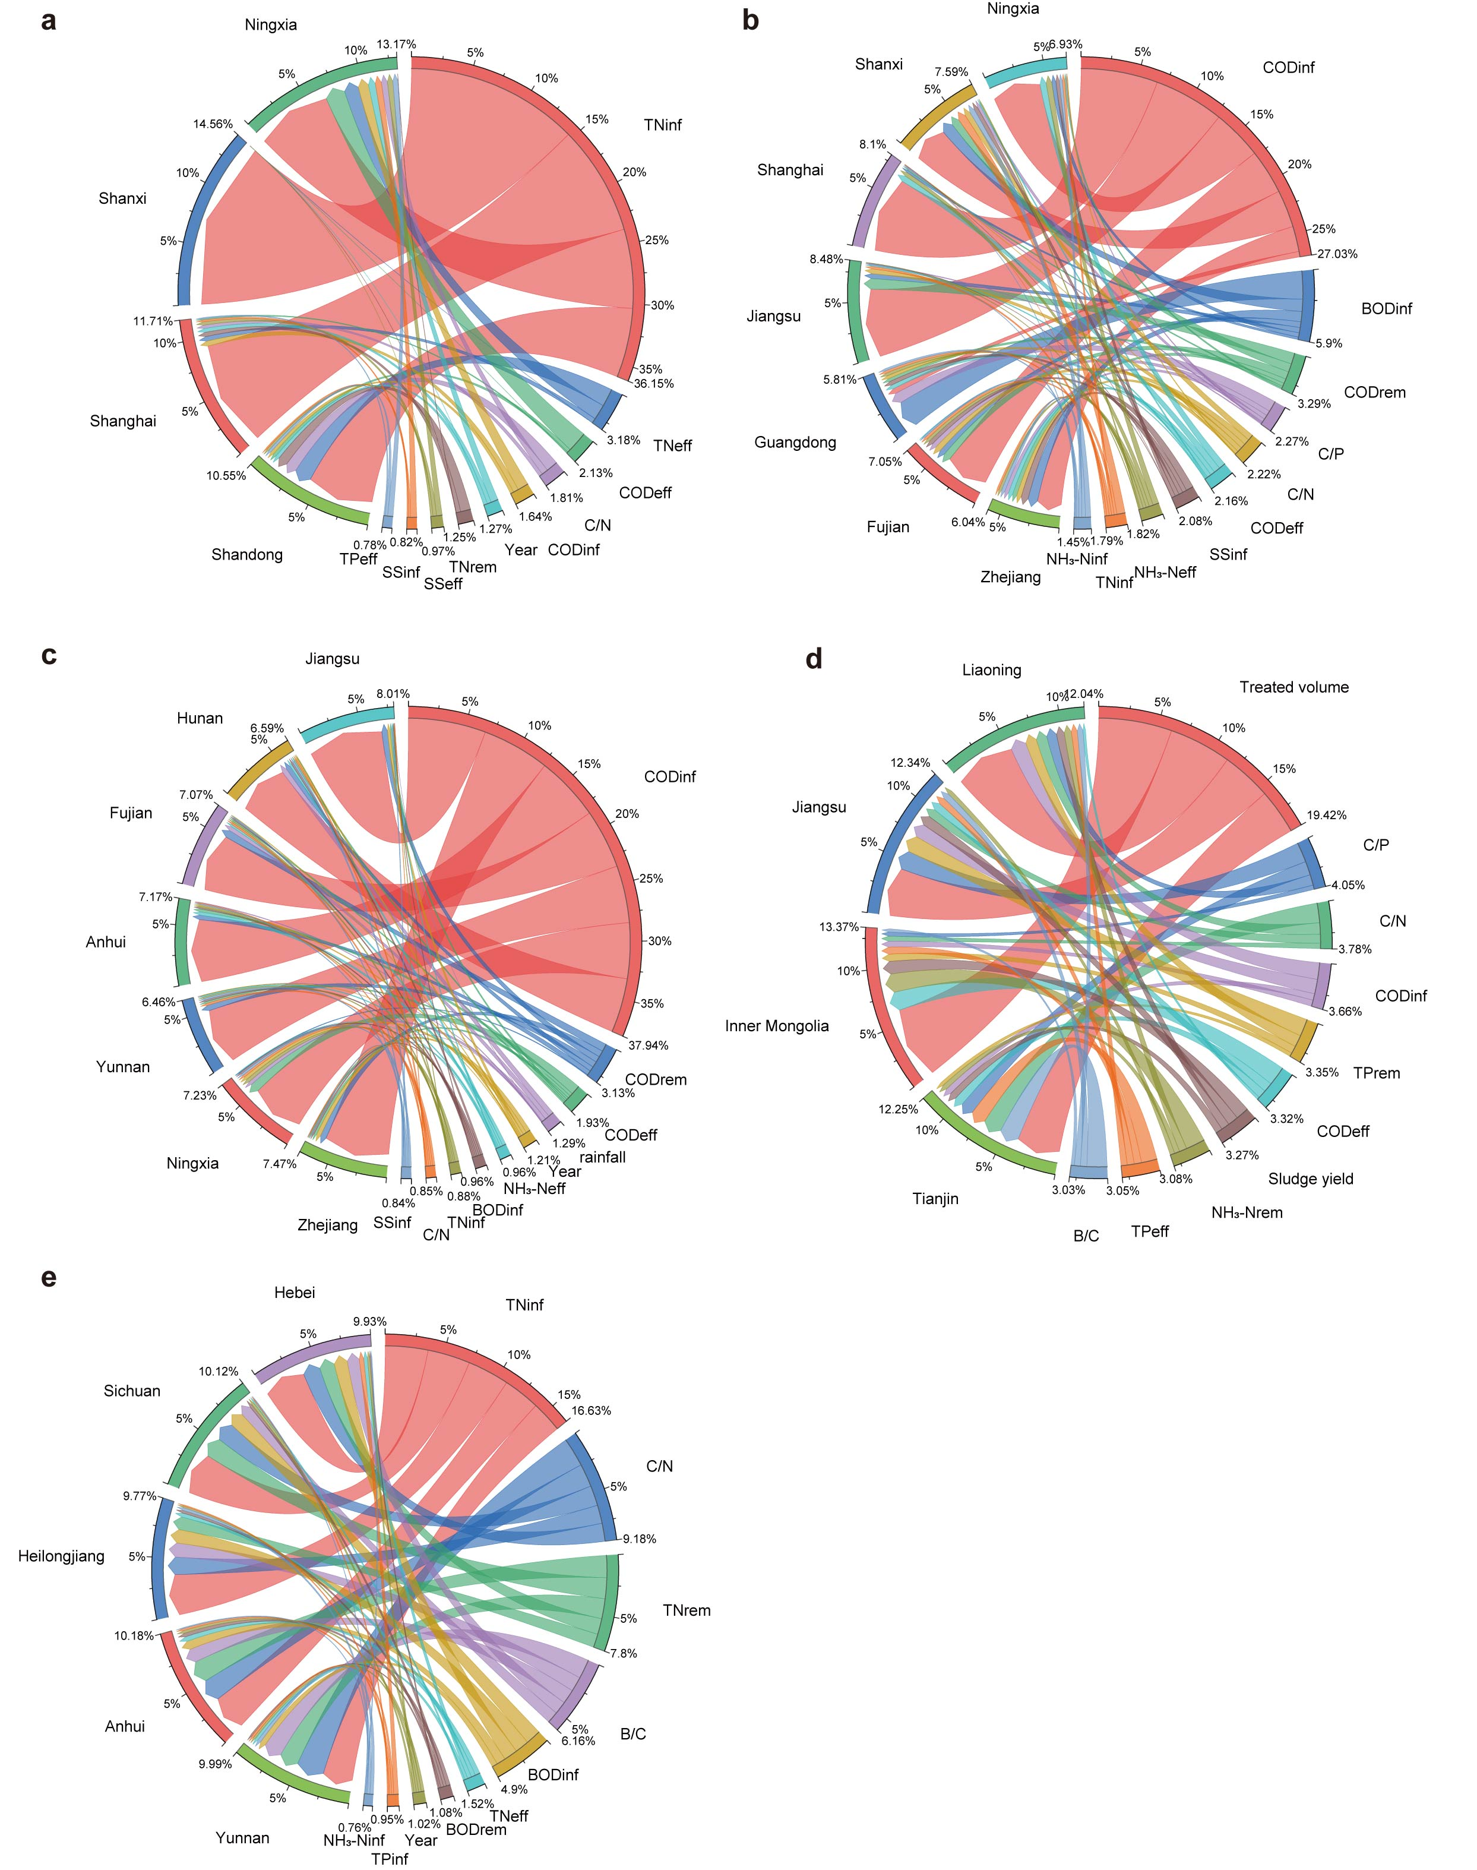

Figure S53. The correspondence of the top ten environmental factors in the high- transferability province prediction models, where a-e correspond to EF-derived N₂O, CH₄, fossil CO₂, EC, and CC emissions, respectively.

Figure S54. The ranking importance of EF-derived N₂O PROV_type_model with high transferability.

Figure S55. The ranking importance of EF-derived CH₄ PROV_type_model with high transferability.

Figure S56. The ranking importance of EF-derived fossil CO₂ PROV_type_model with high transferability.

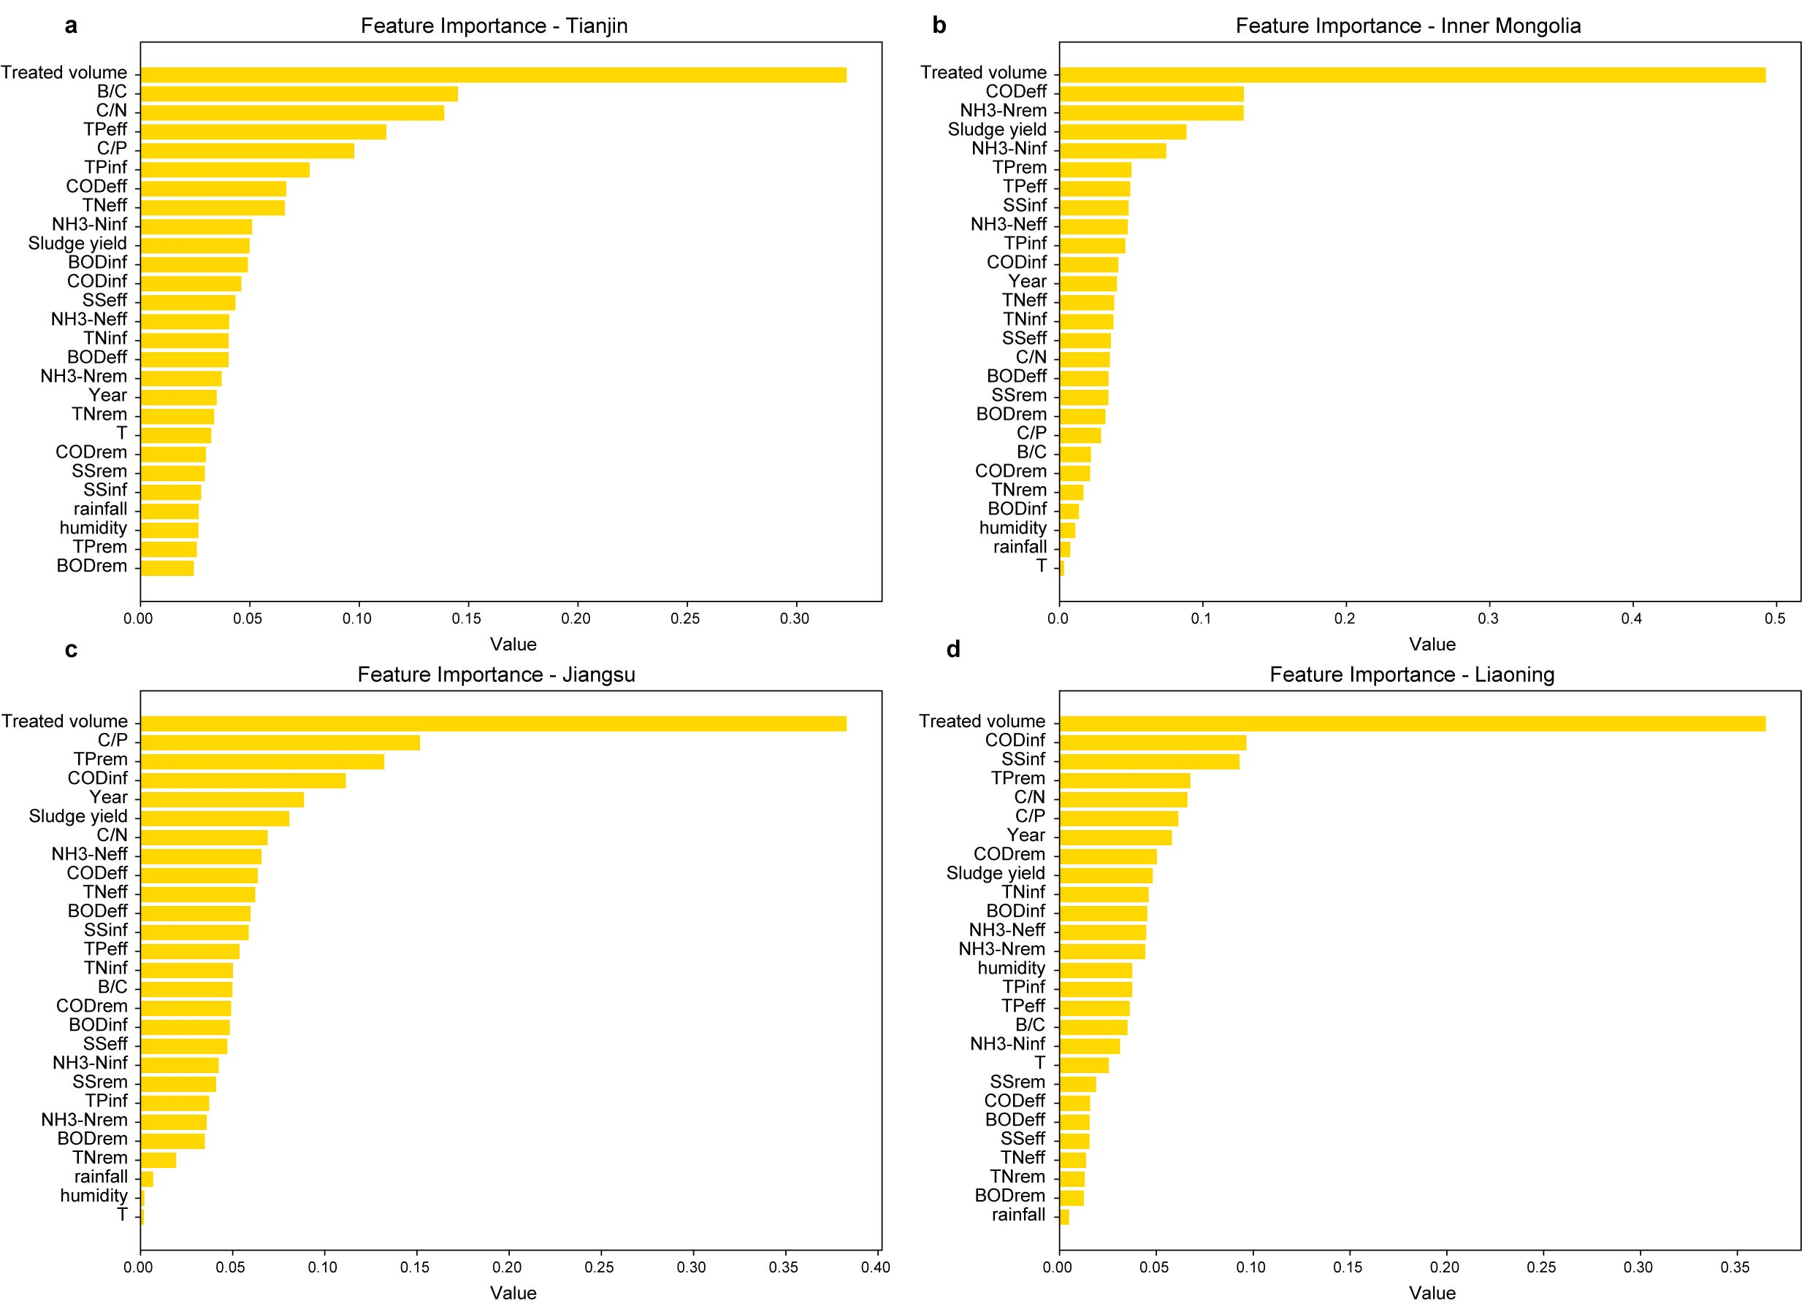

Figure S57. The ranking importance of EF-derived EC PROV_type_model with high transferability.

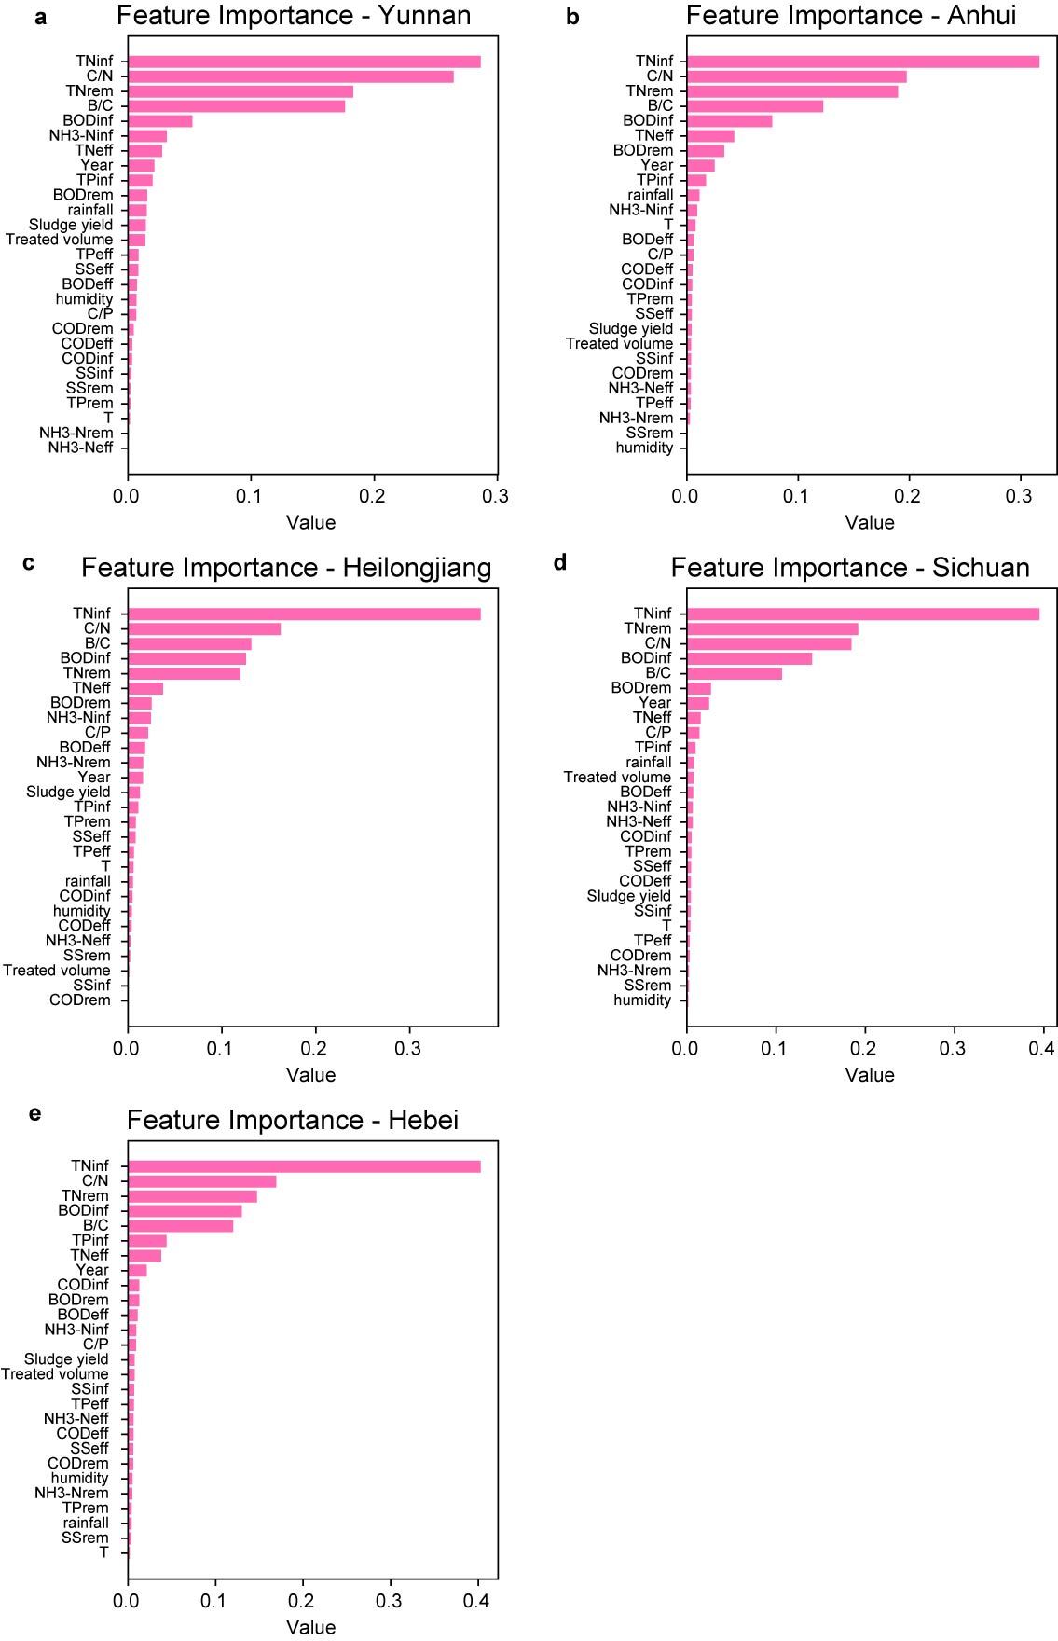

Figure S58. The ranking importance of EF-derived CC PROV_type_model with high transferability.

Further analysis of the predictors was conducted to elucidate their influence (Figure S59). We selected the C/N, C/P, and B/C ratios in top 10 and conducted boxplot analysis on provinces with high transferred EF-derived GHG emissions. The relationships between the predictors and corresponding EF-derived GHG emissions were investigated, providing novel insights into GHG reduction from water quality perspectives. In Shanghai, EF-derived N₂O emissions reached minimum mean values under C/N ratios of 0–6 and 15–25. Jiangsu, showing peak transferability for both EF-derived CH₄ and CO₂, exhibited increasing carbon emissions with elevated C/N and C/P ratios. Notably, B/C ratio exerted greater influence on indirect emissions than direct emissions, highlighting wastewater biodegradability’s critical role in EF-derived EC and CC. Key findings included: (1) EF-derived EC initially decreased then stabilized with rising B/C ratios, suggesting enhanced biodegradability reduces chemical-related emissions; (2) EF-derived CC displayed an inverted U-curve response to B/C ratios, indicating optimal biodegradability minimizes energy usage; (3) Both C/N and C/P ratios demonstrated U-shaped relationships with EC, with optimal ranges at C/P (80–100) and C/N (8–11); (4) EF-derived CC showed continuous decline with increasing C/N ratios. These findings revealed differential regulatory mechanisms of water quality parameters on EF-derived GHG emissions pathways, providing insights for GHG reduction in wastewater treatment systems.

Figure S59. The boxplots of C/N, C/P, and B/C ratios in top 10 correlating corresponding EF-derived GHG emissions: (a) N₂O;(b-c) CH₄; (d) CO₂; (e-g) EC; (h-i) CC.
From transferability patterns, China WTTPs have formed three distinct technological ecosystems: the southeastern coast has established standardized paradigms through low-carbon technologies iterations; the northern industrial belt maintains high GHG emissions parameter transferability via engineering stability; and western ecologically fragile regions have developed specialized adaptive methods (Li and Yu, 2025). We recommend piloting a ‘cluster-based management’ GHG emissions trading system, implementing technical mutual-aid mechanisms for interprovincial transferability alliances, and designing dedicated inventory accounting methods for low- transferability regions such as the Qinghai-Tibet Plateau. Future research should focus on spatial variability patterns of key factors (e.g., C/N, C/P, and B/C), develop benchmark process packages for areas with similar water quality characteristics, and construct dynamic zoning models integrating climate responsiveness and technological innovation timelines to provide theoretical support for carbon footprint management in wastewater treatment.

Text S8. Details of process construction using ML classification models.
- Data Overview and Classification Problem
In 2019, a total of 5,155 data samples were collected, covering six different wastewater treatment processes. We formalized this as a six-class classification problem. However, due to class imbalance, we grouped the AO process into the ‘Others’ category, transforming it into a five-class classification problem. The focus was placed on analyzing the role of the A²O, SBR, OD, and CAS processes in carbon emissions. The five formalized categories are encoded and as follows: A²O (1,857, 4), SBR (603, 0), OD (1,212, 1), CAS (940, 3), and Others (543, 2) (Table S50).

Table S50. The labels’ numbers of different processes when developing the classification model.
Process | A²O | AO | SBR | OD | CAS | Others
Datapoints | 1857 | 307 | 603 | 1212 | 940 | 236
- Description of Wastewater Treatment Processes
The A²O process is a composite and continuous-flow treatment method commonly used for biological nitrogen and phosphorus removal. By adjusting reaction conditions, this process effectively removes organic matter from wastewater while achieving nitrogen and phosphorus removal. It is particularly suitable for treating municipal wastewater and can achieve high pollutant removal efficiency with relatively low energy consumption.
The SBR process is a cyclic wastewater treatment method that operates by dividing a single reaction tank into different treatment phases: influent, reaction, settling, and effluent. This process is highly flexible, allowing adjustments to cycle duration and phase timing according to actual conditions. Due to its ability to perform multiple treatment stages in a single tank, SBR is particularly suitable for areas with fluctuating wastewater volumes.
The OD process is also a continuous-flow biological treatment method commonly used in large-scale wastewater treatment plants. It operates by providing oxygen through aerators in a circular channel, promoting the decomposition of organic matter by microorganisms in activated sludge. OD is widely applied in municipal wastewater treatment, offering high treatment efficiency, low energy consumption, and the ability to handle large wastewater flows.
The CAS process is one of the most common wastewater treatment methods. Its basic principle is the biological degradation of organic pollutants in wastewater. The process involves mixing wastewater with activated sludge and supplying oxygen in an aeration tank to promote microbial growth, thereby breaking down organic matter. CAS is simple to operate and effectively removes most organic pollutants, making it widely used in municipal and industrial wastewater treatment.
- Features and Model Training
The dataset includes the following features: Year, Province, Longitude, Latitude, Rainfall, Temperature (T), Humidity, GDP, Population, Treated Volume, Sludge Yield, COD_{inf}, COD_{eff}, COD_{rem}, BOD_{inf}, BOD_{eff}, BOD_{rem}, B/C, SS_{inf}, SS_{eff}, SS_{rem}, NH₃-N_{inf}, NH₃-N_{eff}, NH₃-N_{rem}, TN_{inf}, TN_{eff}, TN_{rem}, TP_{inf}, TP_{eff}, TP_{rem}, C/N, and C/P. The dataset was also split into training and test sets in a 90:10 ratio. Five-fold cross-validation and Bayesian optimization were used for hyperparameter tuning. The optimization results are listed in Table S51 and Figure S60-61 below. Ultimately, CatBoost achieved the best performance with its default hyperparameters.

Table S51. Hyper-parameters tuning of different classification models.
Methods | Hyper-parameters | Searching space | Classification Set
XGBoost | n_estimators | (10,500,1) | 227
XGBoost | max_depth | (3,15,1) | 9
XGBoost | subsample | (0.5,1,0.001) | 0.887
XGBoost | learning_rate | (0.1,1,0.001) | 0.128
LightGBM | max_depth | (3,15,1) | 7
LightGBM | n_estimators | (10,500,1) | 184
LightGBM | learning_rate | (0.01,1,0.01) | 0.05
CatBoost | iterations | (10,300,1) | default
CatBoost | depth | (3,15,1) | default
CatBoost | learning_rate | (0.03,1,0.001) | default
CatBoost | rsm | (0.6,0.8,0.001) | default
RF | n_estimators | (10,300,1) | 40
RF | max_depth | (3,15,1) | 15
RF | max_features | (1,6,1) | 2
RF | min_samples_leaf | (1,10,1) | 6
SVC | C | (0.1,10,0.01) | 9.98
SVC | kernel | ['linear', 'rbf', 'poly'] | poly
SVC | gamma | ['scale', 'auto', 0.001, 0.01, 0.1, 1] | 1
TabNet | n_d | (8,64,1) | 16
TabNet | n_a | (8,64,1) | 14
TabNet | gamma | (1,2,0.1) | 1
TabNet | n_steps | (3,10,1) | 5

Figure S60. Classification model performances of process construction: (a) F1-scores on training datasets; (b) Macro_AUC on training datasets; (c) F1-scores on testing datasets; (d) Macro_AUC on testing datasets.

Figure S61. AUC-ROC curves of the best-performing CatBoost classification model when constructing the process.

- ML Model Performance
The F1-score reached 0.62, and the macro-AUC achieved 0.77.
F1-score is a metric that balances precision and recall by computing their harmonic mean. It is particularly useful for imbalanced classification tasks as it ensures a trade-off between precision and recall. A higher F1-score, approaching 1, indicates better model performance in predicting the positive class.
Macro-AUC is a commonly used evaluation metric for multi-class classification problems. It calculates the average AUC values across all classes, giving equal weight to each category. Unlike weighted AUC, macro-AUC does not consider class sample size differences, making it particularly useful for evaluating model performance under class imbalance.
- SHAP Analysis of Influencing Factors
Using the SHAP method, we ranked the environmental factors affecting process classification. The SHAP values for each process reflect the strength and direction of influence of these input factors on process selection.
In Figure S62a, the most important factors influencing process selection include geographic location, temperature, and effluent ammonia nitrogen concentration. Spatial distribution is a key determinant, as regional climate conditions and policy differences (e.g., temperature) impact process selection. For example, high-latitude regions may prefer processes more adaptable to low temperatures, while economically developed areas may favor highly efficient modern processes. Temperature significantly affects microbial activity and operational efficiency. Biological processes such as A²O are better suited for higher temperatures, while low temperatures may reduce their efficiency, necessitating alternative physical-chemical treatments or additional heating in biological processes. Regarding water quality parameters (NH₃-Neff, COD_{eff}, TN_{eff}, etc.), stricter ammonia nitrogen and total nitrogen discharge standards (low NH₃-N_{eff}, low TN_{eff}) typically require more advanced biological nitrogen removal processes, such as A²O or SBR. Additionally, treatment scale influences process selection. Large-scale WWTPs tend to adopt CAS and A²O, while smaller plants benefit from simpler, more flexible processes such as SBR.
- Process-Specific Influencing Factors
Figure S62b–f analyzed the relationships between process types and water quality parameters: SBR Process: The key influencing factors are longitude, temperature (T), and effluent total phosphorus (TP_{eff}). A high SHAP value for longitude indicates that SBR distribution has clear geographical tendencies, likely influenced by policies, economic development, discharge standards, energy costs, and wastewater characteristics. In industrially developed eastern China (e.g., Jiangsu, Zhejiang, Guangdong), high wastewater treatment loads favor robust processes like CAS and A²O, whereas SBR is more common in small to medium-sized WWTPs. Conversely, in less developed western and central regions (e.g., Yunnan, Guizhou), where infrastructure is limited, SBR is preferred due to its low construction costs and small footprint. SBR is also sensitive to temperature fluctuations, whereas CAS and A²O, with longer hydraulic retention times and stable biological systems, are more resilient. Higher TP_{eff} values indicate lower phosphorus removal efficiency, which may reduce SBR applicability in certain areas or necessitate additional phosphorus removal steps. In regions with stringent phosphorus discharge standards, A²O may be more advantageous due to its stable biological phosphorus removal capability.
OD Process: Influenced mainly by longitude, latitude, province, and temperature, OD is particularly suitable for economically underdeveloped regions with ample land resources. The OD process has low energy consumption and is ideal for municipal wastewater treatment where nitrogen and phosphorus removal requirements are not extremely stringent. Its long hydraulic retention time (HRT) provides adaptability to varying temperatures, though denitrification efficiency may be limited under low temperatures or high nitrogen loads.
A²O Process: Affected by longitude, C/P ratio, effluent total nitrogen (TN_{eff}), and treatment scale, A²O is preferable in regions with strict environmental regulations and high nitrogen and phosphorus removal demands, particularly in economically developed eastern coastal areas. A²O relies on adequate carbon sources for biological phosphorus removal and denitrification. A high C/P ratio favors A²O selection, whereas a low C/P ratio may require external carbon addition, increasing carbon emissions. Additionally, A²O is typically used in medium-to-large WWTPs due to its stable operation and high treatment efficiency, making it suitable for handling large wastewater flow variations.
CAS Process: Primarily influenced by NH₃-N_{eff}, TN_{eff}, temperature, and longitude, CAS is more common in regions with high nitrogen removal requirements but limited denitrification efficiency. A low NH₃-N_{eff} suggests effective ammonia nitrogen removal, while a high TN_{eff} indicates relatively weak denitrification capacity, potentially leading to lower total nitrogen removal rates. The impact of temperature suggests that higher temperatures favor nitrification, while CAS denitrification efficiency may decline in colder conditions. Longitude indicates regional prevalence, possibly due to policy, climate, or wastewater characteristics.
These findings provide valuable insights for optimizing wastewater treatment processes and regional process selection.

Figure S62. SHAP analysis of the best-performing CatBoost classification model when constructing the process: (a) SHAP summary plots; (b-f) SHAP plots towards SBR, OD, A²O, CAS, and other processes.

Text S9. Details of data encoding.
Label Encoding is a method used to convert categorical data into numerical form by assigning a unique integer to each category. This technique is commonly used for machine learning models that require numerical input. It is particularly useful for ordinal data, where categories have a meaningful order, such as “Low," "Medium," and "High," which can be encoded as 0, 1, and 2, respectively (Jiang et al., 2024).
One of the key advantages of Label Encoding is its simplicity and efficiency, as it requires minimal memory and computational resources compared to more complex encoding techniques like One-Hot Encoding. It is also well-suited for tree-based models (e.g., decision trees, random forests, and gradient boosting), which can handle categorical values effectively without assuming an ordinal relationship. Additionally, Label Encoding is useful when working with high-cardinality categorical features, where One-Hot Encoding would create an excessively large number of columns, leading to the curse of dimensionality.
Label Encoding is simple to implement using libraries like scikit-learn in Python. The LabelEncoder class can easily transform categorical values into numerical labels, making it a useful preprocessing step when handling categorical features. In the GHG emission prediction task, we applied LabelEncoder to encode the province information, with the specific encoding results shown in Table S52.

Table S52. Province data encoding for GHG emission prediction.
Province | Anhui | Beijing | Chongqing | Fujian | Gansu | Guangdong
Encoded | 0 | 1 | 2 | 3 | 4 | 5
Province | Guangxi | Guizhou | Hainan | Hebei | Heilongjiang | Henan
Encoded | 6 | 7 | 8 | 9 | 10 | 11
Province | Hubei | Hunan | Inner Mongolia | Jiangsu | Jiangxi | Jilin
Encoded | 12 | 13 | 14 | 15 | 16 | 17
Province | Liaoning | Ningxia | Qinghai | Shaanxi | Shandong | Shanghai
Encoded | 18 | 19 | 20 | 21 | 22 | 23
Province | Shanxi | Sichuan | Tianjin | Tibet | Xinjiang | Yunnan
Encoded | 24 | 25 | 26 | 27 | 28 | 29
Province | Zhejiang
Encoded | 30

Text S10. Details of data normalization.
When dealing with data preprocessing in machine learning, scaling is an essential step to ensure that different features contribute equally to model training. Two commonly used scaling techniques in scikit-learn are MinMaxScaler and RobustScaler (Zhong et al., 2021).
（1）MinMaxScaler scales the features to a fixed range, typically [0,1] or [-1,1]. It transforms each feature using the following formula:
X_{scale}=$\frac{X-X_{min}}{X_{max}-X_{min}}$
This method preserves the original distribution of data and is particularly useful when feature values have known bounds, such as pixel intensities in images. However, it is highly sensitive to outliers because the presence of extreme values can significantly distort the scaling.
（2）In contrast, RobustScaler is designed to be more resistant to outliers by using the median and interquartile range (IQR) instead of the minimum and maximum values. It scales data using the formula：
X_{scale}=$\frac{X-median(X)}{IQR(X)}$
where IQR is the difference between the 75th and 25th percentiles. This approach ensures that outliers have less impact on the transformed data, making RobustScaler a better choice for datasets with skewed distributions or heavy-tailed features, such as financial data or environmental measurements with extreme values. However, unlike MinMaxScaler, it does not guarantee that the transformed data falls within a specific range, which may make interpretation less straightforward.
Choosing between MinMaxScaler and RobustScaler depends on the nature of the data. If the dataset has a relatively uniform or normal distribution without extreme outliers, MinMaxScaler is an effective choice as it retains the overall structure while ensuring values remain within a defined range. On the other hand, when dealing with skewed data or datasets prone to outliers, RobustScaler provides a more stable transformation by reducing the influence of extreme values. Considering the distribution of the two datasets (Table S53-54), we chose MinMaxScaler for process data reconstruction and RobustScaler for GHGs emission prediction.

Table S53. Analysis of the raw data for the dataset of process data reconstruction.
 | Count | Mean | SD | Min | 25th Percentile | 50th Percentile | 75th Percentile | Max
longitude | 5155 | 113.20 | 6.39 | 87.67 | 106.62 | 113.24 | 117.19 | 126.52
latitude | 5155 | 31.69 | 6.00 | 19.97 | 26.71 | 30.60 | 36.65 | 45.80
rainfall | 5155 | 1083.68 | 613.41 | 145.5 | 633.4 | 874.7 | 1254.1 | 2459.3
T | 5155 | 16.17 | 4.22 | 5.9 | 15 | 16.4 | 18 | 25.8
humidity | 5155 | 69.71 | 12.20 | 37 | 57 | 74 | 82 | 84
Treated volume | 5155 | 1271.72 | 2783.99 | 0.19 | 168.89 | 577.10 | 1375.67 | 106734.31
Sludge yield | 5155 | 7603.13 | 19563.22 | 0.00 | 358.04 | 2186.61 | 7453.95 | 584940.12
COD_{inf} | 5155 | 214.58 | 124.08 | 5.64 | 131.78 | 187.23 | 265.81 | 1483.63
COD_{eff} | 5155 | 20.32 | 11.85 | 1.00 | 14.41 | 18.68 | 23.94 | 413.67
COD_{rem} | 5155 | 0.88 | 0.07 | 0.04 | 0.86 | 0.9 | 0.93 | 0.99
BOD_{inf} | 5155 | 90.04 | 57.70 | 0 | 51.325 | 77.7 | 114.655 | 621.98
BOD_{eff} | 5155 | 5.76 | 6.48 | 0 | 3.09 | 5.13 | 7.25 | 295.83
BOD_{rem} | 5155 | 0.92 | 0.08 | 0 | 0.9 | 0.94 | 0.96 | 1
B/C | 5155 | 0.43 | 0.22 | 0 | 0.34 | 0.42 | 0.5 | 5.99
SS_{inf} | 5155 | 140.35 | 115.64 | 0 | 83.255 | 120.02 | 172.075 | 4549.85
SS_{eff} | 5155 | 7.10 | 7.98 | 0 | 4.82 | 6.49 | 8.01 | 393.37
SS_{rem} | 5155 | 0.93 | 0.07 | 0.04 | 0.91 | 0.95 | 0.97 | 1
NH₃-N_{inf} | 5155 | 24.67 | 14.13 | 0 | 15.665 | 21.97 | 30.26 | 200.23
NH₃-N_{eff} | 5155 | 1.49 | 2.97 | 0 | 0.45 | 0.9 | 1.71 | 94.93
NH₃-N_{rem} | 5155 | 0.93 | 0.09 | 0.03 | 0.92 | 0.96 | 0.98 | 1
TN_{inf} | 5155 | 32.56 | 16.74 | 0 | 21.945 | 29.52 | 39.645 | 200
TN_{eff} | 5155 | 9.19 | 4.00 | 0 | 7.1 | 9.07 | 10.885 | 85.63
TN_{rem} | 5155 | 0.69 | 0.14 | 0 | 0.61 | 0.7 | 0.78 | 1
TP_{inf} | 5155 | 3.41 | 3.90 | 0 | 1.97 | 2.82 | 4.09 | 197.23
TP_{eff} | 5155 | 0.36 | 1.20 | 0 | 0.17 | 0.25 | 0.37 | 58.65
TP_{rem} | 5155 | 0.87 | 0.12 | 0 | 0.84 | 0.91 | 0.95 | 1
C/N | 5155 | 6.90 | 4.40 | 0.5 | 4.91 | 6.35 | 8.05 | 184.11
C/P | 5155 | 72.67 | 48.72 | 0.82 | 50.43 | 65.23 | 85.12 | 1703

Table S54. Analysis of the raw data for the EF-derived GHG emissions prediction dataset.
 | Count | Mean | SD | Min | 25th Percentile | 50th Percentile | 75th Percentile | Max
Year | 40722 | 2014.78 | 3.03 | 2009 | 2012 | 2015 | 2017 | 2019
COD_{inf} | 40722 | 242.57 | 137.77 | 0 | 153.72 | 214.26 | 299.90 | 3999.33
COD_{eff} | 40722 | 28.65 | 19.76 | 0 | 19.36 | 25.32 | 33.74 | 800.12
Treated volume | 40722 | 1270.85 | 2737.84 | 0.03 | 218.01 | 598.21 | 1332.84 | 106734.31
TN_{inf} | 40722 | 29.96 | 18.25 | 0 | 20.41 | 28.58 | 38.1475 | 501
longitude | 40722 | 113.43 | 6.57 | 87.67 | 109.03 | 113.64 | 117.29 | 126.52
latitude | 40722 | 31.99 | 6.05 | 19.97 | 26.71 | 31.87 | 36.65 | 45.80
rainfall | 40722 | 1106.54 | 585.96 | 35.6 | 615.5 | 1045.8 | 1442 | 2939.7
T | 40722 | 16.51 | 9.98 | 4.3 | 14.7 | 16.4 | 18 | 146
humidity | 40722 | 68.54 | 11.34 | 3 | 58 | 72 | 78 | 85
Sludge yield | 40722 | 7324.76 | 23955.04 | 0 | 422.85 | 2135.7 | 6559.443 | 2500592
COD_{rem} | 40722 | 0.86 | 0.07 | 0 | 0.84 | 0.88 | 0.91 | 1
BOD_{inf} | 40722 | 100.16 | 63.85 | 0 | 57.7325 | 88.63 | 128.78 | 947.42
BOD_{eff} | 40722 | 8.11 | 8.53 | 0 | 4.34 | 6.98 | 9.87 | 425.37
BOD_{rem} | 40722 | 0.90 | 0.08 | 0 | 0.88 | 0.92 | 0.95 | 1
B/C | 40722 | 0.42 | 0.17 | 0 | 0.34 | 0.42 | 0.5 | 5.99
SS_{inf} | 40722 | 149.07 | 109.58 | 0 | 89.01 | 127.69 | 183.55 | 4549.85
SS_{eff} | 40722 | 10.01 | 10.39 | 0 | 6.21 | 8.29 | 12.34 | 821.53
SS_{rem} | 40722 | 0.91 | 0.08 | 0 | 0.9 | 0.93 | 0.96 | 1
NH₃-N_{inf} | 40722 | 25.28 | 16.52 | 0 | 16.3 | 22.46 | 30.34 | 476.96
NH₃-N_{eff} | 40722 | 3.09 | 4.85 | 0 | 0.89 | 1.88 | 3.63 | 208.17
NH₃-N_{rem} | 40722 | 0.87 | 0.13 | 0 | 0.83 | 0.91 | 0.96 | 1
TN_{eff} | 40722 | 9.39 | 5.85 | 0 | 6.34 | 9.42 | 12.2 | 150
TN_{rem} | 40722 | 0.69 | 0.17 | 0 | 0.58 | 0.69 | 0.79 | 1
TP_{inf} | 40722 | 3.45 | 7.42 | 0 | 1.94 | 2.78 | 3.93 | 696.54
TP_{eff} | 40722 | 0.56 | 1.15 | 0 | 0.27 | 0.4 | 0.65 | 95.2
TP_{rem} | 40722 | 0.81 | 0.14 | 0 | 0.74 | 0.85 | 0.92 | 1
C/N | 40722 | 8.91 | 130.92 | 0 | 5.57 | 7.23 | 8.91 | 26352
C/P | 40722 | 85.34 | 72.83 | 0 | 56.08 | 73.99 | 95.47 | 3407.88
EC | 40722 | 0.32 | 0.36 | 0 | 0.194 | 0.261 | 0.361 | 49.935
CO₂ | 40722 | 0.01 | 0.01 | 0 | 0.006 | 0.008 | 0.011 | 0.141
CH₄ | 40722 | 0.01 | 0.01 | 0 | 0.008 | 0.012 | 0.018 | 0.249
N₂O | 40722 | 0.06 | 0.10 | 0 | 0.014 | 0.037 | 0.065 | 1.566
CC | 40722 | 0.01 | 0.01 | 0 | 0.001 | 0.005 | 0.011 | 0.431

Text S11. Details of machine learning and deep learning methods.
XGBoost, CatBoost, LightGBM, Random Forest (RF), Support Vector Machine (SVM), and TabNet are all powerful machine learning algorithms, often used for regression tasks. Each algorithm has its own unique approach to learning from data, with strengths in different types of regression problems(Zhu et al., 2023).
XGBoost is an implementation of gradient boosting, which builds an ensemble of decision trees in a sequential manner. In each iteration, it adds a new tree that corrects the errors made by the previous one. The model optimizes a loss function using gradient descent, typically mean squared error (MSE) for regression problems. The basic idea is to minimize the difference between the true and predicted values of the target variable by iteratively improving the model. The optimization process can be expressed as:
L=$\sum_{i=1}^{N}{{(y_{i}-y_{a})}^{2}}$
y_{i} is the true value and y_{a} is the predicted value. The tree construction process involves fitting new models to the residual errors of the previous trees, leading to a model that performs well even in the presence of non-linear relationships.
CatBoost, like XGBoost, is based on gradient boosting but incorporates a novel approach for handling categorical features. It uses an efficient algorithm to transform categorical data into numerical representations, which helps avoid overfitting and improves generalization. In regression tasks, CatBoost minimizes the same loss functions as other gradient boosting methods but also applies techniques like ordered boosting, which enhances model stability and reduces the prediction bias. The ability to handle categorical features directly without extensive preprocessing is one of its key strengths.
LightGBM, another variant of gradient boosting, is designed to be faster and more scalable than XGBoost and CatBoost. It uses a histogram-based approach to decision tree learning, which groups continuous feature values into discrete bins. This approach reduces memory usage and speeds up the training process, making it highly efficient for large datasets. LightGBM also uses leaf-wise tree growth, which can lead to more accurate models by focusing on areas of the data with higher errors. The regression objective for LightGBM is similarly to minimize MSE or other suitable loss functions.
Random Forest (RF) is an ensemble method that constructs a multitude of decision trees, each trained on a random subset of the training data and features. During regression, the model predicts the average of all tree predictions. RF is a non-boosting algorithm, which means that it does not iteratively improve the model like boosting methods but rather relies on the strength of multiple independently trained trees. Its robustness to overfitting, especially when the number of trees is large, makes it an effective choice for regression tasks, particularly when there is high variance in the data.
Support Vector Machine (SVM) for regression (SVR) is based on the idea of finding a hyperplane that best fits the data while allowing for some margin of error. In the context of regression, SVR tries to find a function that deviates from the true target values by a value no greater than a specified margin (epsilon). The key idea is to minimize the complexity of the model (regularization term) while ensuring that the error does not exceed a certain threshold. The loss function for SVR typically combines a regularization term and a loss term for predictions outside the margin:
L=$\sum_{i=1}^{N}{max⁡(0, \left|y_{i}-y_{a}\right|-ϵ）}$+C$\sum_{i=1}^{N}{{||w_{i}||}^{2}}$
where C is a regularization parameter, and ϵ is the margin of tolerance.
TabNet is a deep learning model designed for tabular data, combining the power of deep learning with interpretability. Unlike traditional tree-based models, TabNet uses a series of attention mechanisms to focus on important features for each data point. In regression tasks, TabNet learns to model non-linear relationships between input features and target values through its attention-based architecture. The model trains by minimizing the MSE loss function, similar to other regression algorithms, but it offers greater flexibility in capturing complex interactions within the data.
Each of these algorithms has distinct advantages depending on the problem. XGBoost, CatBoost, and LightGBM are all powerful gradient boosting methods with strengths in accuracy and interpretability. Random Forest excels in its robustness and simplicity. SVM is particularly effective for problems with a clear margin of error, while TabNet leverages deep learning techniques for highly complex data.

Text S12. Details of model development and hyperparameters.
In this study, the entire dataset was first stratified by provincial gradients and divided into a training set (90%) and a test set (10%) to avoid data leakage (Figure S63). Then, encoding techniques were applied to the provincial data, and the training set was normalized, ensuring that the same scaling factor was applied to the test set. We used six machine learning and deep learning algorithms to build the models, including XGBoost, CatBoost, LightGBM, Random Forest, Support Vector Machine (SVM), and TabNet, as described in Text S11. These algorithms each have their advantages in handling tabular data, providing different modeling approaches and results for the task.
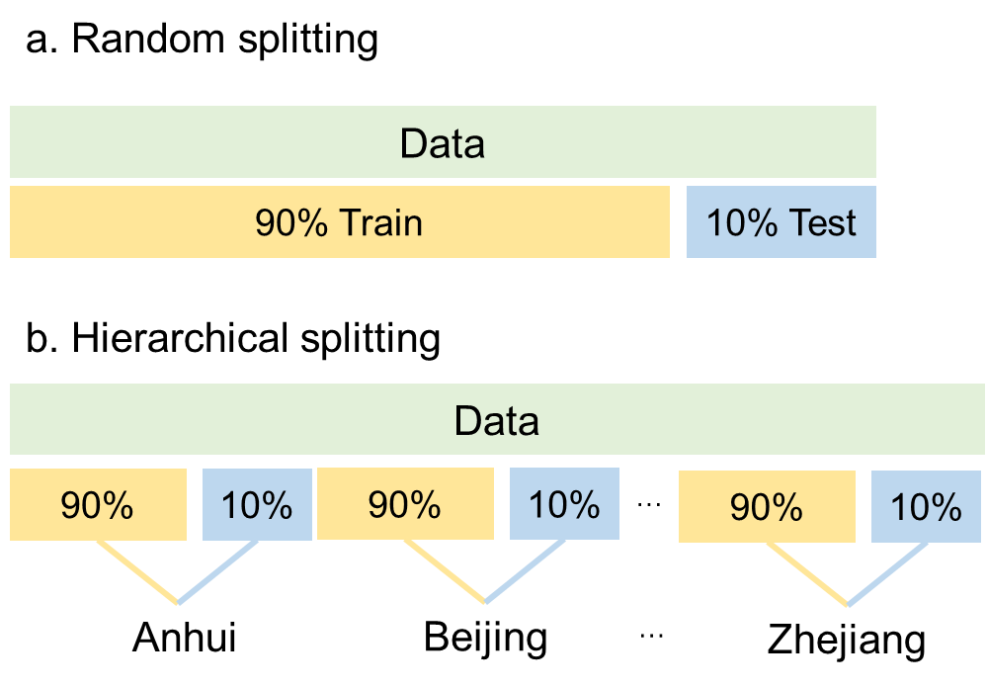

Figure S63. The data splitting formats and differences between (a) traditional and (b) province-stratified methods.
During the model development process, we employed five-fold cross-validation and combined it with Bayesian optimization to tune the hyperparameters of the models.
Five-fold cross-validation is a model validation technique used to assess the performance and generalization ability of a machine learning model. In this method, the dataset is randomly divided into five equal-sized subsets, or ‘folds.’ The model is trained on four of these folds and tested on the remaining fold. This process is repeated five times, each time using a different fold as the test set, while the other four folds are used for training. The results from each iteration are averaged to provide a more reliable estimate of the model's performance. This approach helps reduce overfitting and ensures that the model is evaluated on all parts of the data.
Bayesian optimization is a probabilistic model-based optimization technique used to efficiently search for the best hyperparameters of a machine learning model. It builds a surrogate model (usually a Gaussian process) to approximate the objective function and uses this model to predict the performance of different hyperparameter configurations. Based on these predictions, it chooses the next set of hyperparameters to evaluate by balancing exploration of untested regions with exploitation of known promising areas. This iterative process allows Bayesian optimization to find the optimal hyperparameters in fewer iterations compared to traditional methods.
Compared to grid search and random search, Bayesian optimization offers several advantages: (1) Grid search exhaustively evaluates every combination of hyperparameters within a predefined grid, making it computationally expensive, especially in high-dimensional spaces. Random search randomly samples hyperparameters, which can be more efficient than grid search but still requires many trials. Bayesian optimization intelligently selects hyperparameters based on prior evaluations, leading to fewer iterations to find the optimal configuration. (2) Unlike grid and random search, which might miss valuable hyperparameter regions, Bayesian optimization focuses on areas with the highest potential for improvement, leading to a more efficient search with fewer evaluations.
In conclusion, the goal of hyperparameter tuning is to select the best model configuration to improve predictive performance. Cross-validation was used to assess the stability and generalization ability of the models, helping to identify the most suitable algorithm and parameter combination, laying the foundation for the subsequent testing and evaluation phase.

Text S13. Details of model evaluation.
In the model evaluation phase, for classification tasks (such as process reconstruction), we use the F1 score (F1) and macro_AUC as evaluation metrics; for regression tasks, we use R² and Root Mean Squared Error (RMSE) for evaluation. These evaluation metrics effectively reflect the model's prediction performance, help us compare the performance of different algorithms, and ultimately select the best-performing model.
- F1 Score: The F1 score is the harmonic mean of precision and recall:
F1=$\frac{2*Precision*Recall}{Precision+Recall}$
Precision=$\frac{TP}{TP+FP}$
Recall=$\frac{TP}{TP+FN}$
TP: True Positives, FP: False Positives, FN: False Negatives.
- Macro AUC: Macro AUC is the average AUC (Area Under the Curve) across all classes:
Macro AUC=$\frac{1}{N}\sum_{i=1}^{N}{{AUC}_{i}}$
Where N is the number of classes and AUC_{i} is the AUC for Class i.
- R² (Coefficient of Determination): R² measures the proportion of variance explained by the model:
R²=1-$\frac{\sum_{i=1}^{N}{{(y_{i}-y_{a})}^{2}}}{\sum_{i=1}^{N}{{(y_{i}-y_{n})}^{2}}}$
y_{i} is the true value, y_{a} is the predicted value and yn is the mean of the actual values.
- Root Mean Squared Error (RMSE): RMSE is the square root of the average squared differences between actual and predicted values:
RMSE=$\sqrt{\frac{1}{N}\sum_{i=1}^{N}{{(y_{i}-y_{a})}^{2}}}$
y_{i} is the true value, y_{a} is the predicted value.

Text S14. Details of model interpretation.
To improve the interpretability of the model, we use two techniques: SHapley Additive exPlanations (SHAP) and Partial Dependence Plots (PDP). SHAP is used to analyze the contribution of different environmental factors to the emission of various greenhouse gases, while PDP is employed to explore the relationship between key environmental factors and greenhouse gas emissions. Additionally, two-dimensional PDPs are used to study the interactions between environmental factors and their combined effect on greenhouse gas emissions. These interpretability methods help us better understand the rationale behind the model's decisions, improving the model’s transparency and trustworthiness(Chen et al., 2023).
SHAP is a unified approach based on cooperative game theory that assigns a Shapley value to each feature, representing its contribution to a specific prediction. SHAP values provide a measure of how much each input feature (in this case, environmental factors) contributes to the output prediction, helping to break down the model’s decision-making process. This approach helps quantify the influence of individual variables on model predictions, making it easier to interpret complex machine learning models.
By using SHAP, we can gain a deeper understanding of how different environmental factors, such as temperature, impact greenhouse gas emissions in wastewater treatment processes. This method allows us to identify which factors are most critical and how they affect emissions, enabling better decision-making and targeted interventions.
PDP is a technique used to visualize the relationship between one or more independent variables (environmental factors) and the predicted outcome. It shows how the predicted response changes as a single feature or a pair of features is varied, holding all other features constant. This method is particularly useful for understanding the impact of a specific environmental factor on greenhouse gas emissions while considering the effect of other factors.
PDPs can be used to examine the relationship between environmental factors and emissions, helping us to understand the influence of each factor, or combinations of factors, on the model's output. For example, we can explore how variations in pH, organic carbon concentration, or temperature influence carbon dioxide or methane emissions in wastewater treatment plants. When exploring the interactions between two environmental factors, a 2D PDP can reveal how the joint effect of these features influences the greenhouse gas emissions. This is useful for identifying complex dependencies and interaction effects that might not be obvious when looking at each feature individually.
Together, SHAP and PDP are powerful tools for model interpretability, enabling us to not only understand the individual contributions of environmental factors but also to gain insights into the complex relationships and interactions between these factors and their cumulative impact on greenhouse gas emissions. This leads to more transparent, explainable models, fostering trust in the results and supporting better mitigation strategies for environmental management.

Text S15. Details of Ablation Analysis.
The experimental design includes six configurations per target:
- LR (formula-only): Linear regression using only EF-activity variables, representing the explanatory capacity of conventional EF-based formulations. In this study, EF-activity variables for total emissions (TE) include the core activity terms directly used in emission accounting, specifically: COD_{rem}, TN_{inf}, TN_{rem}, and TP_{rem}. These variables correspond to the primary activity data in traditional EF-based inventories, where emissions are estimated as the product of activity data and predefined emission factors.
- LR (full): Linear regression using all 30 features, to test whether a simple linear structure can sufficiently capture system behavior.
- Best model (formula-only): The best-performing ML model trained exclusively on the same EF-activity variables defined above, i.e., COD_{rem}, TN_{inf}, TN_{rem}, and TP_{rem}, without any additional contextual or process descriptors.
- Best model (−all EF vars): The best model after removing all EF-related variables. Here, all EF variables include not only the direct activity variables (COD_{rem}, TN_{inf}, TN_{rem}, and TP_{rem}), but also extended EF-related descriptors such as influent and effluent pollutant concentrations (COD_{inf}, COD_{eff}, TN_{inf}, TN_{eff}, TP_{inf}, TP_{eff}) and stoichiometric ratios (C/N, C/P), which represent derived or proxy variables commonly used to approximate system loading and nutrient balance.
- Best model (−direct EF vars): The best model after removing only the direct EF activity variables (COD_{rem}, TN_{inf}, TN_{rem}, and TP_{rem}).
- Best model (full): The original model using the complete feature set (all 30 features), representing the fully information-rich scenario.

Table S55. Ablation study of EF-derived variables and non-formula feature contribution across GHG prediction tasks
GHG | Best Model | LR(formula) | LR(full) | Best(formula) | Best(−all EF) | Best(−direct) | Best(full)
TE | XGBoost | 0.12 | 0.19 | 0.27 | 0.53 | 0.58 | 0.6
N₂O | XGBoost | 0 | 0.19 | 0.13 | 0.47 | 0.57 | 0.58
CH₄ | CatBoost | 0.17 | 0.6 | 0.27 | 0.72 | 0.73 | 0.75
CO₂ | LightGBM | 0.03 | 0.9 | 0.31 | 0.91 | 0.95 | 0.95
EC | XGBoost | 0 | 0.12 | −0.17 | 0.38 | 0.38 | 0.54
CC | TabNet | N/A* | 0.85 | 0.31 | 0.28 | 0.97 | 0.99
*CC LR(formula) encountered numerical instability due to singular matrix.
Three conclusions are as follows: 1) Linear models fail: LR (full) achieves R² = 0.12–0.19 for TE/N₂O/EC, demonstrating that the EF formula’s linear multiplication structure is insufficient. If WaterMAP were merely learning a linear accounting formula, linear regression should perform comparably. Taking TE as an example, this may be because TE is an aggregate of the other five emission categories, which has already attenuated the linear relationship with activity data. 2) Removing direct EF activity variables causes minimal R² loss: For TE (Δ = 0.03), N₂O (Δ = 0.01), CH₄ (Δ = 0.02), CO₂ (Δ = 0), and CC (Δ = 0.02), removing the exact variables used in EF calculation barely affects performance. This demonstrates that the model’s predictive power does not depend on EF formula inputs. 3) Non-formula features have strong independent predictive power: Even after removing ALL EF-related variables (including indirect components and derived ratios), the model retains 80–96% of its predictive power for N₂O, CH₄, and CO₂. For TE, 87.6% of predictive power is retained. These non-formula features (meteorological variables, BOD/SS parameters, spatiotemporal factors) carry genuine environmental signals that the EF formula cannot capture.

References
Chen, H., Covert, I.C., Lundberg, S.M. and Lee, S.-I., 2023. Algorithms to estimate Shapley value feature attributions. Nature Machine Intelligence 5(6), 590-601.
Cullen, L., Meng, F., Lupton, R. and Cullen, J.M., 2024. Reducing uncertainties in greenhouse gas emissions from chemical production. Nature Chemical Engineering 1(4), 311-322.
Deng, Y.-F., Zan, F.-x., Huang, H., Wu, D., Tang, W.-t. and Chen, G.-H., 2022. Coupling sulfur-based denitrification with anammox for effective and stable nitrogen removal: A review. Water Research 224, 119051.
Du, W.-J., Lu, J.-Y., Hu, Y.-R., Xiao, J., Yang, C., Wu, J., Huang, B., Cui, S., Wang, Y. and Li, W.-W., 2023. Spatiotemporal pattern of greenhouse gas emissions in China’s wastewater sector and pathways towards carbon neutrality. Nature Water 1(2), 166-175.
El Abbadi, S.H., Feng, J., Hodson, A.R., Amouamouha, M., Busse, M.M., Polcuch, C., Zhou, P., Macknick, J., Guest, J.S., Stokes-Draut, J.R. and Dunn, J.B., 2025. Benchmarking greenhouse gas emissions from US wastewater treatment for targeted reduction. Nature Water 3(10), 1133-1143.
Guo, G., Ekama, G.A., Wang, Y., Dai, J., Biswal, B.K., Chen, G. and Wu, D., 2019. Advances in sulfur conversion-associated enhanced biological phosphorus removal in sulfate-rich wastewater treatment: A review. Bioresource Technology 285, 121303.
Guo, G., Wu, D., Hao, T., Mackey, H.R., Wei, L., Wang, H. and Chen, G., 2016. Functional bacteria and process metabolism of the Denitrifying Sulfur conversion-associated Enhanced Biological Phosphorus Removal (DS-EBPR) system: An investigation by operating the system from deterioration to restoration. Water Research 95, 289-299.
Harrou, F., Cheng, T., Sun, Y., Leiknes, T. and Ghaffour, N., 2021. A Data-Driven Soft Sensor to Forecast Energy Consumption in Wastewater Treatment Plants: A Case Study. IEEE Sensors Journal 21(4), 4908-4917.
Huang, R., Wang, H., Mąkinia, J., Jin, S., Zhou, Z., Zhang, M., Yu, C. and Xie, L., 2025. Optimizing the chemical removal of phosphorus for wastewater treatment: Insights from interpretable machine learning modeling with binary classification of elasticity and productivity. Resources, Conservation and Recycling 215, 108147.
Huang, Y., Xie, Y., Wu, Y., Meng, F., He, C., Zou, H., Wang, X., Shui, A. and Liu, S., 2023. Modeling Indirect Greenhouse Gas Emissions Sources from Urban Wastewater Treatment Plants: Integrating Machine Learning Models to Compensate for Sparse Parameters with Abundant Observations. Environmental Science & Technology 57(48), 19860-19870.
Jiang, J., Lin, Q., Guan, X., Zhou, S., Zhong, S., Xiang, X., Wang, Z., Chen, G. and Guo, G., 2025. Using Machine Learning and GPT Models To Enhance Electrochemical Pretreatment of Anaerobic Cofermentation: Prediction, Early Warning, and Biomarker Identification. ACS ES&T Engineering 5 (5), 1149–1159.
Jiang, J., Xiang, X., Zhou, Q., Zhou, L., Bi, X., Khanal, S.K., Wang, Z., Chen, G. and Guo, G., 2024. Optimization of a Novel Engineered Ecosystem Integrating Carbon, Nitrogen, Phosphorus, and Sulfur Biotransformation for Saline Wastewater Treatment Using an Interpretable Machine Learning Approach. Environmental Science & Technology 58(29), 12989-12999.
Jin, L., Zhang, G. and Tian, H., 2014. Current state of sewage treatment in China. Water Research 66, 85-98.
Khalil, M., AlSayed, A., Liu, Y. and Vanrolleghem, P.A., 2023. Machine learning for modeling N2O emissions from wastewater treatment plants: Aligning model performance, complexity, and interpretability. Water Research 245, 120667.
Kieft, B., Finke, N., McLaughlin, R.J., Nallan, A.N., Krzywinski, M., Crowe, S.A. and Hallam, S.J., 2023. Genome-resolved correlation mapping links microbial community structure to metabolic interactions driving methane production from wastewater. Nature Communications 14(1), 5380.
Lancioni, N., Szelag, B., Sgroi, M., Barbusiński, K., Fatone, F. and Eusebi, A.L., 2024. Novel extended hybrid tool for real time control and practically support decisions to reduce GHG emissions in full scale wastewater treatment plants. Journal of Environmental Management 365, 121502.
Li, H., Liang, Y., Chen, Q., Liang, S., Jetashree and Yang, Z., 2022a. Pollution exacerbates interregional flows of virtual scarce water driven by energy demand in China. Water Research 223, 118980.
Li, H., You, L., Du, H., Yu, B., Lu, L., Zheng, B., Zhang, Q., He, K. and Ren, N., 2024. Methane and nitrous oxide emissions from municipal wastewater treatment plants in China: A plant-level and technology-specific study. Environmental Science and Ecotechnology 20, 100345.
Li, K., Duan, H., Liu, L., Qiu, R., van den Akker, B., Ni, B.-J., Chen, T., Yin, H., Yuan, Z. and Ye, L., 2022b. An Integrated First Principal and Deep Learning Approach for Modeling Nitrous Oxide Emissions from Wastewater Treatment Plants. Environmental Science & Technology 56(4), 2816-2826.
Li, W.-W. and Yu, H.-Q., 2025. Recasting China’s urban wastewater management standards. Nature Sustainability 8(1), 6-8.
Moore, D.P., Li, N.P., Song, C., Zhu, J.-J., Yi, H., Tao, L., McSpiritt, J., Sevostianov, V.I., Wendt, L.P., Rojas-Robles, N.E., Hopkins, F.M., Ren, Z.J. and Zondlo, M.A., 2025. Comprehensive assessment of the contribution of wastewater treatment to urban greenhouse gas and ammonia emissions. Nature Water 3(10), 1114-1124.
Qu, S., Hu, Y., Wei, R., Yu, K., Liu, Z., Zhou, Q., Wang, C. and Zhang, L., 2025. Carbon Footprint Drivers in China’s Municipal Wastewater Treatment Plants and Mitigation Opportunities through Electricity and Chemical Efficiency. Engineering 50, 106-116.
Song, C., Zhu, J.-J., Willis, J.L., Moore, D.P., Zondlo, M.A. and Ren, Z.J., 2024a. Oversimplification and misestimation of nitrous oxide emissions from wastewater treatment plants. Nature Sustainability 7(10), 1348-1358.
Song, C., Zhu, J.-J., Yuan, Z., van Loosdrecht, M.C.M. and Ren, Z.J., 2024b. Defining and achieving net-zero emissions in the wastewater sector. Nature Water 2(10), 927-935.
Torregrossa, D., Leopold, U., Hernández-Sancho, F. and Hansen, J., 2018. Machine learning for energy cost modelling in wastewater treatment plants. Journal of Environmental Management 223, 1061-1067.
Wang, D., Ye, W., Wu, G., Li, R., Guan, Y., Zhang, W., Wang, J., Shan, Y. and Hubacek, K., 2022. Greenhouse gas emissions from municipal wastewater treatment facilities in China from 2006 to 2019. Scientific Data 9(1), 317.
Wang, S., Peng, C., Sheng, N., Lian, L., Dai, J. and Guan, X., 2025. Occurrence, ecological risk and estrogenic effect of 19 bisphenol analogues in the surface water used for drinking water in Shanghai, China. Water Research 279, 123408.
Xu, R., Fang, S., Zhang, L., Cheng, X., Huang, W., Wang, F., Fang, F., Cao, J., Wang, D. and Luo, J., 2022. Revealing the intrinsic drawbacks of waste activated sludge for efficient anaerobic digestion and the potential mitigation strategies. Bioresource Technology 345, 126482.
Xu, R., Li, Y., Luo, Y., Fang, F., Feng, Q., Cao, J. and Luo, J., 2023. Prediction and Evaluation of Indirect Carbon Emission from Electrical Consumption in Multiple Full-Scale Wastewater Treatment Plants via Automated Machine Learning-Based Analysis. ACS ES&T Engineering 3(3), 360-372.
Xue, J., Jiang, N., Liang, S., Pang, Q., Yabe, T., Ukkusuri, S.V. and Ma, J., 2022. Quantifying the spatial homogeneity of urban road networks via graph neural networks. Nature Machine Intelligence 4(3), 246-257.
Yan, X., Qiu, D., Zheng, S., Cheng, K., Han, Y., Sun, J. and Su, X., 2019. Spatial and Temporal Distribution of Greenhouse Gas Emissions From Municipal Wastewater Treatment Plants in China From 2005 to 2014. Earth's Future 7(4), 340-350.
Yin, W.-X., Chen, K.-H., Lv, J.-Q., Chen, J.-J., Liu, S., Song, Y.-P., Zhao, Y.-W., Huang, F., Bao, H.-X., Wang, H.-C., Wang, A.-J. and Ren, N.-Q., 2025a. Deciphering and Mitigating of Dynamic Greenhouse Gas Emission in Urban Drainage Systems with Knowledge-Infused Graph Neural Network. Environmental Science & Technology 59(7), 3592-3602.
Yin, W.-X., Lv, J.-Q., Liu, S., Chen, J.-J., Wei, J., Ding, C., Yuan, Y., Bao, H.-X., Wang, H.-C. and Wang, A.-J., 2025b. Microbial-Guided prediction of methane and sulfide production in Sewers: Integrating mechanistic models with Machine learning. Bioresource Technology 415, 131640.
Yokoyama, H., Yamashita, T., Kojima, Y. and Nakamura, K., 2024. Deep learning-based flocculation sensor for automatic control of flocculant dose in sludge dewatering processes during wastewater treatment. Water Research 260, 121890.
Zhong, S., Zhang, K., Bagheri, M., Burken, J.G., Gu, A., Li, B., Ma, X., Marrone, B.L., Ren, Z.J., Schrier, J., Shi, W., Tan, H., Wang, T., Wang, X., Wong, B.M., Xiao, X., Yu, X., Zhu, J.-J. and Zhang, H., 2021. Machine Learning: New Ideas and Tools in Environmental Science and Engineering. Environmental Science & Technology 55(19), 12741-12754.
Zhou, H., Wei, L., Wang, D. and Zhang, W., 2022. Environmental impacts and optimizing strategies of municipal sludge treatment and disposal routes in China based on life cycle analysis. Environment International 166, 107378.
Zhou, X., Yang, J., Zhao, X., Dong, Q., Wang, X., Wei, L., Yang, S.-S., Sun, H., Ren, N.-Q. and Bai, S., 2023. Towards the carbon neutrality of sludge treatment and disposal in China: A nationwide analysis based on life cycle assessment and scenario discovery. Environment International 174, 107927.
Zhu, J.-J., Yang, M. and Ren, Z.J., 2023. Machine Learning in Environmental Research: Common Pitfalls and Best Practices. Environmental Science & Technology 57(46), 17671-17689.

