Supplementary material
Tables
Table S1. Average values and coefficients of variation for heavy metals in sludge samples 2
Table S2. Mean values, standard deviations, and coefficients of variation for heavy metals in sludge samples. 3
Table S3. Evaluation criteria for Pi and PI values in the Nemerow Comprehensive Pollution Index method. 4
Table S4. Standard values and toxicity response coefficients of heavy metal elements. 5
Table S5. Classification standards for potential ecological risk of heavy metals. 6
Table S6. Pollutant concentration limits for sludge land application and sample contents. 7
Figure S1. Correlation analysis of key sludge characteristics. 8
Figure S2. Comparison of average heavy metal content in sludge samples with national average levels 9
Figure S3. Nemerow single pollution index for sludge samples. 10

Table S1. Average values and coefficients of variation for heavy metals in sludge samples
Heavy Metals | Cd | Hg | Pb | Cr | As | Cu | Total Content
Average mg/kg | 0.70 | 0.23 | 85.92 | 223.94 | 130.50 | 982.66 | 240.84
Coefficients of Variation | 41% | 40% | 15% | 26% | 28% | 16% | 147%

Table S2. Mean values, standard deviations, and coefficients of variation for heavy metals in sludge samples.
No. | Mean Values | Standard Deviations | Coefficients of Variation
1 | 285.58 | 444.43 | 155.62%
2 | 238.76 | 361.90 | 151.57%
3 | 264.33 | 355.09 | 134.34%
4 | 190.47 | 277.55 | 145.72%
5 | 216.70 | 312.18 | 144.06%
6 | 224.52 | 415.30 | 184.98%
7 | 255.78 | 412.62 | 161.32%
8 | 290.77 | 492.26 | 169.30%
9 | 269.30 | 404.98 | 150.38%
10 | 275.12 | 449.49 | 163.38%
11 | 220.65 | 368.56 | 167.04%
12 | 203.82 | 339.32 | 166.48%
13 | 168.49 | 243.08 | 144.27%
14 | 261.67 | 413.85 | 158.16%
15 | 267.48 | 452.94 | 169.34%
16 | 240.38 | 390.94 | 162.63%
17 | 177.55 | 255.72 | 144.03%
18 | 250.55 | 433.74 | 173.11%
19 | 254.30 | 373.31 | 146.80%
20 | 254.76 | 389.33 | 152.82%
21 | 248.61 | 399.33 | 160.62%
22 | 223.69 | 335.51 | 149.99%
23 | 227.11 | 369.68 | 162.78%
24 | 261.86 | 423.62 | 161.78%
25 | 248.77 | 404.92 | 162.76%

Table S3. Evaluation criteria for Pi and PI values in the Nemerow Comprehensive Pollution Index method.
Pollution Level | Pi | PI | Evaluation Standard
Ⅰ | Pi≤0.7 | PI≤0.7 | Clean
Ⅱ | 0.7＜Pi≤1 | 0.7＜PI≤1 | Still Clean
Ⅲ | 1＜Pi≤2 | 1＜PI≤2 | Mild pollution
Ⅳ | 2＜Pi≤3 | 2＜PI≤3 | Significant pollution
Ⅴ | Pi＞3 | PI＞3 | Severe pollution

Table S4. Standard values and toxicity response coefficients of heavy metal elements.
Heavy Metal | Reference Limit Value (mg/kg) | Toxic Response Coefficient
Cd | 0.3 | 30
Hg | 2.4 | 40
Pb | 120 | 5
Cr | 200 | 2
As | 30 | 10
Cu | 100 | 5

Table S5. Classification standards for potential ecological risk of heavy metals.
$$E_{r}^{i}$$ | Degree of Single-Factor Potential Ecological Risk | RI | Degree of Overall Potential Ecological Risk
$$E_{r}^{i}<40$$ | Low | RI$<$150 | Low
${40≤E}_{r}^{i}<$80 | Moderate | 150$≤RI<$300 | Moderate
80${≤E}_{r}^{i}<$160 | Considerable | 300$≤RI<$600 | High
160${≤E}_{r}^{i}<$320 | High | $RI≥$600 | Severe
$E_{r}^{i}≥$320 | Severe

Table S6. Pollutant concentration limits for sludge land application and sample contents.
No. | Control Item | Limit Value (mg/kg Dry Sludge) |  |  |  |  |  | Sample Content (mg/kg dry sludge)
No. | Control Item | Sludge for Landscaping Use |  | Sludge for Agricultural Use |  | For Land Improvement with Sludge |  | Sample Content (mg/kg dry sludge)
No. | Control Item | Acidic Soil | Alkaline Soil | Grade A Sludge Product | Grade B Sludge Product | Acidic Soil | Alkaline Soil | Sample Content (mg/kg dry sludge)
1 | Cd | ＜5 | ＜20 | ＜3 | ＜15 | ＜5 | ＜20 | 0.83
2 | Hg | ＜5 | ＜15 | ＜3 | ＜15 | ＜5 | ＜15 | 0.25
3 | Pb | ＜300 | ＜1000 | ＜300 | ＜1000 | ＜300 | ＜1000 | 79.50
4 | Cr | ＜600 | ＜1000 | ＜500 | ＜1000 | ＜600 | ＜1000 | 238.53
5 | As | ＜75 | ＜75 | ＜30 | ＜75 | ＜75 | ＜75 | 134.16
6 | Cu | ＜800 | ＜1500 | ＜500 | ＜1500 | ＜800 | ＜1500 | 979.48

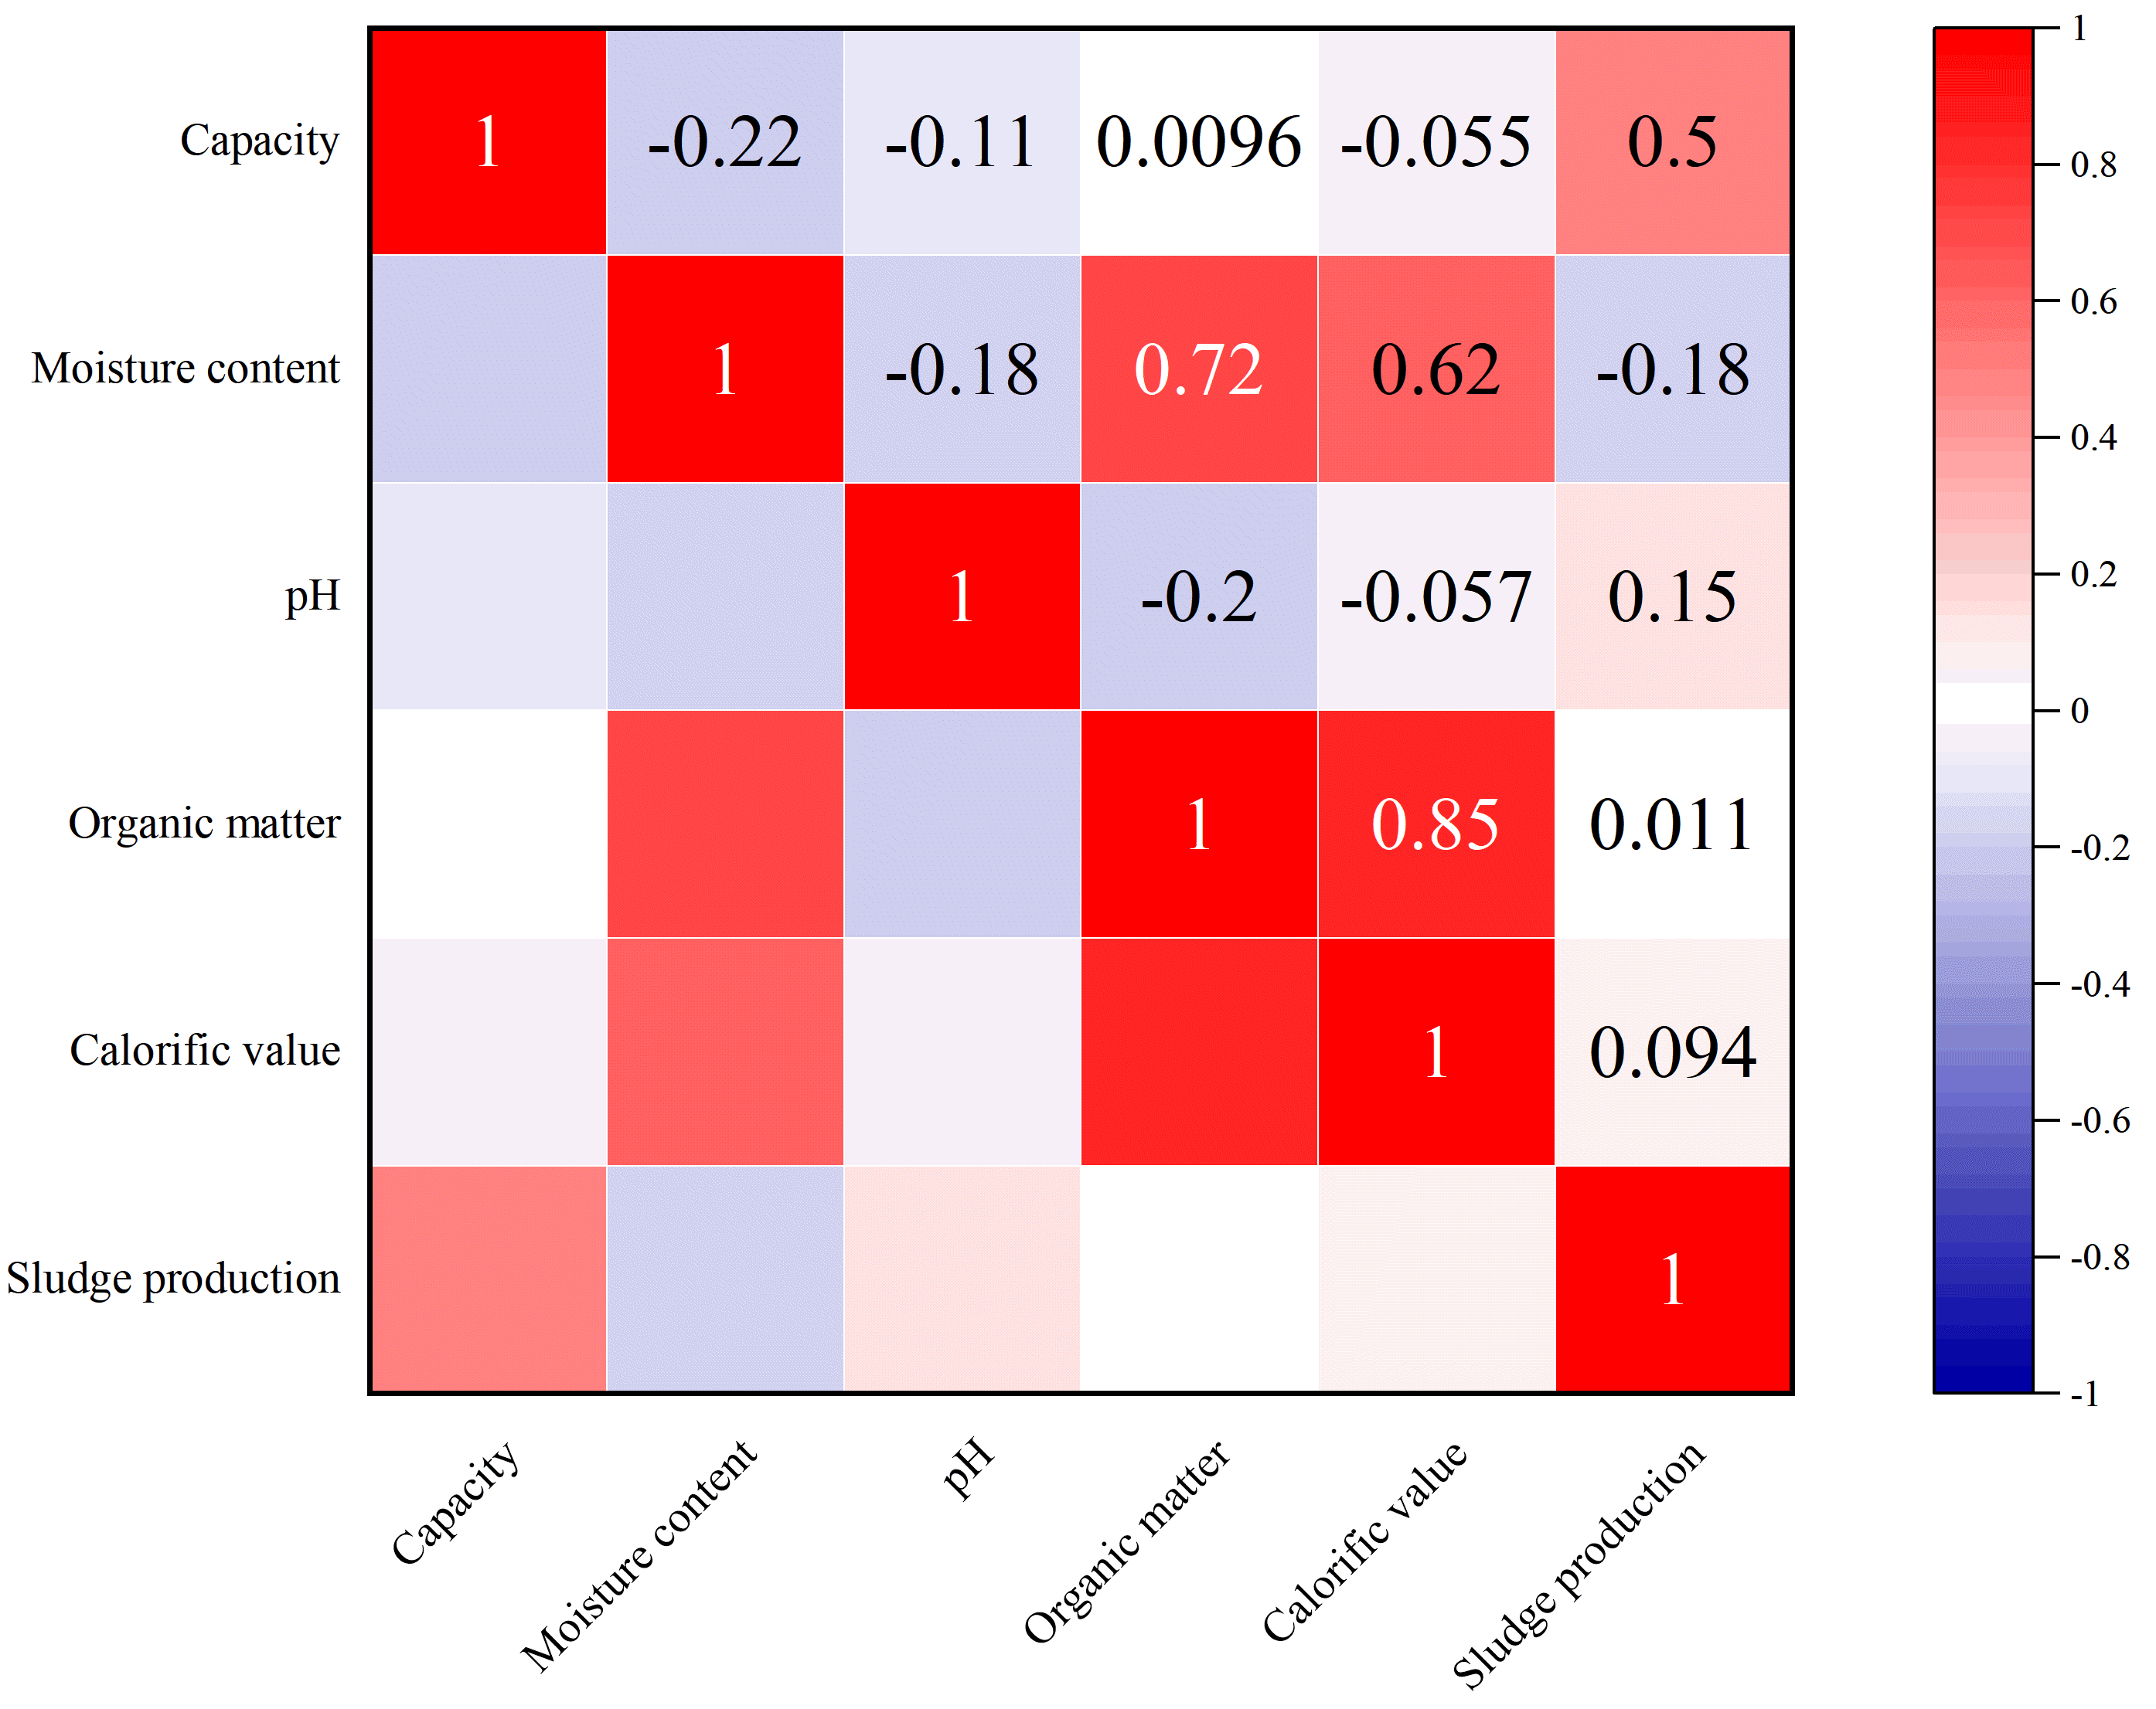

Figure S1. Correlation analysis of key sludge characteristics.
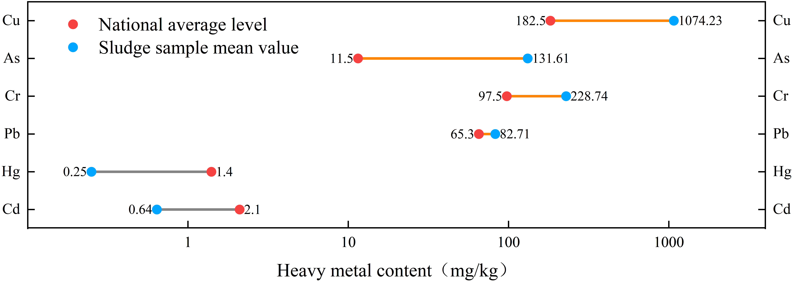

Figure S2. Comparison of average heavy metal content in sludge samples with national average levels

Figure S3. Nemerow single pollution index for sludge samples.

