Jacob Leonard

Math 467

Project #1

Imaginary Analysis

1. Analytically Compute the Gradient and Hessian of the Function: $f\left(x,y\right)= {|{\left(x+iy\right)}^{4}-1|}^{2}$

Evaluating the function at all the points on the intervals:

1. Graph of the function $f\left(z\right)= {|{\left(z\right)}^{4}-1|}^{2}$, z = (x+iy)

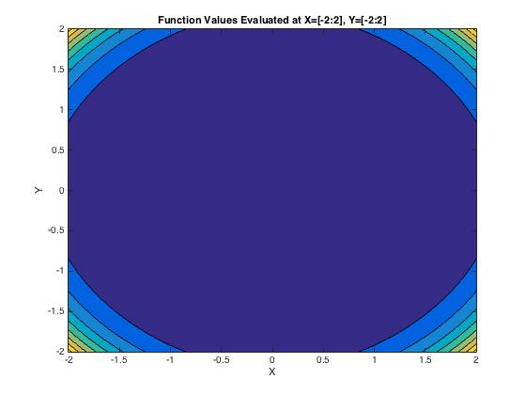

1. Graph of the real values

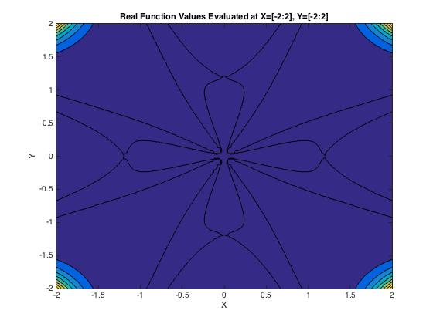

1. Graph of the imaginary values

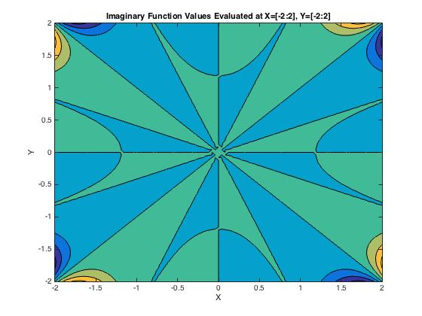

1. Gradient: $∇f\left(x,y\right)=\left[8{(\left(x+iy\right)}^{4}-1\right){(\left(x+iy\right)}^{3},8i{(\left(x+iy\right)}^{4}-1{)\left(x+iy\right)}^{3}];$
2. Hessian:

$H\left(x,y\right)=\left[24{(\left(x+iy\right)}^{2}\left(\left(\frac{7}{3}\right){\left(x+iy\right)}^{4}-1\right), 24i{(\left(x+iy\right)}^{2}\left(\left(\frac{7}{3}\right){\left(x+iy\right)}^{4}-1\right);24{i(\left(x+iy\right)}^{2}\left(\left(\frac{7}{3}\right){\left(x+iy\right)}^{4}-1\right), 24{(\left(x+iy\right)}^{2}\left(1-\left(\frac{7}{3}\right){\left(x+iy\right)}^{4}\right)\right)]$

1. Roots: $\left[y=ix+1,y=ix-1,y=ix+1,y=ix-i\right]$
2. Gradient Along Root Values;
   1. $∇f\left(x,ix+1\right)$ = [0,0]

x = [-2,2], y = ix+1

$∇f\left(x,ix-1\right)=[0,0]$

x = [-2,2], y = ix-1

* 1. = [0,0]

x = [-2,2], y = ix+i

* 1. = [0,0]

x = [-2,2], y = ix-i

1. Gradient Near Root Values: D = +.04
   1. $∇f\left(x,ix+1.04\right)$ = [-1.4698, - 1.4698i]

x = [-2,2}, y = ix+1.04

* Increasing the y value along this root by .04 produces a negative real X gradient and a negative imaginary Y gradient
  1. $∇f\left(x,ix-.96\right)$ = [1.1107, 1.1107i]

x = [-2,2}, y = ix-.96

* Increasing the y value along this root by .04 produces a real positive X gradient, and positive imaginary Y gradient
  1. $∇f\left(x,ix+i+.04\right)$ = [-0.1789 - 1.2698i, 1.2698 - 0.1789i]

x = [-2,2}, y = ix+i+.04

* Increasing the y value along this root by .04 produces a negative X gradient, positive real valued Y gradient and negative imaginary Y gradient
  1. $∇f\left(x,ix-i+.04\right)$ = [-0.1789 + 1.2698i, - 1.2698 - 0.1789i]

x = [-2,2}, y = ix-i+.04

* Increasing the y value along this root by .04 produces a negative Y gradient, negative real valued X gradient and positive imaginary X gradient

1. Gradient Near Root Values: D = -.04
   1. $∇f\left(x,ix+.96\right)$ = [1.1107, 1.1107i]

x = [-2,2}, y = ix+.96

* Decreasing the y value along this root by .04 produces a positive gradient that is isometric to its parallel y= $ix-.96$, meaning the function is symmetric about y = ix
  1. $∇f\left(x,ix-1.04\right)$ = [-1.4698 , - 1.4698i]

x = [-2,2}, y = ix-1.04

* Decreasing the y value along this root by .04 produces a positive gradient that is isometric to its parallel y= $ix+1.04$, meaning the function is symmetric about y = ix
  1. $∇f\left(x,ix+i-.04\right)$ = [-0.1789 + 1.2698i , -1.2698 - 0.1789i]

x = [-2,2}, y = ix+i-.04

* Decreasing the y value along this root by .04 produces a gradient that is isometric to its parallel y= $ix-i+.04$
  1. $∇f\left(x,ix-i-.04\right)$ = [-0.1789 - 1.2698i , +1.2698 - 0.1789i]

x = [-2,2}, y = ix-i-.04

* Decreasing the y value along this root by .04 produces a gradient that is isometric to its parallel y= $ix+i+.04$

1. Hessian Along Root Values:

$H\left(x,ix+1\right)=\left[-32,-32i,-32i,32\right];$

x = [-2,2], y = ix+1

$H\left(x,ix-1\right)=\left[-32,-32i,-32i,32\right]$

x = [-2,2], y = ix-1

* The hessian of the function along the parallel lines y = ix+1, y = ix+1 produces isometric matrices, meaning the function denatures at the same quadratic rate

$H\left(x,ix+i\right)=\left[32,32,32i,-32\right];$

x = [-2,2], y = ix+i

$H\left(x,ix-i\right)=\left[32,32,32i,-32\right];$

x = [-2,2], y = ix-i

* The hessian of the function along the parallel roots y=ix+1, y=ix-1 produces isometric matrices, meaning the function denatures at the same quadratic rate

1. Hessian Near Root Values: D = .04
   1. $H\left(x,ix+1.04\right)$ = [-44.8995, -44.8995i, -44.8995i , 44.8995]

x = [-2,2}, y = ix+1.04

* Increasing the y value along this root by .04 produces a highly negative hessian, except a positive quadratic Y term
  1. $H\left(x,ix-.96\right)$ = [-21.7160, -21.7160i, -21.7160i ,21.7160 ]

x = [-2,2}, y = ix-.96

* Increasing the y value along this root by .04 produces a highly negative hessian, except a positive quadratic Y term
  1. $H\left(x,ix+i+.04\right)$ = [30.6966 -11.4484i, 11.4484 +30.6966i,  
      11.4484 +30.6966i, -30.6966 +11.4484i]

x = [-2,2}, y = ix+i+.04

* Increasing the y value along this root by .04 produces a symmetric hessian with inverse quadratic terms
  1. $H\left(x,ix-i+.04\right)$ = [30.6966 +11.4484i, -11.4484 +30.6966i,  
      -11.4484 +30.6966i, -30.6966 -11.4484i]

x = [-2,2}, y = ix-i+.04

* Increasing the y value along this root by .04 produces a symmetric hessian with inverse quadratic terms, large negative Y and large positive X

1. Hessian Near Root Values: D = -.04
   1. $H\left(x,ix+.96\right)$ = [-21.7160 , -21.7160i, -21.7160i, 21.7160 ]

x = [-2,2}, y = ix+.96

* Decreasing the y value along this root by .04 produces a hessian equal to the line y = ix-.96, meaning the quadratic decomposition is symmetric about y = ix
  1. $H\left(x,ix-1.04\right)$ = [-44.8995, -44.8995i, -44.8995i , 44.8995]

x = [-2,2}, y = ix-1.04

* Decreasing the y value along this root by .04 produces a hessian equal to the line y = ix+1.04, meaning the quadratic decomposition is symmetric about y = ix
  1. $H\left(x,ix+i-.04\right)$ = [30.6966 +11.4484i, -11.4484 +30.6966i,  
      -11.4484 +30.6966i, -30.6966 -11.4484i]

x = [-2,2}, y = ix+i-.04

* Decreasing the y value along this root by .04 produces a hessian equal to the line y = ix-i+.04, meaning the quadratic decomposition is symmetric about y = ix
  1. $H\left(x,ix-i-.04\right)$ = [30.6966 -11.4484i, 11.4484 +30.6966i,  
      11.4484 +30.6966i, -30.6966 +11.4484i]

x = [-2,2}, y = ix-i-.04

* Decreasing the y value along this root by .04 produces a hessian equal to the line y = ix+i+.04, meaning the quadratic decomposition is symmetric about y = ix

Real Analysis

The above analysis looked at the function over the complex plane, but for the use of algorithms within Matlab, the following analysis will look at the function:

$$f\left(x,y\right)= {{\left(x^{4}+y^{4}-6x^{2}y^{2}-1\right)}^{2}+(4x^{3}y-4xy^{3})}^{2}$$

Evaluating the function at all points on the intervals:



1. Gradient:
$$∇f\left(x,y\right)=\left[8x(x^{6}+3x^{4}y^{2}+x^{2}\left(3y^{4}-1\right)+y^{2}(y^{4}+3\right)), 8x(x^{6}+3x^{4}y^{2}+{3x}^{2}\left(y^{4}+1\right)+y^{2}\left(y^{4}-1))\right];$$

2. Hessian:
$$H\left(x,y\right)=\left[8(7x^{6}+15x^{4}y^{2}+x^{2}\left(9y^{4}-3\right)+y^{2}\left(y^{4}+3\right)), 48xy(x^{4}+2x^{2}y^{2}+y^{4}+1);48xy(x^{4}+2x^{2}y^{2}+y^{4}+1), 8(x^{6}+9x^{4}y^{2}+{3x}^{2}\left(5y^{4}+1\right)+y^{2}\left(7y^{4}-3\right)\right)]$$

3. Roots: z = [1,0], [-1,0], [0,1], [0,-1]
4. Gradient Along Root Values:
   1. $∇f\left(x,y\right)$ = [0,0]

x = 1, y = 0

x = -1, y = 0

* 1. = [0,0]

x = 0, y = 1

* 1. = [0,0]

x = 0, y = -1

1. Gradient Near Root Values: D = .04
   1. $∇f\left(1,.04\right)$ = [0.0769, 1.2810]
   2. $∇f\left(-1,.04\right)$ = [-0.0769, 1.2810]

* The gradient at these two points show the function is symmetric about y and opposite about x
  1. $∇f\left(0,1.04\right)$ = [0, 1.5285]
  2. $∇f\left(0,-.96\right)$ = [0, 1.0663]
* The gradient at these points shows that the function has an x gradient of 0 about x=0 and positive in the y direction

1. Gradient Near Root Values: D= -.04
   1. $∇f\left(1,-.04\right)$ = [0.0769, -1.2810]

* The gradient at this point has the same X gradient and negative y gradient, meaning the function is negative symmetric about y=0
  1. $∇f\left(-1,-.04\right)$ = [-0.0769, -1.2810]
* The gradient at this point has the same X gradient and negative y gradient, meaning the function is negative symmetric about y=0
  1. $∇f\left(0,.96\right)$ = [0, -1.0663]
* The gradient at this point is the negative gradient at x = 0, y = -.96, meaning the function is negative symmetric about x = 0
  1. $∇f\left(0,-1.04\right)$ = [0, -1.5285]
* The gradient at this point is the negative gradient at x = 0, y = -.96, meaning the function is negative symmetric about x = 0

1. Hessian At Root Values:

$H\left(1,0\right)=[32,0;0,32]$

$H\left(-1,0\right)=[32,0;0,32]$

$H\left(0,1\right)=[32,0;0,32]$

$H\left(0,-1\right)=[32,0;0,32]$

* All of the hessians are equal at the roots of the function, showing that the minimum of the function is dictated by the quadratic terms, and denatures in the same way

1. Hessian Near Root Values: D = .04

$H\left(1,0.04\right)=[32.2306,3.8461;3.8461,32.0771]$

$H\left(-1,0.04\right)=[32.2306,-3.8461;-3.8461,32.0771]$

* These two hessians have the same quadratic growth, but denature linearly inversely
$H\left(0,1.04\right)=[36.0810,0;0,44.8995]$

$H\left(0,-.96\right)=[28.3805,0;0,21.7160]$

* These two hessians both have zero linear terms and positive quadratic terms, and so both increase about x = 0, y $≠$ 1

1. Hessian Near Root Values: D = -.04

$H\left(1,-0.04\right)=32.2306,-3.8461;-3.8461,32.0771]$

* The hessian at this point is equal to the hessian at x = -1, y=.04, meaning the function is quadratically symmetric about y=-.04x
$H\left(-1,-.04\right)=[32.2306,3.8461;3.8461,32.0771]$

* The hessian at this point is equal to the hessian at x = 1, y=.04, meaning the function is quadratically symmetric about y=.04x
$H\left(0,.96\right)=[28.3805,0;0,21.7160]$

* The hessian at this point is equal to x=0, y=-.96, meaning the function is symmetric about x = 0
$H\left(0,-1.04\right)=[36.0810,0;0,44.8995]$

* The hessian at this point is equal to x=0, y=-.96, meaning the function is symmetric about x = 0

Analysis of code and Matlab scripts:

To help with the use of computer code, and the computations, a new variable z = [z1,z2] was created

Plot of the new function f(z), where z1 = x4, z2 = y4, z1 = [0:16], z2 = [0:16]

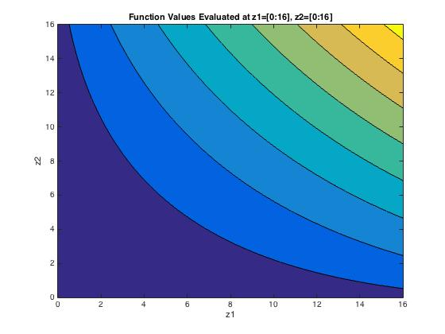

Because Z cannot be negative, this plot is a mirror image of the other 4 quadrants,

1. Fixed Step Size
   1. This code employs the use of a fixed step size to converge to the minimal solution. The fixed step size only converges
   2. The Fixed Step Size Gradient Method requires the step size to be larger than 0, but smaller than 2/lambda(max) if it is to converge. Larger step sizes require fewer steps to converge, but have less accuracy. Smaller lambda take more steps to converge, but increase the accuracy of the estimates
   3. Q = [1,3;1,3] , 0 = (1-x)(1-x)-9 = x2-2x-8 = (x-4)(x+2) -> x=4,-2
   4. In order to converge, alpha must be larger than 0 and less than .5
   5. For the following plots, I choose alpha = .05, .15 (yellow=high, blue=low)

Alpha = .05

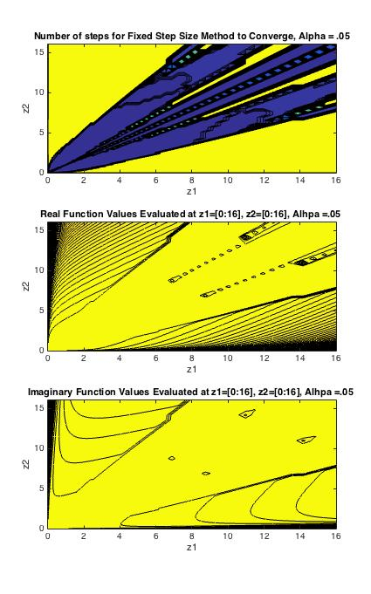

Alpha = .15

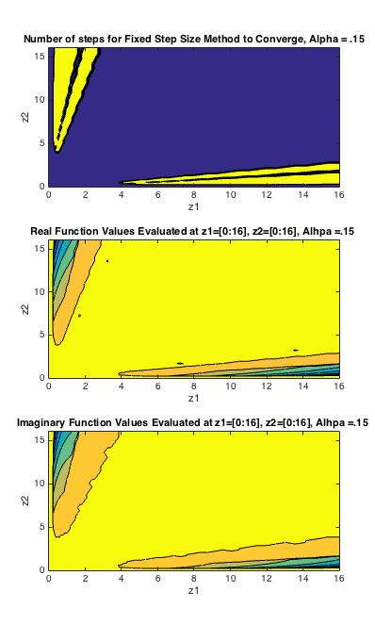

* 1. The first plot shows the number of steps it took the algorithm to converge to a value, with blue being low, and yellow being high. The second plot shows the real values of the function at the value the algorithm converged. The third plot shows the imaginary values of the function at the value the algorithm converged to.
  2. You can see from the two plots above that the size of the step involved in the algorithm determines how the various points converge. With a larger alpha, it takes fewer steps for a point to “converge”, but the distance in value from that point to a real minimum is much larger. With a smaller alpha, the number of steps it takes to get to a minimal value is much larger, but the minimal value is much closer to a true minimum

1. Conjugate gradient method with Fletcher-Reeves formula
   1. This code employs the use of conjugate gradient directions to dictate the descent of the algorithm to minimum solutions, with the fletcher reeves formula to determine the step sizes of the subsequent directions
2. Newton’s Method with Backtracking
   1. This code employs the use of Newton’s method with 1st and 2nd derivatives to determine the direction of the iterations, as well as backtracking to determine the optimal size of alpha at each iteration

* add color bars to plots to give scale

The Fixed Step algorithm fails to converge for most of the values down the diagonal of the values because the gradient runs along that line. Although the minimums are at (0,1) and (1,0), if the gradient method is used, the iterations get sucked into the diagonal gradient, and converge to a small value that is not the minimum.