Supplementary material for

**Developing a variable charge potential for Hf/Nb/Ta/Ti/Zr/O system via machine learning global optimization**

**Yihan Wu Wenshan Yu Shengping Shen**

State Key Laboratory for Strength and Vibration of Mechanical Structures, Shaanxi Engineering Laboratory for Vibration Control of Aerospace Structures, School of Aerospace Engineering, Xi'an Jiaotong University, Xi'an 710049, People's Republic of China

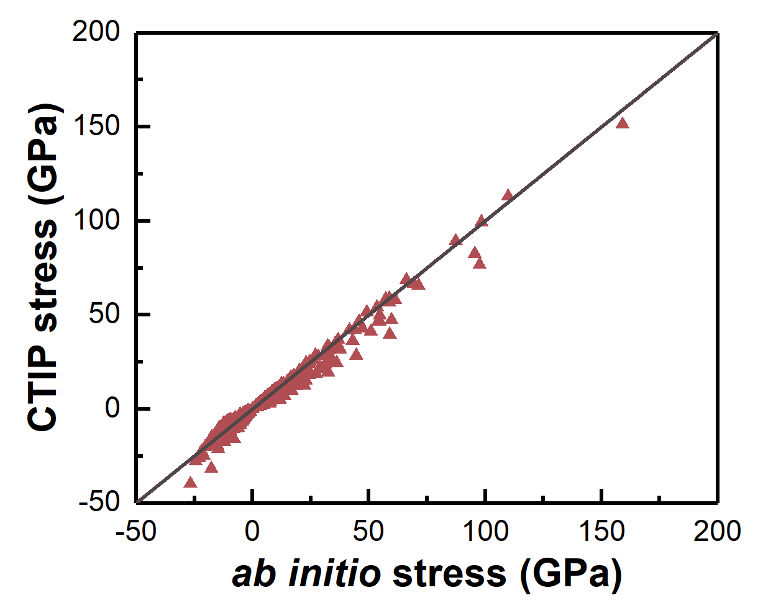

**Figure S1** Comparison between the stress tensors calculated using *ab initio* method and CTIP.

**S1. The charge transfer ionic potential (CTIP)**

In this section, detailed functional form of the CTIP [1] is given. The CTIP decomposes the total energy of the system, *E*, as a sum of electrostatic energy *E*es and non-electrostatic energy *E*ne [1, 2]:

*E* = *E*es + *E*ne. (S1)

In Eq. S1, *E*es depends on both the positions and charges of atoms and can be expressed as

, (S2)

where *N* is the number of atoms in the system, *q*min,i and *q*max,i are the charge bounds for an atom *i* which vary from zero to the valence value. The coefficient *ω* imposes an energy penalty when the atomic charge exceeds the physical range [1]. *X*i and *V*ij are the self-ionic energy and Coulombic interaction respectively, and can be expressed as

, (S3)

, (S4)

where *k*c = 14.4 eVÅ*e*-2 is the Coulomb constant (*e* represents net electron charge). *χ*i and *J*i represent the electronegativity and atomic hardness, respectively. The Coulombic integrals [*a*|*fb*] and [*fa*|*fb*] are calculated based on the assumption of spherical Slater-type electron orbitals as [1, 2]

, (S5)

, (S6)

. (S7)

During the simulation, the atomic charges can dynamically vary based on local environments, which is achieved by searching the optimal set of charges that obeys charge neutral condition and minimizes *E*es. The corresponding potential parameters *Z*i, *χ*i, *ξ*i and *J*i are listed in Table S1.

**Table S1** The potential parameters for the electrostatic energy part.

|  |  |  |  |  |  |  |
| --- | --- | --- | --- | --- | --- | --- |
| **Element** | ***q*min (*e*)** | ***q*max (*e*)** | ***χ* (eV *e*-1)** | ***J* (eV *e*-2)** | ***ξ* (Å-1)** | ***Z* (*e*)** |
| **O** | -2 | 0 | 2.000000 | 16.375151 | 1.077733 | 0.000 00 |
| **Hf** | 0 | 4 | -4.252614 | 14.953699 | 1.402745 | 1.729489 |
| **Nb** | 0 | 5 | -4.284022 | 11.003551 | 0.315922 | 1.366630 |
| **Zr** | 0 | 4 | -3.903803 | 11.785781 | 0.864686 | 1.477683 |
| **Ti** | 0 | 4 | -3.611657 | 13.539700 | 1.656379 | 1.256687 |
| **Ta** | 0 | 5 | -3.697001 | 12.558403 | 1.597987 | 0.964032 |

For the non-electrostatic term *E*ne, we adopt the Zhou and Wadley version of embedded atom method (EAM) functional form [1, 3, 4]:

. (S8)

In Eq. S8, *φ*ij(*r*ij) is the pairwise interaction between atoms *i* and *j*, *F*i is the embedding energy and *ρ*i is the background electron density. The pairwise interaction is described by a Morse-like function divided by a natural cutoff function [4, 5] as

. (S9)

In the original EAM, the exponents in the cutoff function are fixed as 20 [4]. Nonetheless, owing to the similar first- and second-nearest-neighbor distances in FCC and HCP crystals (they are exactly the same in ideal HCP with *c*/*a*=1.633 and FCC structures) [6], such fixed cutoff exponents may lead to an indistinguishable energy difference between FCC and HCP phases. This may further influence the prediction accuracy on the plastic behaviors since the stacking fault energies for FCC and HCP crystals can be closely related to such an energy difference [7]. As a result, the contribution of third-nearest-neighbor [8, 9] to the pairwise energy should be properly included. In this study, a modified cutoff function is proposed as

, (S10)

where new adjustable parameters *m* and *n* are included and *H*(*x*) is the Heaviside step function.

In Eq. S8, *F*i represents the energy required to embed an atom into a lattice site with a background electron density *ρ*i. In this study, different expressions are adopted for the embedded functions of metals and oxygen. *F*i for oxygen is expressed using a cubic spline function as

, (S11)

where *ρ*e is the equilibrium electron density for a ground state crystal structure and *j* varies from 0 to *M* (the number of metal elements). For metals, the *F*i is expressed as

, (S12)

Finally, the electron density *ρ*i is defined as the sum of atomic electron density *f*i provided by neighboring atoms *j* around central atom *i*

, (S13)

. (S14)

The potential parameters for the Hf/Nb/Zr/Ti/Ta/O EAM potential are listed in Tables S2~S4.

**Table S2** EAM parameters for pure metals.

|  |  |  |  |  |  |  |  |
| --- | --- | --- | --- | --- | --- | --- | --- |
| **Element** | ***r*e (Å)** | ***f*e** | ***ρ*e** | ***ρ*s** | ***α*** | ***β*** | ***A* (eV)** |
| **Hf** | 3.036695 | 2.279201 | 39.447272 | 18.953257 | 7.340695 | 2.986907 | 0.626761 |
| **Nb** | 2.841095 | 2.889829 | 31.417267 | 31.699834 | 7.595435 | 4.417068 | 0.579206 |
| **Zr** | 3.151684 | 2.196376 | 38.378598 | 14.274940 | 7.456545 | 3.244183 | 0.499557 |
| **Ti** | 2.833527 | 1.953310 | 32.274144 | 10.692859 | 6.939830 | 3.146787 | 0.627344 |
| **Ta** | 2.791418 | 3.091057 | 31.431176 | 28.577385 | 8.259481 | 4.143922 | 0.689443 |
| **Element** | ***B* (eV)** | ***κ*** | ***λ*** | ***m*** | ***n*** | ***F*n0 (eV)** | ***F*n1 (eV)** |
| **Hf** | 0.645988 | 0.440318 | 1.172855 | 38 | 21 | -4.369507 | -0.516980 |
| **Nb** | 0.909354 | 0.138183 | 0.368801 | 18 | 21 | -4.924136 | -0.535647 |
| **Zr** | 0.623267 | 0.370194 | 1.100718 | 26 | 23 | -4.137022 | -0.294409 |
| **Ti** | 0.672419 | 0.438699 | 1.163775 | 21 | 23 | -3.093380 | -0.321162 |
| **Ta** | 1.019847 | 0.176531 | 0.390894 | 17 | 21 | -5.326794 | -0.579329 |
| **Element** | ***F*n2 (eV)** | ***F*n3 (eV)** | ***F*0 (eV)** | ***F*1 (eV)** | ***F*2 (eV)** | ***F*-3 (eV)** | ***F*+3 (eV)** |
| **Hf** | 0.710178 | -3.142348 | -4.412630 | 0 | 1.695061 | -1.476944 | 1.534853 |
| **Nb** | 1.649732 | -2.738757 | -4.970108 | 0 | 1.928528 | -0.764655 | -0.765052 |
| **Zr** | 0.938471 | -2.904141 | -4.165324 | 0 | 1.464487 | 1.377518 | 0.260959 |
| **Ti** | 0.496175 | -2.276043 | -3.120445 | 0 | 1.089671 | -0.754620 | 0.239451 |
| **Ta** | 1.230484 | -3.516980 | -5.378197 | 0 | 2.310024 | 0.169535 | 2.618849 |
| **Element** | ***η* (eV)** | ***F*e (eV)** |  |  |  |  |  |
| **Hf** | 0.356582 | -4.646960 |  |  |  |  |  |
| **Nb** | 0.909898 | -4.967403 |  |  |  |  |  |
| **Zr** | 0.278061 | -4.399337 |  |  |  |  |  |
| **Ti** | 0.262594 | -3.315911 |  |  |  |  |  |
| **Ta** | 0.805663 | -5.427809 |  |  |  |  |  |

**Table S3** EAM parameters for cross-term interactions.

|  |  |  |  |  |  |  |  |  |  |
| --- | --- | --- | --- | --- | --- | --- | --- | --- | --- |
| **Pair** | ***r*e (Å)** | ***α*** | ***β*** | ***A* (eV)** | ***B* (eV)** | ***κ*** | ***λ*** | ***m*** | ***n*** |
| **Hf-Nb** | 2.969511 | 8.756233 | 3.076312 | 0.410802 | 0.573587 | 1.062141 | 1.207085 | 28 | 26 |
| **Hf-Zr** | 3.411035 | 8.219280 | 3.379865 | 0.255156 | 0.455267 | 0.298418 | 0.934017 | 20 | 26 |
| **Hf-Ti** | 3.229927 | 7.929612 | 3.149661 | 0.289205 | 0.486683 | 0.803686 | 0.975948 | 20 | 20 |
| **Hf-Ta** | 3.226335 | 9.210666 | 3.547917 | 0.235810 | 0.503209 | 0.826245 | 1.0753 | 18 | 20 |
| **Nb-Zr** | 2.998161 | 8.519996 | 3.162518 | 0.384227 | 0.593337 | 1.011727 | 1.175926 | 24 | 28 |
| **Nb-Ti** | 2.874570 | 8.221129 | 3.631985 | 0.479955 | 0.653086 | 0.884104 | 1.054186 | 20 | 20 |
| **Nb-Ta** | 2.617376 | 7.704793 | 3.610211 | 0.934650 | 1.147555 | 0.249344 | 0.477396 | 18 | 20 |
| **Zr-Ti** | 5.975460 | 14.393860 | 6.133182 | 0.000420 | 0.031419 | 0.76071 | 0.085286 | 20 | 20 |
| **Zr-Ta** | 4.697030 | 12.892805 | 6.033640 | 0.004683 | 0.074825 | -0.279701 | 0.993989 | 18 | 22 |
| **Ti-Ta** | 5.910024 | 16.068098 | 9.446161 | 0.000177 | 0.006090 | -0.428474 | 1.009379 | 20 | 20 |
| **Hf-O** | 1.938218 | 7.899236 | 3.162444 | 0.983139 | 1.574250 | 0.464820 | 1.028556 | 20 | 20 |
| **Nb-O** | 1.489420 | 6.677822 | 3.811131 | 1.198669 | 0.945410 | 0.496161 | 1.121436 | 20 | 20 |
| **Zr-O** | 1.966073 | 6.885521 | 3.461640 | 0.959256 | 1.486355 | 0.526812 | 1.083523 | 20 | 20 |
| **Ti-O** | 1.651221 | 7.071813 | 2.730021 | 1.065502 | 1.474285 | 0.359030 | 0.654934 | 20 | 20 |
| **Ta-O** | 1.985520 | 6.569020 | 3.931190 | 1.173747 | 1.842358 | 0.621463 | 0.868149 | 20 | 20 |
| **O-O** | 2.411822 | 6.664614 | 3.205781 | 1.787134 | 1.397276 | 0.438147 | 0.704935 | 20 | 20 |

**Table S4** EAM parameters for oxygen embedded energy.

|  |  |  |  |  |  |
| --- | --- | --- | --- | --- | --- |
| ***i*** | ***F*0,*i* (eV)** | ***F*1,*i* (eV)** | ***F*2,*i* (eV)** | ***F*3,*i* (eV)** | ***ρ*e,*i*** |
| **0** | -2.09295 | 4.26048 | 6.4839 | 0.13047 | 59.777080 |
| **1** | -1.13802 | 7.72000 | 9.02556 | 0 | 70.325976 |
| **2** | 0.81325 | 13.01013 | 8.35517 | 0 | 84.894593 |
| **3** | 2.40945 | 16.30812 | 7.11618 | 0 | 94.647314 |
| **4** | 5.30016 | 20.90029 | 3.35381 | 0 | 110.459837 |
| **5** | 8.21773 | 25.16077 | 7.49615 | 0 | 125.491179 |

**S2. Details of the training and test configurations**

In this paper, training of the CTIP potential is an optimization problem. The derivative-free ML optimization tool is used to search an optimal parameter set that minimizes the prediction error of CTIP against various energetic, structural and mechanical properties of metals, intermetallic compounds and oxides. The simulation settings of training and test configurations are detailed as follows.

* Cohesive energies, lattice constants and ground-state atomic coordinates: 5×5×5 supercells. The sizes of simulation models are allowed to change during structural relaxation. Length variations in *x, y* and *z* directions are not coupled.
* Surface energies: 5×5×10 supercells. Free surfaces are created by using non-periodic boundaries along *z*-direction. *xy* sizes of the models are allowed to change during relaxation.
* Stacking fault energies: 3×3×6 supercells. Three-dimensional periodic boundaries are employed (namely, two stacking faults in the model). Shape of the simulation models are fixed. Rigid body translation (RBT) [10, 11] are applied in different directions for different polymorphs (i.e., (0001)<1100> for HCP crystals, (110)<111> and (112)<111> for BCC crystals, etc.) to calculate the generalized stacking fault energy (GSFE) curves.
* Equations of state (related to bulk modulus): 5×5×5 supercells. Hydrostatic strains range from -0.5 to 0.5 in an interval of 0.05.
* Elastic constants: 5×5×5 supercells. Elastic strains range from -0.015 to 0.015 in an interval of 0.005. Elastic constants are calculated by quadratic regression of the energy variation with strain [12].
* Stress tensors of all the above configurations are calculated and added to the training data.

**S3. Settings of the dynamic simulations**

**S3.1 Calculating the chemical short-range order of RHEA**

A 40*a*×40*a*×40*a* supercell of RHEA model is first created with a randomized initial elemental distribution. Three-dimensional periodic boundary conditions are applied to the model. The model is equilibrated at 300K for 50ps in NPT ensemble to release thermal stress. Thereafter, the density, lattice constant and elastic constants are measured. Then, a Monte Carlo (MC) simulation is conducted by randomly swapping the occupation sites of elements to reach lower system energy [13, 14], which is an imitation of long-period elemental diffusion. We employ a simulated annealing strategy in which the temperature gradually decreases from 2073K to room temperature in steps of 100K. Each MC swap is coupled with one MD step. The Metropolis criterion [13, 15] is adopted as acceptance criterion of the swap trial. During the whole annealing process, NPT ensemble is employed to allow thermal expansion/contraction. After the hybrid MC/MD optimization, the Warren-Cowley order parameters are calculated using the following expression [8, 16, 17]:

, (S15)

where *m* is the *m*th nearest-neighbor shell of the central atom *i*. is the probability of find a *j*-type atom in the *m*th shell, *Cj* is the overall concentration of element *j* and  is the Kronecker delta function.

**S3.2 Uniaxial tensile loading of single crystalline RHEA nanopillar**

A 20*a*×20*a*×50*a* supercell of RHEA nanopillar is first created as shown in Fig. 8a. Periodic boundaries are set in *z* direction while shrink-wrapped boundaries are applied in *x* and *y* directions to create free surfaces. The model is then subjected to a hybrid MC/MD optimization for 100ps. After a subsequent equilibration at 300K, the nanopillar is subjected to uniaxial tensile loading in *z* direction under a typical MD strain rate of 108/s [18]. The corresponding stress-strain data are calculated and shown in Fig. 8b.

It is noteworthy that the loading curve of a single crystalline nanopillar in Fig. 8b cannot be directly compared to experimental results of polycrystals. Therefore, we have conducted an additional simulation about a nanocrystalline RHEA with average grain size of 5nm under uniaxial loads as displayed in Fig. S2a. The mechanical response at 300K predicted using CTIP is well consistent with the loading curve observed in a recent experiment [19]. The slightly higher yield strength can be ascribed to the higher MD strain rate than that used in experiments as well as the fine grain size.

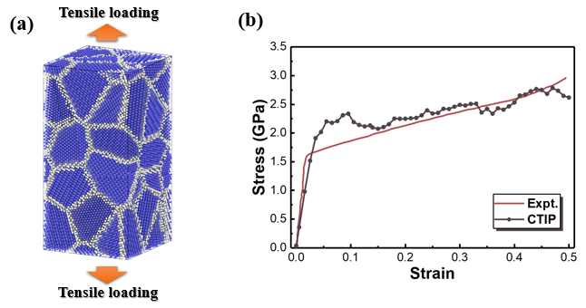

**Figure S2** (a) Polycrystalline HfNbTaTiZr RHEA model subjected to uniaxial loading. Blue atoms are in grain interior with BCC structure; white atoms are at grain boundaries. (b) The mechanical response calculated using CTIP in comparison to experimental results [19].

**S3.3 Dislocation glide**

The generalized stacking fault energy (GSFE) curve is first calculated. A 3×3×6 supercell is created with its *x, y* and *z* directions align with [111], [11-2] and [-110] orientations. The upper half of the model is then displaced along x direction in steps of 1/20 unit length of the <111> BCC direction. After each displacement, the model is energy-minimized using conjugate-gradient method. The energy variation with displacement of identical model is calculated respectively using CTIP and *ab initio*. The GSFE results are shown in Fig. 9.

A 30×10×12 supercell is created with its *x, y* and *z* directions align with [111], [11-2] and [-110]. Periodic boundary conditions are applied in *x* and *y* direction while free surfaces are employed in *z* direction. A central 1/2<111> edge dislocation is then created using the Osetsky method [20]. After a hybrid MC/MD relaxation under NPT ensemble for 50ps, shear loadings are applied to the model under NVT ensemble following the methods in Refs. [7, 20]. Surface atoms with a thickness of 1.0 nm are fixed as shown in Fig. 10a. Then, the upper fixed layer is gradually displaced along *x* direction under a nominal strain rate of 108/s. The mechanical response during loading is recorded and shown in Fig. 10b.

**S3.4 Uniaxial tensile loading of RHEA bicrystal**

A ∑5 (210) GB model is created by join two symmetric grains as shown in Fig. 11. Each grain is a 15×8×25 supercell. Periodic boundary conditions are applied in *x* and *y* directions (within the GB plain) while free surface condition is used in *z* direction (normal to GB plain). After static energy minimization, the system is heated to room temperature and is subjected to a hybrid MC/MD relaxation for 150ps. The atomic volume at GB region before and after relaxation is computed using Voronoi method [21]. The atomic fraction along *z* direction is calculated using fifty bins.

After the structural relaxation, surface atoms in two 1.0 nm layers are set as the boundary layers. The uniaxial tensile loads are then applied through displacing the boundary layers in a nominal strain rate 108/s. During loading stage, NPT ensemble is adopted, which allows *x* and *y* lengths of the model to freely expand/contract. The corresponding structural evolution and mechanical response are recorded.

**S3.5 Surface oxidation of RHEA**

A 10×10×12 supercell is created to model a RHEA thin film. Periodic boundaries are applied in *x* and *y* directions; reflective boundary is employed in *z* direction. The model is first heated to 300K and equilibrated at this temperature for 100ps using NPT ensemble to release thermal stress. Thereafter, three oxygen molecules are inserted to the vacuum space above the RHEA slab, corresponding to ~5MPa oxygen pressure according to the ideal gas law. We select such a gas pressure so that it not only enables a fast surface oxidation within the MD time scale, but is still low enough to ensure the oxidation mechanism uninfluenced, as reported in previous works [13, 22-24]. The oxidation process lasts for 200ps under NVT ensemble, during which the oxygen pressure is maintained by timely supply new O2 once previous molecules are consumed.

The average coordination number of oxygen atoms around each metal element is calculated from the partial radial distribution functions (RDFs). The M-O (M represents different metal elements) RDF curves are first computed. The coordination number is then computed using integral of the RDFs from zero to the first valley in each curve [23, 24].

**S3.6 Structural optimization of an ordered oxide complex**

A 20×20×20 supercell of single crystalline RHEA is created with initial random elemental distribution. Considering similar binding energies of oxygen atoms at octahedral and tetrahedral sites [25, 26], a central OOC with a 15Å radius is constructed by randomly inserting oxygen at the two interstitial sites with equal frequencies. Different numbers of O atoms are inserted (i.e., O/M from 0.5 to 2.0) to consider the influence of oxygen concentration on CSRO. A hybrid MC/MD optimization is then performed by swapping metal atoms while keeping the O atoms unchanged. After a 500ps optimization, the atomic fraction of each metal element within the OOC region is counted and displayed in Fig. 14b.

**References:**

[1] **Zhou, X.W., Wadley, H.N.G., Filhol, J.S., and Neurock, M.N.**, *Modified charge transfer--embedded atom method potential for metal/metal oxide systems.* Physical Review B, 2004. **69**(3): p. 035402.

[2] **Streitz, F.H. and Mintmire, J.W.**, *Electrostatic potentials for metal-oxide surfaces and interfaces.* Physical Review B, 1994. **50**(16): p. 11996-12003.

[3] **Zhou, X.W., Wadley, H.N.G., Johnson, R.A., Larson, D.J., Tabat, N., Cerezo, A., Petford-Long, A.K., Smith, G.D.W., Clifton, P.H., Martens, R.L., and Kelly, T.F.**, *Atomic scale structure of sputtered metal multilayers.* Acta Materialia, 2001. **49**(19): p. 4005-4015.

[4] **Wadley, H.N.G., Zhou, X., Johnson, R.A., and Neurock, M.**, *Mechanisms, models and methods of vapor deposition.* Progress in Materials Science, 2001. **46**(3): p. 329-377.

[5] **Morse, P.M.**, *Diatomic Molecules According to the Wave Mechanics. II. Vibrational Levels.* Physical Review, 1929. **34**(1): p. 57-64.

[6] **Fellinger, M.R., Park, H., and Wilkins, J.W.**, *Force-matched embedded-atom method potential for niobium.* Physical Review B, 2010. **81**(14): p. 144119.

[7] **Choi, W.-M., Jo, Y.H., Sohn, S.S., Lee, S., and Lee, B.-J.**, *Understanding the physical metallurgy of the CoCrFeMnNi high-entropy alloy: an atomistic simulation study.* npj Computational Materials, 2018. **4**(1): p. 1.

[8] **Li, X.-G., Chen, C., Zheng, H., Zuo, Y., and Ong, S.P.**, *Complex strengthening mechanisms in the NbMoTaW multi-principal element alloy.* npj Computational Materials, 2020. **6**(1): p. 70.

[9] **Zhou, X.W., Foster, M.E., and Sills, R.B.**, *An Fe-Ni-Cr embedded atom method potential for austenitic and ferritic systems.* Journal of Computational Chemistry, 2018. **39**(29): p. 2420-2431.

[10] **Hunter, A., Zhang, R.F., Beyerlein, I.J., Germann, T.C., and Koslowski, M.**, *Dependence of equilibrium stacking fault width in fcc metals on the γ-surface.* Modelling and Simulation in Materials Science and Engineering, 2013. **21**(2): p. 025015.

[11] **Jonathan, A.Z., Huajian, G., and Farid, F.A.**, *Generalized stacking fault energies for embedded atom FCC metals.* Modelling and Simulation in Materials Science and Engineering, 2000. **8**(2): p. 103.

[12] **Holec, D., Friák, M., Neugebauer, J., and Mayrhofer, P.H.**, *Trends in the elastic response of binary early transition metal nitrides.* Physical Review B, 2012. **85**(6): p. 064101.

[13] **Wu, Y., Yu, W., and Shen, S.**, *Strain-modulated initial oxidation of Al(1-x)Nix alloy surface.* Applied Surface Science, 2022. **592**: p. 153294.

[14] **Jeon, B. and Ramanathan, S.**, *Atomistic Modeling of Ultrathin Surface Oxide Growth on a Ternary Alloy: Oxidation of Al−Ni−Fe.* Journal of Physical Chemistry C, 2011. **115**(14): p. 6571-6580.

[15] **Mishra, S., Maiti, S., Dwadasi, B.S., and Rai, B.**, *Realistic microstructure evolution of complex Ta-Nb-Hf-Zr high-entropy alloys by simulation techniques.* Scientific Reports, 2019. **9**(1): p. 16337.

[16] **Koch, L., Granberg, F., Brink, T., Utt, D., Albe, K., Djurabekova, F., and Nordlund, K.**, *Local segregation versus irradiation effects in high-entropy alloys: Steady-state conditions in a driven system.* Journal of Applied Physics, 2017. **122**(10): p. 105106.

[17] **Li, Q.-J., Sheng, H., and Ma, E.**, *Strengthening in multi-principal element alloys with local-chemical-order roughened dislocation pathways.* Nature Communications, 2019. **10**(1): p. 3563.

[18] **Zhang, Q., Huang, R., Zhang, X., Cao, T., Xue, Y., and Li, X.**, *Deformation Mechanisms and Remarkable Strain Hardening in Single-Crystalline High-Entropy-Alloy Micropillars/Nanopillars.* Nano Letters, 2021. **21**(8): p. 3671-3679.

[19] **Yang, C., Aoyagi, K., Bian, H., and Chiba, A.**, *Microstructure evolution and mechanical property of a precipitation-strengthened refractory high-entropy alloy HfNbTaTiZr.* Materials Letters, 2019. **254**: p. 46-49.

[20] **Yu, N.O. and Bacon, D.J.**, *An atomic-level model for studying the dynamics of edge dislocations in metals.* Modelling and Simulation in Materials Science and Engineering, 2003. **11**(4): p. 427.

[21] **Yang, X., Zhou, T., and Chen, C.**, *Effective elastic modulus and atomic stress concentration of single crystal nano-plate with void.* Computational Materials Science, 2007. **40**(1): p. 51-56.

[22] **Wu, Y., Yu, W., and Shen, S.**, *Strain-modulated early stage oxidation of Fe films.* Journal of Applied Physics, 2019. **125**(24): p. 245305.

[23] **Hasnaoui, A., Politano, O., Salazar, J.M., and Aral, G.**, *Nanoscale oxide growth on Al single crystals at low temperatures: Variable charge molecular dynamics simulations.* Physical Review B, 2006. **73**(3): p. 035427.

[24] **Hasnaoui, A., Politano, O., Salazar, J.M., Aral, G., Kalia, R.K., Nakano, A., and Vashishta, P.**, *Molecular dynamics simulations of the nano-scale room-temperature oxidation of aluminum single crystals.* Surface Science, 2005. **579**(1): p. 47-57.

[25] **Lei, Z., Liu, X., Wu, Y., Wang, H., Jiang, S., Wang, S., Hui, X., Wu, Y., Gault, B., Kontis, P., Raabe, D., Gu, L., Zhang, Q., Chen, H., Wang, H., Liu, J., An, K., Zeng, Q., Nieh, T.-G., and Lu, Z.**, *Enhanced strength and ductility in a high-entropy alloy via ordered oxygen complexes.* Nature, 2018. **563**(7732): p. 546-550.

[26] **Ye, Y.X., Ouyang, B., Liu, C.Z., Duscher, G.J., and Nieh, T.G.**, *Effect of interstitial oxygen and nitrogen on incipient plasticity of NbTiZrHf high-entropy alloys.* Acta Materialia, 2020. **199**: p. 413-424.