Bk wallet blog documentation :

Using the website :

Login : If you want to log in to the website, add « bk_admin » at the end of the url. You have now access to a connection form.

Edit content : When you are logged in, you have access to new « edit » button beside of each content of the website. Just click on it you will have access to a new form that will allow you to edit the content.

Add, edit and delete a news : At the end of the website, you have an « Update » section, if you want to add any news to this section you have a « create » button available. You are free to choose if you want to add a picture or not. When you have finished to create the news it will appear with the other. If you want you can edit or delete it by clicking on the right button.

Updating the website :

Pictures : If you want to add a new picture to the website, it must be situated in « assets/image/ ». When it’s done you can call it like that :
« <?php echo base_url(); ?>assets/image/ + the name of your picture.jpg ».

Dynamic content : If you want to create a new dynamic content in your website, the first thing you need to do is to create a new tuple in « posts » table on the database. In order to get the right post you just have to do this (using the right tag for each element) :

<?php foreach($posts as $post) :
if ($post['id'] == 1) {
?>
<?php echo $post['title']; ?>
<?php echo $post['body']; ?>
<?php
}
endforeach; ?>

If you want to add an edit button in order to be able to edit this content online :

<?php if($this->session->userdata('user_id') == 1): ?>
<a class="btn btn-outline-primary" href="<?php echo base_url(); ?>posts/edit/<?php echo $post['slug'];?>"> Edit</a>
<?php endif; ?>

Adding a section : If you want to add a section you have to create a new file in « application/views/pages/ », add a class and a tag to the main <div> of the section :
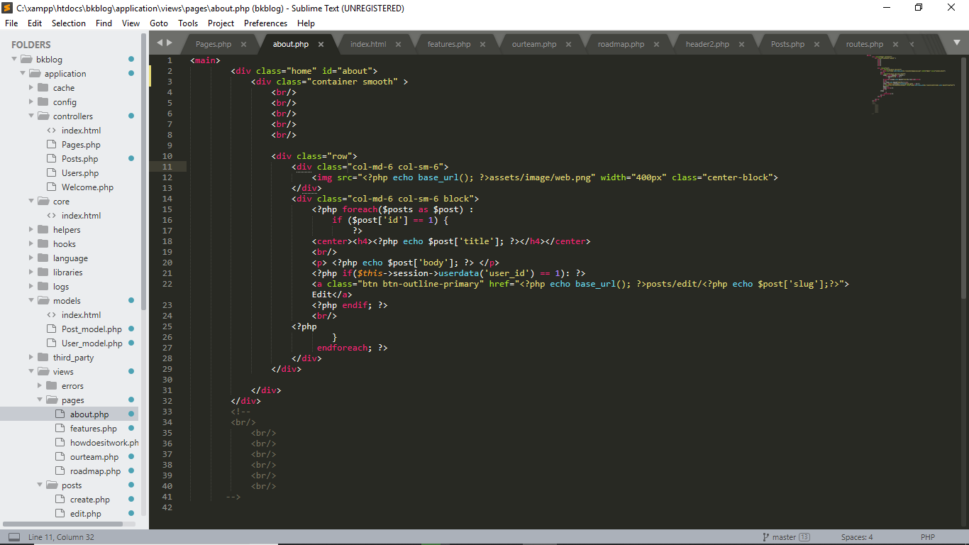

Add the section to your navbar in the « application/views/template/header.php » file. If you want your section to fit with the rest of the website I advice you to have the same structure as on an existing section.
In « application/controllers/Pages.php » add

$this->load->view('pages/yoursection', $data);

with the other sections.

Section « about » :
This section is the simplest, you can directly edit the text with the online editore. But if you want to change the picture or to add another element it is on the file « application/views/pages/about.php ».

Section « How does it work ? » :
This section is situated here : « application/views/pages/howdoesitwork.php ». If you want to add a new explanation. I advice you to create a post in the database and then Copy/paste this (change the id to the one of your post) :

<div class="line">
<img src="<?php echo base_url(); ?>assets/image/enterinformation.png" class="enterinformation rounded-circle" width="100px" height="90px">
<div class="column">
<?php foreach($posts as $post) :
if ($post['id'] == 3) {
?>
<h5> <?php echo $post['title']; ?></h5>
<p class="lilFont"><?php echo $post['body']; ?>
<?php if($this->session->userdata('user_id') == 1): ?></p>
<a class="btn btn-outline-primary" href="<?php echo base_url(); ?>posts/edit/<?php echo $post['slug'];?>"> Edit</a>
<?php endif; ?>

<?php
}
endforeach; ?>
</div>
</div>

Section features : This section is situated here : « application/views/pages/features.php » It is a similar section as before but if you want to add a new content use this template (and change the id) :

<div class="line">
<img src="<?php echo base_url(); ?>assets/image/pay.png" width="100px" height="100px" style="margin-top: 10%;">
<div class="column">
<?php foreach($posts as $post) :
if ($post['id'] == 6) {
?>
<h5> <?php echo $post['title']; ?></h5>
<p class="lilFont"><?php echo $post['body']; ?></p>
<?php if($this->session->userdata('user_id') == 1): ?>
<a class="btn btn-outline-primary" href="<?php echo base_url(); ?>posts/edit/<?php echo $post['slug'];?>"> Edit</a>

<?php
endif;
}
endforeach; ?>
</div>
</div>

Section roadmap : this section is here : « application/views/pages/roadmap.php » . This one is a little bit special if you want to had a new date, please use this template(and put the right id) :

<div class="column">
<?php foreach($posts as $post) :
if ($post['id'] == 14) {
?>
<img src="<?php echo site_url();?>assets/image/posts/<?php echo $post['post_image']; ?>" width="75px" height="75px" style="margin-left: auto; margin-right: auto;">
<img src="<?php echo base_url(); ?>assets/image/node.png" width="50px" height="50px" style="margin-left: auto; margin-right: auto;">
<center><h6><?php echo $post['title']; ?></h6></center>
<center><p style="font-size: 14px"><?php echo $post['body']; ?></p></center>
<?php if($this->session->userdata('user_id') == 1): ?>
<center><a class="btn btn-outline-primary" href="<?php echo base_url(); ?>posts/edit/<?php echo $post['slug'];?>"> Edit</a></center>
<?php
endif;
}
endforeach; ?>
</div>

!! But very important ! Be sur that it is situated in the « slickmap » div !!

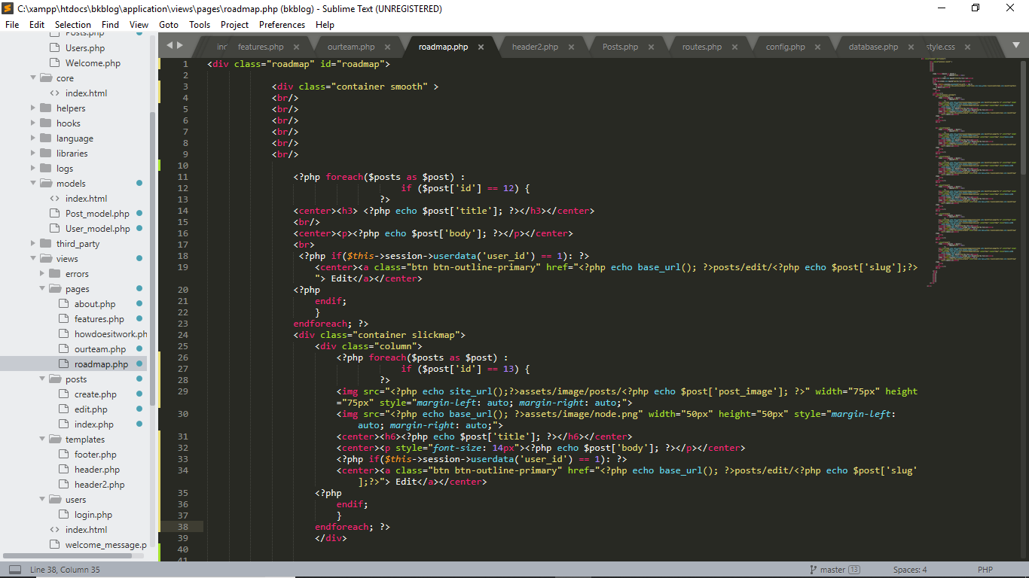

Section « our team » : This one is quite simple too, it is situtated here : « application/views/pages/ourteam.php »

