**Introduction**

See lab instructions.

**Objectives**

See lab instructions.

**Procedure**

*Introduction to Logisim*

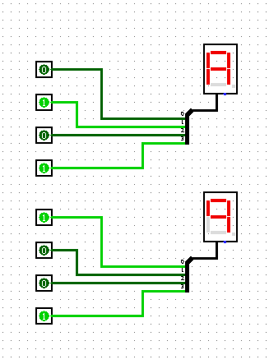

Figure 1: The assigned circuit to be created in logisim. This circuit is diplaying the hexadecimal number A9.

*Lab equipment*

I have read the lab documents and purchased the required breadboard and wire jumper kit.

*Number Conversions*

(0)10 = (0000)2 = (00)8 = (0)16

(1)10 = (0001)2 = (01)8 = (1)16

(2)10 = (0010)2 = (02)8 = (2)16

(3)10 = (0011)2 = (03)8 = (3)16

(4)10 = (0100)2 = (04)8 = (4)16

(5)10 = (0101)2 = (05)8 = (5)16

(6)10 = (0110)2 = (06)8 = (6)16

(7)10 = (0111)2 = (07)8 = (7)16

(8)10 = (1000)2 = (10)8 = (8)16

(9)10 = (1001)2 = (11)8 = (9)16

(10)10 = (1010)2 = (12)8 = (A)16

(11)10 = (1011)2 = (13)8 = (B)16

(12)10 = (1100)2 = (14)8 = (C)16

(13)10 = (1101)2 = (15)8 = (D)16

(14)10 = (1110)2 = (16)8 = (E)16

(15)10 = (1111)2 = (17)8 = (F)16

*MS Word*

|  |  |  |  |  |  |
| --- | --- | --- | --- | --- | --- |
|  |  |  |  |  |  |
|  |  |  |  |  |  |
|  |  |  |  |  |  |
|  |  |  |  |  |  |
|  |  |  |  |  |  |

*MS Word Again!*

A

B

*Base-2 Number Conversions*

(10110110)2 = (182)10 (266)8 = (B6)16

(1001)2 = (9)10 = (11)8 = (9)16

(1001010110)2 = (598)10 = (1126)8 = (256)16

*Base-16 Number Conversions*

(A6F3)16 = (1010011011110011)2 = (123363)8 = (42739)10

(D3)16 = (11010011)2 = (323)8 = (211)10

*Binary Addition*

10110102 + 1001112 = 10000001

1001.011012 + 101.1012 = 1111.00001

*1’s Complement*

1’s complement(10011102) = 01100012

1’s complement(101011012) = 010100102

*2’s Complement*

-910 - 710 = -1610

**Conclusion**

See lab instructions.