**Lab 2: Logic Gates**

Terence Henriod

CPE 201

February 5, 2013

**Introduction**

See lab instructions.

**Objectives**

See lab instructions.

**Procedure**

Part 1: Combinational Logic

Derive truth tables for the following circuits in Logisim using the "Circuit Analyzer". Include a screenshot of each circuit along with the ―Circuit Analyzer" used for determining the truth table in your lab report.

a)

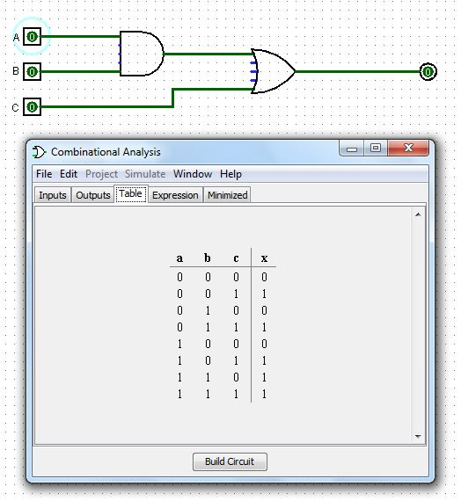

b)

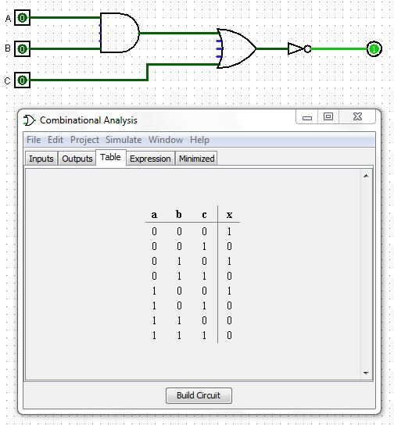

c)

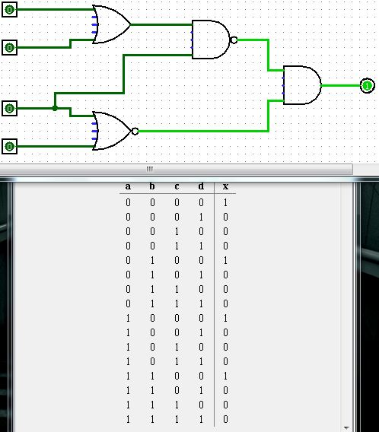

d)

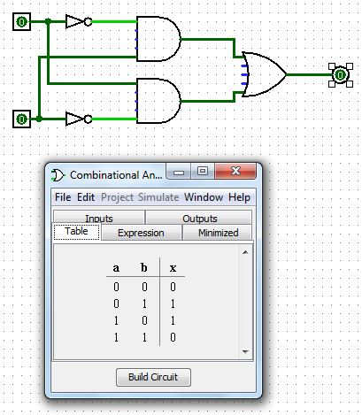

Part 2: Digital Circuit Design

Using truth tables, do the following problems **without use of Logisim**

Note: I didn’t use Logisim to solve the problems initially, but did use it to succinctly illustrate what components would be needed to accomplish the task as well as check the answer.

a) A circuit that outputs “1” only when A is“0” and “B” is “0”

|  |  |  |
| --- | --- | --- |
| A | B | Output |
| 0 | 0 | 1 |
| 1 | 0 | 0 |
| 0 | 1 | 0 |
| 1 | 1 | 0 |

🡪

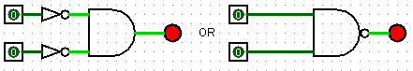

b) A circuit that outputs “1” only when A is“0” and “B” is “1”

|  |  |  |
| --- | --- | --- |
| A | B | Output |
| 0 | 0 | 0 |
| 1 | 0 | 0 |
| 0 | 1 | 1 |
| 1 | 1 | 0 |

🡪 🡪 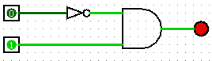

c) A circuit that outputs“1” only when A is “1” and “B” is “0”

|  |  |  |
| --- | --- | --- |
| A | B | Output |
| 0 | 0 | 0 |
| 1 | 0 | 1 |
| 0 | 1 | 0 |
| 1 | 1 | 0 |

🡪 🡪 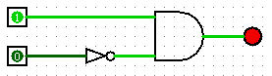

d) A circuit that outputs“1” only when A is “1” and “B” is “1”

|  |  |  |
| --- | --- | --- |
| A | B | Output |
| 0 | 0 | 0 |
| 1 | 0 | 0 |
| 0 | 1 | 0 |
| 1 | 1 | 1 |

🡪 🡪 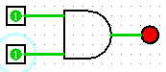

Part 3: Digital Circuit Implementation

a) Files viewed.

b) Read and learn about the XOR gate, answer the following:

1. What is the XOR IC’s name

“Exclusive Or”, or #7486

2. How many pins does it have?

14 pins

3. Which pin is the ground, which is the Vcc?

Pin 7 is the ground, Pin 14 is the Vcc

4. How many XOR gates are there in the IC?

There are 4 XORs in the chip

5. Which pin is the output of the gate whose pins are at pin #1 and pin #2?

Pins 1 and 2 are the input that correspond with the output that leaves pin 3.

c) Learned how to place chip in breadboard.

d) **The breadboard part!**

1. Pins identified.

2. Pre design of the circuit in Logisim:

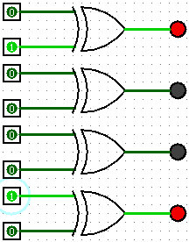

3. Vcc and ground pins properly connected.

4. Power supply connected with voltage off.

5. Input pins connected to switches.

6. Output pins connected to LEDs.

7. Apply voltage and use switches to display (9)10 = (1001)2

Note: Due to the broken input for the 3rd LED in the series (as can be seen in the photo), we had to use what appears to be a fifth LED. It may appear we produced 10001, but 1001 was actually produced.

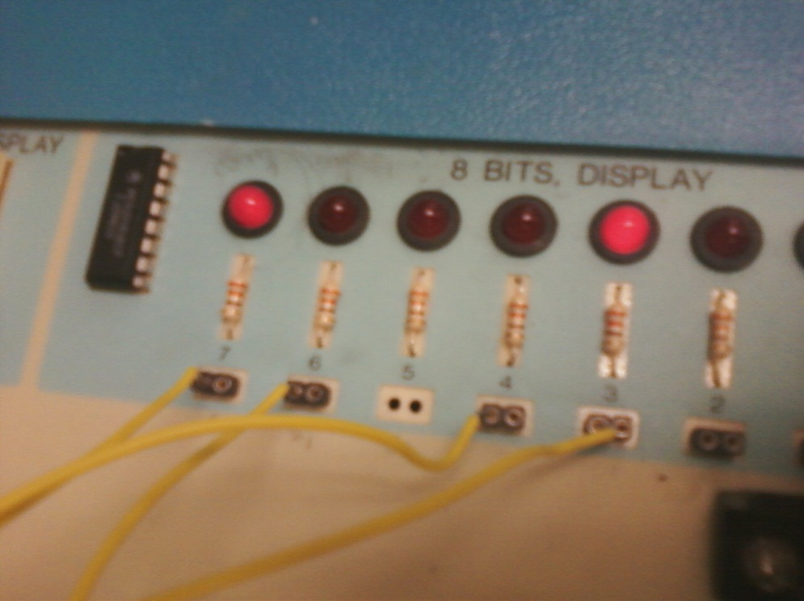

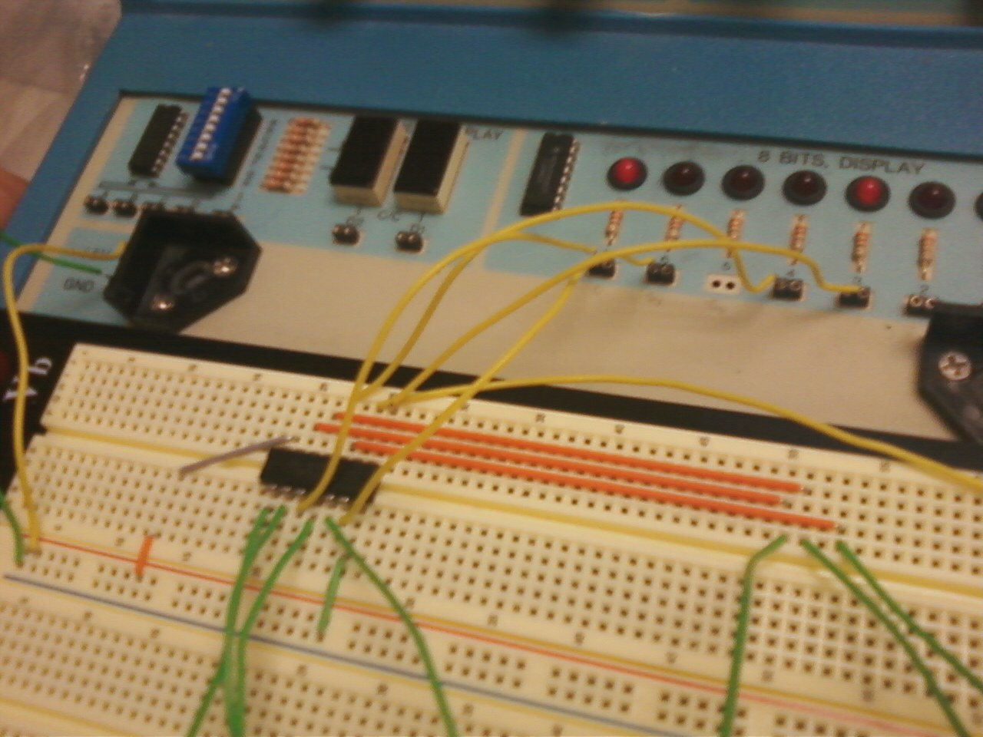

**Conclusion**

See lab instructions.