**Lab 3: Logical Expressions**

Terence Henriod

CPE 201

February 25, 2013

**Part 1: Simplification**

Simplify the following expressions, draw the simplified circuit in Logisim:

1. F = A’B’C’ + A’B’(C + C’) + ABC

= A’B’C’ + A’B’(1) + ABC

= A’B’(C + 1) + ABC

= A’B’ + ABC

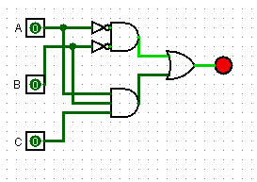

1. F = A’ + A’B’C’D’ + A’B’CD’ + A’B + A’B’C’D’ + C’D + CD’

= A’(1 + B’C’D’ + B’CD’ + B + B’C’D’) + C’D + CD’

= A’(1) + C’D + CD’

= A’ + (C $⊕$ D)

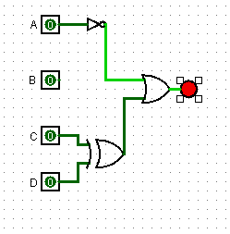

**Part 2: Reverse Engineering**

For the following circuit, derive its truth table, and write down the sum of minterms and the product of maxterms:

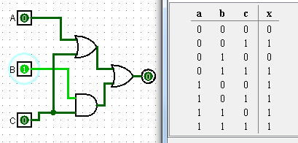

|  |  |  |  |  |  |  |  |  |
| --- | --- | --- | --- | --- | --- | --- | --- | --- |
| i | A | B | C | A + C | B * C | (A + C) + (B * C) | mi | Mi |
| 0 | 0 | 0 | 0 | 0 | 0 | 0 | A’B’C’ | A + B + C |
| 1 | 0 | 0 | 1 | 1 | 0 | 1 | A’B’C | A + B + C’ |
| 2 | 0 | 1 | 0 | 0 | 0 | 0 | A’BC’ | A + B’ + C |
| 3 | 0 | 1 | 1 | 1 | 1 | 1 | A’BC | A + B’ + C’ |
| 4 | 1 | 0 | 0 | 1 | 0 | 1 | AB’C’ | A’ + B + C |
| 5 | 1 | 0 | 1 | 1 | 0 | 1 | AB’C | A’ + B + C’ |
| 6 | 1 | 1 | 0 | 1 | 0 | 1 | ABC’ | A’ + B’ + C |
| 7 | 1 | 1 | 1 | 1 | 1 | 1 | ABC | A’ + B’ + C’ |

Sum of Minterms = Σ( 1, 3, 4, 5, 6, 7)

= A’B’C + A’BC + AB’C’ + AB’C + ABC’ + ABC

Product of Maxterms: Π( 0, 2)

= (A’B’C’) * (A’BC’)

**Part 3: Circuit Implementation**

Using Logisim, design a 3-input circuit that outputs a “1” when the corresponding binary Inputs represent an even number between 1 and 5 (2, 4) following these steps:

1. Draw the truth table

|  |  |  |  |  |  |
| --- | --- | --- | --- | --- | --- |
| 20 | 21 | 22 | (20)’ | 21 22 | (20)’ * (21 22) |
| 0 | 0 | 0 | 1 | 0 | 0 |
| 0 | 0 | 1 | 1 | 1 | 1 |
| 0 | 1 | 0 | 1 | 1 | 1 |
| 0 | 1 | 1 | 1 | 0 | 0 |
| 1 | 0 | 0 | 0 | 0 | 0 |
| 1 | 0 | 1 | 0 | 1 | 0 |
| 1 | 1 | 0 | 0 | 1 | 0 |
| 1 | 1 | 1 | 0 | 0 | 0 |

1. Obtain the logical expression in sum-of-minterms and simplify it. Draw circuit in Logisim.

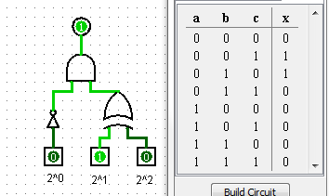

1. Implement circuit on breadboard.

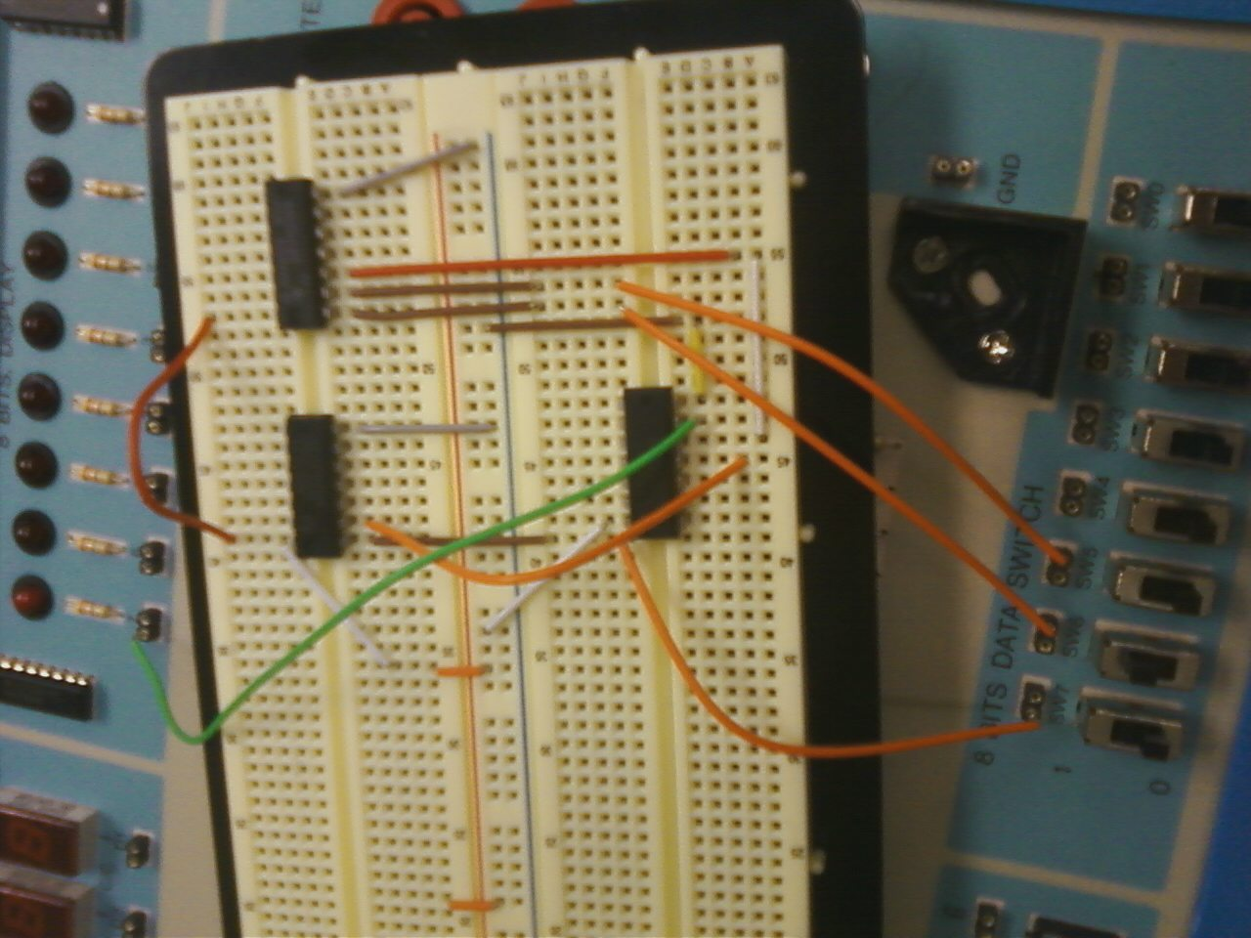

As can be seen in the picture, the switch that would correspond to the binary 21s place digit is switched on, meaning the decimal number 2 is represented. This is one of the conditions for the aforementioned function to output “1,” and so the LED is lit up to indicate this.