**Lab 4: Half-Adders**

Terence Henriod

CPE 201

March 4, 2013

**Half-Adder Design**

1. Truth Table

|  |  |  |  |
| --- | --- | --- | --- |
| Inputs | | Outputs | |
| Input 1 (A) | Input 2 (B) | S | C |
| 0 | 0 | 0 | 0 |
| 0 | 1 | 1 | 0 |
| 1 | 0 | 1 | 0 |
| 1 | 1 | 0 | 1 |

1. Logical Expressions

S(A, B) = A’B + AB’

C(A, B) = AB

1. K-Map

For S:

|  |  |  |
| --- | --- | --- |
| A**\**B | 0 | 1 |
| 0 |  | 1 |
| 1 | 1 |  |

For C:

|  |  |  |
| --- | --- | --- |
| A**\**B | 0 | 1 |
| 0 |  |  |
| 1 |  | 1 |

1. Simplified Logical Expressions

S(A, B) = A $⊕$ B

C(A, B) = AB

**Half-Adder Implementation**

1. Design in Logisim

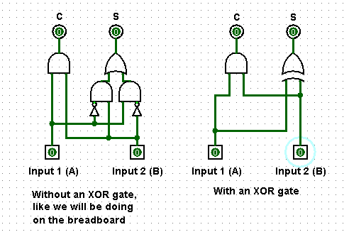

1. Breadboard implementation, using the 7404 (INVERTER), 7432 (OR), and 7408 (AND) chips.

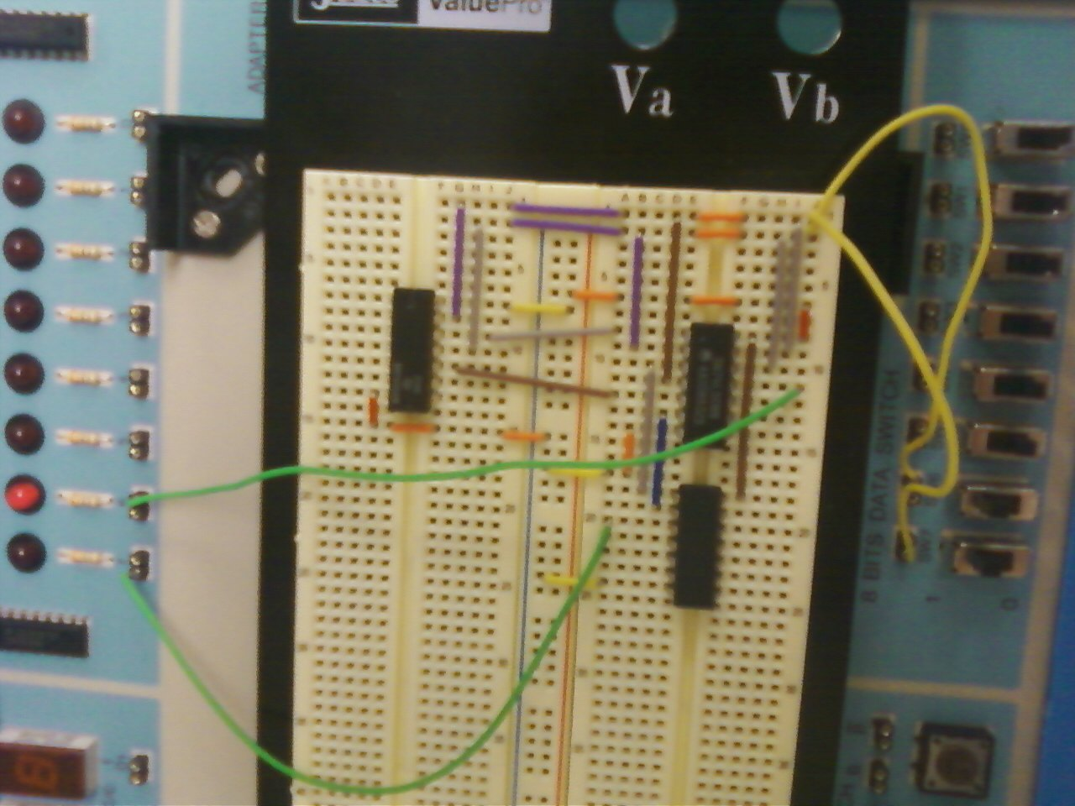

As can be seen above, the two switches are set to on (1) and the functionality of the Carry output can be seen by the second LED. Although not shown, the Solution functionality is also intact.