**Lab 7: Multiplexers**

Terence Henriod

CPE 201

April 1, 2013

**Part 1: Draw an 8-1 Multiplexer in Logisim**

Use logic gates, 8 inputs, 1 output.

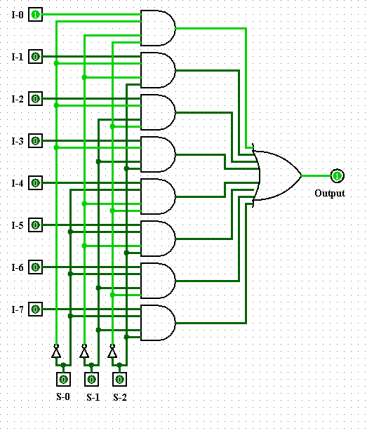

**Part 2: Apply multiplexer to Boolean function**

Consider the binary numbers from 0 to 15. The function F(a, b, c, d) is “1” only when the binary number represented by {a, b, c, d} is divisible by 3.

1. Truth Table

|  |  |  |  |  |  |
| --- | --- | --- | --- | --- | --- |
| a | b | c | d | F | |
| 0 | 0 | 0 | 0 | 0 | 0 |
| 0 | 0 | 0 | 1 | 0 |
| 0 | 0 | 1 | 0 | 0 | d |
| 0 | 0 | 1 | 1 | 1 |
| 0 | 1 | 0 | 0 | 0 | 0 |
| 0 | 1 | 0 | 1 | 0 |
| 0 | 1 | 1 | 0 | 1 | d’ |
| 0 | 1 | 1 | 1 | 0 |
| 1 | 0 | 0 | 0 | 0 | d |
| 1 | 0 | 0 | 1 | 1 |
| 1 | 0 | 1 | 0 | 0 | 0 |
| 1 | 0 | 1 | 1 | 0 |
| 1 | 1 | 0 | 0 | 1 | d’ |
| 1 | 1 | 0 | 1 | 0 |
| 1 | 1 | 1 | 0 | 0 | d |
| 1 | 1 | 1 | 1 | 1 |

1. Using the truth table, design a logic circuit for the function using only the 74151   
   (8-1 MUX) and 7404 (INVERTER) chips. Essentially, we want to group each row in 2s and derive the outputs for {D0 … D7} and additionally figure out where the 1s and 0s will go.

