**Lab 9: 7 Segment Display and JK Flip-Flop**

Terence Henriod

CPE 201

April 15, 2013

**Part 1**

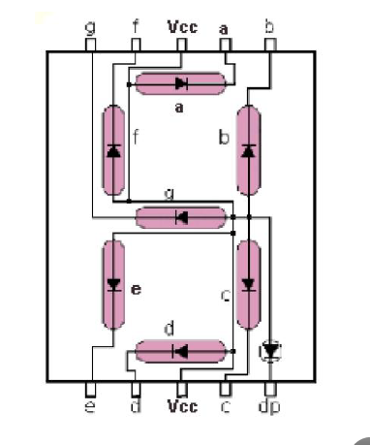

Using a 3-8 decoder and external gates, design a 7 segment display driver. It will only display numbers 0-7.

Figure 1: The layout/reference for a 7-segment display.

1. Truth Table

|  |  |  |  |  |  |  |  |  |  |  |
| --- | --- | --- | --- | --- | --- | --- | --- | --- | --- | --- |
| I2 | I1 | I0 | mi | a | b | c | d | e | f | g |
| 0 | 0 | 0 | 0 | 1 | 1 | 1 | 1 | 1 | 1 | 0 |
| 0 | 0 | 1 | 1 | 0 | 1 | 1 | 0 | 0 | 0 | 0 |
| 0 | 1 | 0 | 2 | 1 | 1 | 0 | 1 | 1 | 0 | 1 |
| 0 | 1 | 1 | 3 | 1 | 1 | 1 | 1 | 0 | 0 | 1 |
| 1 | 0 | 0 | 4 | 0 | 1 | 1 | 0 | 0 | 1 | 1 |
| 1 | 0 | 1 | 5 | 1 | 0 | 1 | 1 | 0 | 1 | 1 |
| 1 | 1 | 0 | 6 | 1 | 0 | 1 | 1 | 1 | 1 | 1 |
| 1 | 1 | 1 | 7 | 1 | 1 | 1 | 0 | 0 | 0 | 0 |

Table 1: The truth table for a 7-segment display using only three input bits and a 3 input decoder.

1. Logical Expressions
$$a= ∑\left(0, 2, 3, 5, 6, 7\right)$$

$$b= ∑\left(0, 1, 2, 3, 4, 7\right)$$

$$c= ∑\left(0, 1, 3, 4, 5, 6, 7\right)$$

$$d= ∑\left(0, 2, 3, 5, 6\right)$$

$$e= ∑\left(0, 2, 6\right)$$

$$f= ∑\left(0, 4, 5, 6\right)$$

$$g= ∑\left(2, 3, 4, 5, 6\right)$$

2. Logisim Implementation with Logic Gates

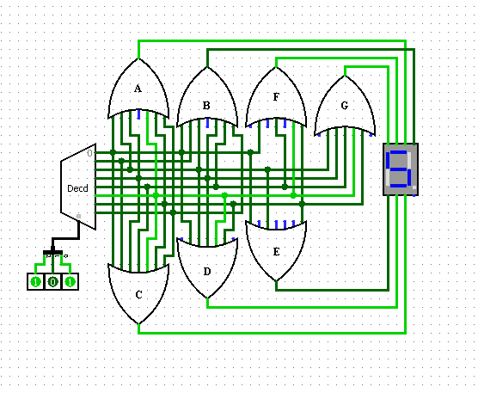

Figure 2: The logic circuit design for a 7-segment display driver using only three inputs and a 3-input decoder.

**Part 2**

Design a JK Flip Flop using D Flip Flop and external gates.

1. Truth Table

|  |  |  |  |
| --- | --- | --- | --- |
| Q(t) | J | K | Q(t+1)  [D] |
| 0 | 0 | 0 | 0 |
| 0 | 0 | 1 | 0 |
| 0 | 1 | 0 | 1 |
| 0 | 1 | 1 | 1 |
| 1 | 0 | 0 | 1 |
| 1 | 0 | 1 | 0 |
| 1 | 1 | 0 | 1 |
| 1 | 1 | 1 | 0 |

Table 2: The truth table for a JK Flip-flop implemented with a D lip-flop.

1. Logical Expression(s)
$$Q\left(t+1\right)=D=J*Q\left(t\right)'+K^{'}*Q(t)$$

2. Logisim Implementation (Just for FUN!)

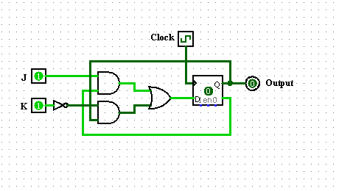

Figure 3: The Logisim implementation of the JK Flip-flop using the D Flip-flop.

1. Breadboard Implementation

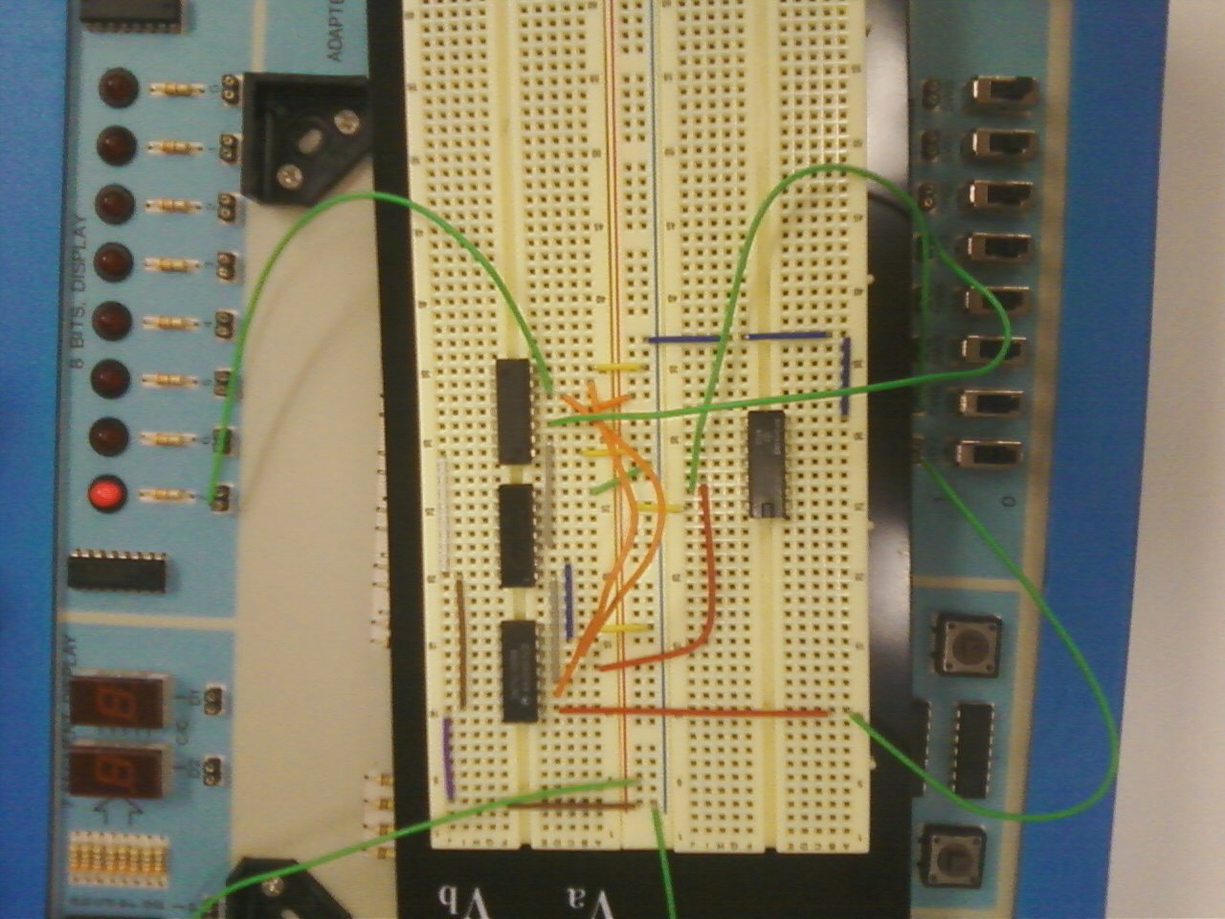

Figure 4: The breadboard implementation of the JK Flip-flop. It is currently in the J = K = 0 state with a 1 being stored.