**Single Board Computers**

*Single Board Computers – What are they?* Single Board Computers (SBCs), as the name implies, are a fully functional computer built into a single circuit board. In general, SBCs offer several advantages over common desktop computers. By placing all components in a single circuit, cost is reduced. Because the components all reside in the same board, fewer connecting components are needed, which, not only reduces the cost of the computer, but also results in increased reliability since connectors can be a regular cause of system failure [1].

SBCs like Arduino can be good for learning because they are easy to program, inexpensive, extensible (easily expanded to use different types of input and output), and open source. Being open source gives Arduino many advantages: in terms of hardware, it means that the Arduino design can be recreated, modified, or improved with relative ease, and that there are many hardware devices that are Arduino compatible for students and hobbyists; in terms of software, it means that there are many programs and routines available to be used or modified to maximize Arduino’s potential for various applications [2].

*Desirable* Features. When it comes to computers, we always want more, we want it faster, and we want it to not take up a lot of space. Cost can also be a concern. Depending on our intended purpose, the capability for the SBC to interface with other devices can influence our decision. But, as with anything else, it is impossible to maximize for all variables at once. Of these, I will describe what would likely be the three most important features when selecting an SBC.

The processor or microcontroller used in an SBC is often the defining component of the SBC, it determines both how fast the computer will operate, but also how much power the SBC will consume. The faster a processor, the more power it will consume. That being said, we need a processor to act quickly enough to react to input, depending on the application.

Depending on the application of an SBC, its ability to interface with a variety of devices, or many devices at once should be taken into consideration. For example, educational SBCs tend to have more versatile interface capability, often having more multi-purpose I/O ports than commercial SBCs that often only use more standard interface like USB or HDMI (compare Arduino [3] and Cotton Candy [4]). This can be important if we want our project to use more input and output devices (like we might see in a multipurpose robot), or if we just want to use the SBC as a streaming or gaming device (purposes that devices like Cotton Candy [4], GameStick [5], or CuBox [6] may be used for). It should also be mentioned that some SBCs are supported with hardware expansions (for example, Arduino’s “Shields” [2]) to supplement an SBC and allow it to have additional/refined interfaces with other devices.

Memory is a definite concern. Depending on our application, we may need a lot of memory to either store program instructions, or to be able to process large amounts of data at once. SBCs like Arduino have only 256 KB of RAM and 4 and 8 KB of SRAM and EEPROM (which won’t hold a lot of data/instructions, certainly not enough to process graphics) [3], while SBCs like the CuBox-i can have as much as 2 GB of RAM, allowing the CuBox to be able to perform graphics and streaming operations [6].

*Other SBCs.* For what it’s worth, Wikipedia has a nice page for comparing SBCs (found at <http://en.wikipedia.org/wiki/Comparison_of_single-board_computers>). This page displays information pertaining to many specifications of interest of many SBCs, and the table can even sort by a given attribute. Unfortunately, the information is not complete for every SBC, nor is it a complete listing, and Wikipedia’s reference links must be followed to verify the information presented.

The following table lists some brief information regarding the three non-Arduino SBCs I found information for:

|  |  |  |  |
| --- | --- | --- | --- |
| Name | Price | URL Information was found at | Source |
| CuBox-i series | 49.99 – 119.99 | <http://cubox-i.com/> | [6] |
| Cotton Candy | $199.00 | <http://www.fxitech.com/wp-content/uploads/2012/11/productbrief_cottoncandy.pdf> | [4] |
| Hackberry A10 | $65.00 | <https://www.miniand.com/products/Hackberry%20A10%20Developer%20Board#specifications> | [7] |

# References

|  |  |
| --- | --- |
| [1] | W. Rosch, Hardware Bible, New York: Que, 1999. |
| [2] | Arduino SA, "Arduino - Introduction," Arduino SA, 19 October 2012. [Online]. Available: http://arduino.cc/en/Guide/Introduction. [Accessed 8 September 2013]. |
| [3] | Arduino SA, "Arduino Mega 2560," Arduino SA, 8 May 2013. [Online]. Available: http://arduino.cc/en/Main/ArduinoBoardMega2560. [Accessed 9 September 2013]. |
| [4] | FXI Technologies, "FXI Technologies," FXI Technologies, 1 September 2013. [Online]. Available: www.fxitech.com. [Accessed 9 September 2013]. |
| [5] | "Game Stick - The World's Most Portable TV Console," PlayJam Ltd., 5 September 2013. [Online]. Available: http://www.gamestick.tv/. [Accessed 8 September 2013]. |
| [6] | Solid-Run Ltd., "The CuBox i from Solid Run - The Little Computer that can," Swift Ideas, 2 September 2013. [Online]. Available: http://cubox-i.com/. [Accessed 9 September 2013]. |
| [7] | Miniand Pty Ltd., "Hackberry A10 Developer Board," Miniand Pty Ltd., 8 July 2013. [Online]. Available: https://www.miniand.com/products/Hackberry%20A10%20Developer%20Board. [Accessed 9 September 2013]. |

CuBox-i Series Specifications:

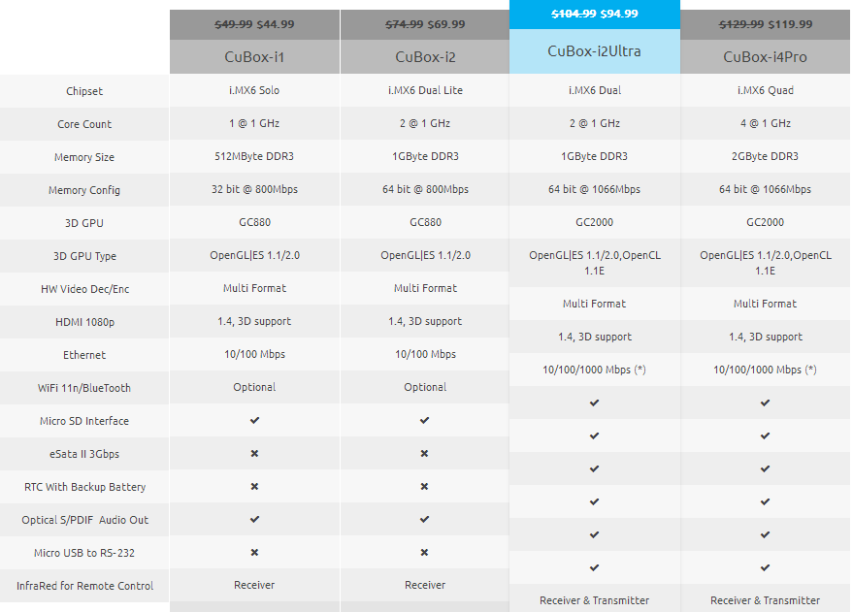

Cotton Candy Specifications:

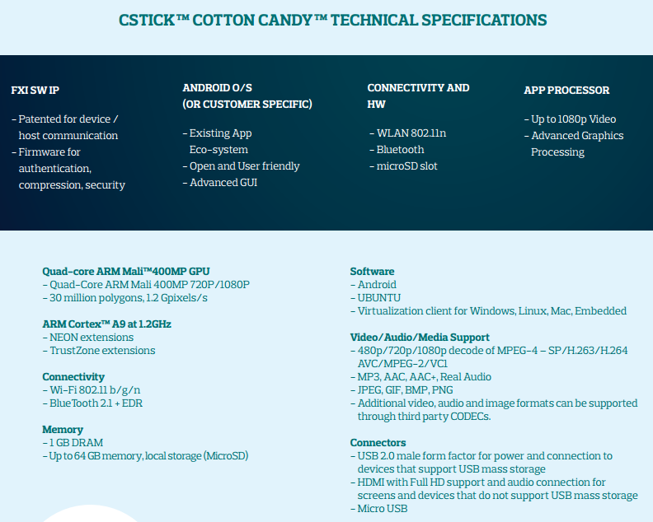

Hackberry A10 Specifications:

