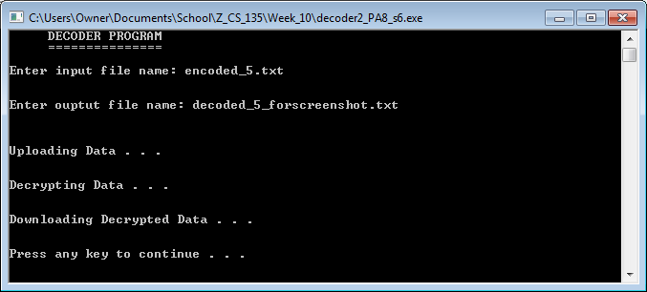

Screenshot #1: The complete display output of decoder2_PA8_s6.cpp

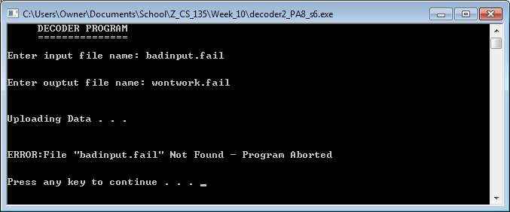

Screenshot #2: The error output of decoder2_PA8_s6.cpp when an invalid input file name is entered