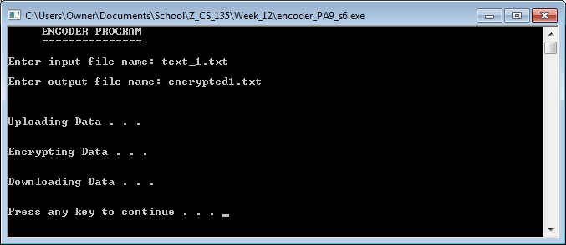

Screenshot 1: The display output of encoder_PA9_s6.cpp with valid file name entries. The program runs successfully.

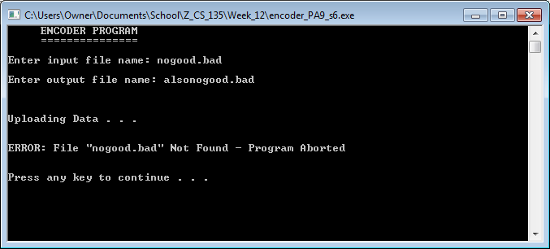

Screenshot 2: The display output of encoder_PA9_s6.cpp when an invalid input file name is entered. The program shuts down.

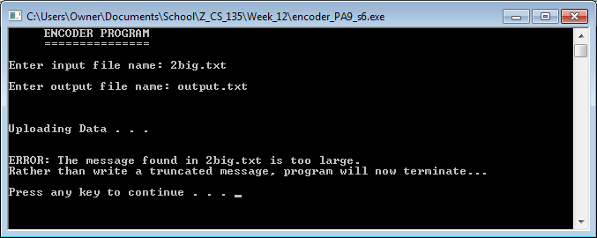

Screenshot 3: The display output of encoder_PA9_s6.cpp when a file with a message too large to be read in is entered as input. The program notifies the user of the problem and shuts down.