A note to the grader: The code we have turned in will actually produce the following images, but it may seem like our program does not. There are two bugs that we should explain:

1. The game matrix (which is unseen) doesn’t correlate with the screen image. This means that the player can run into items, and the appropriate action will occur, but it will be impossible to predict because the game board cannot be viewed properly.
2. We had to create score files manually, rather than with the program, in order to demonstrate that our program will read them in properly, but is unable to manage them properly.

Try as we might, we were unable to fix these bugs in time. Thanks for understanding that we did not cheat.

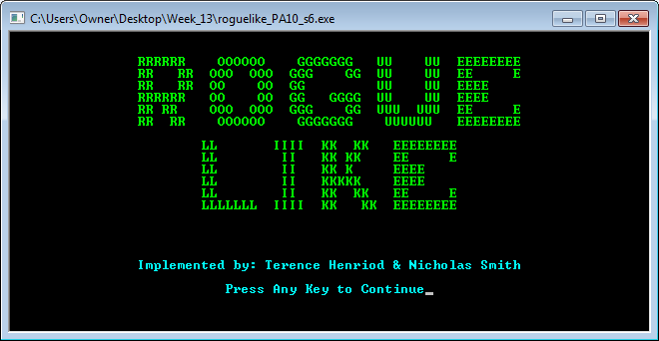

Screenshot 1: The display output of roguelike_PA10_s6.cpp at its splash screen.

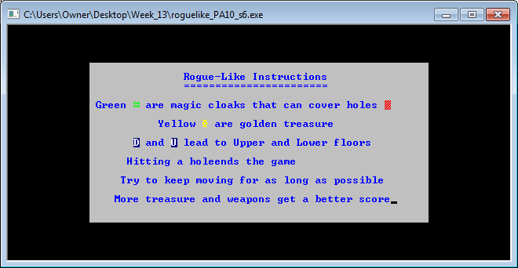

Screenshot 2: The display output of roguelike_PA10_s6.cpp at its instructions screen in normal mode.

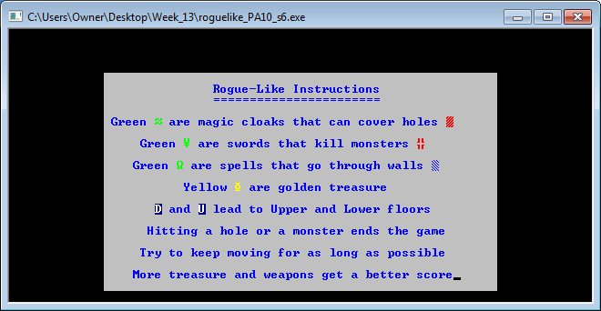

Screenshot 3: The display output of roguelike_PA10_s6.cpp at its instruction screen in extra credit mode.

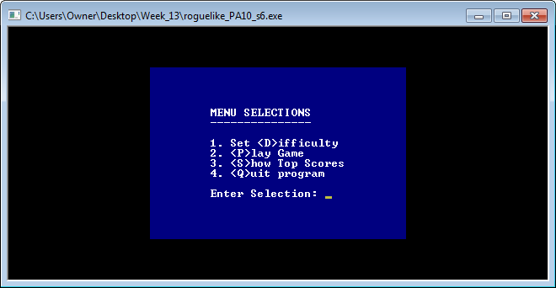

Screenshot 4: The display output of roguelike_PA10_s6.cpp at its main menu.

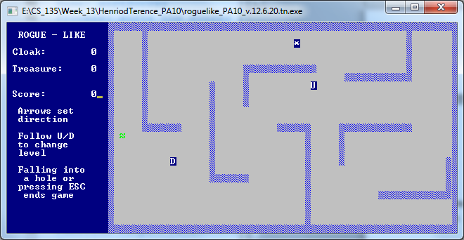

Screenshot 5: The display output of roguelike_PA10_s6.cpp at the start of gameplay in normal mode.

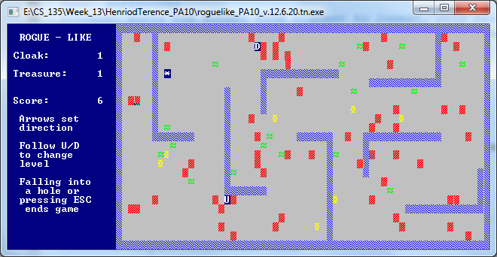

Screenshot 6: The display output of roguelike_PA10_s6.cpp during gameplay in normal mode.

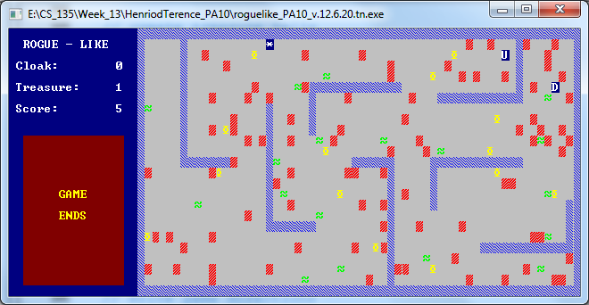

Screenshot 7: The display output of roguelike_PA10_s6.cpp at the end of gameplay in normal mode.

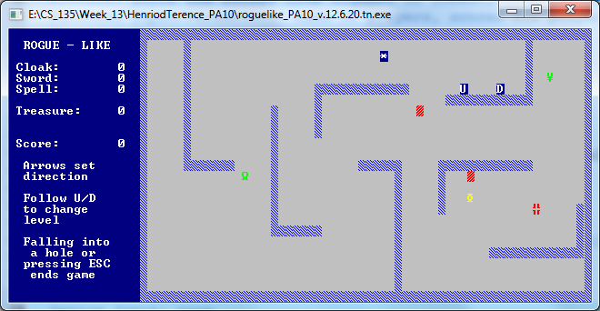

Screenshot 8: The display output of roguelike_PA10_s6.cpp at the start of gameplay in extra credit mode.

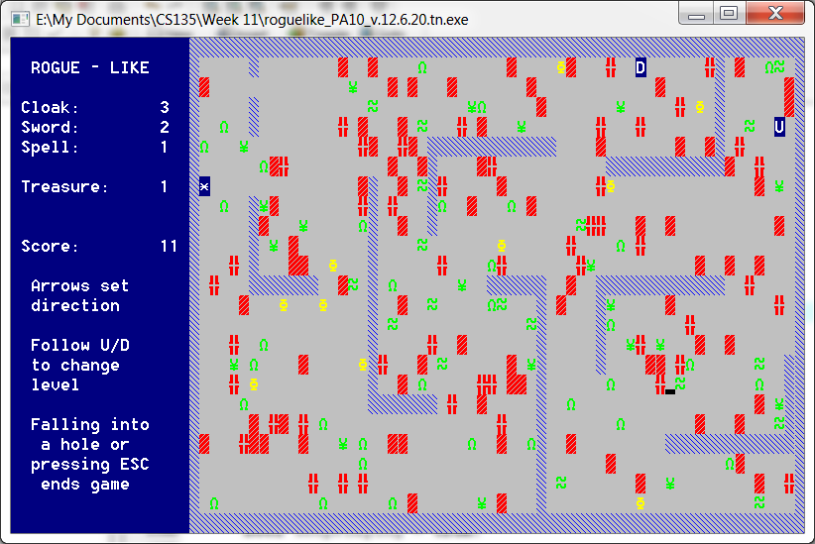

Screenshot 9: The display output of roguelike_PA10_s6.cpp during gameplay in extra credit mode.

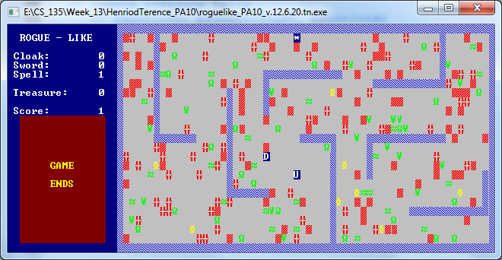

Screenshot 10: The display output of roguelike_PA10_s6.cpp at the end of gameplay in extra credit mode.

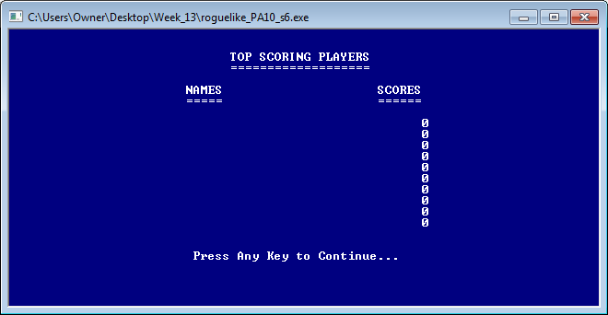

Screenshot 11: The display output of roguelike_PA10_s6.cpp at the high scores screen with no high scores.

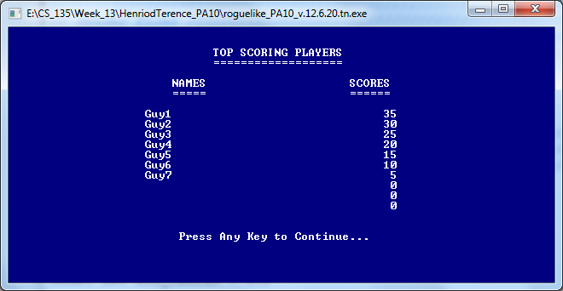

Screenshot 12: The display output of roguelike_PA10_s6.cpp at the high scores screen with some high scores.

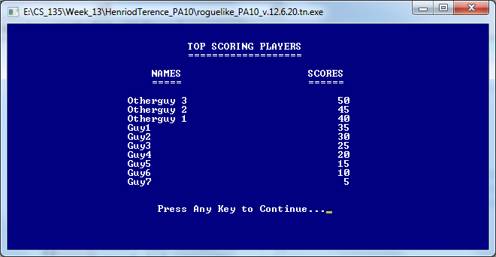

Screenshot 13: The display output of roguelike_PA10_s6.cpp at the high scores screen with ten high scores.