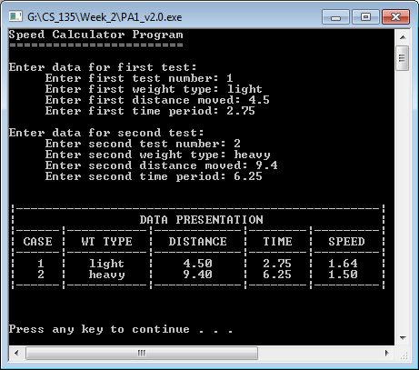

The first, and required, output of PA1_v2.0.exe

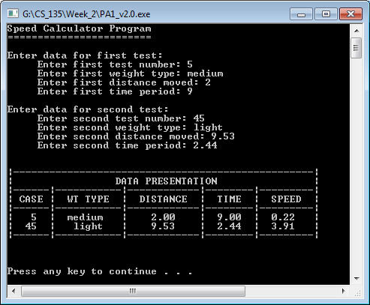

The 2nd output of PA1_v2.0.exe

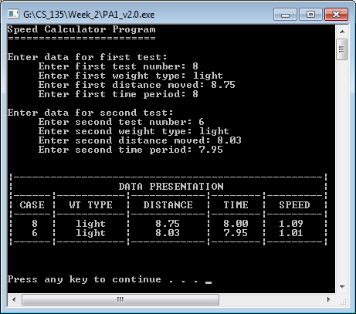

The 3rd output of PA1_v2.0.exe