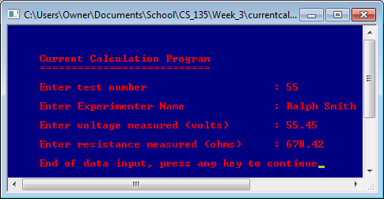

Screen 1 of currentcalc_s4_PA2.cpp using the instructor provided data.

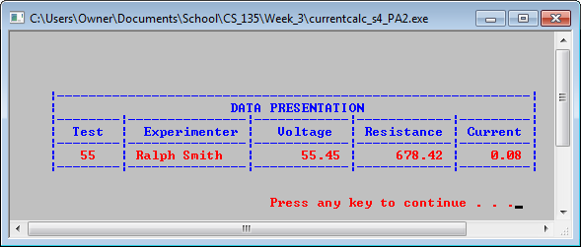

Screen 2 of currentcalc_s4_PA2.cpp using the instructor provided data.

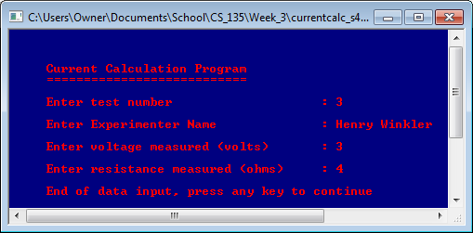

Screen 1 of currentcalc_s4_PA2.cpp using my own data.

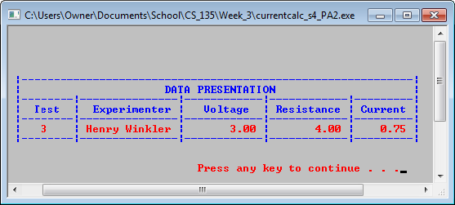

Screen 2 of currentcalc_s4_PA2.cpp using my own data.

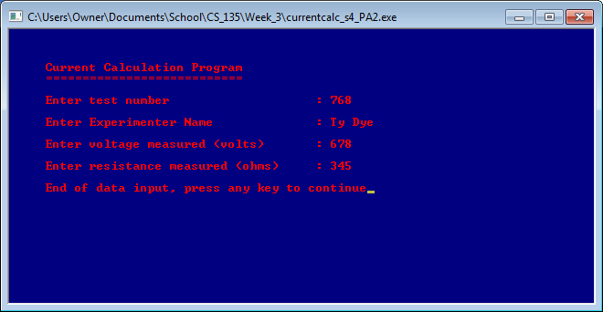

Screen 2 of currentcalc_s4_PA2.cpp using my own data.

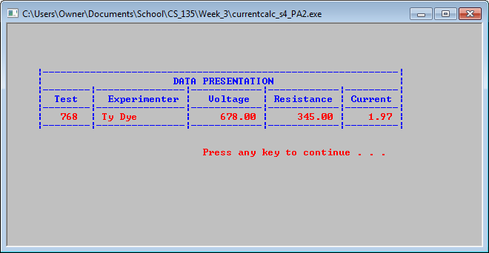

Screen 2 of currentcalc_s4_PA2.cpp using my own data.