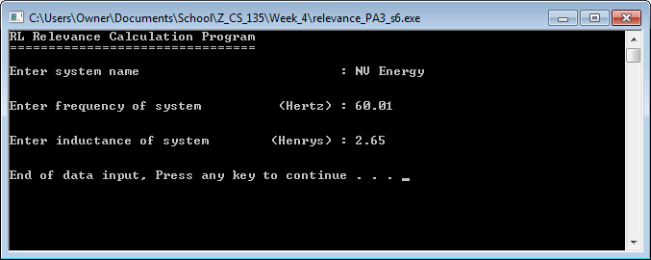

Screen 1 of the program relevance_PA3_s6.cpp using instructor provided data.

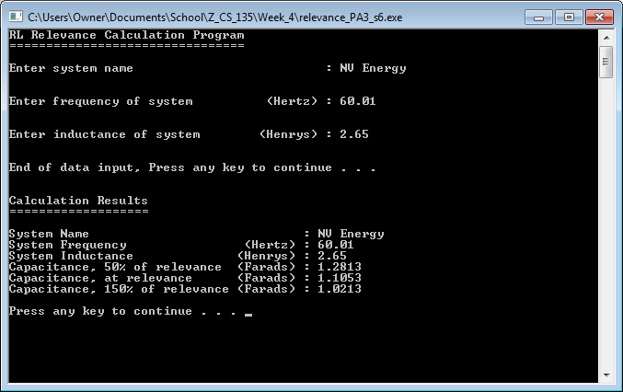

Screen 2 of the program relevance_PA3_s6.cpp using instructor provided data.

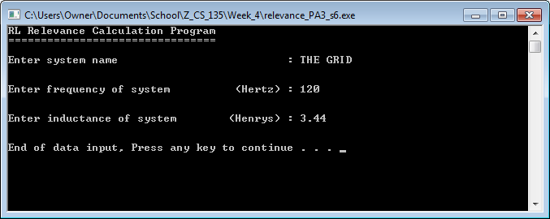

Screen 1 of the program relevance_PA3_s6.cpp using example data.

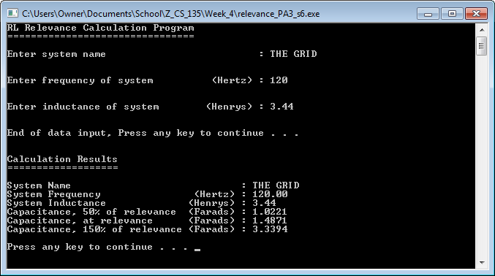

Screen 2 of the program relevance_PA3_s6.cpp using example data. I would like to note that the resulting capacitances don’t decrease as relevance increases (like the results using the instructor provided data) because of the fickleness of the cosine function implicit in the given equation for capacitance.

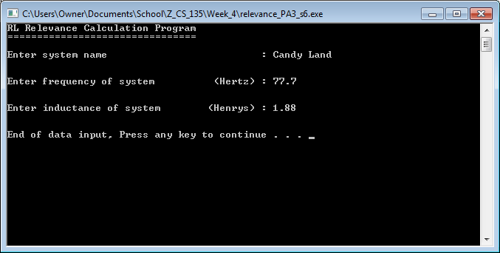

Screen 1 of the program relevance_PA3_s6.cpp using different example data.

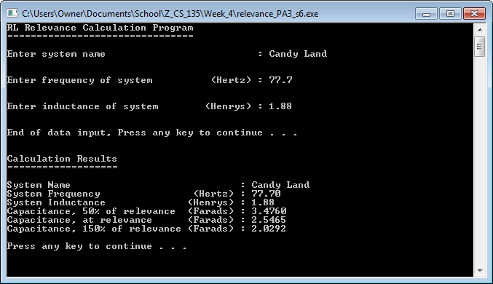

Screen 2 of the program relevance_PA3_s6.cpp using different example data. I would like to note that the resulting capacitances don’t decrease as relevance increases (like the results using the instructor provided data) because of the fickleness of the cosine function implicit in the given equation for capacitance.