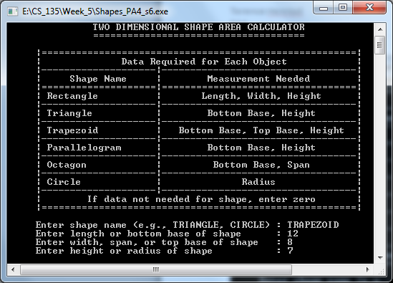

The screenshot of Screen1 of Shapes_PA4_s6.cpp using the first set of instructor provided data.

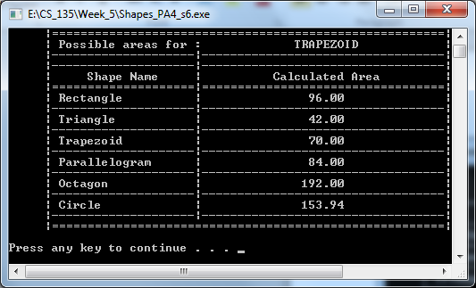

The screenshot of Screen2 of Shapes_PA4_s6.cpp using the first set of instructor provided data. Any discrepancy between my output data and the instructor’s likely comes from using different methods of calculating the areas.

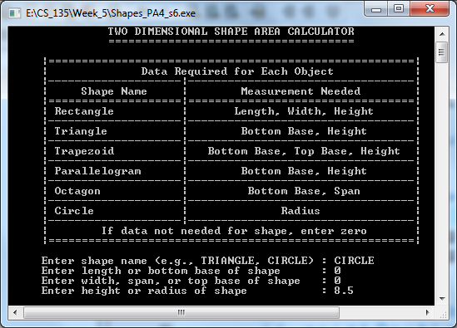

The screenshot of Screen1 of Shapes_PA4_s6.cpp using the second set of instructor provided data.

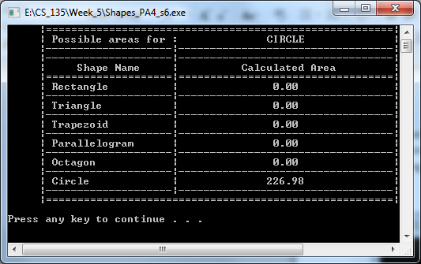

The screenshot of Screen2 of Shapes_PA4_s6.cpp using the second set of instructor provided data.

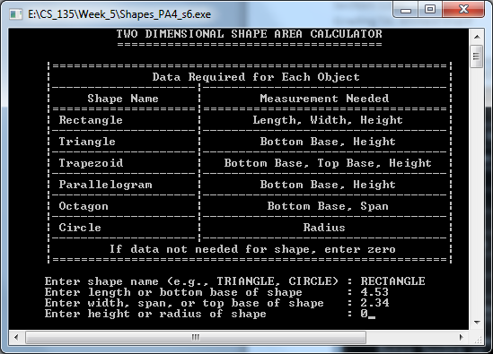

The screenshot of Screen1 of Shapes_PA4_s6.cpp using the first set of example data (rectangle).

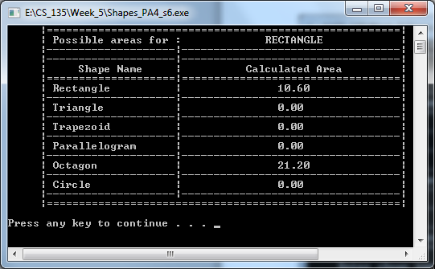

The screenshot of Screen2 of Shapes_PA4_s6.cpp using the first set of example data (rectangle).

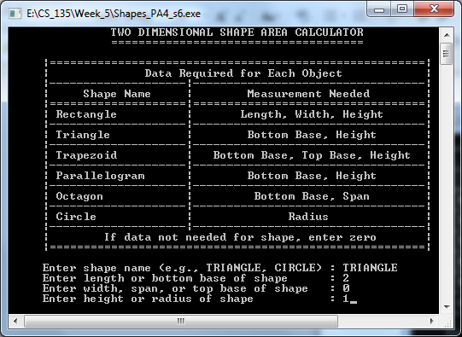

The screenshot of Screen1 of Shapes_PA4_s6.cpp using the second set of example data (triangle).

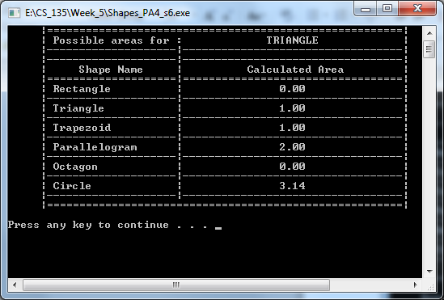

The screenshot of Screen2 of Shapes_PA4_s6.cpp using the second set of example data (triangle).

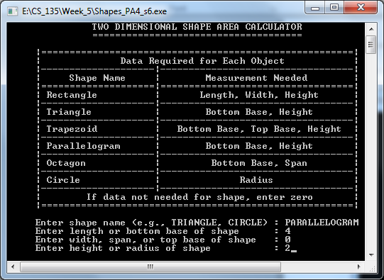

The screenshot of Screen1 of Shapes_PA4_s6.cpp using the third set of example data (parallelogram).

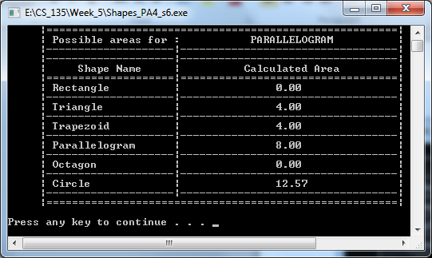

The screenshot of Screen2 of Shapes_PA4_s6.cpp using the third set of example data (parallelogram).

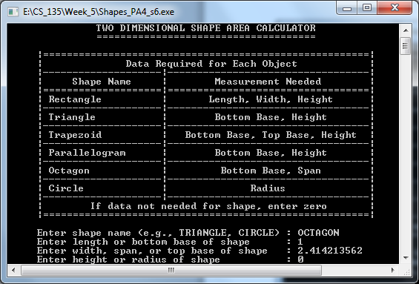

The screenshot of Screen1 of Shapes_PA4_s6.cpp using the fourth set of example data (octagon).

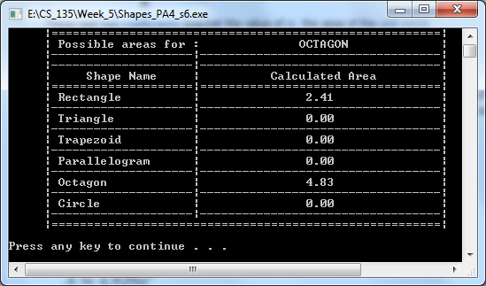

The screenshot of Screen2 of Shapes_PA4_s6.cpp using the fourth set of example data (octagon).