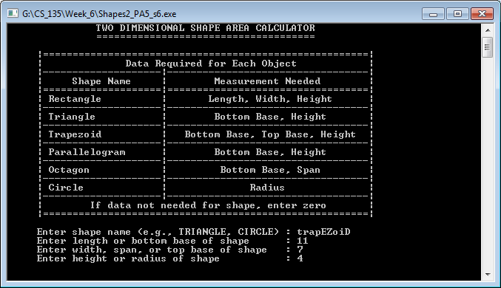

Screenshot 1: Screen #1 of shapes2_PA5_s6.cpp using the first set of instructor provided input.

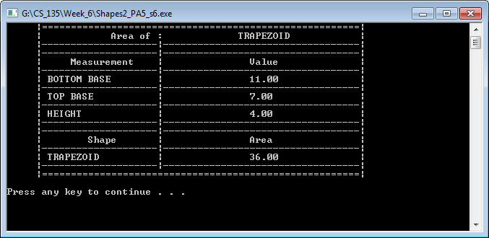

Screenshot 2: Screen #2 of shapes2_PA5_s6.cpp using the first set of instructor provided input.

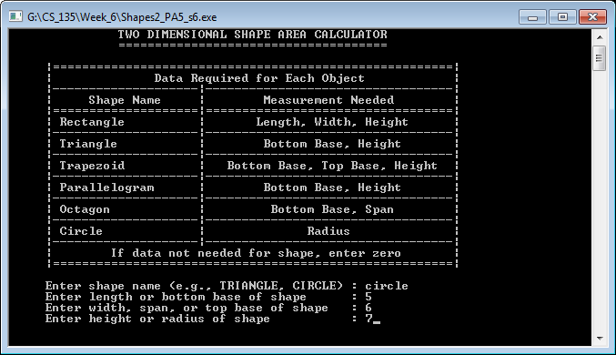

Screenshot 3: Screen #1 of shapes2_PA5_s6.cpp using the second set of instructor provided input.

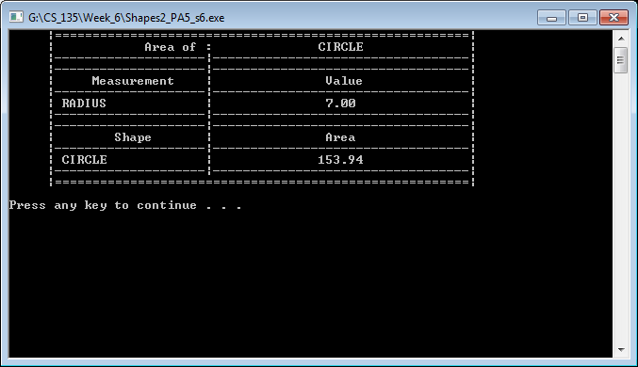

Screenshot 4: Screen #2 of shapes2_PA5_s6.cpp using the second set of instructor provided input.

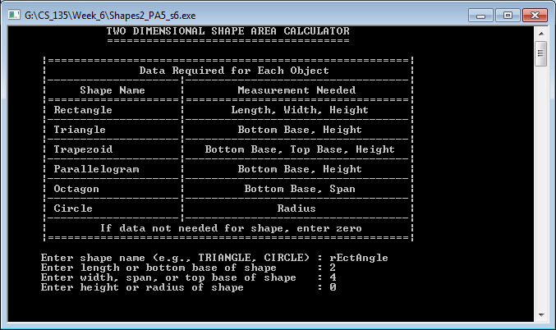

Screenshot 5: Screen #1 of shapes2_PA5_s6.cpp using the first set of student input.

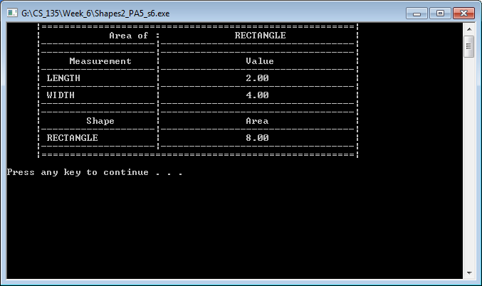

Screenshot 6: Screen #2 of shapes2_PA5_s6.cpp using the first set of student input.

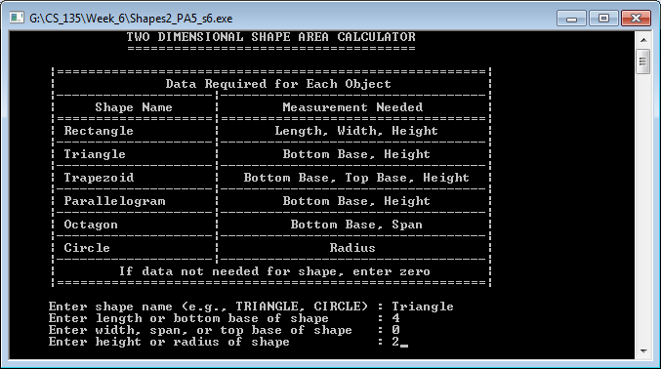

Screenshot 7: Screen #1 of shapes2_PA5_s6.cpp using the second set of student input.

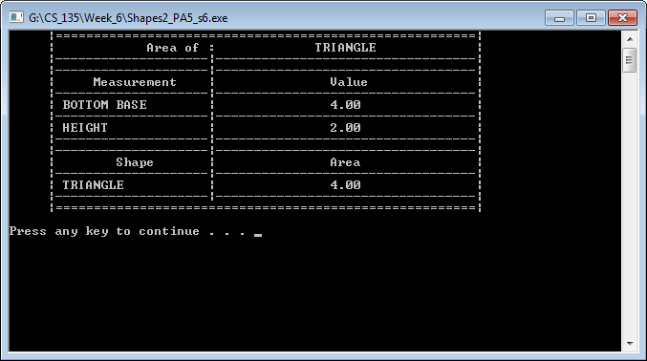

Screenshot 8: Screen #2 of shapes2_PA5_s6.cpp using the second set of student input.

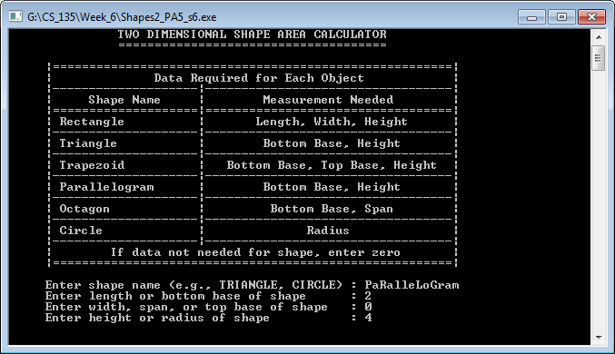

Screenshot 9: Screen #1 of shapes2_PA5_s6.cpp using the third set of student input.

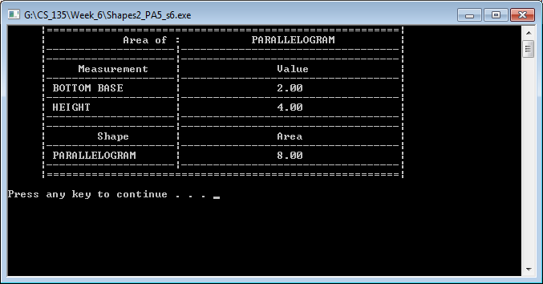

Screenshot 10: Screen #2 of shapes2_PA5_s6.cpp using the third set of student input.

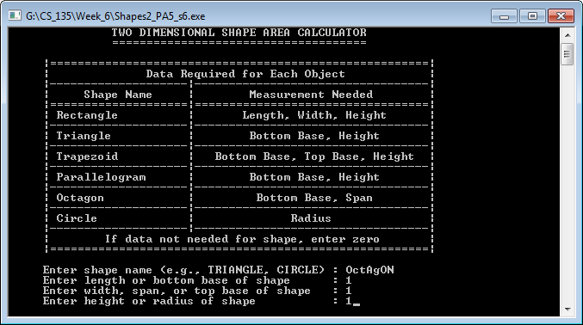

Screenshot 11: Screen #1 of shapes2_PA5_s6.cpp using the fourth set of student input.

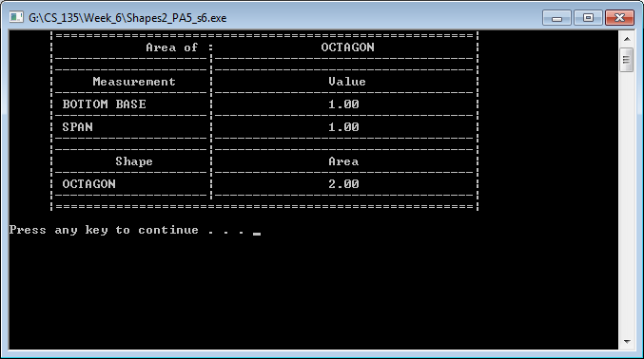

Screenshot 12: Screen #2 of shapes2_PA5_s6.cpp using the fourth set of student input.

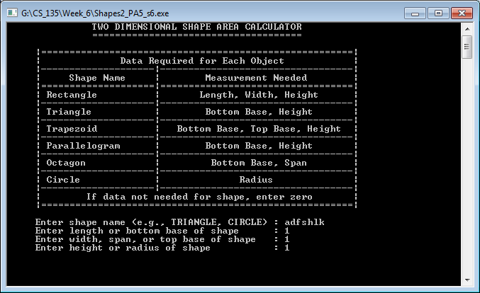

Screenshot 13: Screen 1 of shapes2_PA5_s6.cpp displaying shape name data that would result in error.

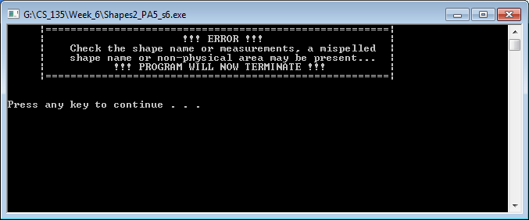

Screenshot 14: Screen 2 of shapes2_PA5_s6.cpp displaying shape name data that resulted in error.

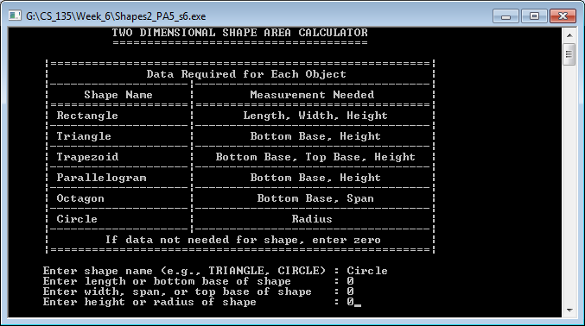

Screenshot 15: Screen 1 of shapes2_PA5_s6.cpp displaying numerical data that would result in error.

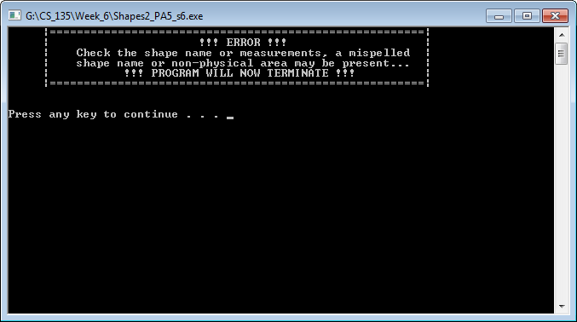

Screenshot 16: Screen 2 of shapes2_PA5_s6.cpp displaying numerical data that resulted in error.