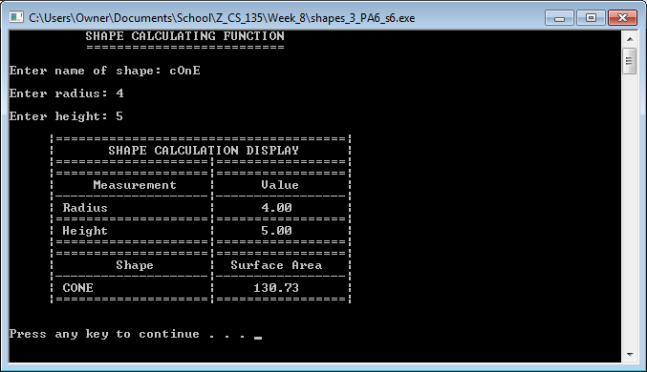

Screenshot 1: The output of shapes3_PA6_s6.cpp when provided cone data.

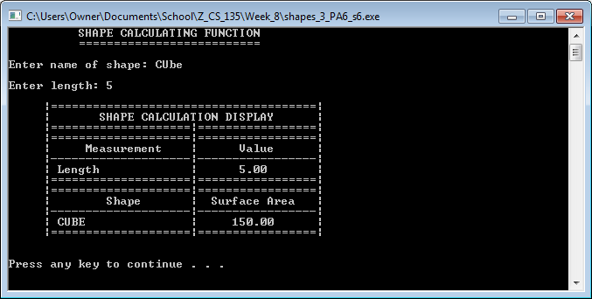

Screenshot 2: The output of shapes3_PA6_s6.cpp when provided cube data.

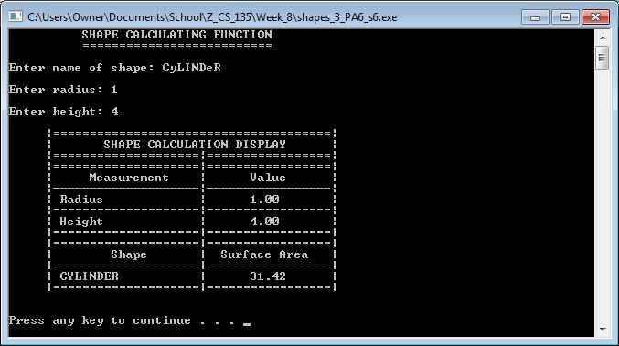

Screenshot 3: The output of shapes3_PA6_s6.cpp when provided cylinder data.

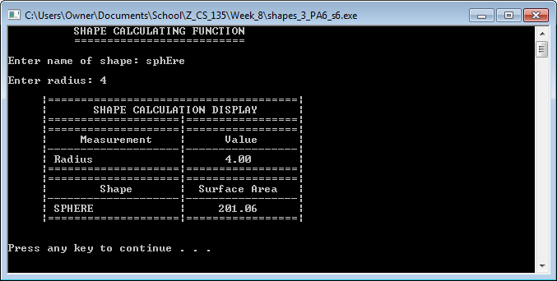

Screenshot 4: The output of shapes3_PA6_s6.cpp when provided sphere data.

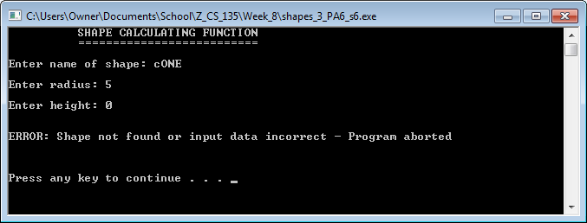

Screenshot 5: The output of shapes3_PA6_s6.cpp when provided measurement data that results in an error.

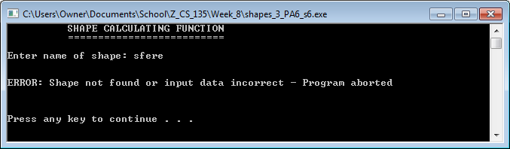

Screenshot 6: The output of shapes3_PA6_s6.cpp when provided shape name data that results in an error.