1. True/False

T/F: The graph ADT is a graph in the sense that it represents data in an intuititive format for comparing frequencies.

Answer: False, the graph ADT is a graph in the sense that is represents a set of relationships between objects, that is it represents pairwise relationships between vertices (object in a set). (Page 604)

1. Multiple Choice

Which of the following is not a technique or concept related to searching a graph?

1. Searching a tree
2. Depth-First Search
3. Linear Probing
4. Breadth-First Search

Answer: C. Linear probing is a hash table resolution technique. Note on A: Trees are a type of graph, so searching a tree is related to searching a graph (Pages 611 - 614)

1. Fill in the Blank

A graph consists of two sets: a set V of ________________, and a set E of ________________ that connect the [ first blank ].

Answer: vertices (or nodes), edges. (Page 604)

1. Short Answer or Code

Draw two graphs: one that has as many edges as possible without needing more than 4 colors for a proper coloring and a second graph that needs precisely 5 colors to be properly colored. (Hint: it might be easiest to draw two graphs that differ only by the presence of a single edge)

Answer: (one example) K5 minus an edge and K5 work well for this.

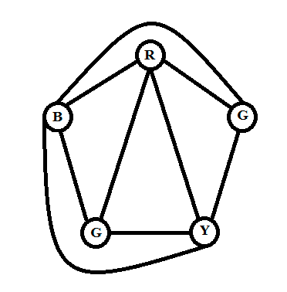

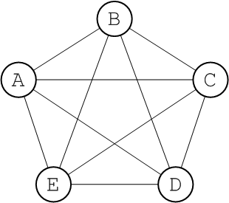

(Page 630)