**PA05: Multithreaded Matrix Multiplication**

**Jordan Blocher**

**Raja Singh**

**Terence Henriod**

**Dr. Fred Harris**

**CS615: Parallel Computing**

**Monday May 5, 2014**

**Introduction**

Shared memory versions of parallel computing are often much faster than message passing paradigms. Because data does not need to be sent over network connections, but can instead be accessed in the usual manner by each running process or thread, the overhead of message passing is all but eliminated. However, shared memory applications can present their own challenges, such as maintaining memory consistency or being able to afford hardware that has enough Processing Units or large enough memory to be useful for the target application.

In this experiment, single process, multi-threaded programs were used in a shared memory environment using up to 8 CPUs. The programs are designed to perform simple matrix multiplication, so many of the issues regarding memory consistency did not need to be addressed, as memory was only read from by multiple threads of execution, and no memory locations were ever written to by different threads; in short, no data race conditions existed.

**Theory**

*Threaded Applications*

In traditional operating systems, programs typically run as “heavyweight” processes. Processes have their own instruction sets, data, stacks, and heaps and so forth. A process is relatively isolated from other processes, and in order for processes to share information, usually some kind of message passing paradigm needs to be constructed. This would be the typical structure found in an MPI environment.

However, a heavyweight process is not always necessary for a task, so the overhead needed to spawn a process and facilitate message passing or complex memory sharing schemes is not always as efficient as might be desired. For this reason, we have *threads*. Threads are “lightweight” processes. Threads can have some of their own system resources, but do share much of their parent process’ resources as well, including memory, and just in general carry less creation/destruction overhead. These reasons make threads ideal for simple parallelizable tasks.

It should be noted that threads, just like processes, can still only utilize a CPU for processing one at a time. The proportion of CPU time required by a thread affects the degree of multithreading an application can have; threads that do non-CPU dependent activities and need the CPU less allow for the use of more threads per processing core, threads that are very CPU dependent (as in our matrix multiplication) will need the CPU so fewer threads (as few as one per core) is more efficient. The programmer should always keep in mind that the operating system does need to schedule threads along with other threads and processes, so there is no completely deterministic ideal number of threads.

Of course, one should always take their hardware’s architecture, operating system, and reservation of cores into consideration, as some hardware or process management schemes facilitate multi-threading very well, while others, like the setup described previously, do not.

*Matrix Multiplication*

Matrix Multiplication can be summarized as “row times column.” This means that each resulting element from a matrix multiplication is found by the summing of pairwise multiplications across the index row of the left side matrix and the index column of the right side of the matrix. Formally defined, each element of a matrix multiplication result matrix is found by:

|  |  |
| --- | --- |
| $$C_{i,j}=\sum_{k=0}^{n}{A_{i,k}*B_{k,j}}$$ | [1] |

where A must be a $p ×n$ matrix and B must be a $n×q$ matrix. In order for any single resulting element of a matrix multiplication to be computed, all of row *i* of A and all of column *j* of B are required, hence the reason for devising various parallel matrix multiplication algorithms.

*A Simple Threaded Matrix Multiplication*

An intuitive way to compute matrix multiplication using multiple execution threads is to simply give each thread a share of rows from matrix A to use in computation, use all of the columns of matrix B, and thus compute all of the results of a corresponding set of rows in matrix C. Doing this job allocation in a static manner should be more efficient that attempting a dynamic job allocation scheme. Since all threads will share the same memory as their parent process, there is no delay in terms of memory access and all threads can easily access the matrices as needed.

*A Threaded Cannon’s Algorithm*

Cannon’s algorithm utilizes sub matrices in order to reduce the memory usage for any one processor at a time. Sub-matrices are multiplied and then shifted around a mesh composed of torus shaped groups. Cannon’s algorithm is easily adapted to use threads in that the same threading method described above can be applied to multiplying the sub-matrices.

(Definitions of speedup and efficiency are listed for completeness, this is not new information)

*Speedup*

When computing things in parallel, it is advantageous to know how much faster the parallel algorithm/program runs compared to a sequential one. This is one metric used to evaluate the quality of a parallel algorithm, the *speedup factor*. The speedup factor represents how many times faster the parallel algorithm using *p* processors is compared to the sequential one. The speedup factor, *S(p)*, is computed as follows:

|  |  |
| --- | --- |
| $$S\left(p\right)= \frac{t_{s}}{t_{p}}=\frac{t_{s}}{ft_{s}+(1-f)\frac{t_{s}}{p}}=\frac{p}{1+(p-1)f}$$ | [2] |

where *p* is the number of processors used in the parallel algorithm, *ts* and *tp* are the respective running times for sequential and parallel runs of the algorithms, and *f* is the fraction of the work in a program that must be run sequentially. The second and third expressions are known as Amdahl’s law. Ideally, the speedup factor will represent a number of factors $S_{p}=p$, but this is often not the case due to various factors including non-parallelizable segments of a job or inter-process communication overhead. If *Sp* is small relative to *p*  or even approaches 1, then the parallel algorithm should either be improved or not used. Should *Sp* ever exceed *p*, this is known as *super-linear speedup*. A super-linear speedup factor is often the product of the use of a runtime that resulted from a sub-optimal sequential algorithm.

*Efficiency*

Parallel algorithms can also be measured in terms of how well the time to run a program is used by all of the processors. Efficiency measures how well the processors are used (what percentage of the runtime the processors spend working). Efficiency is found by:

|  |  |
| --- | --- |
| $$E= \frac{t_{s}}{t_{p}* p}= \frac{S(p)}{p}$$ | [3] |

where *ts*, *tp*, and *S(p)* are defined as in [2].

**Pseudo-Code**

It should be noted that the following pseudo-code should not be considered functional code. Functional code has either been previously submitted or . I have left out many details that would arise in actual code for the sake of brevity and actually describing the algorithms. Each set of pseudo-code assumes that the matrix data has already been read in to the program, so only significant computation and data gathering actions are presented.

*Sequential Pseudo-Code*

In a sequential program, the entire matrix multiplication procedure is done on one processor, with no additional threads of execution:

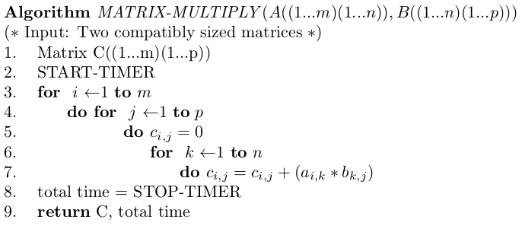

*Parallel Psuedo-Code*

In the simplistic version of the parallel algorithm, only one machine (“box”) is used, with multiple cores, and multiple threads are spawned to compute various segments of the result matrix C. In this version, all matrix data is made global to ease the burden of passing data to threads:

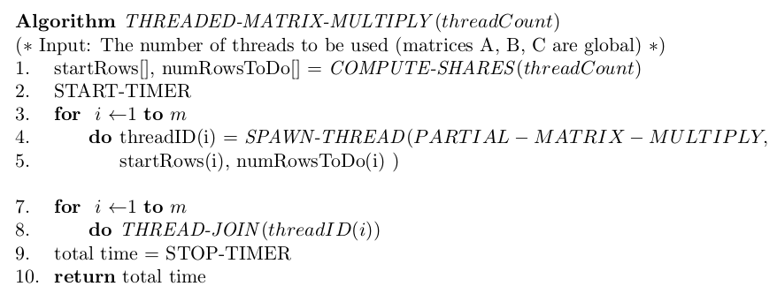

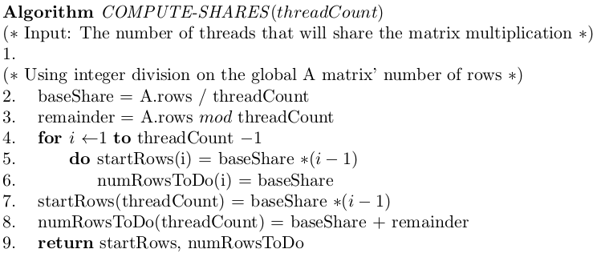

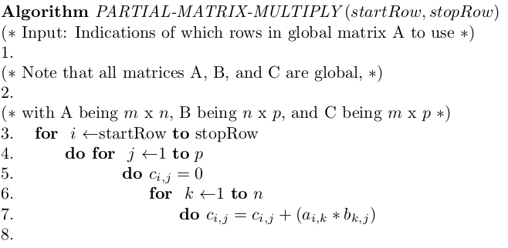

*Cannon’s Algorithm with Threads*

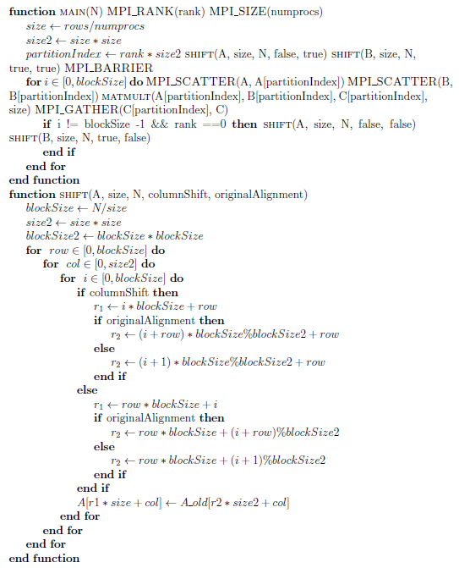

**Results**

The use of threads greatly improved performance over the single threaded version. The speedups observed seemed almost unreal. The extreme speedup (super-linear) was likely due to the fact that hardware optimizations for threading made more extremely fast memory referencing, and the fact that shared memory was used meant that no message passing was required; all threads of execution could simply due their computations and “be done with it,” so to speak.

It was also observed that using more threads than available cores resulted in minor performance gains. This was likely due to minor multithreading hardware optimizations and the fact that the threads’ tasks were primarily computational. Had the threads had more of other kinds of work to do, better performance gains by adding more threads would have likely been observed. That all being said, based on the trend of performance gain by adding more threads, it is likely that using more than 16 threads on 8 cores would not have produces any gain in performance.

**Output Data Summaries**

|  |  |  |  |  |  |
| --- | --- | --- | --- | --- | --- |
| Computing Nodes Used in Experiment | | | | | |
| 0: | compute-1-32 | 3: | compute-1-32 | 6: | compute-1-32 |
| 1: | compute-1-32 | 4: | compute-1-32 | 7: | compute-1-32 |
| 2: | compute-1-32 | 5: | compute-1-32 |  |  |
| Sequential 0: compute-41-16 | | | | | |

Table 1: The processor nodes used for the basic threaded matrix multiplication program using up to 8 threads.

(More summaries to follow, whitespace is used to accommodate figures and their corresponding tables existing on the same page)

|  |  |  |  |  |  |  |
| --- | --- | --- | --- | --- | --- | --- |
| Average Sequential Run Times | | | | | | |
|  | Matrix Size | | | | | |
| 800 | 1600 | 2400 | 3200 | 4000 | 4800 |
| Run Time (seconds) | 11.83 | 110.33 | 286.33 | 1842.92 | 1327.29 | 5849.56 |

Table 2: The average running times for the sequential matrix multiplication program

Figure 1: A graph representing the sequential matrix multiplication run times

|  |  |  |  |  |  |  |  |
| --- | --- | --- | --- | --- | --- | --- | --- |
| Average Threaded Matrix Multiplication Run Times with 8 Cores Available  (in seconds) | | | | | | | |
|  |  | Matrix Size | | | | | |
|  |  | 800 | 1600 | 2400 | 3200 | 4000 | 4800 |
| Number of Threads Used | 2 | 2.580 | 25.872 | 85.670 | 245.206 | 396.823 | 855.287 |
| 4 | 1.296 | 13.481 | 46.458 | 135.864 | 217.931 | 471.820 |
| 6 | 0.873 | 9.095 | 31.923 | 99.542 | 149.922 | 343.234 |
| 8 | 0.911 | 8.904 | 27.935 | 87.573 | 136.643 | 301.377 |
| 10 | 0.820 | 7.572 | 25.246 | 78.155 | 121.107 | 271.037 |
| 12 | 0.751 | 6.945 | 23.141 | 74.446 | 111.431 | 258.513 |
| 14 | 0.722 | 6.682 | 23.233 | 74.481 | 118.377 | 261.646 |
| 16 | 0.704 | 6.298 | 22.596 | 73.903 | 115.011 | 254.126 |

Table 3: The average running times for matrix multiplication using various numbers of threads distributed across 8 processors

Figure 2: A graph representing the average run times for the multithreaded matrix multiplication program

|  |  |  |  |  |  |  |  |
| --- | --- | --- | --- | --- | --- | --- | --- |
| Average Threaded Matrix Multiplication Speed Up with 8 Cores Available | | | | | | | |
|  |  | Matrix Size | | | | | |
|  |  | 800 | 1600 | 2400 | 3200 | 4000 | 4800 |
| Number of Threads Used | 2 | 4.583 | 4.264 | 3.342 | 7.516 | 3.345 | 6.839 |
| 4 | 9.127 | 8.184 | 6.163 | 13.564 | 6.090 | 12.398 |
| 6 | 13.553 | 12.130 | 8.969 | 18.514 | 8.853 | 17.042 |
| 8 | 12.986 | 12.391 | 10.250 | 21.044 | 9.714 | 19.409 |
| 10 | 14.417 | 14.569 | 11.342 | 23.580 | 10.960 | 21.582 |
| 12 | 15.753 | 15.886 | 12.373 | 24.755 | 11.911 | 22.628 |
| 14 | 16.387 | 16.512 | 12.324 | 24.743 | 11.212 | 22.357 |
| 16 | 16.790 | 17.516 | 12.672 | 24.937 | 11.541 | 23.018 |

Table 4: The speedups observed for matrix multiplication using various numbers of threads distributed across 8 processors

Figure 3: A graph representing the average speedups for the multithreaded matrix multiplication program

|  |  |  |  |  |  |  |  |
| --- | --- | --- | --- | --- | --- | --- | --- |
| Average Threaded Matrix Multiplication Efficiency with 8 Cores Available (in %) | | | | | | | |
|  | | Matrix Size | | | | | |
| 800 | 1600 | 2400 | 3200 | 4000 | 4800 |
| Number of Threads Used | 2 | 229.161 | 213.218 | 167.112 | 375.790 | 167.239 | 341.965 |
| 4 | 228.163 | 204.595 | 154.082 | 339.111 | 152.260 | 309.946 |
| 6 | 225.878 | 202.169 | 149.489 | 308.566 | 147.553 | 284.041 |
| 8 | 162.323 | 154.884 | 128.122 | 263.055 | 121.420 | 242.618 |
| 10 | 144.166 | 145.694 | 113.416 | 235.804 | 109.596 | 215.822 |
| 12 | 131.279 | 132.386 | 103.112 | 206.293 | 99.261 | 188.564 |
| 14 | 117.049 | 117.943 | 88.031 | 176.739 | 80.088 | 159.691 |
| 16 | 104.940 | 109.478 | 79.197 | 155.856 | 72.128 | 143.865 |

Table 5: The observed efficiencies relative to the sequential program for matrix multiplication using various numbers of threads distributed across 8 processors

Figure 4: A graph representing the observed efficiencies for the multithreaded matrix multiplication program

|  |  |  |  |  |  |  |  |
| --- | --- | --- | --- | --- | --- | --- | --- |
| Speedup Observed by Doubling the Number of Threads with 8 Cores Available | | | | | | | |
|  | | Matrix Size | | | | | |
| 800 | 1600 | 2400 | 3200 | 4000 | 4800 |
| Number of Threads Used | 8 vs 4 | 2.833 | 2.906 | 3.067 | 2.800 | 2.904 | 2.838 |
| 12 vs 6 | 1.162 | 1.310 | 1.380 | 1.337 | 1.345 | 1.328 |
| 16 vs 8 | 1.293 | 1.414 | 1.236 | 1.185 | 1.188 | 1.186 |

Table 6: An indication of performance gains by using more threads than cores. These “speedups” were computed by simply dividing the runtimes of the trials that used fewer threads by the times of those that used more threads.

Figure 5: A graph representing the “speedups” gained by using more threads than cores

|  |
| --- |
| This Data was lost and is unrecoverable. With the difficulty of getting jobs into the grid, it is not feasible to re-run the trials just to get the node names. |

Table 7: The processor nodes used for the basic, non-threaded version of Cannon’s algorithm

|  |  |  |  |  |  |  |
| --- | --- | --- | --- | --- | --- | --- |
| Average Sequential Run Times | | | | | | |
|  | Matrix Size | | | | | |
| 800 | 1600 | 2400 | 3200 | 4000 | 4800 |
| Run Time (seconds) | 18.91 | 166.03 | 567.52 | 1199.30 | 2383.09 | 4227.44 |

Table 8: The running times for the sequential matrix multiplication program used for Cannon’s algorithm comparisons

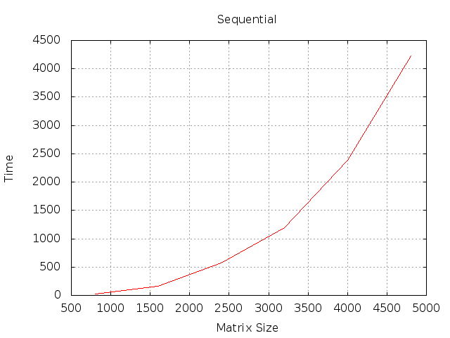

Figure 6: A graph representing the sequential run times used for computing Cannon’s algorithm speedups

|  |  |  |  |  |  |  |  |
| --- | --- | --- | --- | --- | --- | --- | --- |
| Runtimes (in seconds) of the Basic Cannon’s Algorithm Implementation | | | | | | | |
|  | | Matrix Size | | | | | |
| 800 | 1600 | 2400 | 3200 | 4000 | 4800 |
| Number of Processors Used | 4 | 8.03 | 47.96 | 221.58 | 531.24 | 1034.88 | 1422.14 |
| 16 | --- | 13.30 | 38.74 | 61.86 | 122.41 | 175.77 |

Table 9: The running times for the basic, non-threaded version of Cannon’s algorithm

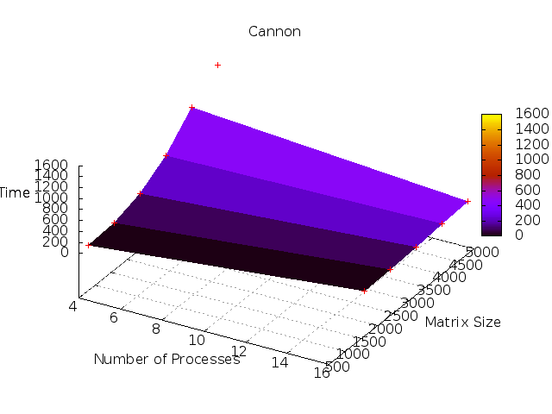

Figure 7: A graph representing the basic, non-threaded version of Cannon’s algorithm run times

|  |  |  |  |  |  |  |  |
| --- | --- | --- | --- | --- | --- | --- | --- |
| Runtimes (in seconds) of the Multithreaded Cannon’s Algorithm Implementation | | | | | | | |
|  | | Matrix Size | | | | | |
| 800 | 1600 | 2400 | 3200 | 4000 | 4800 |
| Number of Threads Used | 4 | 2.739 | 24.23 | 77.78 | 234.74 | --- | --- |
| 16 | 1.76 | 14.73 | 37.86 | 81.97 | 126.76 | 174.187 |

Table 10: The average running times for matrix multiplication using the multi-threaded Cannon’s algorithm

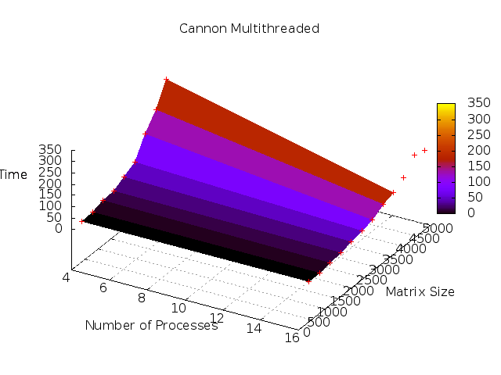

Figure 8: A graph representing the average run times for the multi-threaded Cannon’s algorithm

|  |  |  |  |  |  |  |  |
| --- | --- | --- | --- | --- | --- | --- | --- |
| Speedups of the Multithreaded Cannon’s Algorithm Implementation | | | | | | | |
|  | | Matrix Size | | | | | |
| 800 | 1600 | 2400 | 3200 | 4000 | 4800 |
| Number of Threads Used | 4 | 6.90 | 6.85 | 7.30 | 5.11 | --- | --- |
| 16 | 10.77 | 11.27 | 14.99 | 14.63 | 18.8 | 24.27 |

Table 11: The speedups observed for matrix multiplication using the multi-threaded Cannon’s algorithm

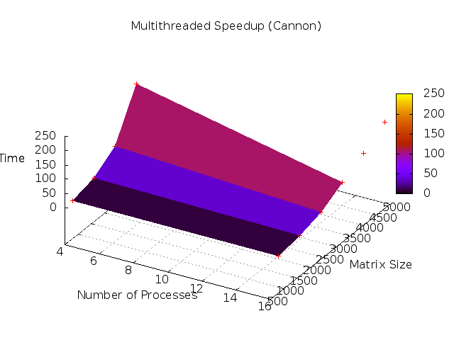

Figure 9: A graph representing the average speedups for the multi-threaded Cannon’s algorithm

|  |  |  |  |  |  |  |  |
| --- | --- | --- | --- | --- | --- | --- | --- |
| Efficiency (in %) of the Multithreaded Cannon’s Algorithm Implementation | | | | | | | |
|  | | Matrix Size | | | | | |
| 800 | 1600 | 2400 | 3200 | 4000 | 4800 |
| Number of Threads Used | 4 | 172.62 | 171.30 | 182.41 | 127.72 | --- | --- |
| 16 | 67.33 | 70.45 | 93.68 | 91.45 | 117.51 | 151.68 |

Table 12: The observed efficiencies relative to the basic program for the multi-threaded Cannon’s algorithm

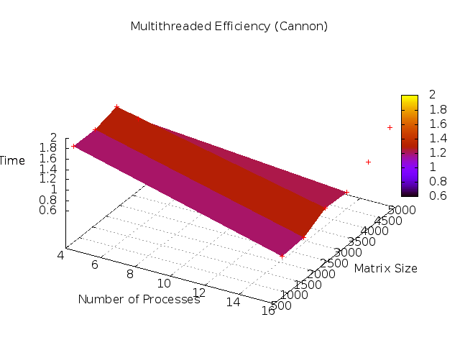

Figure 10: A graph representing the observed efficiencies for the multi-threaded Cannon’s algorithm

**Issues**

We were supposed to try the matrix multiplication using as many as 16 cores, but because someone else was using the machines on the grid that had 16 core machines with shared memory, this did not happen. Also, in order for job simplicity, multi-thread-per-core runs were not done every number of cores possible to use. The rationale behind this was that the performance trends would be apparent without having to trouble ourselves with creating jobs that ran 4 threads on 2 cores and such.