QUESTION 1:

SELECT

a_IssueReport.IssueReportId,

a_IssueReport.ProductSerialNumber,

a_IssueReport.ReportDate,

a_TestForm.TestCompleted,

DATEDIFF(DAY,a_IssueReport.ReportDate,a_TestForm.TestCompleted) 'Days in System',

a_Unit.ModelNumber,

CASE

WHEN a_IssueReport.CustomerId is not null

THEN a_customer.FirstName +' ' + a_Customer.LastName

WHEN a_IssueReport.EmployeeId is not null

THEN a_Employee.FirstName +' ' + a_Employee.LastName

WHEN a_IssueReport.DistributorId is not null

THEN a_Distributor.Name

END 'Reporter',

CASE

WHEN a_IssueReport.CustomerId is not null

THEN 'Customer'

WHEN a_IssueReport.EmployeeId is not null

THEN 'Employee'

WHEN a_IssueReport.DistributorId is not null

THEN 'Distributor'

END 'Reporter Type',

a_IssueReportProblem.Description 'Type of Problem',

a_IssueReport.ProblemDescription 'Description of Problem',

CASE

WHEN a_IssueReport.InjuryOccurred = 1

THEN 'Yes'

ELSE

'No'

END 'Injury',

CASE

WHEN a_IssueReport.InjuryOccurred = 1

THEN a_IssueReport.InjuryDescription

ELSE

'None'

END 'Injury'

FROM

a_IssueReport

INNER JOIN

a_TestForm ON a_IssueReport.IssueReportId = a_TestForm.IssueReportId

INNER JOIN

a_Unit ON a_IssueReport.ProductSerialNumber = a_Unit.SerialNumber

LEFT JOIN

a_Customer ON a_IssueReport.CustomerId = a_Customer.CustomerId

LEFT JOIN

a_Employee ON a_IssueReport.EmployeeId = a_Employee.EmpId

LEFT JOIN

a_Distributor ON a_IssueReport.DistributorId = a_Distributor.DistributorId

INNER JOIN

a_IssueReportProblem ON a_IssueReportProblem.ProblemID = a_IssueReport.IssueReportProblemId

WHERE

a_IssueReport.IssueReportId = 5

;

GO

OUTPUT QUESTION 1: CROPPED TO FIT PAGE WIDTH





QUESTION 2:

SELECT

a_IssueReport.IssueReportId,

a_IssueReport.ProductSerialNumber,

a_IssueReport.ReportDate,

a_TestForm.TestCompleted,

a_Employee.FirstName + ' ' + a_Employee.LastName 'Tester',

a_TestForm.TestDescription,

a_TestForm.TestResults,

CASE

WHEN a_TestForm.TestCompleted is NULL

THEN 'NO'

ELSE

'YES'

END 'Test Completed?'

FROM

a_IssueReport

INNER JOIN

a_TestForm ON a_IssueReport.IssueReportId = a_TestForm.IssueReportId

INNER JOIN

a_Unit ON a_IssueReport.ProductSerialNumber = a_Unit.SerialNumber

LEFT JOIN

a_Employee ON a_TestForm.EmpId= a_Employee.EmpId

WHERE

a_IssueReport.IssueReportId = 5

;

GO

OUTPUT QUESTION 2:



QUESTION 3:

/*

CREATE VIEW av_ReturnedUnits -- the view was important to merge the data from model and unit. Because

unit contained the fk to th model enitity which held the model description. We need to merge the two so that when we

needed to access the model description from enitities that only had the serial number we were able to do so via the unit entity

or I should say from this view.

*/

CREATE VIEW av_ReturnedUnits AS

SELECT

SerialNumber,

a_Unit.ModelNumber,

a_Model.[Description],

MSRP

FROM

a_Unit

INNER JOIN a_Model ON

a_Unit.ModelNumber = a_Model.ModelNumber

;

GO

/*

CREATE VIEW av_TestCounts was usefull because it allowed us to count the number of tests completed for each issue report.

*/

CREATE VIEW av_TestCounts AS

SELECT

Test.IssueReportId,

COUNT(*) AS 'TestsConducted'

FROM

a_TestForm Test

GROUP BY

Test.IssueReportId

;

GO

/*

CREATE VIEW av_Number3 was important because it utilized the two prior views and merged their data with the

additional data we needed to complete the queury for problem number 3. By using mulitple view for this problem, we were

able to modularize a large query into smaller more manageable queries. We were also able to extract data from this view

for query number 4 with a where condition.

*/

CREATE VIEW av_Number3 AS

SELECT

Report.IssueReportId AS 'Report ID',

Report.ReportDate AS 'Date Made',

Report.ProductSerialNumber AS 'Product Serial Number',

Unit.ModelNumber AS 'Model #',

Unit.[Description] AS 'Model Description',

Problem.[Description] AS 'ProblemType',

ISNULL(TestCounts.TestsConducted, 0) AS 'Number of Tests Performed',

CASE

WHEN Distributor.DistributorId IS NOT NULL

THEN Distributor.Name

WHEN Employee.EmpId IS NOT NULL

THEN Employee.LastName + ', ' + Employee.FirstName

WHEN Customer.CustomerId IS NOT NULL

THEN Customer.LastName + ', ' + Customer.FirstName

END AS 'Reporter Name',

CASE

WHEN Distributor.DistributorId IS NOT NULL

THEN 'Distributor'

WHEN Employee.EmpId IS NOT NULL

THEN 'Employee'

WHEN Customer.CustomerId IS NOT NULL

THEN 'Customer'

END AS 'ReporterType'

FROM

a_IssueReport Report

INNER JOIN a_IssueReportProblem Problem ON

Report.IssueReportProblemId = Problem.[ProblemID]

INNER JOIN av_ReturnedUnits Unit ON

Report.ProductSerialNumber = Unit.SerialNumber

LEFT OUTER JOIN av_TestCounts TestCounts ON

Report.IssueReportId = TestCounts.IssueReportId

LEFT OUTER JOIN a_Distributor Distributor ON

Report.DistributorId = Distributor.DistributorId

LEFT OUTER JOIN a_Customer Customer ON

Report.CustomerId = Customer.CustomerId

LEFT OUTER JOIN a_Employee Employee ON

Report.EmployeeId = Employee.EmpId

;

GO

SELECT

*

FROM

av_Number3

;

GO

OUTPUT QUESTION 3:

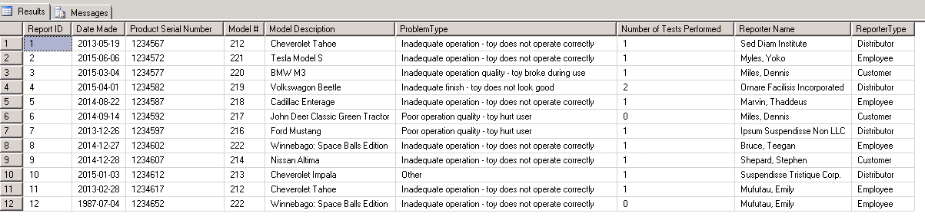

QUESTION 4:

SELECT

*

FROM

av_Number3

WHERE

av_Number3.[Number of Tests Performed] = 0

;

GO

OUTPUT QUESTION 4:



QUESTION 5:

/*

CREATE VIEW av_Number5 wasn't really important for us to create for query number five, however looking ahead to query number six, we knew we had

to extract information from within this query for a particular condition so we decided to store the query as a view. This enabled

us to utilize the query again without having to copy and pasting the same code.

*/

CREATE VIEW av_Number5 AS

SELECT

Report.IssueReportId AS 'Report ID',

Report.ReportDate AS 'Date Made',

Report.ProductSerialNumber AS 'Product Serial Number',

Unit.ModelNumber AS 'Model #',

Unit.[Description] AS 'Model Description',

Problem.[Description] AS 'ProblemType',

ISNULL(TestCounts.TestsConducted, 0) AS 'Number of Tests Performed',

CASE

WHEN Distributor.DistributorId IS NOT NULL

THEN Distributor.Name

WHEN Employee.EmpId IS NOT NULL

THEN Employee.LastName + ', ' + Employee.FirstName

WHEN Customer.CustomerId IS NOT NULL

THEN Customer.LastName + ', ' + Customer.FirstName

END AS 'Reporter Name',

CASE

WHEN Distributor.DistributorId IS NOT NULL

THEN 'Distributor'

WHEN Employee.EmpId IS NOT NULL

THEN 'Employee'

WHEN Customer.CustomerId IS NOT NULL

THEN 'Customer'

END AS 'ReporterType'

FROM

a_IssueReport Report

INNER JOIN a_IssueReportProblem Problem ON

Report.IssueReportProblemId = Problem.[ProblemID]

INNER JOIN av_ReturnedUnits Unit ON

Report.ProductSerialNumber = Unit.SerialNumber

LEFT OUTER JOIN av_TestCounts TestCounts ON

Report.IssueReportId = TestCounts.IssueReportId

LEFT OUTER JOIN a_Distributor Distributor ON

Report.DistributorId = Distributor.DistributorId

LEFT OUTER JOIN a_Customer Customer ON

Report.CustomerId = Customer.CustomerId

LEFT OUTER JOIN a_Employee Employee ON

Report.EmployeeId = Employee.EmpId

WHERE

Report.IssueReportId IN (

SELECT

TF.IssueReportId

FROM

a_TestForm TF

WHERE

TF.TestCompleted IS NULL

)

;

GO

SELECT

*

FROM

av_Number5

;

GO

OUTPUT QUESTION 5:



QUESTION 6:

SELECT

*

FROM

av_Number5 OuterNumber5

WHERE

OuterNumber5.[Date Made] = (

SELECT

MIN(InnerNumber5.[Date Made])

FROM

av_Number5 InnerNumber5

)

;

GO

OUTPUT QUESTION 6:



QUESTION 7:

/*

CREATE VIEW v_ModelReportCount, v_ModelTestCount, v_ModelInjuryCount, and v_ModelReportDate were useful because they allowed us

to summerize the data for each model number and description. By breaking up the query into multiple views we were able to gather

specific data (such as count of probs,tests,problem reports) for each vehicle model. This allowed for more logical approach to the ultimate

query and we were able to debug any errors we had in our enity attributes as we went. The views also allowed us to easily use aggregate functions

without the complexity of having to keep track of all the joins or groups.

*/

select * from v_ModelReportCount

select * from v_ModelTestCount

CREATE VIEW v_ModelReportCount AS

SELECT

a_Unit.ModelNumber,

Count(*) 'Report Count'

FROM

a_IssueReport

LEFT JOIN a_Unit

ON a_Unit.SerialNumber = a_IssueReport.ProductSerialNumber

GROUP BY a_Unit.ModelNumber

;

GO

CREATE VIEW v_ModelTestCount AS

SELECT

a_Unit.ModelNumber,

Count(*) 'Test Count'

FROM

a_TestForm

LEFT JOIN a_IssueReport

ON a_IssueReport.IssueReportId = a_TestForm.IssueReportId

LEFT JOIN a_Unit

ON a_IssueReport.ProductSerialNumber = a_Unit.SerialNumber

Group BY a_Unit.ModelNumber

;

GO

CREATE VIEW v_ModelInjuryCount AS

SELECT

a_Unit.ModelNumber,

COUNT(*) 'Injury Count'

FROM

a_IssueReport

LEFT JOIN a_Unit

on a_IssueReport.ProductSerialNumber = a_Unit.SerialNumber

WHERE a_IssueReport.InjuryOccurred = 1

Group BY a_Unit.ModelNumber

;

GO

CREATE VIEW v_ModelReportDate AS

SELECT

a_IssueReport.ProductSerialNumber,

a_Unit.ModelNumber,

a_issueReport.ReportDate

FROM

a_IssueReport

LEFT JOIN a_Unit

on a_IssueReport.ProductSerialNumber = a_Unit.SerialNumber

;

GO

/*

CREATE VIEW v_ModelSummary, this view allowed us to bring all the data from the four prior views into one

qeury and summarize all the data for each model into one place. We also knew we needed to use this data for query number eight

so it made sense to create a view that we could reference down the road.

*/

CREATE VIEW v_ModelSummary AS

SELECT

a_Model.ModelNumber,

a_Model.[Description],

ISNULL(v_ModelReportCount.[Report Count],0) 'Count of Problem Reports',

ISNULL(v_ModelTestCount.[Test Count],0) 'Count of Tests',

ISNULL(v_ModelInjuryCount.[Injury Count],0) 'Count of Injury Problem Reports',

(SELECT MIN(v_ModelReportDate.ReportDate) FROM v_ModelReportDate WHERE a_Model.ModelNumber = v_ModelReportDate.ModelNumber) 'Earliest Problem Report Date',

(SELECT MAX(v_ModelReportDate.ReportDate) FROM v_ModelReportDate WHERE a_Model.ModelNumber = v_ModelReportDate.ModelNumber) 'Most Recent Problem Report Date'

FROM

a_Model

LEFT JOIN v_ModelReportCount

ON a_Model.ModelNumber = v_ModelReportCount.ModelNumber

LEFT JOIN v_ModelTestCount

ON a_Model.ModelNumber = v_ModelTestCount.ModelNumber

LEFT JOIN v_ModelInjuryCount

ON a_Model.ModelNumber = v_ModelInjuryCount.ModelNumber

GROUP BY

a_Model.ModelNumber,a_Model.[Description],v_ModelReportCount.[Report Count],v_ModelTestCount.[Test Count],v_ModelInjuryCount.[Injury Count]

;

GO

OUTPUT QUESTION 7:

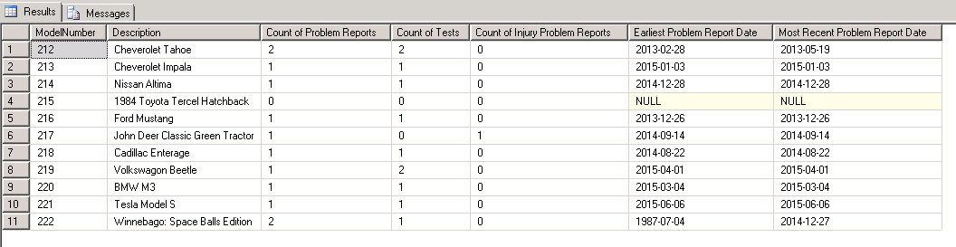

QUESTION 8:

/*

CREATE VIEW v_ModelMinReport and v_ModelMaxReport allowed us to complete this query systematically. We originally tried to

write the query for number eight without any views and it got really messy, so we opted to use the modular approach once again and do

views so we could see what the results as we went. Due to the nature of query number eight, we concluded that doing views to determine

which vehilce had the minimum amount of issues (as in v_ModelminReport) and the maximimum amount of issues (as in v_ModelMaxReport)

was appropriate because each of these views required a sub query to compute the min and max report vehicles. These views were helpful

because for the completion of query number eight we just had to create a select statment that took the values produced from the two

views and ORed (unioned) the results to complete the final query.

*/

CREATE VIEW v_ModelMinReport AS

SELECT

v_ModelSummary.ModelNumber,

v_ModelSummary.Description,

v_ModelSummary.[Count of Problem Reports]

FROM

v_ModelSummary

WHERE

v_ModelSummary.[Count of Problem Reports] = (SELECT MIN(v_ModelSummary.[Count of Problem Reports]) FROM v_ModelSummary)

;

GO

CREATE VIEW v_ModelMaxReport AS

SELECT

v_ModelSummary.ModelNumber,

v_ModelSummary.Description,

v_ModelSummary.[Count of Problem Reports]

FROM

v_ModelSummary

WHERE

v_ModelSummary.[Count of Problem Reports] = (SELECT MAX(v_ModelSummary.[Count of Problem Reports]) FROM v_ModelSummary)

;

GO

SELECT

*,

'Min' AS MinOrMax

FROM

v_ModelMinReport

UNION

SELECT

*,

'Max' AS MinOrMax

FROM

v_ModelMaxReport

;

GO

OUTPUT QUESTION 8:

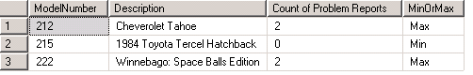

QUESTION 9:

/*

CREATE VIEW av_ReporterTypeFrequency was useful because it allowed us to count the number of issue reports made by

each entity (customer, distributor, employee). From this we could create a subquery that just pulled the entity that

filed the most reports. This query was useful in keeping the whole query simple. Like most other views we have used in

this project, the purpose was to be able to see our logic and program in modular fashion.

*/

CREATE VIEW av_ReporterTypeFrequency AS

SELECT

av_Number3.ReporterType,

COUNT(*) AS 'Frequency'

FROM

av_Number3

GROUP BY

av_Number3.ReporterType

;

GO

SELECT

RTF.ReporterType,

RTF.Frequency

FROM

av_ReporterTypeFrequency RTF

WHERE

RTF.Frequency = (

SELECT

MAX(InnerRTF.Frequency)

FROM

av_ReporterTypeFrequency InnerRTF

)

;

GO

OUTPUT QUESTION 9:

