Database Design and Implementation

HW 06

Team 08

Henriod, Terence

Santoyo, Jorge

Singh, Raja

March 11, 2015

/**

* IS675 - HW06 - Team08

* Using SQL Operations with More Complex Queries

*

* Division of Labor

* Well...

*/

/**

* Exercise 01

*

* Summarize the actual hours worked and labor cost (hours worked * hourly

* pay rate) by JobID and TaskID for all rows in the JobTask table. Remember

* that an employee's pay rate changes by date, so it is necessary to locate

* the correct pay rate by date as you did for question #15 for HW#5. If you

* were not able to get question #15 on HW#5 to work, I recommend doing that

* before starting on this question. Compare the actual labor hours to the

* estimated labor hours, and the actual labor costs to the estimated

* labor costs.

*/

DROP VIEW [v_TimeSheetsWithPay];

CREATE VIEW [v_TimeSheetsWithPay] AS

SELECT

[TimeSheet].[EmpID] AS 'EmpID',

[Employee].[LastName] + ', ' + [Employee].[FirstName] AS 'Employee Name',

[TimeSheet].[JobID] AS 'JobID',

[TimeSheet].[TaskID] AS 'TaskID',

[Job].[JobCompleted] AS 'JobCompleted',

[TimeSheet].[StartWork] AS 'StartWork',

[TimeSheet].[HoursWorked] AS 'HoursWorked',

[EmployeePay].[HourlyPayRate] AS 'HourlyPay',

[TimeSheet].[HoursWorked] * [EmployeePay].[HourlyPayRate] AS 'LaborCost'

FROM

[TimeSheet]

INNER JOIN [EmployeePay] ON

[TimeSheet].[EmpID] = [EmployeePay].[EmpID]

INNER JOIN [Employee] ON

[TimeSheet].[EmpID] = [Employee].[EmpID]

INNER JOIN [Job] ON

[TimeSheet].[JobID] = [Job].[JobID]

WHERE

[EmployeePay].[DateStartPay] <= [TimeSheet].[StartWork] AND

[TimeSheet].[StartWork] < ISNULL([EmployeePay].[DateEnd], GETDATE()) AND

[TimeSheet].[JobID] IS NOT NULL

;

DROP VIEW [v_ActualLaborByJobTask];

CREATE VIEW [v_ActualLaborByJobTask] AS

SELECT

[v_TimeSheetsWithPay].[JobID] AS 'JobID',

[v_TimeSheetsWithPay].[TaskID] AS 'TaskID',

SUM([v_TimeSheetsWithPay].[HoursWorked]) AS 'HoursWorked',

SUM(

[v_TimeSheetsWithPay].[HoursWorked] * [v_TimeSheetsWithPay].[HourlyPay]

) AS 'LaborCost'

FROM

[v_TimeSheetsWithPay]

GROUP BY

[v_TimeSheetsWithPay].[JobID],

[v_TimeSheetsWithPay].[TaskID]

;

DROP VIEW [v_LaborCostComparisons];

CREATE VIEW [v_LaborCostComparisons] AS

SELECT

[JobTask].[JobID] AS 'JobID',

[JobTask].[TaskID] AS 'TaskID',

[Task].[TaskDescription] AS 'TaskDescription',

CONVERT(varchar, [JobTask].[DateStarted], 101) AS 'DateStarted',

ISNULL(

CONVERT(varchar, [JobTask].[DateCompleted], 101),

'Not Done'

) AS 'DateCompleted',

[JobTask].[EstHours] AS 'EstHours',

ISNULL([v_ActualLaborByJobTask].[HoursWorked], 0.00) AS 'ActualHoursWorked',

[JobTask].[EstHours] - ISNULL([v_ActualLaborByJobTask].[HoursWorked], 0.00)

AS 'LaborHoursVariance',

[JobTask].[EstLaborCost] AS 'EstLaborCost',

ISNULL([v_ActualLaborByJobTask].[LaborCost], 0.00) AS 'ActualLaborCost',

[JobTask].[EstLaborCost] -

ISNULL([v_ActualLaborByJobTask].[LaborCost], 0.00) AS 'LaborCostVariance'

FROM

[JobTask]

INNER JOIN [Task] ON

[JobTask].[TaskID] = [Task].[TaskID]

LEFT OUTER JOIN [v_ActualLaborByJobTask] ON

[JobTask].[JobID] = [v_ActualLaborByJobTask].[JobID] AND

[JobTask].[TaskID] = [v_ActualLaborByJobTask].[TaskID]

;

SELECT

*

FROM

[v_LaborCostComparisons]

ORDER BY

[v_LaborCostComparisons].[JobID],

[v_LaborCostComparisons].[TaskID]

;

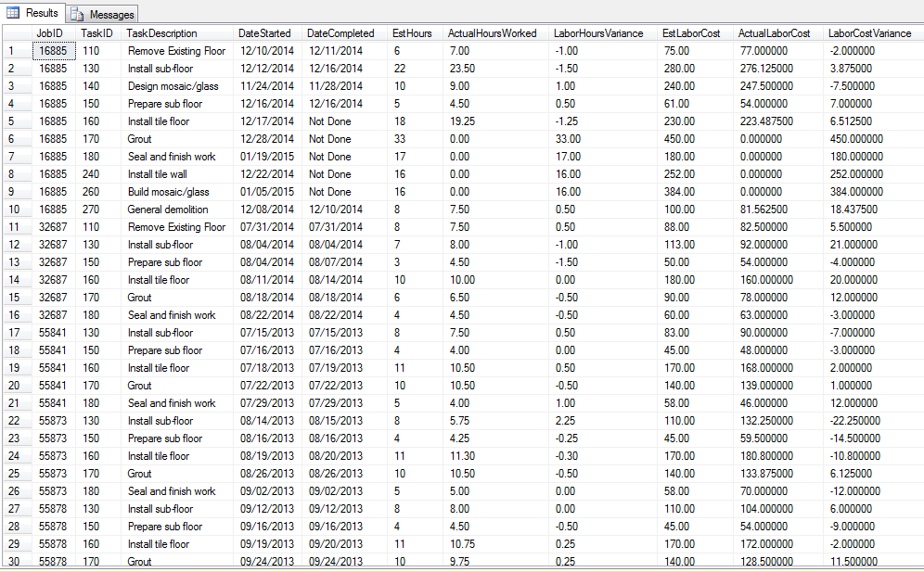

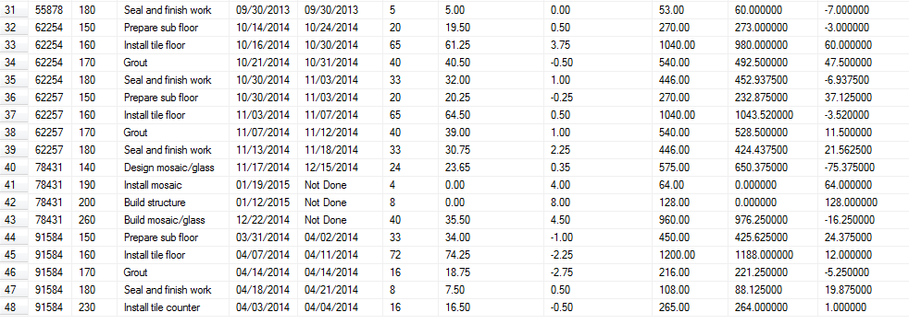

/**

* Exercise 02

*

* Summarize the actual material costs by jobID and task ID and compare

* them to the estimated material cost for each row in the JobTask table.

* This is very similar to what you did for question #11 in HW#5, so this

* should be fairly easy if you got question #11 to work.

*/

DROP VIEW [v_ActualMaterialsByTask];

CREATE VIEW [v_ActualMaterialsByTask] AS

SELECT

[MaterialAssigned].[JobID] AS 'JobID',

[MaterialAssigned].[TaskID] AS 'TaskID',

SUM([MaterialAssigned].[Quantity] * [MaterialPurchased].[CostPerUOM]) AS 'MaterialCost'

FROM

[MaterialAssigned]

INNER JOIN [MaterialPurchased] ON

[MaterialAssigned].[POID] = [MaterialPurchased].[POID]

GROUP BY

[MaterialAssigned].[JobID],

[MaterialAssigned].[TaskID]

;

DROP VIEW [v_MaterialCostComparisons];

CREATE VIEW [v_MaterialCostComparisons] AS

SELECT

[JobTask].[JobID] AS 'JobID',

[JobTask].[TaskID] AS 'TaskID',

[Task].[TaskDescription] AS 'TaskDescription',

CONVERT(varchar, [JobTask].[DateStarted], 101) AS 'DateStarted',

ISNULL(

CONVERT(varchar, [JobTask].[DateCompleted], 101),

'Not Done'

) AS 'DateCompleted',

[JobTask].[EstMaterialCost] AS 'EstMaterialCost',

ISNULL([v_ActualMaterialsByTask].[MaterialCost], 0.00) AS 'ActualMaterialCost',

(

[JobTask].[EstMaterialCost] -

ISNULL([v_ActualMaterialsByTask].[MaterialCost], 0.00)

) AS 'MaterialCostVariance'

FROM

[JobTask]

INNER JOIN [Task] ON

[JobTask].[TaskID] = [Task].[TaskID]

LEFT OUTER JOIN [v_ActualMaterialsByTask] ON

[JobTask].[JobID] = [v_ActualMaterialsByTask].[JobID] AND

[JobTask].[TaskID] = [v_ActualMaterialsByTask].[TaskID]

;

SELECT

*

FROM

[v_MaterialCostComparisons]

ORDER BY

[v_MaterialCostComparisons].[JobID],

[v_MaterialCostComparisons].[TaskID]

;

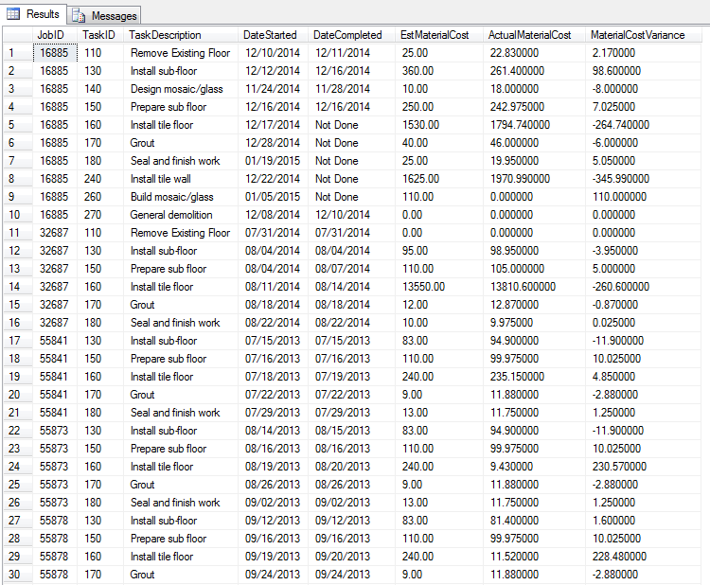

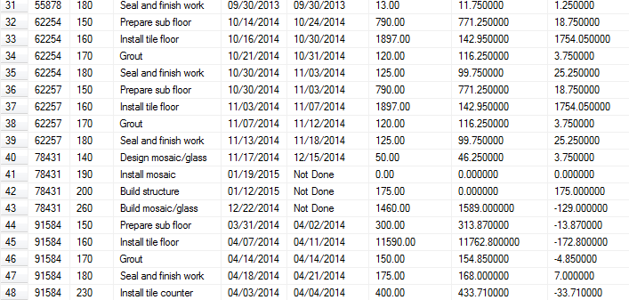

/**

* Exercise 03

*

* Now it’s time to put them together. Compare actual to estimated costs

* for each row in the JobTask table. The PercentVariance is the percentage

* variance between the TotalEstCost and the TotalActualCost. The

* general calculation is:

* ((TotalEstCost – TotalActualCost)/TotalEstCost) * 100.

*/

CREATE VIEW [v_TotalCostsByTask] AS

SELECT

[v_LaborCostComparisons].[JobID] AS 'JobID',

[v_LaborCostComparisons].[TaskID] AS 'TaskID',

[v_LaborCostComparisons].[TaskDescription] AS 'TaskDescription',

[v_LaborCostComparisons].[DateStarted] AS 'DateStarted',

[v_LaborCostComparisons].[DateCompleted] AS 'DateCompleted',

(

[v_LaborCostComparisons].[EstLaborCost] +

[v_MaterialCostComparisons].[EstMaterialCost]

) AS 'TotalEstCost',

(

[v_LaborCostComparisons].[ActualLaborCost] +

[v_MaterialCostComparisons].[ActualMaterialCost]

) AS 'TotalActualCost'

FROM

[v_LaborCostComparisons]

INNER JOIN [v_MaterialCostComparisons] ON

[v_LaborCostComparisons].[JobID] = [v_MaterialCostComparisons].[JobID] AND

[v_LaborCostComparisons].[TaskID] = [v_MaterialCostComparisons].[TaskID]

;

DROP VIEW [v_AllCostComparisonsByTask];

CREATE VIEW [v_AllCostComparisonsByTask] AS

SELECT

[v_TotalCostsByTask].[JobID] AS 'JobID',

[v_TotalCostsByTask].[TaskID] AS 'TaskID',

[v_TotalCostsByTask].[TaskDescription] AS 'Task Description',

[v_TotalCostsByTask].[DateStarted] AS 'DateStarted',

[v_TotalCostsByTask].[DateCompleted] AS 'DateCompleted',

[v_LaborCostComparisons].[EstHours] AS 'EstHours',

[v_LaborCostComparisons].[ActualHoursWorked] AS 'ActualHoursWorked',

[v_LaborCostComparisons].[LaborHoursVariance] AS 'LaborHoursVariance',

[v_LaborCostComparisons].[EstLaborCost] AS 'EstLaborCost',

[v_LaborCostComparisons].[ActualLaborCost] AS 'ActualLaborCost',

[v_LaborCostComparisons].[LaborCostVariance] AS 'LaborCostVariance',

[v_MaterialCostComparisons].[EstMaterialCost] AS 'EstMaterialCost',

[v_MaterialCostComparisons].[ActualMaterialCost] AS 'ActualMaterialCost',

[v_MaterialCostComparisons].[MaterialCostVariance] AS 'MaterialCostVariance',

[v_TotalCostsByTask].[TotalEstCost] AS 'TotalEstCost',

[v_TotalCostsByTask].[TotalActualCost] AS 'TotalActualCost',

(

[v_TotalCostsByTask].[TotalEstCost] -

[v_TotalCostsByTask].[TotalActualCost]

) AS 'TotalCostVariance',

(

(

[v_TotalCostsByTask].[TotalEstCost] -

[v_TotalCostsByTask].[TotalActualCost]

) *

(

100.00 /

[v_TotalCostsByTask].[TotalEstCost]

)

) AS 'PercentVariance'

FROM

[v_TotalCostsByTask]

INNER JOIN [v_LaborCostComparisons] ON

[v_TotalCostsByTask].[JobID] = [v_LaborCostComparisons].[JobID] AND

[v_TotalCostsByTask].[TaskID] = [v_LaborCostComparisons].[TaskID]

INNER JOIN [v_MaterialCostComparisons] ON

[v_TotalCostsByTask].[JobID] = [v_MaterialCostComparisons].[JobID] AND

[v_TotalCostsByTask].[TaskID] = [v_MaterialCostComparisons].[TaskID]

;

SELECT

*

FROM

[v_AllCostComparisonsByTask]

ORDER BY

[v_AllCostComparisonsByTask].[JobID],

[v_AllCostComparisonsByTask].[TaskID]

;

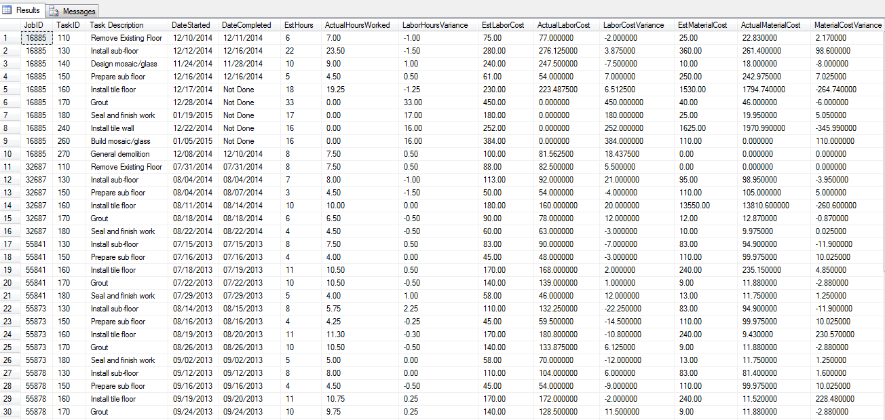

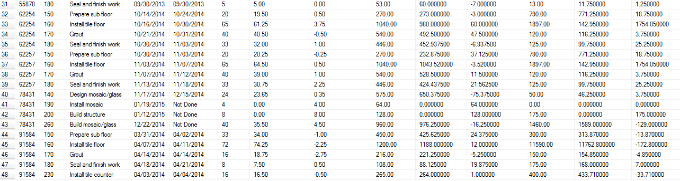

/**

* Exercise 04

*

* Summarize the information created in question #3 by job. The result

* table should have one row per job in the Job table. Add additional data

* from the Job and Client tables to provide more information about each

* job in the result table. Hint: \textbf{\underline{Calculate}} the

* PercentVariance – you cannot sum that field.

*/

DROP VIEW [v_TotalCostsByJob];

CREATE VIEW [v_TotalCostsByJob] AS

SELECT

[v_AllCostComparisonsByTask].[JobID] AS 'JobID',

SUM([v_AllCostComparisonsByTask].[EstHours]) AS 'EstHours',

SUM([v_AllCostComparisonsByTask].[ActualHoursWorked]) AS 'ActualHoursWorked',

SUM([v_AllCostComparisonsByTask].[LaborHoursVariance]) AS 'LaborHoursVariance',

SUM([v_AllCostComparisonsByTask].[EstLaborCost]) AS 'EstLaborCost',

SUM([v_AllCostComparisonsByTask].[ActualLaborCost]) AS 'ActualLaborCost',

SUM([v_AllCostComparisonsByTask].[LaborCostVariance]) AS 'LaborCostVariance',

SUM([v_AllCostComparisonsByTask].[EstMaterialCost]) AS 'EstMaterialCost',

SUM([v_AllCostComparisonsByTask].[ActualMaterialCost]) AS 'ActualMaterialCost',

SUM([v_AllCostComparisonsByTask].[MaterialCostVariance]) AS 'MaterialCostVariance',

SUM([v_AllCostComparisonsByTask].[TotalEstCost]) AS 'TotalEstCost',

SUM([v_AllCostComparisonsByTask].[TotalActualCost]) AS 'TotalActualCost',

SUM([v_AllCostComparisonsByTask].[TotalCostVariance]) AS 'TotalCostVariance',

(

SUM([v_AllCostComparisonsByTask].[TotalCostVariance]) * 100 /

SUM([v_AllCostComparisonsByTask].[TotalEstCost])

) AS 'PercentVariance'

FROM

[v_AllCostComparisonsByTask]

GROUP BY

[v_AllCostComparisonsByTask].[JobID]

;

DROP VIEW [v_JobInfo];

CREATE VIEW [v_JobInfo] AS

SELECT

[Job].[JobID] AS 'JobID',

[Job].[JobName] AS 'JobName',

[Client].[ClientName] AS 'ClientName',

CASE

WHEN [Job].[JobCompleted] = 1

THEN 'Finished'

ELSE

'Not Finished'

END /**/ AS 'JobStatus'

FROM

[Job]

INNER JOIN [Client] ON

[Job].[ClientID] = [Client].[ClientID]

;

DROP VIEW [v_JobSummary];

CREATE VIEW [v_JobSummary] AS

SELECT

[v_JobInfo].[JobID] AS 'JobID',

[v_JobInfo].[JobName] AS 'JobName',

[v_JobInfo].[ClientName] AS 'ClientName',

[v_JobInfo].[JobStatus] AS 'JobStatus',

[v_TotalCostsByJob].[EstHours] AS 'EstHours',

[v_TotalCostsByJob].[ActualHoursWorked] AS 'ActualHoursWorked',

[v_TotalCostsByJob].[LaborHoursVariance] AS 'LaborHoursVariance',

[v_TotalCostsByJob].[EstLaborCost] AS 'EstLaborCost',

[v_TotalCostsByJob].[ActualLaborCost] AS 'ActualLaborCost',

[v_TotalCostsByJob].[LaborCostVariance] AS 'LaborCostVariance',

[v_TotalCostsByJob].[EstMaterialCost] AS 'EstMaterialCost',

[v_TotalCostsByJob].[ActualMaterialCost] AS 'ActualMaterialCost',

[v_TotalCostsByJob].[MaterialCostVariance] AS 'MaterialCostVariance',

[v_TotalCostsByJob].[TotalEstCost] AS 'TotalEstCost',

[v_TotalCostsByJob].[TotalActualCost] AS 'TotalActualCost',

[v_TotalCostsByJob].[TotalCostVariance] AS 'TotalCostVariance',

[v_TotalCostsByJob].[PercentVariance] AS 'PercentVariance'

FROM

[v_JobInfo]

LEFT OUTER JOIN [v_TotalCostsByJob] ON

[v_JobInfo].[JobID] = [v_TotalCostsByJob].[JobID]

;

SELECT

*

FROM

[v_JobSummary]

ORDER BY

[v_JobSummary].[JobID]

;

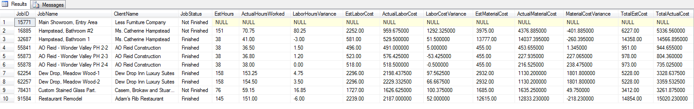

/**

* Exercise 05

*

* Which job that is \underline{finished} had actual total costs that were

* closest to the estimated total costs? (PercentVariance closest to zero)

* Make sure that the query could select the correct job from any data

* set – the query should not just work with our test data set.

*/

SELECT

*

FROM

[v_JobSummary]

WHERE

[v_JobSummary].[PercentVariance] = (

SELECT

MIN(ABS([v_JobSummary].[PercentVariance]))

FROM

[v_JobSummary]

)

;

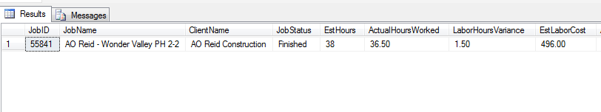

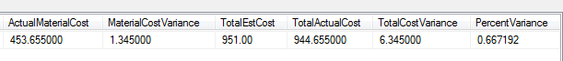

/**

* Exercise 06

*

* Which job that is \underline{finished} had the largest percentage

* positive labor hours variance? In other words, which finished job was

* able to be completed with the least number of labor hours, when compared

* to the estimated labor hours? The percentage labor hours variance is

* calculated as the LaborHoursVariance/EstHours * 100. Add in the name of

* the employee who served as the manager for the job.

*/

DROP VIEW [v_LaborHoursVariance];

CREATE VIEW [v_LaborHoursVariance] AS

SELECT

[v_JobSummary].[JobID],

[v_JobSummary].[JobName],

[v_JobSummary].[ClientName],

[v_JobSummary].[EstHours],

[v_JobSummary].[ActualHoursWorked],

[v_JobSummary].[EstHours] - [v_JobSummary].[ActualHoursWorked] AS 'LaborHoursVariance',

([v_JobSummary].[EstHours] - [v_JobSummary].[ActualHoursWorked]) * 100 / [v_JobSummary].[EstHours] AS 'PercentHoursVariance'

FROM

[v_JobSummary]

WHERE

[v_JobSummary].[JobStatus] = 'Finished'

;

DROP VIEW [v_JobManagerNames];

CREATE VIEW [v_JobManagerNames] AS

SELECT

[Job].[JobID] AS 'JobID',

[Employee].[LastName] + ', ' + [Employee].[FirstName] AS 'EmployeeManager'

FROM

[Job]

INNER JOIN [Employee] ON

[Job].[EmpManagerID] = [Employee].[EmpID]

;

SELECT

[v_LaborHoursVariance].[JobID],

[v_LaborHoursVariance].[JobName],

[v_LaborHoursVariance].[ClientName],

[v_JobManagerNames].[EmployeeManager] AS 'EmployeeManager',

[v_LaborHoursVariance].[EstHours],

[v_LaborHoursVariance].[ActualHoursWorked],

[v_LaborHoursVariance].[LaborHoursVariance],

[v_LaborHoursVariance].[PercentHoursVariance]

FROM

[v_LaborHoursVariance]

INNER JOIN [v_JobManagerNames] ON

[v_LaborHoursVariance].[JobID] = [v_JobManagerNames].[JobID]

WHERE

[v_LaborHoursVariance].[PercentHoursVariance] =

(SELECT

MAX([v_LaborHoursVariance].[PercentHoursVariance])

FROM

[v_LaborHoursVariance]

)

ORDER BY

[v_LaborHoursVariance].[JobID]

;



/**

* Exercise 07

*

* What is the average amount of time (labor hours) spent on a

* \underline{completed} job task per square foot, as compared to the

* estimated amount of time that should be spent on a task per square foot?

*

* Use the data in the JobTask table to calculate the average amount of

* EstHours/Squarefeet, but use the data in the TimeSheet table to calculate

* the average amount of time that was actually worked on a completed task.

* I recommend creating separate views for the estimated hours per square

* feet and the actual hours per square feet. The estimate view is a little

* easier to create because it doesn’t require a join. Include all rows in the

* JobTask table to get the average EstHours/Squarefeet for a task. To get the

* average \underline{actual} hours per square feet requires that you join the

* TimeSheet table and the JobTask table to be able to use the square feet in

* the JobTask table. Do not include data for incompleted tasks when

* calculating the ActualHours/SquareFeet. Remember that you have to SUM the

* HoursWorked in the TimeSheet table by JobID and TaskID to get the Actual

* HoursWorked from the TimeSheet table. I rounded the final results to 6

* digits after the decimal point. The result table is at the top of the

* next page. There is one row in the result table for each row in the Task

* table. Sort the result table by TaskID.

*

* The ComparisonMessage should be generated as shown on the result table

* above; if both the EstimatedHours and ActualHours are null, then put the

* message ``Null Estimate" in the ComparisonMessage column. Remember that

* a CASE statement in the SELECT list executes sequentially, so whatever

* WHEN statement is placed first will be executed first. The CASE

* statement stops executing as soon as a WHEN condition is true.

* Potential problem: EstHours and Squarefeet are integers and must

* be converted to decimal data types before they can be used in a

* calculation that could generate a decimal result.

*/

DROP VIEW [v_EstHoursPerSqFt];

CREATE VIEW [v_EstHoursPerSqFt] AS

SELECT

[JobTask].[TaskID] AS 'TaskID',

SUM([JobTask].[EstHours]) /

CAST(SUM([JobTask].[SquareFeet]) AS DECIMAL(6, 2)) AS 'EstimatedHoursPerSqFt'

FROM

[JobTask]

GROUP BY

[JobTask].[TaskID]

;

----------

CREATE VIEW v_CompleteSqFtSum AS

SELECT

TaskID,

SUM(SquareFeet) 'SquareFeet'

FROM

JobTask

WHERE

DateCompleted IS NOT NULL

GROUP BY

TaskID

;

CREATE VIEW v_CompleteActualHours AS

SELECT

TimeSheet.TaskID,

SUM(TimeSheet.HoursWorked) 'Hours'

FROM

TimeSheet

INNER JOIN JobTask ON

TimeSheet.JobID = JobTask.JobID AND TimeSheet.TaskID = JobTask.TaskID

WHERE

JobTask.DateCompleted IS NOT NULL

GROUP BY

TimeSheet.TaskID

;

CREATE VIEW v_CompleteActualHoursPerSqFt AS

SELECT

A.TaskID,

A.[Hours] / S.SquareFeet 'ActualHoursPerSqFt'

FROM

v_CompleteActualHours A

INNER JOIN v_CompleteSqFtSum S ON

A.TaskID = S.TaskID

;

DROP VIEW [v_ActualHoursPerSqFt];

CREATE VIEW [v_ActualHoursPerSqFt] AS

SELECT

[TimeSheet].[TaskID] AS 'TaskID',

SUM([TimeSheet].[HoursWorked]) /

SUM([JobTask].[SquareFeet]) AS 'ActualHoursPerSqFt'

FROM

[v_TimeSheetsWithPay] [TimeSheet]

INNER JOIN [JobTask] ON

[TimeSheet].[JobID] = [JobTask].[JobID] AND

[TimeSheet].[TaskID] = [JobTask].[TaskID]

WHERE

[JobTask].[DateCompleted] IS NOT NULL

GROUP BY

[TimeSheet].[TaskID]

;

------------------------------

DROP VIEW [v_HoursPerSqFtComparison];

CREATE VIEW [v_HoursPerSqFtComparison] AS

SELECT

[Task].[TaskID] AS 'TaskID',

[Task].[TaskDescription] AS 'TaskDescription',

[v_EstHoursPerSqFt].[EstimatedHoursPerSqFt] AS 'EstimatedHoursPerSqFt',

[v_CompleteActualHoursPerSqFt].[ActualHoursPerSqFt] AS 'ActualHoursPerSqFt',

CASE

WHEN [v_EstHoursPerSqFt].[EstimatedHoursPerSqFt] IS NULL

THEN 'Null Estimate'

WHEN [v_CompleteActualHoursPerSqFt].[ActualHoursPerSqFt] IS NULL

THEN 'Null Actual'

WHEN [v_EstHoursPerSqFt].[EstimatedHoursPerSqFt] > [v_CompleteActualHoursPerSqFt].[ActualHoursPerSqFt]

THEN 'Estimate Larger'

WHEN [v_CompleteActualHoursPerSqFt].[ActualHoursPerSqFt] > [v_EstHoursPerSqFt].[EstimatedHoursPerSqFt]

THEN 'Actual Larger'

ELSE

'No Difference'

END /**/ AS 'Comparison Message'

FROM

[Task]

LEFT OUTER JOIN [v_EstHoursPerSqFt] ON

[Task].[TaskID] = [v_EstHoursPerSqFt].[TaskID]

LEFT OUTER JOIN [v_CompleteActualHoursPerSqFt] ON

[Task].[TaskID] = [v_CompleteActualHoursPerSqFt].[TaskID]

;

SELECT * FROM v_HoursPerSqFtComparison;

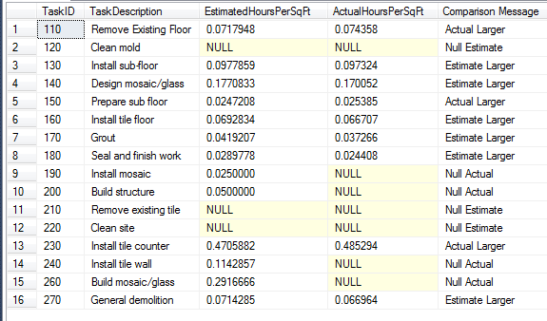

/**

* Exercise 08

*

* Use the result table generated for question #7 to help you answer

* this question. The goal of this query is to identify which task has

* the largest negative difference between the EstimatedHoursPerSqFt and

* ActualHoursPerSqFt (which estimate is the worst because the actual

* is larger).

*/

SELECT

*

FROM

v_HoursPerSqFtComparison Comparison

WHERE

Comparison.EstimatedHoursPerSqFt - Comparison.ActualHoursPerSqFt = (

SELECT

MIN(EstimatedHoursPerSqFt - ActualHoursPerSqFt)

FROM

v_HoursPerSqFtComparison

)

;

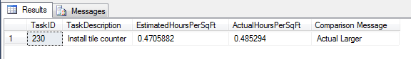

/**

* Exercise 09

*

* The objective of this query is similar to that for question #7, except

* this time we are going to look at labor costs rather than labor hours.

* What is the average estimated labor cost per square foot as compared

* to the actual labor cost per square foot for each task? I recommend

* looking back at question #1, where you probably created a view to help

* you calculate actual labor costs for a task on a job. That view will help

* you with this question. Do \textbf{\underline{not}} include data for

* incompleted tasks when calculating the actual labor cost/SquareFeet;

* do include data for incompleted tasks when calculating the estimated

* labor cost/squarefeet.

*/

DROP VIEW [v_EstWagesPerSqFt];

CREATE VIEW [v_EstWagesPerSqFt] AS

SELECT

[JobTask].[TaskID] AS 'TaskID',

CAST(SUM([JobTask].[EstLaborCost]) AS DECIMAL) /

CAST(SUM([JobTask].[SquareFeet]) AS DECIMAL(6, 2)) AS 'EstimatedWagesPerSqFt'

FROM

[JobTask]

GROUP BY

[JobTask].[TaskID]

;

----------

CREATE VIEW v_ActualPay AS

SELECT

TS.TaskID,

SUM(TS.LaborCost) 'ActualWagesPerSqFt'

FROM

v_TimeSheetsWithPay TS

INNER JOIN JobTask JT ON

TS.JobID = JT.JobID AND TS.TaskID = JT.TaskID

WHERE

JT.DateCompleted IS NOT NULL

GROUP BY

TS.TaskID

;

DROP VIEW [v_ActualWagesPerSqFt];

CREATE VIEW [v_ActualWagesPerSqFt] AS

SELECT

[v_ActualPay].[TaskID] AS 'TaskID',

v_ActualPay.ActualWagesPerSqFt /

v_CompleteSqFtSum.SquareFeet AS 'ActualWagesPerSqFt'

FROM

[v_ActualPay]

INNER JOIN [v_CompleteSqFtSum] ON

[v_ActualPay].[TaskID] = [v_CompleteSqFtSum].[TaskID]

;

------------------------------

SELECT

[Task].[TaskID] AS 'TaskID',

[Task].[TaskDescription] AS 'TaskDescription',

[v_EstWagesPerSqFt].[EstimatedWagesPerSqFt] AS 'EstimatedLaborCostPerSqFt',

[v_ActualWagesPerSqFt].[ActualWagesPerSqFt] AS 'ActualLaborCostPerSqFt',

CASE

WHEN [v_EstWagesPerSqFt].[EstimatedWagesPerSqFt] IS NULL

THEN 'Null Estimate'

WHEN [v_ActualWagesPerSqFt].[ActualWagesPerSqFt] IS NULL

THEN 'Null Actual'

WHEN [v_EstWagesPerSqFt].[EstimatedWagesPerSqFt] > [v_ActualWagesPerSqFt].[ActualWagesPerSqFt]

THEN 'Estimate Larger'

WHEN [v_ActualWagesPerSqFt].[ActualWagesPerSqFt] > [v_EstWagesPerSqFt].[EstimatedWagesPerSqFt]

THEN 'Actual Larger'

ELSE

'No Difference'

END /**/ AS 'Comparison Message'

FROM

[Task]

LEFT OUTER JOIN [v_EstWagesPerSqFt] ON

[Task].[TaskID] = [v_EstWagesPerSqFt].[TaskID]

LEFT OUTER JOIN [v_ActualWagesPerSqFt] ON

[Task].[TaskID] = [v_ActualWagesPerSqFt].[TaskID]

;

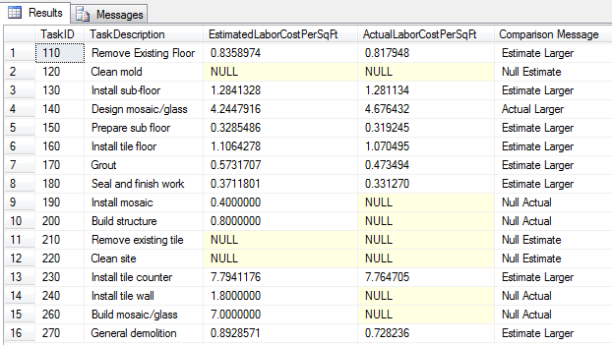

/**

* Exercise 10

*

* Which clients did not have any jobs with a DateAccepted last year?

* Which materials were not assigned (DateAssigned) to any job tasks last year?

* Combine the clients and materials into a single result table (hint: Use the

* UNION statement). Make sure that you use the GETDATE() function to

* determine the correct year.

*/

DROP VIEW [v_ClientsWithoutJobsInPreviousYear];

CREATE VIEW [v_ClientsWithoutJobsInPreviousYear] AS

SELECT

[Client].[ClientID] AS 'ClientID',

[Client].[ClientName] AS 'ClientName'

FROM

[Client]

WHERE

[Client].[ClientID] NOT IN (

SELECT

ClientID

FROM

Job

WHERE

DATEDIFF(YEAR, DateAccepted, GETDATE()) = 1

)

;

DROP VIEW v_MaterialsAssignedYearPrevious;

CREATE VIEW v_MaterialsAssignedYearPrevious AS

SELECT

DISTINCT(Material.MaterialID)

FROM

MaterialAssigned

INNER JOIN MaterialPurchased ON

MaterialAssigned.POID = MaterialPurchased.POID

INNER JOIN Material ON

MaterialPurchased.MaterialID = Material.MaterialID

WHERE

DATEDIFF(YEAR, MaterialAssigned.DateAssigned, GETDATE()) = 1

;

DROP VIEW v_MaterialsNotAssignedYearPrevious;

CREATE VIEW v_MaterialsNotAssignedYearPrevious AS

SELECT

MaterialID,

MaterialName

FROM

Material

WHERE

MAterial.MaterialID NOT IN (SELECT * FROM v_MaterialsAssignedYearPrevious)

SELECT

'Client: ' + CAST(ClientID AS VARCHAR) AS 'ClientOrMaterialID',

'Client: ' + ClientName AS 'ClientOrMaterialName'

FROM

v_ClientsWithoutJobsInPreviousYear

/**/

UNION

/**/

SELECT

'Material: ' + CAST(MaterialID AS VARCHAR) AS 'ClientOrMaterialID',

'Material: ' + MaterialName AS 'ClientOrMaterialName'

FROM

v_MaterialsNotAssignedYearPrevious

;

