**Understanding Motion**

Terence Henriod

TA: Marshall Liddle

Class: PHYS 180L, Section 1010

Thursday, September 27, 2012

**Abstract**

“We tested the theory that position, velocity, and acceleration are mathematically consistent, related physical properties; and we measured a value for the gravitational constant ‘g’” (Lab, 9/20/2012). This was accomplished by evaluating the plots of motion data and the slopes of lines of best fit, which were collected and computed by DataStudio data collection software. My findings supported the theory that position, velocity, and acceleration are mathematically consistent and related physical properties. This was illustrated by demonstrating that the rate of change of one quantity resulted in the magnitude of the next. The values found in this experiment were consistent with the predicted or accepted values: velocity is the rate of change in position (found with 2.86% discrepancy), acceleration is the rate of change in velocity (found with 5.0% discrepancy in the “ideal” situation, to be discussed later), and the experimental value for Earth’s gravity was measured to be 9.75 m/s/s (a 6.00% discrepancy from the widely accepted value of 9.81 m/s/s). Thus, it can be concluded that the aforementioned theory holds true.

**Theory**

In this lab, the relationship between position, velocity, and acceleration can be demonstrated. That is, that each is a derivation of the previous or the result of the rate of change of the previous, i.e. velocity is the rate of change in motion, and acceleration is the rate of change in velocity. This was tested by performing experiments wherein an experimenter attempts to demonstrate motion that matches simple plots on graphs of that motion. By changing position at a faster or slower rate, the relationship between position and velocity is discovered (or tested). In the same manner the relationship between velocity and acceleration can be discovered (or tested). This can all be shown by using the mathematical technique of graphing and calculating the slopes of lines of bust fit. These slopes can be predicted by the graphs types of motion the experimenter attempts to match. In addition, acceleration was measured in this experiment by observing the times required for a falling object to travel set increments of distance, further testing the theory that acceleration constitutes the change in velocity.

These lab procedures define position, velocity, and acceleration in the following ways:

$x\left(t\right)= \frac{∆x}{∆t}$ and $Δx= x_{2}-x_{1}$, [unit: meters from reference point]

Position can be defined as a function of time (not expressly shown here, varies from situation to situation), or simply tracked at various times. Often when position is discussed, the change in position is of interest. In this case, our points of reference for determining position are in Parts 1 & 2 the sonic motion sensor, and in Part 3 the beginnings and ends of the transparent and darkened areas of the “picket fence”

$v\left(t\right)=\frac{dx}{dt}$ and $v=\frac{Δx}{Δt}$, [unit: meters/second]

Velocity is defined as the rate of change of position. Instantaneous velocity can be found by taking the time derivative of the position function, or the average velocity is found by computing the change in position over time.

$a\left(t\right)=\frac{d^{2}x}{dt^{2}}= \frac{dv}{dt}$ and $a=\frac{Δv}{Δt^{}}$, [unit: meters/second2]

Acceleration is defined as the rate of change of velocity. Again, it is a time derivative of velocity

(or the second time derivative of position), or the average acceleration is computed as the change in velocity over time.

$Percent Difference= \frac{\left|observed value-accepted value\right|}{accepted value}*100\%$, measured in percent

Finally, once again, experimental values will be compared to accepted ones with a percent difference approach.

*Procedure*

This lab consisted of three parts. The first two utilized data collection software and a sonic motion detector. A flat object was also used to aid in detection of the person’s movement by the motion detector. The third part used a photo gate, “picket fence” implement (a plastic rectangle with alternating transparent and darkened areas), and the same data collection software.

In part 1, the software presented a graph of position vs. time, and the user had to attempt to match the graph by moving further from the motion sensor, or not moving, at appropriate times as the data was collected.

In part 2, the user was presented with a graph of velocity vs. time, and again, the user had to match this graph by moving closer and farther away from the sensor at varying rates at appropriate times while data was collected.

The results of these two experiments were plotted on top of the “prompt” graphs. Time sections of the graphs were chosen, and lines of best fit were plotted for the user’s motion by the software on each graph, respectively.

In part 3, the photo gate was implemented. The photo gate is a device that records when a beam of light is blocked and when it is not. For this experiment, the “picket fence” was allowed to free fall through the gate, and the software recorded the times when the light was blocked and when it was not, and the acceleration of the fence was calculated using the differing times of blockage, assuming that the distance across blockages were uniform and of a certain predetermined distance. The software then plotted a curve of the downward position (plotted as a positive y value) of the fence against time (on the positive x axis), as well as a line of best fit for the registered velocity vs. time.

Screenshots were taken of all graphs so that the results of both the motion samples and the equations of the lines of best fit could be collected as the data for this experiment.

**Data**

The data collected is displayed in Figures 1, 2, and 3.

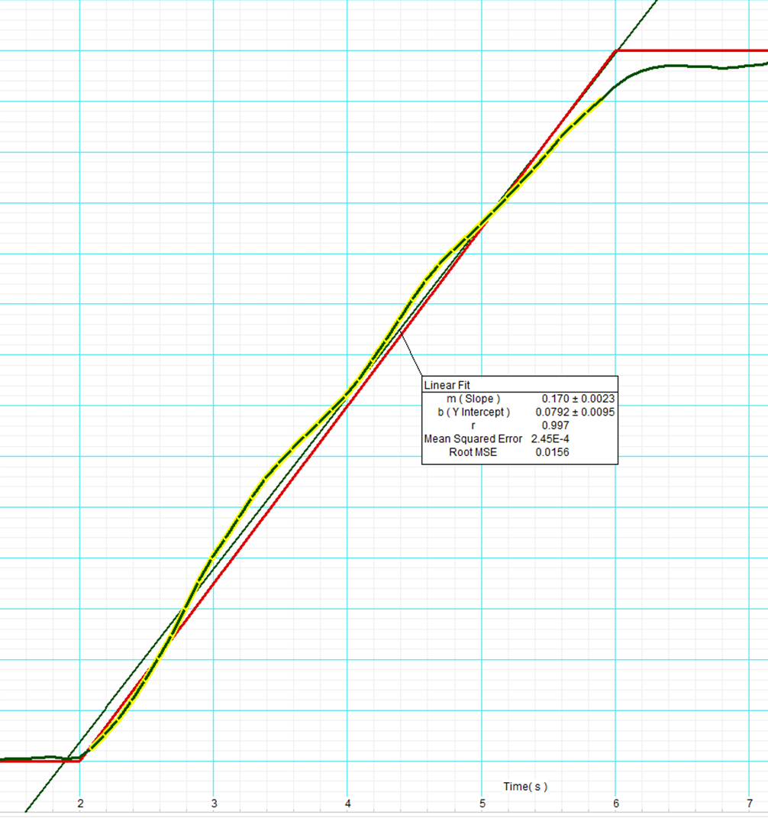

Figure 1: The graph and resulting charted motion of Part 1. As can be seen, the user’s motion closely matched that of the “prompt curve.” The average velocity for 2s ≤ t ≤ 6s is represented by the slope (because the slope of this line represents the change in position over the change in time) of the line of best fit: 0.17 m/s. This is in accordance with the theory that velocity is the time derivative of position.

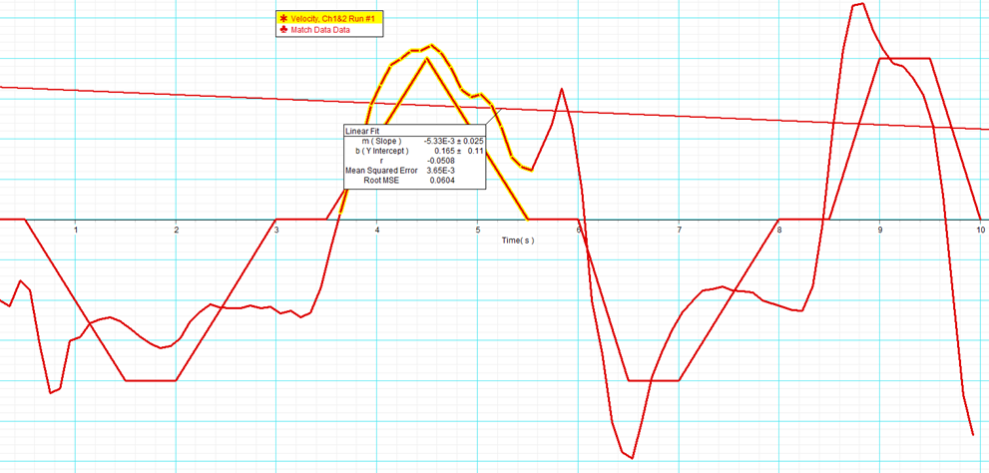

Figure 2: In this screenshot, the chosen selection ( ~3.5s ≤ t ≤ ~5.5s ) represents an increase in positive velocity, and then a decrease in positive velocity, starting and ending with no motion. The average slope of the prompt curve in this selection is 0, because it is equal parts upward slope and downward slope. The line of best fit has a slope of 0.00533 m/s/s, which is reasonably close to 0. Unfortunately, this is a deviation from the intended lab procedure. Ideally, only the first half of this selection (the “acceleration”) would be chosen ( ~3.5s ≤ t ≤ ~4.5s ), as opposed to the second half (or the “deceleration”), resulting in a line of best fit with a slope closer to .2 m/s/s, representing the average acceleration that should be achieved for that portion of the data collection period.

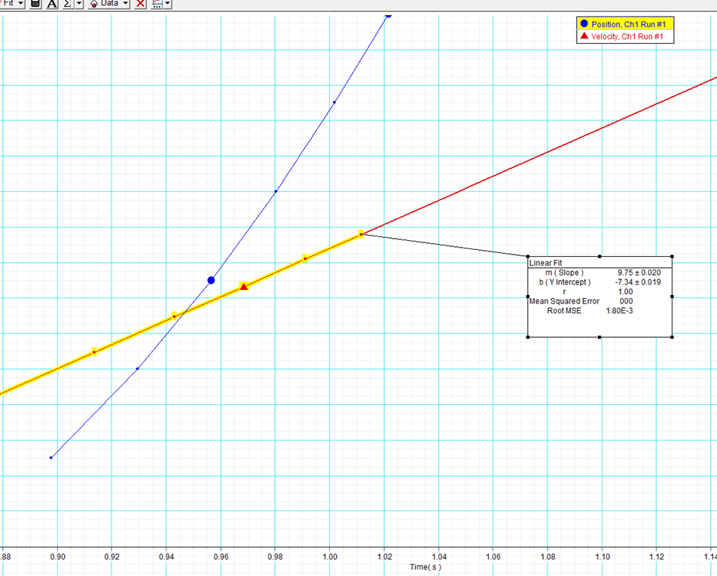

Figure 3: This graph shows the position of the picket fence plotted in blue (the result of some calculations involving the decreasing periods of time necessary for successive darkened areas to break the light beam), and the computed velocity at various times plotted in red. The slope of the line of best fit (9.75 m/s/s) represents the experimental value of the gravitational constant ‘g’ (9.81 m/s/s) that was found in this experiment.

There were some questions within the procedures section to prepare the user for conducting the motion experiment. Some did require some calculations to find.

1. From Part 1
   1. Start position (relative to motion sensor) = 0.4 m
   2. Total distance to be moved = 0.7 m (0.4m to 1.1m)
   3. Duration of movement (change in position) = 4s (2s to 6s)
   4. Speed of motion =0.175 m/s
2. From Part 2
   1. Will distance between the experimenter and the sensor increase or decrease? The separation will increase to achieve negative velocity.
   2. Maximum speed (velocity) to be achieved = +/- .2 m/s (both will be achieved)
   3. Duration of positive velocity = 2s (3.5s to 5.5s), and 1.5s (8.5s to 10s), respectively
   4. Accelerations during positive velocity segments = .2 m/s/s, -.2 m/s/s, .4 m/s/s, 0 m/s/s, -.4 m/s/s
   5. Where will the final position of the motion relative to the motion sensor, closer or farther than the start position? Farther away from the sensor, if we find the area under the “curve,” we will find that the “positive” (away from the sensor) will be greater than the “negative” (closer to the sensor).

**Computations**

The majority of computations for this experiment were done by the DataStudio data collection software. These included finding lines of best fit and their equations, and finding an experimental value for ‘g,’ again with a line of best fit.

Sample computations performed by the experimenter:

Change in position, found in Part 1:

$Δx= x_{2}-x_{1}$

$=\left(1.1m\right)-\left(.4m\right)$

$= .7m$

Velocity based on change in position, found in Part 1:

$v=\frac{Δx}{Δt}$

$$=\frac{\left(.7m\right)}{\left(4s\right)}$$

$$=.175 m/s$$

Acceleration based on change in velocity, found in the Part 2 “ideal” situation:

$a=\frac{Δv}{Δt}$

$= \frac{(.2\frac{m}{s})}{(1s)}$

$= .2\frac{m}{s^{2}}$

Finally, percent difference (discrepancy) from the data of Part 1:

$Percent Difference= \frac{\left|observed value-accepted value\right|}{accepted value}*100\%$

$= \frac{\left|(.170 m/s)-(.175 m/s)\right|}{(.175 m/s)}*100\%$

= 2.86%

*Uncertainty*

This section will appear in future lab reports, but not this one.

**Results**

The experiment was carried out, and the results proceeded as expected. Experimental results corresponded with predicted or accepted values. The results of interest are displayed in Table 1. In Part 1, the change in position was found to be consistent with velocity, in Part 2 the change in velocity was found to be consistent with acceleration, and finally in Part 3, the measured value for the acceleration of gravity was consistent with the accepted value.

|  |  |  |  |
| --- | --- | --- | --- |
|  | Experimental Value | Accepted Value | Discrepancy |
| Part 1 | 0.170 m/s | 0.175 m/s | 2.86% |
| Part 2 (using ideal arbitrary value) | 0.19 m/s/s | 0.20 m/s/s | 5.0% |
| Part 3 | 9.75 m/s/s | 9.81 m/s/s | 6.00% |

Table 1: The primary results of each part of the lab, the corresponding accepted value, and the % difference. Because I did not follow instructions in Part 2, my accepted value was 0 m/s, which, when used in the percent difference calculation, returns and undefined result. To avoid this, I used my arbitrary data from the “ideal” situation to demonstrate my knowledge of the correct lab procedures.

*Discussion*

Data was collected first by plotting experimenter motion tracked by a motion sensor on a “prompt” graph presented by data collection software, first for a position vs. time “curve,” then by a velocity vs. time “curve.” Lines of best fit were calculated to approximate the experimenter’s motion for certain selections of time of interest. In Part 3, data was collected by passing a “picket fence” through a photo gate, and the collected data was used to find an experimental value for the gravity of Earth.

The data collected did support the theory that position, velocity, and acceleration are all related physical properties. Data from the first two parts had relatively small discrepancies, with only a 2.86% discrepancy between the experimental and expected value for the velocity in Part 1; I found only a 0.533% error for the experimental versus expected value for acceleration in Part 2. Finally, a somewhat larger error of 6% emerged in Part 3 for the measurement of the acceleration of Earth’s gravity. These results support the notion that velocity is the result of a change in position and that acceleration is the result of a change in velocity.

Sources of error in this experiment include, in Parts 1 & 2, the inability of the experimenter to perfectly match the prompted motion, any error in the sonar of the motion sensor to accurately ascertain the position of the experimenter, and in Part 3, an imperfect drop of the picket fence. In Parts 1 & 2, the experimenter’s motion was not executed smoothly, and not in a manner perfectly matching the prompt positions and rates of change. This resulted in some discrepancy from the expected values. In Part 3, an imperfect drop could result in a result less than the accepted value for ‘g.’ This would occur due to: first, a crooked drop of the picket fence, resulting in the distances across the alternating sections of the fence becoming longer because the diagonal of a rectangle is longer than the width, resulting in the picket fence “traveling farther” than the DataStudio calculations are assuming; and second, a non-instantaneous drop with the fence sliding from the experimenter’s grip would result in a slower fall of the fence as friction prevented maximal acceleration. These sources of error could only be minimized through use of better apparatuses, perhaps through the use of a mechanical picket fence dropping apparatus in Part 3, or using an object that moves along a track for Parts 1 & 2.

*Questions*

1. Part 1
   1. The slope of the line of best fit is 0.170 m/s
   2. No movement for 2s, constant movement away from sensor for 4s, no movement for 2s.
2. Part 2 (Note: I will do calculations for both the improper data collection I did, as well as with some arbitrary data for the “ideal” situation)
   1. Expected acceleration (actual): 0 m/s/s
   2. Actual acceleration (actual): 0.00533 m/s/s
   3. Percent error (actual): .533%
   4. Expected acceleration (ideal situation): .2 m/s/s
   5. Actual acceleration (ideal situation): .19 m/s/s
   6. Percent error (ideal situation: 5.0%
3. Part 3
   1. There is a 6% discrepancy between my result and the accepted value of ‘g’. (Actual: 9.81 m/s/s, Experimental: 9.75 m/s/s)
   2. N/A, I have no table. However, this value should be similar to the one above.
   3. I expect the discrepancy is the result of (1) some equipment imprecision and imperfection and (2) (most likely) an imperfect drop of the picket fence. A non-straight drop of the picket fence will result in a distortion of the lengths of the alternating segments from what the software is expecting. This is due to the fact that the diagonal of a rectangle is broader than its width. Also, the fence may not have been dropped instantly, but rather allowed to slide from the fingers of the experimenter, decreasing the acceleration.