**Uniform Circular Motion**

Terence Henriod

TA: Marshall Liddle

Class: PHYS 180L, Section 1010

Thursday, November 1, 2012

**Abstract**

This week, the theory that was tested was the theoretical definition of centripetal force, and more precisely, its relation to the quantities that define it. The definition was tested by its constituent parts, which were later combined to represent the entire definition. The relationships between centripetal force and these quantities were tested by spinning a mass using an electric motor and measuring the force required to hold the mass in that pattern of rotation, measured by a force gauge.

The experiment proceeded as expected and successfully tested the relationship between force and linear velocity, mass, and the radius of the circular path an object travels, thus supporting the theory that is the definition of centripetal force. The relationships found between force and its defining variables are displayed in Table 5. These models that were found had very low error, 0.0389 for the linear velocity model, 0.130 for the mass model, and 0.0285 for the radius model.

**Theory**

The experiment allowed us to test the relationships between centripetal force and velocity, mass, and radius by allowing us to vary each quantity individually. It should be noted that this formula/these relationships stem from Newton’s Second Law.

In order for an object that would otherwise follow a straight-line path to follow a circular path, *centripetal acceleration* is required. This acceleration is always directed towards the center of the circular path. In this lab, our aim was to test or redefine the force that effects this acceleration, known as *centripetal force*.

First, it should be made clear that centripetal acceleration is defined by the square of the tangential velocity of the object divided by the radius of the circular path the object will be made to follow:

$${\vec{a}}_{centripetal}=\frac{{{\vec{v}}_{tangential}}^{2}}{r}$$

[ units: m/ss ]

Using Newton’s Second Law, $\vec{F}=m\vec{a}$, we can substitute and rearrange the previous equation to find that centripetal force is equal to the mass multiplied by the tangential velocity squared, all divided by the radius, and thus we are able to define the relationship between force and two of our target constituent variables:

$$\vec{F}=\frac{{{m*\vec{v}}_{tangential}}^{2}}{r}$$

[ units: Newtons ]

Giving us that:

$F ∝ m$ and $F∝ \frac{1}{r}$ and $F∝{\vec{v}}^{2}$

Finally, it is important to note that by making substituting the expression that equates angular velocity to linear velocity ($\vec{v}=ωr$), we can obtain the expression that the data collection software will be utilizing to relate linear velocity to force, as it is difficult to directly measure linear velocity, however the angular velocity can be measured simply by measuring the frequency of revolutions made:

$$\vec{F}=\frac{{m*(ω*r)}^{2}}{r}=m*ω^{2}*r$$

[ units: F in N, $ω$ in rad/s ]

*Procedure*

In this experiment, a mass was spun in a circle using an electric motor to spin an electric arm. The speed of the motor was controlled by a variable power supply. The arm was centered about the axis of rotation so that the arm spanned the diameter of a circle, which was the circular path the ends of the arm would trace when spun. The arm had slots running lengthwise that allowed a screw to pass through, allowing masses to be fixed in varying positions. The arm also had a ruler displayed along these slots to indicate how far away from the center the weights were fixed (i.e. the radius of rotation for the mass). A force scale was attached to one of the weight holding screws via a small cord or wire to measure the centripetal force required to hold the weight in while it spun. The force meter sat above the center of rotation, but fixed so that it did not rotate, and a light pulley was affixed to the arm holding the screw affixed to the force meter to redirect the small cord. Several of these items can be seen in Figure 1. A photogate sat below the arm, and was blocked periodically as the arm spun by a small marker that hung from the underside of the arm.

Weights were placed on eight side of the arm to balance each other; the counter-weight was fixed by tightening the screw so it would not slide, while the other weight was allowed to slide to out to a radius slightly greater than the radius of the counter-weight.

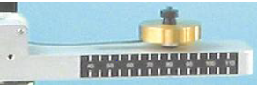

Figure 1: The side of the lab apparatus arm that holds the sliding weight. The ruler, weight, and small cord (barely visible) can be seen. (Courtesy of the Lab Assignment Document)

The weights were spun by gradually increasing the motor speed by gradually increasing the voltage on the power supply. Data was recorded by data collection software, which tracked the force necessary to hold the sliding mass in as the arm spun, and rotational velocity was calculated and tracked using the frequency with which the photogate was blocked.

The experiment was carried out in three parts, varying one quantity at a time while holding the others constant:

In the first part, mass and radius of the weights were kept constant. The data collection software was used to collect force and rotational velocity as the arm was spun faster and faster, and the relationship between the two was plotted on a graph and fit with a quadratic fit line.

The data collection software only collected force and rotational velocity data. To accommodate for this, in the next two parts, the values for the independent variable (mass, then radius) were entered into a table, and then values for force collected at a set rotational velocity were collected over five trials, and then a graph was plotted using the data stored in the table. The graph was then fitted with a line representative of the theoretical relationship between that variable and force.

In the next part, the mass affixed to the arm was varied. The counter-weight was ensured to be the same as the sliding weight to prevent breaking the apparatus. The mass was varied, the apparatus spun, and data was collected in the aforementioned manner for five different masses. A linear fit line was used.

For the third, and final, part, mass and velocity were held constant, while the radial positions of the weights were varied. Again, the counter weight was adjusted to match the reference weight to prevent damage to the apparatus. Data for five different radius positions was collected in the aforementioned manner once again. An inverse fit curve was used.

**Data**

Note: There was no tabular data for velocity vs. force collected; however, the graph of this data will appear in the results section.

|  |  |
| --- | --- |
| Mass (kg) | Force (N) |
| 0.030 | 8.04 |
| 0.040 | 10.93 |
| 0.050 | 12.01 |
| 0.055 | 13.45 |
| 0.060 | 13.97 |

Table 1: The data collected for the varying mass stage of the experiment. The radius was set to 0.05 m and the reference velocity was approximately 4.76 m/s.

|  |  |
| --- | --- |
| Radius (m) | Force (N) |
| 0.05 | 5.390 |
| 0.06 | 4.580 |
| 0.07 | 3.810 |
| 0.08 | 2.816 |
| 0.09 | 2.750 |

Table 2: The data collected for the varying radius stage of the experiment. The mass was kept at 0.03 kg and the reference velocity was approximately 3.0 m/s.

**Computations**

Computations were performed by the Science Workshop data collection software.

However, one sample calculation will be performed using data from the first trial of the varied radius segment of the experiment to demonstrate how centripetal force can be calculated:

$$\vec{F}=\frac{{{m*\vec{v}}_{tangential}}^{2}}{r}$$

$$=\frac{{\left(o.o3 kg\right)*(3.0 m/s)}^{2}}{(0.05 m)}$$

$=5.4 N$

*Uncertainty*

This week’s uncertainty assignment was to create tables demonstrating precision analysis for each measurement device, as well as for calculated results, seen in Tables 3 & 4.

|  |  |  |  |  |
| --- | --- | --- | --- | --- |
| Measuring Device | Quantity Measured | Smallest Increment Reported by Device | Sample Measurement | Claimed Precision |
| Force Guage | Force | 0.001 N | 5.390 N | 0.01 N |
| Photogate | Angular Velocity | .01 rad/s | 60.00 rad/s | 0.1 rad/s |
| Distance Guage (ruler) | Distance/ Length | 0.001 m | 0.050 m | 0.001 m |
| Masses (self measuring | Mass | 0.001 kg | 0.010 kg | 0.001 kg |

Table 3: A summary of the measuring devices and their capabilities, as well as what level of precision is expected to be valid.

|  |  |  |
| --- | --- | --- |
| Quantity Calculated | Value | Claimed Precision For Quantity |
| $$\frac{m*v^{2}}{r}$$ | 5.4 N | 0.1 N |

Table 4: A summary of the precision expected for calculated values that might be found when using the measuring devices from Table 3. Note that the precision is limited to .1 based on the claimed precision of the photogate.

**Results**

The experiment proceeded as expected and successfully tested the relationship between force and linear velocity, mass, and the radius of the circular path an object travels, thus supporting the theory that is the definition of centripetal force. The relationships found between force and its defining variables are displayed in Table 5. It should be noted that while a percent difference approach was not used in this lab to determine how well observed values matched predicted ones, this lab could have been improved greatly through their use to demonstrate how well the results supported the theory. (For example, using the data and conditions of the first trial in the varied radius segment, we see that the % error amounts to $\frac{\left|5.390-5.4N\right|}{5.4 N}*100\%=0.185\%$, very low!)

|  |  |  |
| --- | --- | --- |
| Experiment Stage | Fitted Equation Relating Force to the Quantity in Question | Mean Squared Error |
| Varied Rotational Velocity | $$F=.384v^{2}-.229v+.187$$ | 0.0389 |
| Varied Mass | $$F=193m+2.6$$ | 0.130 |
| Varied Radius | $$F=.319r^{-1}$$ | 0.0285 |

Table 5: A display of the fitted equations for the relationships between the variables of interest and force. Mean Squared Errors have been included as an indicator for the quality of the fit equation. These lines can be seen (along with the data) graphically in Figures 2-4.

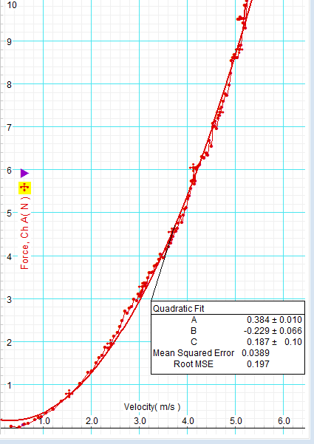 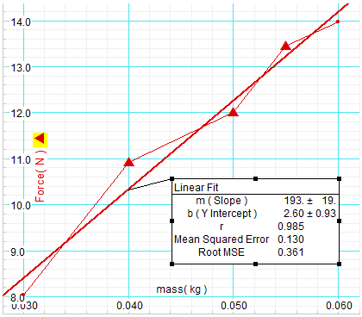

(2) (3)

Figures 2 and 3: The graph of tangential velocity vs. centripetal force and the graph of mass of the object vs. centripetal force.

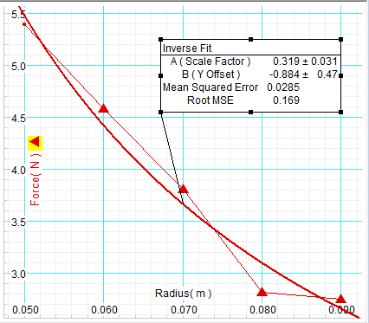

Figure 4: The graph of radius of the circular path vs. centripetal force.

*Questions*

1. Using words and a mathematical expression, describe the relationship between force and mass in uniform circular motion.

Centripetal force is directly proportional to the mass being held in the circular path: $F ∝ m$

1. Using words and a mathematical expression, describe the relationship between force and velocity in uniform circular motion.

Centripetal force is proportional to the square of the angular velocity: $F∝ v^{2}$

1. Using words and a mathematical expression, describe the relationship between force and radius in uniform circular motion.

Centripetal force is inversely proportional to the radius of the circular path: $F∝ \frac{1}{r}$

1. Combine the three relationships above to create one relationship for force, mass, velocity, and radius.
$$\vec{F}=\frac{m{\vec{v}}^{2}}{r}$$

2. How would you convert this expression into an equation?

The expression is already converted to an equation (see #4).

1. What is the constant of proportionality for this equation? Explain.

The constant of proportionality based on this model, using the constants of proportionality form each variable would be $\frac{193* .384}{.319}=232.32$ (using the constants of proportionality found with the fitted lines). This number is relatively meaningless, and obviously represents error of some sort as all proportionality should be defined by the variables themselves.

1. How could such an equation be used?

This equation could be used to calculate centripetal force under a variety of circumstances, allowing a scientist to determine either how much force will be necessary to maintain circular motion or to determine how much force an object is experiencing in circular motion.

1. The figure below is an overhead view of the rotating mass. For each of the 4 points, draw the direction and relative magnitude of the force

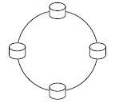

*Discussion*

The relationships between centripetal force and linear velocity, mass of the object traveling in a circle, and the radius of said circle were all tested. Calculations were performed by Science Workshop software, and fitted equations were given to display the relationship between force and these variables. These models had very low error, 0.0389 for the linear velocity model, 0.130 for the mass model, and 0.0285 for the radius model.

These results do support the accepted definition of centripetal motion, in fact, these models represent this very well given their low levels of error, giving us reason to believe that these models are sound. Unfortunately, these results may be somewhat skewed, from perfectly modeling the theory, as sources of error may have corrupted out measurements, which will be discussed in the next paragraph. As can be seen in Figures 2-4, the fitted lines do in fact fit very well.

Sources of error may have included friction between the sliding weight and the slot, skewness of the apparatus components, and friction or a non-smooth sliding of the small cable in the force gauge and the pulley. Friction between the sliding mass and the pulley would have made it appear that less centripetal force was required to maintain the circular path. Skewness of the apparatus components could have introduced a variety of measurement errors and even friction, disrupting the overall quality of the experiment. Finally, if the small cable did not slide well, it might appear, again, that the centripetal force was not as large as it really was. All in all, however, the results seemed to deviate little from expected values, and it would seem that any lack of precision significantly detracted from the quality of the results, in all actuality, the measurements were overall very precise.