**Torque**

Terence Henriod

TA: Marshall Liddle

Class: PHYS 180L, Section 1010

Thursday, November 8, 2012

**Abstract**

The theory in question in this week’s lab was Newton’s Second Law as applied to rotational motion, as opposed to translational motion. More precisely, we tested that torque was equal to moment of inertia multiplied by angular acceleration, as opposed to another variation of the Law. This was accomplished through the use of a few mediating relationships relating angular motion between objects with differing radii within an apparatus that used a falling weight to provide torque to spin a large platter, and angular motion was measured through the use of a smart pulley.

The results of the experiment did support the theory in question. Results ranged from, on the low end, a suspended mass of 0.025 kg producing a torque of 3.82 E-3 N*m for a percent discrepancy of 37.93%, while at the high end, a suspended mass of 0.105 kg produced a torque of 2.468 E-2 N*m for a 3.77% discrepancy.

**Theory**

This experiment allowed us to test the theory of Newton’s Second Law applied to rotational motion, that is that Torque (the rotational analog of force) is equal to the moment of inertia (the rotational analog of mass) multiplied by the angular acceleration (the rotational analog of translational acceleration):

$$τ=Iα$$

[ units: N*m ]

The moment of inertia is specific to an object’s shape and density, as well as what axis the object is being rotated around. For a disk or solid cylinder of uniform density rotated about a central, perpendicular axis, it is one half the mass multiplied by the radius squared:

$$I=\frac{1}{2}Mr^{2}$$

[ units: kg*m2 ]

Angular Acceleration is simply the change in rotational velocity per unit time:

$$α=\frac{ω}{∆t}$$

[ units: rad/s2 ]

It should be noted that while the above expression is analogous to the application of Newton’s Second Law to translational motion, the rotational quantities described in this report are not the same: Force is not the same as Torque, mass and the moment of inertia are not the same, and linear acceleration and angular acceleration are not the same.

Because the angular motion of the platter was measured indirectly via the smart pulley, we needed to convert the angular motion of the smart pulley to appropriate values for the platter. This was done by multiplying the angular acceleration measured for the smart pulley by the ratio of the smart pulley’s radius to the platter’s:

$$α_{platter}=\frac{r_{pulley}}{r_{platter}}α_{pulley}$$

[ units: rad/ss, m ]

The acceleration that the platter should have achieved in theory could be found using the previously stated application of Newton’s Second Law to rotational motion, rearranged to solve for angular acceleration and with values relevant to the experiment substituted; the moment of inertia for the platter for I, and the torque exerted on the spool by the falling weight for the torque applied to the system:

$$α_{theoretical}=\frac{τ}{I}=\frac{r_{spool}m_{weight}g}{\frac{1}{2}M_{platter}{r_{platter}}^{2}}$$

[ units: rad/s2 ]

The theoretical torque applied to the system is defined through some algebraic manipulation of a relation that has a moment of inertia and an angular acceleration implicit within it. In fact, it is the torque definition formula applied to the platter using the spool’s measurements, where m is the hanging mass exerting the torque, g is the gravitational constant, D is the radius of the spool, and α is the predicted acceleration for the platter:

$$τ_{theoretical}=m\left[g-\left(D*α_{theoretical}\right)\right]*D$$

[ units: N*m ]

Finally, the actual torque applied to the platter was found by applying Newton’s Second Law (previously stated).

Experimental values were compared to accepted or expected values with a percent difference approach:

$Percent Difference= \frac{\left|observed value-accepted value\right|}{accepted value}*100\%$

[unit: percent]

*Procedure*

This experiment was conducted using data collection software, a smart pulley, large experimental platter that had a spool attached on top in the center, a string, a second pulley, and a weight hanger and some small masses.

The string was attached to the platter via the spool (which was placed horizontally on a small metal rod so that it could spin freely), run over the normal pulley, and attached to the weight hanger so that the weight hanger would be allowed to fall. The string was around the spool so that the falling weight would create a tension in the string to produce a torque that would spin the spool/platter. The smart pulley was held gently against the platter so that the turning of the platter would ideally spin the smart pulley without slipping. A schematic of the setup can be seen in Figure 1.

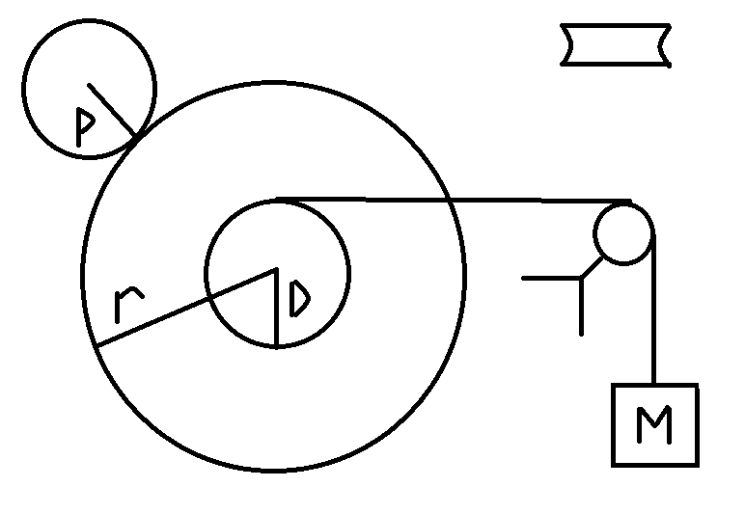

Figure 1: A schematic of the experiment setup. P represents the radius of the smart pulley, r is the radius of the platter, D is the radius of the spool (indicated twice, the second time to show that the spool was concave), and M is the suspended mass. Note: the rotating objects were actually placed horizontally (perpendicular to the hanging mass), but were rotated in this drawing to display the experiment apparatus more clearly.

The data collection software interpreted the motion of the pulley and plotted its angular motion against time on a graph. The slope of the graph was used to find a value for the angular acceleration of the smart pulley. The weight hanger was allowed to oscillate up and down three times for each trial to ensure a quality graph could be plotted, despite the fact that the initial weight drop/platter acceleration was used to collect values for angular acceleration (an example graph can be seen in Figure 2). Four trials with different masses hung on the weight hangers were conducted.

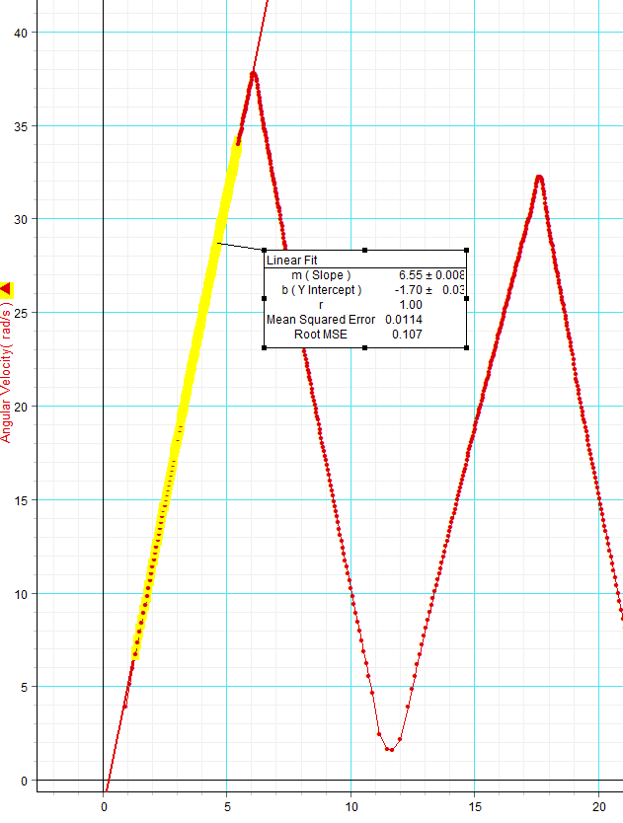

Figure 2: A sample graph produced from the second trial of the experiment. The description of the fitted line has become obscured due to shrinking of the image, but important information is found in the data tables.

**Data**

|  |  |  |  |  |  |
| --- | --- | --- | --- | --- | --- |
| Radius of Spool, D  (m) | Radius of Platter, r  (m) | Moment of Inertia for Platter, I  (kg*m2) | Mass of Platter (and Spool), M  (kg) | Mass of Weight Hanger, m  (kg) | Radius of Smart Pulley, p  (m) |
| 0.02512 | 0.126 | 0.00780 | 0.9823 | 0.0050 | 0.02447 |

Table 1: Prerequisite data for conducting the experiment.

|  |  |  |  |  |  |  |
| --- | --- | --- | --- | --- | --- | --- |
| Suspended Mass  (kg) | αgraph  (rad/s2) | αmeasured  (rad/s2) | αtheoretical  (rad/s2) | τtheoretical  (N*m) | τobserved  = I* αmeasured (N*m) | % Discrepancy (τ) |
| 0.0250 | 2.52 | 0.489 | 0.790 | 0.00615 | 0.00382 | 37.93 |
| 0.0450 | 6.55 | 1.272 | 1.422 | 0.01105 | 0.00992 | 10.23 |
| 0.0650 | 9.67 | 1.878 | 2.054 | 0.01593 | 0.01464 | 8.10 |
| 0.1050 | 16.3 | 3.166 | 3.318 | 0.02565 | 0.02468 | 3.79 |

Table 2: Data gathered while conducting the experiment. Note: the suspended mass is the sum of the mass of the hanger and any added weight.

**Computations**

Computations were performed with the use of Microsoft Excel. Line fitting for finding the angular acceleration of the smart pulley was performed by Science Workshop software. Sample calculations are as follows:

(Note: all calculations use data from the fourth trial of the experiment)

The moment of inertia of the platter, used throughout the experiment:

$$I=\frac{1}{2}Mr^{2}$$

$=\frac{1}{2}(0.9823 kg){(0.126 m)}^{2}$

$= 0.00780 kg*m^{2}$

The measured angular acceleration of the platter:

$$α_{platter}=\frac{r_{pulley}}{r_{platter}}α_{pulley}$$

$=\frac{\left(0.02447 m\right)}{\left(0.126 m\right)}(16.3 \frac{rad}{s^{2}})$

$= 3.166 \frac{rad}{s^{2}}$

The expected acceleration of the platter:

$$α_{theoretical}=\frac{r_{spool}m_{weight}g}{\frac{1}{2}M_{platter}{r_{platter}}^{2}}$$

$=\frac{2\left(0.02512 m\right)\left(0.1050 kg\right)(9.81 \frac{m}{s^{2}})}{(0.9823 kg){(0.126 m)}^{2}}$

$=3.318 \frac{rad}{s^{2}}$

The expected torque estimated to be applied to the platter:

$$τ_{theoretical}=m\left[g-\left(D*α_{theoretical}\right)\right]*D$$

$=(0.1050 kg)\left[(9.81 \frac{m}{s^{2}})-\left(\left(0.02512 m\right)*(3.318 \frac{rad}{s^{2}} )\right)\right]*\left(0.02512 m\right)$

$= 0.02565 N*m$

The measured torque applied to the platter:

$$τ_{measured}=Iα_{measured}$$

$=(0.00780 kg*m^{2})(3.166 \frac{rad}{s^{2}})$

$=$ 0.02468 N*m

Finally, the percent discrepancy between the theoretical estimate of torque applied to the platter and the measured one:

$Percent Difference= \frac{\left|observed value-accepted value\right|}{accepted value}*100\%$

$= \frac{\left|(0.02468 N*m)-(0.02565 N*m)\right|}{(0.02565 N*m)}*100\%$

$= 3.79 \%$

*Uncertainty*

There were five devices used in the experiment, none of which would be expected to introduce an excessive level of uncertainty into the results:

A scale and self-labeling masses were used to measure the masses of the objects used in the experiment. The scale measured down to the tenth of a gram (0.0001 kg), while the masses were labeled to the single gram. These were sufficient levels of precision for this experiment because most objects measured had masses on the order of ten grams or higher. I believe both modes of measurement to be sufficiently accurate because when weighing a few of the labeled masses with the scale, both the label and reading were in agreement.

A meter stick and micrometer were used to measure length (diameters/radii) of the circular objects in the lab. The meter stick was used to measure the platter, and measured to a precision of 0.001 m; the micrometer could measure with a precision of one one-hundredth of a millimeter (1 E-5 m), and was used to measure the spool and smart pulley. Their precision was sufficient for this experiment; any more would not have enhanced our results significantly, despite the fact that the measurement provided by the meter stick was be the limiting factor in terms of significant figures in the results. These devices also can be assumed to be reasonably accurate for the purposes of the experiment. The meter stick has been tried and true, while micrometers are purchased with the expectation of being a high quality, precise and accurate tool.

Finally, the smart pulley and associated software measured the angular speed of the smart pulley. It is difficult to say with what precision this combination could measure angular speed, but it is also inconsequential since the slope of a line of best fit applied to the graph of measured results was used to report angular acceleration, which was reported with a precision of 0.01 rad/s2. I would also consider this sufficiently precise, and relatively accurate. I believe it to be accurate because as mass used increased and as the experimenters became more practiced, the discrepancy between theoretical and measured values became significantly decreased. This mode of measurement tied with the meter stick for lack of precision/significant digits, but I would still assert that relatively little uncertainty was introduced by this measurement.

**Results**

Data and results of the experiment can be found in Tables 1-3, results of interest are found in Table 3. The experiment proceeded as expected, and the results were, for the most part, in accordance with the predicted values (the first trial produced an unexpectedly high percent discrepancy). Results ranged from, on the low end, a suspended mass of 0.025 kg producing a torque of 3.82 E-3 N*m for a percent discrepancy of 37.93%, while at the high end, a suspended mass of 0.105 kg produced a torque of 2.468 E-2 N*m for a 3.77% discrepancy.

|  |  |  |  |  |  |
| --- | --- | --- | --- | --- | --- |
| Suspended Mass  (kg) | αmeasured  (rad/s2) | αtheoretical  (rad/s2) | τtheoretical  (N*m) | τobserved  (N*m) | % Discrepancy (τ) |
| 0.0250 | 0.489 | 0.790 | 0.00615 | 0.00382 | 37.93 |
| 0.0450 | 1.272 | 1.422 | 0.01105 | 0.00992 | 10.23 |
| 0.0650 | 1.878 | 2.054 | 0.01593 | 0.01464 | 8.10 |
| 0.1050 | 3.166 | 3.318 | 0.02566 | 0.02468 | 3.77 |

Table 3: A summary of the results of interest of the experiment.

*Questions*

1. What effect did the increased mass have in the angular acceleration?

When speaking of increased mass of the hanging weight, it resulted in an increase in acceleration, because it created a stronger torque. When speaking of the mass of the object being rotated, even though it didn’t occur in the lab, increasing the mass of the object would have resulted in a decreased acceleration, assuming torque was kept constant.

1. What effect did it have on the percent discrepancy between the two torque calculations, why?

Increasing mass of the hanging weight was correlated with decreasing percent discrepancy. This was likely due to the fact that an increased torque being applied to the platter was better able to overcome the friction applied to the platter when holding the smart pulley tight enough to the platter to get a good reading of the angular motion.

*Discussion*

The theory of Newton’s Second Law, as applied to rotational motion, was tested. This was performed by using a hanging weight to provide torque to a spool attached to a platter to rotate the platter, and rotational motion was measured by applying a smart pulley to the edge of the spinning platter.

The results observed by this experiment support the theory of Newton’s Second Law as applied to rotational motion, as well as the intermediate relations used to measure torque in this experiment. With each trial of increasing suspended mass, percent discrepancy shrank, from 37.93% to 3.77%. The measured torque ranged increased with each trial from 3.82 E-3 N*m to 2.468 E-2 N*m. The weights/masses used in the experiment ranged from 0.025 kg to 0.105 kg. I would claim that if all the trials were redone with the experimenter now having more experience holding the smart pulley to the wheel, the discrepancy between measured values and theoretical ones would shrink.

Sources of error included friction, lack of friction, and experimenter inexperience. Friction that resulted from the rotating of the objects in the experiment (pulleys, platter) about their axles would have produced friction that would have slowed motion, decreasing the result of measured torque. A lack of friction between the surfaces of the smart pulley and the platter would have presented slippage, not allowing the smart pulley to be accelerated to an appropriate angular speed for measuring the angular speed and acceleration of the system, again reducing the resulting torque value. I believe this happened in the first trial, resulting in such a large error. This would be the result of experimenter inexperience because the experimenter had to learn how to hold the smart pulley tight to the platter without inhibiting any rotation by pressing too tightly, but not too loosely else slippage was allowed to occur.