**Rotational Kinetic Energy**

Terence Henriod

TA: Marshall Liddle

Class: PHYS 180L, Section 1010

Thursday, November 15, 2012

**Abstract**

The theory in question in this week’s lab was the definition of Rotational Kinetic Energy, along with the relationship between angular and tangential velocity. This was accomplished by utilizing theory of conservation of energy, and also through the use of a few mediating relationships relating angular motion, and therefore kinetic energy, between objects with differing radii within an apparatus that used a falling weight to provide torque to spin a large platter, and angular motion was measured through the use of a smart pulley.

The results of the experiment did support the theory in question. Results ranged from, on the low end, a suspended mass of 0.025 kg producing a rotational kinetic energy of the platter of 0.115 J and a percent loss of energy of the system of 21.386%, while at the high end, a suspended mass of 0.170 kg produced a rotational kinetic energy of the platter of 0.897 J and a 9.55% energy loss.

**Theory**

This experiment allowed us to test the theory of Rotational Kinetic Energy, which in this experiment was induced by transforming the potential energy of a falling mass into rotational kinetic energy of the platter and translational kinetic energy of the falling mass. The definition of rotational kinetic energy is:

$${KE}_{rotational}=\frac{Iω^{2}}{2}$$

[ units: J ]

Which is analogous to the definition of translational kinetic energy:

$${KE}_{translational}=\frac{MV^{2}}{2}$$

[ units: J ]

The following quantities defined are implicit in the definition of rotational kinetic energy:

The moment of inertia is specific to an object’s shape and density, as well as what axis the object is being rotated around. For a disk or solid cylinder of uniform density rotated about a central, perpendicular axis, it is one half the mass multiplied by the radius squared:

$$I=\frac{1}{2}Mr^{2}$$

[ units: kg*m2 ]

Angular velocity is simply the change in angular orientation per unit time:

$$ω=\frac{∆θ}{∆t}$$

[ units: rad/s ]

Because the angular motion of the platter was measured indirectly via the smart pulley, we needed to convert the angular motion of the smart pulley to appropriate values for the platter. This was done by multiplying the angular velocity measured for the smart pulley by the ratio of the smart pulley’s radius to the platter’s:

$$ω_{platter}=\frac{R_{pulley}}{R_{platter}}ω_{pulley}$$

[ units: rad/s, m ]

Angular velocity can be converted to tangential (linear) velocity simply by multiplying the angular velocity by the radius of the object experiencing the angular velocity:

$$V= ωR$$

[ units: m/s ]

In this experiment, it was necessary to find the linear velocity of the falling mass, which was essentially the tangential velocity of the spool, so the angular velocity of the platter/ spool comination had to be multiplied by the ratio of their radii to find the speed of the falling mass:

$$V= ω\frac{r}{R}$$

[ units: m/s ]

Because we were interested in the energy values that arose in the experiment, we needed to estimate the loss of potential energy of the experiment:

$${PE}_{loss}= -mg∆h$$

[ units: J ]

A key assumption to this experiment was that energy would be conserved. Using conservation of energy theory, this would mean that the sum of kinetic energies should be equal to the loss in potential energy:

$$\left|{PE}_{loss}\right|= {KE}_{total}={KE}_{rotational}+{KE}_{translational}$$

[ units: J ]

Giving us the “accepted” value that we will use for comparisons in a percent difference approach. In this experiment, one objective was to find the percent of energy lost, so the approach to calculating this quantity was slightly varied, the sum of the calculated kinetic energy gained and loss of potential energy was placed in the absolute value numerator, and the negative value of change in potential energy was kept negative so that the result would also be negative to indicate that the system had lost energy:

$Percent Difference= \frac{\left|∆PE + ∆KE\right|}{∆PE}*100\%$

[unit: percent]

*Procedure*

This experiment was conducted using data collection software, a smart pulley, large experimental platter that had a spool attached on top in the center, a string, a second pulley, and a weight hanger and some small masses.

Measurements of the radii of the platter, smart pulley and spool, the mass of the platter/spool and weight hanger/additional weights, and the height of the starting and ending points of the falling mass were collected, to be used later in calculations.

The string was attached to the platter via the spool (which was placed horizontally on a small metal rod so that it could spin freely), run over the normal pulley, and attached to the weight hanger so that the weight hanger would be allowed to fall. The string was around the spool so that the falling weight would create a tension in the string to produce a torque that would spin the spool/platter. The smart pulley was held gently against the platter so that the turning of the platter would ideally spin the smart pulley without slipping. A schematic of the setup can be seen in Figure 1.

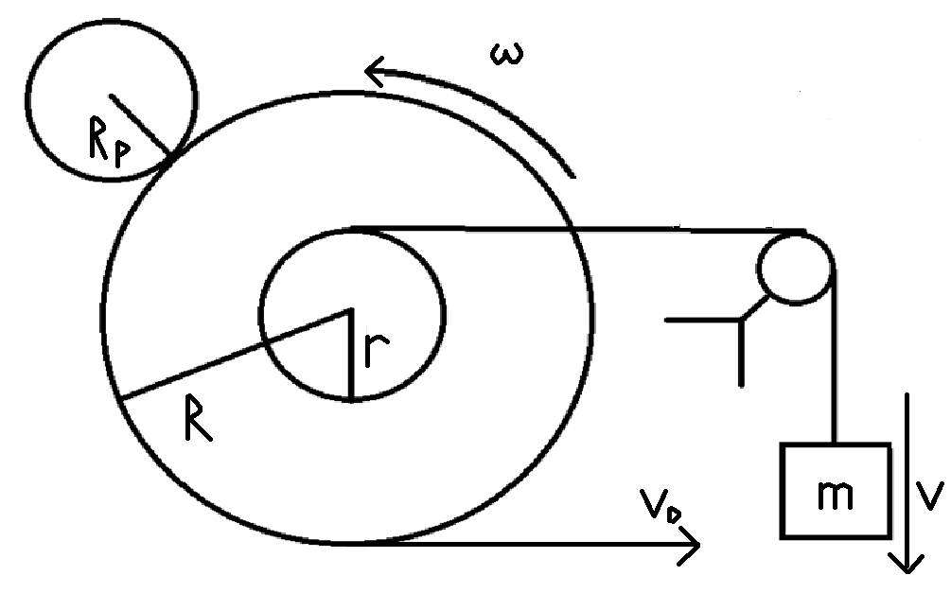

Figure 1: A schematic of the experiment setup. Note: Not drawn to scale.

The data collection software interpreted the motion of the pulley and plotted its angular motion against time on a graph. The line/curve was allowed to peak once, and data collection was ended shortly after the angular speed began to slow. The maximum angular speed was recorded (seen in Figure 2).

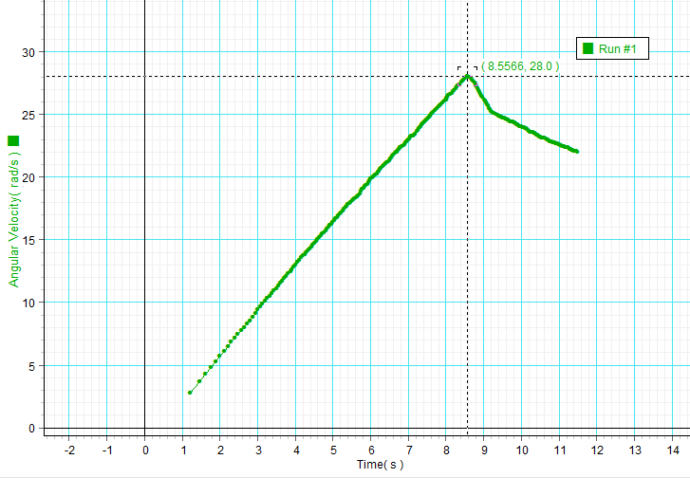

Figure 2: A sample graph used in the data collection process. The graph shown is from the first trial using a falling mass of 0.025 kg.

Using this data and previously taken measurements, various speed and energy measurements were calculated, and a percent difference approach was used to estimate the energy loss of each trial run.

**Data**

|  |  |  |  |  |  |  |  |
| --- | --- | --- | --- | --- | --- | --- | --- |
| Mass of Platter (and Spool), M (kg) | Mass of Weight Hanger, m  (kg) | H0  (m) | H1  (m) | Radius of Platter, R  (m) | Radius of Spool, r  (m) | Radius of Smart Pulley, RP  (m) | Moment of Inertia for Platter, I  (kg*m2) |
| 0.9823 | 0.005 | 0.308 | 0.911 | 0.126 | 0.02512 | 0.02447 | 0.00780 |

Table 1: Prerequisite data for conducting the experiment.

|  |  |  |  |
| --- | --- | --- | --- |
| Maximum Angular Velocity, ωmax  (rad/s) | Angular Velocity of the Platter, ωdisc  (rad/s) | Speed of Outer Edge of Platter, Vdisc  (m/s) | Speed of Falling Mass, V (m/s) |
| 28.0 | 5.44 | 0.69 | 0.137 |
| 40.8 | 7.92 | 1.00 | 0.199 |
| 48.9 | 9.50 | 1.20 | 0.239 |
| 78.1 | 15.17 | 1.91 | 0.381 |

Table 2: Velocity data, both angular and tangential/linear. Note: the tangential speed of the platter corresponds with the linear speed of the falling mass.

|  |  |  |  |  |  |  |  |
| --- | --- | --- | --- | --- | --- | --- | --- |
| Falling Mass  (kg) | Δ H  (m) | KE of Disc  (J) | KE of Falling Mass  (J) | Total Δ KE  (J) | Δ PE  (J) | Δ PE + Δ KE  (J) | % Difference (E0 and Efinal) |
| 0.025 | 0.603 | 0.115 | 0.00023 | 0.116 | -0.148 | -0.0323 | -21.86 |
| 0.050 | 0.603 | 0.245 | 0.00099 | 0.246 | -0.296 | -0.0499 | -16.88 |
| 0.070 | 0.603 | 0.352 | 0.00199 | 0.354 | -0.414 | -0.0604 | -14.58 |
| 0.170 | 0.603 | 0.897 | 0.01234 | 0.910 | -1.006 | -0.0961 | -9.55 |

Table 3: Data related to the energy values of each trial. The mass used and change in height were used to compute the loss of gravitational potential energy. Note: the sign of the % difference was kept to illustrate that energy was lost, as opposed to using the absolute value, which would not indicate whether or not the system had gained or lost energy.

**Computations**

Computations were performed with the use of Microsoft Excel. Line fitting for finding the angular acceleration of the smart pulley was performed by Science Workshop software. Sample calculations are as follows:

(Note: all calculations use data from the fourth trial of the experiment)

The moment of inertia of the platter, used throughout the experiment:

$$I=\frac{1}{2}Mr^{2}$$

$=\frac{1}{2}(0.9823 kg){(0.126 m)}^{2}$

$= 0.00780 kg*m^{2}$

The rotational kinetic energy of the platter:

$${KE}_{rotational}=\frac{Iω^{2}}{2}$$

$=\frac{(0.00780 kg*m^{2}){(15.17 \frac{rad}{s})}^{2}}{2}$

$=0.897 J$

The kinetic energy of the falling mass:

$${KE}_{translational}=\frac{MV^{2}}{2}$$

$=\frac{(0.170 kg){(0.381 \frac{m}{s})}^{2}}{2}$

$=1.234 E -2 J$

The rotational speed of the platter:

$$ω_{platter}=\frac{R_{pulley}}{R_{platter}}ω_{pulley}$$

$$=\frac{\left(0.02447 m\right)}{\left(0.126 m\right)}(78.1\frac{rad}{s})$$

$=15.17\frac{rad}{s}$

The tangential speed of the rim of the platter:

$$V= ωR$$

$=(15.17\frac{rad}{s})(0.126 m)$

$=1.91\frac{m}{s}$

The translational speed of the falling mass:

$$V= ω\frac{r}{R}$$

$=(15.17\frac{rad}{s})\frac{(0.02512 m)}{(0.126 m)}$

$= 0.381\frac{m}{s}$

The change in gravitational potential energy of the falling mass:

$${PE}_{loss}= -mg∆h$$

$= -(0.170 kg)(9.81\frac{m}{s^{2}})(0.603 m)$

$= -1.006 J$

The total kinetic energy was computed simply by summing the two previously calculated kinetic energies, for later use in the percent difference function:

$${KE}_{total}={KE}_{rotational}+{KE}_{translational}$$

$=(0.897 J)+(1.234 E -2 J )$

$=$ 0.909 J

Finally, the percent discrepancy between the expected loss in potential energy and the gain in kinetic energy (or loss of energy in the system):

$Percent Difference= \frac{\left|∆PE + ∆KE\right|}{∆PE}*100\%$

$= \frac{\left|\left(-1.006 J\right)+(0.909 J)\right|}{(-1.006 J)}*100\%$

$= 9.55 \%$

*Uncertainty*

I think that the best approach for the uncertainty section taken in this class thus far was the table approach, where every measurement is identified, the precision that device reports is listed, and the “trusted level” of precision for the device, and then a second table displaying computations using these “trusted levels” of precision, and then a result with an appropriate level of significant figures. I think this method most clearly illustrates what I believe are the aims of this class as far as measurement theory is concerned.

In addition to the table approach being the most clear, I think it results in the smallest amount of “busy work.” There is little need for paragraphs of text discussing uncertainty or quality of measurements, unless there are significant doubts about the precision of measurements reported by the device, and it is believed that the device is actually much less precise than it appears to be. The table approach allows for the student to quickly report the uncertainty of their measurements, and spend more time and effort on other, more intensive sections of the lab reports.

Personally, I would suggest that in the future, students are provided with a standardized guide to uncertainty, significant figures, etc. and that a standardized format is used throughout the course, to help alleviate confusion. I would suggest that the standardized format be the tabular one described previously, and the student should only need to use text to support their assertions if significant doubt about either precision or accuracy is present (although this may be somewhat redundant to the discussion section – perhaps some reformatting could be done to eliminate this).

**Results**

Data and results of the experiment can be found in Tables 1-4, results of interest are found in Table 4. Figure 3 displays the relationship between falling mass used and energy loss of the system. The experiment proceeded as expected, and the results were within an acceptable range of predicted values. The results of the experiment did support the theory in question. Results ranged from, on the low end, a suspended mass of 0.025 kg producing a rotational kinetic energy of the platter of 0.115 J and a percent loss of energy of the system of 21.386%, while at the high end, a suspended mass of 0.170 kg produced a rotational kinetic energy of the platter of 0.897 J and a 9.55% energy loss.

|  |  |  |  |  |  |  |
| --- | --- | --- | --- | --- | --- | --- |
| Falling Mass  (kg) | Angular Velocity of Disc, ωdisc (rad/s) | KE of Disc  (J) | Speed of Falling Mass, V (m/s) | KE of Falling Mass  (J) | Δ PE  (J) | % Difference (E0 and Efinal) |
| 0.025 | 5.44 | 0.115 | 0.137 | 0.00023 | -0.148 | 21.86 |
| 0.050 | 7.92 | 0.245 | 0.199 | 0.00099 | -0.296 | 16.88 |
| 0.070 | 9.50 | 0.352 | 0.239 | 0.00199 | -0.414 | 14.58 |
| 0.170 | 15.17 | 0.897 | 0.381 | 0.01234 | -1.006 | 9.55 |

Table 4: A summary of the results of interest of the experiment.

Figure 3: A graphical display of the relationship between increasing mass used in the experiment and the energy dissipated by friction in the system in each trial. As can be seen in the graph, the relationship between mass used and energy loss is approximately inverse.

*Questions*

1. Is energy conserved?

Energy is not conserved, in fact, depending on the trial, approximately 9-22% of the energy is dissipated.

1. What are the potential sources of the error (percentage difference)?

Friction between the rotating discs and pulleys and their axes is likely a significant source, as well as any slippage that may have occurred between the string and its pulley or between the platter and the smart pulley.

1. Does the percent difference vary with the value of the falling mass?

It does, percent difference decreases with increases in falling mass.

1. Why does the percent difference vary, or not vary, with the value of the falling mass?

I would claim that there are two reasons: the first being that as the discs/pulleys spin faster, they overcome the friction between them and their axles more easily, and that as the experiment continues, the experimenter becomes more capable of holding the smart pulley against the platter so that slipping or over pressing (which would result in an extreme amount of axle friction) does not occur.

*Discussion*

The theory of Rotational Kinetic Energy was tested. This was performed by using a hanging weight to provide torque to a spool attached to a platter to rotate the platter, and rotational velocity was measured by applying a smart pulley to the edge of the spinning platter. Using a system of equations, various angular, tangential, and linear velocities were found, allowing for rotational and translational kinetic energies to be found, which were then compared to the change in potential energy experienced by the falling mass using conservation of energy theory.

The results that were observed in this experiment did support the definition of rotational kinetic energy. Since the increase in rotational kinetic energy was, by far, the largest component of the gain in kinetic energy in this experiment, and the values of gained kinetic energy were reasonably close to the loss of potential energy when the difference is attributed to frictional losses, it is reasonable to assume that the results are supportive of the theory in question, despite so many other quantities being entangled in both the derivation of the energy results and the multiple kinetic energies appearing in the results to muddle the route to this conclusion. To reiterate: the results of the experiment ranged from, on the low end, a suspended mass of 0.025 kg producing a rotational kinetic energy of the platter of 0.115 J and a percent loss of energy of the system of 21.386%, while at the high end, a suspended mass of 0.170 kg produced a rotational kinetic energy of the platter of 0.897 J and a 9.55% energy loss. As illustrated by Figure 3, the percent of frictional loss of the system decreased with increasing mass (weight) used to power the system.

Sources of error included friction, lack of friction, and experimenter inexperience. Friction that resulted from the rotating of the objects in the experiment (pulleys, platter) about their axles would have produced friction that would have slowed the rotation of the discs/pulleys used in this experiment. A lack of friction between the surfaces of the smart pulley and the platter would have presented slippage, not allowing the smart pulley to be accelerated to an appropriate angular speed, reducing the calculated values for kinetic energy. These sources of error are also discussed in Question 4, and illustrated in Figure 3. I would claim that these relative frictional losses decrease because the increased speed of the rotating objects can better overcome the friction they experience. Another source of error might be that the falling mass was not dropped from exactly the same height every time, resulting in inaccurate expectations for loss of potential energy, or it may have hit the clamp that held the pulley to the table on the way down (unbeknownst to the experimenter), which would have further taken energy from the system in a manner that was not accounted for.