EMF Source Characteristics

Name: Terence Henriod

Partner’s Name: .

TA’s Name: Justin Wojdula

Section: 1006

Date: March 27, 2013

**Objective**: To investigate the characteristics of an electro-motive force (emf) source, namely the relationship between terminal voltage and internal resistance, as well as the condition(s) for maximum power output. This will be accomplished by connecting additional “internal” resistance to a typical battery, and then using a voltmeter and an ammeter to take readings as an “external” resistance is varied in a simple circuit.

**Theory**

It is known that electrical current, voltage, and resistance are all related in an electrical circuit in the following manner:

$V=IR ↔ R= \frac{I}{V} ↔I= \frac{V}{R}$ [1]

Where current I is measured in Amperes (A), voltage V is measured in volts (V), and resistance R is measured in ohms (Ω). Further, the current of a circuit with an electromotive force (emf) source with internal and external resistance is represented by:

$I= \frac{ε}{(R + r)}$ [2]

where ε is the emf measured in volts and r is the internal resistance in ohms of the emf source. An emf source is a source of electric potential, something that can drive electrical current through a circuit. An everyday example is a common dry-cell battery.

The power delivered by an emf source to be dissipated in the circuit is found by:

$P=IV= \frac{V^{2}}{R} = I^{2}R$ [3]

where power is measured in watts (W). Equations [1] and [3] can be combined to form the following formula for the power drawn from an emf source:

$P = \frac{ε^{2}*R}{{\left(R+r\right)}^{2}}$ [4]

The maximum power that can be drawn in a circuit is found by differentiating [4] with respect to R:

$\max\left(P\right)=\frac{d}{dR}\frac{ε^{2}*R}{{\left(R+r\right)}^{2}}=0 →\frac{ε^{2}(r - R)}{{\left(r+R\right)}^{3}}=0 → thus P→maximum as R→r$ [5]

given that ε and r are held constant, as a rule, although in reality they can vary somewhat. This demonstrates that there is some ideal resistance for a circuit that is not too high or too low to effectively draw power from an emf source. If external resistance is too low and current is fixed, then the circuit cannot draw much power; if the resistance is too high and voltage remains constant the circuit will not be able to draw much power in this situation either (see [3]).

The previous statements lead us to a brief discussion of battery design. Due to this idea that an emf source has an ideal resistance in order to produce maximum power output, we can see why batteries that are used to produce a large current have low internal resistances compared with those that don’t produce so much current. This is because when we want a battery to have a high power output, it also needs to have a large current output, but the emf does not vary (see the first element of [3]), but some batteries do not need to produce a lot of power so they can be long lasting, so they should have a high internal resistance (see [4]).

It should be noted that when performing the following experiment, we need to add a resistor to act as “internal” resistance for the battery. This is because typical batteries have very low, almost negligible internal resistances in order to produce sufficient electrical current when used in a circuit. This is apparent when we consider that the potential difference read from a seat of emf remains constant (generally), so in order for the power/current delivered by the battery to vary, they vary with respect to resistance. It follows that a dead battery has a very high internal resistance because it produces little or no power/current.

For the purposes of the experiment, we will assume that these equations will apply to our measurements as well, as the ideal ammeter has no resistance, and the ideal voltmeter draws no current, so as not to disrupt the intended operation of the circuit. If they did significantly alter these respective quantities in the circuit, they would need to be accounted for by being considered when computing R and I, respectively.

**Procedure**

This experiment will require an emf source, such as a typical 3v battery, an small 30-40Ω resistor to add to the battery to act as “internal” resistance, a dial-box resistor to act as “external” resistance, a voltmeter, an ammeter, and test leads to construct the circuit.

The circuit should be connected in the manner depicted by the following figure:

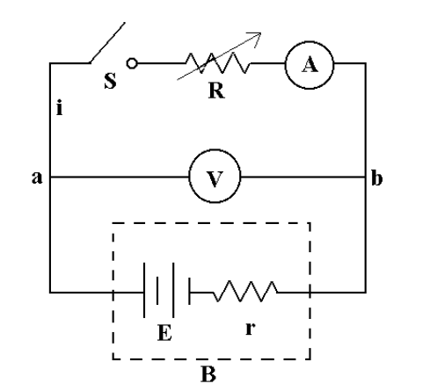

Figure 1: The schematic for the experimental circuit.

As can be seen, the battery, E, and the “internal” resistor, r, are connected in series such that a pair of test leads will now act as the terminals of the seat of emf. This portion of the circuit will be known as the effective battery, B. Then the variable resistor, R, and the switch, S, will be connected in series with B. The switch’s purpose is to disconnect the circuit when not in use so as to not draw on the battery unnecessarily. The voltmeter, V, is connected across the circuit to measure the terminals of B, and the ammeter, A, is connected in series after R.

Once the apparatus is set up and checked by the lab instructor, measurements will be taken in the following manner: R will be set to 300Ω and S will be closed so that a reading may be taken. Readings from V and A will be collected, and the power dissipated in the system will be computed. For subsequent readings, R will be gradually increased, at first in larger steps, and then in smaller steps as Power approaches its maximum value. The observations will be recorded in the manner previously mentioned. Finally, the data will be graphed: first, as a graph of V as a function of I; second, as a graph of P as a function of R (up to R = 100Ω).