**Lab 3**

1. Horseshoe Crab Study
   1. Construct GLMs

Logit Model

[Description/Summary]

Logit(π(having a satellite)) = -11.79311 + .47186 * X

Probit Model

[Description/Summary]

Probit(π(having a satellite)) = -7.1806 + .2873 * X

* 1. Plot the observed values and the probit and logit models on a graph

Response Plots

Link Plots

* 1. Find the probability of having at least one satellite for a female of width 25.5 cm according to each model.

Logit

Probit

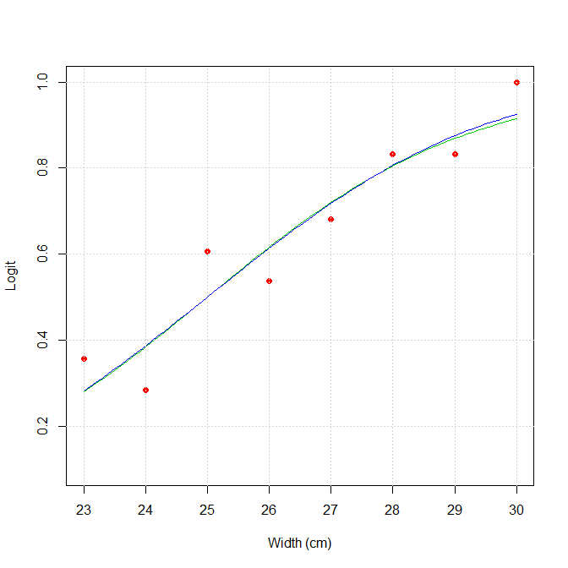

Linear Plot

* 1. Fds