
University of Bristol
Msc. Bioinformatics
Supervisor: Maria Sachkova

11th May 2026

Prediction of neuropeptide - receptor pairs in the nervous system of evolutionary ancient Ctenophora

Leonardo Lenin Rosas Godinez. 2594060

Abstract
Despite extensive research, there remains a gap in characterization of the nervous system of diverging animal lineages, especially non-bilaterians such as Ctenophora or Cnidaria. Understanding the interactions between neuropeptides and receptors in the earliest organisms is vital to reconstructing the evolutionary origin of the first animal nervous systems. For this regard, Ctenophora have been not studied enough despite being some of the earliest branching organisms with simple nervous system architectures. This work provides an overview of relevant literature surrounding neuropeptide-receptor pairs in the nervous system of ancient Ctenophora and the existing methods to explore these interactions. The aim is to establish the current state-of-the-art knowledge and highlight the methodological challenges that this work seeks to address. To achieve this, a workflow is proposed, integrating Machine learning tools (Alphafold 3) and RNA seq analysis for structure complex predictions and functional characterization. Additionally, alternative approaches to Alphafold are proposed for probable low-quality results to characterize neuropeptide-receptor interactions. This involves 3D structure prediction of the neuropeptides, receptors, and a combination of molecular docking and molecular dynamics simulations. A timeline to achieve this is also presented.
Keywords: Ctenophora, Neuropeptides, GPCRs, Molecular docking, Alphafold, Transcriptomics
Literature review
Research to study the ancient nervous systems in cnidarians and ctenophores is becoming an important focus as it relates to the understanding of the origins of the first systems of neurotransmission which have been unique to the animal taxa, except for the lineages sponges and placozoans. Understanding the evolution of the nervous system is key to build a picture of the evolution of the animal kingdom. Among the lineages, ctenophores represent an informative model for studying these questions.
Ctenophora
The animal kingdom can be divided into 5 large groups: Porifera (sponges), Ctenophora (comb jellies), Placozoa, Cnidaria and Bilateria (vertebrates, insects, molluscs). Of these, Porifera and Placozoa did not evolve a nervous system but rather cell-to-cell signalling for body activity (Leys, 2015). When it comes to Ctenophora and Cnidaria, they evolved a nerve net (a network of interconnected neurons lacking brain centralization) with key differences. Cnidarians’ nervous system shares a common origin to bilaterians as the neurons are connected via synapses. In contrast, Ctenophora’s subepithelial neurons form a syncytium, which is a single continuous mass of cytoplasm containing several nuclei (Burkhardt et al., 2023) and possess chemical synapses between sensory cells and subepithelial neurons. There is still a need to identify common features between Cnidaria and Ctenophora to identify the origins of their nerve nets.
Understanding how such nervous systems emerged has led to several hypotheses including the neurosecretory network hypothesis (Bullock and Horridge, 1965). The hypothesis is based on proposing the apparition of neurosecretory cells to transmit information from sensory cells to effector cells (e.g. muscles) using small molecules (e.g. glutamate) and peptides. In fact, placozoans and sponges encode for neurosecretion proteins in their genomes and perform paracrine signalling via peptides as well. In other words, cell signalling to nearby cells via diffusion (Senatore, Reese and Smith, 2017). This system resembles peptidergic nerve nets (or simpler said, systems that respond to peptide neurotransmitters) and endocrine cells in animals with nervous systems. These proteins have been named protoneurons (Najle et al., 2023) and hint that paracrine signaling would have been the initial cell-to-cell communication system (Jékely, 2021) (Sachkova, Modepalli and Kittelmann, 2025). And for the placozoans, their peptidergic cell nerve nets share similarities with GPCRs, neuropeptide-processing cells and the neuronal presynaptic scaffold present in cnidarians and bilaterials (Burkhardt et al., 2014) (Sachkova, Modepalli and Kittelmann, 2025). Of note, GPCRs are not only present in these animal groups, but also in ctenophores. Their involvement in the understanding of the first nervous systems, especially in ctenophores, is critical.
GPCR in Ctenophora
Understanding the nervous systems of Ctenophora requires familiarity with the G protein coupled receptors. These are membrane receptors that transform extracellular signals in intracellular responses. They represent the most abundant membrane bound proteins to regulate neurotransmission, hormone releases and immune responses. Particularly, ctenophores such as M. leidyi are known to have at least 3 of the 5 main GPCR families: glutamate, rhodopsin and adhesion (Ryan et al., 2013). The amount distribution of these receptors is shown for other groups is shown in Fig 1. As for Rhodopsin, M. leidyi has 605 genes with homologs to serotonin, adrenergic and adrenaline receptors. However, this species lacks the enzymes for synthesis of these neurotransmitters, which could reveal unknown functions for Rhodopsin proteins (Krishnan and Schiöth, 2015). As for adhesion GPCRs in Ctenophora, their role remains unknown despite encoding for 26 adhesion-protein genes (Jékely, 2021). So far, their role in vertebrates includes cell-cell adhesion and synapse formation (Bukalo and Dityatev, 2012). But its role in pre-bilaterial organisms like M. leidyi remains to be elucidated. Finally, 18 genes for glutamate proteins are present, but little to no information exists to their role other than the presence of conserved N-terminal domains such as the Venus-flytrap domain (ligand binding domain) and a cysteine rich domain (CRD) (Krishnan and Schiöth, 2015). So far, these information gaps represent a central role in the methodology discussed further in this work.

Neuropeptide repertoire
As for the neuropeptides present in M leidyi., it is believed that their nervous system evolved independently. A study by Sachkova et al (2024) found 129 putative peptide precursors, being 16 of them localized in the subepithelial nerve net (SNN), sensory aboral organ (SAO) and epithelial sensory cells (ESC) mainly. A more detailed morphologic schematic of these body parts is shown in Fig 2.
The subepithelial nerve net can be described as a nerve net throughout the epidermis, and their neurites and cell bodies can be found across other epidermal cell types. It has a distributed neuronal network located beneath the epidermis. The aboral organ is better described as a complex containing an apical organ and polar fields (Hernandez-Nicaise, 1991). The apical organ is a sensory and balance organ at the opposite end of the mouth and is in the aboral pole and is responsible for detecting gravity and environmental stimuli. Its cells, denominated as ciliated, control comb row and beating frequency. The polar fields, paired ciliated structures near the aboral organ, are two tongue shaped flanking areas in the complex (Jager et al., 2010). Its function is still not fully studied but a work from Jager hypothesizes a function based on its shape. It is well known that this animal can move vertically due to contraction of deep mesoglea muscle fibres. The polar field muscles might be involved in antagonizing this movement to trigger the upwards migration of the apical organ. Finally, epithelial sensory cells are also ciliated in the form of vibroreceptors and hoplocytes and can establish synapses with neurons of the subepithelial polygonal nerve net (Jager et al., 2010) (Hernandez-Nicaise, 1991).
As a whole, these peptides have been found out to have a role in the neuro-sensory system and behaviour including swimming speed. They constitute a peptidergic nerve net, which means that the nervous system is triggered by neuropeptides (Jager et al., 2010). Together, the peptides form an interconnected network of neurites through anastomoses (continuous membranes) which has not been observed in other metazoans (Sachkova et al., 2021). In fact, the neuropeptide repertoire is highly divergent from other ctenophores and cannot be homologized due to neuropeptides being fast evolving (Ryan et al., 2013), although many putative neuropeptides are conserved across ctenophores. They are believed to be produced by precursors-like neurons. Based on this, enrichment in these precursors would signal enrichment of the neuropeptides, which still need to undergo a muli-step processing to become mature and functional (Sachkova et al., 2021). Despite this growing body of biological knowledge, the interactions between neuropeptides and their receptors remains unresolved.
Existing methods to explore neuropeptide-receptor interactions
A range of approaches have been developed to understand peptide-receptor interactions. Alphafold (AF) has become a strong tool in the understanding of orphan ligands binding to receptors. It starts with a sequence input and performs database searching (on which the model has been previously trained). The search results in a model inference and structure prediction with confidence scores associated. In a study by Danneskiold-Samsøe et al (2024), AF2 was used for ligand-receptor interactions. In their study, for 90% of the studied ligands, candidates were found above a iPTM=0.5 value. This highlights the accuracy prediction power and its potential to elucidate the GPCR and peptide interactions. Additionally, they suggest that employing only the extracellular domain (ECD) of the receptor is sufficient for predictions. This is because they observed cases where including intracellular domains did not affect performance, making this parameter negligible (Danneskiold-Samsøe et al, 2024).
Alphafold is an example of sequence-based methods to study proteins and make predictions on structure and binding. Other sequence-based methods to study proteins and especially the binding pockets are available especially when there is no structure data available, such as PSeq2Sites and SeqInSite (Tran-Nguyen and Camproux, 2025). Alternatives are also available focused on structure rather than sequence such as Deeppocket, and Fpocket, but require high quality input and are computationally intensive (Tran-Nguyen and Camproux, 2025) (Seo et al., 2024).
At the same time, while several 3D protein structures are available in the Mnemiopsis genome server for the receptors (National Human Genome Research Institute, no date), there is less availability on the 3D structures of the neuropeptides transmitted. Nonetheless, there are tools to assess this peptide structure predictions. Some of the best performing include Alphafold3 and PepFold, the last one with similar performance and in some cases even more reliable results for ligands especially at ph and salt dependent conformations (Rey et al., 2023).
When it comes to protein-peptide interactions for M leidyi, little information is available on their conformations. While AF is a powerful tool, it relies on data availability, which the organism lacks in public databases. Nevertheless, other softwares have not yet been tried to determine the best pose conformation and its evolution throughout time. Molecular docking and molecular dynamics can assist in this matter. Molecular docking refers to a computational prediction of how two molecules bind in a 3D space. Rosetta’s FlexPepDock and HADDOCK are already validated tools with peptide modes which could prove useful in determining a neuropeptide-receptor pose for M. Leidyi. Molecular dynamics is on the other hand a simulation of atomic movements over time to assess stability (GROMACS is the most-spread used) (Bicak et al., 2020). It is based on determining the properties of each atom and its interactions and solve Newton’s equations for movement throughout time. The result is a system to determine stability of the complex using energies and temperatures that resemble morphological conditions (Vidal-Limon, Aguilar-Toalá and Liceaga, 2022). It can provide insights into the evolving dynamics of the complexes and their function.

RNA seq analysis
In addition to structural prediction approaches, transcriptomics offers complementary insights into neuropeptide-receptor relationships. Single cell (scRNAseq) experiments have proven useful to make insights about the nature of these unique neuropeptides and their protein interactions. Particularly, when used with in situ hybridization and immunohistochemistry, it is possible to annotate metacell clusters in different parts of the ctenophore body (such as AO cells and pharyngeal neurons) (Sachkova et al, 2021). Metacells are defined as disjoint groups of highly similar cells aggregated together (Bilous et al, 2024). At the same time, a study found 30 putative neuropeptides enriched in several specific metacell clusters (Sachkova et al, 2021). Yet, co-expression might still give some insights if further used. The use of RNA-seq can determine autocrine (cell signaling to itself) or paracrine neural signalling to further characterize how signalling in M. leidyi works.
The approach
Despite the current knowledge in peptide expression in different celltypes, the receptors for these peptides remain unknown. While several sequence based and structure-based methods are available to characterize the interactions and there is existent knowledge about the protein families present in Ctenophora, none of the methods have been tested in M. leidyi, especially considering the lack of sequential and structural data on which ML methods are trained. Given that M. leidyi neuropeptides are unique and show divergence with other species, there is still no established workflow to link ctenophore neuropeptides and candidate receptors.
To address these information gaps hindering peptide-receptor interaction characterization, a workflow is proposed based on hypothesis combining peptide structure prediction, receptor structure prediction, interaction prediction using ML-tools, docking, MD simulations and gene expression profiles to identify biologically plausible receptors in the ctenophore nervous system.
Methods
The aim of this project is to identify candidate receptors for a given neuropeptide expressed in the nervous system of Mnemiopsis leidyi using ML-tools and molecular interaction softwares, as well as co-expression profiling assessment via RNA-seq analysis.
To achieve this, the project is structured in the following specific objectives:
- Predict the 3D structure of the neuropeptides
The neuropeptide structure will be predicted using Alphafold and will be evaluated for confidence due to the small size of the peptide. To mitigate potential low-confidence predictions, other tools will be evaluated such as PepFold to generate a plausible conformation.
- Identify or predict the 3D structure of candidate membrane receptors
This will be done based on genome annotation structure availability in the Mnemiopsis genome browser or structure prediction softwares like Alphafold. Consequently, softwares like Deeppocket, Fpocket, Pseq2Sites, and SeqinSites will be considered as options to find protein-binding pockets for downstream analysis.
- Predict peptide-receptor interactions
To do this, two possible pathways are available. The first is to attempt the generation of a neuropeptide-receptor complex using Alphafold. However, since alphafold is trained on existing structures, there is the risk of low confidence predictions considering the special divergence and unique neuropeptide properties of M. leidyi. To address this possibility, a second pathway is proposed by combing molecular docking softwares (FlexPepDock, HADDOCK) and molecular dynamics (GROMACS) as options for modelling. Receptors will be ranked based on energy binding mode performance and metrics in each of the softwares.
- Study co expression of receptors and peptide-precursor and the implications of interactions using expression context in in silico validation.
For this, RNA seq data will be used to examine co-expression of peptides and candidate receptors in neuronal and possibly other cells. This is to study the characterization of the nervous system and its connection with other celltypes. Genes could be expressed in several types of cells and a co-expression analysis of the precursors and receptors at the biological level can help to elucidate the relationship between them.
There are a few clarifications on the objectives and methodologies to be employed. Alphafold has the capacity of modelling interactions using only the sequence of the receptor and peptide, skipping steps 1 and 2 in the methodology. However, as already stated, there is a high risk of unreliable results as this organism is poorly characterized for the Alphafold database. Although not verified yet, the lack of support data for M. leidyi in the Alphafold database is probable to produce low quality results. More of that in risk section. For this respect, molecular docking and dynamics present themselves as alternatives, and both require not only the sequence but the 3-dimensional structure, making steps 1 and 2 necessary for the workflow. In other words, Alphafold will be tested using its current database to model the best possible peptide-receptor interactions for M. leidyi. In case of failing to this task, 3D structure prediction, molecular docking and dynamics simulation steps will be followed as an alternative. A summary of the methodology is found in Fig 3.
The project is designed to be feasible and prioritize data preparation and receptor-peptide conformation predictions. Optional RNA seq analyses, while enriching, are scheduled later in the timeline to avoid deviating from the core objectives.
A Gantt chart is presented (Figure 4) summarising the timeline, illustrating task durations, key milestones in structure prediction, interaction analyses, interpretation and report writing. Table 1 also describes the start and end dates for each of the tasks.
Risk identification
No biological or safety risks can be identified in the scope of the project given that the work is exclusively computational. However, results would be affected depending on the performance of the softwares employed in the workflow. The following risks have been identified:
Nature of the risk | Likelihood and potential impact on the project | Mitigation strategy / contingency plan
Low AlphaFold metrics performance when large proteins are combined with small interfaces (such as ligands or peptides) (Danneskiold-Samsøe et al, 2024). | Moderate likelihood  Could limit the reliability of AF to characterize the receptor-peptide complexes and determine plausibility in nature | In case that Alphafold cannot generate a quality complex due to its low metrics, the workflow suggests using alternative softwares like Pepfold, HADDOCK and others mentioned in methods to characterize the neuropeptides and receptor interactions
Ligand binding positioning inaccurate and variable due to lack of support data for M. leidyi as this organism is not well characterized for Alphafold to be trained on the proteins and structures from this organism. Failure in binding positioning has already been observed in GPCR-ligand interactions (Shen et al., 2025) | Moderate likelihood  Could limit the ability to assess if neuropeptides are binding to a receptor in M. leidyi, | In case Alphafold cannot tell where the peptide is binding in the receptor, pocket finding softwares like Deeppocket, Fpocket, Pseq2Sites, and SeqinSites will be used to determine where the ligand binds, and Molecular docking and dynamics will be employed how these interactions evolve through time to assess stability of the interactions

Reference list
Bicak, B., Kokcu, Y., Kecel-Gunduz, S., Ozel, A.E. and Akyuz, S. (2020) The interaction of Ile-Phe dipeptide with phosphatidylinositide 3-kinase (PI3K): Molecular dynamics and molecular docking studies. NESciences, 5(1), pp. 18–29. Available at: https://doi.org/10.28978/nesciences.691673
Bilous, M., Hérault, L., Gabriel, A.A. et al. (2024) ‘Building and analyzing metacells in single-cell genomics data’, Molecular Systems Biology, 20, pp. 744–766. Available at: https://doi.org/10.1038/s44320-024-00045-6.
Bukalo, O. and Dityatev, A. (2012) Synaptic cell adhesion molecules. In: Kreutz, M. and Sala, C. (eds.) Synaptic plasticity. Advances in Experimental Medicine and Biology, vol. 970. Vienna: Springer. Available at: https://doi.org/10.1007/978-3-7091-0932-8_5
Bullock, T.H. and Horridge, G.A. (1965) Structure and function in the nervous systems of invertebrates. San Francisco: W.H. Freeman. Available at: https://archive.org/details/structurefunctio0001theo (Accessed: 10 May 2026).
Burkhardt, P., Colgren, J., Medhus, A., Digel, L., Naumann, B., Soto-Angel, J.J., Nordmann, E.-L., Sachkova, M.Y. and Kittelmann, M. (2023) Syncytial nerve net in a ctenophore adds insights on the evolution of nervous systems. Science, 380(6642), pp. 293–297. Available at: https://doi.org/10.1126/science.ade5645
Danneskjold-Samsøe, N.B., Kavi, D., Jude, K.M., Nissen, S.B., Wat, L.W., Coassolo, L., Zhao, M., Santana-Oikawa, G.A., Broido, B.B., Garcia, K.C. and Svensson, K.J. (2024) AlphaFold2 enables accurate deorphanization of ligands to single-pass receptors. Current Biology, 15(11), pp. 1046–1060.e3.
Hernandez-Nicaise, M.L. (1991) Ctenophora. In: Harrison, F.W. and Westfall, J.A. (eds.) Microscopic anatomy of invertebrates. Vol. II: Placozoa, Porifera, Cnidaria, and Ctenophora. New York: Wiley, pp. 359–418.
Jager, M., Chiori, R., Alié, A., Dayraud, C., Quéinnec, E. and Manuel, M. (2010) New insights on ctenophore neural anatomy: Immunofluorescence study in Pleurobrachia pileus (Müller, 1776). Journal of Experimental Zoology Part B: Molecular and Developmental Evolution, 316B(3), pp. 171–187. Available at: https://doi.org/10.1002/jez.b.21386
Jékely, G. (2021) The chemical brain hypothesis for the origin of nervous systems. Philosophical Transactions of the Royal Society B: Biological Sciences, 376(1821), p. 20190761. Available at: https://doi.org/10.1098/rstb.2019.0761
Krishnan, A. and Schiöth, H.B. (2015) The role of G protein-coupled receptors in the early evolution of neurotransmission and the nervous system. Journal of Experimental Biology, 218(4), pp. 562–571. Available at: https://doi.org/10.1242/jeb.110312
Leys, S.P. (2015) Elements of a ‘nervous system’ in sponges. Journal of Experimental Biology, 218(4), pp. 581–591. Available at: https://doi.org/10.1242/jeb.110817
Najle, S.R., Grau-Bové, X., Elek, A., Schierwater, B., Serrano, L. and Sebé-Pedrós, A. (2023) Stepwise emergence of the neuronal gene expression program in early animal evolution. Cell, 186(21), pp. 4676–4693.e29. Available at: https://doi.org/10.1016/j.cell.2023.09.012
National Human Genome Research Institute (NHGRI) (no date) Genome Browser: Mnemiopsis genome viewer. Available at: https://research.nhgri.nih.gov/mnemiopsis/jbrowse/jbrowse.cgi (Accessed: 10 May 2026).
Rey, J., Murail, S., de Vries, S., Derreumaux, P. and Tuffery, P. (2023) PEP-FOLD4: a pH-dependent force field for peptide structure prediction in aqueous solution. Nucleic Acids Research, 51(W1), pp. W432–W437. Available at: https://doi.org/10.1093/nar/gkad376
Ryan, J.F., Pang, K., Schnitzler, C.E., Nguyen, A.-D., Moreland, R.T., Simmons, D.K., Koch, B.J., Francis, W.R., Havlak, P. et al. (2013) The genome of the ctenophore Mnemiopsis leidyi and its implications for cell type evolution. Science, 342(6164), pp. 1242592. Available at: https://doi.org/10.1126/science.1242592
Sachkova, M., Modepalli, V. and Kittelmann, M. (2025) The deep evolutionary roots of the nervous system. Annual Review of Neuroscience, 48, pp. 311–329. Available at: https://doi.org/10.1146/annurev-neuro-112723-040945
Sachkova, M.Y., Nordmann, E.-L., Soto-Àngel, J.J., Meeda, Y., Górski, B., Naumann, B., Dondorp, D., Chatzigeorgiou, M., Kittelmann, M. and Burkhardt, P. (2021) Neuropeptide repertoire and 3D anatomy of the ctenophore nervous system. Current Biology, 31(23), pp. 5274–5285.e6.
Sachkova, M.Y. (2024) Evolutionary origin of the nervous system from Ctenophora perspective. Evolution & Development, 26(4), p. e12472. Available at: https://doi.org/10.1111/ede.12472
Sachkova, M.Y., Nordmann, E.-L., Soto-Àngel, J.J., Meeda, Y., Górski, B., Naumann, B., Dondorp, D., Chatzigeorgiou, M., Kittelmann, M. and Burkhardt, P. (2021) Neuropeptide repertoire and 3D anatomy of the ctenophore nervous system. Current Biology, 31(23), pp. 5274–5285.e6. Available at: https://doi.org/10.1016/j.cub.2021.09.005
Senatore, A., Reese, T.S. and Smith, C.L. (2017) Neuropeptidergic integration of behavior in Trichoplax adhaerens, an animal without synapses. Journal of Experimental Biology, 220(18), pp. 3381–3390. Available at: https://doi.org/10.1242/jeb.162396
Seo, S., Choi, J., Choi, S., Lee, J., Park, C., Park, S. and Park, S. (2024) Pseq2Sites: Enhancing protein sequence-based ligand binding-site prediction accuracy via the deep convolutional network and attention mechanism. Engineering Applications of Artificial Intelligence, 127(A), p. 107257. Available at: https://doi.org/10.1016/j.engappai.2023.107257
Shen, S., Li, J., Wang, Y. et al. (2025) An update for AlphaFold3 versus experimental structures: assessing the precision of small molecule binding in GPCRs. Acta Pharmacologica Sinica, 46, pp. 3355–3364. Available at: https://doi.org/10.1038/s41401-025-01617-4
Tran-Nguyen, V.-K. and Camproux, A.-C. (2025) Computational modeling of protein–ligand interactions: From binding site identification to pose prediction and beyond. Current Opinion in Structural Biology, 95, p. 103152. Available at: https://doi.org/10.1016/j.sbi.2025.103152
Vidal-Limon, A., Aguilar-Toalá, J.E. and Liceaga, A.M. (2022) Integration of molecular docking analysis and molecular dynamics simulations for studying food proteins and bioactive peptides. Journal of Agricultural and Food Chemistry, 70(4), pp. 934–943. Available at: https://doi.org/10.1021/acs.jafc.1c06110

Additional figures and tables
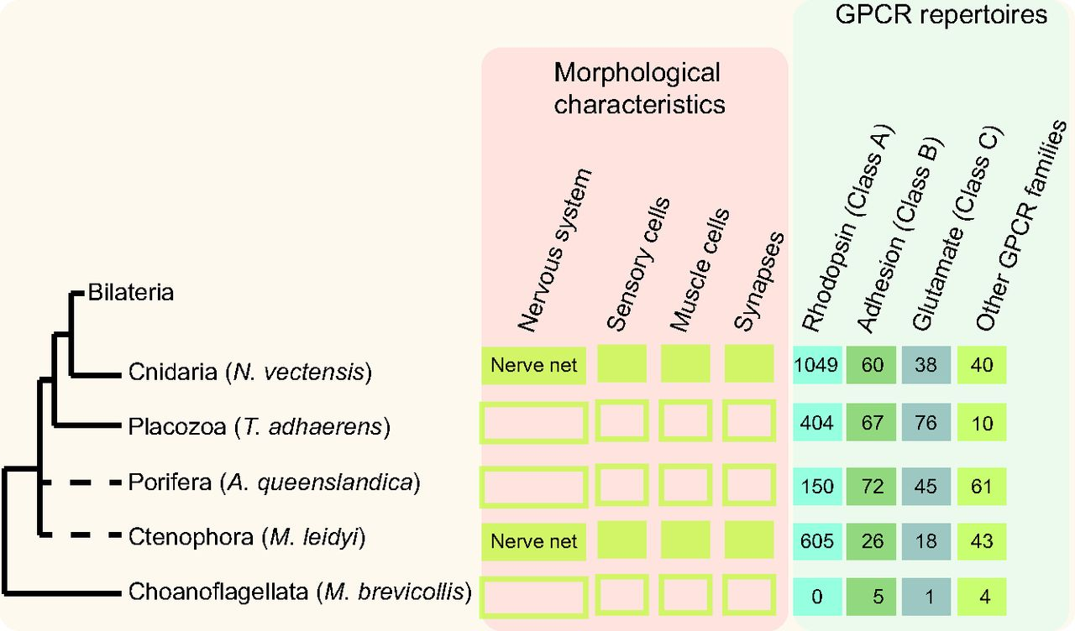
Fig 1. Ratio of GPCR distribution across different groups of the animal kingdom. Retrieved from Krishnan and Schiöth (2015).
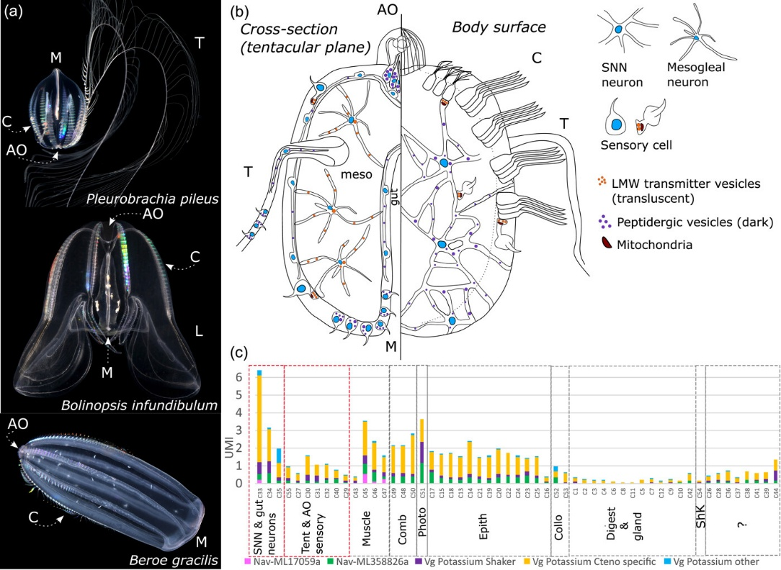
Fig 2. Schematic of ctenophore nervous system. Details of anastomosed SNN, mesogleal neurons, and sensory cells are shown for M. leidyi larvae. The left side of the larva is shown as a cross-section through tentacular plane, while the right side is showing the body surface. Synapses are shown with low molecular weight (LMW) neurotransmitter vesicles and mitochondria inside. AO aboral organ; M mouth; C combs; T tentacles; L lobe; and meso mesoglea. Retrieved from Sachkova (2024)

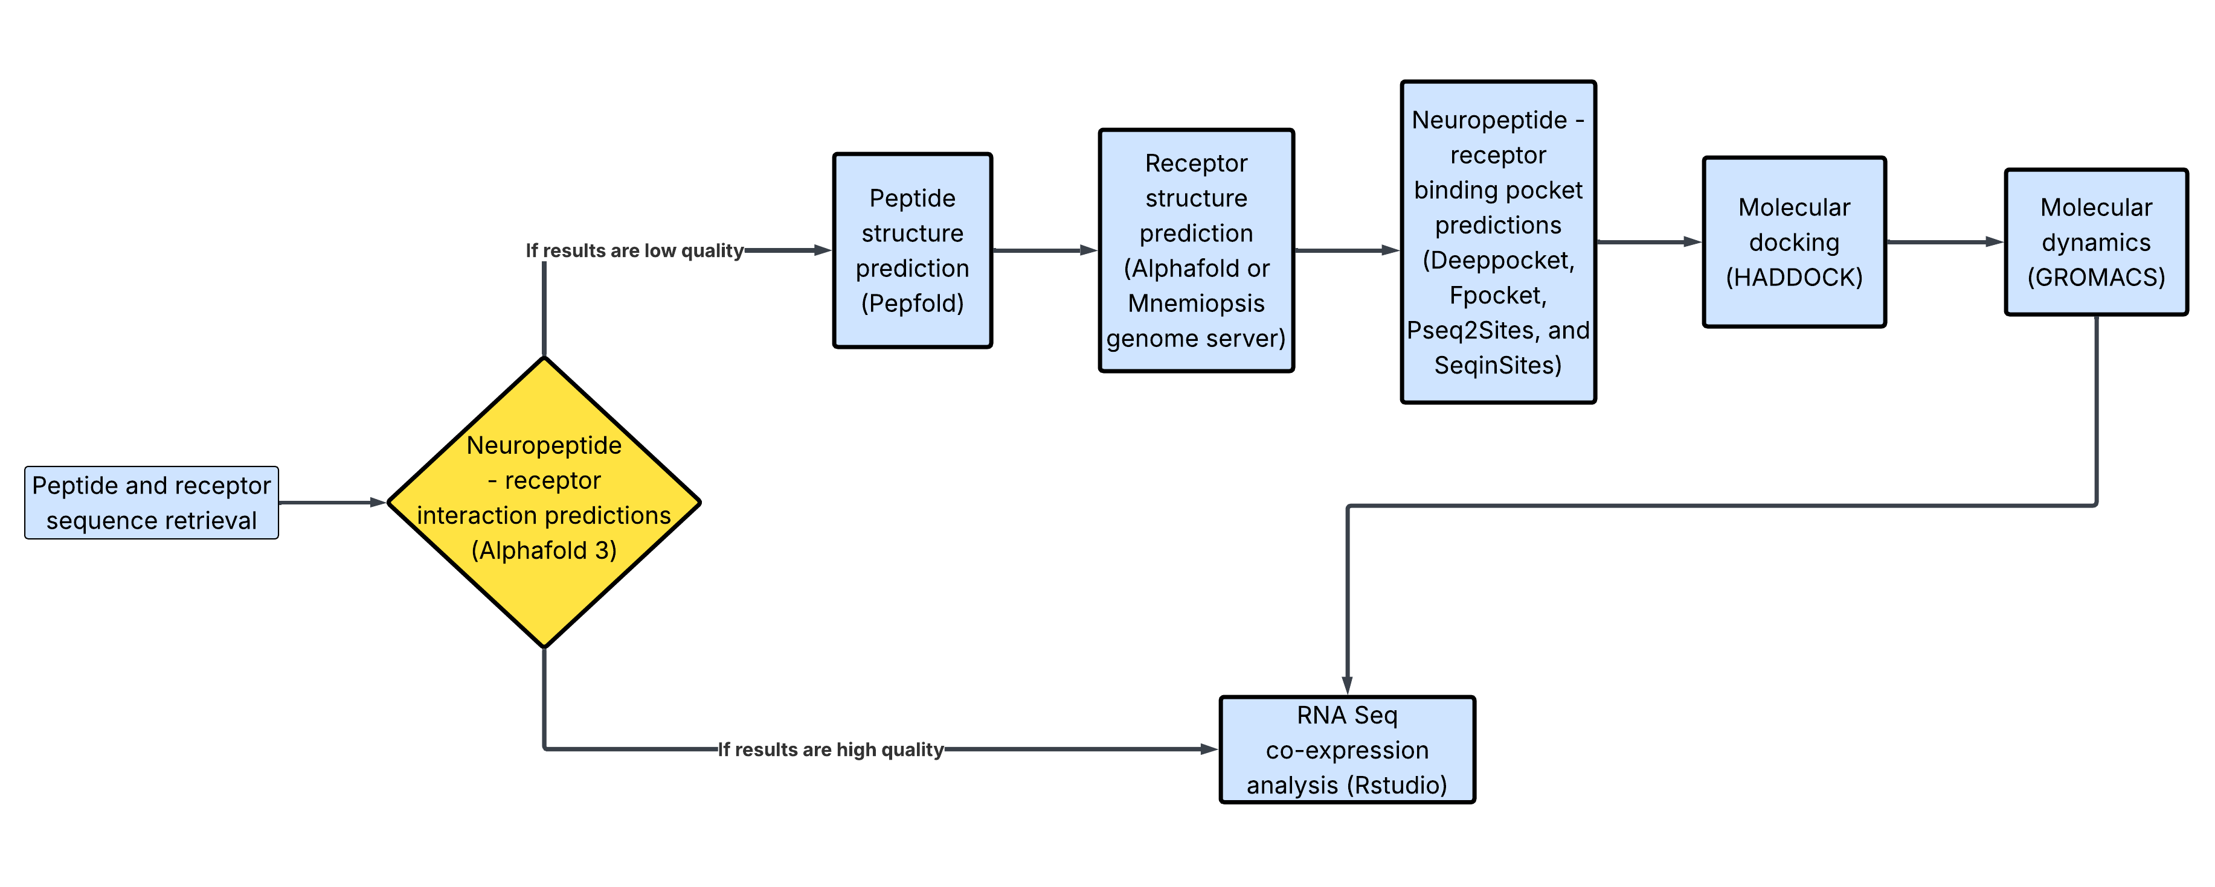
Fig 3. M. leidyi neuropeptide-receptor interactions workflow. It considers both scenarios where AF could output low and high quality results.

Fig 4. Gantt chart describing each of the tasks in the neuropeptide-receptor prediction workflow.
Prediction of neuropeptide-receptor pairs in ancient Ctenophora
Task | Start date | Days needed | Completion
Predict 3D structure of neuropeptides | 15/05/2026 | 5 | 22/05/2026
Identify or predict 3D structure of receptors | 23/05/2026 | 10 | 05/06/2026
Predict peptide-receptor interactions with AF | 06/06/2026 | 15 | 26/06/2026
Predict interactions with docking and MD | 27/06/2026 | 15 | 17/07/2026
RNA-seq analysis in biological context | 18/07/2026 | 15 | 07/08/2026
Report writing | 08/08/2026 | 20 | 04/09/2026
Table 1. Neuropeptide-receptor pair prediction workflow. Start and end dates for each task are highlighted.

For GPCRs, focus on: 7 domains in the GPCR present, GPCRs should contain a few hundreds of AA, and good quality predictions in the GPCRs (pLDDT scores if any available)
Class A Rhodopsin like GPCRs should be priority for the study

