Data lake for aggregation of
production data and visualization
tools in the stamping industry
ABSTRACT
The stamping industry faces a challenge to have an effective real-time monitoring systems to track machine operation and enable data-driven management. To address this, the primary objective was to develop a system to monitor industrial sensors tailored to the stamping sector. This system leverages Python on the backend, FastAPI for the API, MongoDB for data storage, and NextJs for the dashboard display. In practice, the system proved its ability to monitor, analyze, and present sensor data in real-time, equipped with an alert mechanism for immediate notifications based on predefined parameters. While current implementation may be simpler than some alternatives in the literature, it acts as a robust proof of concept. Crucially, it's adaptable for future modifications, especially when informed by real production environment feedback. In conclusion, the system developed successfully a real-time monitoring tool tailored to its specific needs. This system meet the initial objectives and offers a foundation upon which further enhancements can be made. This adaptability ensures that as industry demands evolve, the system can be modified accordingly, emphasizing its long-term value. Looking ahead, with the integration of Artificial Intelligence, anticipating significant advancements in data analytics and predictive maintenance, reinforcing the potential of the work for future industrial applications.

KEYWORDS
Industrial Internet of Things (IIoT), Real-time Monitoring, Sensor Data Analytics, Data Lake

- INTRODUCTION
In the contemporary industrial scenario, the constant pursuit of efficiency and innovation has become an essential pillar for the competitiveness and financial sustainability of companies [1]. As technology advances, companies face pressure to remain competitive in the market [2]. In this context, monitoring and optimizing machines in production lines become crucial to ensure effective operation and prevent potential downtime or operational failures.

However, the tradition of industrial practices is often characterized by manual inspections and outdated monitoring systems that fail to provide real-time information or in-depth analysis of machine performance. This technological gap can result in significant losses in terms of production, financial resources, and machine maintenance, considering that investment in technology and monitoring can make companies more financially efficient [3].

DESENVOLVER MELHOR O ESTADO DA ARTE

In this market context, a stamping industry company sought to build projects that enable the sensorization of their machines, storage and processing of data, and visualization of this information, in order to become more competitive, efficient, and profitable. These projects were grouped within the "ATTRACT - Digital Innovation Hub for Artificial Intelligence and High-Performance Computing - Project: 101083770 — ATTRACT — DIGITAL-2021-EDIH-01" context, with funding from the "Digital Europe Programme (DIGITAL) - DIGITAL-2021-EDIH-INITIAL-01 — Initial Network of European Digital Innovation Hubs", referred to as the Attract Project in this document.

Given the previous framework, the identified need is to develop a robust system that can receive data from sensors that collect real-time data from machines, store them efficiently in a data lake, and present them through a dashboard, transforming the way the company monitors and optimizes its production line, ensuring efficiency and a proactive approach to maintenance and industrial management. This system would provide real-time information about the status, performance of the machines, and would allow for historical analyses, helping managers and technicians to identify trends and failures, as well as optimize production, minimizing production losses and maximizing financial gains.
- System architecture
The system is fundamentally structured in distinct layers, the backend, the frontend, and the database.

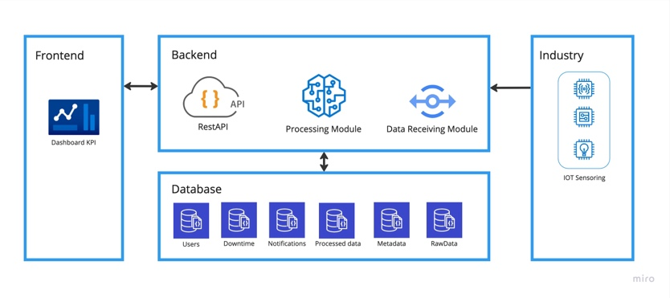
Figure 1: System Architecture.

The backend functions as the core of the system. Mande with Python [8] and FastAPI [9], its main role is to receive the data, process it according to the rules established in the requirements and user stories, and store it securely in the database, MongoDB [10]. In addition to storage and processing functions, the backend is also assigned the responsibility of making these data available through an API (Application Programming Interface), which can be accessed using HTTP (HyperText Transfer Protocol) methods. This API acts as an intermediary between the central logic of the system and the interfaces with which the end user interacts, the frontend.
On the other hand, the frontend is characterized as the visual interface that the end user accesses. It serves as a means by which users interact with the system, sending and receiving information. This layer is designed to access, retrieve, and present the data processed and stored by the backend according to design principles and data visualization [4].
As can be seen in figure 1, in the industrial plant, where the machines with the sensors are located, the sensors send the data to the system, which receives them through the Data Receiving Module and stores them in the Database. The processing module accesses the stored data to perform aggregation, and the API manages access to the database, making the information available to users on the frontend.

The data receiving module utilizes the SensorConnection class to manage the connection with the sensor network and forward received data for proper handling. Adaptability is ensured through the IotSensorConnectionInterface, from which the IotSensorConnection class originates, facilitating integration of various data receipts. This class, when instantiated, establishes a connection, and monitors new data, forwarding it to the SensorsRepository class. This class evaluates sensor data based on set parameters, deciding on alert triggers, making data available via API in real-time, and saving it in the Raw Data collection of the data lake. The provision of data is managed by the SensorValue class, which updates in-memory data accessed by users. This structure effectively handles the receipt, evaluation, and storage of raw sensor data.

The data processing module processes the raw data to deliver statistical analysis for users, executing a specific function that first establishes lists of database collections and machines sending information. Iteratively, data from each machine undergoes statistical analysis using the Box Plot method [11], a graphical representation showcasing data variation through quartiles. This method offers insights into data centrality, dispersion, and potential outliers, providing a comprehensive understanding of data trends and anomalies.

The API is modularized into specific sub-modules, ensuring each segment has a distinct responsibility. Within these modules, there's a three-tiered structure: the controller layer manages HTTP requests, the service layer processes information and applies business rules, and the repository layer connects with the database for data access.
In addition, the API also has parts that are common to all modules. The infrastructure that has the function of providing a database access interface, a web socket message sending access interface, authentication means, and the thread manager. The common codes, which store constants, common functions that need to be standardized, and data models.

The frontend, built using Next.js [5], adheres to the framework's predefined structure. Routes are contained within the pages folder, while base layouts are in the layouts folder. Built upon React components [6], these layouts ensure reusability throughout the application. The use of Typescript [7] streamlines data structuring through models in the types folder, improving development efficiency. To manage component data, the React Context API centralizes information sharing, leading to a more organized architectural approach.

- System Characteristics from a Functional Point of View – DEVELOPMENT OF THE SYSTEM

The project encompasses several components, including a frontend layer, a backend layer, a data receiving module, a data processing module, and the database. Therefore, this chapter aims to detail the operation of each system functionality, providing a comprehensive view of how each component interacts and contributes to the operation of the system as a whole.
Each section of this chapter will be dedicated to a specific functionality, examining its role and operation in depth, as well as the interaction between different system components for its realization.

3.1 Real-time Monitoring

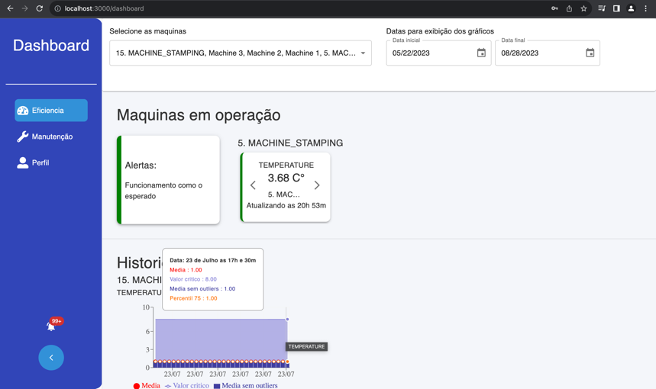
Figure 2: Dashboard with real time and graph data

On the user interface dashboard, individual cards corresponding to each monitored machine are presented. In figure 2 this page can be seen with a card for the machine 5. MACHINE_STAMPING. On each card, sensor information is displayed with the possibility of navigating between them with a directional arrow. The card can be seen in figure 3.

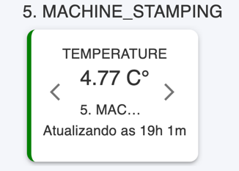
Figure 3: Card with machine data.

The acquisition of this real-time data is carried out through a continuous data stream. The frontend of the application makes a request to the endpoint iot_realtime, which returns this real-time data stream.
In the backend layer, the data stream is constantly fed by the SensorValue class, which in turn, is updated by the data receiving module. Upon receiving new sensor readings, the module performs appropriate validations before updating the values in the SensorValue class. Once updated, the API accesses these new values and inserts them into the data stream transmitted to the connected user.

3.2 Alerts and notifications

The main objective of this feature is to monitor the performance of the machines in real time and issue alerts and notifications to users if inappropriate operating conditions are detected. This allows corrective actions to be taken immediately.

Whenever a new sensor reading is received by the data receiving module, a validation is performed to check if the machine is operating within acceptable parameters. These parameters are obtained through the system metadata, loaded at the initialization of the API.

If a value outside the acceptable range is identified during validation, the data receiving module inserts a special marking on this reading within the SensorValue class. This marking is later transmitted to the frontend during the data streaming process by the IOT Analytics module of the API.

Upon receiving a marked reading, the frontend updates the corresponding information card to reflect the anomalous state. Specifically, within the dashboard shown in figure 2, the color of the card is changed to red or yellow, both on individual cards, figure 3, and on the general card that is used to show the overall status of the machines, figure 4, thus serving as an immediate visual alert for the user.

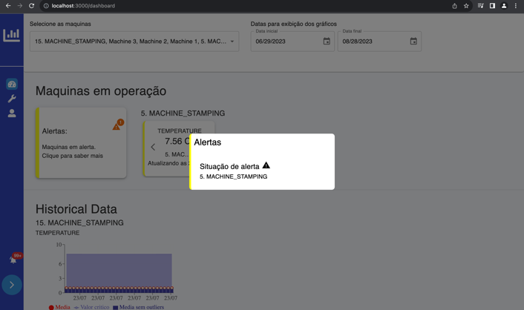
Figure 4: General Notifications.

The data receiving module, keeps track of the operational state of each machine that is sending information. When a machine exits an alert state, the occurrence is recorded in the database, with the start and end date of the alert state, along with information related to the sensor and the involved machine. Subsequently, a message is sent to the connected users using the WebSocket interface, informing them of the machine's malfunction during the period recorded by the system.

Information about alert completion can be accessed by users through notifications in the system interface, as can be seen in figure 5. By clicking on the notification icon in the dashboard's side menu, the user can view these notifications.

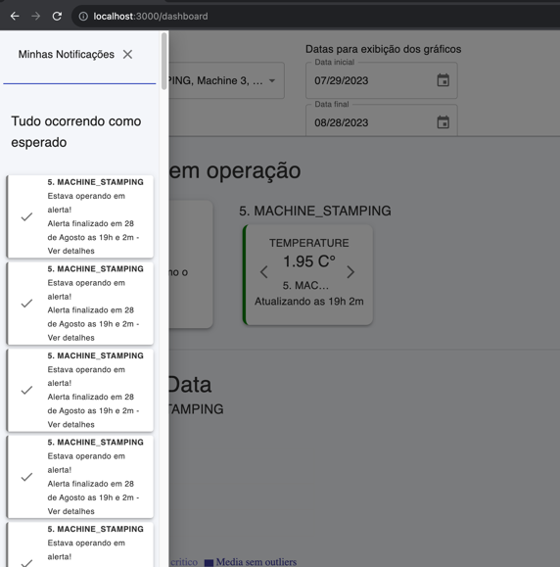
Figure 5: Notification drawer.

Therefore, when starting a session in the system, previous notifications are loaded for the user. In addition, any new notification generated during the user's session is transmitted in real time through a WebSocket connection established between the frontend and the backend.

3.3 Statistical Analysis of Historical Data

The data processing module is responsible for the statistical analysis of historical data. Following the system's standard parameter, every day at midnight, the raw unprocessed data is read and analyzed. The result of the analysis is then stored in the database for future queries.

The possibility to access these analytical data is provided by the API, specifically by the "IOT Analytics" module. The request to obtain this information must be authenticated.

The visual representation of these analyses is carried out through graphs that aggregate four main metrics resulting from the processing. Thus, the graph displays:

- Ideal Value: Represented in an area chart, it serves as an ideal operating parameter to provide a perspective relative to the other data.
- 75th Percentile: Displayed in a line chart, this metric offers a view on the distribution of values during the aggregation period and its evolution over time.
- Aggregation Average: Represented in a scatter chart, this metric provides the average value of the aggregated data.
- Average with Outlier Removal: Illustrated in a bar chart, this metric is calculated after the removal of outlier values, as determined by the boxplot construction method.

Therefore, image 6 shows how these information are displayed within the dashboard.

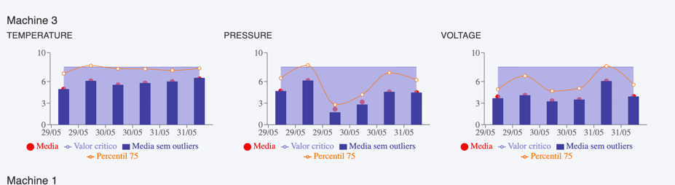
Figure 6: Graph example.

The visualization of these graphs can be filtered by date, allowing the selection of the start date and the end date for the data to be displayed. When these fields are changed and the "apply filter" button is clicked, a new request is sent and the data is loaded according to the specified period. By default, when the page is first loaded, the system sends a request seeking data from the last 30 days, and it is up to the user to use the filter to view a different period. The date filter can be seen in figure 7.

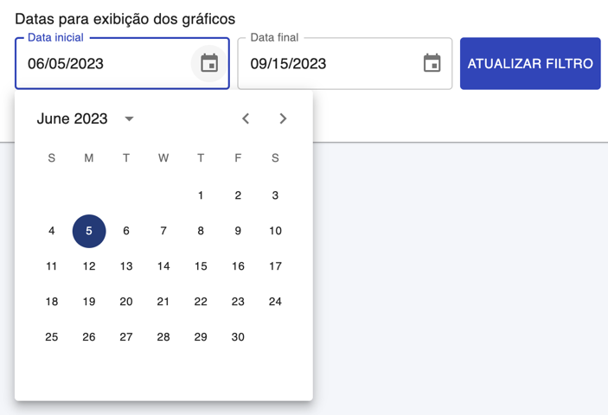
Figure 7: Date filter.
- Results and conclusion
In this project, a multifunctional system was developed for the collection, storage, processing, and visualization of data generated by sensors. Python was used for the creation of the API, and the processing module, MongoDB for database management, and NextJs for the construction of the control panel, known as dashboard.

A series of benefits is offered by the developed system. Firstly, comprehensive monitoring of machines throughout the industrial plant is facilitated. Through this monitoring, crucial information about the operational status of each machine is displayed to employees in real time.

Additionally, the system provides the ability to take quicker actions in case of operational issues, and as a result, the downtime of machines can be reduced, mitigating losses associated with production. Consequently, it allows for timely oversight and understanding of the machinery's current state. The use of such a system not only ensures that the machinery is functioning optimally, but it also aids in the early detection of potential issues, making it an essential tool in modern industrial operations.

Another advantageous aspect lies in the evaluation of the effectiveness of the implemented maintenance measures. Through historical tracking, the system allows for the visualization of the effects of actions taken for machine maintenance, thus, more informed and effective decisions can be made quickly, extending the benefits to other machines in the plant.

The developed system features a modular characteristic, which allows the integration of new modules to expand its functionalities. A practical example of this is the possibility of adding a module intended for working with data from computer vision. This module would be capable of evaluating and monitoring the quality of production in real time, identifying defects with greater precision and efficacy. Additionally, another module that can be integrated refers to the access to historical data from the machines, providing a retrospective view and facilitating access to this information. Finally, considering the importance of maintenance, a module for predictive maintenance can be implemented. This module, by using the received data, could develop a model that understands the operation pattern of the machines, allowing more assertive and optimized interventions.

Finally, the system's historical data also contributes to the generation of insights from its analysis. This analysis can provide a new perspective for monitoring machine performance, and operational anomalies can be identified and specific corrective measures can be implemented to improve certain indicators.

REFERENCES

[1] S. Bonilla, H. Silva, M. T. da Silva, R. F. Gonçalves, and J. Sacomano, “Industry 4.0 and sustainability implications: A scenario-based analysis of the impacts and challenges,” Sustainability, vol. 10, no. 10, p. 3740, 2018. doi: 10.3390/SU10103740. [Online]. Available: https : / / www . mdpi . com / 2071 - 1050 / 10 / 10 / 3740 / pdf ?version=1539767696.

[2] W. M. Ashraf, G. M. Uddin, S. M. Arafat, et al., “Optimization of a 660 mwe supercritical power plant performance—a case of industry 4.0 in the data-driven op- erat ional management part 1. thermal efficiency,” Energies, vol. 13, no. 21, p. 5592, 2020. doi: 10.3390/en13215592. [Online]. Available: https://www.mdpi.com/1996-1073/13/21/5592/pdf?version=1603956781

[3] T. Mabad, O. Ali, M. A. Ally, S. Wamba, and K. C. Chan, “Making investment decisions on rfid technology: An evaluation of key adoption factors in construction firms,” IEEE Access, doi: 10 . 1109 / ACCESS . 2021 . 3063301. [Online]. Available: https://ieeexplore.ieee.org/ielx7/6287639/9312710/09366873.pdf

[4] S. Barbosa and G. Barbosa, “Introduction to data visualization,” in 17th IFIP Conference on Human-Computer Interaction (INTERACT), Paphos, Cyprus, 2019, pp. 527–529. doi: 10.1007/978-3-030-29390-1_30. [Online]. Available: https://hal.inria.fr/hal-02877680/file/488595_1_En_30_Chapter.pdf.

[5] V. Inc. “Next.js documentation.” Accessed on: 2023-09-13. (2023), [Online]. Available: https://nextjs.org/docs

[6] F. Inc. “React documentation.” Accessed on: 2023-09-13. (2023), [Online]. Available: https://react.dev/.

[7] M. Corporation. “Typescript language documentation.” Accessed on: 2023-09-13. (2023), [Online]. Available: https://www.typescriptlang.org/.

[8] P. S. Foundation. “Python official documentation.” Accessed on: 2023-09-13. (2023), [Online]. Available: https://www.python.org/.

[9] S. Ramírez. “Fastapi documentation.” Accessed on: 2023-09-13. (2023), [Online]. Available: https://fastapi.tiangolo.com/.

[10] M. Inc. “Mongodb documentation.” Accessed on: 2023-09-13. (2023), [Online]. Avail-able: https://www.mongodb.com/docs/.

[11] F. Marmolejo-Ramos and T. Tian, “The shifting boxplot. a boxplot based on essential summary statistics around the mean,” Ingenieria y Ciencia, vol. 6, no. 12, pp. 119–132, 2010. doi: 10 . 21500 / 20112084 . 823. [Online]. Available: https://revistas.usb.edu.co/index.php/IJPR/article/download/823/597.

