**Single Area OSPF IPv4 Lab**

Leo Reyes

Purpose

The purpose of this lab was to set up single area OSPF with IPv4 over different networks. This was done to review the steps of configuring networks, review OSPF commands and review how to fix problems in the networks in the process. Additionally, this lab was meant to teach how to do a Lab write up.

Background Information

OSPF is a link-state interior gateway. It stands for Open Shortest Path First, meaning that it will always choose the best and cheapest route to send packets in. This protocol was invented as an alternative to RIP, and while both OSPF and RIP are based on SPF algorithms, OSPF offers more options for traffic to travel in, as compared to RIP which just sends the entire routing table to each router, at the cost of more overhead. OSPF is a very common protocol used to manage the network of a company and would therefore be used in large networks where RIP will not be able to handle the larger network or if a fast communication between routers and areas is needed. This protocol can also be very useful because it reduces the amount of manual labor in setting up routes in a network due to the AS (Autonomous System) which decides which route the traffic should be sent in. As mentioned earlier, OSPF uses the concept of areas which divides the network into more logical segments of routers and networks. By dividing the network into areas, it reduces the size of the network and the cost. These areas are managed by ABRs (Area Border Routers) which connect to the DR (Designated Router); the DR acts as the main point of interaction for the network segment. OSPF deals a lot with LSAs (Link State Advertisement) since this gives the information of the other routers to the network through LSAs and storing them in a LSDB (Link State Data Base) in each router, making it possible for each router in an area and network to connect to each other.

Lab Summary

In Packet Tracer I set up a topology with 4 4321 routers connected to each with serial interfaces and 4 pcs, one connected to each router. There is a total of 7 networks, 1 network for each serial interface between the routers, which is 3, and 4 networks 1 for each pc connected to a router. As seen in the topology, R2 and R3 are connected to 2 routers which means they each have 2 neighbors while R1 and R4 will only have 1 neighbor. The network ips are labeled and the pcs are also labeled with their ip address

Topology

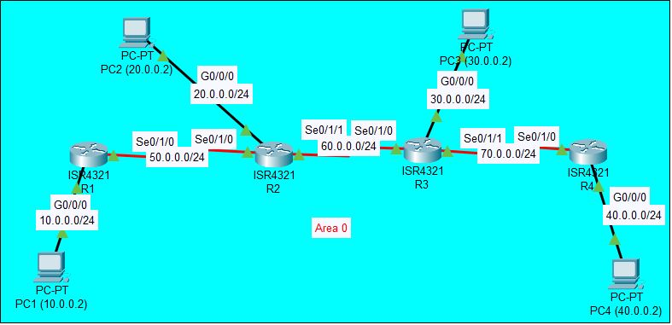

Lab Commands

* Router ospf *process id*: starts the configuration of ospf for a router
* Network *network address wildmask* area: assigns a network to have ospf
* Traceroute: traces how many hops it takes a route to ping
* Show ip ospf neighbor: shows the adjacent neighbors of the router
* Show ip ospf interface: shows the status of ospf in that interface
* Show ip ospf: shows information regarding any ospf neighbors, interfaces, states, neighbor’s addresses, and router id

Configurations

Router 1:

Current configuration : 840 bytes

version 15.4

no service timestamps log datetime msec

no service timestamps debug datetime msec

no service password-encryption

hostname R1

no ip cef

no ipv6 cef

spanning-tree mode pvst

interface GigabitEthernet0/0/0

ip address 10.0.0.1 255.255.255.0

duplex auto

speed auto

interface GigabitEthernet0/0/1

no ip address

duplex auto

speed auto

shutdown

interface Serial0/1/0

ip address 50.0.0.1 255.255.255.0

clock rate 56000

interface Serial0/1/1

no ip address

clock rate 2000000

shutdown

interface Vlan1

no ip address

shutdown

router ospf 1

log-adjacency-changes

network 10.0.0.0 0.0.0.255 area 0

network 50.0.0.0 0.0.0.255 area 0

router rip

ip classless

ip flow-export version 9

line con 0

line aux 0

line vty 0 4

login

end

Codes: L - local, C - connected, S - static, R - RIP, M - mobile, B - BGP

D - EIGRP, EX - EIGRP external, O - OSPF, IA - OSPF inter area

N1 - OSPF NSSA external type 1, N2 - OSPF NSSA external type 2

E1 - OSPF external type 1, E2 - OSPF external type 2, E - EGP

i - IS-IS, L1 - IS-IS level-1, L2 - IS-IS level-2, ia - IS-IS inter area

* - candidate default, U - per-user static route, o - ODR

P - periodic downloaded static route

Gateway of last resort is not set

10.0.0.0/8 is variably subnetted, 2 subnets, 2 masks

C 10.0.0.0/24 is directly connected, GigabitEthernet0/0/0

L 10.0.0.1/32 is directly connected, GigabitEthernet0/0/0

20.0.0.0/24 is subnetted, 1 subnets

O 20.0.0.0/24 [110/65] via 50.0.0.2, 00:13:43, Serial0/1/0

30.0.0.0/24 is subnetted, 1 subnets

O 30.0.0.0/24 [110/129] via 50.0.0.2, 00:13:43, Serial0/1/0

40.0.0.0/24 is subnetted, 1 subnets

O 40.0.0.0/24 [110/193] via 50.0.0.2, 00:13:43, Serial0/1/0

50.0.0.0/8 is variably subnetted, 2 subnets, 2 masks

C 50.0.0.0/24 is directly connected, Serial0/1/0

L 50.0.0.1/32 is directly connected, Serial0/1/0

60.0.0.0/24 is subnetted, 1 subnets

O 60.0.0.0/24 [110/128] via 50.0.0.2, 00:13:43, Serial0/1/0

70.0.0.0/24 is subnetted, 1 subnets

O 70.0.0.0/24 [110/192] via 50.0.0.2, 00:13:43, Serial0/1/0

Neighbor ID Pri State Dead Time Address Interface

60.0.0.1 0 FULL/ - 00:00:37 50.0.0.2 Serial0/1/0

Serial0/1/0 is up, line protocol is up

Internet address is 50.0.0.1/24, Area 0

Process ID 1, Router ID 50.0.0.1, Network Type POINT-TO-POINT, Cost: 64

Transmit Delay is 1 sec, State POINT-TO-POINT,

Timer intervals configured, Hello 10, Dead 40, Wait 40, Retransmit 5

Hello due in 00:00:00

Index 2/2, flood queue length 0

Next 0x0(0)/0x0(0)

Last flood scan length is 1, maximum is 1

Last flood scan time is 0 msec, maximum is 0 msec

Neighbor Count is 1 , Adjacent neighbor count is 1

Adjacent with neighbor 60.0.0.1

Suppress hello for 0 neighbor(s)

Router 2:

Current configuration : 852 bytes

version 15.4

no service timestamps log datetime msec

no service timestamps debug datetime msec

no service password-encryption

hostname R2

no ip cef

no ipv6 cef

spanning-tree mode pvst

interface GigabitEthernet0/0/0

ip address 20.0.0.1 255.255.255.0

duplex auto

speed auto

interface GigabitEthernet0/0/1

no ip address

duplex auto

speed auto

shutdown

interface Serial0/1/0

ip address 50.0.0.2 255.255.255.0

interface Serial0/1/1

ip address 60.0.0.1 255.255.255.0

clock rate 56000

interface Vlan1

no ip address

shutdown

router ospf 1

log-adjacency-changes

network 20.0.0.0 0.0.0.255 area 0

network 50.0.0.0 0.0.0.255 area 0

network 60.0.0.0 0.0.0.255 area 0

ip classless

ip flow-export version 9

line con 0

line aux 0

line vty 0 4

login

end

Codes: L - local, C - connected, S - static, R - RIP, M - mobile, B - BGP

D - EIGRP, EX - EIGRP external, O - OSPF, IA - OSPF inter area

N1 - OSPF NSSA external type 1, N2 - OSPF NSSA external type 2

E1 - OSPF external type 1, E2 - OSPF external type 2, E - EGP

i - IS-IS, L1 - IS-IS level-1, L2 - IS-IS level-2, ia - IS-IS inter area

* - candidate default, U - per-user static route, o - ODR

P - periodic downloaded static route

Gateway of last resort is not set

10.0.0.0/24 is subnetted, 1 subnets

O 10.0.0.0/24 [110/65] via 50.0.0.1, 00:20:53, Serial0/1/0

20.0.0.0/8 is variably subnetted, 2 subnets, 2 masks

C 20.0.0.0/24 is directly connected, GigabitEthernet0/0/0

L 20.0.0.1/32 is directly connected, GigabitEthernet0/0/0

30.0.0.0/24 is subnetted, 1 subnets

O 30.0.0.0/24 [110/65] via 60.0.0.2, 00:20:53, Serial0/1/1

40.0.0.0/24 is subnetted, 1 subnets

O 40.0.0.0/24 [110/129] via 60.0.0.2, 00:20:53, Serial0/1/1

50.0.0.0/8 is variably subnetted, 2 subnets, 2 masks

C 50.0.0.0/24 is directly connected, Serial0/1/0

L 50.0.0.2/32 is directly connected, Serial0/1/0

60.0.0.0/8 is variably subnetted, 2 subnets, 2 masks

C 60.0.0.0/24 is directly connected, Serial0/1/1

L 60.0.0.1/32 is directly connected, Serial0/1/1

70.0.0.0/24 is subnetted, 1 subnets

O 70.0.0.0/24 [110/128] via 60.0.0.2, 00:20:53, Serial0/1/1

Neighbor ID Pri State Dead Time Address Interface

70.0.0.1 0 FULL/ - 00:00:35 60.0.0.2 Serial0/1/1

50.0.0.1 0 FULL/ - 00:00:35 50.0.0.1 Serial0/1/0

Serial0/1/0 is up, line protocol is up

Internet address is 50.0.0.2/24, Area 0

Process ID 1, Router ID 60.0.0.1, Network Type POINT-TO-POINT, Cost: 64

Transmit Delay is 1 sec, State POINT-TO-POINT,

Timer intervals configured, Hello 10, Dead 40, Wait 40, Retransmit 5

Hello due in 00:00:00

Index 3/3, flood queue length 0

Next 0x0(0)/0x0(0)

Last flood scan length is 1, maximum is 1

Last flood scan time is 0 msec, maximum is 0 msec

Neighbor Count is 1 , Adjacent neighbor count is 1

Adjacent with neighbor 50.0.0.1

Suppress hello for 0 neighbor(s)

Serial0/1/1 is up, line protocol is up

Internet address is 60.0.0.1/24, Area 0

Process ID 1, Router ID 60.0.0.1, Network Type POINT-TO-POINT, Cost: 64

Transmit Delay is 1 sec, State POINT-TO-POINT,

Timer intervals configured, Hello 10, Dead 40, Wait 40, Retransmit 5

Hello due in 00:00:07

Index 2/2, flood queue length 0

Next 0x0(0)/0x0(0)

Last flood scan length is 1, maximum is 1

Last flood scan time is 0 msec, maximum is 0 msec

Neighbor Count is 1 , Adjacent neighbor count is 1

Adjacent with neighbor 70.0.0.1

Suppress hello for 0 neighbor(s)

Router 3:

Current configuration : 852 bytes

version 15.4

no service timestamps log datetime msec

no service timestamps debug datetime msec

no service password-encryption

hostname R3

no ip cef

no ipv6 cef

spanning-tree mode pvst

interface GigabitEthernet0/0/0

ip address 30.0.0.1 255.255.255.0

duplex auto

speed auto

interface GigabitEthernet0/0/1

no ip address

duplex auto

speed auto

shutdown

interface Serial0/1/0

ip address 60.0.0.2 255.255.255.0

interface Serial0/1/1

ip address 70.0.0.1 255.255.255.0

clock rate 56000

interface Vlan1

no ip address

shutdown

router ospf 1

log-adjacency-changes

network 30.0.0.0 0.0.0.255 area 0

network 60.0.0.0 0.0.0.255 area 0

network 70.0.0.0 0.0.0.255 area 0

ip classless

ip flow-export version 9

line con 0

line aux 0

line vty 0 4

login

end

Codes: L - local, C - connected, S - static, R - RIP, M - mobile, B - BGP

D - EIGRP, EX - EIGRP external, O - OSPF, IA - OSPF inter area

N1 - OSPF NSSA external type 1, N2 - OSPF NSSA external type 2

E1 - OSPF external type 1, E2 - OSPF external type 2, E - EGP

i - IS-IS, L1 - IS-IS level-1, L2 - IS-IS level-2, ia - IS-IS inter area

* - candidate default, U - per-user static route, o - ODR

P - periodic downloaded static route

Gateway of last resort is not set

10.0.0.0/24 is subnetted, 1 subnets

O 10.0.0.0/24 [110/129] via 60.0.0.1, 00:24:26, Serial0/1/0

20.0.0.0/24 is subnetted, 1 subnets

O 20.0.0.0/24 [110/65] via 60.0.0.1, 00:24:26, Serial0/1/0

30.0.0.0/8 is variably subnetted, 2 subnets, 2 masks

C 30.0.0.0/24 is directly connected, GigabitEthernet0/0/0

L 30.0.0.1/32 is directly connected, GigabitEthernet0/0/0

40.0.0.0/24 is subnetted, 1 subnets

O 40.0.0.0/24 [110/65] via 70.0.0.2, 00:24:26, Serial0/1/1

50.0.0.0/24 is subnetted, 1 subnets

O 50.0.0.0/24 [110/128] via 60.0.0.1, 00:24:26, Serial0/1/0

60.0.0.0/8 is variably subnetted, 2 subnets, 2 masks

C 60.0.0.0/24 is directly connected, Serial0/1/0

L 60.0.0.2/32 is directly connected, Serial0/1/0

70.0.0.0/8 is variably subnetted, 2 subnets, 2 masks

C 70.0.0.0/24 is directly connected, Serial0/1/1

L 70.0.0.1/32 is directly connected, Serial0/1/1

Neighbor ID Pri State Dead Time Address Interface

70.0.0.2 0 FULL/ - 00:00:32 70.0.0.2 Serial0/1/1

60.0.0.1 0 FULL/ - 00:00:32 60.0.0.1 Serial0/1/0

Serial0/1/0 is up, line protocol is up

Internet address is 60.0.0.2/24, Area 0

Process ID 1, Router ID 70.0.0.1, Network Type POINT-TO-POINT, Cost: 64

Transmit Delay is 1 sec, State POINT-TO-POINT,

Timer intervals configured, Hello 10, Dead 40, Wait 40, Retransmit 5

Hello due in 00:00:05

Index 2/2, flood queue length 0

Next 0x0(0)/0x0(0)

Last flood scan length is 1, maximum is 1

Last flood scan time is 0 msec, maximum is 0 msec

Neighbor Count is 1 , Adjacent neighbor count is 1

Adjacent with neighbor 60.0.0.1

Suppress hello for 0 neighbor(s)

Serial0/1/1 is up, line protocol is up

Internet address is 70.0.0.1/24, Area 0

Process ID 1, Router ID 70.0.0.1, Network Type POINT-TO-POINT, Cost: 64

Transmit Delay is 1 sec, State POINT-TO-POINT,

Timer intervals configured, Hello 10, Dead 40, Wait 40, Retransmit 5

Hello due in 00:00:00

Index 3/3, flood queue length 0

Next 0x0(0)/0x0(0)

Last flood scan length is 1, maximum is 1

Last flood scan time is 0 msec, maximum is 0 msec

Neighbor Count is 1 , Adjacent neighbor count is 1

Adjacent with neighbor 70.0.0.2

Suppress hello for 0 neighbor(s)

Router 4:

Current configuration : 809 bytes

version 15.4

no service timestamps log datetime msec

no service timestamps debug datetime msec

no service password-encryption

hostname R4

no ip cef

no ipv6 cef

spanning-tree mode pvst

interface GigabitEthernet0/0/0

ip address 40.0.0.1 255.255.255.0

duplex auto

speed auto

interface GigabitEthernet0/0/1

no ip address

duplex auto

speed auto

shutdown

interface Serial0/1/0

ip address 70.0.0.2 255.255.255.0

interface Serial0/1/1

no ip address

clock rate 56000

shutdown

interface Vlan1

no ip address

shutdown

router ospf 1

log-adjacency-changes

network 40.0.0.0 0.0.0.255 area 0

network 70.0.0.0 0.0.0.255 area 0

ip classless

ip flow-export version 9

line con 0

line aux 0

line vty 0 4

login

end

Codes: L - local, C - connected, S - static, R - RIP, M - mobile, B - BGP

D - EIGRP, EX - EIGRP external, O - OSPF, IA - OSPF inter area

N1 - OSPF NSSA external type 1, N2 - OSPF NSSA external type 2

E1 - OSPF external type 1, E2 - OSPF external type 2, E - EGP

i - IS-IS, L1 - IS-IS level-1, L2 - IS-IS level-2, ia - IS-IS inter area

* - candidate default, U - per-user static route, o - ODR

P - periodic downloaded static route

Gateway of last resort is not set

10.0.0.0/24 is subnetted, 1 subnets

O 10.0.0.0/24 [110/193] via 70.0.0.1, 00:27:21, Serial0/1/0

20.0.0.0/24 is subnetted, 1 subnets

O 20.0.0.0/24 [110/129] via 70.0.0.1, 00:27:21, Serial0/1/0

30.0.0.0/24 is subnetted, 1 subnets

O 30.0.0.0/24 [110/65] via 70.0.0.1, 00:27:31, Serial0/1/0

40.0.0.0/8 is variably subnetted, 2 subnets, 2 masks

C 40.0.0.0/24 is directly connected, GigabitEthernet0/0/0

L 40.0.0.1/32 is directly connected, GigabitEthernet0/0/0

50.0.0.0/24 is subnetted, 1 subnets

O 50.0.0.0/24 [110/192] via 70.0.0.1, 00:27:21, Serial0/1/0

60.0.0.0/24 is subnetted, 1 subnets

O 60.0.0.0/24 [110/128] via 70.0.0.1, 00:27:31, Serial0/1/0

70.0.0.0/8 is variably subnetted, 2 subnets, 2 masks

C 70.0.0.0/24 is directly connected, Serial0/1/0

L 70.0.0.2/32 is directly connected, Serial0/1/0

Neighbor ID Pri State Dead Time Address Interface

70.0.0.1 0 FULL/ - 00:00:30 70.0.0.1 Serial0/1/0

Serial0/1/0 is up, line protocol is up

Internet address is 70.0.0.2/24, Area 0

Process ID 1, Router ID 70.0.0.2, Network Type POINT-TO-POINT, Cost: 64

Transmit Delay is 1 sec, State POINT-TO-POINT,

Timer intervals configured, Hello 10, Dead 40, Wait 40, Retransmit 5

Hello due in 00:00:08

Index 2/2, flood queue length 0

Next 0x0(0)/0x0(0)

Last flood scan length is 1, maximum is 1

Last flood scan time is 0 msec, maximum is 0 msec

Neighbor Count is 1 , Adjacent neighbor count is 1

Adjacent with neighbor 70.0.0.1

Suppress hello for 0 neighbor(s)

Pings

PC1:

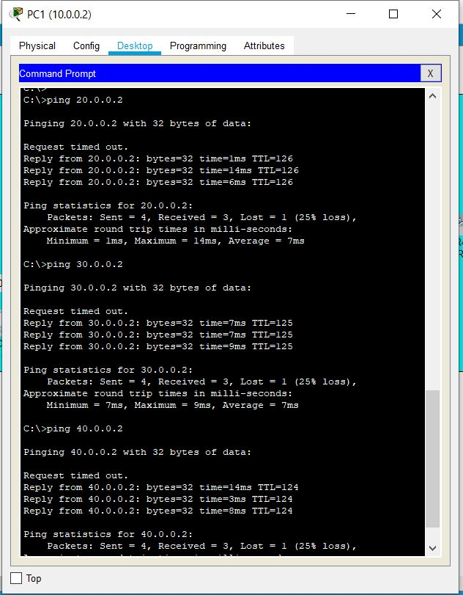

PC2:

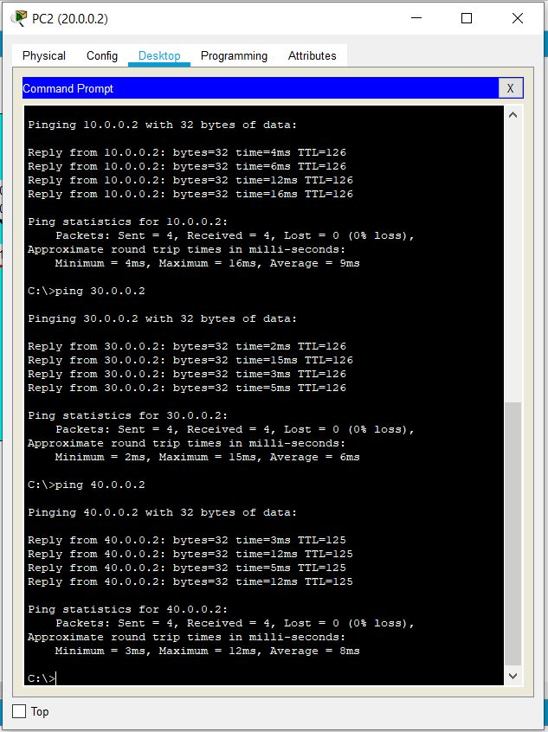

PC3:

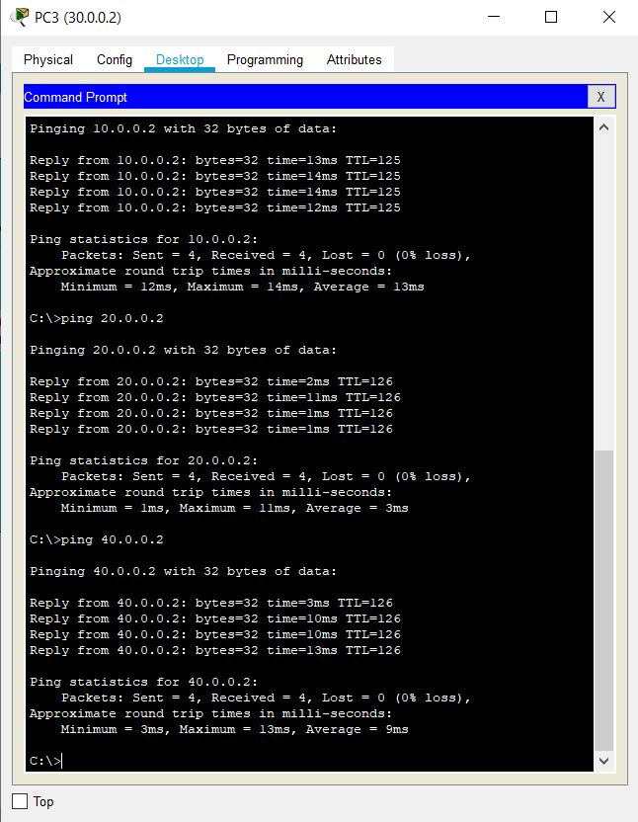

PC4:

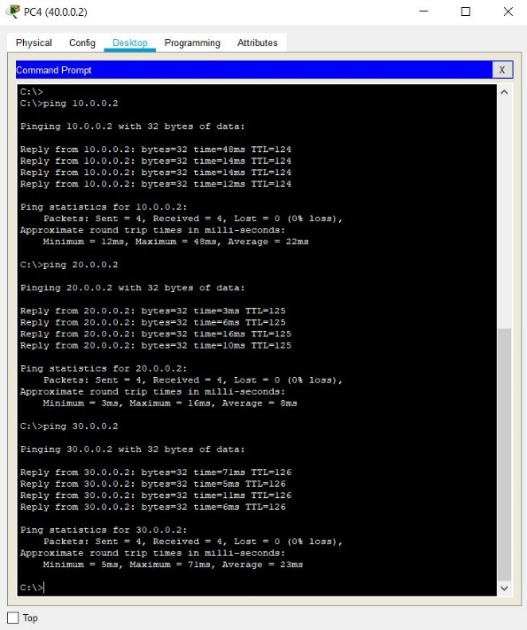

Problems

Some of the problems I ran into in this lab had a lot to deal with remembering and having to review commands for setting up OSPF. At the very beginning I couldn’t remember how to add the serial cards in the back of the router so that they could have a serial connection. It took me some trial and error but I was able to figure out that I needed to turn off the router first. I had no trouble changing the name of the routers, but I had trouble remembering the right commands for the interfaces. In addition, I couldn’t remember how to add the networks of a router to OSPF after the router OSPF . I kept thinking I needed an “add network” when it was just network. This was a simple fix after asking some peers and reviewing some notes.

A big problem I had was when I was setting up the ip addresses of each interface. I kept adding the ip addresses 192.168.1.0 for the first network and used the same ip address for the serial interface of the first router and when I finally did no shut on the serial interface, it gave me an error stating there was an overlapping issue. After viewing this and asking some peers I came to the conclusion that it would be easier if my networks all had different numbers so I changed my networks to 10.0.0.0, 20.0.0.0, 30.0.0.0 and so on for every network. This was a simple fix where I just made a simple mistake of remembering the subnet masks.

Conclusion

After this lab, I was able to review and refresh my memory on how to set up OSPF over multiple networks with only 1 area. I set up 7 different networks in the lab, 4 of them were connections form the routers to the PCs and the other 3 were the serial connections between the routers. Something that went really well was that I was able to remember the simple commands to set up ip addresses to the interfaces as well as figure out how to set up the clock rate for the serial interfaces. I had some trouble setting up the ip addresses of the serial interfaces because there was an overlapping issue but after reviewing my notes it became very easy to continue with the lab. Overall this lab helped me remember how ospf works and how I can set it up in different networks.