1 - Instalando o Delphi 4 (sem o interbase)
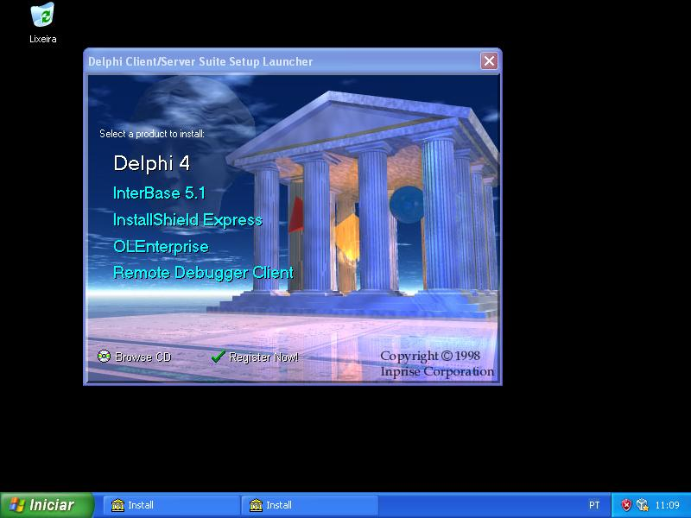 | 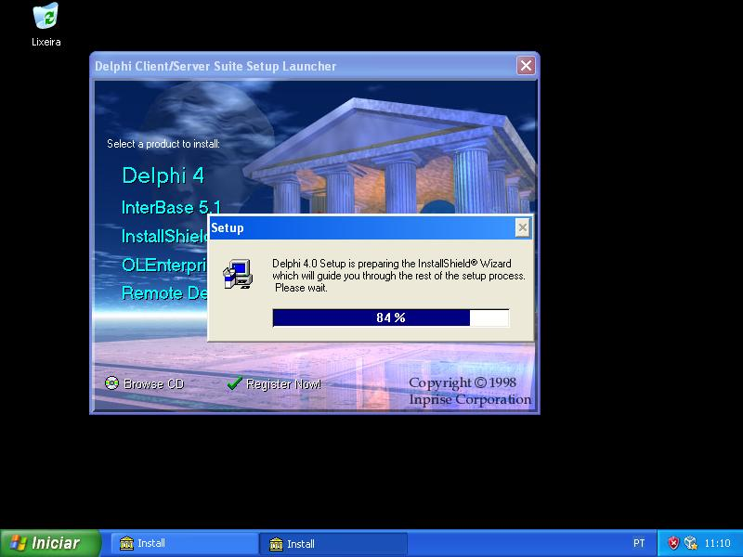
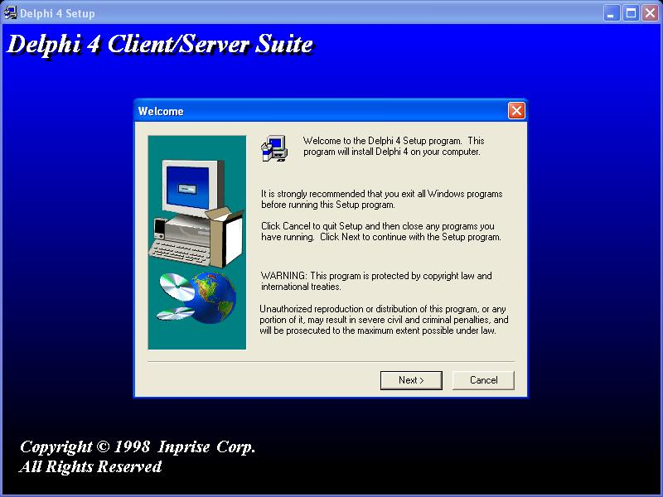 | 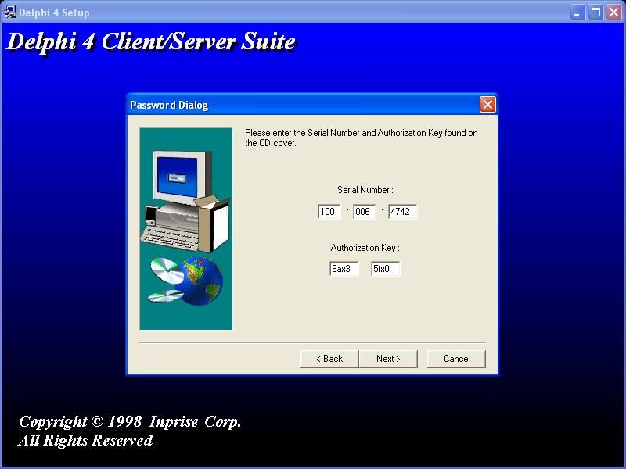
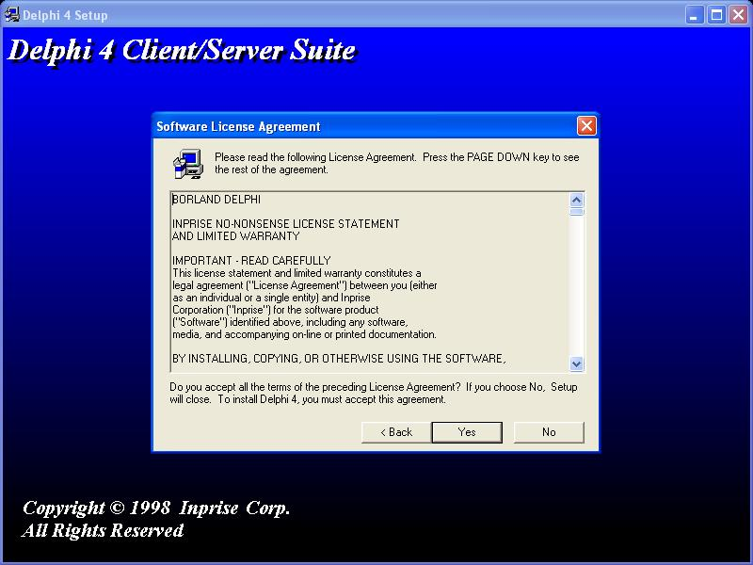 | 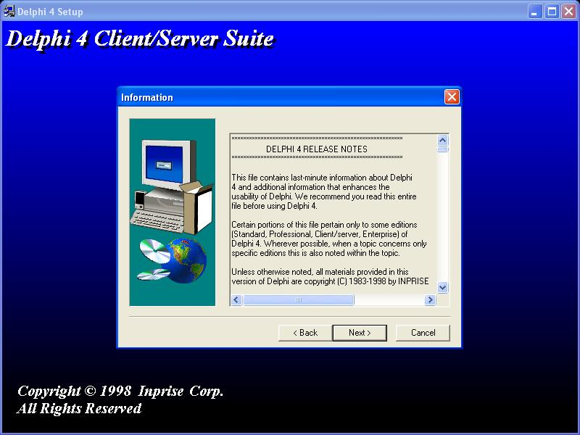
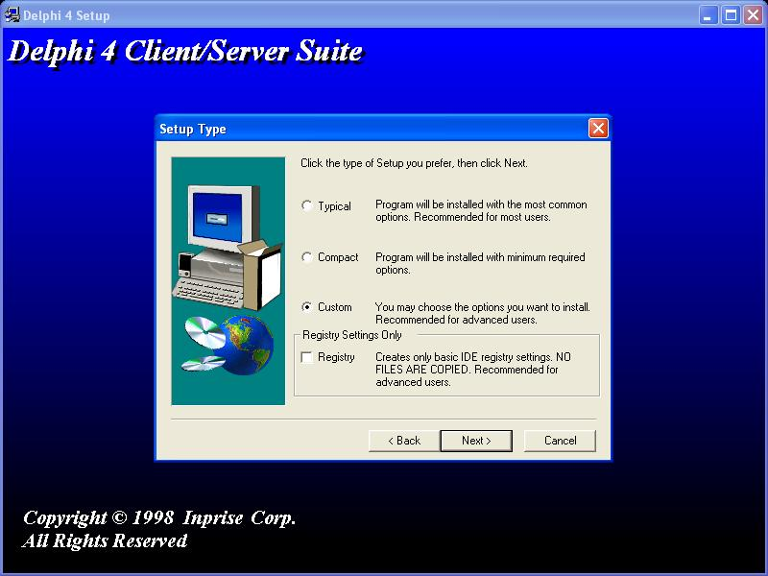 | 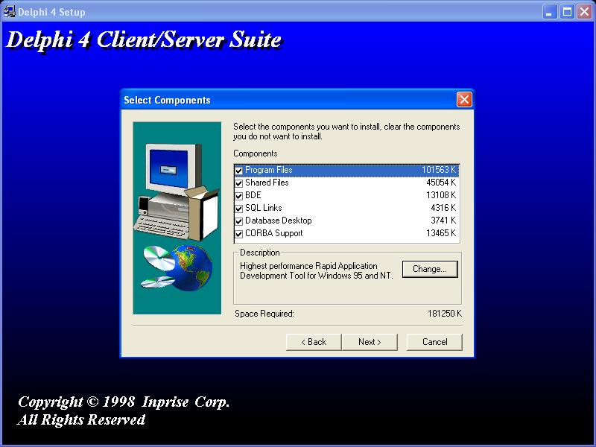
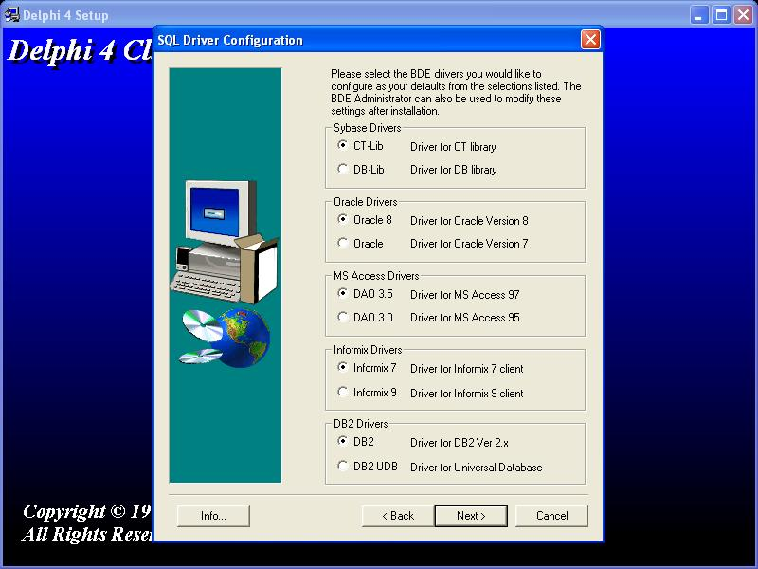 | 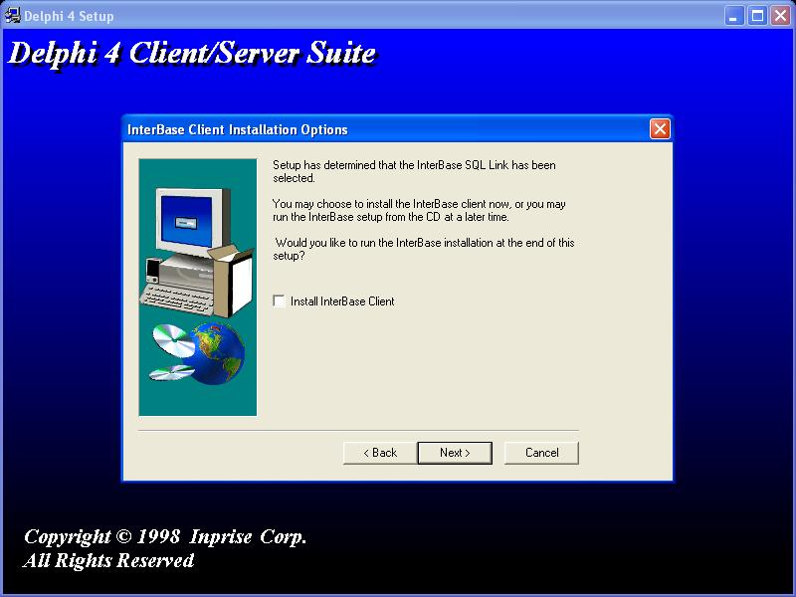
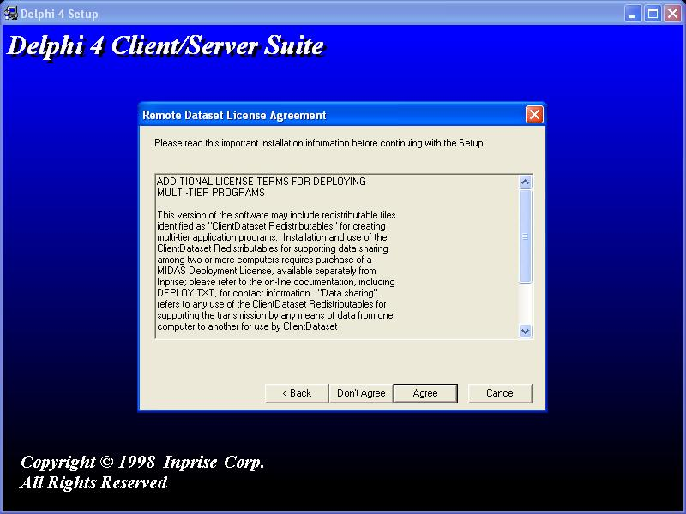 | 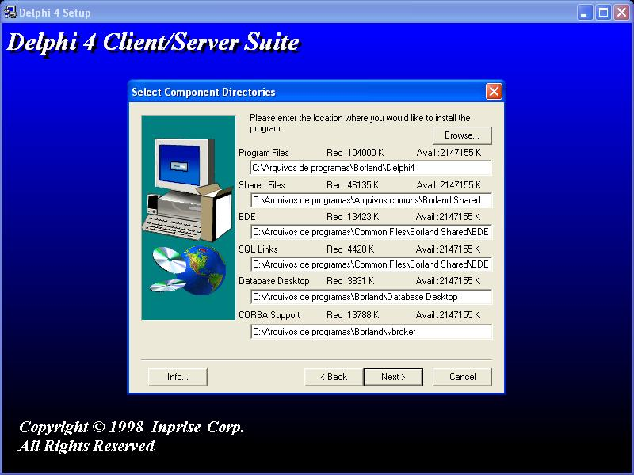
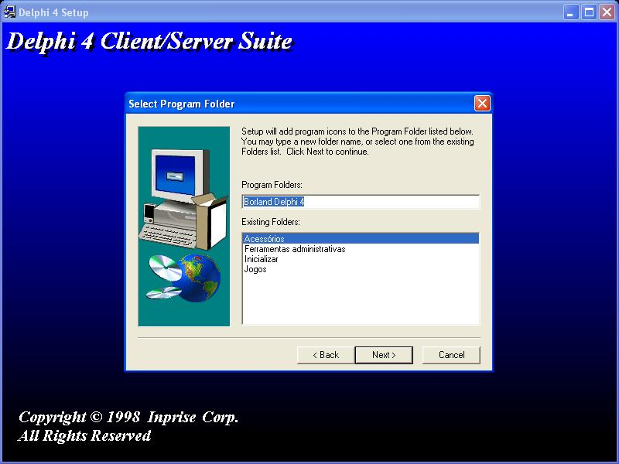 | 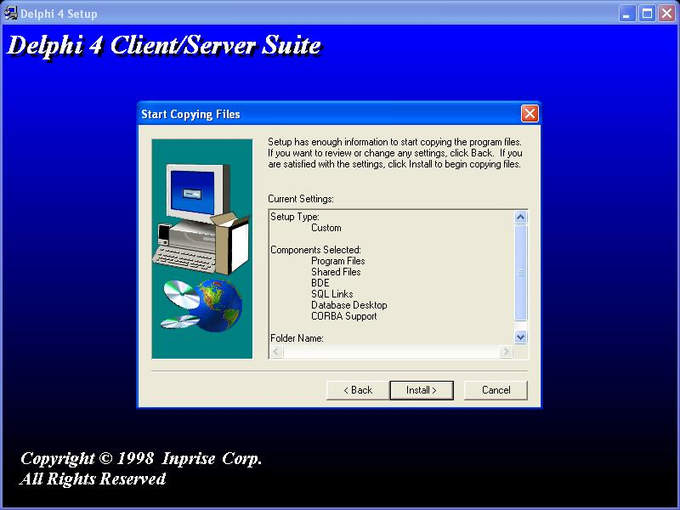
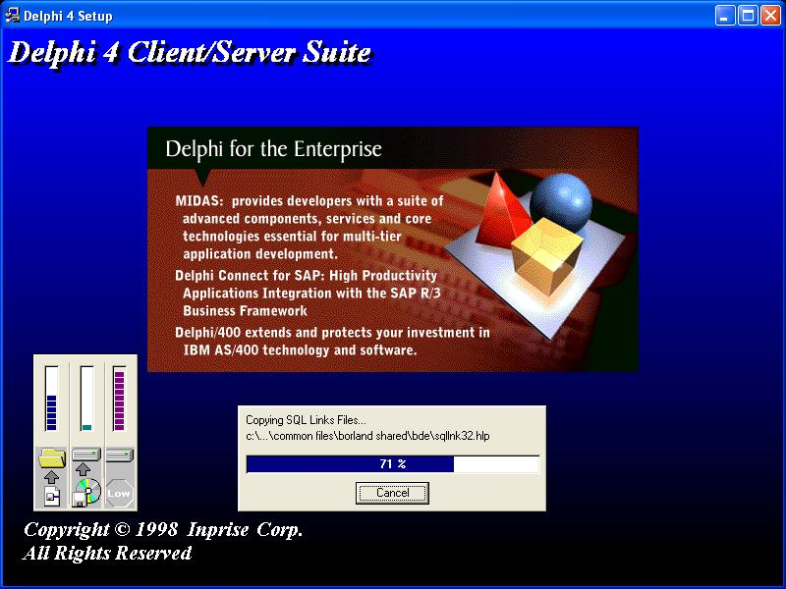 | 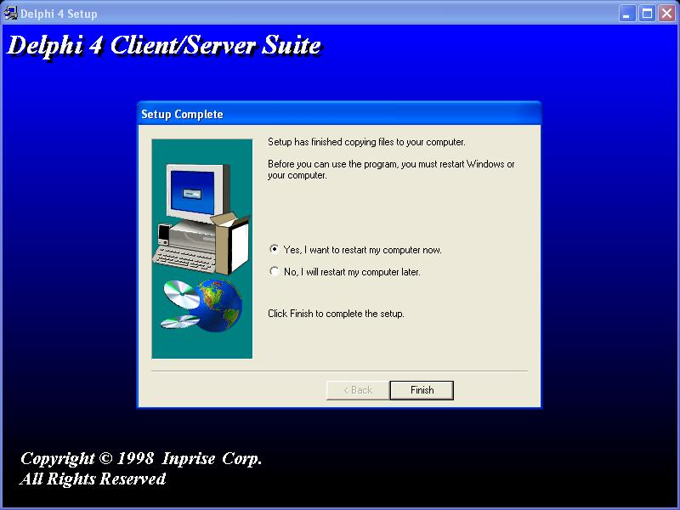

2 Arquivos do Delphi Developer Suport
Link: http://info.borland.com/devsupport/delphi/downloads/

2.1 Delphi 4 Items
Link: http://info.borland.com/devsupport/delphi/downloads/#Delphi%204

2.1.1 Delphi 4 Client/Server Update Pack #2
2.1.1.1 Instructions for Use
http://info.borland.com/devsupport/delphi/downloads/dcs402readme.html

2.1.1.2 Download

2.1.1.2.1 Borland (Official - broken link)
http://info.borland.com/devsupport/delphi/downloads/dcs402download.html

2.1.1.2.2 Faculty of Biomedical Technology - Bauman Moscow State Technical University
http://www.rl7.bmstu.ru/archives/Delphi/
http://www.rl7.bmstu.ru/archives/Delphi/d4cupd2.exe

2.1.1.2.3 Interdiciplinary Centre for Mathematical and computational modeling – university of Warsaw
http://delphi.icm.edu.pl/ > Delphi 4 > Miscellaneous
http://delphi.icm.edu.pl/ftp/d40free/d4cupd2.exe

2.1.1.2.4 Object Programming Center – ThinkQuest – Oracle Education Foundation
http://library.thinkquest.org/C004162/index2e.html > Delphi 4 > Miscellaneous
http://delphi.icm.edu.pl/ftp/d40free/d4cupd2.exe

2.1.1.3 Instalação

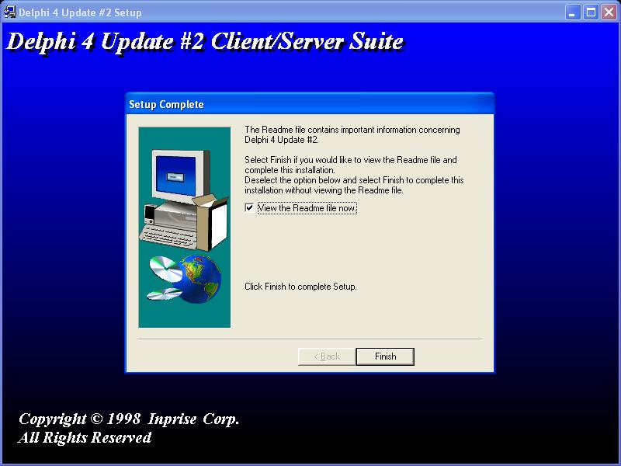 | 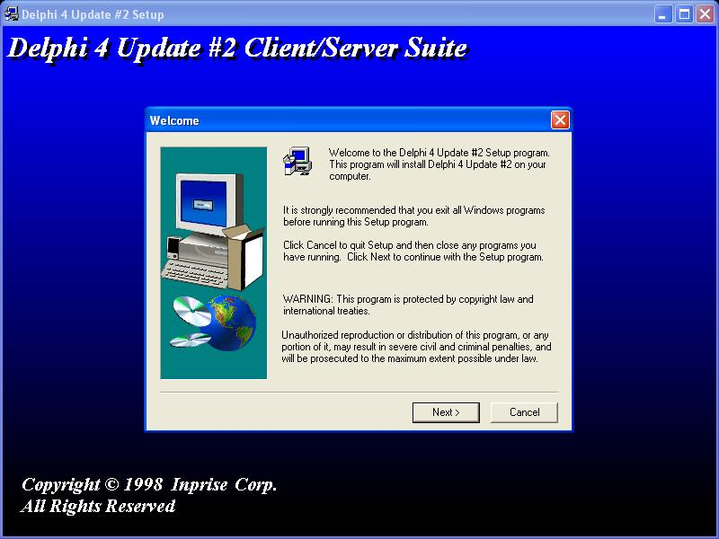
 | 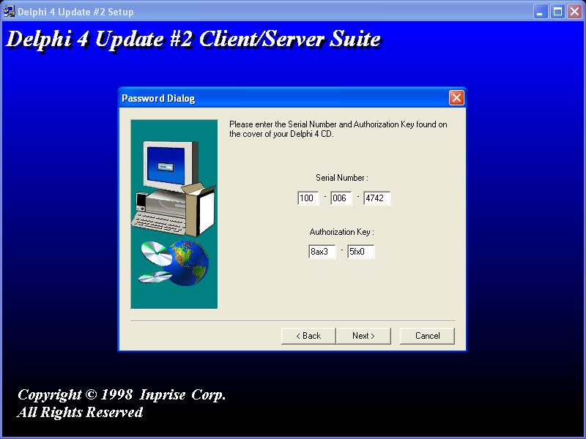
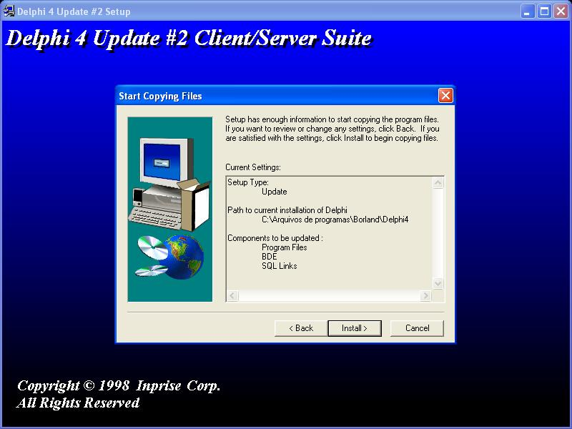

2.1.2 Delphi 4 Client/Server Update Pack #3

2.1.2.1 Instructions for Use
http://info.borland.com/devsupport/delphi/downloads/dcs403readme.html

2.1.2.2 Downloads

2.1.2.2.1 Borland (Official - broken link)
http://info.borland.com/devsupport/delphi/downloads/dcs403download.html

2.1.2.2.2 Faculty of Biomedical Technology - Bauman Moscow State Technical University
http://www.rl7.bmstu.ru/archives/Delphi/
http://www.rl7.bmstu.ru/archives/Delphi/d4cupd3.exe

2.1.2.2.3 Interdiciplinary Centre for Mathematical and computational modeling – university of Warsaw
http://delphi.icm.edu.pl/ > Delphi 4 > Miscellaneous
http://delphi.icm.edu.pl/ftp/d40free/d4cupd2.exe

2.1.2.2.4Object Programming Center – ThinkQuest – Oracle Education Foundation
http://library.thinkquest.org/C004162/index2e.html > Delphi 4 > Miscellaneous
http://delphi.icm.edu.pl/ftp/d40free/d4cupd2.exe

2.1.2.3 Instalação

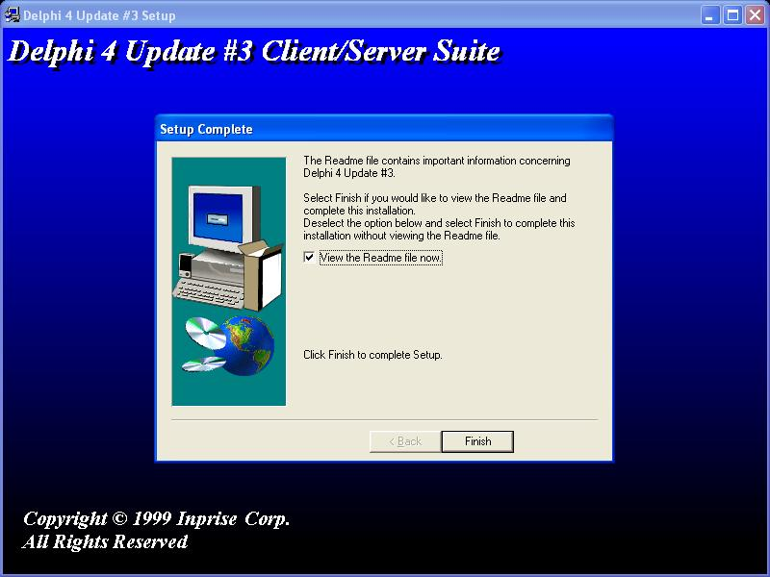 | 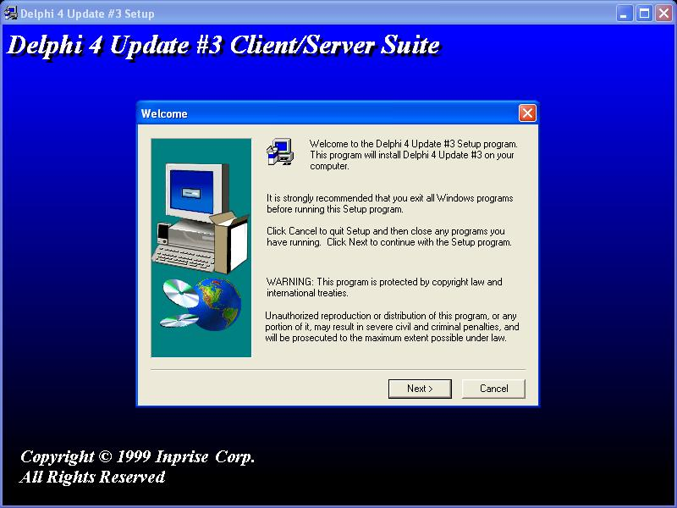
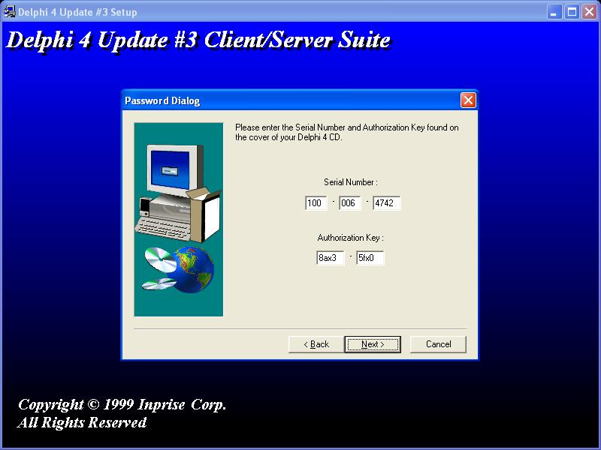 | 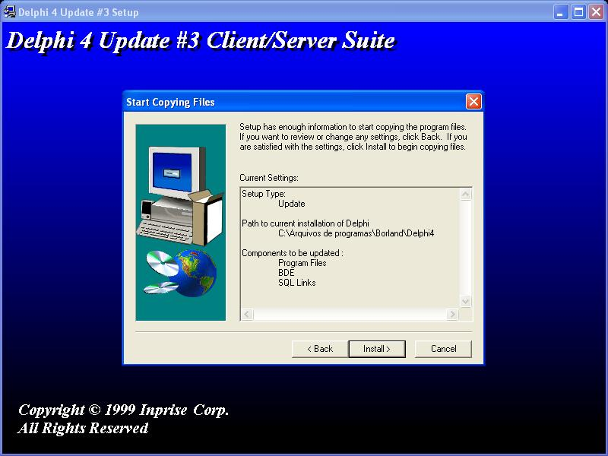
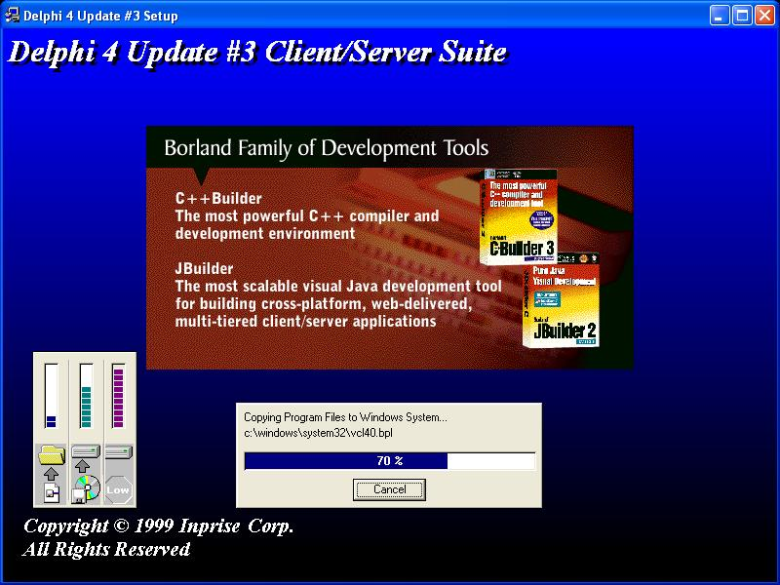

2.1.3 Delphi 4 Update Pack #3 Additions:

2.1.3.1 Info
http://info.borland.com/devsupport/delphi/downloads/index.html#Delphi%204

2.1.3.2 Download

2.1.3.2.1 Borland (official)
http://info.borland.com/devsupport/delphi/download_files/d4u3menu.zip

2.1.3.2.2 Faculty of Biomedical Technology - Bauman Moscow State Technical University
http://www.rl7.bmstu.ru/archives/Delphi/
http://www.rl7.bmstu.ru/archives/Delphi/d4u3menu.zip

2.1.3.3 Instalação

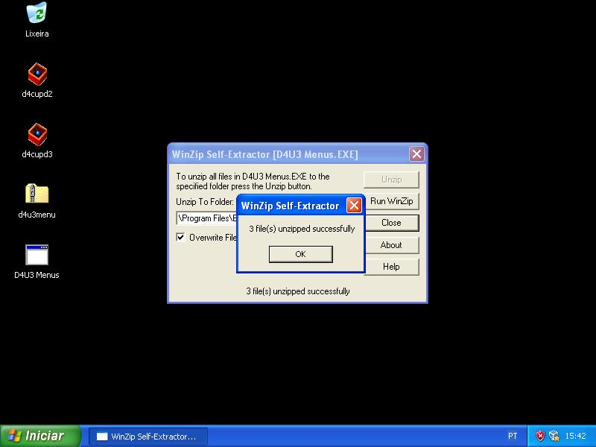 | 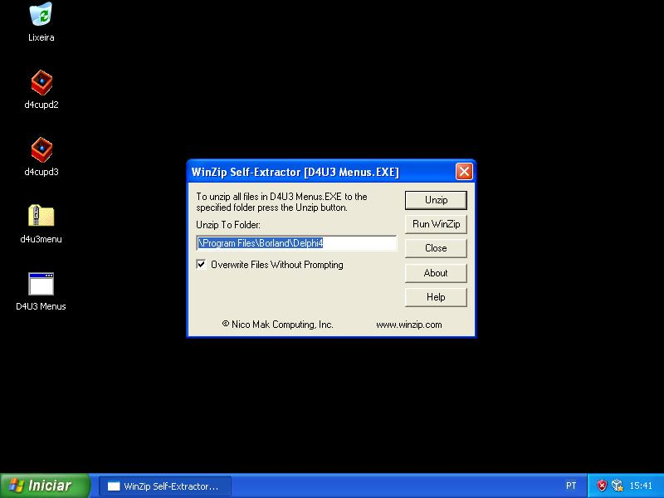

2.1.4 TeeChart
2.1.4.1 Removendo o TeeChart nativo
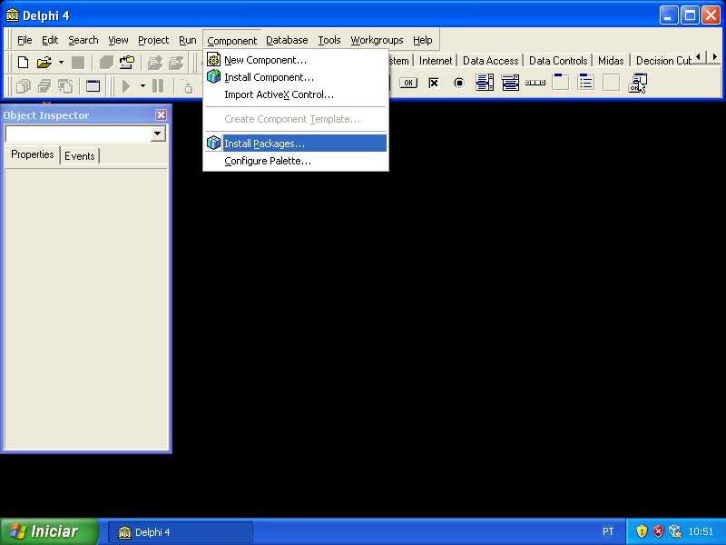 | 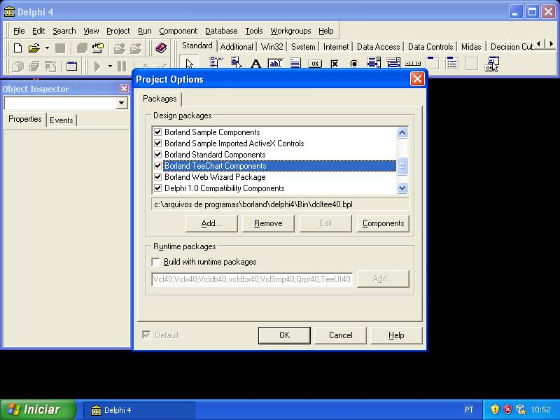
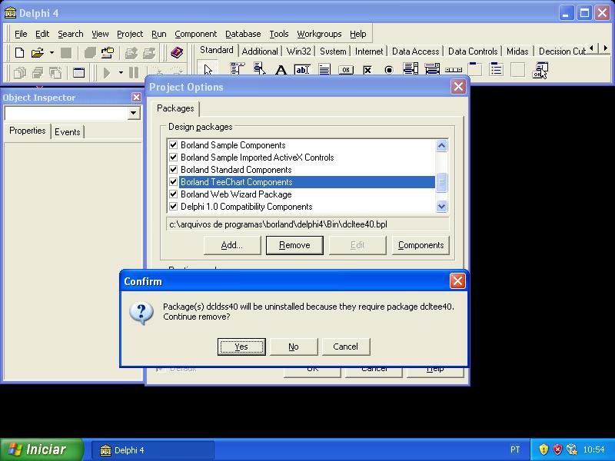

2.1.4.2 TeeChart pro 4.01
2.1.4.2.1 download
http://www.teechart.net/files/vcl/public/TeeChartPro4
http://www.teechart.net/files/vcl/public/TeeChartPro4/Tee401D4TRIAL.EXE
http://www.steema.com/download/TeeChart_v4/translations_for_teechart_pro_4.htm

2.1.4.2.2 instalando (instalar após o quick report)

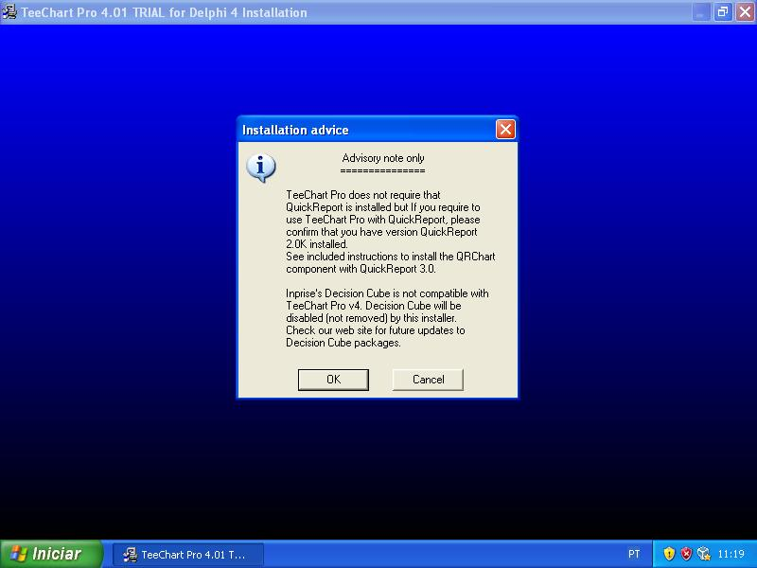 | 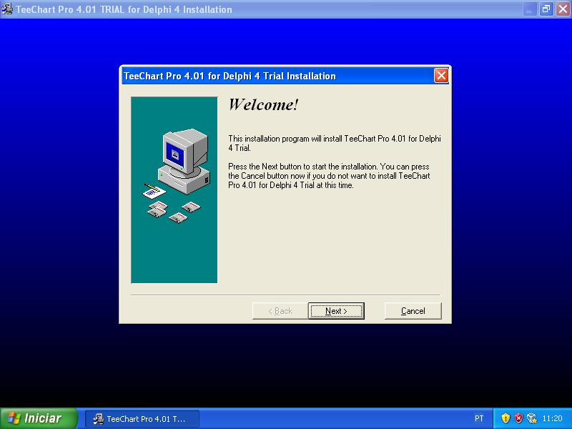
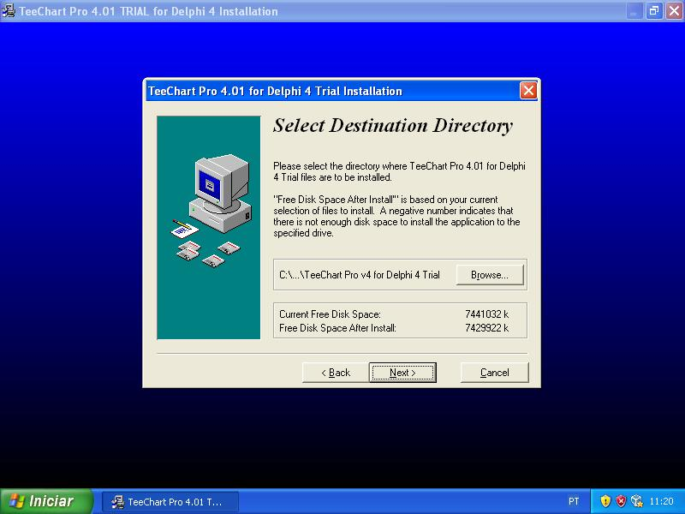 | 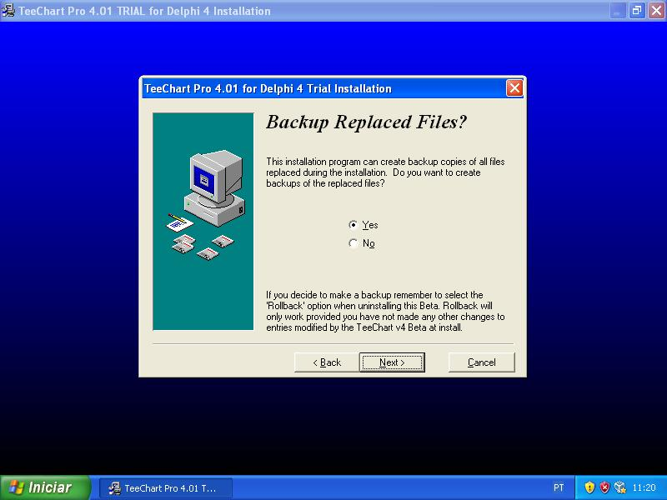
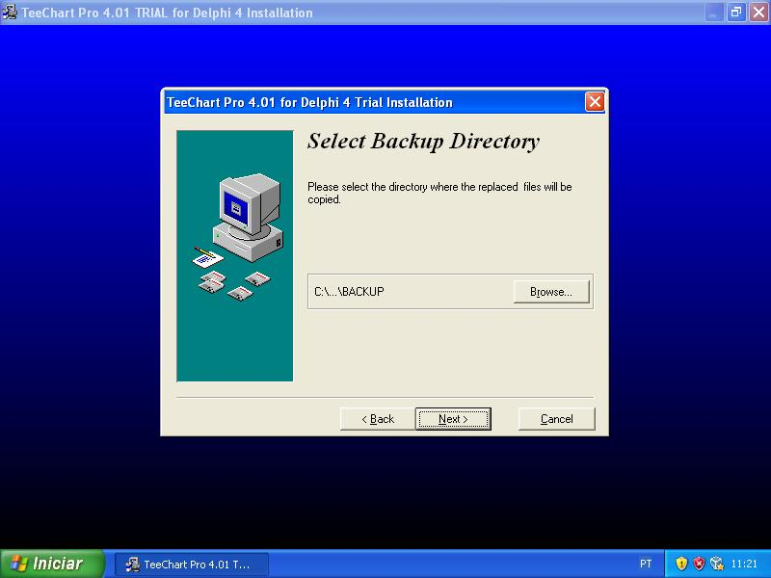 | 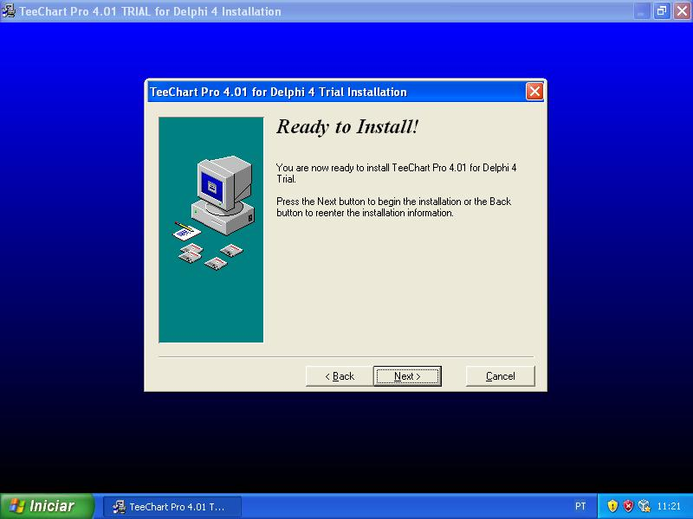
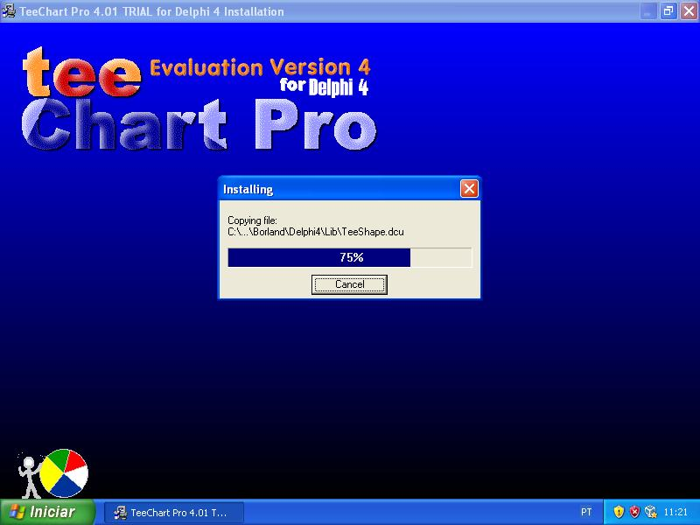 | 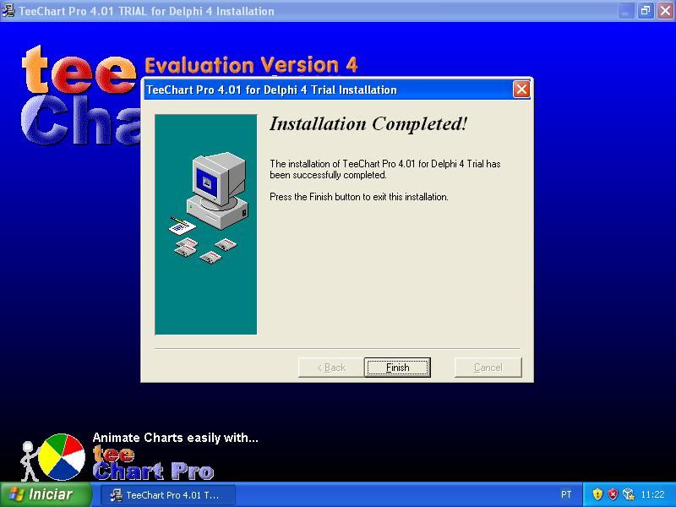

$(DELPHI) \quickrpt
Dclqrt40.dpl

2.1.5 quick report

2.1.5.1 download
http://www.podgoretsky.pri.ee/ftp/Language/Components/PRINT/QR/

2.1.5.2 instalação

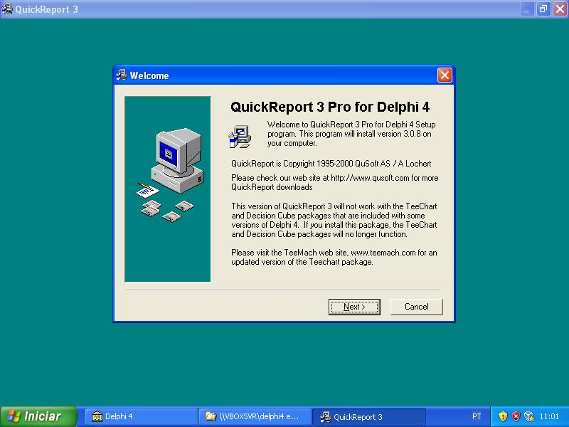 | 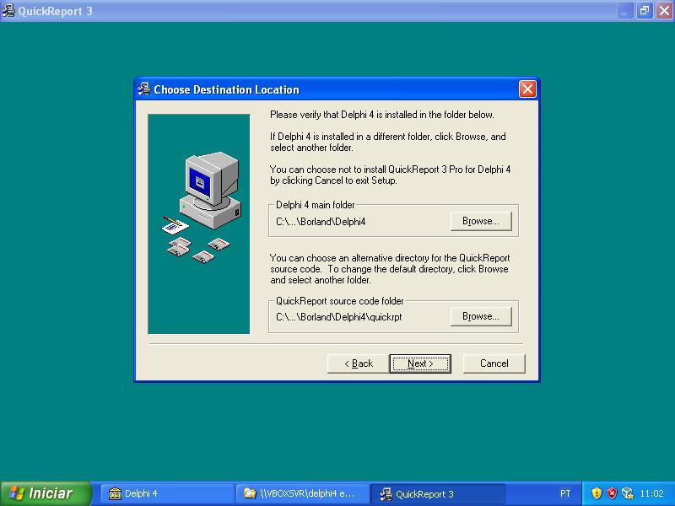
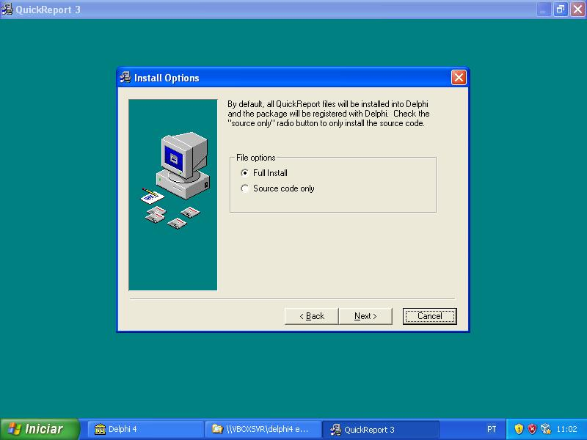 | 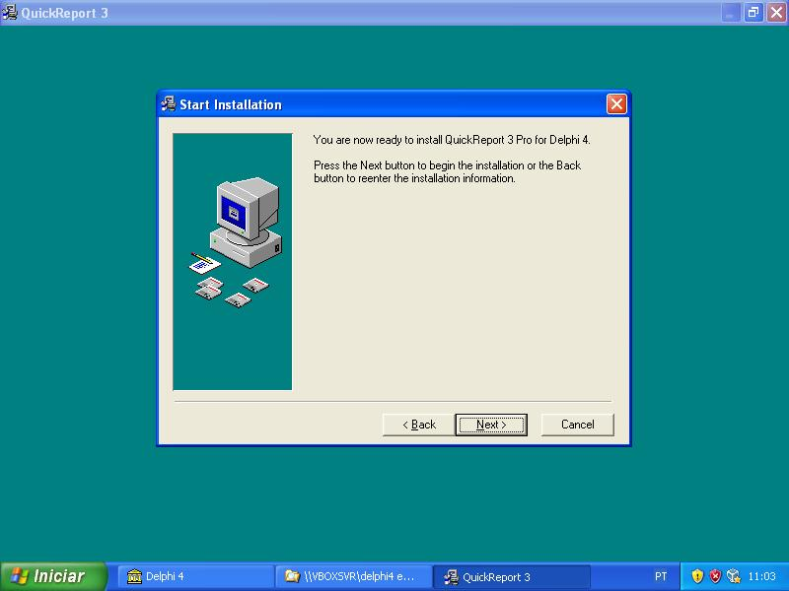
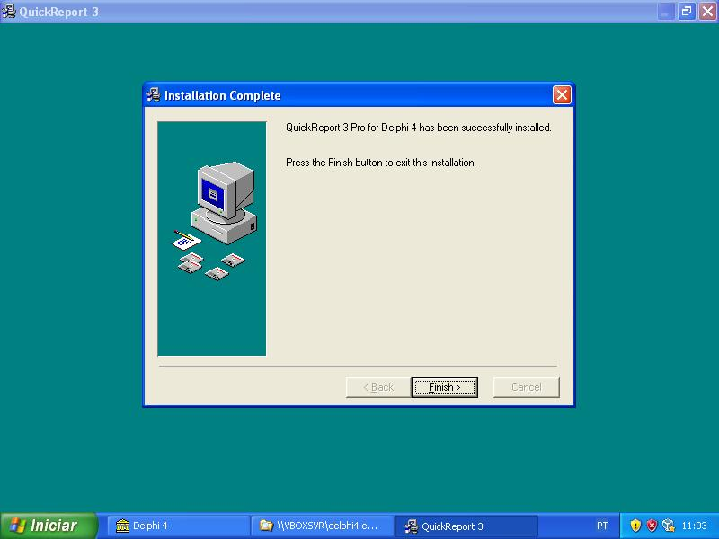 | 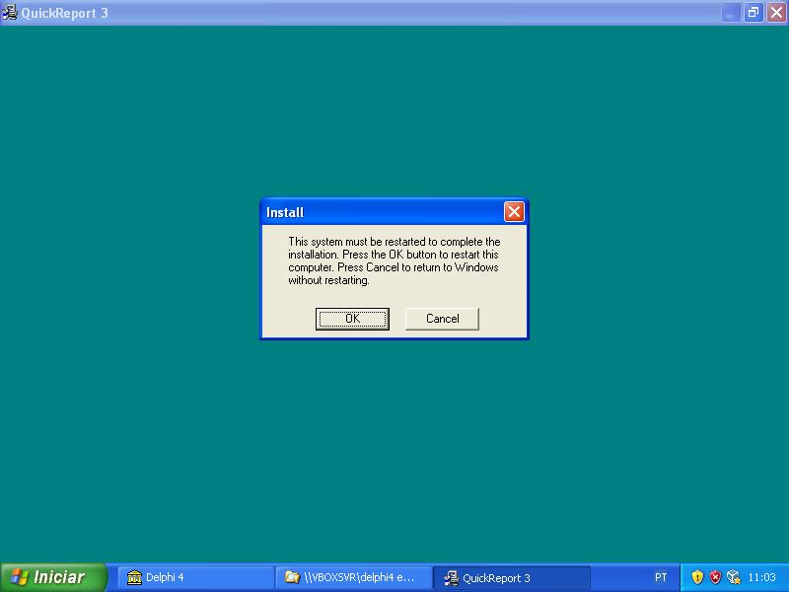

3 Delphi 5
3.1 BDE

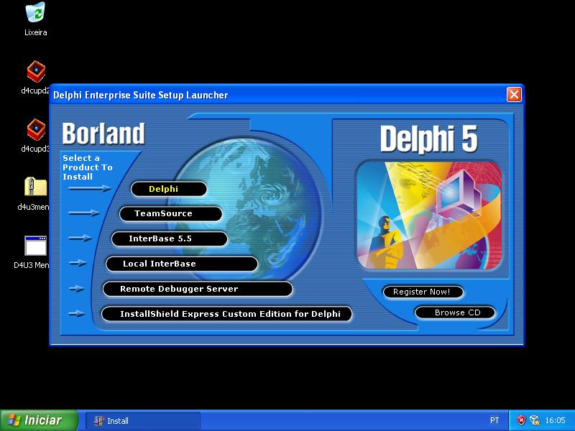 | 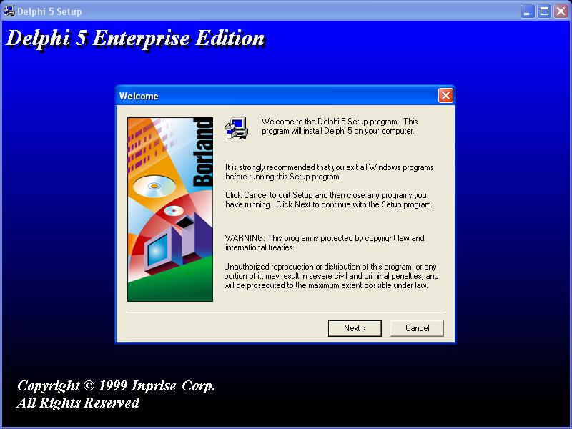
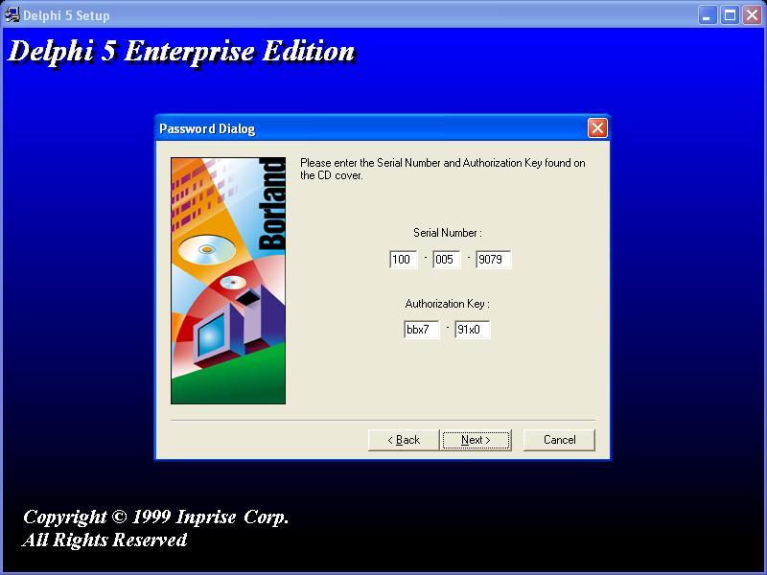 | 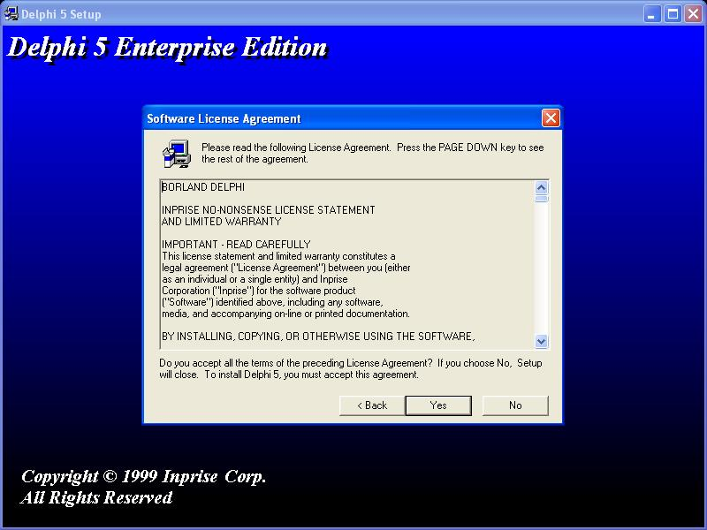
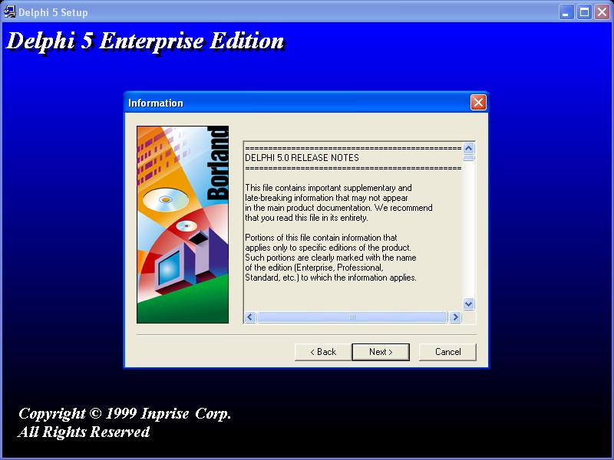 | 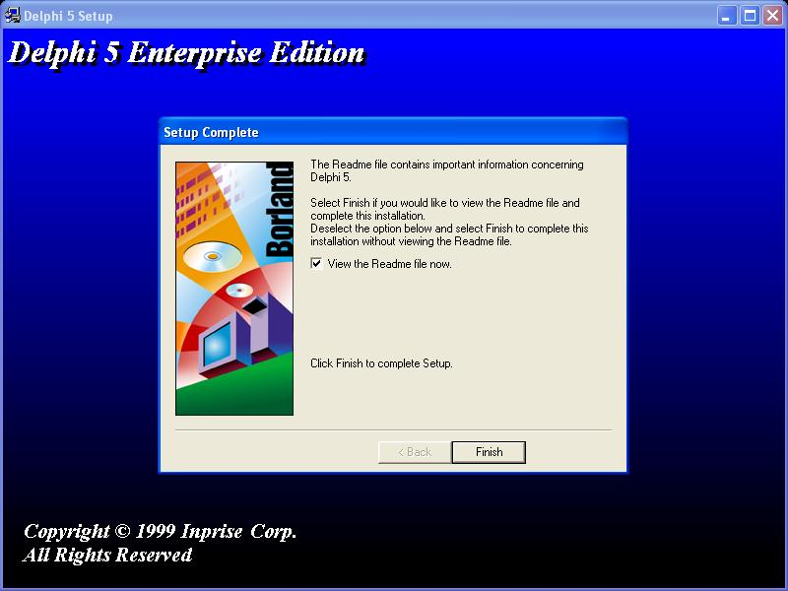
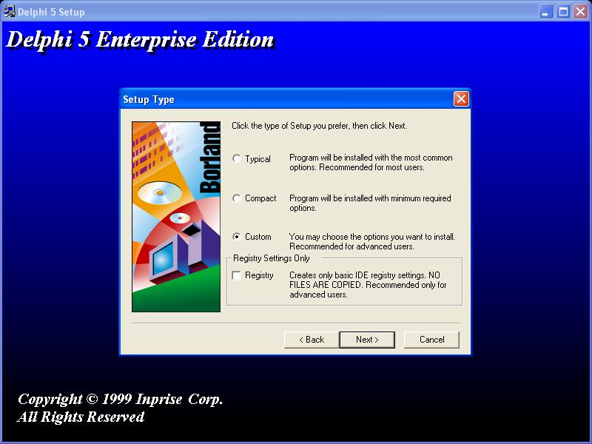 | 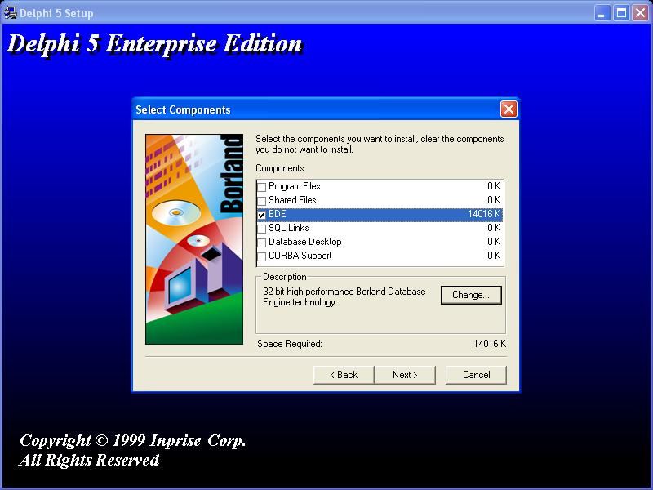
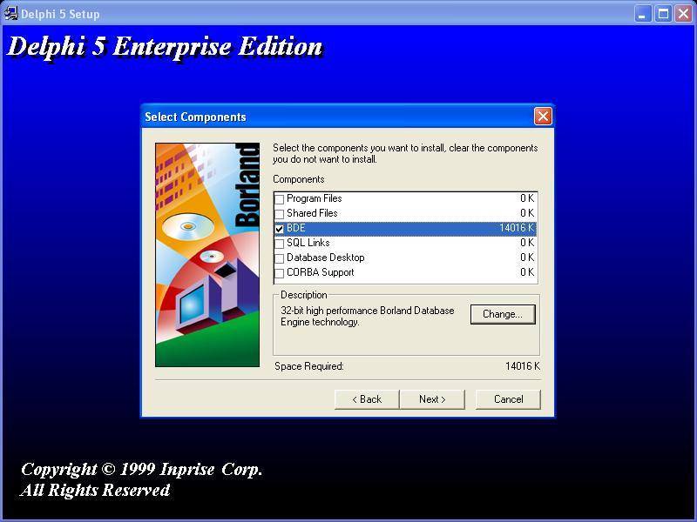 | 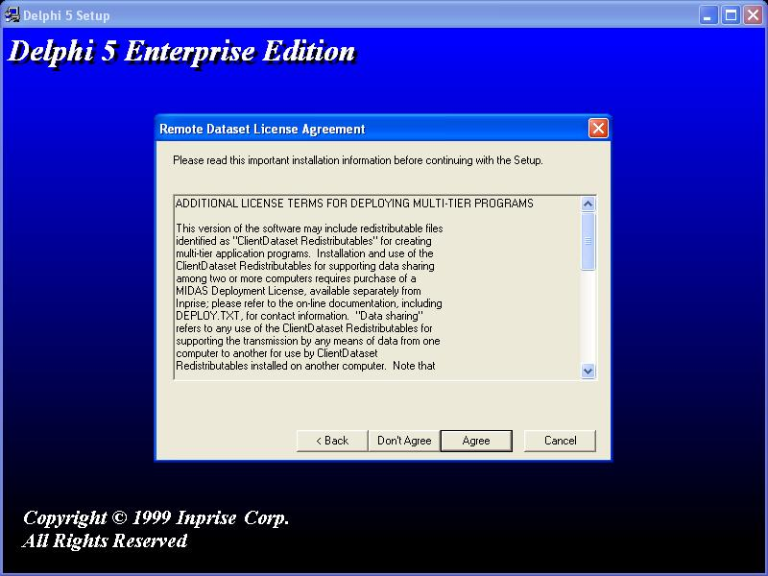
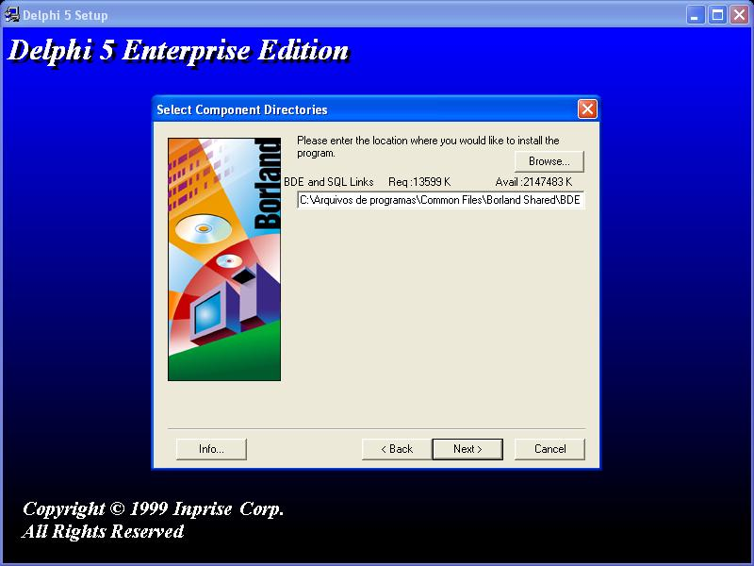 | 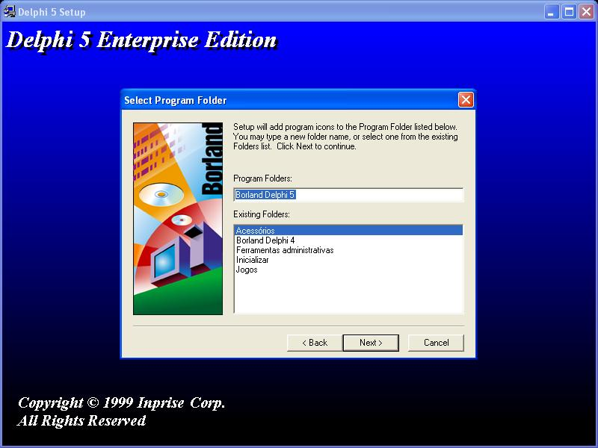
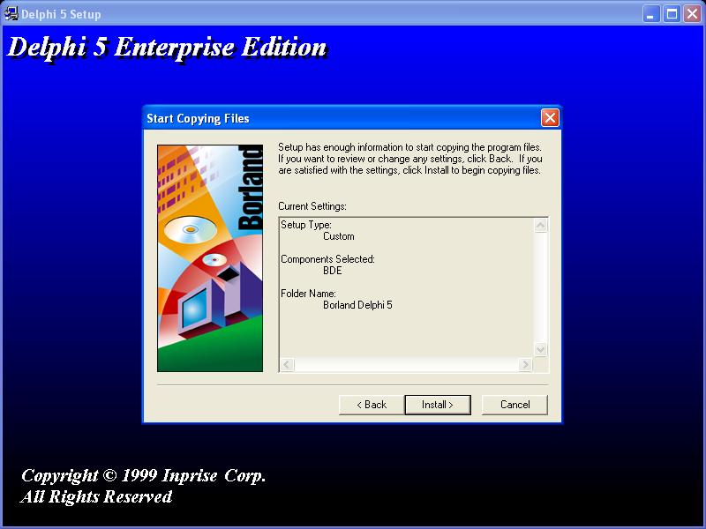 | 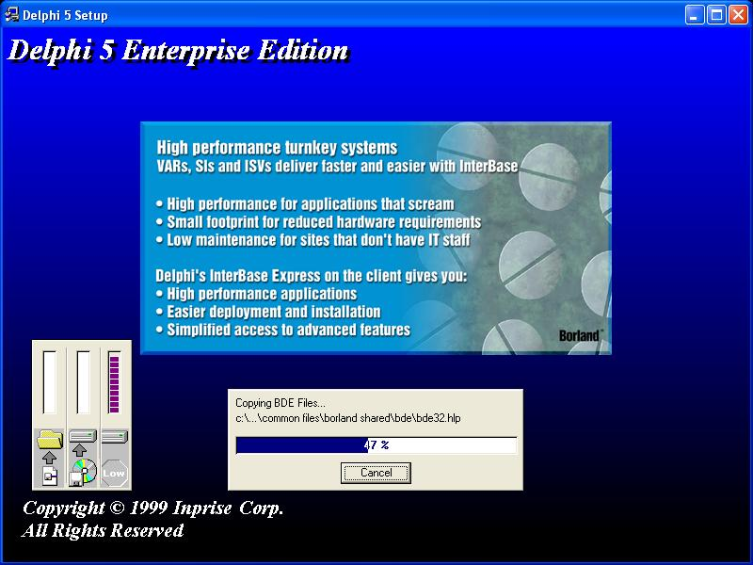

3.2 InterBase

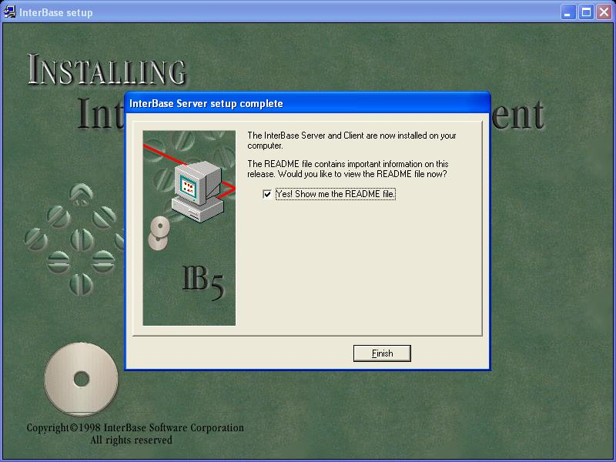 | 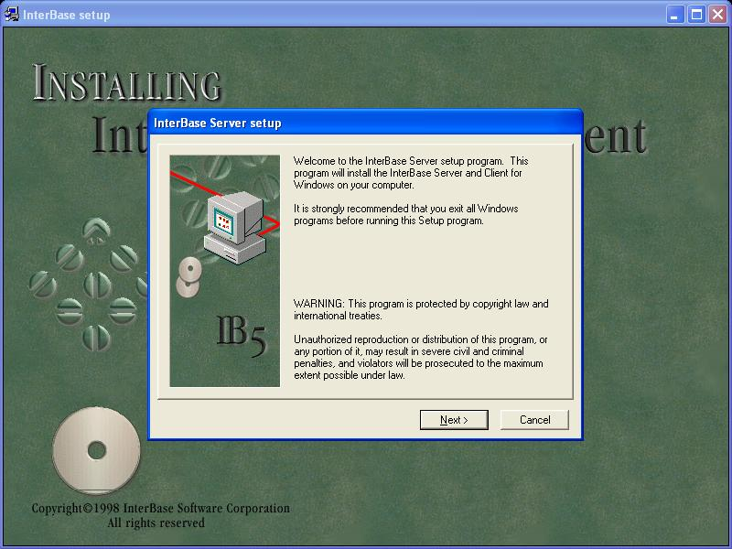
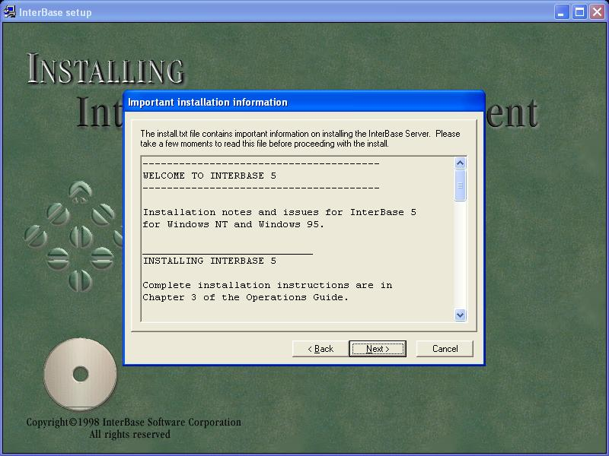 | 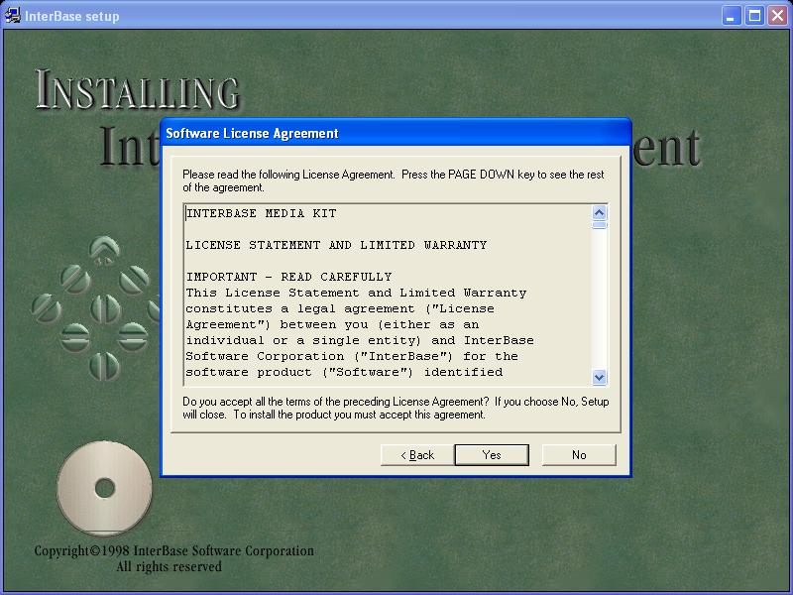
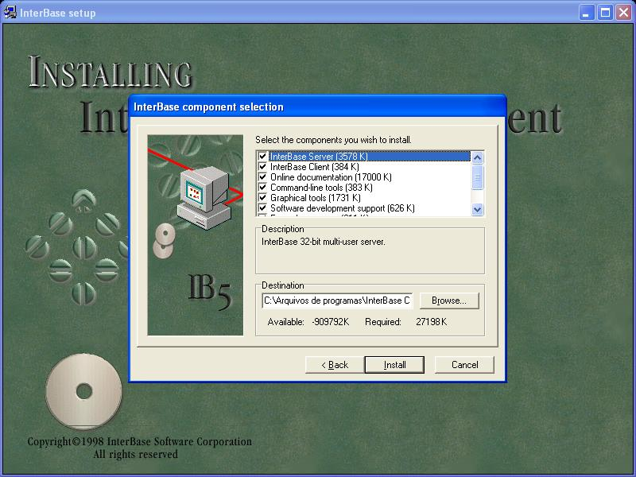 | 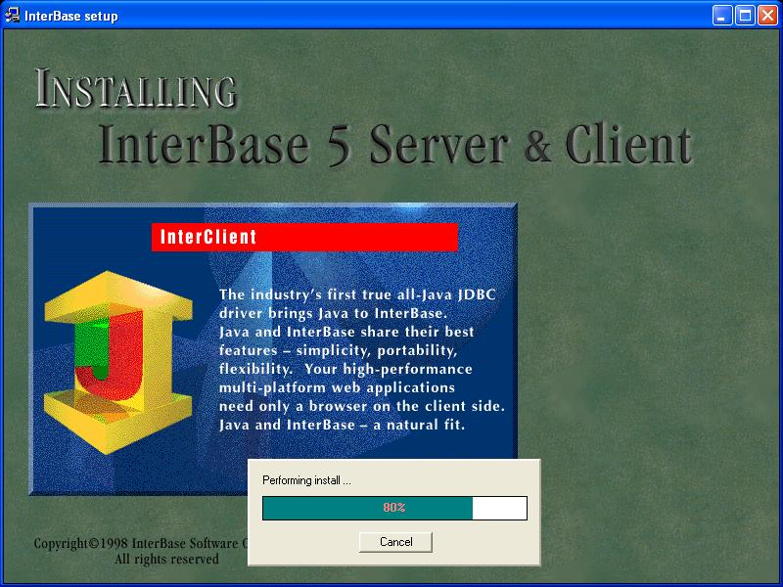

Ib6 http://instalki.emapa.pl/windows/InterBase/

4 componentes
4.1 library path

$(DELPHI)\Lib
$(DELPHI)\Bin
$(DELPHI)\Imports
$(DELPHI)\lalsoft limited\aboutbox
$(DELPHI)\imports
$(DELPHI)\Quickrpt
$(DELPHI)\lib
$(DELPHI)\TeeChart Pro v4 for Delphi 4\Delphi4\Lib
c:\projeto\compdelphi
C:\Projeto\CompDelphi\ABOUT
C:\Projeto\CompDelphi\Abreviador
C:\Projeto\CompDelphi\AliNut
c:\projeto\compdelphi\backup
C:\Projeto\CompDelphi\Calculo
C:\Projeto\CompDelphi\CompoundComp\DEMO
C:\Projeto\CompDelphi\CompoundComp\LIB\D4
C:\Projeto\CompDelphi\Conectores
C:\Projeto\CompDelphi\conversao
C:\Projeto\CompDelphi\DataIdade
C:\Projeto\CompDelphi\Dblistview
C:\Projeto\CompDelphi\DelayedOpIndicator
C:\Projeto\CompDelphi\Fonetizador
C:\Projeto\CompDelphi\Formula
C:\Projeto\CompDelphi\GraficoFaixa
c:\projeto\compdelphi\hintlistbox
c:\projeto\compdelphi\hintlistbox
C:\projeto\CompDelphi\HlpNut
c:\projeto\compdelphi\Htmlhlp
c:\projeto\compdelphi\ibman
C:\Projeto\CompDelphi\InsereForm
C:\Projeto\CompDelphi\KeyNav
C:\Projeto\CompDelphi\ListaLink
C:\projeto\CompDelphi\LockDB
C:\Projeto\CompDelphi\Medida
C:\Projeto\CompDelphi\MoveItens
C:\Projeto\CompDelphi\MYNAV
C:\Projeto\CompDelphi\NAVTABLE
C:\Projeto\CompDelphi\Numedit
C:\Projeto\CompDelphi\ObjetoVisual 1.0
C:\Projeto\CompDelphi\OCXDCN\DICDELP
C:\Projeto\CompDelphi\OCXDCN\ListDic
C:\Projeto\CompDelphi\OCXDCN\novodic
C:\Projeto\CompDelphi\OCXDCN\TreeDic
C:\Projeto\CompDelphi\Pesqcid
c:\projeto\compdelphi\pgpdc208
C:\Projeto\CompDelphi\Pilhas
C:\Projeto\CompDelphi\Preparar
C:\Projeto\CompDelphi\regEdit
C:\Projeto\CompDelphi\RTTI
C:\Projeto\CompDelphi\RX\Units
c:\projeto\compdelphi\skinimage
C:\Projeto\CompDelphi\Tabela
C:\Projeto\CompDelphi\TfunctionParser10
c:\projeto\compdelphi\validade
C:\Projeto\CompDelphi\VCFonAbv
c:\projeto\compdelphi\waihintlistbox
C:\Projeto\CompDelphi\wizard
C:\Projeto\CompDelphi\XMLPrsrFree
C:\Projeto\NUTWIN\calc
C:\ARQUIV~1\CodeSite\Lib4

4.2 Instalando compoenetes
4.2.1 RX
http://br.geocities.com/all_software/download/componentes/rxlib275.zip
4.2.1.1 Install
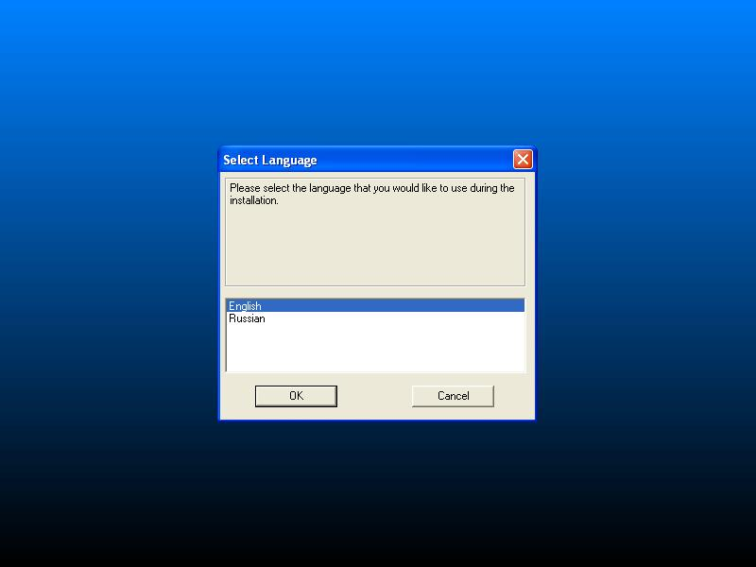 | 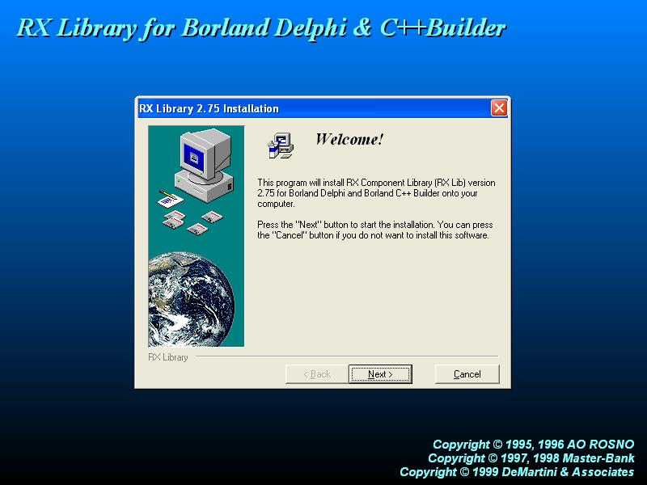
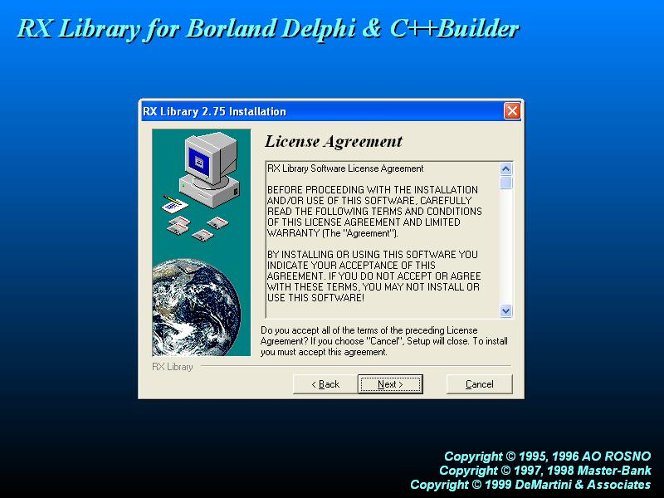 | 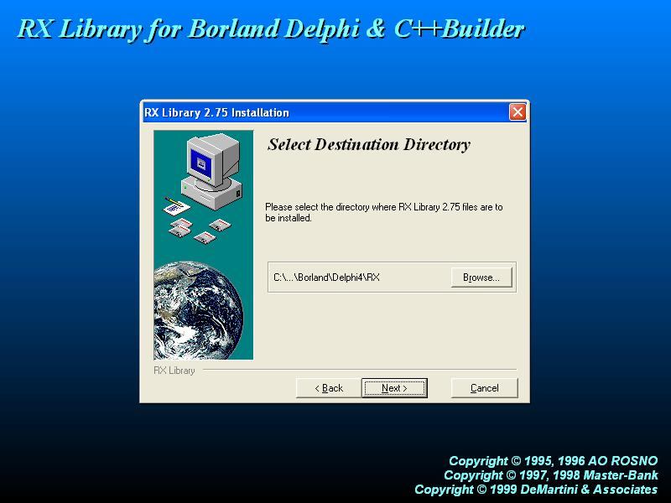
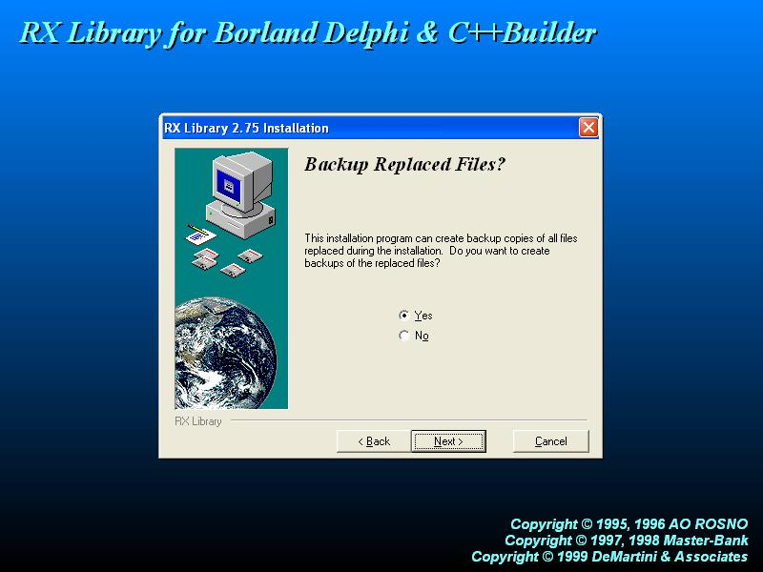 | 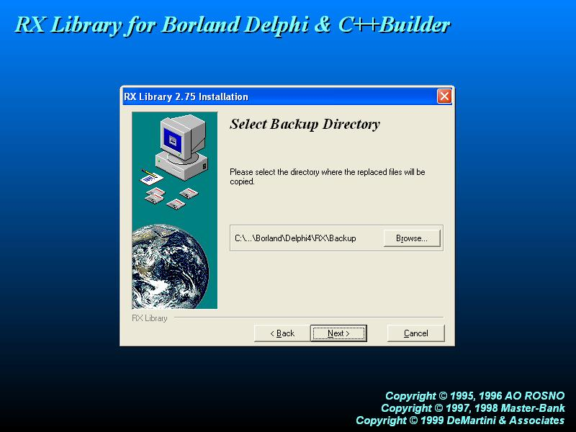
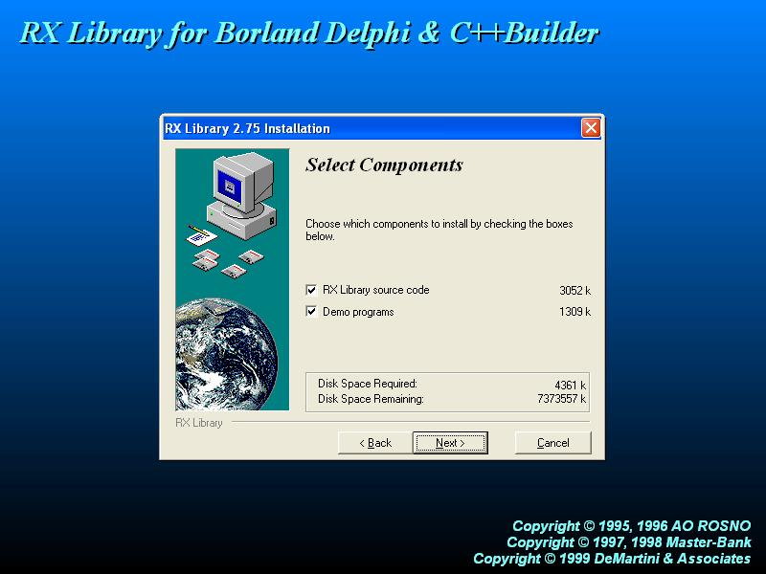 | 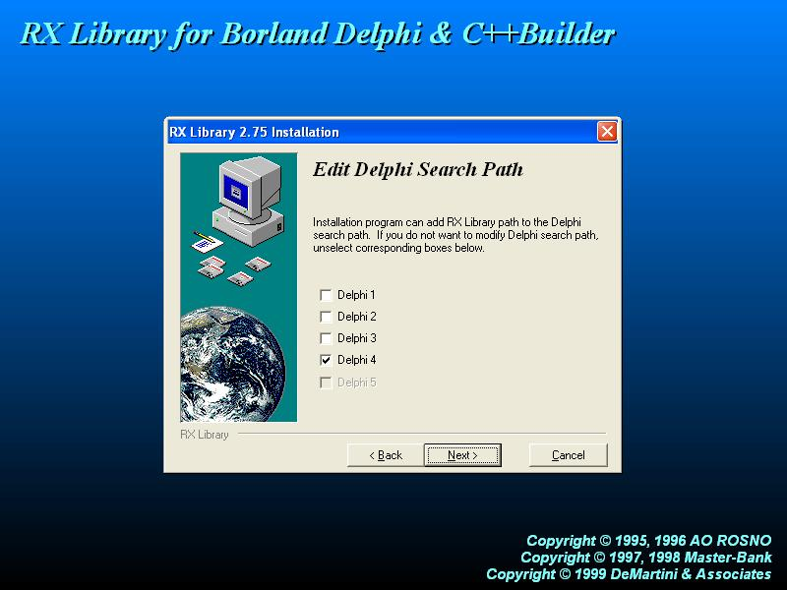
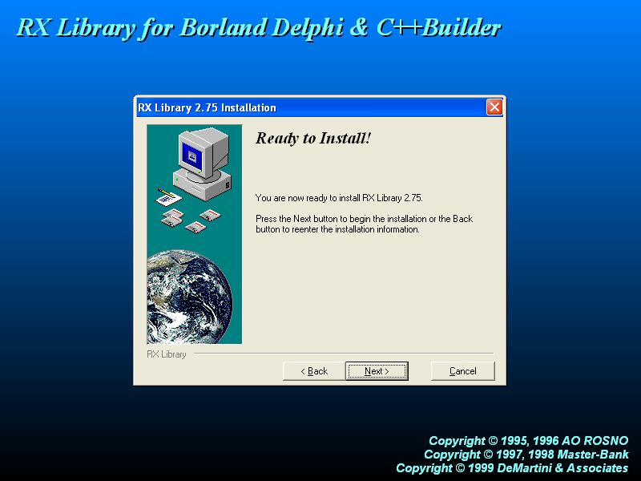 | 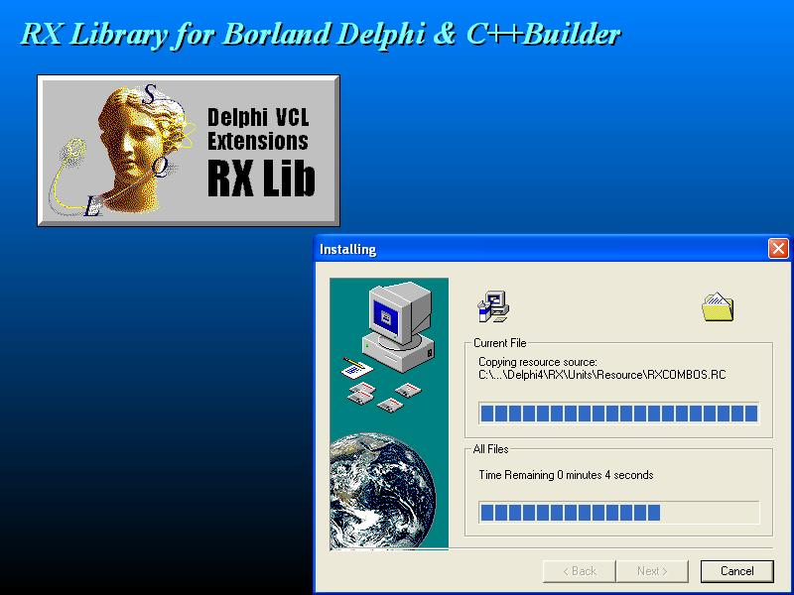
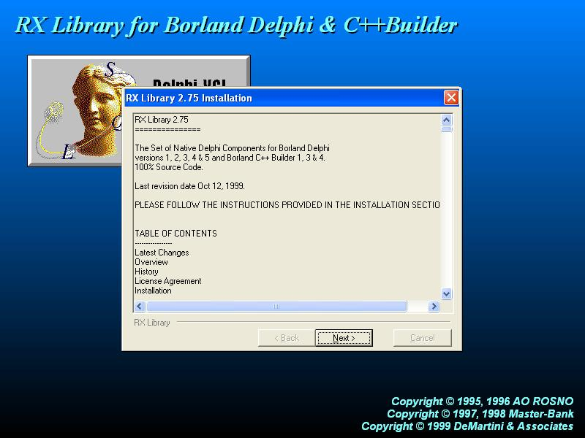 | 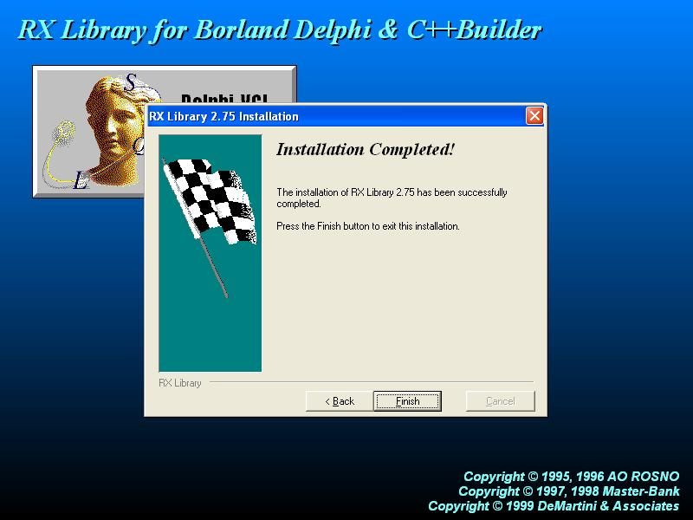

4.2.1.2 configure
Configuração do leia-me num funciona , fazer a com os arquivos com sufixo “4”

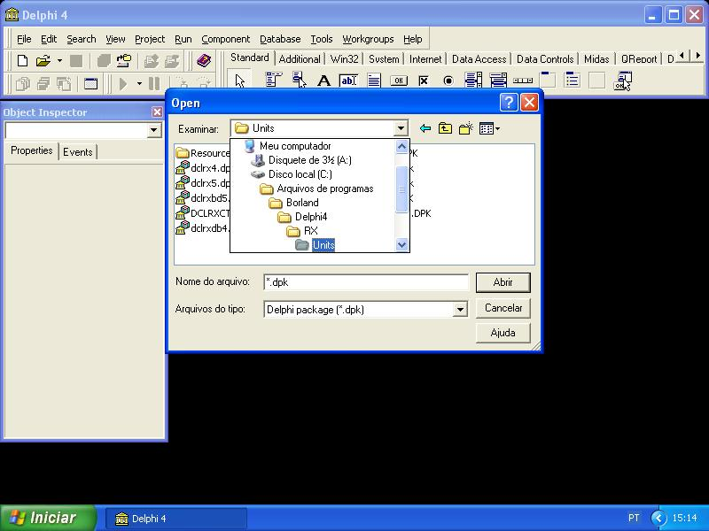 | 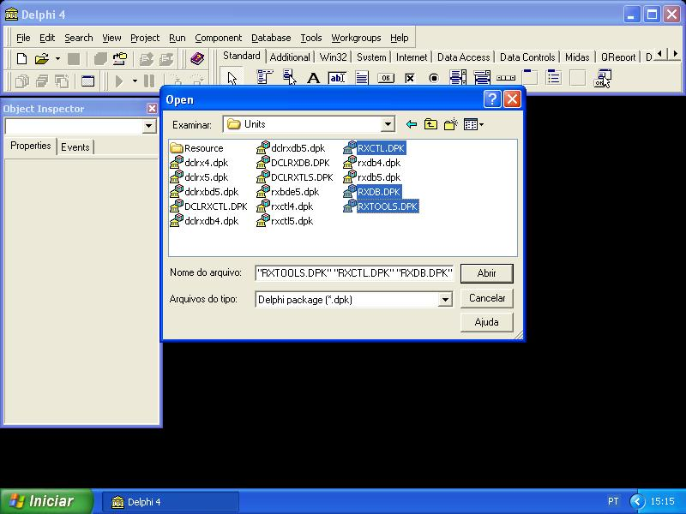
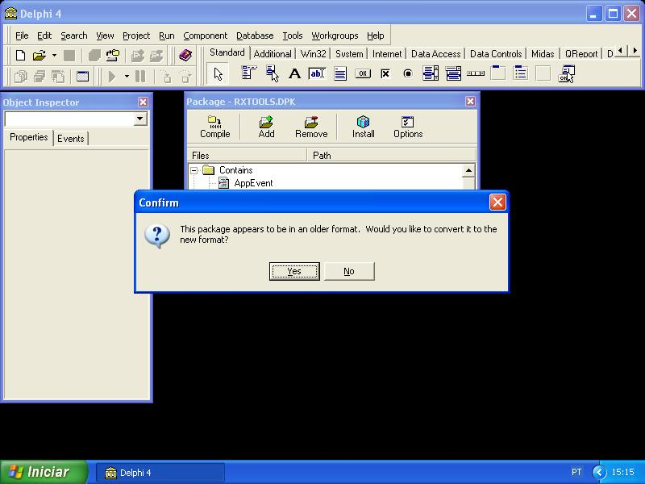 | 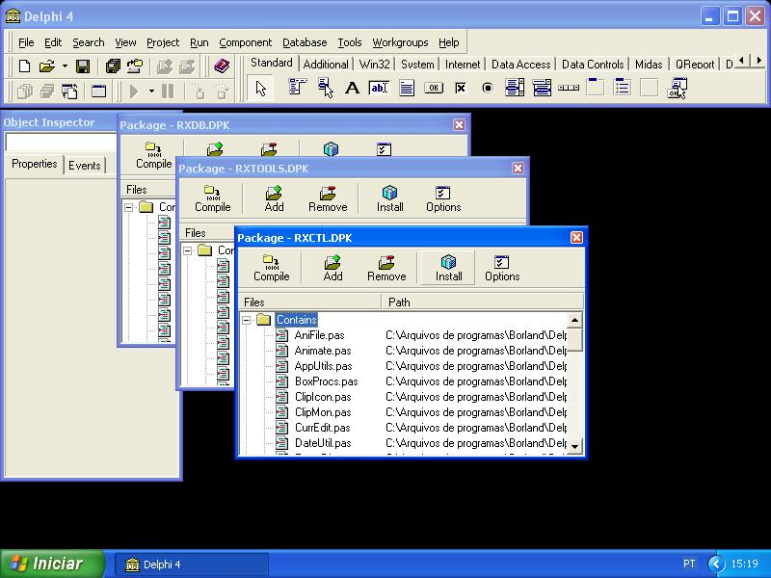
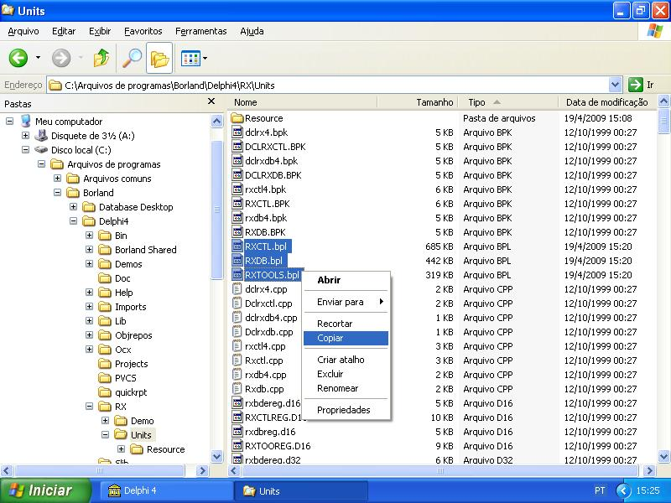 | 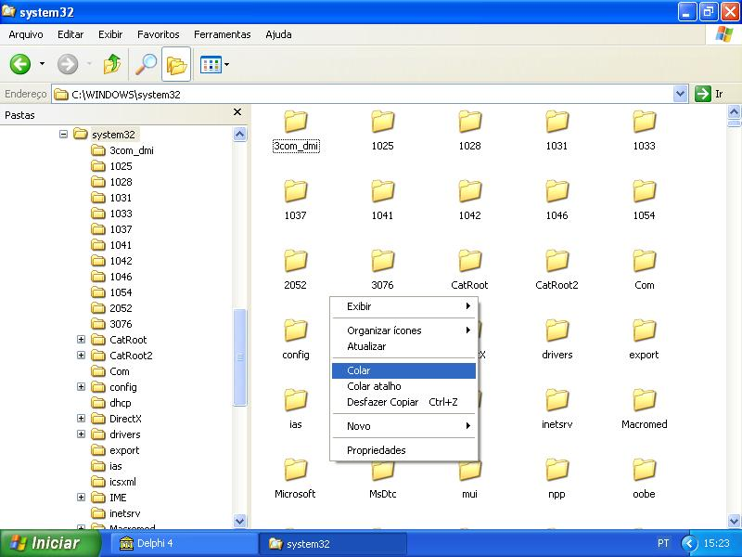
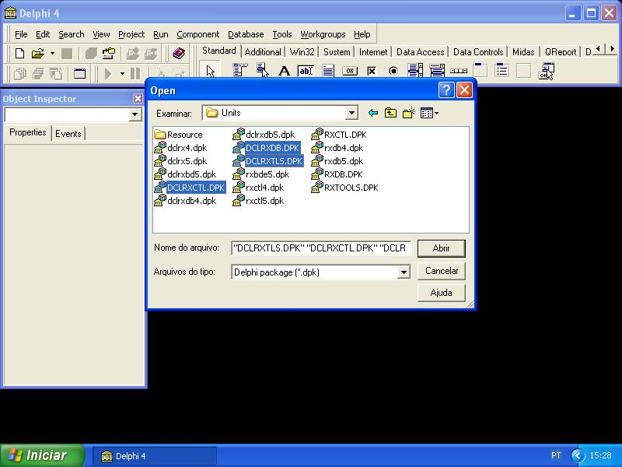 | 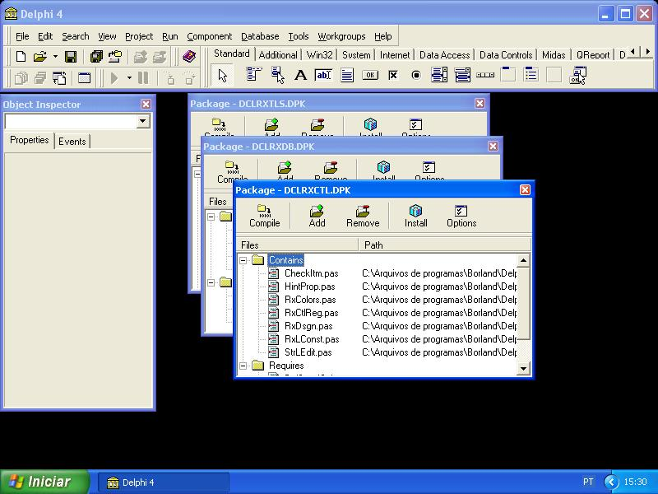

4.2.1 Dclbox40

4.2.1 Básicos, Conectores, Conversao, Dic, Fonteabrv, Freeware, Nutrição

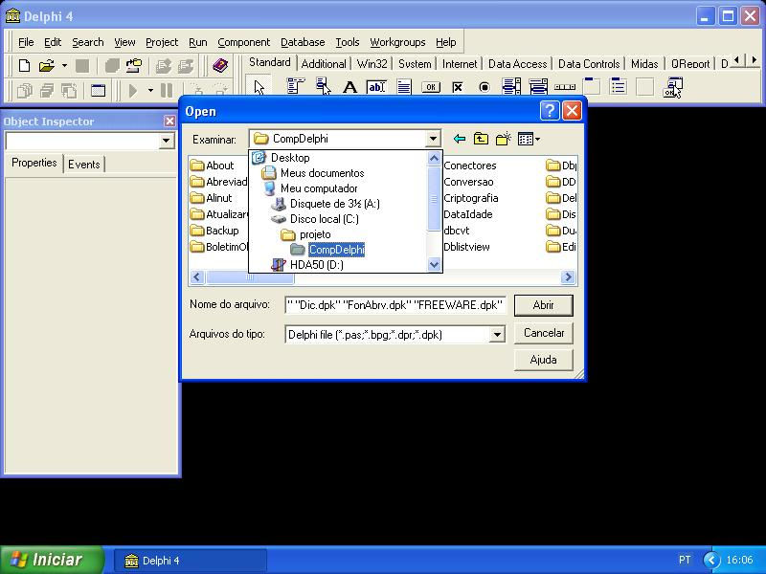 | 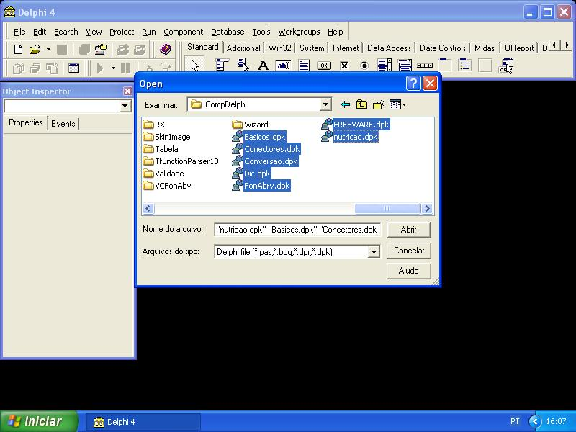

4.2.3 IsAboutBox

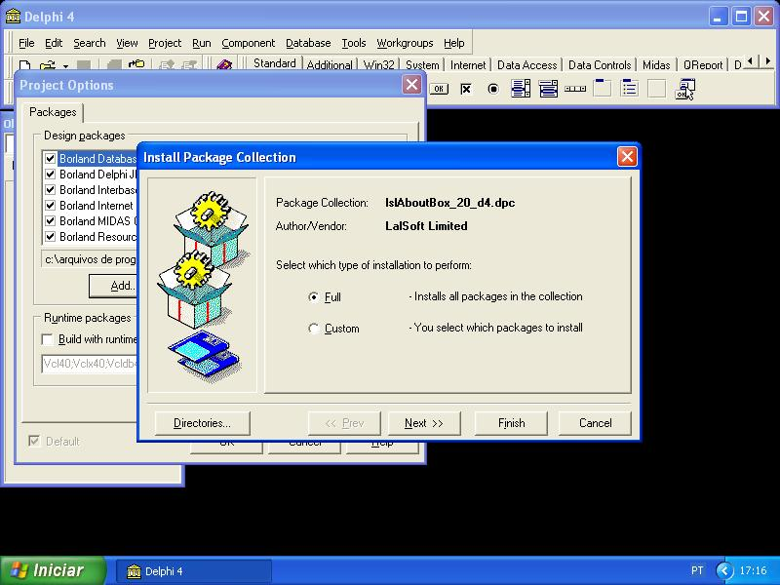 | 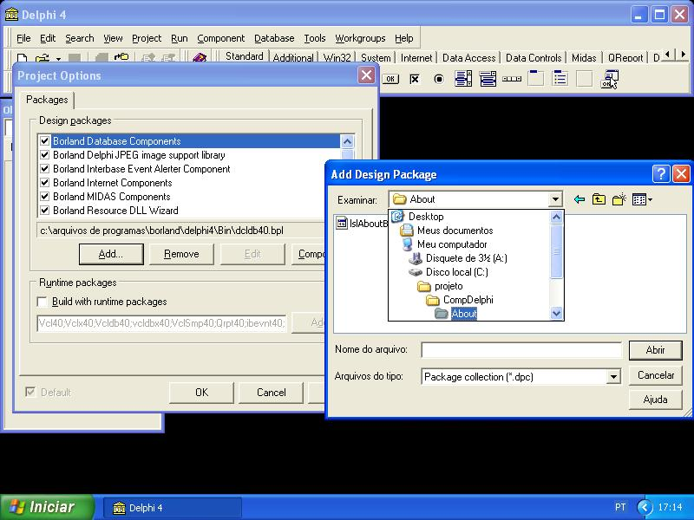

4.2.4
TeeChartPro quick report – instalar o sourceQRtee
http://www.steema.com/download/TeeChart_v4/Tee4forQuickReport.htm
http://www.steema.com/files/vcl/public/SourceQRTee.zip
Instalar o hhpack (compDelphi\htmlhelp)

5 instalar o Nutwin

