Reappraising the variability of effects of antipsychotic medication in schizophrenia: a meta-analysis

Robert A. McCutcheon, Toby Pillinger, Orestis Efthimiou, Marta Maslej, Benoit H. Mulsant, Allan H. Young, Andrea Cipriani, Oliver D. Howes

World Psychiatry 2022

Supplementary Information

Overview
We searched for studies providing IPD from the Yale University Open Data Access (YODA) clinical trials database¹. We used this data to estimate the correlation between placebo and treatment effects at the individual patient level, using two alternative methods. The impact this correlation has on the relationship between variability ratios and treatment effect heterogeneity is explained in eFigure1. We also used study level data from a recent meta-analysis of randomised controlled trials to estimate the correlation at the study level ². We then used the most conservative of these coefficients to calculate the heterogeneity of treatment effects, using aggregate data from antipsychotic trials of schizophrenia². The estimates of treatment effect heterogeneity were then combined meta-analytically.

Statistical Analysis
The average treatment effect for a population of interest is defined as the difference between the mean outcome if the whole population received placebo versus the outcome when receiving the active treatment. This can be estimated in RCTs (Figure 1). The treatment effect at the individual level cannot be estimated as easily as it refers to the difference between outcome under placebo and outcome under active treatment for the same patient with all other factors (including the moment in time) being identical. It is, however, under certain assumptions, possible to estimate a treatment effect for an individual. We performed this using two separate methods, which rest upon different assumptions.

Open label method
The ‘open label method’ made use of one study from the YODA database, in which, for patients randomised to placebo, symptomatic change data was available for the same individual receiving both placebo and then active treatment. The placebo response for individuals randomised to the placebo arm during the double-blind period, was quantified as the change in PANSS score, between the start of the double-blind period and the point at which that individual left the double-blind portion of the trial. The estimated treatment effect was calculated as the change in symptom severity from the end of the double-blind period (during which the individual was receiving placebo) up until the timepoint that maximised the similarity between time spent in double-blind and open-label periods of the study

This method relies on the assumption that the PANSS score we would observe if we could follow-up this patient under drug in the double-blind period (dashed line in eFigure 1A; this is unobservable) equals the score we actually observe at the end of an-open label period of equal duration.

Linear model method
This method makes the usual assumption of linearity and additivity of the effects of the covariates and treatment on the outcome.

We fit a linear model of the following form in the IPD from the RCT:

$$y_{T,i}=α+β_{sex} sex_{i}+β_{age} age_{i}+β_{base} y_{0,i}+\left(γ_{sex} sex_{i}+γ_{age} age_{i}+γ_{base} y_{0,i}\right) treat_{i}+δ treat_{i}+e_{i}$$
$$e_{i}\sim N(0, s^{2})$$

where $y_{T,i}$ is the final outcome (symptoms at endpoint) for patient $i$, $y_{0,i}$ is baseline symptoms, $sex_{i}$ is 0/1 for male/female, $treat_{i}$ is the 0/1 for placebo/drug.

This model was fit to all patients included in the trial and treatment effects were then estimated for each subject as:
$$γ_{sex} sex_{i}+γ_{age} age_{i}+γ_{base} y_{0,i}+δ$$

The outcomes in placebo (required for the calculation of $ρ$) were taken as observed in the data, i.e. we only used patients randomized to placebo.

In other words, the treatment condition during the double-blind period was a predictor variable, with sex, age and baseline symptoms as additional predictors. Then based on this model, we estimated outcome for the participants who received placebo had they received treatment (by setting the condition to 1).

Correlation of placebo response and treatment effect
In both the linear model and open label methods the correlation between placebo response and treatment effect was calculated only for those patients randomised to placebo. Note that placebo response is directly observable for these patients. This correlation was calculated for positive and negative subscales, and the total score.

In the case of the study level method, this method of calculating the correlation rests upon the assumption that the correlation between treatment effects and placebo response at the patient-level equals the one at the study-level.

Estimating treatment effect variability
We have described three alternative methods for calculating the correlation between placebo response and treatment effect. Below we describe how to use this $ρ$ to calculate heterogeneity of treatment effects from aggregate data.

Due to a lack of previous estimates for the correlation between placebo and treatment effects, prior analyses of variability have not accurately quantified the magnitude of treatment effect heterogeneity ^{2–5}. They have instead reported a lack of difference between active and placebo response variabilities, that is a variability ratio (VR) that does not demonstrate a statistically significant difference from one.

VR is defined as follows, with AT referring to the active treatment arm and PL referring to the placebo treatment arm:
$$VR=\frac{σ_{AT}}{σ_{PL}}$$

The variable of clinical interest, however, is the variability of the treatment effect ($σ_{TE}$). This can be estimated if VR and the correlation ($ρ$) between placebo-effect and treatment-effect are known. For instances where VR≥1, there is a single value of $\frac{σ_{TE}}{σ_{PL}}$ for any value of $ρ$ :
$$σ_{TE}=σ_{PL}\left(\sqrt{{VR}^{2}-1+ρ^{2}}-ρ\right)$$

Whereas for instances where VR≤1 there are two possible solutions:

$$σ_{TE}=σ_{PL}\left(±\sqrt{{VR}^{2}-1+ρ^{2}}-ρ\right)$$

In what follows we use the former formula; see some discussion below and also^{6,7} regarding the second.

After estimating the value for $ρ$ as described in the main paper (i.e. using three different methods, and picking the most conservative estimate for $ρ$) we then calculated $σ_{TE}$ for all studies from a recent meta-analysis² given the formula above. The sampling variance for the natural logarithm of $σ_{TE}$, $\ln{σ_{TE}}$ was estimated numerically. More specifically, based on previous work, for every study we can estimate the population standard deviation and the sampling variance of $\ln{σ_{PL}}$ as⁸
$\ln{\hat{σ_{PL}}}=\ln{s_{PL}}+\frac{1}{2(n_{PL}-1)}$ and $S_{\ln{\hat{σ_{PL}}}}^{2}$= $\frac{1}{2(n_{PL}-1)}$
where $s_{PL}$ is the standard deviation of the placebo group, and $n_{PL}$ the number of patients in placebo in that study. Likewise, for the active treatment we have:
$\ln{\hat{σ_{AT}}}=\ln{s_{AT}}+\frac{1}{2(n_{AT}-1)}$ and $S_{\ln{\hat{σ_{AT}}}}^{2}$= $\frac{1}{2(n_{AT}-1)}$
We now rewrite
$$σ_{TE}=\left(\sqrt{{σ_{AT}}^{2}-σ_{PL}^{2}+σ_{PL}^{2}ρ^{2}}-ρ\right)$$
Thus, we need three estimates ($\hat{σ_{PL}}$ ,$\hat{σ_{AT}}$, $\hat{ρ}$) to obtain an estimate $\hat{σ_{TE}}$. Each of these three numbers is estimated in a different way, and they come with their own uncertainty. For $ρ$, we assumed this was a fixed value, namely the most conservative value for the coefficient (but see sensitivity analyses described below; results did not materially change when we used the alternative values for $ρ$).

Next, we want to quantify the uncertainty associated with our estimated $\hat{σ_{TE}}$. Unfortunately, there is no simple way to do this in an analytical manner. Instead, we used a sampling method: we generated 10,000 values of $σ_{PL}$ and $σ_{AT}$ by drawing from their corresponding distributions. For instance, we sampled 10,000 values of $\ln{σ_{PL}}$ by drawing from the normal distribution $N\left(\ln{s_{PL}}+\frac{1}{2\left(n_{PL}-1\right)}, \frac{1}{2\left(n_{PL}-1\right)}\right)$; likewise for $\ln{σ_{AT}}$. For each of these 10,000 pairs we calculated the corresponding $σ_{TE}$; finally, from 10,000 $σ_{TE}$ we calculated the corresponding standard deviation. This quantifies our uncertainty (standard error) around the estimated value of $\hat{σ_{TE}}$. In a sensitivity analysis we also used the uncertainty around the estimation of $\hat{ρ}$ to generate 10,000 values; results regarding the standard errors of $\hat{σ_{TE}}$ did not materially change.

Having estimated $\ln{σ_{TE}}$ and the corresponding standard error from each study, we then combined results in a random effects meta-analysis (note that the results presented in text are as $σ_{TE}$ rather than its logarithm, for interpretability). The analysis was implemented by the package ‘meta’ (version 4.18-2) for R (version 3.6.3) with between study inconsistency quantified using the I² statistic.^{9,10} In addition to a single summary estimate across all trials meta-analyses were also performed with studies grouped according to antipsychotics used. Meta-analyses were also performed for positive and negative PANSS subscales where these were reported, using the relevant value of $ρ$ calculated above. In a sensitivity analysis we redid the calculations using instead the most liberal value (i.e. the value corresponding to the correlation of highest absolute magnitude) for $ρ$ among the three methods.

To centre the $σ_{TE}$ around a clinically meaningful value we also calculated an estimate of the mean treatment effect by performing a random effects meta-analysis of unadjusted mean difference between placebo and active treatment. At this point readers should note that the estimated $\ln{σ_{TE}}$ across studies are correlated, owing to the fact that they are all calculated using the same values for $ρ$. Our analysis disregards this correlation, and this could in principle be a limitation, leading to narrower confidence intervals. However, we calculated the correlations induced across the study-specific estimates and we found them to be very small for most cases. Thus, disregarding these induced correlations is expected to have minimal impact on our results.

In some trials the observed VR was not compatible with our main estimate of $ρ$ (in cases of low VR a greater absolute value of $ρ$ is required for solutions to contain only real numbers). These trials were removed in our main analysis.

For studies in which VR<1 there exists an additional second solution:

$$σ_{TE}=σ_{PL}\left(-\sqrt{{VR}^{2}-1+ρ^{2}}-ρ\right)$$

We presented only the findings for the first solution:

$$σ_{TE}=σ_{PL}\left(\sqrt{{VR}^{2}-1+ρ^{2}}-ρ\right)$$

This is because the alternative of using the second solution for those studies with VR<1 leads to a situation in which there is a large discontinuities for the estimate of $σ_{TE}$ between a study with a VR of e.g. 1.01 and a study with a VR of e.g. 0.99. This discontinuity appears implausible, and we have therefore restricted the possible solutions.

Throughout, reported p values are two sided, and test against a null hypothesis of both the correlation ($ρ$) and the heterogeneity of treatment effects not differing from zero.

The assumption underlying the open label method is supported by the fact that PANSS scores at the end of the double-blind period for those initially randomized to antipsychotic treatment were similar to the scores at the end of the open label period for those initially receiving placebo (see supplementary eFigure 2).

Both methods estimate individual treatment effects and thereby allow for estimation of treatment effect heterogeneity within the trial. Clinically meaningful heterogeneity was apparent with both methods when observing the distribution of treatment effects (see supplementary eFigure3).

Results

The assumption underlying the open label method is supported by the fact that PANSS scores at the end of the double-blind period for those initially randomized to antipsychotic treatment were similar to the scores at the end of the open label period for those initially receiving placebo (see supplementary eFigure 2). Both of the individual patient data methods estimate individual treatment effects and thereby allow for estimation of treatment effect heterogeneity within the trial. Clinically meaningful heterogeneity was apparent with both methods when observing the distribution of treatment effects (see supplementary eFigure3).

Screening
Included
Eligibility
Identification
Additional records identified through other sources
(n = 73)
Records after duplicates removed
(n =7,936)
Records screened
(n = 7,936)
Records excluded
(n =6,805)
Full-text articles assessed for eligibility
(n = 1,131 )
Full-text articles excluded (n = 1,067)
Studies included in qualitative synthesis
(n = 66)
Studies included in quantitative synthesis (meta-analysis)
(n = 66)
Records identified through database searching
(n = 11, 006 )

PRISMA Flow Diagram

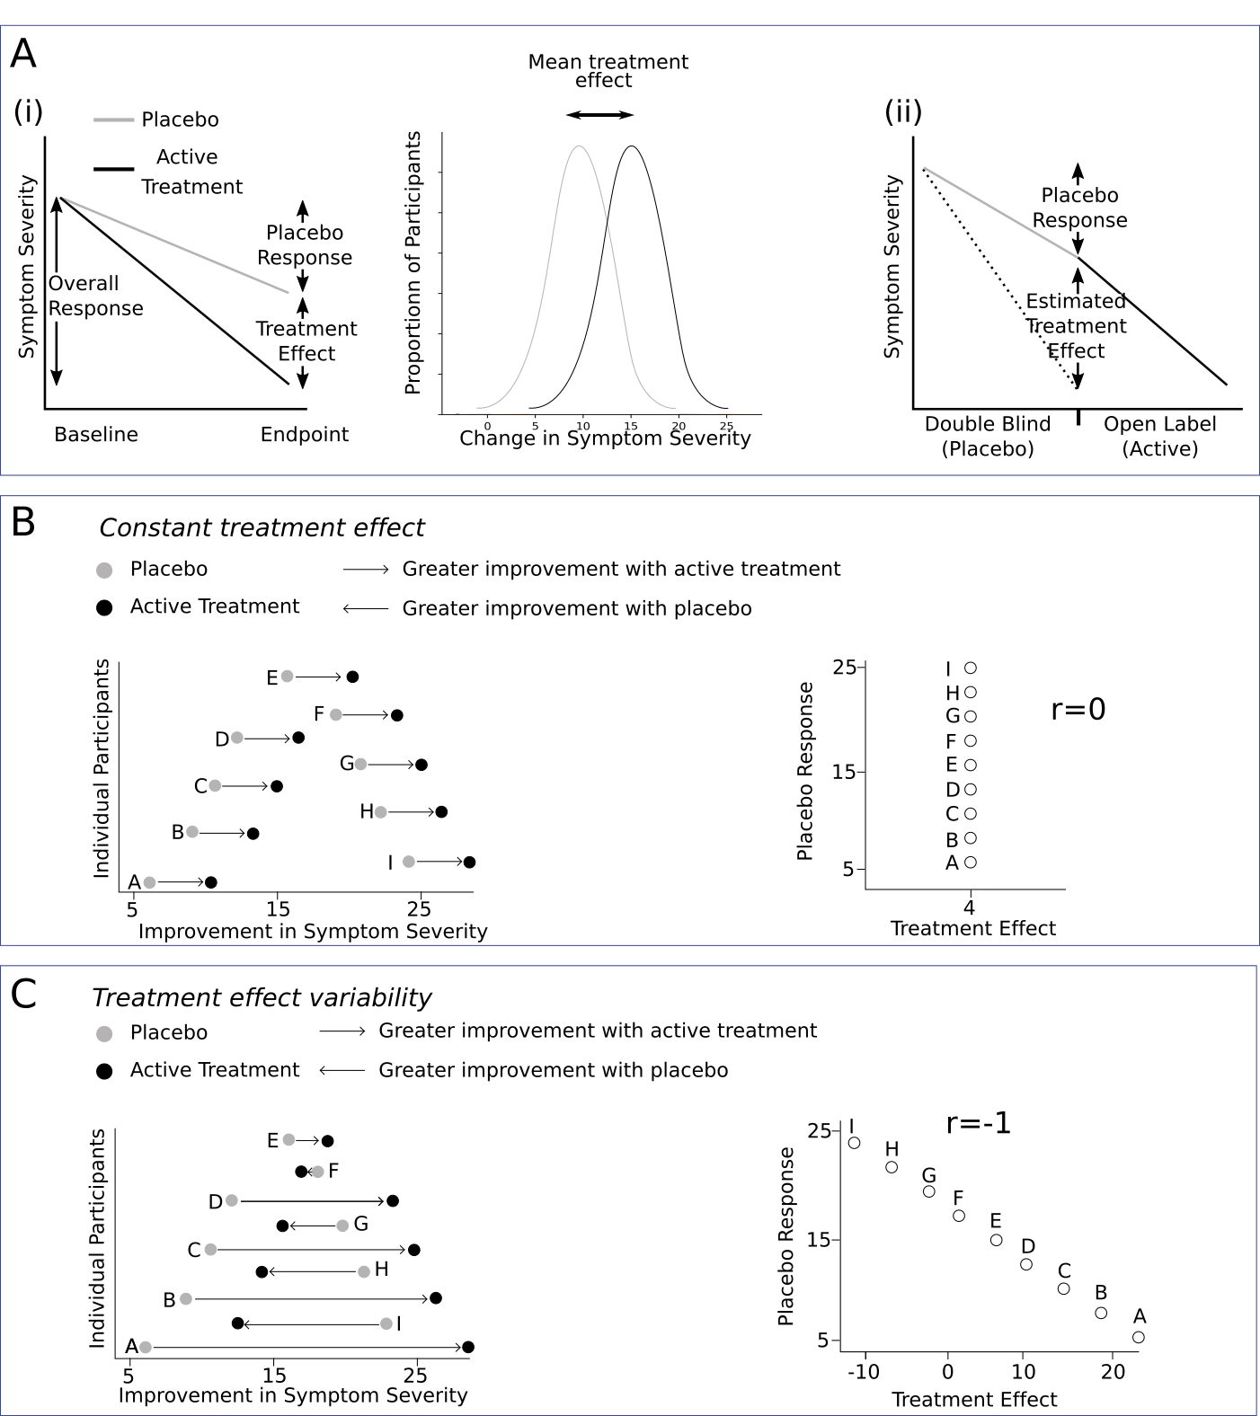

eFigure 1. Inferring the variability of treatment effects

- (i) For a simple trial of parallel design, the average treatment effect can be estimated as the difference between mean outcome in placebo and mean outcome in active treatment. It is not possible, however, to directly determine the variability of individual treatment effects. (ii) Figure illustrates symptom change for a single participant initially receiving placebo followed by an open-label period of active treatment. Our ‘open label method’ estimation of treatment effects relies on the assumption that if this patient had taken drug in the double-blind period instead of placebo, the symptoms would change as indicated by the dashed line.

- The hypothetical case where for nine patients (A-I) we observe the outcomes in both treatment and placebo. Placebo response is illustrated by how far along the x-axis the grey marker is, while treatment effect is illustrated by the width of the line joining grey marker and black marker (if the black marker is to the right of the grey marker this indicates a net benefit of active treatment, if it is to the left a net detriment). In this case there is no correlation between the magnitude of placebo response and the magnitude of treatment effect, and the variability of placebo (grey markers) and active (black markers) arms is identical. We can see that as a result of these conditions (identical placebo and active variability, and no correlation between placebo and treatment effects) it follows that treatment effect heterogeneity is zero and all individuals receive an identical treatment effect (i.e. the width of all the lines joining grey and black markers are identical).

- It is possible that individuals with a greater placebo response may have a smaller medication-specific benefit, i.e. a negative correlation exists between placebo response and treatment effect. As in (B), both placebo and active treatment outcomes have the same variability at the group level. In this case, however, treatment effects and outcomes in placebo are negatively correlated at the patient level. One can see that in this case a negative correlation between placebo and treatment effects leads to marked treatment effect heterogeneity (i.e. the width of the lines joining grey and black markers varies between individuals.)

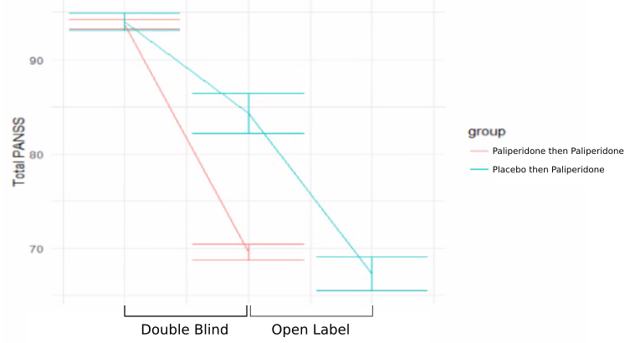
eFigure 2
Mean PANSS score at the end of the double blind period for patients that received active paliperidone (69.5, SD 19) was very similar to the mean PANSS scores at the end of the open label period for patients that initially received placebo (67.2, SD 19.9) (Independent sample t- test t=0.93, p = 0.34). This observation provides support for the assumptions behind the “open label” method described in our paper.

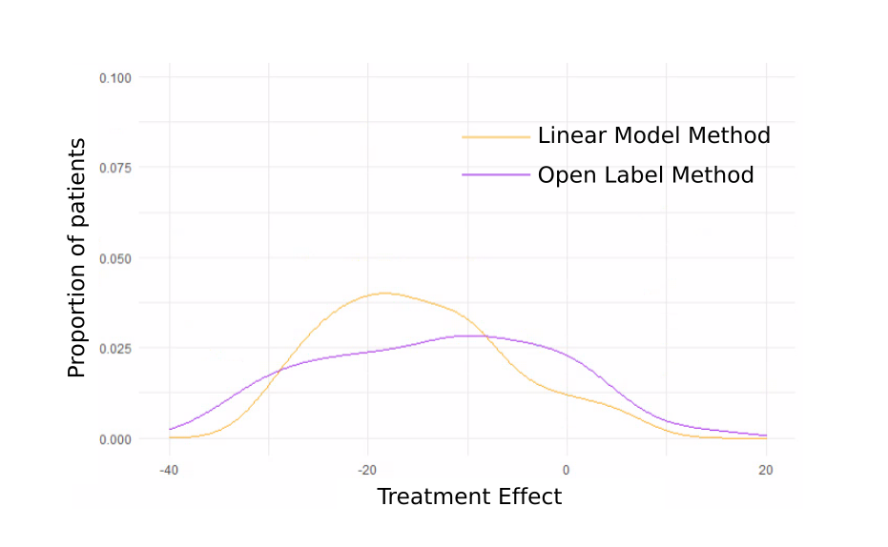
eFigure 3
Density plot of treatment effects within the individual patient data. Both methods of individual treatment effect estimation show clinically significant inter-individual differences.

PRISMA Checklist
Section/topic | # | Checklist item | Reported on page #
TITLE
Title | 1 | Identify the report as a systematic review, meta-analysis, or both. | 1
ABSTRACT
Structured summary | 2 | Provide a structured summary including, as applicable: background; objectives; data sources; study eligibility criteria, participants, and interventions; study appraisal and synthesis methods; results; limitations; conclusions and implications of key findings; systematic review registration number. | 3
INTRODUCTION
Rationale | 3 | Describe the rationale for the review in the context of what is already known. | 3-5
Objectives | 4 | Provide an explicit statement of questions being addressed with reference to participants, interventions, comparisons, outcomes, and study design (PICOS). | 5
METHODS
Protocol and registration | 5 | Indicate if a review protocol exists, if and where it can be accessed (e.g., Web address), and, if available, provide registration information including registration number. | 6
Eligibility criteria | 6 | Specify study characteristics (e.g., PICOS, length of follow-up) and report characteristics (e.g., years considered, language, publication status) used as criteria for eligibility, giving rationale. | 6
Information sources | 7 | Describe all information sources (e.g., databases with dates of coverage, contact with study authors to identify additional studies) in the search and date last searched. | 6-7
Search | 8 | Present full electronic search strategy for at least one database, including any limits used, such that it could be repeated. | 6, supplement
Study selection | 9 | State the process for selecting studies (i.e., screening, eligibility, included in systematic review, and, if applicable, included in the meta-analysis). | 6-7
Data collection process | 10 | Describe method of data extraction from reports (e.g., piloted forms, independently, in duplicate) and any processes for obtaining and confirming data from investigators. | 6-7
Data items | 11 | List and define all variables for which data were sought (e.g., PICOS, funding sources) and any assumptions and simplifications made. | 6-7
Risk of bias in individual studies | 12 | Describe methods used for assessing risk of bias of individual studies (including specification of whether this was done at the study or outcome level), and how this information is to be used in any data synthesis. | 7
Summary measures | 13 | State the principal summary measures (e.g., risk ratio, difference in means). | 7-8
Synthesis of results | 14 | Describe the methods of handling data and combining results of studies, if done, including measures of consistency (e.g., I²) for each meta-analysis. | 8-9

Section/topic | # | Checklist item | Reported on page #
Risk of bias across studies | 15 | Specify any assessment of risk of bias that may affect the cumulative evidence (e.g., publication bias, selective reporting within studies). | 7-10
Additional analyses | 16 | Describe methods of additional analyses (e.g., sensitivity or subgroup analyses, meta-regression), if done, indicating which were pre-specified. | 7-9
RESULTS
Study selection | 17 | Give numbers of studies screened, assessed for eligibility, and included in the review, with reasons for exclusions at each stage, ideally with a flow diagram. | 11, supplement
Study characteristics | 18 | For each study, present characteristics for which data were extracted (e.g., study size, PICOS, follow-up period) and provide the citations. | supplement
Risk of bias within studies | 19 | Present data on risk of bias of each study and, if available, any outcome level assessment (see item 12).
Results of individual studies | 20 | For all outcomes considered (benefits or harms), present, for each study: (a) simple summary data for each intervention group (b) effect estimates and confidence intervals, ideally with a forest plot. | 11-12
Synthesis of results | 21 | Present results of each meta-analysis done, including confidence intervals and measures of consistency. | 11-12
Risk of bias across studies | 22 | Present results of any assessment of risk of bias across studies (see Item 15). | 12
Additional analysis | 23 | Give results of additional analyses, if done (e.g., sensitivity or subgroup analyses, meta-regression [see Item 16]). | 12-14
DISCUSSION
Summary of evidence | 24 | Summarize the main findings including the strength of evidence for each main outcome; consider their relevance to key groups (e.g., healthcare providers, users, and policy makers). | 2,3,15
Limitations | 25 | Discuss limitations at study and outcome level (e.g., risk of bias), and at review-level (e.g., incomplete retrieval of identified research, reporting bias). | 16-17
Conclusions | 26 | Provide a general interpretation of the results in the context of other evidence, and implications for future research. | 2,3,17
FUNDING
Funding | 27 | Describe sources of funding for the systematic review and other support (e.g., supply of data); role of funders for the systematic review. | 18

References
1. Yale University Open Data Access (YODA) clinical trials database.
2. McCutcheon RA, Pillinger T, Mizuno Y, et al. The efficacy and heterogeneity of antipsychotic response in schizophrenia: A meta-analysis. Mol Psychiatry. 2021;26(4):1310-1320. doi:10.1038/s41380-019-0502-5
3. Winkelbeiner S, Leucht S, Kane JM, Homan P. Evaluation of Differences in Individual Treatment Response in Schizophrenia Spectrum Disorders: A Meta-analysis. JAMA Psychiatry. 2019;76(10):1063-1073. doi:10.1001/jamapsychiatry.2019.1530
4. Homan S, Muscat W, Joanlanne A, et al. Treatment effect variability in brain stimulation across psychiatric disorders: A meta-analysis of variance. Neurosci Biobehav Rev. 2021;124(October 2020):54-62. doi:10.1016/j.neubiorev.2020.11.033
5. Plöderl M, Hengartner MP. What are the chances for personalised treatment with antidepressants? Detection of patient-by-treatment interaction with a variance ratio meta-analysis. BMJ Open. 2019;9(12):34816. doi:10.1136/bmjopen-2019-034816
6. Volkmann A. On the Relationship between Treatment Effect Heterogeneity and the Variability Ratio Effect Size Statistic. 2020;(2019). http://arxiv.org/abs/2006.11848
7. Volkmann C, Volkmann A, Müller CA. On the treatment effect heterogeneity of antidepressants in major depression: A Bayesian meta-analysis and simulation study. PLoS One. 2020;15(11 November):1-22. doi:10.1371/journal.pone.0241497
8. Nakagawa S, Poulin R, Mengersen K, et al. Meta-analysis of variation: Ecological and evolutionary applications and beyond. Methods Ecol Evol. 2015;6(2):143-152. doi:10.1111/2041-210X.12309
9. Balduzzi S, Rücker G, Schwarzer G. How to perform a meta-analysis with R: A practical tutorial. Evid Based Ment Health. 2019;22(4):153-160. doi:10.1136/ebmental-2019-300117
10. Higgins JPT, Thompson SG. Quantifying heterogeneity in a meta-analysis. Stat Med. 2002;21(11):1539-1558. doi:10.1002/sim.1186

