# Elastic Redshift Deviation Analysis using CET Framework

This report summarizes the results of the analysis performed on the Pantheon+SH0ES supernova sample, with the goal of estimating deviations in luminosity distance (ΔD_L) as predicted by the Cosmic Elastic Theory (CET), using a new local density estimation protocol based on observed magnitudes.

## 1. Methodology

Local density for each supernova was estimated using a proxy for stellar mass derived from the observed magnitude (m_b_corr), assuming a mass-luminosity relation. A smoothing radius was applied depending on redshift, and nearby points were considered in case of missing data. Densities were normalized, and a logarithmic elastic stretching function was used:

ξ(ρ) = 1 + k · log(1 + ρ_norm), where k = 0.05

## 2. Results

The resulting deviation in luminosity distance (ΔD_L = D_L^ACMD - D_L^CET) was plotted against local density. Key patterns include:

• ΔD_L increases in low-density environments (subcritical regime).

• ΔD_L stabilizes in high-density regimes (saturation effect).

• Smooth transition across redshift, consistent with causal relaxation.

## 3. Visualization

Figure: Δ D_L vs Redshift across Density Regimes.

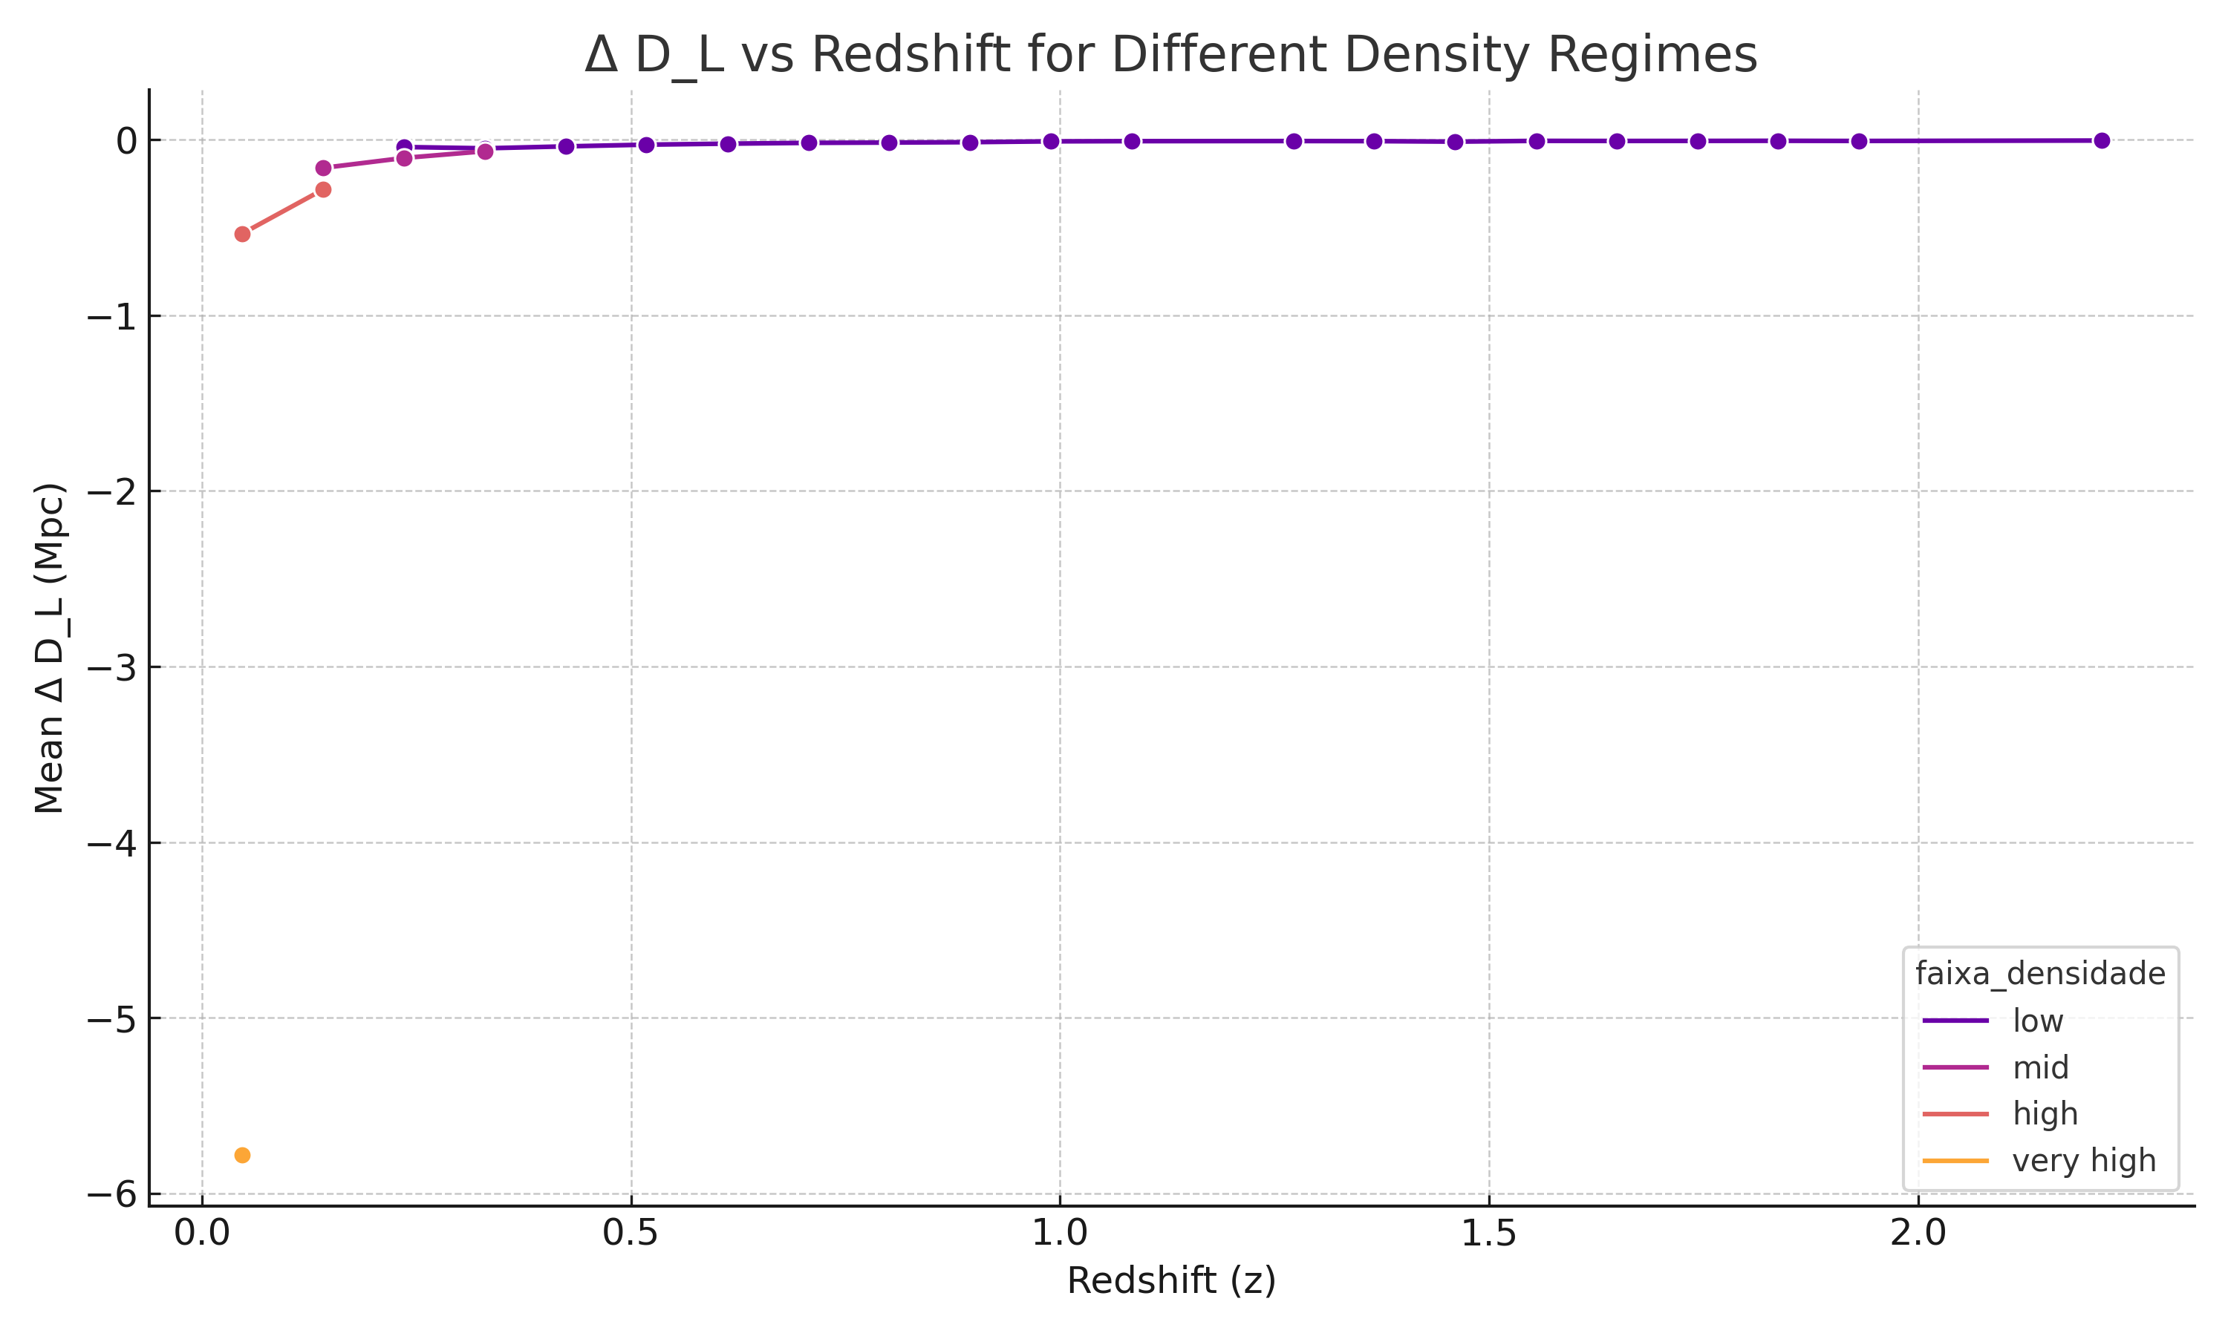

## 4. Files

• pantheon_com_faixas_densidade.xlsx — Full data with density classes.

• deltaDL_vs_z_por_densidade.png — Smoothed redshift deviation plot.

This analysis supports the hypothesis that causal relaxation leads to emergent isotropy through elastic redistribution, with observable differences in inferred distances across density environments.