Leonardo Rafting Site Plan

# Branding

Logo

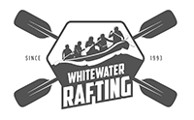

# Style Guide

Color Schema

Color palette URL: ***https://coolors.co/fbfcff-******605856-******1c6e8c-******274156***

primary-color: #1c6e8c

secondary-color: #274156

accent1-color: #fbfcff

accent2-color: #605856

Typography

heading-font: Roboto 100

text-font: Roboto 400