# UNIVERSIDAD DE LAS FUERZAS ARMADAS – ESPE

# Department of Computer Science

# PIM “PRODUCT INVENTORY MANAGER” - IEEE 830

# Patrocinadores de la revista

# Tutor: JORGE EDISON LASCANO

# GROUP 3

# MARTINEZ DARIAN

# MERINO JOSUE

# MORAN LEONCIO

# MORALES JOHAO

# MOSCOSO ALEXANDRA

# 2020

# Table

# Introduction 3

# Purpose…………………………………………………………………………………….... 3

# Scope……………………………………………………………………….....…………….. 3

# Involved Staff…………………………………………………………………………….…. 3

* 1. Definitions, acronyms y abbreviators……………………………………………………….. 4

# References ………………………………..………………………………………………… 5

# Resume……………………………………………………………………………………… 5

# General Description

# Product Perspective …………….…………………………………………………………... 6

# Product Functionality ………………………………………………………………………. 6

# User Characteristics ……………………………………………………………………….... 6

# Restrictions…………………………………….……………………………………………. 6

* 1. Assumptions and dependencies…………………………………………………………...… 7
  2. Predictable evolution of the system…………………………………………………………. 7

# Specific Requirements 8

# Introduction

* 1. **Purpose**

This system will be utilized for the administration and manage the inventory of a store, which is responsible to distribute pairs of shoes, the proposit of the program is drastically contribute to the organization of the business in a practical way, thus facilitating the process of purchasing, invoicing and registering an inventory.

* 1. **Scope**

The program called “PIM” Product Inventory Manager will be used, in a store managed by an organization that contains factors such as an inventory to keep an organized record of it.

The cashier staff, to invoice and select the types of payment, in a physical context in which all these processes are carried out in a way that hinders the fast and effective process, will manage a computer.

Cashier Application:

* Entry the system
* Manage the purchase
* Manage payment method
* Manage invoice registration

Manager Application:

* Manage Inventory
* Entry the system
* Manage Records
  1. **Involved Staff**

|  |  |
| --- | --- |
| **Name** | Darian Martinez |
| **Role** | Analyst, developer, tester, reviewer |
| **Professional Category** | Student of Software Engineering |
| **Responsibilities** | Review And Develop the code |
| **Contact information** | [dmmartinez3@espe.edu.ec](mailto:dmmartinez3@espe.edu.ec) |
| **Approbation** | Yes |

|  |  |
| --- | --- |
| **Name** | Leoncio Moran |
| **Role** | Analyst, reviewer |
| **Professional Category** | Student of Software Engineering |
| **Responsibilities** | Review, Analysist the code, documentation |
| **Contact information** | [lemoran3@espe.edu.ec](mailto:lemoran3@espe.edu.ec) |
| **Approbation** | Yes |

|  |  |
| --- | --- |
| **Name** | Josué Merino |
| **Role** | Analyst, developer, tester, project manager |
| **Professional Category** | Student of Software Engineering |
| **Responsibilities** | Review and develop the code, documentation and Leader of the project. |
| **Contact information** | [ejmerino@espe.edu.ec](mailto:ejmerino@espe.edu.ec) |
| **Approbation** | Yes |

|  |  |
| --- | --- |
| **Name** | Johao Morales |
| **Role** | Analyst, developer, reviewer |
| **Professional Category** | Student of Software Engineering |
| **Responsibilities** | Review and develop the code, documentation |
| **Contact Information** | [jamorales26@espe.edu.ec](mailto:jamorales26@espe.edu.ec) |
| **Approbation** | Yes |

|  |  |
| --- | --- |
| **Name** | Alexandra Moscoso |
| **Role** | Analyst, developer |
| **Professional Category** | Student of Software Engineering |
| **Responsibilities** | Review and develop the code, documentation |
| **Contact Information** | [lamoscoso1@espe.edu.ec](mailto:lamoscoso1@espe.edu.ec) |
| **Approbation** | Yes |

* 1. **Definitions, acronyms y abbreviators**

|  |  |
| --- | --- |
| ***Name*** | ***Description*** |
| **User** | Person that will use the system to manage process. |
| **PIM** | Product Inventory Manager |
| **ERS** | Software Requirements Specification |
| **RF** | Functional requirement |
| **RNF** | No functional requirement |
| **FTP** | File Transfer Protocol |

* 1. **References**

|  |  |  |  |
| --- | --- | --- | --- |
| **Title of Document** | **Route** | **Date** | **Reference** |
| Standard IEEE 830 | PDF | 22/10/2008 | IEEE |
| Software Requirements Specification | <http://www.qualitatis.org> | 12/04/2010 | Qualitatis.org |

* 1. **Resume**

The system was develop with the IDE NetBeans in focus Java, the Scrum life cycle is be utilized where is specified the sprints that develop each one of the contributors. As a group of work we will be focus in provide a system that set the tasks requested by the user, likewise developing the points that will contribute directly to the organization of an inventory of pairs of shoes where there will be correct and organized records of the purchase of the product.

A billing process will be carried out that allows us to easily select methods and payments and fill invoices in the corresponding way, the program will have maintenance if so warranted but options not specified in advance will be restricted, they will be fully complied with the requirements provided, with the care and respective analysis to meet the needs of the interested party in the system.

# General Description

* 1. **Product Perspective**

The system “PIM” is a product designed to work in physic environments, and the user in charge of manage it, must be related to the work environment for which it is intende.

Thus allowing to select options related to the sale and billing of the products offered, the administrator on the other hand will be able to manage the same options including the one related to inventory.

* 1. 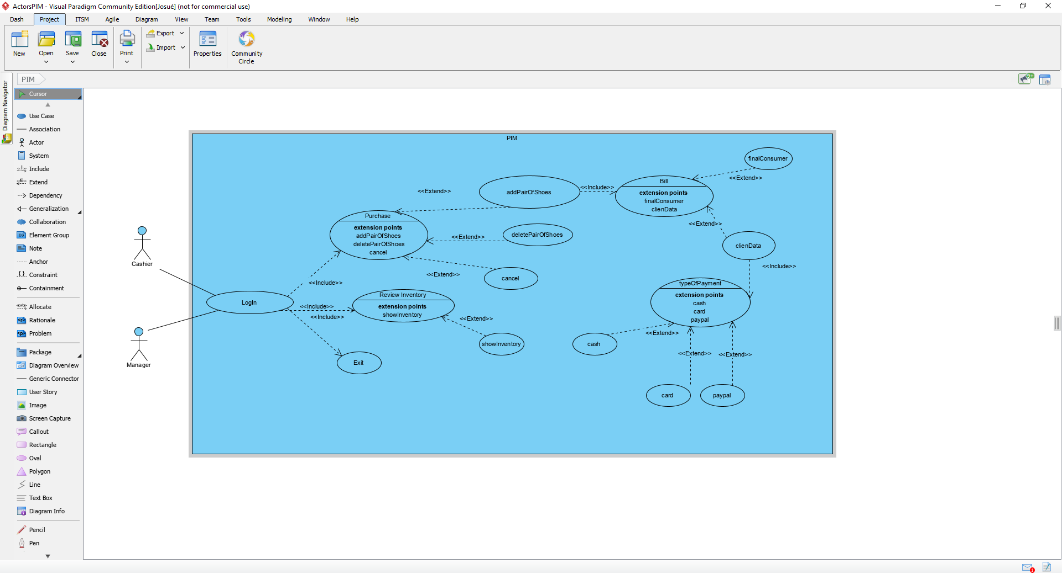**Product Functionality**
  2. **User characteristics**

|  |  |
| --- | --- |
| **Type of user** | Cashier |
| **Training** | Accountability |
| **Activities** | Control the system |

|  |  |
| --- | --- |
| **Type of user** | Manager |
| **Training** | Administration |
| **Activities** | Manage and view |

* 1. **Restrictions**
* Languages and technologies that is used: JAVA.
* The system has to run quickly.
* The system will be built as the client wants.
* The system has to be simple.

*.*

* 1. **Assumptions and dependencies**
* The requirments have to be stable
* Los equipos en los que se vaya a ejecutar el sistema deben cumplir los requisitos antes indicados para garantizar una ejecución correcta de la misma
* The equipment where the system will be run, have to meet the requirements indicated to guarantee a correct execution.
* It is assumed that users of the software must have knowledge and skills within the scope of their functions.
  1. **Predictable evolution of the system**

It is assumed to use basic servers for the use of the program but with the necessary capacity to run on one or more computers.

# 

# Specific Requirements

|  |  |
| --- | --- |
| **Name of the requirement:** | Develop the menu |
| **Characteristics:** | The principal menu will have with the options: purchase, review the inventory and exit. |
| **Description of the requirement:** | The system can deploy submenus depending the option selected in the principal menu |
| **Priority of the requirement:** High | |

|  |  |
| --- | --- |
| **Name of the requirement:** | Submenu of the purchase |
| **Characteristics:** | In this submenú will unfold options relationated to the product billing process. |
| **Description of the requirement:** | The system will allow to the user (cashier) add pair of shoes, delete pair of shoes and cancel the purchase. |
| **Priority of the requirement:** High | |

|  |  |
| --- | --- |
| **Name of the requirement:** | Billing process. |
| **Characteristics:** | The system will offer different types of invoice process. |
| **Description of the requirement:** | The system will allow choosing between making the invoice with data and sending it to the final consumer. |
| **No functional requirement** | The payment type menu option is displayed. |
| **Priority of the requirement:** High | |

|  |  |
| --- | --- |
| **Name of the requirement:** | Invoice with data |
| **Characteristics:** | The system must enter customer data and select their payment method |
| **Description of the requirement:** | The client's personal data will be requested to make the invoice and to select their payment methods. |
| **No functional requirement** | It will print, company name, invoice number, shoe pair ID, customer name, payment type, total price. |
| **Priority of the requirement:** High | |

|  |  |
| --- | --- |
| **Name of the requirement:** | Payment method |
| **Characteristics:** | The system will offer the customer to select their payment method. |
| **Description of the requirement:** | The options will be: PayPal, credit / debit card or cash |
| **Priority of the requirement:** High | |

|  |  |
| --- | --- |
| **Name of the requirement:** | Review inventory |
| **Characteristics:** | The system will subtract from the inventory products that have already been selected or taken. |
| **Description of the requirement:** | Thanks to the ID of the pair of shoes, an orderly inventory will be maintained |
| **Priority of the requirement:** High | |

|  |  |
| --- | --- |
| **Name of the requirement:** | Select brand |
| **Characteristics:** | The system will assign a brand and an ID to make billing easier and to carry a more ordered inventory |
| **Description of the requirement:** | Thanks to this, the warehouse will be able to better order its brands and consequently its inventory. |
| **Priority of the requirement:** High | |

|  |  |
| --- | --- |
| **Name of the requirement::** | Exit |
| **Characteristics:** | This option will be to exit the system. |
| **Description of the requirement:** | By selecting the exit option the system ends its operation |
| **Priority of the requirement:** High | |