Honey Bee Colonies Impacted by Varroa, American Fouldbrood and Global Warming

Edward Cruz, Jr, Leonel G. Salazar, Amelia Tristan, Mojisola Popoola

2024-08-01

The structure below is one possible setup for a data analysis project (including the course project). For a manuscript, adjust as needed. You don’t need to have exactly these sections, but the content covering those sections should be addressed.

This uses MS Word as output format. [See here](https://quarto.org/docs/output-formats/ms-word.html) for more information. You can switch to other formats, like html or pdf. See [the Quarto documentation](https://quarto.org/) for other formats.

Warning: package 'here' was built under R version 4.3.3

Warning: package 'ggplot2' was built under R version 4.3.3

Warning: package 'dplyr' was built under R version 4.3.3

Warning: package 'scales' was built under R version 4.3.2

# 1. Summary/Abstract

Group Ten is pursuing the historical data collected by various public agencies to determine if the impact of Varroa, American Foulbrood, and global warming has demonstrated an increase in hive losses across the United States and Texas. The research will be accomplished using data sets derived from the agencies National Agricultural Statistics Service, Agricultural Statistics Board, and United States Department of Agriculture (USDA). Data sets containing several years of hive losses based on varroa and bacterium losses including recent possible environmental thermal global warming. A visualization of outcomes using R demonstrating and validating possible detrimental effects on honeybee colonies in the United States and Texas wrought by the negative impact of mites, bacterium, and global warming that will affect honey production and inevitably impact food production.

# 2. Introduction

### 2.0.1 Composition of Honey

The first image is a pie chart that illustrates the composition of honey by percentage. The main components are:

* **Fructose**: 38.5%
* **Glucose**: 31%
* **Water**: 17.1%
* **Maltose**: 7.2%
* **Other components**:
  + Sucrose: 1.5%
  + Minerals, Vitamins, Enzymes: 0.5%
  + Trisaccharides, Carbohydrates: 4.2%

This composition indicates that honey is primarily made up of sugars, specifically fructose and glucose, with water being the third major component. The presence of minerals, vitamins, and enzymes, though in smaller amounts, adds nutritional value to honey. This detailed breakdown underscores honey’s role as a natural sweetener with additional health benefits beyond its primary carbohydrate content.

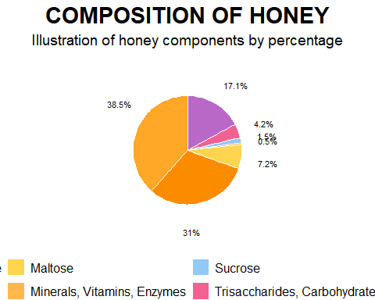

Honeybees have been nature’s pollinators for centuries, with documented relationships with humans dating back to ancient Egyptians and Hindus. Historically, humans have maintained beehives, using honey as medicine in cultures such as the Egyptians, Assyrians, Chinese, Greeks, and Romans. The natural antibacterial properties of honey made it a valuable treatment for wounds, preventing infection, a practice used by Romans and Russians during World War I. Honeybees and other pollinators are critical for food production and nutritional security, yet bees face a variety of survival challenges. Currently, Varroa mites impact bee colonies and this mite infestation, a tiny red-brown parasite that can live on adult honeybees and reproduce on larvae and pupae in the developing brood. Another major threat is American Foulbrood Disease (AFB), caused by the bacterium Paenibacillus larvae. A disease that is fatal to honeybee larvae and found worldwide. The only effective control measure is to incinerate and destroy infected hives and live bees mitigating the infectious spread to other colonies. In addition, the exploration of climate change impacting honeybee colony losses has only recently been researched. While there are correlations between higher winter temperatures and greater colony losses, the effects of warmer autumn and winter temperatures on colony population dynamics and age structure as potential causes of reduced colony survival have not yet been fully investigated.Index Catalog // USDA Economics, Statistics and Market Information System. (n.d.-b). Index Catalog // USDA Economics, Statistics and Market Information System. (n.d.-a). , USDA - National Agricultural Statistics Service - Surveys - honey bee surveys and reports. (n.d.).  
<https://usda.library.cornell.edu/catalog?f%5Bkeywords_sim%5D%5B%5D=honey+bees&locale=en> <https://www.nass.usda.gov/Surveys/Guide_to_NASS_Surveys/Bee_and_Honey/>

### 2.0.2 Spread of Varroa Mites

The second image is a map illustrating the spread of Varroa mites in the United States from 1986 to 1995. The map uses different colors to represent the year of the first appearance of Varroa mites in each state:

* **1986 - 1987**: Red
* **1988 - 1989**: Yellow
* **1990 - 1991**: Green
* **1992 - 1993**: Blue
* **1994 - 1995**: Grey
* **NA**: States where data is not available

The map reveals the progressive spread of Varroa mites from the mid-1980s to the mid-1990s, affecting bee colonies across the country. The earliest appearances were concentrated in specific regions and gradually spread to more states over time. This visual representation highlights the increasing geographical distribution of Varroa mites and underscores the growing challenge they pose to beekeeping and agricultural industries in the United States.

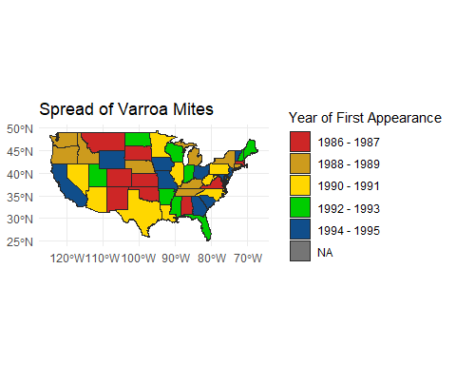

Written By:sdns6mchl4. (2016, February 24). Varroa mite spread in the United States. Beesource Beekeeping Forums. https://www.beesource.com/threads/varroa-mite-spread-in-the-united-states.365462/ ## General Background Information

**Uncapped Honey Floresville,Texas Hive**

**Capped Honey one Month Later same hive frame- Italian bees Floresville, Texas**

## 2.1 Description of data and data source

Bee colonies maintained by beekeepers are considered livestock by the USDA due to their ability to produce honey, a consumable food item, and their essential role in assisting farmers with pollination crop seasons. Given the importance of bee colonies in agriculture, it was logical to source data from the following two authoritative websites: 1. USDA National Agricultural Statistics Service (NASS): This site provides comprehensive agricultural data, including statistics on honey production and colony health. 2. Bee Informed Partnership: This site offers detailed insights and research on bee colony management and health, contributing valuable information on the status and trends of bee populations. Index Catalog // USDA Economics, Statistics and Market Information System. (n.d.-a). https://usda.library.cornell.edu/catalog?f%5Bkeywords_sim%5D%5B%5D=honey+bees&locale=en  
USDA - National Agricultural Statistics Service - Surveys - honey bee surveys and reports. (n.d.). https://www.nass.usda.gov/Surveys/Guide_to_NASS_Surveys/Bee_and_Honey/

## 2.2 Questions/Hypotheses to be addressed

Hypothesis: “The negative impacts of mites, bacterium, and global warming have detrimental effects on honeybee colonies in the United States and Texas, which in turn will lead to a decline in honey production and negatively impact food production.” This hypothesis can be tested and validated through a visualization of outcomes using R, demonstrating the relationship between these factors and their effects on honeybee colonies.

**Bacterium Infection Foul Brood.**

**Dead bees resulting from extreme heat found in hive**.

To cite other work (important everywhere, but likely happens first in introduction), make sure your references are in the bibtex file specified in the YAML header above and have the right bibtex key. Then you can include like this:

Examples of reproducible research projects can for instance be found in (**mckay2020?**; **mckay2020a?**).

# 3. Methods

*Describe your methods. That should describe the data, the cleaning processes, and the analysis approaches. You might want to provide a shorter description here and all the details in the supplement.*

## 3.1 Schematic of workflow

Sometimes you might want to show a schematic diagram/figure that was not created with code (if you can do it with code, do it). **?@fig-schematic** is an example of some - completely random/unrelated - schematic that was generated with Biorender. We store those figures in the assets folder.

#knitr::include_graphics(here("assets","antigen-recognition.png"))

## 3.2 Data aquisition

We got our data from the United States Department of Agriculture (USDA).

## 3.3 Data import and cleaning

We decided to clean out our data from a few different datasets. We had to remove blank spaces and columns that were not pertinent to our analysis. We then filtered out other observations that did not directly deal with the data we are exploring. We are looking for cause of death to bee colonies and how they are affected by mites and climate change so we wanted to single out data that represented the losses so we can explore the different states by year and determine how the colonies were affected.

library(readxl)  
library(tidyverse)

Warning: package 'tidyr' was built under R version 4.3.3

Warning: package 'stringr' was built under R version 4.3.2

Warning: package 'lubridate' was built under R version 4.3.2

── Attaching core tidyverse packages ──────────────────────── tidyverse 2.0.0 ──  
✔ forcats 1.0.0 ✔ stringr 1.5.1  
✔ lubridate 1.9.3 ✔ tibble 3.2.1  
✔ purrr 1.0.2 ✔ tidyr 1.3.1  
✔ readr 2.1.4   
── Conflicts ────────────────────────────────────────── tidyverse_conflicts() ──  
✖ readr::col_factor() masks scales::col_factor()  
✖ purrr::discard() masks scales::discard()  
✖ dplyr::filter() masks stats::filter()  
✖ dplyr::lag() masks stats::lag()  
✖ purrr::map() masks maps::map()  
ℹ Use the conflicted package (<http://conflicted.r-lib.org/>) to force all conflicts to become errors

library(ggplot2)  
library(knitr)

library(here)  
  
here()

[1] "C:/Users/Leonel/Desktop/MSDA/MS Data Analytics/Current Class/DA 6833/Practicum 2 Github/leonelsalazar-P2-portfolio/starter-analysis-exercise"

# Read the CSV file  
data <- read.csv(here("Databystate.csv"))

# Select all columns except 3, 6, and 9  
Data_Clean <- dplyr::select(data, -c(3, 6, 9))

# Output cleaned data file to a csv file.  
  
write.csv(Data_Clean, "Data_Clean.csv", row.names = FALSE)  
  
#write.csv(Data_Clean, "C:/Users/ecruz/OneDrive/Documents/UTSA - Data Science Program/Semester Classes/Practicum II Repository/P2-Practicum-II-Portfolio-EdwardCruz/docs/Databystate_Clean.csv")

# Assuming your data frame is named "data"  
  
# Filter for rows where "Loss" or "Deadout" is present in any column (case-insensitive)  
  
library(stringr) # Load stringr package for regular expressions  
data_filtered <- Data_Clean[rowSums(sapply(data, grepl, pattern = c("Loss"), ignore.case = TRUE)) > 0, ]

# Output cleaned data file to a csv file.  
  
write.csv(data_filtered, "Data_Filtered.csv", row.names = FALSE)  
  
#write.csv(Data_Clean, "C:/Users/ecruz/OneDrive/Documents/UTSA - Data Science Program/Semester Classes/Practicum II Repository/P2-Practicum-II-Portfolio-EdwardCruz/docs/Databystate_Filtered.csv")

# View data str to see what class they are.  
  
str(data_filtered)

'data.frame': 718 obs. of 6 variables:  
 $ Year : int 2017 2017 2017 2017 2017 2017 2017 2017 2017 2017 ...  
 $ Period : chr "JAN THRU MAR" "JAN THRU MAR" "JAN THRU MAR" "JAN THRU MAR" ...  
 $ State : chr "ALABAMA" "ARIZONA" "ARKANSAS" "CALIFORNIA" ...  
 $ State.ANSI: int 1 4 5 6 8 9 12 13 15 16 ...  
 $ Data.Item : chr "LOSS, COLONY COLLAPSE DISORDER" "LOSS, COLONY COLLAPSE DISORDER" "LOSS, COLONY COLLAPSE DISORDER" "LOSS, COLONY COLLAPSE DISORDER" ...  
 $ Value : chr "250" "2,600" "180" "19,000" ...

str(data_filtered)

'data.frame': 718 obs. of 6 variables:  
 $ Year : int 2017 2017 2017 2017 2017 2017 2017 2017 2017 2017 ...  
 $ Period : chr "JAN THRU MAR" "JAN THRU MAR" "JAN THRU MAR" "JAN THRU MAR" ...  
 $ State : chr "ALABAMA" "ARIZONA" "ARKANSAS" "CALIFORNIA" ...  
 $ State.ANSI: int 1 4 5 6 8 9 12 13 15 16 ...  
 $ Data.Item : chr "LOSS, COLONY COLLAPSE DISORDER" "LOSS, COLONY COLLAPSE DISORDER" "LOSS, COLONY COLLAPSE DISORDER" "LOSS, COLONY COLLAPSE DISORDER" ...  
 $ Value : chr "250" "2,600" "180" "19,000" ...

# Load the dataset  
data_filtered <- read.csv(here::here("Data_Filtered.csv"), stringsAsFactors = FALSE)  
  
# Convert 'Value' to numeric  
data_filtered$Value <- as.numeric(gsub(",", "", data_filtered$Value))  
  
# Handle missing values by replacing NAs with the median value  
data_filtered$Value[is.na(data_filtered$Value)] <- median(data_filtered$Value, na.rm = TRUE)  
  
# Boxplot of Value by Year and Data.Item  
ggplot(data_filtered, aes(x = factor(Year), y = Value, fill = Data.Item)) +  
 geom_boxplot() +  
 theme(axis.text.x = element_text(angle = 45, hjust = 1)) +  
 scale_y_continuous(labels = comma) +  
 labs(title = "Boxplot of Value by Year and Data.Item", x = "Year", y = "Value") +  
 theme_minimal()

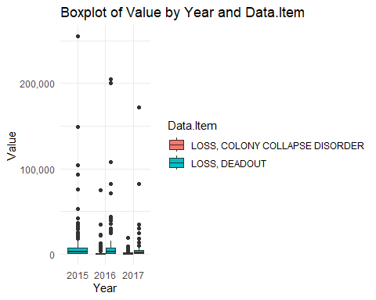

# Scatterplot of Value by State.ANSI  
ggplot(data_filtered, aes(x = State.ANSI, y = Value, color = factor(Year))) +  
 geom_point() +  
 labs(title = "Scatterplot of Value by State.ANSI", x = "State.ANSI", y = "Value") +  
 theme_minimal()

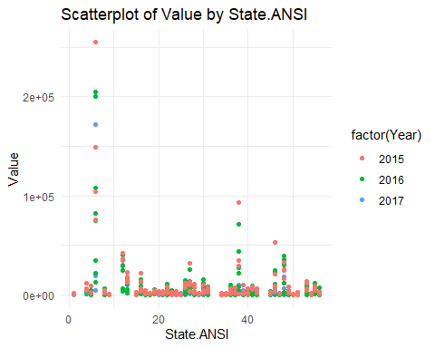

# Load necessary library  
library(scales)  
  
  
# Assuming data_filtered is already loaded and has the required columns  
  
# Create the plot  
p <- ggplot(data_filtered, aes(x = Period, y = Value, fill = Data.Item)) +  
 geom_boxplot() +  
 theme(axis.text.x = element_text(angle = 45, hjust = 1)) +  
 scale_y_continuous(labels = comma) +  
 labs(title = "Boxplot of Value by Period and Data.Item", x = "Period", y = "Value")  
  
# Print the plot  
print(p)

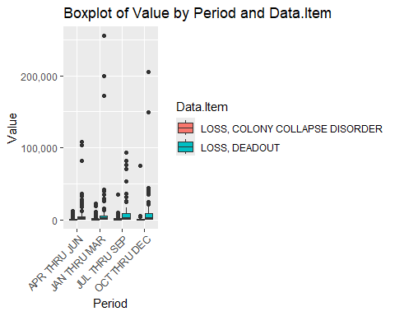

************** Leo provided additional code below and works perfectly********************

# Load necessary libraries  
library(ggplot2)  
library(dplyr)  
library(tidyr)  
library(reshape2)

Warning: package 'reshape2' was built under R version 4.3.3

Attaching package: 'reshape2'

The following object is masked from 'package:tidyr':  
  
 smiths

library(cluster)

Attaching package: 'cluster'

The following object is masked from 'package:maps':  
  
 votes.repub

library(car)

Loading required package: carData

Attaching package: 'car'

The following object is masked from 'package:purrr':  
  
 some

The following object is masked from 'package:dplyr':  
  
 recode

library(factoextra)

Warning: package 'factoextra' was built under R version 4.3.3

Welcome! Want to learn more? See two factoextra-related books at https://goo.gl/ve3WBa

library(rpart)  
library(rpart.plot)

Warning: package 'rpart.plot' was built under R version 4.3.3

library(randomForest)

Warning: package 'randomForest' was built under R version 4.3.3

randomForest 4.7-1.1

Type rfNews() to see new features/changes/bug fixes.

Attaching package: 'randomForest'

The following object is masked from 'package:dplyr':  
  
 combine

The following object is masked from 'package:ggplot2':  
  
 margin

library(e1071)

Warning: package 'e1071' was built under R version 4.3.3

# Load your dataset  
# Assuming your data frame is named 'data_hcny'  
  
data_hcny <- read.csv(here("hcny_CleanDraft.csv"))  
  
  
data_clean <- na.omit(data_hcny)

# Descriptive Statistics  
print("Descriptive Statistics:")

[1] "Descriptive Statistics:"

summary(data_clean)

state varroa_mites other_pests disease   
 Length:11 Min. : 8.00 Min. : 1.70 Min. : 0.100   
 Class :character 1st Qu.:13.45 1st Qu.: 3.20 1st Qu.: 0.750   
 Mode :character Median :26.80 Median : 6.40 Median : 1.000   
 Mean :32.41 Mean :11.55 Mean : 6.718   
 3rd Qu.:48.85 3rd Qu.:11.85 3rd Qu.: 4.600   
 Max. :67.20 Max. :42.30 Max. :47.800   
 pesticides other unknown   
 Min. : 0.50 Min. : 0.50 Min. : 1.100   
 1st Qu.: 1.70 1st Qu.: 1.05 1st Qu.: 2.900   
 Median : 5.70 Median : 3.40 Median : 4.400   
 Mean :10.34 Mean :10.51 Mean : 8.718   
 3rd Qu.:11.30 3rd Qu.:11.35 3rd Qu.: 8.100   
 Max. :49.20 Max. :48.10 Max. :46.800

# Visualizations  
  
# Bar Plot for varroa_mites by State  
ggplot(data_clean, aes(x = state, y = varroa_mites)) +  
 geom_bar(stat = "identity") +  
 theme(axis.text.x = element_text(angle = 45, hjust = 1)) +  
 labs(title = "Varroa Mites by State", y = "Percentage", x = "State")

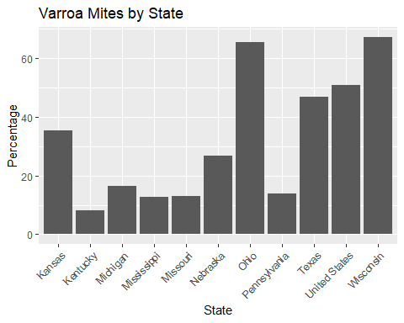

# Stacked Bar Plot  
data_long <- data_clean %>%  
 gather(key = "factor", value = "percentage", -state)  
  
ggplot(data_long, aes(x = state, y = percentage, fill = factor)) +  
 geom_bar(stat = "identity") +  
 theme(axis.text.x = element_text(angle = 45, hjust = 1)) +  
 labs(title = "Factors Affecting Bees by State", y = "Percentage", x = "State")

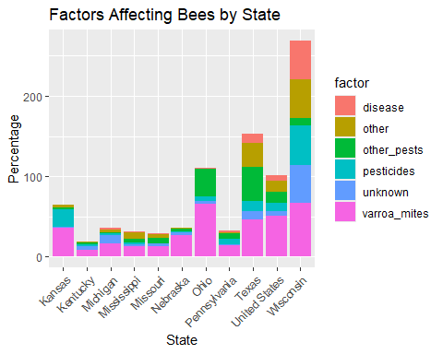

# Heatmap  
data_melt <- melt(data_clean, id.vars = "state")  
  
ggplot(data_melt, aes(x = variable, y = state, fill = value)) +  
 geom_tile() +  
 scale_fill_gradient(low = "white", high = "red") +  
 theme(axis.text.x = element_text(angle = 45, hjust = 1)) +  
 labs(title = "Heatmap of Factors Affecting Bees", y = "State", x = "Factor")

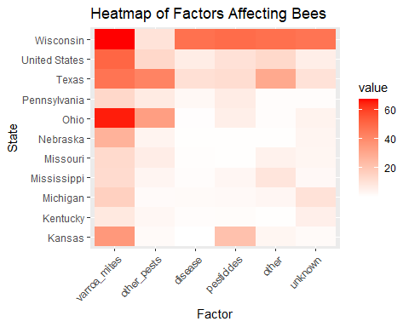

# Pie Chart for the United States  
us_data <- data_clean %>%  
 filter(state == "United States") %>%  
 dplyr::select(-state) %>%  
 gather(key = "factor", value = "percentage")  
  
ggplot(us_data, aes(x = "", y = percentage, fill = factor)) +  
 geom_bar(width = 1, stat = "identity") +  
 coord_polar("y") +  
 theme_void() +  
 labs(title = "Distribution of Factors Affecting Bees in the United States")

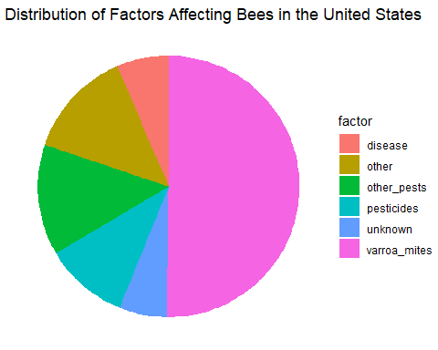

# Correlation Analysis  
cor_data <- cor(data_clean[,-1])  
print("Correlation Matrix:")

[1] "Correlation Matrix:"

print(cor_data)

varroa_mites other_pests disease pesticides other unknown  
varroa_mites 1.0000000 0.62115999 0.5907042 0.65228365 0.6085037 0.55340334  
other_pests 0.6211600 1.00000000 0.1180091 0.06810399 0.3449221 0.05806591  
disease 0.5907042 0.11800909 1.0000000 0.90369098 0.9194785 0.97833233  
pesticides 0.6522836 0.06810399 0.9036910 1.00000000 0.8235853 0.86362322  
other 0.6085037 0.34492207 0.9194785 0.82358532 1.0000000 0.86993151  
unknown 0.5534033 0.05806591 0.9783323 0.86362322 0.8699315 1.00000000

# Assumption Checks for Descriptive Analysis  
print("Assumption Checks:")

[1] "Assumption Checks:"

# Normality check  
shapiro_results <- lapply(data_clean[-1], function(column) shapiro.test(column))  
print("Shapiro-Wilk Test for Normality:")

[1] "Shapiro-Wilk Test for Normality:"

print(shapiro_results)

$varroa_mites  
  
 Shapiro-Wilk normality test  
  
data: column  
W = 0.87839, p-value = 0.09925  
  
  
$other_pests  
  
 Shapiro-Wilk normality test  
  
data: column  
W = 0.72499, p-value = 0.0009831  
  
  
$disease  
  
 Shapiro-Wilk normality test  
  
data: column  
W = 0.51395, p-value = 2.235e-06  
  
  
$pesticides  
  
 Shapiro-Wilk normality test  
  
data: column  
W = 0.70512, p-value = 0.0005444  
  
  
$other  
  
 Shapiro-Wilk normality test  
  
data: column  
W = 0.70797, p-value = 0.0005924  
  
  
$unknown  
  
 Shapiro-Wilk normality test  
  
data: column  
W = 0.55542, p-value = 7.156e-06

# Homogeneity of variances  
  
levene_results <- leveneTest(varroa_mites ~ state, data = data_clean)

Warning in leveneTest.default(y = y, group = group, ...): group coerced to  
factor.

print("Levene's Test for Homogeneity of Variances:")

[1] "Levene's Test for Homogeneity of Variances:"

print(levene_results)

Levene's Test for Homogeneity of Variance (center = median)  
 Df F value Pr(>F)  
group 10 NaN NaN  
 0

# Cluster Analysis  
data_cluster <- data_clean %>%  
 filter(state != "United States") %>%  
 dplyr::select(-state)  
  
hc <- hclust(dist(data_cluster), method = "complete")  
plot(hc, labels = data_clean$state[data_clean$state != "United States"], main = "Hierarchical Clustering of States")

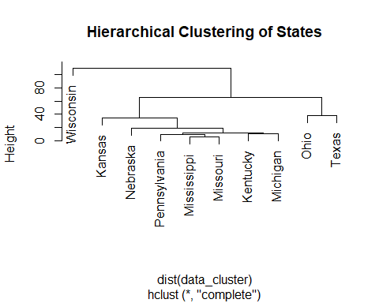

# Principal Component Analysis (PCA)  
data_pca <- data_clean %>%  
 filter(state != "United States") %>%  
 dplyr::select(-state) %>%  
 scale()

pca_result <- prcomp(data_pca, center = TRUE, scale. = TRUE)  
summary(pca_result)

Importance of components:  
 PC1 PC2 PC3 PC4 PC5 PC6  
Standard deviation 2.0647 1.1246 0.5666 0.34369 0.15432 0.09672  
Proportion of Variance 0.7105 0.2108 0.0535 0.01969 0.00397 0.00156  
Cumulative Proportion 0.7105 0.9213 0.9748 0.99447 0.99844 1.00000

fviz_pca_var(pca_result, col.var = "contrib", gradient.cols = c("#00AFBB", "#E7B800", "#FC4E07"))

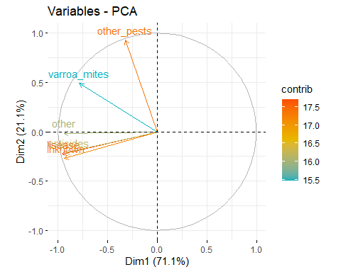

# Support Vector Machine (SVM)  
svm_model <- svm(varroa_mites ~ other_pests + disease + pesticides + other + unknown, data = data_clean)  
summary(svm_model)

Call:  
svm(formula = varroa_mites ~ other_pests + disease + pesticides +   
 other + unknown, data = data_clean)  
  
  
Parameters:  
 SVM-Type: eps-regression   
 SVM-Kernel: radial   
 cost: 1   
 gamma: 0.2   
 epsilon: 0.1   
  
  
Number of Support Vectors: 10

# Assuming predictions and data_clean$varroa_mites are already created  
  
# Example data  
data_clean <- data.frame(  
 varroa_mites = c(5, 10, 15, 20),  
 other_variable = c(2, 4, 6, 8)  
)  
  
# Fit a linear model  
model <- lm(varroa_mites ~ other_variable, data = data_clean)  
  
# Generate predictions  
predictions <- predict(model, newdata = data_clean)  
  
  
# Plot the data  
plot(predictions, data_clean$varroa_mites,   
 xlab = "Predictions",   
 ylab = "Varroa Mites",   
 main = "Predictions vs Varroa Mites",  
 las = 1, # makes y-axis labels horizontal  
 cex.lab = 1.2, # increases axis labels size  
 cex.axis = 1.2) # increases tick labels size

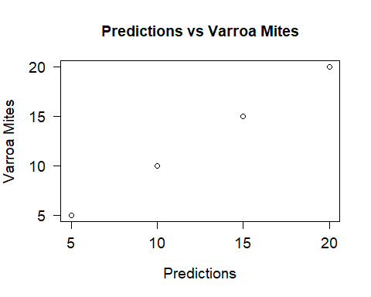

# Write the cleaned data to a new CSV file  
  
  
# Assuming your dataset is named data_hcny  
data_hcny_clean <- data_hcny %>% drop_na()  
  
  
write.csv(data_hcny_clean, here("hcnydata_cleaned.csv"), row.names = FALSE)

Varroa Mite

## 3.4 Statistical analysis

*Explain anything related to your statistical analyses.*

# 4. Results

**Texas Bee gathering pollen from natural Texas foliage**

## 4.1 Exploratory/Descriptive analysis

*Use a combination of text/tables/figures to explore and describe your data. Show the most important descriptive results here. Additional ones should go in the supplement. Even more can be in the R and Quarto files that are part of your project.*

**?@tbl-summarytable** shows a summary of the data.

Note the loading of the data providing a **relative** path using the ../../ notation. (Two dots means a folder up). You never want to specify an **absolute** path like C:\ahandel\myproject\results\ because if you share this with someone, it won’t work for them since they don’t have that path. You can also use the here R package to create paths. See examples of that below. I generally recommend the here package.

# 5. Discussion

## 5.1 Summary and Interpretation

*Summarize what you did, what you found and what it means.*

## 5.2 Strengths and Limitations

*Discuss what you perceive as strengths and limitations of your analysis.*

## 5.3 Conclusions

*What are the main take-home messages?*

*Include citations in your Rmd file using bibtex, the list of references will automatically be placed at the end*

This paper (**leek2015?**) discusses types of analyses.

These papers (**mckay2020?**; **mckay2020a?**) are good examples of papers published using a fully reproducible setup similar to the one shown in this template.

Note that this cited reference will show up at the end of the document, the reference formatting is determined by the CSL file specified in the YAML header. Many more style files for almost any journal [are available](https://www.zotero.org/styles). You also specify the location of your bibtex reference file in the YAML. You can call your reference file anything you like.

# 6. References