PowerCore ERP — Operational Demo
Modular system designed to optimize operational processes, inventory management, and administrative control.

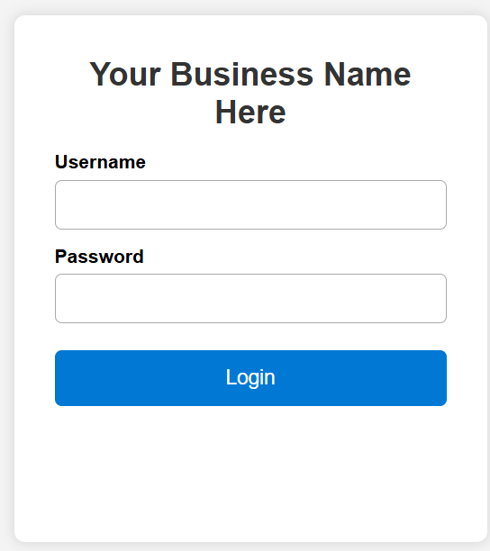

Designed and developed by Leonel Tapia
Denver, CO — 2026
Personal Project Demo — For Review Only

Executive Overview

PowerCore ERP is a modular, lightweight, and operations‑focused system designed to improve daily workflows, inventory visibility, and administrative control. This demo showcases the core structure and interface of the platform, highlighting its simplicity, clarity, and operational efficiency.

Key Objectives of the System:
• Provide a clean and intuitive interface for operational staff.
• Improve accuracy and visibility of inventory and material movement.
• Reduce manual processes through structured digital workflows.
• Offer a scalable foundation for future modules and integrations.

About This Demo:
This document presents a functional prototype developed independently as a personal project. The purpose is to demonstrate interface design, workflow structure, and system logic.

This overview page summarizes the intent and scope of the demo before presenting screenshots of the main menu and modules.

Main Menu — System Navigation Overview
The Main Menu serves as the central navigation hub of PowerCore ERP. It provides quick access to the core operational modules and is designed to keep the interface simple, intuitive, and efficient for daily use.
Key Design Principles:
• Clear and minimal layout to reduce cognitive load.
• Direct access to primary modules without unnecessary steps.
• Consistent visual structure across all sections of the system.
• Focus on operational clarity rather than decorative elements.
What This Page Shows:
The screenshot below represents the initial landing view after login. From here, users can navigate to modules such as Inventory, Purchase Orders, Material Movement, and future operational components.
This menu structure is intentionally lightweight to support fast adoption and ease of use for operational staff.
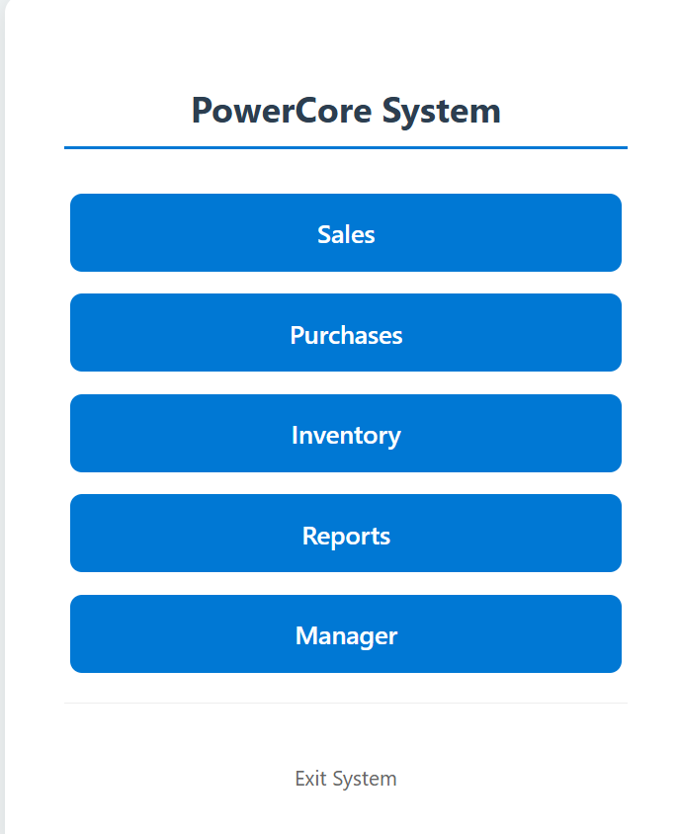
Inventory Module — Key Screens Overview
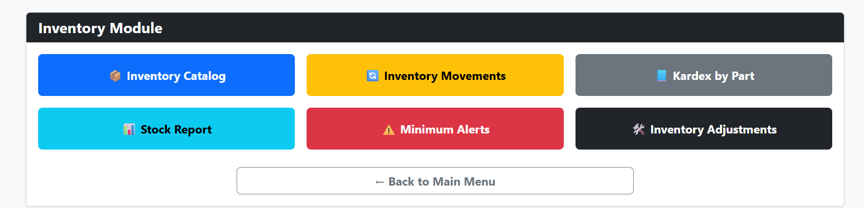

Vendor Management — Operational View
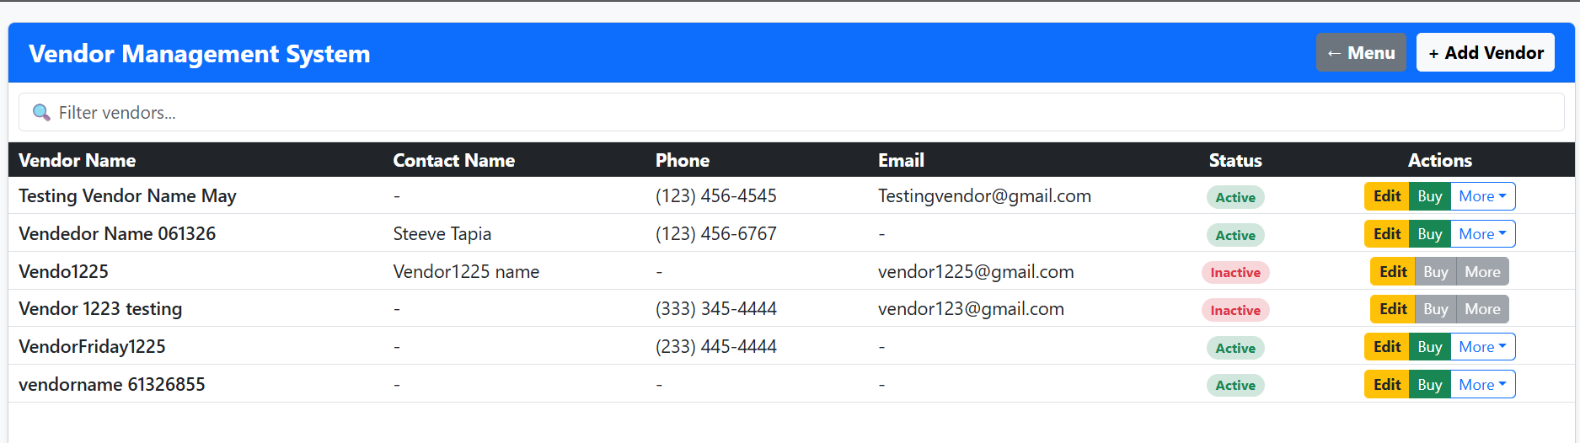

Additional modules such as Clients, Reports, and extended operational tools follow the same clean and intuitive structure. Further screens or walkthroughs can be provided upon request.

