PROJECT DOCUMENTATION
SIMPLE FILE MANAGEMENT SYSTEM
Computer Architecture and Organization (CpE 412)

Submitted by:
CENTINALES, JUNE LEONEL O.
BUSTAMANTE, CHAD OWYNE R.
CEPEDOZA, MARK GWEN
CABALIT, NETTEL P.
BSCpE 4-B

Submitted to:

JERALYN G. ALAGON, CpE
Faculty

TABLE OF CONTENTS

- Introduction
- System Requirements
- The Code
- System Implementation
- Possible Applications
- The Programmers
- Performance Rating

- INTRODUCTION
Objective
Files are the most basic way a computer keeps data after the power is turned off, and every program that saves a report, a log or a setting depends on the same few operations: create, read, write, rename and delete. The Simple File Management System was built to practice these operations the way the operating system really performs them, through file handles, buffers, flags and error codes, and to wrap them in a program that a non-technical user can operate safely.
General objective. To design and implement a menu-driven file management system for Windows that can create, read, append to, rename and delete text files while checking every operation for errors and never overwriting a file by accident.
Specific objectives:
  - Provide a menu (File, Go and Help menus, a toolbar, a right-click menu and keyboard shortcuts) from which every file operation can be started.
  - Accept a file name or path and file content from the user, and check the name against the Windows naming rules before anything is written.
  - Open and close every file correctly: each opened file handle is closed in all cases, and a failed close is reported.
  - Detect and report errors such as a missing file, a file that already exists, a read-only file, a folder used as a file, a binary file and a full disk, in plain words.
  - Prevent accidental data loss: creating never replaces an existing file, renaming never replaces another file, deleting asks for confirmation first, and a failed append restores the file to its previous content.
  - Let the user move between folders and drives (A: to Z:) and view a file's name, size, date and read-only status.
  - Relate the program to the low-level file services studied in Computer Architecture and Organization, such as the DOS INT 21h file-handle functions used in assembly language.
System Concept
The Simple File Management System (shown in its window as "Files") is a desktop application for Windows 10 and 11. It is written in JavaScript and runs on Electron, a platform that combines the Chromium browser engine (for the interface) with Node.js (for access to the file system). The interface uses a modern glass-style design with light and dark themes, but it remains menu-driven: the user always picks an operation from a menu or presses its key, then fills in a small dialog.
The program is divided into three layers that cannot reach into each other directly (Figure 1). The renderer draws the window and decides what happens when the user chooses a command. It has no access to the disk. The preload bridge exposes a small, fixed set of functions named window.fm (such as validate, info, list, create, read, append, rename, delete and drives). Each call travels as an inter-process message to the main process, where the file logic in file_ops.js performs the real system calls and returns a result code such as FM_OK, FM_ERR_EXISTS or FM_ERR_NO_SPACE. This separation is the same idea as user mode and kernel mode in a processor: the part that talks to the user cannot touch the hardware, and must ask a trusted layer through a defined interface.
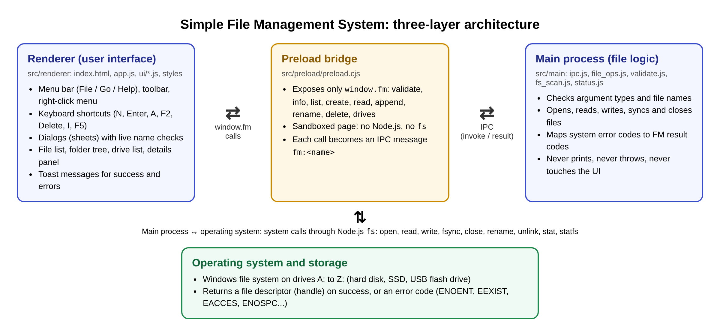
Figure 1. Three-layer architecture of the Simple File Management System
Every file operation follows the same sequence (Figure 2). The command is received, the program checks that a file is selected and that it still exists, a dialog collects the name or text while checking it as the user types, and only then is the request sent to the file logic. The file logic opens the file with the exact flags needed, reads or writes in a loop until every byte is processed, forces the data to disk with fsync, and closes the handle. The result is shown either as a short message (a "toast") or inside the dialog so the user can correct the input.
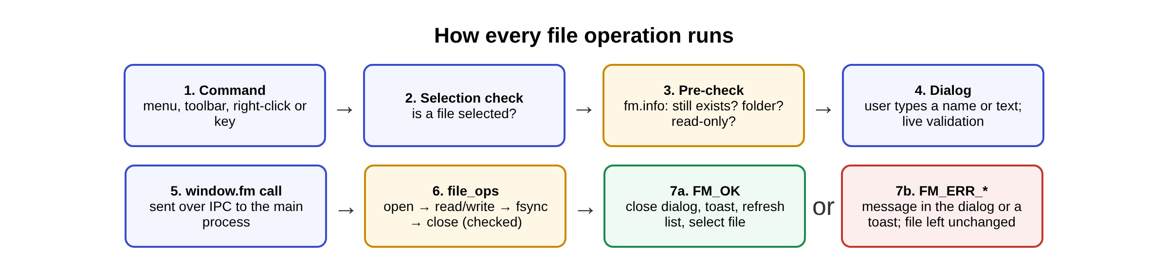
Figure 2. Sequence followed by every file operation
The main safety rules are summarized in Table 1.
Table 1. How each operation protects the user's files
Operation | Protection
Create | The file is opened with O_WRONLY | O_CREAT | O_EXCL, so the operating system creates it only if it does not exist yet. An existing file is never replaced. If writing fails, the half-written file is removed.
Read | Shows up to 1 MiB of text. A zero byte in the first 512 bytes marks the file as binary, and it is not shown as text.
Append | Opened with O_RDWR | O_APPEND and without O_CREAT, so a file deleted in the meantime is never re-created. If the write fails part-way, the file is truncated back to its old size.
Rename | Refuses when the new name already belongs to another file (checked by device and inode number), because the system rename call would silently replace it. Changing only capital letters is allowed.
Delete | Asks first, showing the name, size and date, with Cancel selected. Read-only files and folders are refused before the delete call is made.
Names | Rejects the characters < > : " | ? *, reserved device names (CON, PRN, AUX, NUL, COM1 to COM9, LPT1 to LPT9), names ending in a space or dot, and paths of 260 characters or longer.

Applications
The system can be used as a simple, safe file manager for students and office staff who mainly work with text files such as notes, reports, logs and source code. Because the file logic is separate from the interface, the same module can also serve as the storage layer of other programs that need to keep records in text files, for example data loggers, attendance and inventory records, or configuration editors for embedded devices. These uses are discussed in Section V.
- SYSTEM REQUIREMENTS
1. Hardware Requirements
These are the minimum and recommended physical components needed to run the installed application.
Processor (CPU): Intel Core i3 or equivalent 64-bit (x64) processor (minimum); Intel Core i5 or higher (recommended)
Memory (RAM): 4 GB (minimum); 8 GB (recommended)
Storage: About 370 MB of free space for the installed program (the installer file itself is about 115 MB), plus space for the user's own files
Display: 1366 × 768 or higher. The window opens at 1290 × 850 and can be reduced to 900 × 580, where the layout switches to a single column.
Peripherals: Keyboard and mouse or touchpad. Every action can be done with the keyboard alone. A USB flash drive is optional, for working with files on another drive.
2. Software Requirements
These are the programs, operating system and tools used to develop and to run the system.
Operating System: Windows 10 or Windows 11, 64-bit
Programming Language: JavaScript (ES modules), HTML5 and CSS3
Framework/Platform: Electron 44.9.0 (Chromium and Node.js); Node.js 20 or newer is needed only to build from source
Database: None. The system works directly on the Windows file system. The chosen theme and the five most recent folders are stored in the browser's localStorage.
Web Server: None. It is a desktop application; the interface is loaded from local files and the program's code makes no network connections.
Other Tools:
  - Code editor: Visual Studio Code
  - AI coding assistant: Claude Code, used to help write and test the program
  - Testing: node:test (built into Node.js) and ESLint 10.13.0 (zero warnings allowed)
  - Packaging: electron-builder 26.17.0, which produces the Windows installer (NSIS)
  - Version control: Git and GitHub
  - Windows PowerShell, used by the icon script (scripts/make-icon.ps1)
  - Fonts bundled with the app: Manrope and JetBrains Mono (SIL Open Font License)
3. Functional Requirements
These describe what the system does. The system shall:
  - Create a file: accept a name or path and optional content, show live hints ("Available at …" or "already exists"), and create the file only if the name is free.
  - Read a file: display the contents of a text file with line numbers, its size and line count, and a notice if the file is larger than 1 MiB; show a 10-line preview of the selected file in the details panel.
  - Append to a file: add new text to the end of an existing file without changing what is already there, starting on a new line if needed.
  - Rename a file: change a file's name while refusing names that are already taken.
  - Delete a file: remove a file only after the user confirms, with Cancel as the default button.
  - Show file information: type, size in bytes, last modified date, location and read-only status.
  - Validate names and paths: reject illegal characters, reserved device names, empty names and paths that are too long, each with its own message.
  - Check for errors: report missing files, existing files, read-only files, folders, binary files, a full disk and other input/output errors without crashing.
  - Navigate: open folders, go up one level, pick a folder with the system dialog, jump to one of the five most recent folders, and switch between every ready drive with its free space shown.
  - Menu-driven control: File, Go and Help menus, a toolbar, a right-click menu and keyboard shortcuts (N, Enter, A, F2, Delete, I, Backspace, F5, Alt+F, F10, Ctrl+Enter, Esc).
  - Themes and accessibility: light and dark themes that follow Windows, and support for the Windows reduce-motion and reduce-transparency settings.
Assembly programming concepts used in the code
Although the system is written in JavaScript, its file logic follows the same low-level model that an assembly-language program uses when it calls the operating system. In 8086 assembly under DOS, a program loads a function number into AH, places its arguments in registers, executes INT 21h, and then checks the Carry Flag: if CF is set, AX holds an error code. The Simple File Management System performs the same steps through Node.js, which in turn calls the Windows file system. Table 2 maps each part of the code to its assembly counterpart.
Table 2. Assembly-language concepts reflected in the code
Concept | Assembly (8086, DOS INT 21h) | Where it appears in the code
System call / software interrupt | MOV AH, function number; INT 21h transfers control to the operating system. | fs.openSync, fs.readSync, fs.writeSync and others in file_ops.js. The renderer reaches them only through an IPC call, just as a user program reaches the OS only through an interrupt.
Create a new file without overwriting | AH = 5Bh "Create new file" fails if the file exists (AH = 3Ch would truncate it). | fm_create opens with O_WRONLY | O_CREAT | O_EXCL, which fails with EEXIST instead of replacing the file.
Open an existing file with an access mode | AH = 3Dh, AL = 0 (read), 1 (write) or 2 (read/write); returns a file handle in AX. | fs.openSync(p, O_RDONLY) in fm_read and O_RDWR | O_APPEND in fm_append; the returned number fd is the file handle.
Read into a buffer | AH = 3Fh, BX = handle, CX = byte count, DS:DX = buffer; AX = bytes actually read. | fm_read allocates a Buffer and loops on fs.readSync until the byte count is reached or 0 is returned.
Write from a buffer | AH = 40h; AX = bytes actually written, which can be less than CX when the disk is full. | writeAll() loops on fs.writeSync, adding the returned count to an offset until every byte is written.
Move the file pointer | AH = 42h, AL = 2 moves the pointer relative to the end of the file. | O_APPEND makes every write go to the end; fm_append also reads the byte at position size − 1 to check for a final line feed.
Flush buffers to disk | AH = 68h "Commit file" (DOS 3.3+). | fs.fsyncSync(fd) after every create and append.
Close the handle | AH = 3Eh, BX = handle. | closeChecked() inside a finally block, so the handle is released on every path, and a failed close is reported.
Delete and rename | AH = 41h (delete), AH = 56h (rename). | fs.unlinkSync in fm_delete and fs.renameSync in fm_rename.
File attributes | AH = 43h gets the attribute byte; bit 0 = read-only. | isReadOnly() tests bit 0o200 (owner write permission) of the mode returned by fs.statSync.
Disk free space | AH = 36h returns sectors per cluster, free clusters and bytes per sector. | fs_drives() calls statfs on A:\ to Z:\ and computes free = bavail × bsize.
Error reporting | Carry Flag set and an error code in AX (02h file not found, 03h path not found, 05h access denied, 50h file exists). | Each call is wrapped in try/catch; statusFromErrno() maps ENOENT, EEXIST, EACCES, ENOSPC and others to FM_ERR_* codes, like a lookup table of error numbers.
Conditional branching on status | JC / JNC jump to an error routine. | if (r.code !== FM.OK) return r; after each step.
Bit masks and logical operations | OR combines flags; AND / TEST isolate bits. | O_WRONLY | O_CREAT | O_EXCL builds the open flags; (mode & 0o200) === 0 tests the read-only bit.
Byte-level data and ASCII codes | DB data, CR = 0Dh, LF = 0Ah, NUL = 00h. | Text is written with CR LF line endings; a 00h byte in the first 512 bytes marks a binary file; the last byte is compared with 0Ah.
Loops and counters | LOOP with CX as the counter. | while (off < buf.length) in writeAll; the read loop that counts bytes in n.
Subroutines | CALL and RET; registers saved and restored. | Small functions such as writeAll, closeChecked and parentCheck that are called by each operation.
Menu-driven program / jump table | Read a key (INT 16h or INT 21h AH = 01h), compare it (CMP / JE) and jump to the handler. | The keydown handler and runMenu() in app.js compare the key or menu id and call actNew, actOpen, actAppend, actRename or actDelete.

4. Non-Functional Requirements
These describe how well the system performs its functions.
Performance: The window is shown as soon as it is ready. A 1 MiB text file opens in the viewer in about 0.45 seconds, because the viewer draws only the visible blocks of 400 lines. The drive list is read in parallel and each drive is given at most 1.5 seconds, so a disconnected network drive cannot freeze the program. At most 1 MiB is read for viewing and 4 KB for the preview.
Security: The page runs in a sandbox with contextIsolation on and nodeIntegration off, under a strict Content-Security-Policy. Navigation and pop-up windows are blocked. The page can reach files only through the small set of window.fm functions, and a test checks that the interface code never imports fs, path or electron. The program's code makes no network connections.
Usability: Every operation is available from the menus, the toolbar, the right-click menu and a keyboard shortcut. Names are checked while the user types, buttons stay disabled until the input is valid, and messages say what failed and why (for example "Cannot append to "class-rules.txt": it is read-only."). Dialogs trap keyboard focus and close with Esc.
Reliability: Every open, read, write, fsync, close, rename and delete call is checked. Files are never overwritten by accident, a failed append is rolled back, and a partly created file is removed. 24 automated tests (including simulated disk-full, short-write, failed-close and failed-fsync errors) and a 28-step manual test script all passed.
Scalability: Folders of any size are listed and sorted (folders first, then files A to Z). Every drive from A: to Z: is detected, and USB drives plugged in later appear after a refresh. A test runs 1,000 create, read, append and delete cycles without running out of file handles. New operations can be added as one function in file_ops.js, one IPC handler and one menu entry.
Maintainability: The file logic, the interface and all user-visible messages are kept in separate modules. ESLint reports zero warnings.
- THE CODE
The complete source code (2,012 lines of application code and 447 lines of automated tests) is published in a public GitHub repository instead of being printed in full:
https://github.com/LeonelCents04/Simple-File-Manager

Scan to open the repository
Repository: LeonelCents04/Simple-File-Manager (public)
Branch and version: main, version 2.0.0 (commit ddf35a0)
Install and test the application yourself
The repository also provides the ready-to-use Windows installer, so the program can be tested without building it. To install it on a Windows 10 or 11 computer:
  - Open the repository's Releases page: https://github.com/LeonelCents04/Simple-File-Manager/releases
  - Download Simple-File-Manager-Setup-2.0.0.exe (about 115 MB).
  - Run the file. Because the program is not code-signed, Windows may show "Windows protected your PC". Click More info, then Run anyway.
  - Keep the default install folder or choose another one. No administrator rights are needed. The installer adds a desktop shortcut and a Start menu entry named Simple File Manager.
  - Open the program and try the operations shown in Section IV: create, read, append, rename and delete a file.
  - To uninstall: Settings → Apps → Installed apps → Simple File Manager → Uninstall.
To run from source: npm install, then npm start (needs Node.js 20 or newer). npm test runs the 24 automated tests.
Table 3 lists the files in the repository and what each one does. The folder src/main holds all file logic, src/preload holds the bridge, src/shared holds the messages, and src/renderer holds the interface. The tests are in the tests folder.
Table 3. Source files in the repository
File | Purpose | Lines
package.json | Project name, version, scripts (start, test, lint, dist) and installer settings | 35
scripts/start.js | Development launcher used by npm start | 9
src/main/main.js | Creates the window, sets security options, single instance | 50
src/main/ipc.js | One handler per file operation; checks argument types | 60
src/main/file_ops.js | Create, read, append, rename, delete, exists and info | 248
src/main/fs_scan.js | Lists a folder and detects ready drives | 58
src/main/validate.js | File name and path rules | 52
src/main/status.js | Result codes and system error mapping | 45
src/main/util.js | Path helpers for the main process | 27
src/preload/preload.cjs | The window.fm bridge between page and file logic | 23
src/shared/messages.js | Every user-visible message | 67
src/shared/format.js | Size, date and byte formatting | 29
src/renderer/index.html | Page structure and Content-Security-Policy | 55
src/renderer/app.js | State, menus, shortcuts and the flow of every action | 510
src/renderer/ui/dom.js | DOM helpers and icons | 31
src/renderer/ui/menubar.js | File / Go / Help menu bar | 88
src/renderer/ui/toolbar.js | Toolbar buttons | 10
src/renderer/ui/contextmenu.js | Right-click menu | 31
src/renderer/ui/sheets.js | Dialogs: new, viewer, append, rename, delete, info | 132
src/renderer/ui/list.js | File list rows | 24
src/renderer/ui/details.js | Details panel and preview | 33
src/renderer/ui/sidebar.js | Folder tree and drives | 33
src/renderer/ui/breadcrumbs.js | Location bar | 23
src/renderer/ui/toasts.js | Status and error messages | 21
src/renderer/ui/specpanel.js | Requirements checklist and call log panel | 39
src/renderer/styles/tokens.css | Colors and sizes for light and dark themes | 53
src/renderer/styles/app.css | Layout and glass styling | 226
tests/*.js (7 files) | Automated tests (node:test) | 447

Key Code Excerpts
The parts of the code that answer the main coding requirements, opening and closing files correctly, checking errors and preventing accidental overwriting, are reproduced below.
1. Writing every byte and closing the file handle
writeAll() repeats the write until every byte is on disk, because a single write may write fewer bytes than asked. closeChecked() is always called from a finally block, so the file handle is released on every path, and a failed close is reported instead of being ignored.
File: src/main/file_ops.js
/** Loops because writeSync may write fewer bytes than asked. */
function writeAll(fd, buf) {
let off = 0;
while (off < buf.length) off += fs.writeSync(fd, buf, off, buf.length - off);
}

/** Closes fd; a close failure only replaces a success. */
function closeChecked(fd, r) {
try {
fs.closeSync(fd);
} catch (err) {
if (r.code === FM.OK) return { ...fromError(err), code: FM.IO };
}
return r;
}
2. Creating a file without overwriting
The O_EXCL flag makes the operating system create the file only if it does not exist yet, so an existing file can never be replaced. Every step is checked, and a half-written file is removed if anything fails.
File: src/main/file_ops.js
export function fm_create(p, content) {
if (typeof content !== 'string') return badArg();
let r = checkPath(p);
if (r.code !== FM.OK) return r;
try {
r = parentCheck(p);
if (r.code !== FM.OK) return r;
} catch (err) {
return fromError(err);
}

const buf = toDisk(content);
let fd;
try {
// Create-or-fail in one atomic step: never overwrites, no check-then-create race.
fd = fs.openSync(p, O_WRONLY | O_CREAT | O_EXCL, 0o666);
} catch (err) {
// Windows reports a folder with the same name as EPERM/EACCES/EISDIR.
if (err.code !== 'EEXIST' && fm_exists(p)) return result(FM.EXISTS, err.code);
return fromError(err);
}

r = ok({ bytes: buf.length });
try {
writeAll(fd, buf);
fs.fsyncSync(fd);
} catch (err) {
r = fromError(err);
} finally {
r = closeChecked(fd, r);
}
if (r.code !== FM.OK) {
try {
fs.unlinkSync(p); // we created it, so we remove the partial file
} catch { /* the original error is what the user needs to see */ }
}
return r;
}
3. Translating system errors into result codes
Every system error code is mapped in one place to a result code, which the interface then turns into a plain message such as "it is read-only" or "disk full".
File: src/main/status.js
export function statusFromErrno(code) {
switch (code) {
case 'ENOENT': case 'ENOTDIR': return FM.NOT_FOUND;
case 'EEXIST': return FM.EXISTS;
case 'EACCES': case 'EPERM': case 'EROFS': return FM.PERMISSION;
case 'EISDIR': return FM.IS_DIR;
case 'ENOSPC': case 'EDQUOT': return FM.NO_SPACE;
case 'EXDEV': return FM.CROSS_DEVICE;
case 'ENAMETOOLONG': return FM.PATH_TOO_LONG;
default: return FM.IO;
}
}

/** Turns a caught Node error into a result, keeping the raw code for the log panel. */
export function fromError(err) {
const code = (err && err.code) || 'EUNKNOWN';
return result(statusFromErrno(code), code);
}
- SYSTEM IMPLEMENTATION
The application was packaged with electron-builder into a Windows installer, Simple-File-Manager-Setup-2.0.0.exe (about 115 MB). The installer uses the usual setup wizard, installs per user without administrator rights, and adds a desktop shortcut and a Start menu entry. The figures below show the program running, with the input given for each operation and the output produced. A sample folder named "CpE412 Files" containing text files, a read-only file, an image and two subfolders was used for the demonstration.
A. Main Window
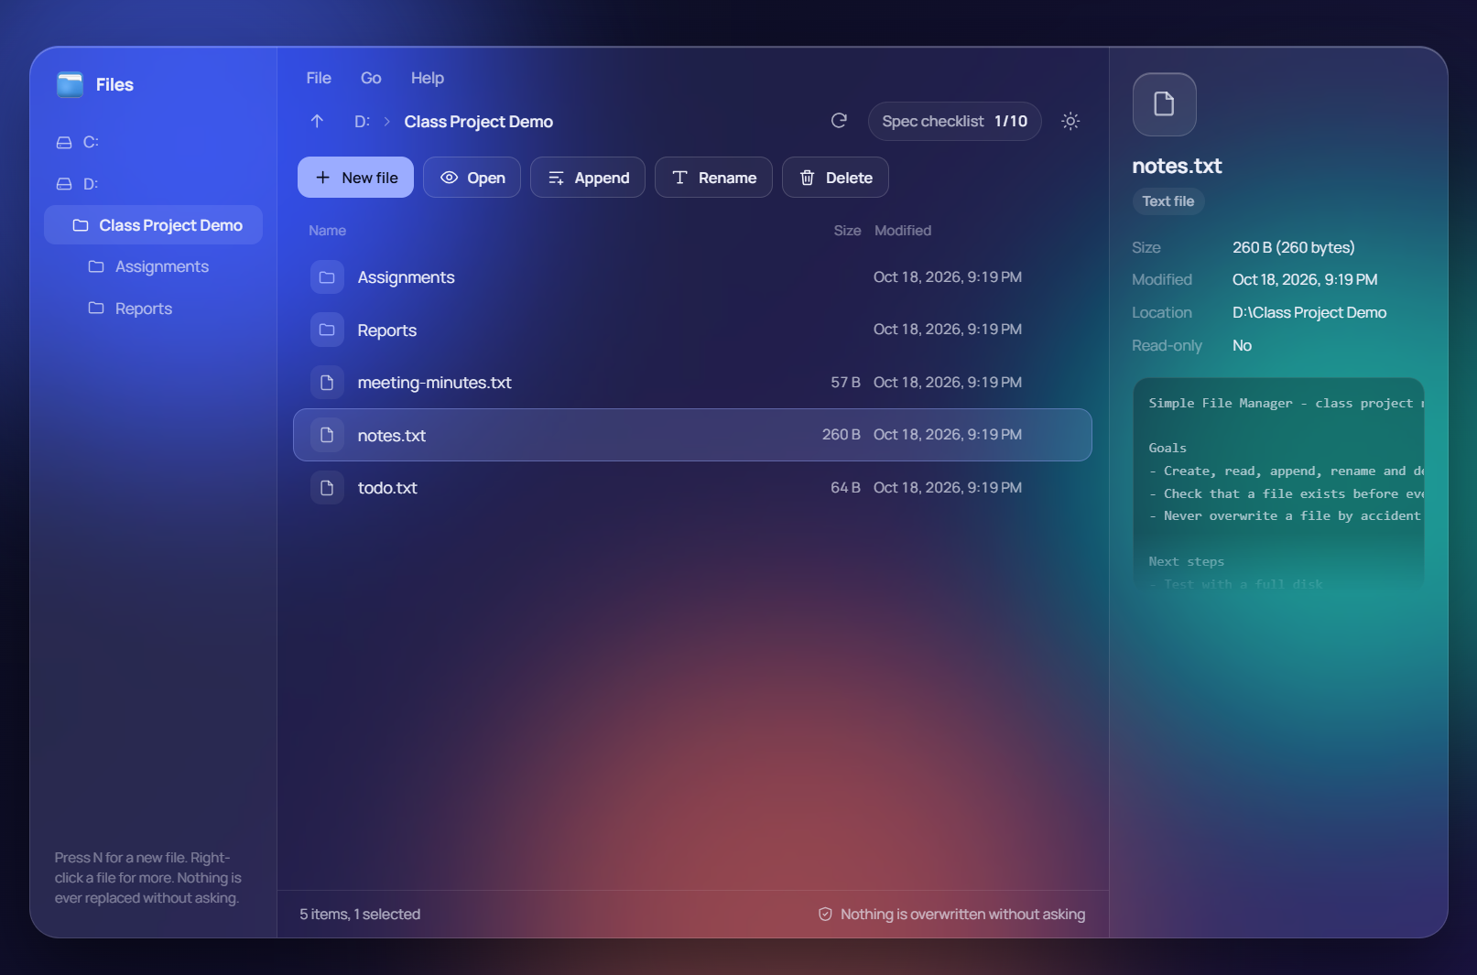
Figure 3. Main window on Windows (dark theme): folder tree and drives on the left, file list in the middle, details and preview on the right
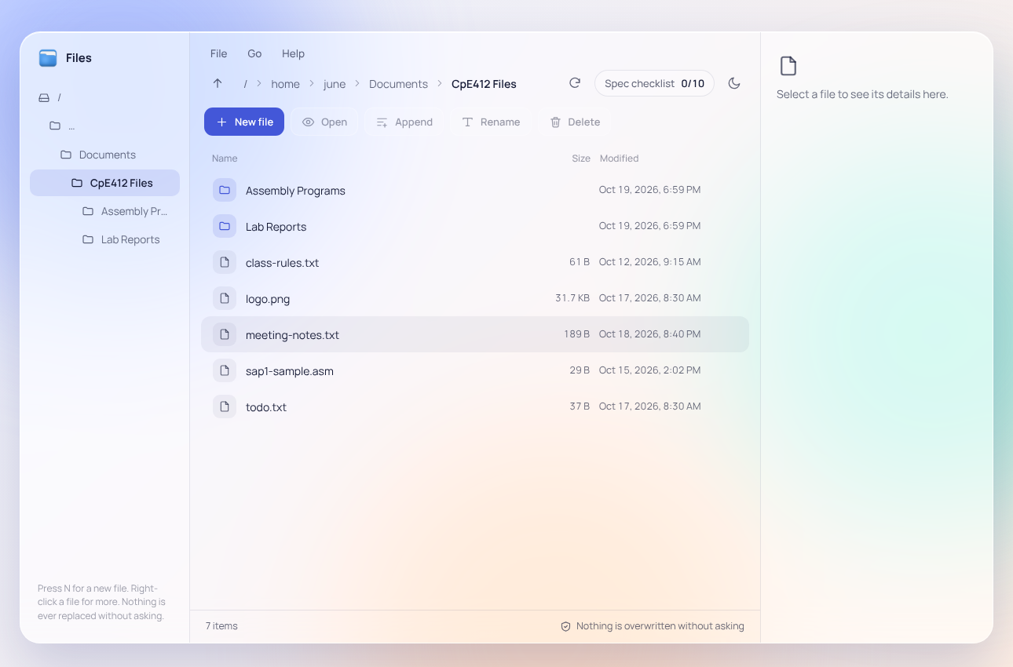
Figure 4. Main window (light theme) opened in the sample folder "CpE412 Files"
The window has a sidebar with the folder tree and drives, a menu bar (File, Go, Help), a location bar, a toolbar with the five operations, the file list with Size and Modified columns, and a details panel. The status bar shows the item count and the reminder "Nothing is overwritten without asking".
B. Menu-Driven Navigation
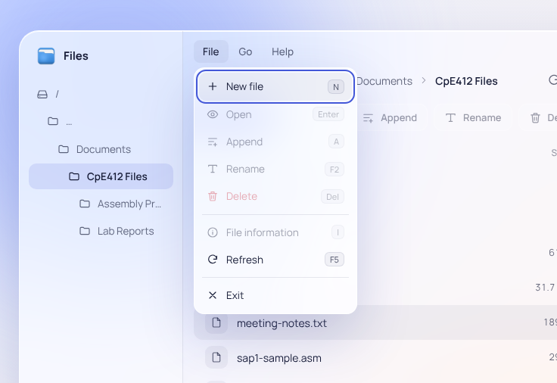
Figure 5. File menu (Alt+F): New file, Open, Append, Rename, Delete, File information, Refresh and Exit, each with its shortcut
Input: Alt+F, or a click on "File".
Output: The File menu opens with the focus on "New file". Operations that need a selected file are disabled until a file is selected.
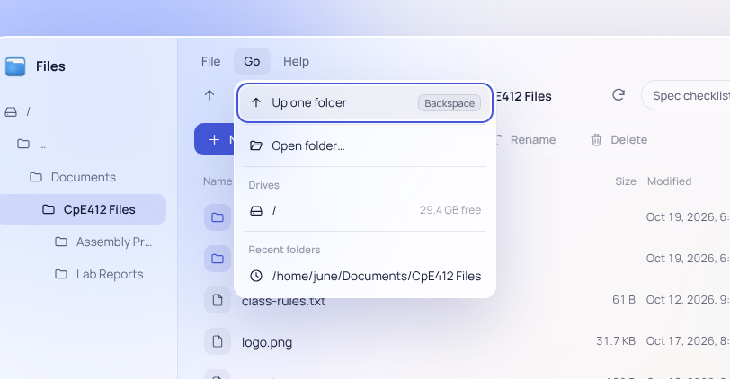
Figure 6. Go menu (Alt+G): Up one folder, Open folder…, the list of drives with free space, and recent folders
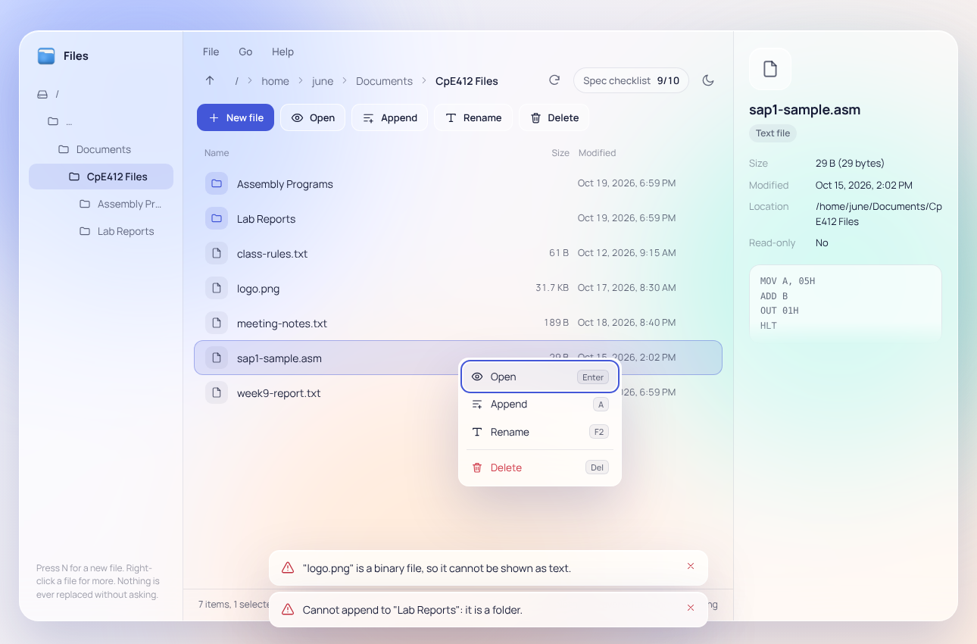
Figure 7. Right-click menu on a file: Open, Append, Rename and Delete
C. Create a File
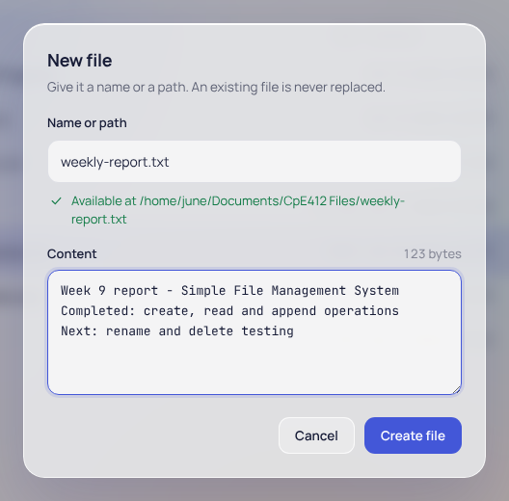
Figure 8. New file dialog with the name and content entered (input)
Input: N (or File → New file); name "weekly-report.txt"; three lines of content; Ctrl+Enter.
Output: While typing, the hint shows "Available at" followed by the full path, and the byte counter shows the size of the content. The file is created and selected.
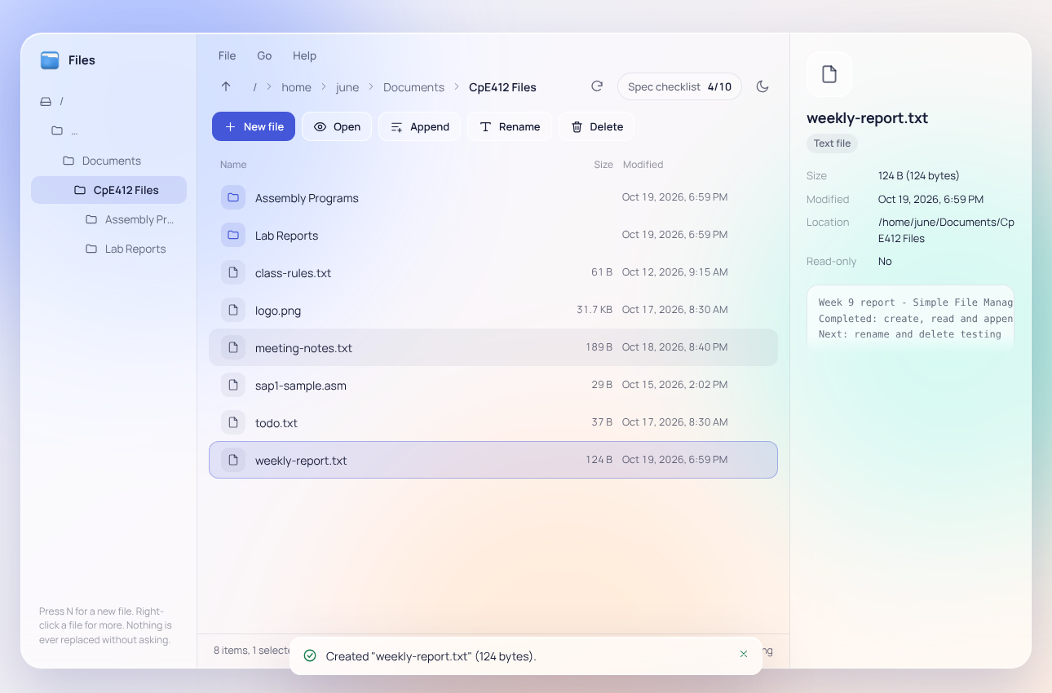
Figure 9. Result: toast "Created "weekly-report.txt" (124 bytes)." and the new file selected with its preview (output)
D. Read (Open) a File
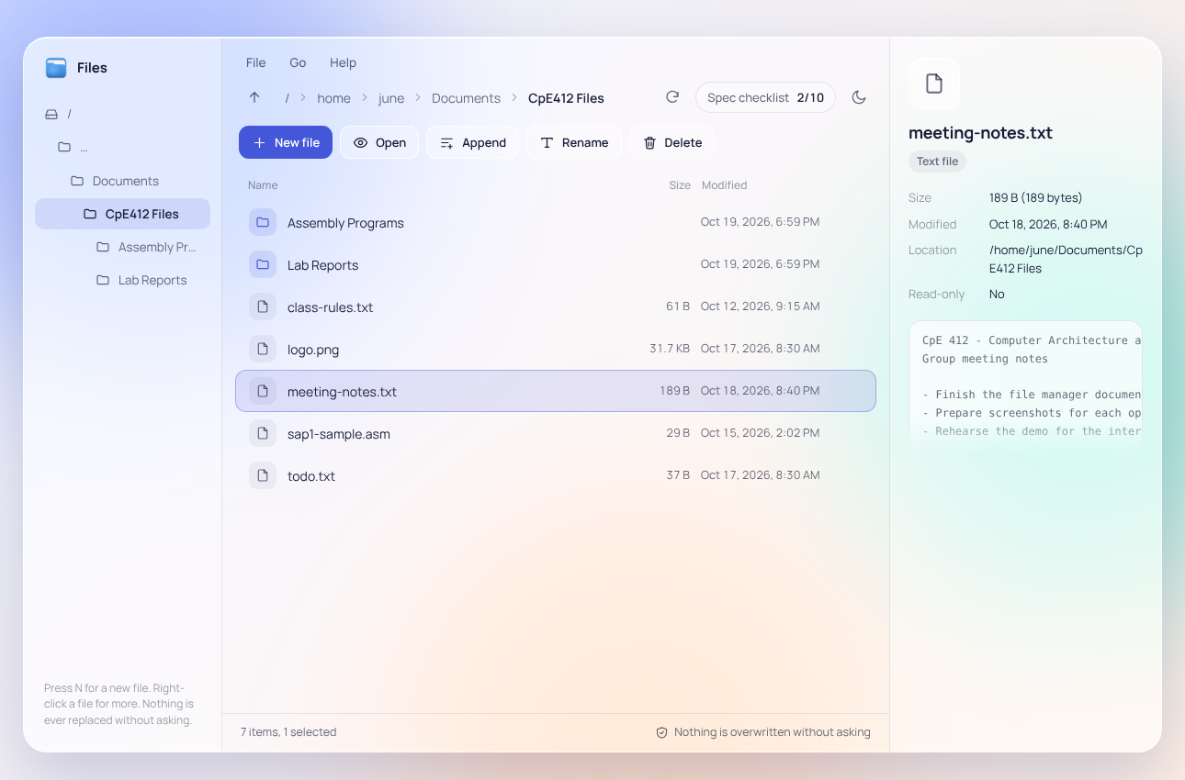
Figure 10. Selecting a file shows its details and a preview of the first lines
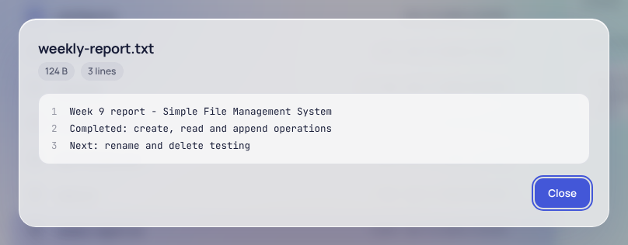
Figure 11. File viewer with line numbers, size chip (124 B) and line count (3 lines)
Input: Select "weekly-report.txt" and press Enter (or double-click, or File → Open).
Output: The viewer shows the contents with line numbers. Esc or Close returns to the list.
E. Append to a File
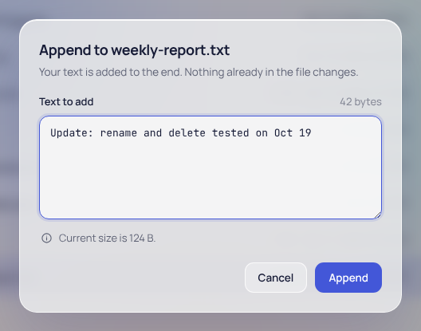
Figure 12. Append dialog with the text to add (input); the hint shows the current size of the file
Input: A (or File → Append); "Update: rename and delete tested on Oct 19"; Ctrl+Enter.
Output: Toast "Appended 43 bytes to "weekly-report.txt"." The existing lines are unchanged and the new text is on its own line.
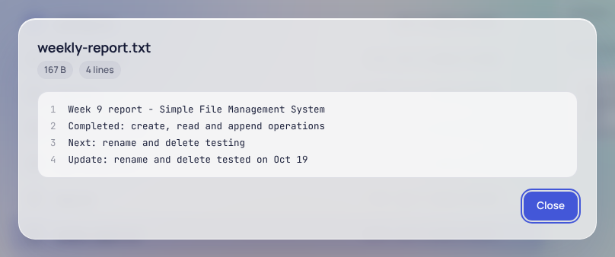
Figure 13. The file after appending: 4 lines, 167 B (output)
F. Rename a File
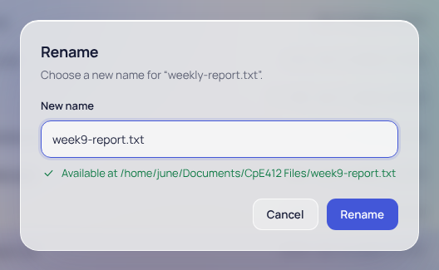
Figure 14. Rename dialog with the new name "week9-report.txt" (input)
Input: F2 (or File → Rename); new name "week9-report.txt"; Enter.
Output: Toast "Renamed "weekly-report.txt" to "week9-report.txt"." The selection follows the renamed file.
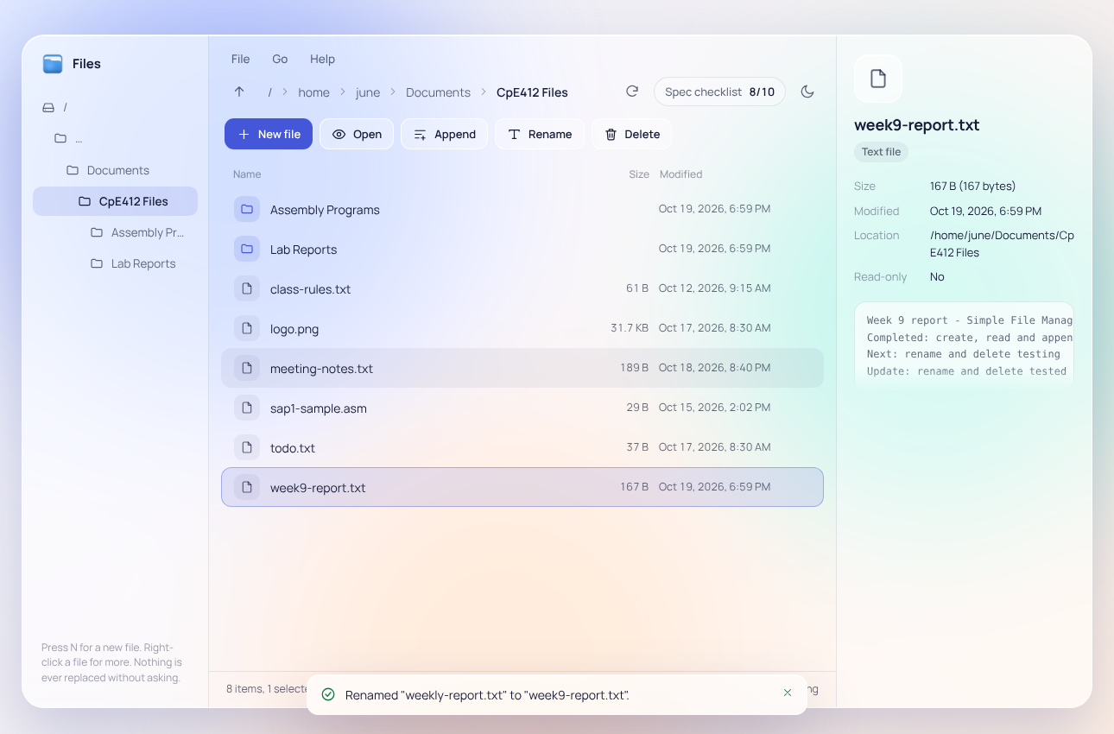
Figure 15. Result of the rename (output)
G. File Information
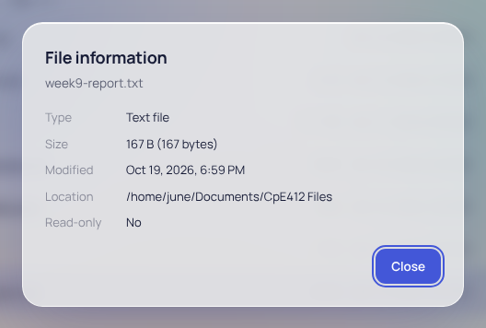
Figure 16. File information dialog: type, size in bytes, last modified, location and read-only status
H. Delete a File
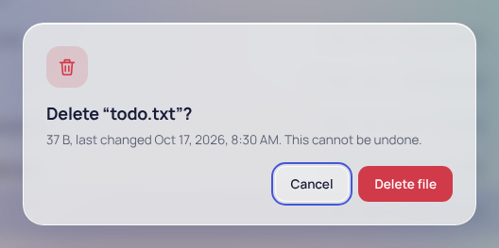
Figure 17. Delete confirmation for "todo.txt" showing its size and date; Cancel has the focus (input)
Input: Select "todo.txt", press Delete, then click "Delete file".
Output: Pressing Enter at the prompt would cancel. After "Delete file", the toast shows "Deleted "todo.txt"." and the selection moves to the next file.
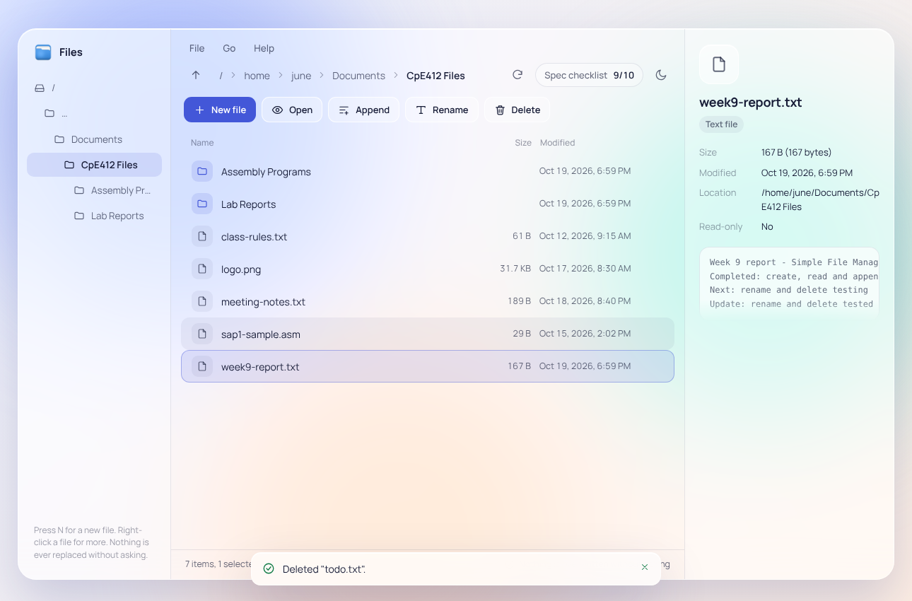
Figure 18. Result of the delete (output)
I. Error Checking and Overwrite Protection
The following figures show how the system responds to wrong or unsafe input. In each case the file on disk is left unchanged.
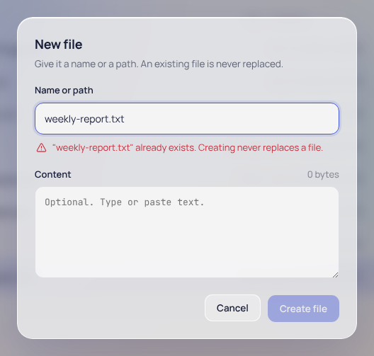
Figure 19. Creating "weekly-report.txt" again: "already exists. Creating never replaces a file." and the Create button stays disabled
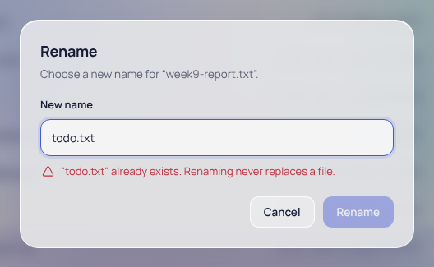
Figure 20. Renaming to an existing name ("todo.txt") is refused
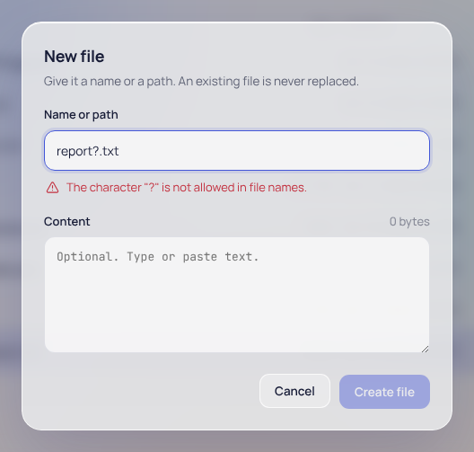
Figure 21. Invalid character: "The character "?" is not allowed in file names."
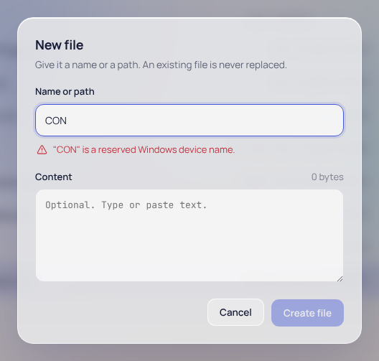
Figure 22. Reserved device name: ""CON" is a reserved Windows device name."
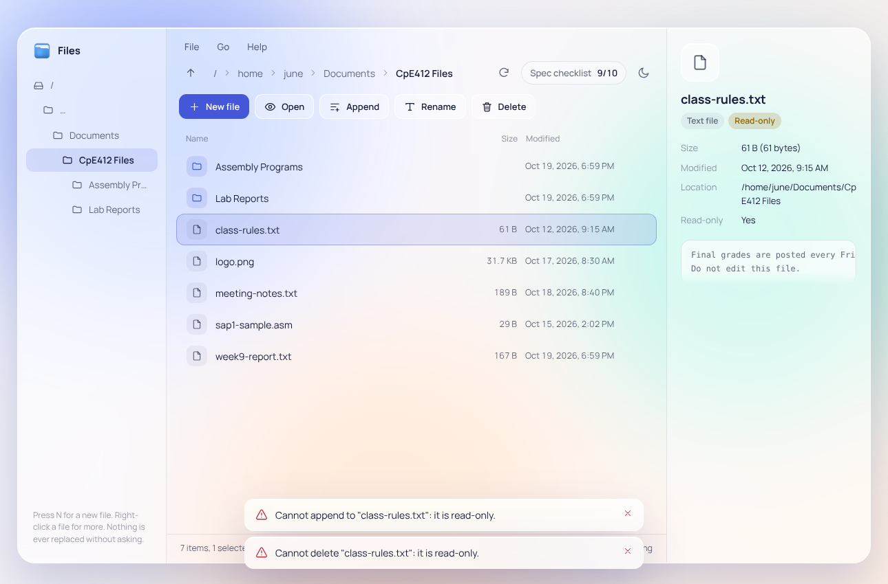
Figure 23. Read-only file "class-rules.txt": append and delete are refused with "it is read-only"
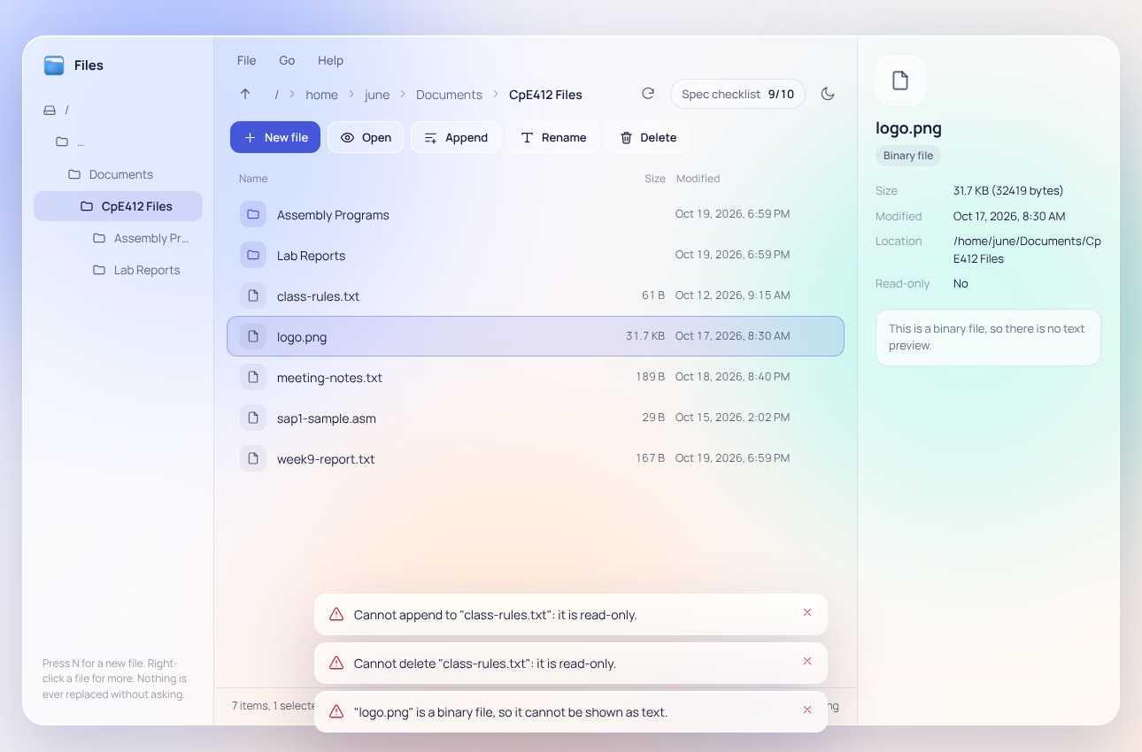
Figure 24. Binary file "logo.png": the details panel says there is no text preview, and opening it shows "is a binary file, so it cannot be shown as text"
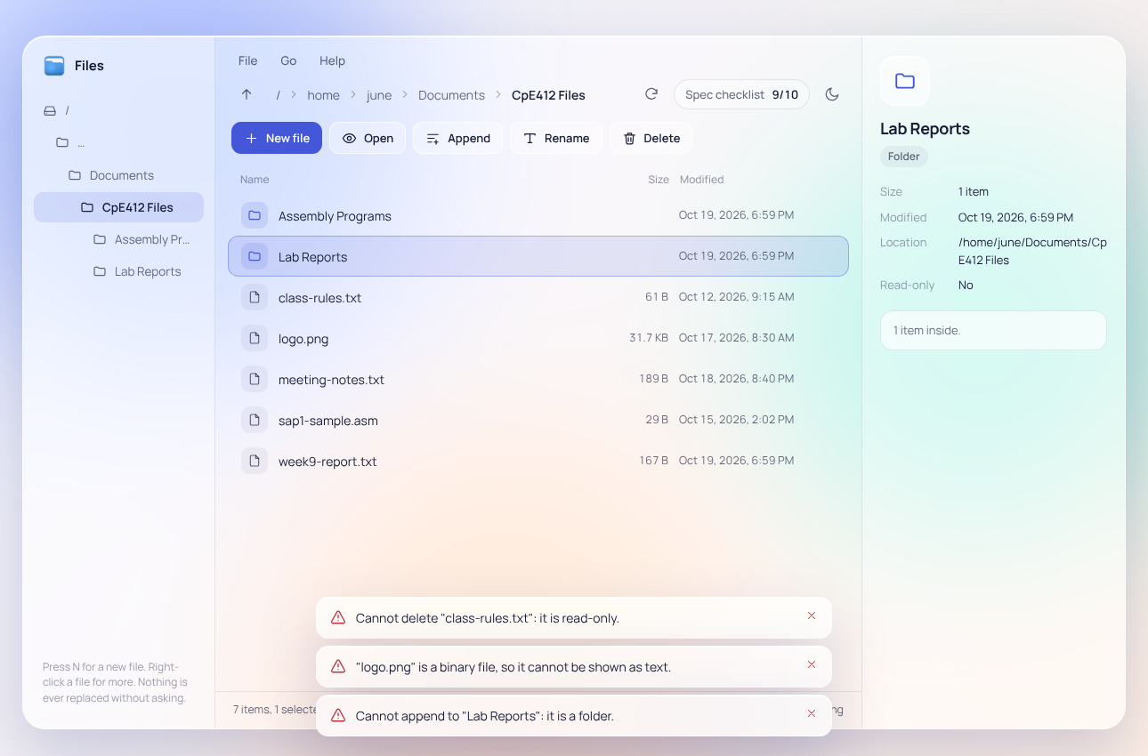
Figure 25. Appending to a folder is refused: "Cannot append to "Lab Reports": it is a folder."
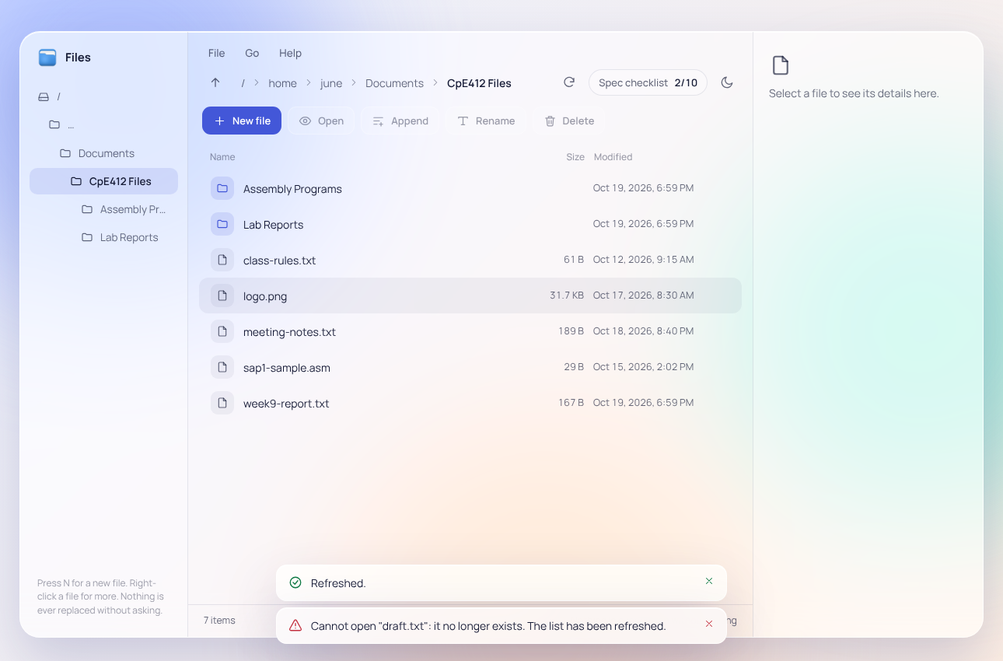
Figure 26. A file deleted outside the program ("draft.txt"): opening it reports "it no longer exists. The list has been refreshed." and the file is not re-created
Table 4. Summary of the inputs and outputs demonstrated
Test | Input | Output
Create | weekly-report.txt + 3 lines | Created "weekly-report.txt" (124 bytes).
Read | Enter on weekly-report.txt | Viewer with 3 numbered lines
Append | "Update: rename and delete tested on Oct 19" | Appended 43 bytes; file now 4 lines, 167 B
Rename | week9-report.txt | Renamed "weekly-report.txt" to "week9-report.txt".
Delete | todo.txt, then Delete file | Deleted "todo.txt".
Duplicate name | New file weekly-report.txt | Already exists; Create disabled
Rename conflict | week9-report.txt → todo.txt | Already exists; Rename disabled
Invalid name | report?.txt / CON | Character not allowed / reserved device name
Read-only file | Append or Delete class-rules.txt | Cannot append to / delete: it is read-only.
Binary file | Open logo.png | Is a binary file, cannot be shown as text
Folder | Append on Lab Reports | Cannot append to "Lab Reports": it is a folder.
Missing file | Open draft.txt after deleting it outside | It no longer exists; list refreshed

J. Themes, Help and Exit
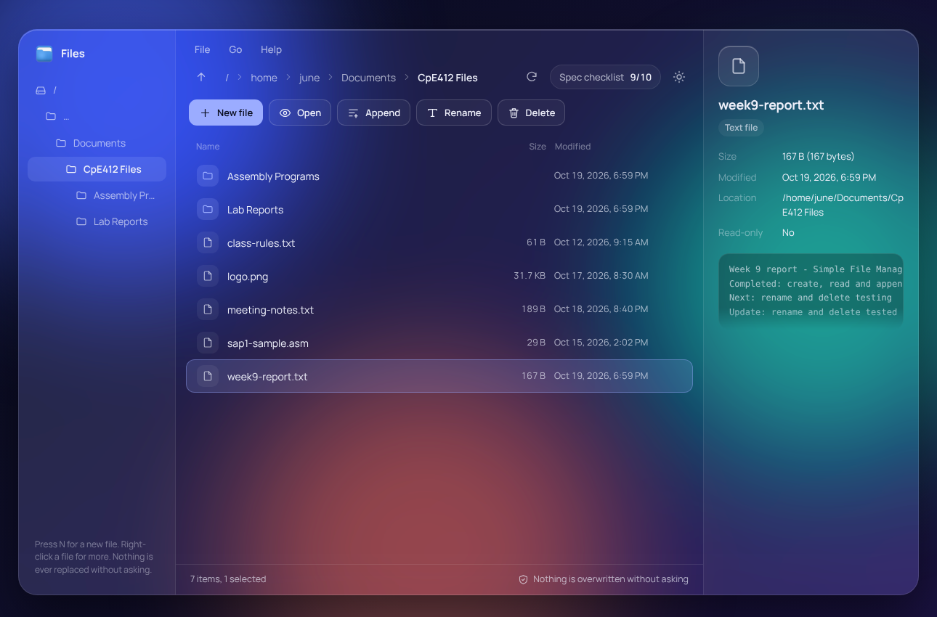
Figure 27. Dark theme, switched with the moon/sun button in the location bar
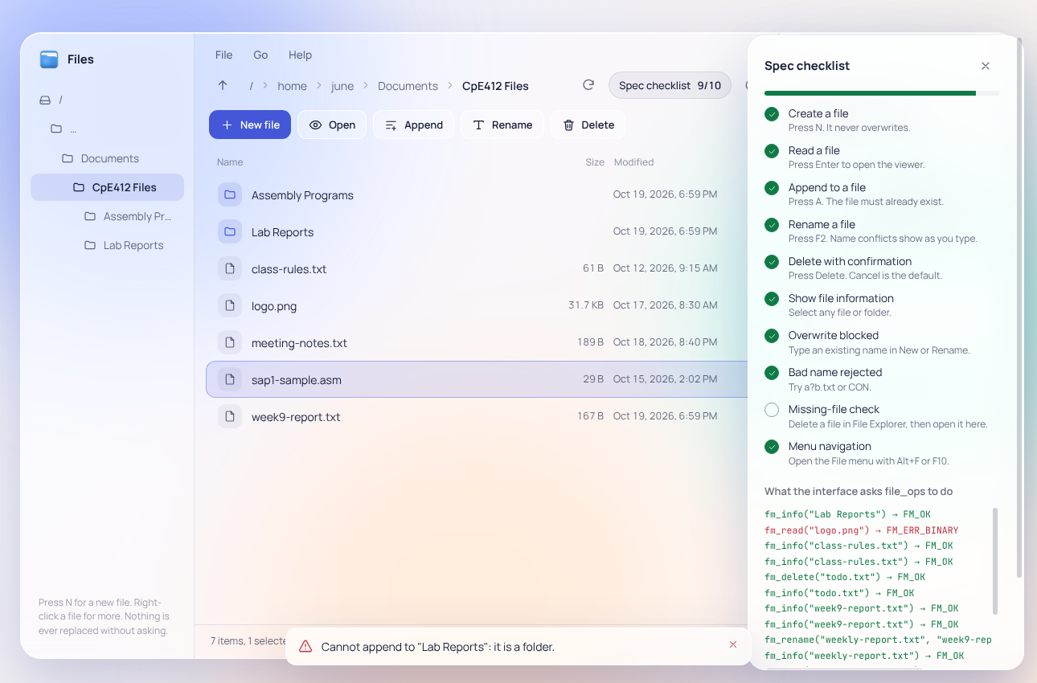
Figure 28. Help → Spec checklist: the requirements checklist and a log of every call made to the file logic with its result code
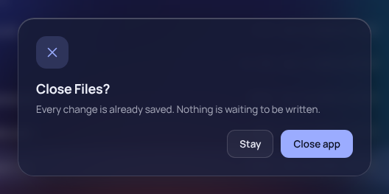
Figure 29. File → Exit asks for confirmation, with Stay as the default
K. Testing Results
Besides the demonstration above, the program was tested with automated unit tests (npm test) and a manual test script that drove the real window with keyboard and mouse events. The results recorded in the project's test plan are summarized in Table 5.
Table 5. Test results
Test | What it covers | Result
Automated tests (node:test) | All five operations, name rules, folder listing, messages, injected disk-full / short-write / failed-close / failed-fsync errors, 1,000 create-read-append-delete cycles | 24 / 24 passed
Code quality (ESLint) | All source files | 0 warnings
Manual test script | Create, read, append, rename, delete, duplicate names, invalid names, read-only, binary, missing file, menus, keyboard-only use, themes | 28 / 28 passed
Large file | 2 MiB, 18,725-line text file in the viewer | Passed; opens in about 0.45 s
Drive picker | Lists drives C: and D: with free space; switching drives | 5 / 5 passed
Installed application | The 28-step script run against the installed program | 28 / 28 passed
Dependency audit | npm audit of the shipped application | 0 vulnerabilities

- POSSIBLE APPLICATIONS
The Simple File Management System can be used on its own or as part of a larger system. Because the file logic (file_ops.js, validate.js, fs_scan.js and status.js) does not depend on the interface, it can be reused in other Node.js or Electron programs with no changes.
A. Applications and Integration
  - Data logging for embedded and IoT systems. Microcontroller projects such as sensor monitors and dryer controllers often send readings to a computer as text. The append operation, which never re-creates a missing file, adds new text on its own line, and rolls back a partial write, is a safe way to keep these logs. Log files copied from an SD card or USB drive can be opened and checked in the viewer.
  - School and office records. Attendance sheets, inventory lists, meeting notes and reports kept as text or CSV files can be created, updated with Append and organized with Rename, with no risk of replacing an existing file by mistake.
  - Configuration editor. Settings files for other programs or devices (for example .ini, .txt or .csv files) can be created and extended safely, and the read-only check protects files that should not be changed.
  - Teaching tool for computer architecture and operating systems. The Spec checklist panel shows every call the interface makes to the file logic and its result code. This makes the hidden steps of file I/O visible and can be used alongside assembly-language exercises on INT 21h file handles, buffers and error codes.
  - Restricted or kiosk computers. Because the interface can only call the small set of window.fm functions, the program can be given to users who should edit text files but should not have full access to File Explorer or a command prompt.
  - Storage layer for other applications. The file_ops module can serve as the save-and-load layer of a note-taking app, a simple document manager or a report generator, giving them atomic create, checked writes and clear error codes.
B. Contribution to the Overall Performance of the System
In a computer system, the input/output (I/O) subsystem is usually the slowest and least reliable part: disks fill up, drives are removed, and other programs change files at the same time. The design of this project improves the overall system in several ways:
  - Data integrity. Creating with O_EXCL, refusing rename conflicts, rolling back a failed append and calling fsync before close mean that a power loss, a full disk or a user mistake does not leave files half-written or replaced.
  - Efficient use of memory and the processor. Files are read through a fixed-size buffer limited to 1 MiB, the preview reads only 4 KB, and the viewer renders only the visible blocks of lines, so large files do not exhaust memory or freeze the interface.
  - Responsiveness. The slow operation of probing 26 drive letters is done asynchronously and in parallel with a 1.5-second limit per drive, so the main process is never blocked by a slow or disconnected drive.
  - Correct resource management. Every file handle is closed in a finally block, which was confirmed by 1,000 repeated cycles without running out of handles. Leaked handles would otherwise lock files and eventually stop other programs from opening files.
  - Security and isolation. Separating the interface from the file logic, as user mode is separated from kernel mode in a processor, limits what any fault in the interface can do to the user's files.
- THE PROGRAMMERS
A. Personal Information
Attach 2×2  ID picture | Name: CENTINALES, JUNE LEONEL O.  Program, Year and Section: BS Computer Engineering, BSCpE 4-B  Address: Lapacan Sur, Inabanga, Bohol  Contact Number: ____________________________  Email: leonelcents@gmail.com  Role in the Project: ____________________________

Attach 2×2  ID picture | Name: BUSTAMANTE, CHAD OWYNE R.  Program, Year and Section: BS Computer Engineering, BSCpE 4-B  Address: ____________________________  Contact Number: ____________________________  Email: ____________________________  Role in the Project: ____________________________

Attach 2×2  ID picture | Name: CEPEDOZA, MARK GWEN  Program, Year and Section: BS Computer Engineering, BSCpE 4-B  Address: ____________________________  Contact Number: ____________________________  Email: ____________________________  Role in the Project: ____________________________

Attach 2×2  ID picture | Name: CABALIT, NETTEL P.  Program, Year and Section: BS Computer Engineering, BSCpE 4-B  Address: ____________________________  Contact Number: ____________________________  Email: ____________________________  Role in the Project: ____________________________

B. Group Project Implementation Documentation
The project was carried out in the following phases. The group defined the requirements and the design, and used Claude Code, an AI coding assistant, to help write, test and package the program.
Table 6. Project implementation phases
No. | Phase | Activities and output
1 | Planning and requirements | Wrote the project plan (PROJECT_STRUCTURE.md): the five file operations, name rules, error messages, safety rules and the test plan.
2 | Interface design | Designed the menu-driven layout and the glass-style mockup (UI_MOCKUP_GLASS.html) with light and dark themes.
3 | First version (text console) | Built an earlier text-console version in C with PDCurses. It was later moved to a separate project.
4 | Desktop version (Electron) | Chose Electron and implemented the three layers: file logic, preload bridge and interface, porting the mockup to real file operations.
5 | Testing and fixes | Wrote 24 automated tests and a 28-step manual script. Testing found and fixed several problems, for example a failed append that left half of the new text in the file, and a 1 MiB file that took about 5 s to appear (now about 0.45 s).
6 | Drive picker and app icon | Added the list of drives with free space, and the application icon.
7 | Packaging and release | Built the Windows installer (Simple-File-Manager-Setup-2.0.0.exe) and tested the installed program.
8 | Documentation | Prepared the README, design decisions, test plan and this project documentation.

[Insert photos of the group during planning, development, testing and the demonstration, with a short caption for each.]

- PERFORMANCE RATING

PERFORMANCE RATING
Course Code: CpE 412 Date: __________
Year & Section: BSCpE 4 – B Group No.: ______
Project Title: Simple File Management System

No. | Member |  | Performance Criteria |  |  |  | Score
No. | Member | Interview/  Q & A  (50%) | System  Functionality &  Performance  (15%) | Program  Complexity  (15%) | Documentation  (10%) | Timeliness  (10%) | Score
1 | CENTINALES, JUNE LEONEL O.
2 | BUSTAMANTE, CHAD OWYNE R.
3 | CEPEDOZA, MARK GWEN
4 | CABALIT, NETTEL P.

PROJECT EVALUATION RUBRIC

Criteria | Description | Excellent (5) | Very Good  (4) | Satisfactory  (3) | Needs  Improvement  (2) | Poor (1) | Weight (%)
1. Interview /  Question &  Answer | Ability to explain, defend, and  demonstrate understanding of the project, system design, and implementation. | Confidently and clearly explains all  aspects;  demonstrates mastery of the project. | Can explain most parts well with minimal guidance. | Answers basic questions but lacks depth. | Struggles to explain system details;  limited understanding. | Unable to  answer questions or explain project. | 50%
2. Program  Complexity | Level of difficulty, innovation, and use of advanced  techniques,  algorithms, or technologies. | Highly complex, innovative, and demonstrates advanced technical skills. | Moderately complex; shows creativity and solid technical skill. | Average  complexity;  meets minimum requirements. | Simple program with limited features. | Very basic or incomplete system. | 15%
3. System  Functionality &  Performance | Working features, error handling, and usability of the system. | Fully functional, user-friendly, and free of major errors. | Mostly functional with minor bugs. | Functional but lacks polish or stability. | Partially working; several errors present. | Not working or fails to run. | 15%
4.  Documentation | Completeness,  clarity,  organization, and adherence to  format | Complete, well-  organized, free of errors; follows proper format and logical flow. | Mostly complete;  minor errors in format or clarity. | Adequate but lacks detail in some parts. | Incomplete; lacks organization and coherence. | Very incomplete or  poorly presented. | 10%
5. Timeliness | Submission of project deliverables and final output according to the timeline or deadlines. | Submitted before or on time;  consistent progress throughout. | Submitted on time with minor delays in earlier stages. | Slightly late submission but acceptable. | Frequently delayed with poor time management. | Very late or incomplete submission. | 10%

Total Score: 100%

Grading Scale Example:
  - 90–100: Excellent
  - 80–89: Very Good
  - 70–79: Satisfactory
  - 60–69: Needs Improvement
  - Below 60: Poor

[Print this form.]

