*作业须知：请特别注意截止时间，老师会在教学系统里多设定一周，以防止因系统不稳定而导致有的同学未能及时提交，请同学们务必提早一周提交。超过截止时间将不再收取作业，请不要通过Email发送作业。*

Shell脚本编写：

1. 编写一个shell脚本显示HOME、PATH、SHLVL、LOGNAME变量的值。

答：

#!/bin/sh

echo “HOME: $HOME”

echo “PATH: $PATH”

echo “SHLVL: $SHLVL”

echo “LOGNAME: $LOGNAME”

exit 0

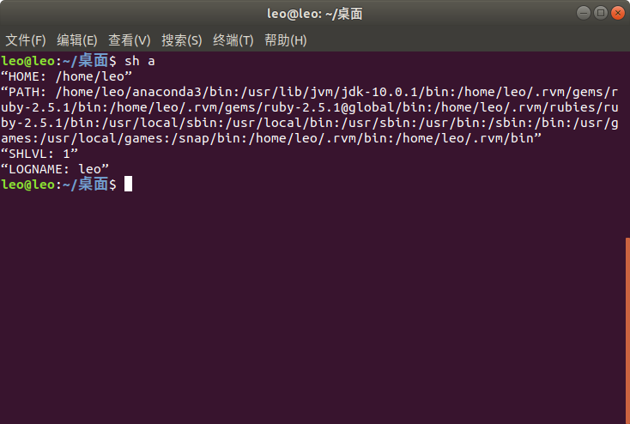

2. 用while语句重写下列Shell脚本程序，以实现相同的功能：

#!/bin/sh

clear

select item in Continue Finish

do

case “$item” in

Continue) ;;

Finish) break ;;

\*) echo “Wrong choice! Please select again!” ;;

esac

done

答：

#!bin/sh

clear

echo "1) Continue"

echo "2) Finish"

choice=1

while [ "$choice" -ne 2 ]

do

read -p "#?" choice

if [ "$choice" -ne 1 -a "$choice" -ne 2 ]

then

echo "Wrong choice! Please select again!"

fi

done

exit 0

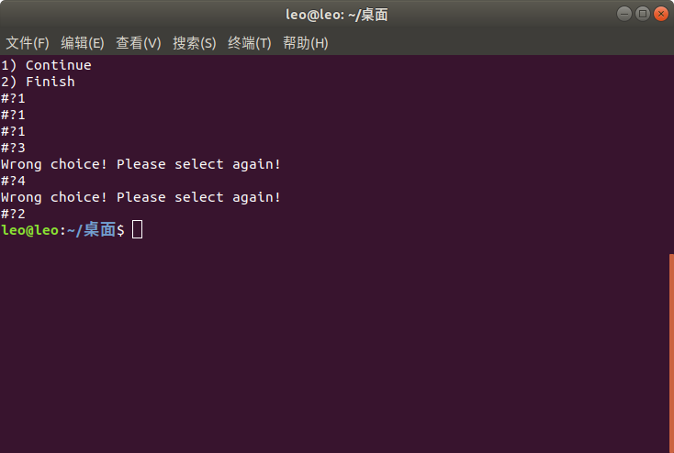

3. 编写一个shell脚本，显示Fibonacci数列的前10个数字。(Fibonacci数列: a[i+2]=a[i+1]+a[i], a[1]=0, a[2]=1, i>=1)

答：

#!/bin/bash

first=0

second=1

count=8

echo $first

echo $second

while [ "$count" -ne 0 ]

do

third=$[first+second]

echo "$third"

first=$second

second=$third

count=$[count-1]

done

exit 0

