Shell脚本编写：

1． 编写一个shell脚本显示HOME、PATH、SHLVL、LOGNAME变量的值。

#!/bin/bash

#filename value

echo "HOME:$HOME"

echo "PATH:$PATH"

echo "SHLVL:$SHLVL"

echo "LOGNAME:$LOGNAME"

exit 0

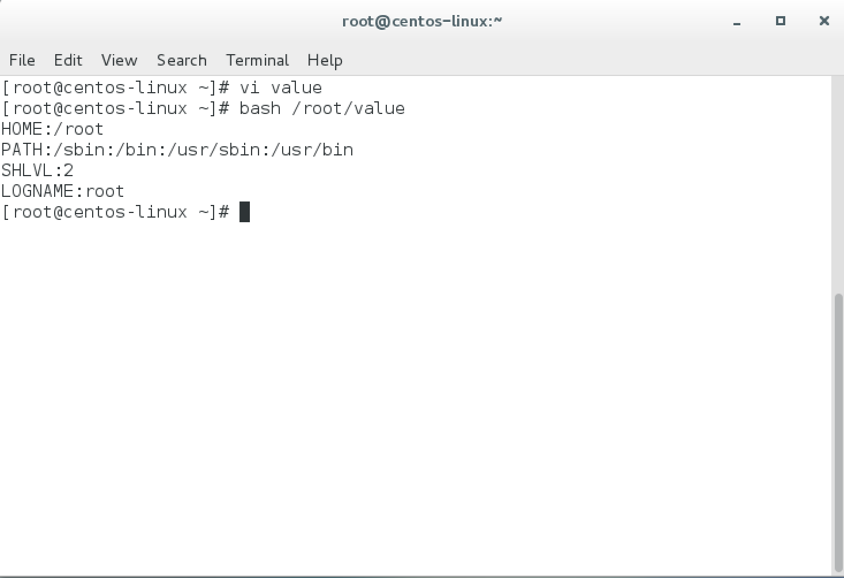

2. 用while语句重写下列Shell脚本程序，以实现相同的功能：

#!/bin/sh

clear

select item in Continue Finish

do

case “$item” in

Continue) ;;

Finish) break ;;

\*) echo “Wrong choice! Please select again!” ;;

esac

done

答：

#!/bin/sh

clear

echo '1) Continue'

echo '2) Finish'

while read item

do

case $item in

[1]) ;;

[2]) break ;;

\*) echo “Wrong choice! Please select again!” ;;

esac

done

3. 编写一个shell脚本，显示Fibonacci数列的前10个数字。(Fibonacci数列: a[i+2]=a[i+1]+a[i], a[1]=0, a[2]=1, i>=1)

#!/bin/sh

echo -n "Fibonacci: "

a=0

b=1

echo -n "$a, $b"

i=1

while [ $i -le 8 ]

do

c=`expr $a + $b`

echo -n ", $c"

a=$b

b=$c

i=`expr $i + 1`

done

echo ""