Tab 1


DSE/QF 4211 Group Project Report
19 April 2025

BlockSquad

Kwek Wan Ting (E0772914)
Kwek Jie Lin (E0970379)
Leong Chong Gui (E0957478)
Nicholas Cheong Jun Hong (E0725023)
Tan Soo Yap (E0958407)

Executive Summary
This project aims to develop a trading strategy that allocates weights (which represents portfolio allocations) hourly across stocks and cryptocurrencies by integrating the Prophet forecasting model with the Minimum-Variance Optimization Portfolio (MVOP) framework. This hybrid strategy enables forward-looking, risk-adjusted asset allocation across both traditional and digital assets. Unlike static models, our ensemble dynamically adjusts portfolio weights based on predicted trends, offering adaptability in volatile markets. The approach which generated the best performance, based on a predetermined set of metrics (returns, Sharpe ratio, max drawdown etc.) was selected and used as our final model.
The team comprises members from data science and quantitative finance backgrounds. Those from data science focused on machine learning models for price prediction, while those in quantitative finance applied traditional trading strategies and modern portfolio theory. These efforts were later integrated into an ensemble strategy. Nicholas explored a Reinforcement Learning-based approach using PPO. Jie Lin applied Linear Regression with MVOP, while Soo Yap combined MVOP with the Kelly Criterion and a Markov Regime Switching model. Wan Ting developed a Prophet - MVOP strategy. Chong Gui handled data cleaning, parameter tuning, and backtesting to maximize overall model performance.
In terms of outcomes, the Prophet - MVOP Ensemble strategy delivered exceptional risk-adjusted returns relative to other models we considered, with a Sharpe ratio of 2.30 and 65.54% annualized returns. Despite a slightly high drawdown of -5.47% and moderate win rate of 52.08%, it outperformed other models’ portfolio value at 1.042 Million USD.
Research points to the Prophet model as a strong forecasting tool. However, current strategies using the Prophet model mostly work with single-asset allocation without the ability to model dependencies. Our chosen ensemble strategy outperforms in this regard with its ability to dynamically adjust weights at each interval using price predictions, taking into account correlation between assets.

Dynamic Multi-Modal Portfolio Management and Optimization
Objectives
The primary objective of this project is to build and optimize a dynamic and predictive strategy that allocates weights hourly across both stocks and cryptocurrencies. This will be achieved through an ensemble trading strategy that combines both machine learning models and traditional trading strategies. Our aim is to maximize the portfolio’s performance by evaluating key metrics such as returns, Sharpe ratio, win rate, and maximum drawdown. Beyond enhancing financial performance, this project aspires to generate positive economic and societal impact through two main avenues – incorporating Traditional and Digital assets and contributing to the educational and research sectors for ensemble strategies.
Literature Review
Lamba et al. (2024) demonstrated Prophet’s utility for financial forecasting, leveraging its automated seasonality detection, robustness to missing data, and cross-validation (Mean Absolute Percentage Error: 0.017–0.124), though constrained by linear growth assumptions and single-asset focus. Separately, Worasucheep (2022) proposed a heterogeneous ensemble of machine learning models (SVM, ANN, RF, XGBoost, LightGBM) with selective majority voting and hyperparameter tuning, achieving good Sharpe ratios but limited by static thresholds and single-asset reliance. Both studies prioritize predictive accuracy – Prophet through time-series adaptability, the ensemble via algorithmic diversity. However, they share critical gaps which are the lack of dynamic risk controls, single-asset strategies, and inability to model cross-asset dependencies.
Dataset Characteristics
We fetched hourly data from 1 Jan 2024 to 4 April 2025 from yfinance for stocks (AAPL, GLD, GOOGL) and cryptodatadownload for crypto (BTC, ETH). Then, we performed data visualisation with standardised close prices for each asset.
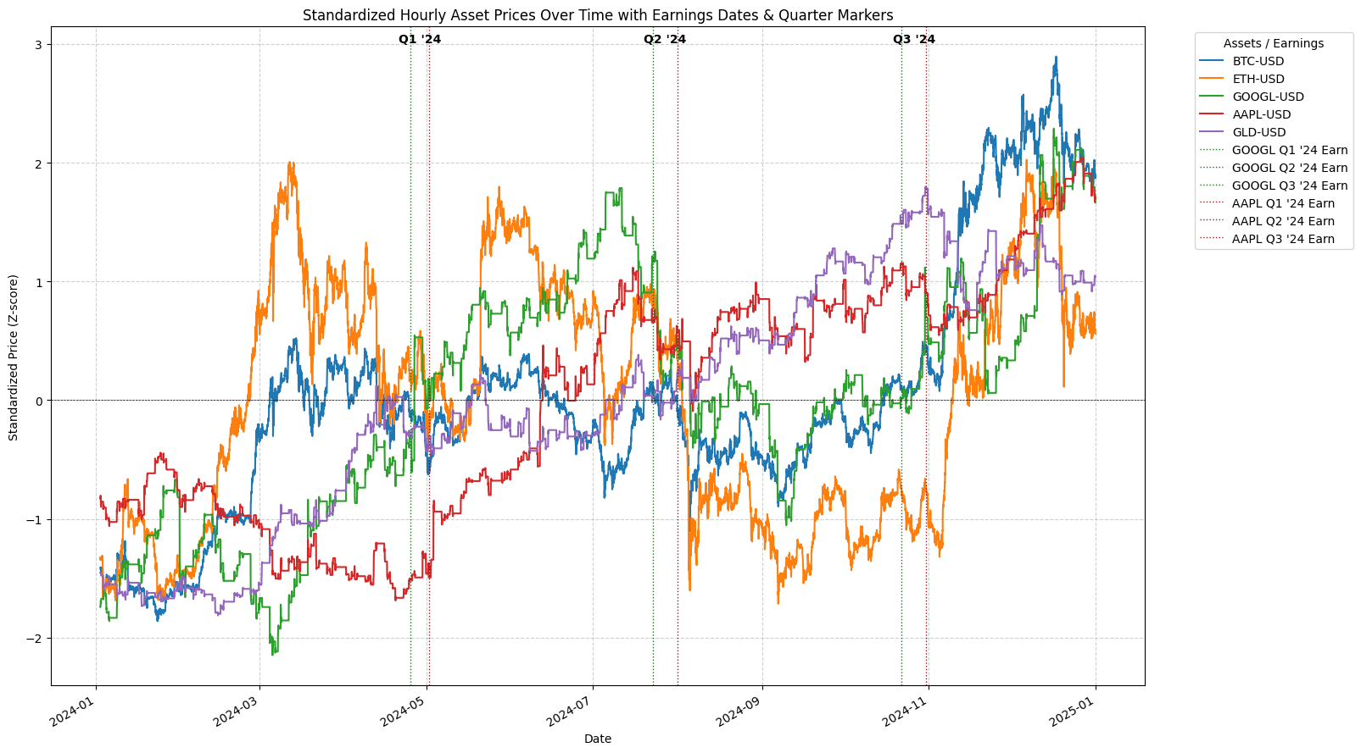
Figure 1: Dataset characteristics
From the graph, 3 main observations stood out to us. Firstly, all assets displayed a non linear trend, characterised by rise and fall in prices inherent to asset data. Secondly, there is strong correlation between certain assets such as BTC and ETH (Zhang & Mani, 2021), where they rise and fall in sync. Lastly, there are quarterly trends observed for AAPL and GOOGL, likely due to quarterly earnings affecting their price. For example in Q1 24, both GOOGL and AAPL saw a sharp rise in their prices due to positive earnings. With these observations in mind, we sought for a model that could adapt well to our dataset and eventually decided on the prophet model, which we will elaborate on in the next section.
Next, we performed data preprocessing through dropping null columns and standardised the feature variables to standard normal while leaving the target variable intact. As the crypto data was given in 24 hours time format, we standardized its datetime index to US market hours (930am - 4pm ET) and performed forward fill to ensure the time interval matched. We then split the data into train (2024-01-01 to 2025-01-01), validation (2025-01-02 to 2025-02-28) and test (2025-03–01 to 2025-04-04) partitions.
Prophet Model
Prophet is a time-series forecasting model developed by Meta, designed for robust, scalable, and interpretable predictions on time series data (Rafferty, 2023). It uses an additive regression model with the formula y(t)=g(t)+s(t)+r(t)+h(t)+ϵ(t), where g(t) is the trend component, s(t) is the combined seasonality component, r(t) is the combined regressor component, e(t) is the noise and y(t) is the predicted output at time t. This additive regression model allows Prophet to capture our dataset characteristics well, as it can capture nonlinear patterns in our data with its piecewise functions. Custom regressors can also be added, allowing us to use prices of assets with strong correlation (e.g BTC/ETH) to improve the prediction of our model. The trend and seasonality component also allows us to capture potential trends in the assets such as quarterly earnings. Hence, we decided to use the prophet model to determine the price of each asset, which we then pass to the MVOP strategy.

Minimum Variance Optimization Portfolio (MVOP)
MVOP aims to construct an optimal portfolio by minimizing the overall risk while targeting a desired level of return with the formula:$\min_{\{w_{i}\}{}_{i=1}^{N-1}}{ σ}_{p}^{2}=\sum_{i = 1}^{N}{}w_{i}^{2}σ_{i}^{2}+2\sum_{i = 1}^{N-1}{}\sum_{j = i+1}^{N}{}w_{i}w_{j}σ_{ij}^{}$ , subjected to the constraint of full investment $\sum_{i = 1}^{N}{}$$w_{i}=1$ and no short selling $w_{i }≥0$. We choose MVOP as it achieves balance of risk and return through optimization and is better suited for high frequency, automated trading (Rubio et al., 2012). A unique feature of our implementation is the integration of both cryptocurrency and stock assets. This dual-market focus allows us to benefit from the diversification effects of combining traditional and digital financial instruments, while also addressing the rising demand for robust multi-asset strategies in modern portfolios.
Trading Strategy: Ensemble algorithm combining Prophet & MVOP
Our ensemble model integrates Prophet with MVOP by using Prophet’s forecast to adjust MVOP’s risk-based weights. Prophet predicts the target asset’s future price using other asset prices as regressors. This forecast is compared to the asset’s historical average; if it signals strong expected growth, the target asset’s MVOP weight is increased proportionally and vice versa. This allows the MVOP allocation to incorporate forward-looking price information, which results in a dynamic strategy where asset weights are optimized for both low risk and predictive opportunity. This integration makes the portfolio more responsive to market conditions while maintaining risk control.
Key Findings
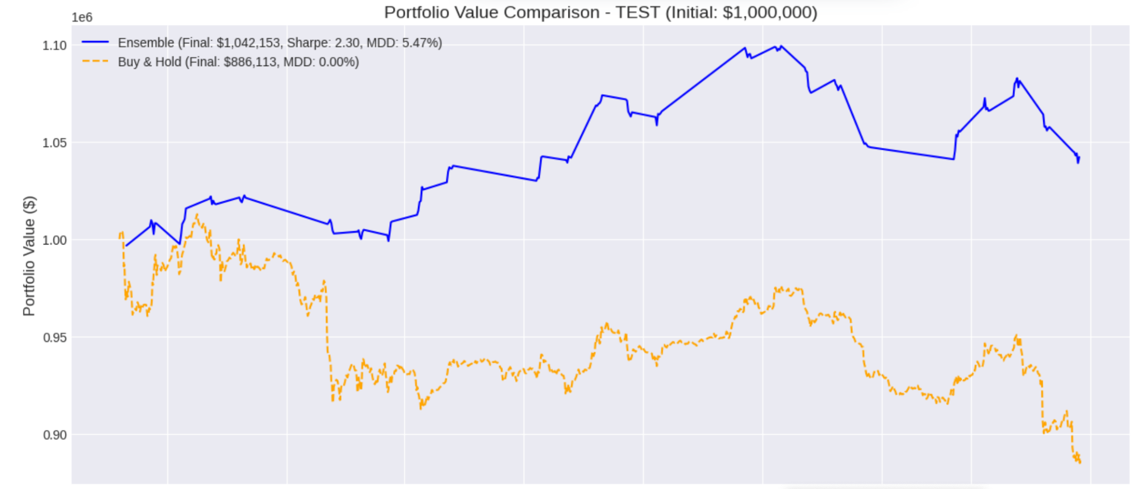
Figure 2: Comparison of Portfolio Returns between ensemble model and benchmark model
From Figure 2, the ensemble model consistently outperforms the buy-and-hold strategy across the test period, highlighting its robustness and superior performance. The final portfolio value reaches $1,042,153 despite market downturns, underscoring the model’s adaptability. With a maximum drawdown of -5.47% and a Sharpe ratio of 2.3, the model not only delivers high risk-adjusted returns but also maintains a remarkably smooth equity curve. These results affirm the model’s capability to effectively manage volatility and deliver consistent gains.
Uniqueness and Innovations
Our project uniquely incorporates traditional and digital assets into our portfolio to form a diverse portfolio that can adapt well to the fluctuations in the market. Focusing on risk-return profile, AAPL and GOOGL were chosen for their higher Sharpe ratios relative to most S&P constituents. In contrast ETH and BTC bring higher volatility, which can offer more upside potential. GLD plays a stabilizing role, reducing portfolio volatility and drawdown risk. We also focused on market capitalization and liquidity, where AAPL, GOOGL, BTC, and ETH were ranked among the highest market cap assets, while GLD is the most liquid ETF tracking gold. These metrics ensure that our portfolio is balanced and diverse, allowing for a good mix of speculative growth and hedging.
Our model uniquely bridges time-series forecasting and portfolio optimization through combining Prophet’s multi-asset predictions with MVOP. Unlike standard models, we train a Prophet model for each asset by using other assets' prices as regressors, capturing real-time interdependencies. We also dynamically adjust our portfolio holdings based on the results of our ensemble strategy. To ensure proper adjustment, customised preprocessing was done to ensure on BTC and ETH datetime index to ensure trade timings align with US market trading hours. Stop loss mechanisms and volatility based thresholds were also implemented to mitigate drawdowns. This integration of predictive accuracy, correlation-based allocation, and real world trading constraints creates a novel ensemble strategy that outperforms the single model framework common in existing literature.
Contributions of our Research
Our model proposes a novel integration of time-series forecasting and traditional risk-based allocation models, where we leverage Prophet's predictive capability to forecast price trends, then use this forecast to dynamically adjust the weights in MVOP. This bridges the gap between predictive modeling and reactive risk control, enabling our portfolio to adapt to market conditions more effectively than static strategies. We hope that our approach can encourage more research into ensemble strategies, spearheading new insights and development in the educational and research sector.
Our project also emphasizes cross-domain applicability by merging traditional equity and modern cryptocurrency markets. Our findings underscore the potential of incorporating traditional and digital assets to improve portfolio returns, which could address the evolving demands of institutional and retail investors seeking diversification across asset classes.
Conclusion
Based on the performance of key metrics such as portfolio returns, sharpe ratio, win rate, our ensemble methods (Prophet model - MVOP) produced the best results and outperformed traditional portfolio based strategies. This suggests that ensemble methods have better market adaptability, as they can dynamically allocate portfolios to cater to changing market conditions.
Moving forward, we intend to explore dynamic model selection from a pool of different models and techniques to better suit different market conditions.

Appendix
References
Lamba, M., Loyal, M., & Kapoor, H. S. (2024, April). Forecasting of stock price and cryptocurrency using prophet. In AIP Conference Proceedings (Vol. 3081, No. 1). AIP Publishing.

Rafferty, G. (2023). Forecasting Time Series Data with Prophet: Build, improve, and optimize time series forecasting models using Meta's advanced forecasting tool. Packt Publishing Ltd.

Rubio, F., Mestre, X., & Palomar, D. P. (2012). Performance analysis and optimal selection of large minimum variance portfolios under estimation risk. IEEE Journal of Selected Topics in Signal Processing, 6(4), 337-350.

Worasucheep, C. (2022). Ensemble classifier for stock trading recommendation. Applied Artificial Intelligence, 36(1), 2001178.

Zhang, S., & Mani, G. (2021). Popular cryptoassets (Bitcoin, Ethereum, and Dogecoin), Gold, and their relationships: Volatility and correlation modeling. Data Science and Management, 4, 30-39.

