**Home Assignment**

write a simple, responsive, web app that shows the weather of some city. The user should be able to search for a city , save it to favorites , get current weather , get favorites and delete favorite.

We expect to see 2 pages in this app. (weather page and favorites page).

the application should be written in .net or .net core(bonus) the db should be MS-Sql or MySQL or sqlite

**API**

The API that you’ll use for this app is [AccuWeather API](https://developer.accuweather.com/) . Please signup and create a new app in order to get an API key.

You will use 3 endpoints: [location autocomplete](https://developer.accuweather.com/accuweather-locations-api/apis/get/locations/v1/cities/autocomplete) for the search field, [get current weather](https://developer.accuweather.com/accuweather-current-conditions-api/apis/get/currentconditions/v1/%7BlocationKey%7D) and

[5-day daily forecast](https://developer.accuweather.com/accuweather-forecast-api/apis/get/forecasts/v1/daily/5day/%7BlocationKey%7D) . Please read those API docs.

NOTE: this API is limited to 50 requests per day. our recommendation is to save the responses and use them locally during development.

The api should be restful api with those end points:

1. Search - get query from client and call [location autocomplete](https://developer.accuweather.com/accuweather-locations-api/apis/get/locations/v1/cities/autocomplete)
2. GetCurrentWeather - send city key to [get current weather](https://developer.accuweather.com/accuweather-current-conditions-api/apis/get/currentconditions/v1/%7BlocationKey%7D)
   1. Before calling to [get current weather](https://developer.accuweather.com/accuweather-current-conditions-api/apis/get/currentconditions/v1/%7BlocationKey%7D) need to check if the current weather for current city exists in DB if it does get the weather from DB without calling AccuWeather API (need to save only the Celsius Temperature value and WeatherText).
3. AddToFavorites – add city to favorites
   1. Should save city key and LocalizedName
4. DeleteFavorite – delete city from favorites

**GOALS**

1. Show us your coding skills - We want to see your strengths, don’t be afraid to go wild.
2. Readability - Your code should be readable and self-explanatory .

Remove any unused code, console logs, and files. Use logical project

structure and code separation.

**HOW TO SUBMIT**

Push your code to your git repository,include sql to create DB, and make it public (we recommend GitHub in order

to use GitHub Pages with ease), **name the repo as firstName-lastName-dateOfStart-FullStack**

**(John-Doe-01-12-2018-FullStack)**

**Send us the git repository link**

**SPECS**

1. The main screen will be composed of a search field to search a

location’s weather by city name:

* 1. After entering data in the search field the right side should display all found cities
  2. When city is clicked the left side should display current whether

1. The favorites screen will be composed of favorites cities

**EXAMPLE**

main screen:

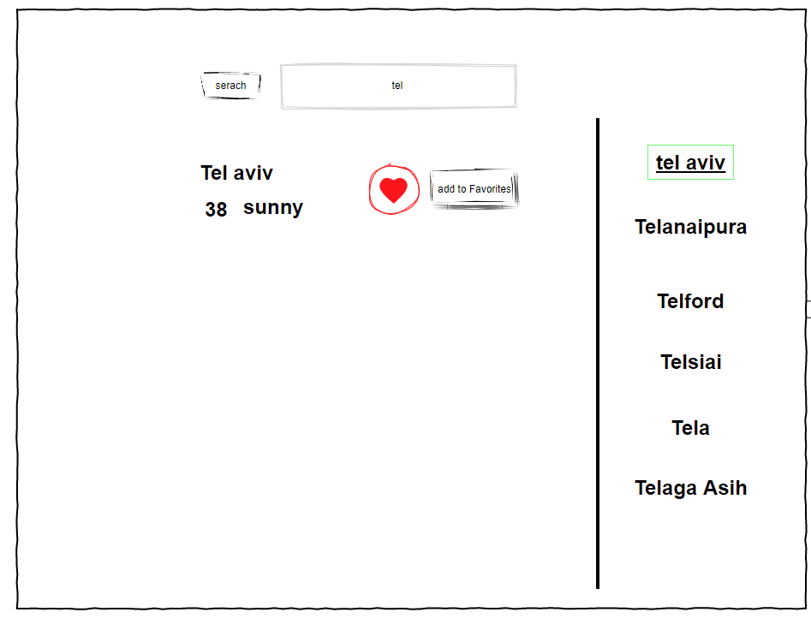

Favorites screen:

