Contents

Preparing for the first launch of ARACHNE full version. 1

Local machine side (GUI operating on MATLAB under Windows) 1

ARACHNE with preinstalled cluster 1

How to run a simulation on any remote cluster 2

Preparing a HPC cluster (under Linux) 2

Preparing local machine (under Windows) 2

How to run simulation on local machine with OS Windows 3

Download file ARACHNER.exe to any directory of local computer operating under Windows.:

<https://github.com/LeonidSavtchenko/Arachne>

Run ARACHNE.

When GUI appears you have three options

1. Download "output.mat" and analyses results.

Using this option you can download and analyses the previously computed results.

1. Start simulation from scratch (current files "output.mat" and "intermediate.mat" will be lost).
   1. Choose the option 2 to start a new simulation.
   2. Option 2 generates the GUI windows contains the basic parameters. Using this window, you can check and modify the parameters of the network.

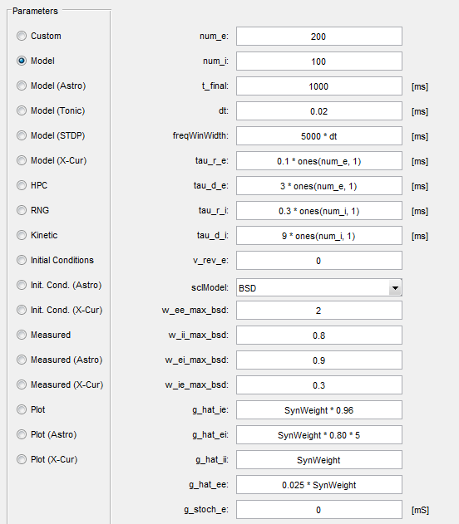

* 1. After modifying the parameters you can start “Run” -- the simulation will be conducted on the remote cluster at 144.82.46.83.
  2. When the simulation is completed, the model generates the plots with the simulation results.

1. Continue simulation from the same point.

This option allows continuing previous calculations by changing network parameters.

Time of next computation. “Please specify the additional period to simulate (e.g. "1234.5 ms" or "12345 it") and parameters of computation and new extra inputs.

* 1. 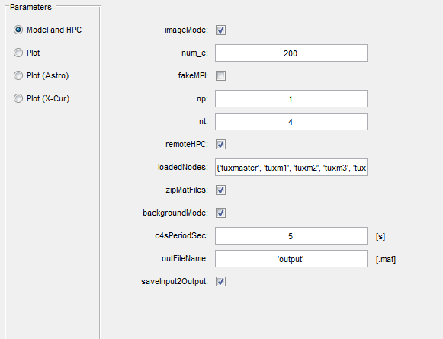

It is convenient to study the mechanism of memory formation and recall by networks.